Operating Systems Report
Name: Ada Leka
Student Number: 2428666
Course: Computing Skills for the Workplace
Module: Computer Architecture and Operating Systems ACCA4022

1. Introduction
An operating system (OS) is essential software that acts as an interface between computer hardware and users. It manages hardware resources, provides services for application programs, and ensures that the system operates efficiently and securely. Common operating systems include Microsoft Windows, Linux, and macOS, each offering different features an capabilities . This report explores the key functions of operating systems, demonstrates the use of Windows command-line interface (CLI) commands, examines Linux command-line tools, and discusses scripting for automation in both environments. The aim is to provide both theoretical understanding and practical examples of how operating systems are used to manage computing resources effectively.

2. Key Functions of Operating Systems
Operating systems manage processes, memory, files, devices, and provide user interfaces.
Figure 1: Control Panel showing system settings
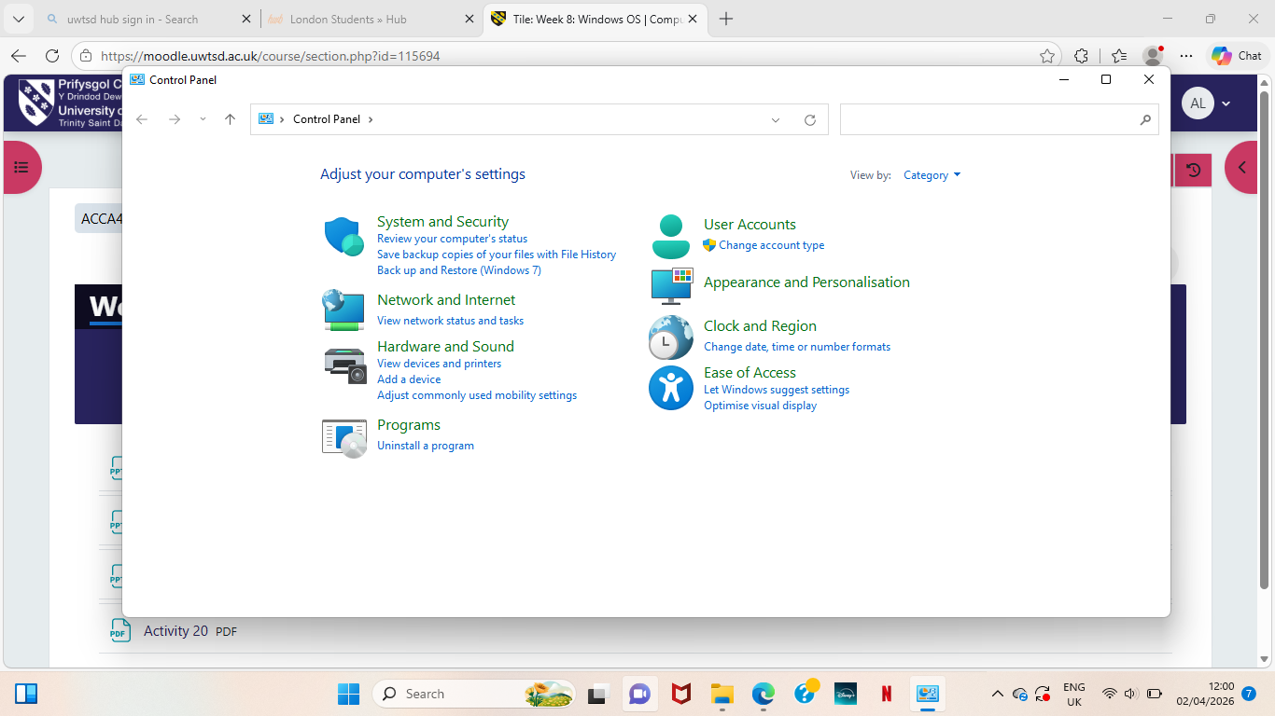

3. Windows CLI Commands
The mkdir command creates directories in Windows.
Figure 2: mkdir command in CMD
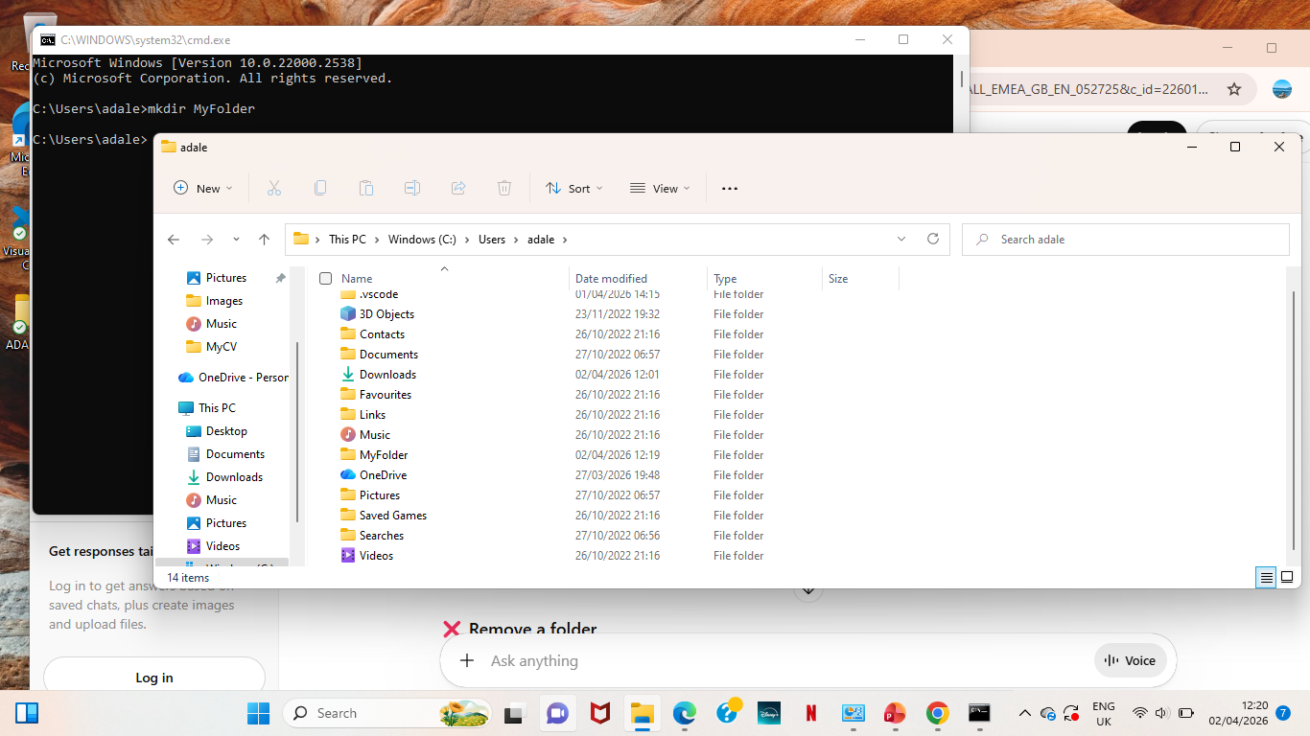
Figure 3: Folder created in File Explorer

4. Linux CLI Commands
Linux systems rely heavily on CLI for system management.

4.1 File Management

Commands include:
- ls
The ls command is used to list files and directories in the current directory.
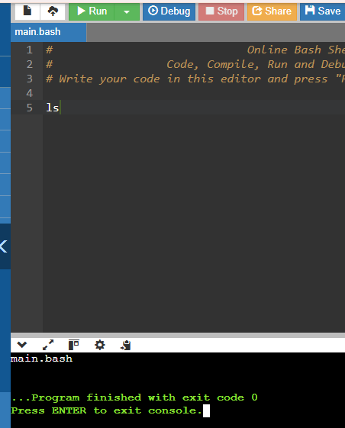
- cd (change directory)
The cd command is used to change the current directory.
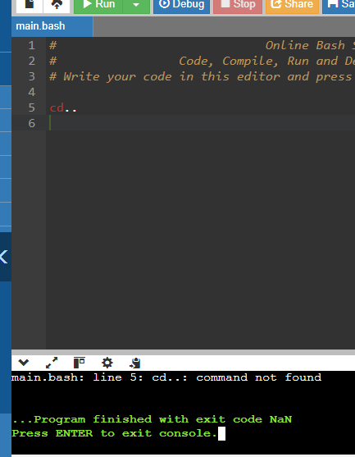
- pwd (show current directory)
The pwd command displays the current working directory .Ds
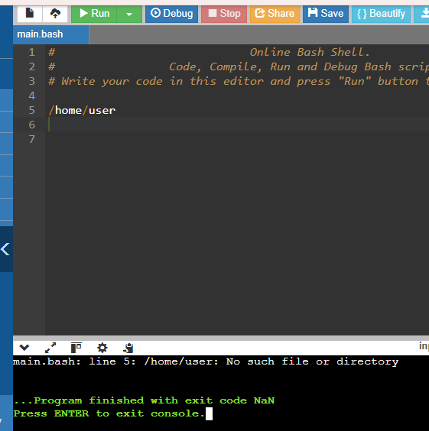

4.2 Process Management
- ps shows active processes
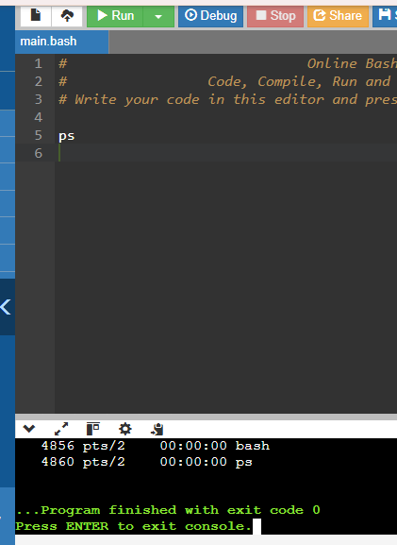
- top provides real-time monitoring

4.3 Network Monitoring
- ping tests connectivity
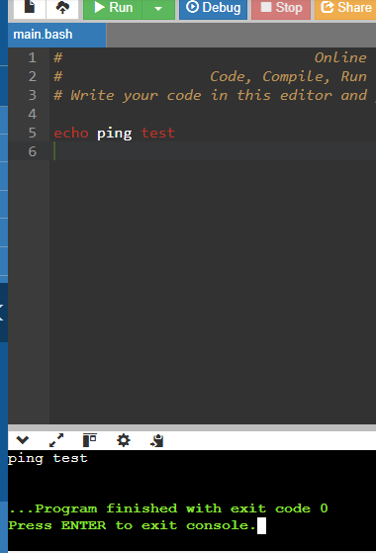

4.4 File Operations
- cp copies files
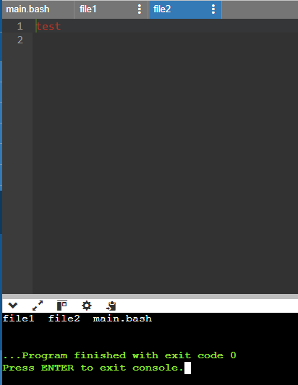
The cp command is used to copy files from one location to another.

- mv moves or renames files
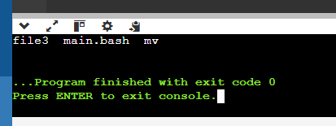
The mv command is used to move or rename files.

- rm deletes files
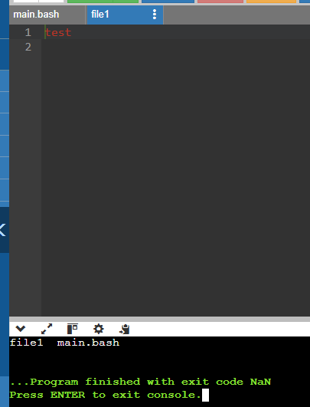
The rm command is used to delete files. In this example, file3 is removed from the directory.

Linux CLI is powerful and widely used in servers due to its efficiency and flexibility.

5. Windows Scripts
Batch scripting allows automation of tasks in Windows.
Script 1:User input
@echo off
set /p name=Enter your name:
echo Hello %name%
pause
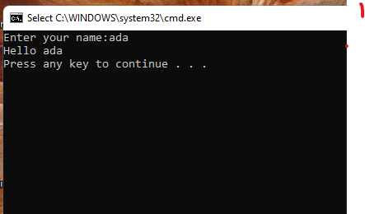
This script prompts the user to enter their name and then displays a personalized greeting using the entered input. The use of the "set /p" command allows user interaction, while the "echo" command outputs the result.
Script 2:Calculation
@echo off
set /a num=5+5
echo Result %num%
pause
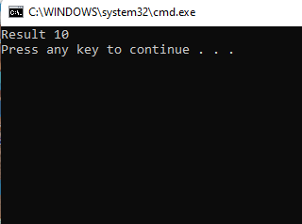
This script performs a simple arithmetic calculation using the "set /a" command and displays the result using the "echo" command.

6. Linux Scripts
Script 1
#!/bin/bash
name="ada"
echo Hello $name
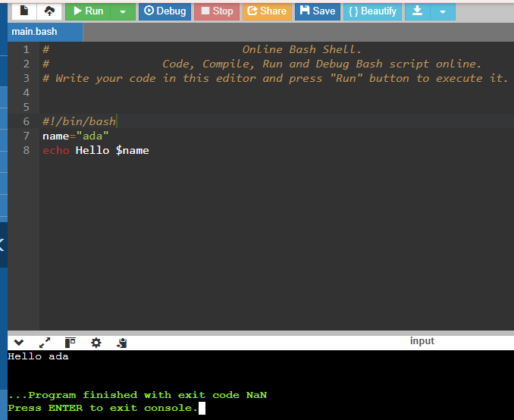

Script 2

#!/bin/bash
a=5
b=3
sum=$((a + b))
echo The result of 5 + 3 is 8
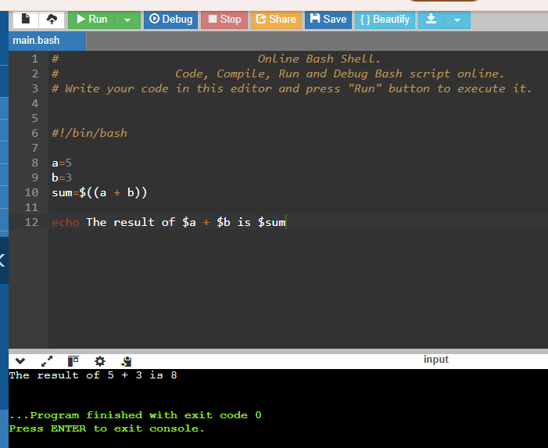
This script demonstrates the use of variables and arithmetic operations in Linux. It assigns values to variables, performs a calculation, and displays the result using the echo command.

7. Conclusion
Operating systems play a crucial role in managing computer hardware and software resources. This report has demonstrated the core functions of operating systems, including process, memory, file, and device management. It has also explored the use of command-line tools in both Windows and Linux environments, highlighting their importance in system administration. Additionally , scripting in both environments allows users to automate repetitive tasks, improving efficiency and productivity. Understanding these concepts is essential for anyone working in computing or IT-related fields.

8. References

[1] A. S. Tanenbaum and H. Bos, Modern Operating Systems, 4th ed. Pearson, 2015.
[2] Microsoft, "Windows Commands Documentation." [Online]. Available: https://learn.microsoft.com
[3] The Linux Foundation, "Linux Command Line Basics." [Online]. Available: https://training.linuxfoundation.org
[4] W3Schools, "Linux Commands Tutorial." [Online]. Available: https://www.w3schools.com

9. Appendices

9.1 Evidence of Online Course Engagement


Figure 1: Participation in an online Linux tutorial course (Great Learning platform), showing course content and progress.

Updated References (IEEE)

