

The development of criminals. Nature V Nurture. Are criminals made or born?

Name: Michal Tatar
Student ID:1900905
School: UWTSD Swansea
Degree: BSc Criminology and Policing
Due Date: 6th May 2022
Word Count: 8412

Declaration

This work has not been previously in substance for any degree and is not being concurrently submitted in candidature for any degree.

Signed: Date:06/05/22

STATEMENT 1

This dissertation is being submitted in partial fulfilment of the requirement for the degree of BSc.

Signed: Tatar Date: 06/05/22

STATEMENT 2
This dissertation is the result of my own independent work/investigation, expect where otherwise stated.

Signed: Tatar Date:06/05/22

STATEMENT 3

I hereby give consent for my dissertation, if accepted, to be available for photocopying and for interlibrary loan, and for the title and summary to be made available to outside organisations.

Signed: Tatar Date:06/05/22

STATEMENT 4

I hereby give consent for my dissertation, if accepted, to be available on the university’s IT system to those who have consent to use the system.

Acknowledgements

I would like to thank my supervisor, Mike Durke, not just for his continued support and availability during the process of writing this dissertation, but also, for the extensive amount of effort provided by Mike to ensure we understood the task at hand since the introductory session. I would like to say that throughout my years at university Mike has been a positive role model figure and I thoroughly enjoyed my time spent with Mike and his lectures.

I would also like to thank my girlfriend and family for the continuous support and motivation even when things were tough for me personally. I never felt alone and your support guided me in ensuring I fulfilled my goal of writing a dissertation I can be proud of. You were all part of this journey and I’m extremely grateful to have had such great support.

Abstract

There is a vast amount of information available in regard to criminals and what makes people commit crime. It is evident that crime has been around since the dawn of humanity. The idea to understand what makes people commit crime was vastly brought to life in the 19th century as many researchers tried to understand what the contributing factors were to make us commit crimes. Crime touches every part of our planet and can occur in many different formats. The reader should be made aware that the paper will touch upon sensitive topics to provide an understanding of the arguments formed. Thus, this study aims to dig deeper into the understanding of what makes people commit crime. Can it be a case of nature or nurture? Are we born to commit crime or do we get taught to commit crime? This paper will attempt to better understand these questions to provide an understanding into this topic.

A questionnaire was distributed to volunteers via online resources. The findings will help the researcher understand the public consensus on why they believe people commit crimes.

Table of Contents
Chapter One: Introduction 6
1.1 Background 6
1.2 Rationale 7
1.3 Aims and Objectives 8
1.3.1 Aim: 8
1.3.2 Objectives 9
1.4 Research Structure 9
1.5 Conclusion 10
2. Chapter 2: Literature Review 11
2.1 Introduction 11
2.2 Nature and its relation to crime 12
2.3 Cesare Lombroso’s theory of crime 12
2.4 The argument of Nature according to Lombroso 13
2.5 Neurological diseases and its correlation to crime 14
2.6 brain disorders and crime 14
2.7 Concept of Nurture and its relation to crime 16
2.8 Classical Conditioning 17
2.9 Conclusion 18
3. Chapter three: Research Methods 20
3.1 Introduction 20
3.2 Research Onion 20
3.2.1 Philosophy 21
3.2.2 Approach 22
3.2.3 Research Strategy 23
3.2.4 Choice 23
3.2.5 Time Horizons 24
3.3 Ethical Considerations 24
3.4 Limitations 25
3.5 Conclusion 25
4. Chapter Four: Data Analysis 27
4.1 Introduction 27
4.2 Data Presentation 29
4.3 Conclusion 36
5.Chapter Five: Conclusions and Recommendations 37
5.1 Introduction 37
5.2 Main Findings 37
5.3 Recommendations 38
5.4 Conclusions 39
Bibliography 40
Appendices 48

Chapter One: Introduction

The introductory chapter aims to provide the background of the topic that will be extensively covered in the paper. The rationale behind the research will be explored alongside the aims and objectives of this paper to establish what this paper sets to achieve through extensive research and evaluation of evidence gathered. This dissertation is designed to understand why people commit crime and what factors contribute to our decisions to become deviant. Crime can be defined in many ways but the general definition states that crime is an offence which goes beyond the personal and into the public sphere breaking prohibitor rules or laws, to which legitimate punishments or sanctions are attached, and which requires the intervention of a public authority (The Scottish Centre for Crime and Justice Research, 2015).

1.1 Background

There were just under 5.5 million crime offences recorded by the Police in England and Wales in the year 2020/21 (Clark, 2021) which was the lowest figure recorded since the year 2017/18. However, understanding why people commit crime has been a question that has left many questions answered for centuries. Theories ranging from one's appearance, DNA, childhood upbringing, environments and many other factors have all been potentially recognised as triggers for individuals committing crimes.

The most common form of argument is the format of Nature V Nurture a long-lasting argument in society that has dominated the spectrum of crime and our understanding of individuals, for example a blockbuster Hollywood film Split portrayed a troubled man with multiple personality disorder in which the condition led him to kidnapping multiple underage teenage girls where they were exposed to rape, beatings and emotional abuse. Although this example is indeed fictional, the portrayal of how mental health disorders can affect one's mind and the understanding of right and wrong can provide a sense of understanding in the role nature plays.

A real-life example can be seen in the notorious serial killer Ted Bundy who murdered and sexually abused 30 women. It was found that Bundy was suffering from a chronic mental disorder with abnormal or violent social behaviour (Piercy, 2019). Crime can affect anyone from children to adults, unfortunately certain age groups are more likely to be victims of crime as statistics show that the victimisation rate increases through teenage years, peeks at around 20 and slowly decreases through the remaining years (Craig, 2001). This, pattern exist across all races, sex, and ethnic groups with some exceptions although recorded evidence to provide sufficient data is rare.

The majority of arguments were formed in the 19th century by early criminologists such as Cesare Lombroso, Cesare Beccaria, Edwin Sutherland and many more who decided to investigate reasons behind people committing crimes. Although some of the theories introduced by these great minds may be seen as outdated in today’s standards and our understanding of crime it is essential to appreciate their importance in how they shaped our understanding of crime today. Many modern criminologists such as Adrian Raine expanded upon such theories to new and modern theories that could be applied in modern society.

1.2 Rationale

The researcher believes that this topic should be of high significance because crime happens in every corner of the world and in some cases, crime is misunderstood by many people and if just one more person understands what makes people commit crime a difference can be made in their communities. Crime can have devastating effects on victims for example you may fall into a state of depression, self-harm. The development of physical symptoms can occur which can include night terrors, lack of sleep, decreased/increased appetite (Victims Support, 2021).

Diving deep into this topic could benefit many organisations if they choose to use the research to spread awareness of crime to provide a better chance of citizens playing their part to ultimately reduce crime. This can include early intervention, rehabilitation, and acceptance of criminals back into society. Conducting this research will also benefit the researcher himself by providing a more detailed understanding of crime which can be beneficial in career paths for example my career path is to become a police officer and this research can be crucial in aiding my understanding of how to manage situations that relate to examples such as mental health related cases. Therefore, the research can have widespread benefits for the future and present to those who seek interest in understanding crime.

1.3 Aims and Objectives

The main objective of the research conducted will be to gain an understanding how Nature and Nurture contribute to crime. Understanding theories both outdated and modern will be essential in providing an idea of how criminologists view crime and what their research and findings suggested. The main aim will be to extensively evaluate all the information present at hand to form arguments and make suggestions based on findings.

1.3.1 Aim:

- To critically explore the general public’s view on crime, contributions to crime and whether rehabilitation is possible whilst discerning whether a pattern of prejudice exists against criminals.

- To gather evidence through a publicly accessible questionnaire based on the topic discussed to form arguments using existing theories.

1.3.2 Objectives

- To understand the implications of the research, making reasonable recommendations for future research and social practices.

- To analyse the data collected while exploring public views and attitudes concerning whether criminals are made or born?

- To explore academic literature regarding the topic through extensive research into theories, arguments and case law that can be used to form arguments.

- To explore the idea of Nature V Nurture and its relation to crime

- To critically evaluate how adverse childhood experiences influence the possibility of committing crime, alcoholism, environment factors and mental health

1.4 Research Structure

In order to achieve the aims and objectives set out the research project will consist of five chapters. Each chapter will contribute to the research topic and will take a deep dive into the topic of discussion. Chapter one being the introduction, the reader can gain a taste of what they can expect from the paper; chapter two, will be presenting the literature review; chapter three, being the methodology and how the research gained was accessed; chapter four, following the data analyses from the research gained and finally, chapter five, will be the conclusion where the reader can find recommendations and what the paper has concluded based on its findings.

1.5 Conclusion

This chapter has explained the topic of the study and what the paper sets out to achieve and what methods will be used to ensure that all aims and objectives as outlined are achieved. The chapter has provided a good idea of the structure the paper will follow and has ensured that a disclaimer is provided to any readers that some research and topics may be sensitive however, will be of utmost importance to establish valid points and arguments. The next chapter will consist of a literature review to provide more substance on the topic to which the study is based upon.

2. Chapter 2: Literature Review

2.1 Introduction

The purpose of this chapter is to review previous academic research surrounding the topic in order to gain an understanding whether criminals are made through Nature or Nurture and how academic theories suggest the case for both factors. Or could it be that both nature and nurture are interconnected with crime. However, the nature/nurture debate has raged for decades, both within and outside of criminology. Early biological theories of crime were strongly influenced by Darwinian views of inheritance and natural selection and tended to ignore or downplay environmental influences (Coyne, Wright, 2013).

This chapter will aim to achieve objectives three, four and five:

“To explore academic literature regarding the topic through extensive research into theories, arguments and case law that can be used to form arguments.”

“To explore the idea of Nature V Nurture and its relation to crime”

“To critically evaluate how adverse childhood experiences influence the possibility of committing crime, alcoholism, environmental factors, mental health and neglect during pregnancies and its influence.”

2.2 Nature and its relation to crime

Cesare Lombroso was one of the firsts minds to look into the criminal mind to gain an understanding of what makes us commit crime. He is most famously known for his theory of the born criminal, a dangerous individual marked by what he called ’anomalies’ created the idea that nature such as neurological and biological factors were the main reason why people committed crime. Physical and psychological abnormalities determined whether man would be classed as a criminal (Gibson, Rafter, 2006). For Lombroso these anomalies resembled traits of primitive peoples, animals and even plants to some extent proving that the most dangerous criminals were atavistic throwbacks on the evolutionary scale (Mazzarello, 2011).

2.3 Cesare Lombroso’s theory of crime

When a Lombroso who worked at in an Asylum in Pavia located in Italy during his early career was asked to perform a post-mortem examination on a criminal named Villela, an Italian Jack the Ripper who by atrocious crimes had spread terror in the Province of Lombardy. Lombroso had cracked the skull open and began his investigation in which he found that the cerebellar vermis was so enlarged when compared to normal individuals that it almost formed a small, intermediate cerebellum like that found in the lower types of apes, rodents, and birds. This anomaly is very rare among inferior races (Thorndike, Bennard, 1944). This would suggest that the concept of nature and its relation to crime shows that factors out of human control do create criminals sometimes without exhibiting knowledge.

Later investigations did show this anomaly to be present in criminals suggesting that neurological disorders confirm the fact that in some cases individuals who commit crime can’t help the urge for example retro prospective records review of patients with frontotemporal dementia, primary progressive aphasia disease were found to have a high frequency of anti-social and criminals’ behaviour urges (Liljegren M., et al. 2015).

2.4 The argument of Nature according to Lombroso

The unfortunate nature of Lombroso’s theory relied on racist stereotypes for example oblique eyelids which he defined as a characteristic of Mongolian people, the projection of lower face and jaws found in African native people (Little 2019) which in today’s society would be heavily controversial to suggest that such characteristics contribute to defining whether someone is a criminal.

However, Lombroso strongly implies that the perfectly normal individual from a biological point of view, could not become a criminal as they would not possess skeletal structures of primitive people, social circumstances could not create a criminal out of a naturally honest or normal man (Ellword, 1912) although Lombroso did acknowledge that social circumstances may be necessary to call forth the latent criminal tendencies in the abnormal or degenerate individual. He suggested that such tendencies can be found in children on a regular basis however he suggested that most normal children outgrow the tendencies through normal organic development.

Lombroso believed as mentioned that those who committed crime were atavistic, a term he later developed for those who he believed were not fully developed and thus, compared to primitive versions of early humans than non-offenders (Hayward, Maruna & Mooney, 2010) to support this view Lombroso examined over four thousand offenders (dead and alive) to identify physical markers of atavistic form. The weight: height, arm span, size of their hands, eye colour and other factors he believed would contribute to his theory were examined. Lombroso found that 40% of the four thousand offenders he examined had atavistic characteristics (Brooks, 2021). According to Agnew (1992) possessing these unpleasant physical characteristics might lead to unpleasant social interactions, this leads to frustration and anger which, in turn, lead to offending behaviour. Thus, these arguments support the theory that criminals can be born because at one stage they will not be able to escape offending behaviour due to their characteristics of their body which suggest that the argument for Nurture is a potentially valid and strong argument.

2.5 Neurological diseases and its correlation to crime

Adrian Raine, one of the leading criminologists of the modern era may not agree with Lombroso’s theory however, Raine acknowledged that crime can be linked to biological factors. In his book Anatomy of Violence, he suggests that criminals are born based on the lives of their parents; he uses the example, Jeffrey Landrigan. In his example he talks about Landrigan being adopted into a well-respected American family, it is important to consider the fact that Landrigan had never met his biological father.

At the age of two he started displaying temper tantrums and lack of emotional control that later escalated. Later on, in his life Landrigan was sentenced to death after being found guilty of homicide and while in prison another inmate told him about a man named Darrel Hill who was the spitting image of Landrigan. It turned out that Hill was Jeffrey's biological father sentenced for the exact same crimes. Raine suggested that Landrigan clearly inherited more than just his father’s looks but also, the same behaviour patterns (Raine, 2013).

2.6 brain disorders and crime

Most habitual criminals are antisocial personalities which is classed as a disorder due to reduced volumes of cells in the prefrontal cortex which effects how individuals suffer with neurological impairment of moral reasoning (Barber, 2009) which could suggest why Landrigan committed his crimes the argument could suggest that he may have been born to commit crime based on the fact that the disease was heritable?
Gazzaniga, (2005) would suggest that people with brain injuries do not tend to behave in antisocial ways which would suggest that potentially those born with brain disorders cannot control their emotions and the urge to satisfy sadistic desires.

Charles Whitman, an engineering student in Texas killed sixteen people including his wife and mother in 1966. During the post-mortem examination of his brain a tumour was found near to the right amygdala, which some scientists think might have led to Whitman’s inability to control his emotions and actions (Sutton, 2016). To support the theory that brain disorders are a contributing factor in showing that offenders are born Taylor (1984) demonstrates that genetic disorders promote violent behaviour and such behaviour may in turn rise to violent crime. This point was present in the Michigan Law Review (1985) for example in Mainland China a wide range of antisocial behaviours are incredibly being reframed as clinical disorders that require specific medical interventions to cure. Chinese media report that youths suffer with insatiable desire to offend (Peckham, 2014).

Thus, research and case law does indeed suggest that criminals with hereditary diseases such as Alzheimer's disease and frontotemporal dementia were in fact likely to show a history of criminal behaviour. A study showed that out of 2397 patients studied, 204 (8.5%) had a history of criminal behaviour that emerged during their illness. The study found that patients with frontotemporal dementia were statistically more likely to present criminal behaviour urges (Liljegren, Naasan, et al., 2016).

To further suggest that this argument holds great value we can return back to Raine and his case study of Herbert Weinstein. In this case a fight broke out between Weinstein and his wife which resulted in the cold-blooded murder of his wife which led to Weinsten being charged with second degree murder. However, upon an MRI scan of his brain the results showed that Weinstein had a large chunk of his brain missing from his prefrontal cortex as a result of a subarachnoid cyst that was growing in his left frontal lobe. This cyst displaced brain tissue in both frontal and temporal cortices.

The neurologist examining Weistein concluded that he was born with the disease which ultimately impaired his ability to regulate his emotions and make rational decisions based on what was right and wrong (Raine, 2013). Therefore, the argument whether criminals born can be answered with case files such as the ones mentioned which clearly suggest that in many cases the individual’s destiny is to become an offender due to the nature of the diseases spoken about.

2.7 Concept of Nurture and its relation to crime

The Nature/Nurture argument has raged for decades both within and outside of criminology as some of the most influential minds tried to understand what made people commit crimes. Beginning with the early work of Lombroso’s work of Criminal Man as discussed, biological influences were dominant for much of the 19th, 20th centuries. The advent of sociology challenged these dominant explanations. Durkheim, Weber and Marx for example, each located different causes of crime not in individual pathologies but in the way, societies were organised (Coyne, Wright, 2013). The concept of Nurture suggests that psycho-social influences, such as parenting practices, exposure to delinquent peers, and academic achievement have a major influence on crime (Rowe, Vazsonyi, Flannery, 1995) for example, differences in how parents socialise their male and female children are thought to differentially impact their propensity for deviance (Keena & Shaw, 1997). Thus, presenting an argument that deviant behaviour can be created through social influences rather than biological factors.

2.8 Classical Conditioning

Classical conditioning (also known as Pavlovian) is a theory developed in the early 20th century by Russian psychologist Ivan Pavlov. In essence his theory suggested that humans learn through association whereby two stimuli (any object or event that triggers a behavioural response) were linked together to create new learnings and responses in humans and animals (Mcleod, 2021).

The theory was heavily developed for example, the term instrumental conditioning was coined by Clark Hull and he chose this term to describe the type of learning where the subject's response is "instrumental" in obtaining the reinforcement (Bolles, 1993). Operant conditioning was chosen by B.F. Skinner (1935) to describe a similar type of learning because the subject must perform a behavioural operation to obtain reinforcement such as rewards for good behaviour.

Watson and Rayner (1920) were the first psychologists to apply the principles of classical conditioning in human behaviour by looking at how the process may explain the development in phobias. They conducted their research through the Little Albert Experiment which is known as one of the most unethical psychological experiments. In this experiment Watson and Rayner used a toddler (Albert) to create a phobia of rats by striking a metal bar behind Alberts’s head when in contact with a rat which ultimately frightened the rat to react aggressively towards Albert. Over the duration of weeks Little Albert became terrified of rats just at the sight of them thus, showing how classical conditioning could be manipulated to affect behaviour.

On the other hand, two researchers who did cite the Little Albert study, Bregman (1934) and Valentine (1930), were unable to replicate Watson and Rayner’s (1920) results and pointed out methodological flaws as Fridlund et al. (2012) claimed that Little Albert was neurologically impaired because he appeared to have serious behavioural deficits in Watson’s (1923) film which would support the argument of nature as suggested by Raine in regard to neurological brain deficiencies. However, the theory can be applied to gang culture and how it shapes criminals. In an article regarding gang initiation written by The Independent (2011) a support worker stated how one of the individuals she was supported was asked to stab and rob someone or eat dog faeces in order to be accepted into the gang. Also, beliefs towards violence, and negative relationships result in a greater probability of violence involvement among youth (Klat et al., 2016).

The BBC (2019) reported that the Metropolitan Police estimates that there are around 27,000 youth aged between 10 to 15 years of age to be an active member of a gang in which an argument of classical and operant conditioning can potentially influence individuals to join gangs. As explained in order for a behavioural response there must be a reward or positive outcome for an individual in the case of gangs the reward is being accepted into the gang and treated as a family member which relates to Maslow’s (1954) basic needs theory which suggested that the basic needs for individuals are hierarchical for example individuals seek security, friends etc. which can explain why people join gangs which contributes to the argument how nurture reinforces deviant and criminal behaviour.

2.9 Conclusion

The literature review presented findings from a wide range of arguments based around the argument of Nature Vs Nurture and its relation to crime. It's evident that there is no definitive answer however all of us have a general notion of right and wrong. But the criminal orientation of mind which tends to flout many of these accepted notions of right and wrong usually begins to form at a very early age in life. Criminality alongside other characteristic traits are associated with aggressiveness, impulsivity, inability to control emotions etc. (Ebstein, Belmaker, 2002). Based on the research into genetics and biological factors it was confirmed that genetic factors did indeed contribute directly to influencing the development of criminal activity as for many years it was believed that biological factors did not contribute to anti-social behaviour or any other criminal behaviour (Ishikawa, Raine, 2002).

Theories and search can lead to the formation of an argument to support both cases, based on Raine (2013) he shows how neurological brain diseases that can be hereditary create criminals without their knowledge. However, Watson and Rayner (1920) and their Little Albert experiment as unethical as it was suggesting how environmental factors can manipulate behaviour and in relation to gang initiation rituals in a way brainwash individuals in order to be accepted into the gang. Thus, this can be considered as strong evidence to suggest that Nurture shapes criminals. Therefore, this chapter has achieved its objectives as listed at the start of the chapter and has shown the many arguments with the use of academic literature to create a balanced and unbiased argument.

The next chapter will identify the appropriate methods that are essential to consider to ensure that data is collected effectively and ethically which will be discussed in this chapter.

3. Chapter three: Research Methods

3.1 Introduction

Findings from the literature review provided existing academia and highlighted the importance of both sides of the argument to gain an understanding whether criminals are born or made. Gathering data that was trusted was essential as it ensured that the arguments presented were based around individuals whose theories and viewpoints helped shape modern criminology and our understanding of who people commit crime. Thus, this chapter aims to achieve the first objective as listed in chapter 1.3 aims and objectives.

- To understand the implications of the research, making reasonable recommendations for future research and social practices.

Before conducting research, it is important to go through a process of decision making. In order to achieve this, The Research Onion developed by Saunders et al (2019) will be used to ensure that the correct pathway for research is achieved.

3.2 Research Onion

The Research Onion was first developed by Saunders et al (2007). It shows the stages that must be covered when developing a research strategy which is an important aspect when conducting any research by showing various steps of decision making that can aid any individual when deciding what research method to follow. Its usefulness lies in its adaptability for almost any type of research methodology and can be used in a variety of contexts (Bryman, 2012). Thus, following The Research Onion by Saunders et al (2007) provides many benefits as it provides many methods of data collection that can be understood. Therefore, the research onion was used in this study as a guidance to collect data appropriately and accurately. Below is a of The Research Onion.
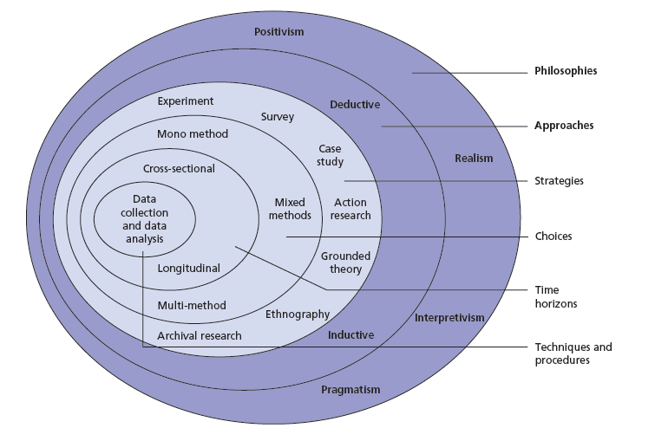

Figure 3.1: The Research Onion (Saunders et al, 2007)

3.2.1 Philosophy

Following specific research philosophy refers to a set of beliefs concerning the nature of what's being investigated (Bryman, 2012). The assumptions created by a research philosophy provide the justification for how the research will be undertaken (Flick, 2011). Research philosophy allows researchers to differ on how to achieve goals and provides methods to best achieve set goals throughout research (Goddard and Melville, 2004). The understanding of results found are influenced by the perspective of the person viewing them (Saunders et al, 2009). Thus, having appropriate knowledge of what is being investigated can help the researcher with the choices they make throughout their research (May, 2011).

Both positivism and interpretivism were considered as valid research methods for this project. Interpretivism aims to understand the lives of participants to gain knowledge on why they make the decisions they make. In most cases the method prefers qualitative data which allows for close interaction with correspondents (Myers, 2008).
On the other hand, positivism explains that generally actions can be explained through social norms taking into consideration factors such as gender, age, social class, and ethnic background. The method places vital emphasis on quantitative data with the use of surveys, official statistics, and questionnaires. However, this ensures that the researcher is detached from correspondents (Thompson, 2015).

The research method didn’t want to be held back by picking one of the other instead, it chose the philosophical viewpoint of pragmatism which places an emphasis that there is no right or wrong way of research, instead it tries to balance both methods to achieve both qualitative and quantitative data.

3.2.2 Approach

There were two approaches that were considered for this project, deductive and inductive. The deductive approach forms arguments upon pre-existing theories and then formulates the research to test whether the theory supports its viewpoints (Silverman, 2013). This approach best suits contents where the research project is concerned with examining theory and whether it fits expectations based on previous research that the researcher observes (Wiles, et al., 2011).

The inductive approach is characterised by the switch from specific to general where quantitative data is of importance (Bryman and Bell, 2011). The method avoids the use of theory which can be of benefit by avoiding researcher bias.

It was decided that the best method would be the deductive approach as due to the nature of the research, theory would play an essential role in establishing knowledge of topic, formation of arguments and providing different perspectives into the research topic to create a balanced argument on whether criminals are born or made.

3.2.3 Research Strategy

The research strategy will consist of methods to gather and analyse data. The idea of interviews was considered as a strategy however, Saunders et al. (2009) argued that surveys were the best method to use when aiming to gain quick responses and are easily analysed efficiently. Thus, a survey was the chosen method of research strategy.

The survey in this project will be created through Google Forms where a link will be provided to the public where they can access the survey. Social media platforms such as Facebook, Twitter and snapchat will be used to ensure the survey reaches a wide variety of audiences. Facebook is a great tool when publishing the link to the survey due to its sharing capabilities and its ability to quickly reach audiences outside my own reach. The survey will remain completely confidential, brief and should not take the participants long to complete. After the introduction the participant will be asked to complete nine questions based on the topic of the research method.

The introduction of the survey will explain to the participant the purpose of the survey and how the data provided will be used. In the introduction the participants will also find the disclaimer of confidentiality before they proceed to answer any questions.

3.2.4 Choice

The choices within the research onion include mono method, the mixed method and the multi method (Saunders et al., 2007). The mono method includes using one for the study such as sticking to quantitative data for research. The mixed method uses multiple research methods which enables the researcher to create more varied datasets (Flick, 2011). The multi method approach is where the research is divided into separate segments and then each segment is evaluated with the use of qualitative or qualitative data (Feilzer, 2010). For the purpose of this research the mixed method was used as it ensured that the research was well balanced and enabled was in benefit when avoiding researcher bias.

3.2.5 Time Horizons

The Time Horizon is the framework within which the project is intended for completion (Saunders et al., 2007). Two types of time horizons are specified within the research onion, the cross sectional and the longitudinal (Bryman, 2012). The cross-sectional time horizon explains that data must be collected whereas the longitudinal time horizon collects data over a large period of time where change of views in time on the topic is of utmost importance (Goddard and Melville, 2004) which benefits the study when looking at change and development. However, due to the nature of this research it was concluded that the cross-sectional time horizon was the more beneficial method to use as the study cannot rely on data from the survey being collected over a long period of time.

3.3 Ethical Considerations

Ethics are a vital consideration as they provide the very essence of integrity of any research undertaken. Ethics in research help the researcher stick to their aims and objectives which ensures that the researcher achieves the goals they set for their research (Resnik, 2015) which also enables the researcher to understand the moral and social values from all backgrounds.

An ethics form will be completed before any research takes place to ensure that the researcher fully understands the ethical values they must follow. The form will provide the aim of the research as well as outlining how data will be collected throughout the research. In addition, every individual who participates in the survey will be informed of the anonymity and confidentiality to ensure that they can confidently answer any of the questions within the survey based on their beliefs. This ensures that the research has integrity and respects individuals who chose to participate.

3.4 Limitations

The main limitation of this research was the ongoing Covid-19 pandemic which prevented any ability to take the survey to the streets and meet the participants to gain an understanding of what audience has an interest in the study. This would have given the data that would have been evaluated to understand whether views have shifted over time when comparing the younger generation to the older generation. Thus, the survey had to be completed in an online setting which is actually beneficial as it maintains anonymity which can make individuals feel freer to answer the given questions. Anderson and Mayer, (2019) suggested that when anonymity is given participants of any research survey have more confidence to answer questions and allows the research to avoid any demographic bias such as gender, age, race etc. as the survey is voluntary.

3.5 Conclusion

Chapter three has established the following objective:

“To understand the implications of the research, making reasonable recommendations for future research and social practices.”

This chapter has helped establish the appropriate paths for the research that will be undertaken. Following the guidance of the research onion (Saunders et. al, 2007) the research will be integral and contain full confidentiality of all participants during the survey that will be used to gather data from a public sample. The next chapter will analyse the data from the survey and discuss the findings and what they suggest.

4. Chapter Four: Data Analysis

4.1 Introduction

Following on from the methodology in chapter three, the next chapter will present and analyse the data gathered from the survey.

This chapter aims to achieve the second aim.
“To gather evidence through a publicly accessible questionnaire based on the topic discussed to form arguments using existing theories.”

A total of 82 responses were collected between the 15th and 30th of April. The survey consisted of nine questions excluding the declaration and the beginning of the survey. The survey was completed through Google forms as it allowed for a friendly user interface and for the researcher to use the tools at hand effectively to form an easy to read and answer questionnaire. The data was analysed using Google Sheets which converted the data into graphs and pie charts.

A total 45.1% of the responders were between 16-21 age mark, 34.1% were between 22-30 age range and 20.7% were aged 31 and over. These statistics suggest that the survey appealed more towards the younger audience which can provide views regarding the topic of discussion from the younger generations which can be used to gain a better understanding of public views. The fact that only 20.7% of the participants were aged 31 and over may suggest that older individuals may not have access to social media platforms which could have potentially influenced the trends in participants' ages.

In total 53.9% of the 82 participants identified as male, 40.2% were female and 4.9% were listed as “prefer not to say”. These statistics may suggest that the survey appealed more towards males as they consisted of the large majority who participated in the survey. A link that could be made to explain this could be the difference between male and female crime numbers. A survey into crime statistics in 2019 identified that in the UK, 85% of crimes were committed which led to arrests were male. Females made up the 15%, however, prosecution numbers leading to prison sentences found that men contributed to 95% compared 5% of females going to prison (Ministry of Justice, 2020)

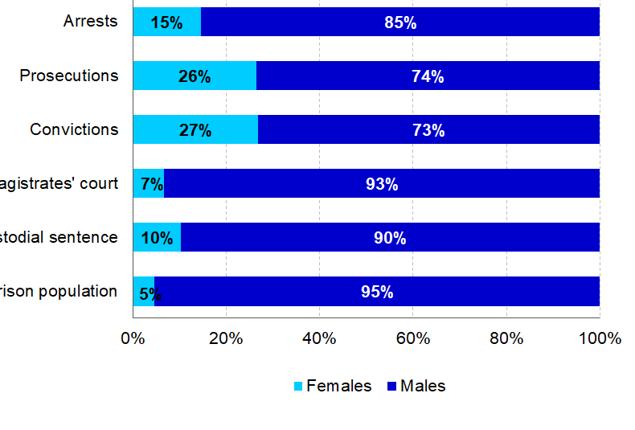

Figure 4.1- graph showing statistics of crimes committed by men compared to women

4.2 Data Presentation

The data presentation will follow on from question three from the questionnaire as the survey asked questions relating to the topic from question three and onwards. Within these questions the participants were asked to choose options based on how they agreed with the question asked. The data will be presented using charts created by Google Forms showing percentages of participant answers.

Q.3: Do you agree with the statement? ‘Are criminals born?
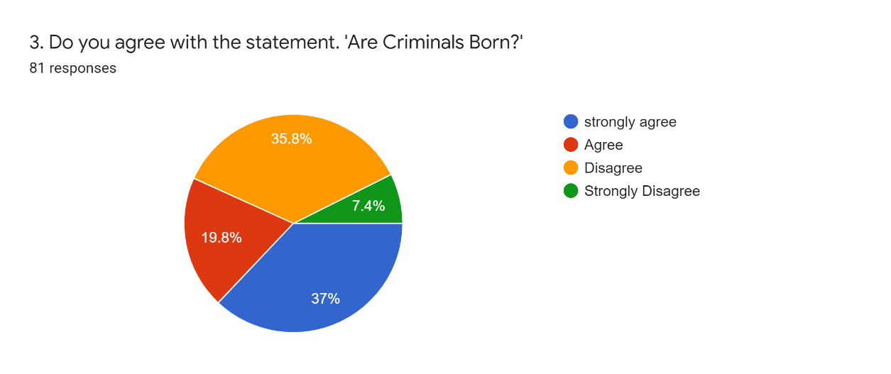

Figure 4.2: Graph Presenting Data Findings from Question 3.
Lombroso’s (1876) Biological Theory of Crime suggests that criminality is inherited and people who are “born” as criminals can be identified by their looks as discussed in the literature review. Lombroso argued that individual had bodily features which would identify them as criminals. However, the main criticism of Lombroso’s theory was that he didn’t care about ethical concerns. More often than not his research focused on ethnic minorities from poor backgrounds. Therefore, it does not come as a surprise that 35.8% disagree with the statement which would suggest that many people truly do believe that criminals cannot be born contrary what Lombroso would suggest. However, it is important to consider that technology and science has progressed compared to when Lombroso was arguing his theory which could have influenced the answers.

However, majority of the participants (37%) agreed with the statement which leans more towards Raines theory of how criminals can be born. Raine argues that criminal behaviour has biological roots as he believes that brain dysfunctions contribute to criminal and deviant behaviour (Raine, 2013). Thus, when looking at this question from the prospective that as Raine would describe “bad brains” do contribute to creating criminals it can be suggested that the public may have the same views as the argument is viable. Diseases such as schizophrenia we can find many correlations to crime. The central Swedish Police Register carried out research in 1971 into crime rate within individuals suffering with schizophrenia. The crime rate among male schizophrenics was almost the same as that in the general male population, whereas among females it was twice that of the general female population (Lindqvist, Allebeck, 2018).

Q4. Do you agree with the statement? ‘Are criminals made?’

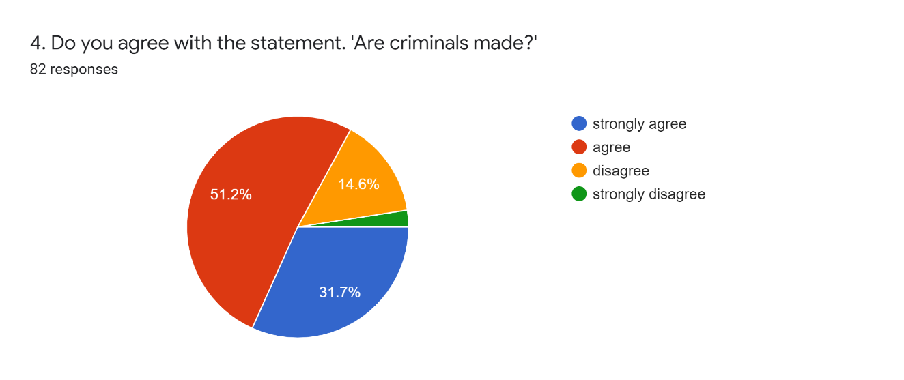

Figure 4.3: Graph Presenting Data findings from Question 4.

Out of the 82 participants 51.2% agreed with this statement which is more than the majority of the total participants in this survey. This suggests that the theory that criminals are made dominates modern society. It comes as no surprise that the majority of the participants agreed with the statement as advancements in psychology, medicine, technology, and science have given us a better idea of how people become criminals.

B.F Skinner (1948) used Thorndike’s law of effect theory to develop operant conditioning which suggested that individuals learn through reinforced behaviour such as pleasant consequences. In this case the gratification for some individuals may persuade them to commit crime for example that gaming console, or car you been dreaming of but can’t afford? Stealing it is an easy way of obtaining such items. The pleasant experience of accessing the item can result in individuals committing more theft offences and potentially to violent crimes. in 2020-21 there were a total of 1.9 million theft offences recorded by Police Forces across England and Wales (Clark, 2022).

However, 31.7% of the participants disagreed with the statement which comes in as a surprise as it suggests that many individuals who participated in the survey do not believe that criminals are made. This suggests that people do not believe that external factors such childhood upbringing, environment, society, friendship groups and many other external factors do not contribute to creating criminals. Modern criminal theories place a huge emphasis on environmental factors as the main contributing factors to crime which as mentioned is why the results from this question come in as a major surprise because many people can easily access modern arguments based around the Nature Vs Nurture argument through social media, internet, and other methods whereas older theories tend to be more difficult to access due to the times of their publication.

Q5. Can diseases such as dementia cause deviant/criminal behaviour?
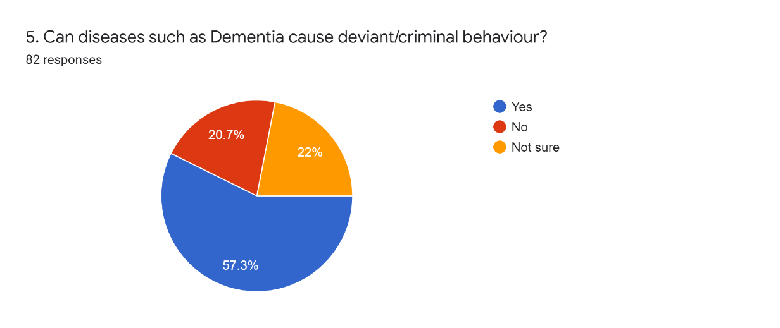

Figure 4.4: Graph Presenting Data Findings from Question 5.
In this question the participants were asked whether neurological diseases that essentially effect the function of the brain effect criminal behaviour. This question was chosen to see whether the public support the view of Raine (2013) and his argument that as mentioned brain disease do contribute to crime. A total of 57.3% of the 82 participants agree with the statement which suggests that the public do strongly agree with Raine’s theory without knowing the argument Raine suggests. This statistic supports the argument that criminals are in fact made as humans do not control their chances of suffering with neurological diseases if inherited.

The University of California conducted research with a sample of 2,400 individuals suffering with diseases that effected their memory such as Alzheimer’s disease. The study found that individuals suffering with frontotemporal dementia (FTD) showed that 37% individuals had committed a crime compared to the 8% suffering with Alzheimer’s disease (Crisis Prevention Institute, 2015). Therefore, official research is in line with public reviews based on the answers collected within this question. It is also, relevant to mention that 20.7% answered with ‘no’ and 22% were unsure which suggests that some participants would suggest other reasonings for criminal behaviour than diseases such as dementia.


Q6. In a few words why do you think people commit crime

Figure 4.5. Presenting Data Findings from Question 6.

In this question the participants were given the opportunity to describe in their own words why they think people commit crime. This was a great opportunity to see what the public views were in relation to the topic without being constraint by a specific choice answer. The participants were able to answer the question freely as they pleased. Unfortunately, the answers received were extremely vague and many participants chose not to enter too much detail with their answers potentially explaining their reasons behind their answers.

However, the most common answer that appeared the most was ‘lack of money’ which links to poverty and the social class structure. In today’s society people living in poverty tend to act the same, stealing food from food-counters, anti-social behaviour, violating loitering crimes are all linked to poverty (Gaille, 2016). Poverty tends to determine a certain stereotype in person’s thoughts as they do not see constructive solving of the problem. Instead, they seek the easiest way of making money and are in most cases willing to harm other people in their quest for money. Poverty is known to cause psychological complications such as making people depressed which can often lead to individuals feeling desperate to obtain what they want or need (UK Essays, 2018).

A particularly interesting answer that was mentioned was that “prisons are not a strong punishment; people are not scared to go to prison anymore”. This answer raises many questions as statistics suggest that black offenders had the highest rate of re-offending at 32.7% in 2018 based on re-offending in England and Wales (Gov.UK, 2021). However, official statistics show that between 2015-21 there were a total of 56.3 thousand white prisoners compared to 9.9 thousand black prisoners (Clark, 2021). When considering the reoffending numbers, it can be suggested that prisons do not work as suggest by the participant in his answer as the success of rehabilitation is failing as up to 57% of incarnated individuals do reoffend (Thompson, 2016).

Q7. Do you believe that parenting styles can enforce criminal behaviour in youths?
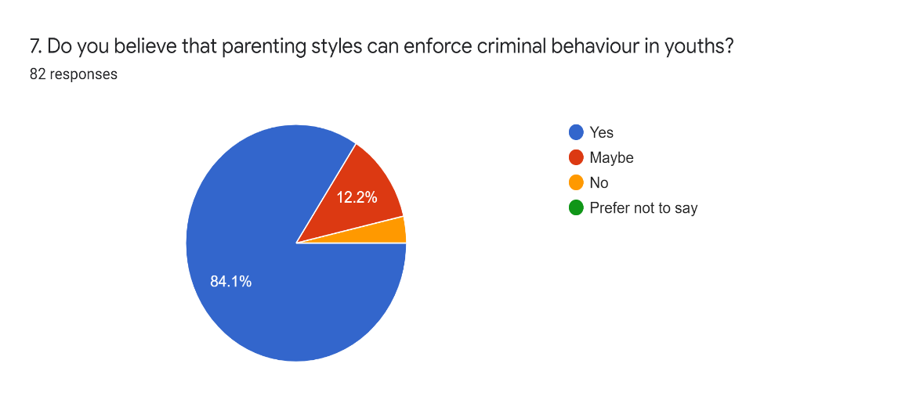

Figure 4.6: Graph Presenting Data Findings from Question 7.

This question aimed to understand whether there is a correlation between parenting styles and the shaping of criminals in their youth. It does not come as a surprise that 84.1% of all answers do agree with the fact that parenting styles can enforce criminal behaviour. A survey conducted by the Association of Teachers and Lecturers found that poor parenting and family breakdown was fuelling the rise in violent and bad behaviour amongst youths in the UK (Richardson, 2012). Parenting Orders were first introduced to England and Wales in the Crime and Disorder Act 1998 to tackle the issue of youth receiving Anti-social Behaviour Orders (Edge Hill University, 2016) thus, there are measures to ensure that parents are held accountable for the actions of their children. However, it is evident based on the answers from the survey that parents are responsible in shaping criminal behaviour among young individuals through bad parenting styles.

Q8. Do environmental factors shape criminals? e.g., friendship groups, financial status.
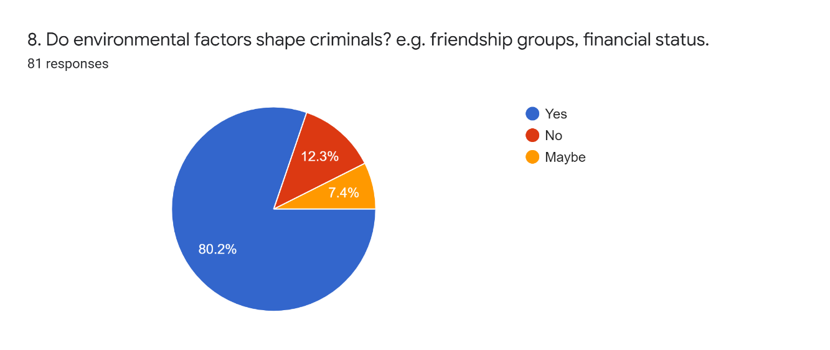

Figure 4.7: Graph Presenting Data Findings from Question 8.

This question relates to the argument that criminals are made and the answers from the participants would suggest that they agree with the prospective as 80.2% answered with ‘yes’ which showed that they do believe that environmental factors such as friendship groups and financial status to shape criminals. To highlight friendship groups, we can look at gang initiation rituals, as discussed in the literature review it was evident that in many cases individuals will commit horrific crime such as stabbings, gang rapes and robberies in order to be accepted into gangs. This can be considered as an environmental factor as the individuals seek acceptance from the particular gang they wish to join. Society creates gangs as a form of showing power and dominance in certain areas, gangs are not born they are made. Thus, it was to be expected that many would agree with the given question.

However, what comes as a surprise is that 12.3% answered with ‘no’ and 7.4% answered with ‘maybe’. This shows that some participants either disagreed or were unsure on the matter. For those who disagreed could it be recommended that they believe factors out of societies hands are the main reasons behind shaping criminals? This is the question this result raises and with its right to do so as criminologist such as Raine and Lombroso would suggest that criminals are simply born and whatever society does will not effect their nature to commit crime.

Q9. The researcher has chosen to leave this question out of the analyses as the question heavily relates to a question already covered and its in the best of interest of the data analyses to avoid repetition.

4.3 Conclusion

This chapter achieved the second aim.
“To gather evidence through a publicly accessible questionnaire based on the topic discussed to form arguments using existing theories.”

The final chapter will conclude the findings gathered in this paper and provide recommendation for the future.

5.Chapter Five: Conclusions and Recommendations

5.1 Introduction
The chapter of this research project looks to present the main findings of the main study and provide recommendations for both future research and social practices.
This chapter also aims to achieve the first objective. “To understand the implications of the research, making reasonable recommendations for future research and social practices.”

5.2 Main Findings
One of the main findings that this research has found was that generally the public are truly unsure whether criminals are made or born. Many of the answers gathered from the questionnaire provided a balanced argument to suggest that both cases are correct. The data unfortunately didn’t provide a clear understanding of the Nature Vs Nurture argument and its contribution to crime. However, it cannot be ignored that the data gathered helped to form arguments and provided academic theories to support their viewpoints.
Many of the participants however, agreed on the fact that social factors such as financial position were a heavy contributor to crime. In question six where the participants were given the opportunity to provide their personal opinions on why people commit crime, the answer of financial status dominated the spectrum. This would support the theory of Nature and how it shapes criminals. It is evident that financial status can contribute mental health, overall life satisfaction and the ability to stay away from crime. On the other hand, the survey provided a good steppingstone into understanding criminals from the public’s view as their answers were unbiased and pure due to the possibility of many participants lacking expertise knowledge.
Based on the findings from the literature review it was evident that certain theories do not hold up well in modern society. Lombroso’s theory of The Criminal Man was a perfect example of how theory can become outdated and lose its liability in swaying the argument direction of Nature. However, the work of Raine was of upmost importance in gaining an understanding of how criminals can be made. The Anatomy of Violence (2013) published by Raine provide the project with essential proof how neurological diseases and as Raine would call it “bad brains” can contribute to shaping criminals.
The research was used in great extent to form arguments and real-life example of cases with individuals suffering with brain diseases who committed crime were clear and obvious evidence that provided an understanding of how and why criminals can be born. In contrast the arguments to support the Nature side were evidently more relevant to modern society and its influence on criminal behaviour was evident within the research presented.

5.3 Recommendations

Using what has been learnt from the data and the conclusions that have been made, recommendations can be made for both future research and societal structures. Firstly, the biggest issue that arose was the fact that the sample within the survey was extremely poor at only 82 participants. This ensured that it was impossible to determine whether these views represented the views of the entire UK. Based on the sample numbers it was easy to have a majority on most answers which meant that potentially in some cases less than ten participants answered certain questions to the contrary of the majority. The issue this bough upon this research project was that with such small numbers, it was difficult to form conclusions and make suggestions to answer the research question.

In addition, the Covid-19 pandemic made it difficult to use different methos of sampling as the research project was burdened by the fact that the only available option was an online survey. This ensured that the researcher had to promote the research to the best of their ability however, as mentioned the numbers did not reach the expectations which was a major disappointed and a draw back for this research project.

Furthermore, more though should go into how societal factors effect criminal behaviour as the research available regarding the topic was vague and, in some cases, difficult to obtain. The dominant theories consisted of Classical, Operant Conditioning, Bobbo Boll experiment, Little Albert experiment which were all relevant to the research question however, it restrained the study from understanding different factors as the theories mentioned had many similarities in regard to their presentations and arguments suggested.

5.4 Conclusions
The final chapter has achieved the final objective:

“To understand the implications of the research, making reasonable recommendations for future research and social practices.”
The research project has completed all of its aims and objectives.
This concludes the research project.

Bibliography
Agnew, R., (1992). Foundation for a general strain theory of crime and delinquency. Criminology, 30(1), 47-88.
Anderson, K. and Mayer, L. (2019) Findings from Formative Research to Develop a Strength-Based HIV Prevention and Sexual Health Promotion Health Intervention for Transgender Women. Transgender Health, 4(1), pp.350-358.
Barber, N., Ph.D. (2009) Crime as a brain disorder. Did his brain make him a killer? Psychology Today. Available at: Crime as a brain disorder | Psychology Today

Brookes, E., (2021). Cesare Lombroso: Theory of crime, criminal man, and atavism. Simply Psychology. Available at: www.simplypsychology.org/lombroso-theory-of-crime-criminal-man-and-atavism.html
Bregman, E. O. (1934). An attempt to modify the emotional attitudes of infants by the conditioned response technique. The Pedagogical Seminary and Journal of Genetic Psychology, 45, 169-198
Bryman, A. (2012). Social research methods (5th ed.). Oxford: Oxford University Press
Bryman, A., & Bell, E. (2011). Business Research Methods (3rd ed.) Oxford: Oxford University Press.

Bolles, R.C. (1993). The story of psychology: A thematic history. Pacific Grove, Calif.: Brooks/Cole Pub. Co. Christian, K.M. & Thompson, R.F. (2003). Neural substrates of eyeblink conditioning: Acquisition and retention. Learning and Memory, 11,427--455.
Butcher, B., Schraer, R.,(2019). How do we know how many children are in gangs? BBC news. Available at: How do we know how many children are in gangs? - BBC News
Clark. D., (2021) Crime in the UK- Statistics & Facts
Available at: Crime in the UK - Statistics & Facts | Statista

Clark, D., (2022) Number of police recorded theft offences in England and Wales from 2002/03 to 2020/21. Statista. Available at:• Theft in England and Wales 2021 | Statista

Clark, D., (2021) Number of prisoners in England and Wales 2015-2021, by ethnicity. Statista. Available at:• England and Wales prison population by ethnicity 2021 | Statista
Crisis Prevention Institute, (2015). Are Persons with Dementia Responsible for Crimes they commit? Available at: Are Persons With Dementia Responsible for Crimes They Commit? (crisisprevention.com)
Craig, A., (2001) Age Patterns of Victims of Serious Violent Crime. Bureau of Justice statistics. Special Report. U.S. Department of Justice.
Available at: Age Patterns of Victims of Serious Violent Crime (ojp.gov)

Coyne, M., Wright, J. (2013) Nature Versus Nurture. Oxford Bibliographies.
Available at: Nature Versus Nurture - Criminology - Oxford Bibliographies

Coyne, M., Wright, J. (2013) Nature Versus Nurture. Oxford Bibliographies.
Available at: Nature Versus Nurture - Criminology - Oxford Bibliographies
Ebstein R. & Belmaker R.H. (2002). Genetics of Sensation or Novelty Seeking and Criminal Behaviour. In, The Neurobiology of Criminal Behaviour, ed. J. Glicksohn. pp. 51-80.
Edge Hill University, (2016). Parenting Orders and the criminalisation of parenting. Available at: Parenting Orders and the criminalisation of parenting - Law & Criminology (edgehill.ac.uk)
Ellwood, C., (1912). Lombros’s Theory of Crime. Journal of Criminal Law and Criminology. Volume 2, Issue 5, Page 4.
Feilzer, M. Y. (2010). Doing mixed methods research pragmatically: Implications for the rediscovery of pragmatism as a research paradigm. Journal of Mixed Methods Research, 4(1), pp.6-16.

Flick, U. (2011). Introducing research methodology: A beginner’s guide to doing a research project. London: Sage.

Flick, U. (2011). Introducing research methodology: A beginner’s guide to doing a research project. London: Sage.

Fridlund, A. J., Beck, H. P., Goldie, W. D., & Irons, G. (2012). Little Albert: A neurologically impaired child. History of Psychology, 15, 302-327. doi: 10.1037/a0026720

Gaille, L., (2016). How Poverty Influences Crime Rates. Personal Finance Blog. Available at: How Poverty Influences Crime Rates – Vittana.org

Gibson, M., Rafter., N (2006) Criminal Man-with translation assistance from Mark Seymour. Duke University Press. Durham and London. Page 20.
Goddard, W. & Melville, S. (2004). Research Methodology: An Introduction, (2nd ed.) Oxford: Blackwell Publishing.

Gov.UK, (2021) Reoffending. 1. Main facts and figures. Available at: Reoffending - GOV.UK Ethnicity facts and figures (ethnicity-facts-figures.service.gov.uk)

Hayward, K., Maruna, S., Mooney, J., (2010). Fifty Key Thinkers in Criminology. United Kingdom: Routledge.

Ishikawa, S.S. & Raine A. (2002). Behavioural Genetics and Crime. In, The Neurobiology of Criminal Behaviour, ed. J. Glicksohn. pp. 27-50.

Keenan, K., & Shaw, D. (1997). Developmental and social influences on young girls’ early problem behaviour. Psychological Bulletin, 121, 95-113.

Klatt, T., Hagl, S., Bergmann, M.C., Baier, D.,(2016) Violence in youth custody: risk factors of violent misconduct among inmates of German young institutions. Eur. J. Criminol. 13 (6), 727-743

Lindqvist, P., Allebeck, P., (2018) Schizophrenia Follow-up of 644 schizophrenics in Stockholm. Cambridge University Press. Available at: Schizophrenia and Crime | The British Journal of Psychiatry | Cambridge Core

Liljegren, M., Naasan, G., et al. (2016) Criminal behaviour in Frontotemporal Dementia and Alzheimer Disease.
Available at: 10.1001/jamaneurol.2014.3781

Little, B., (2019) What Type of Criminal Are You? 19th- Century Doctors claimed to know by your face. The now-debunked “born criminal” theory was highly influential in criminology circles.
Available at: The Dark Origins of Criminology and ‘Facial Recognition’ - HISTORY

Mazzarello, P., (2011). Cesare Beccaria:An anthropologist between evolution and degeneration. Functional Neurology, 26(2), 97-101.
Available at: http://search.proquest.com/docview/947561454?accountid=17074
Maslow, A. H. Motivation, and personality. New York: Harper, 1954.
May, T. (2011). Social research: Issues, methods, and research. London: McGraw-Hill International.
Mcleod, S., (2021) Classical Conditioning: How it works with examples. Available at: Classical Conditioning: How It Works With Examples | Simply Psychology
Myers, M.D. (2008) Qualitative Research in Business & Management, SAGE Publications
Ministry of Justice, (2020). National Statistics. Women and the Criminal Justice System, 2019. Available at: Women and the Criminal Justice System, 2019 - GOV.UK (www.gov.uk)
Michigan Law Review, Born to Crime: The Genetic Causes of Criminal Behavior, 83 MICH. L. REV. 1218 (1985). Available at: https://repository.law.umich.edu/mlr/vol83/iss4/57
Peckham, R., (2014) Disease and Crime. A history of social pathologies and the new politics of health. Routledge, New York, Page.192

Piercy, L., (2019) UK Researcher Unravels Serial Killer Ted Bundy’s Mental Health. University of Kentucky. Available at: UK Researcher Unravels Serial Killer Ted Bundy's Mental Health | UKNow (uky.edu)
Raine, A., (2013) Anatomy of Violence: The biological roots of crime, vol 3.1, Pp 174-75 broken brains
Raine, A., (2013) The Anatomy Of Violence. The Biological Roots of Crime. United States, Pantheon Books, Page. 47
Resnick, D. B. (2015) What is Ethics in Research and Why is it Important? List adapted from Shamoo A and Resnik D. 2015. Responsible Conduct of Research, 3rd ed. (New York: Oxford University Press).
Richardson, H., (2012). Poor parenting ‘fuels rise in violent behaviour’. BBC News, London. Available at: Poor parenting 'fuels rise in violent behaviour' - BBC News
Rowe, D., Vazsonyi, T., Flannery, D., (1995) Ethnic and Racial Similarity in Developmental Process: A Study of Academic Achievement. Available at: https://doi.org/10.1111%2Fj.1467-9280.1995.tb00301.x
Saunders, M., Lewis, P., Thornhill, A. and Bristow, A. (2019) Research Methods for Business Students. 8th ed. Pearson, pp.128-171.

Saunders, M., Lewis, P., & Thornhill, A. (2007). Research Methods for Business Students, (6th ed.) London: Pearson.

Saunders, M., Lewis, P. and Thornhill, A. (2009) Research Methods for Business Students (5th ed). Essex, England: Pearson Education Limited.
Silverman, D. (2013). Doing Qualitative Research: A practical handbook. London: Sage.

Skinner, B.F. (1935). Two types of conditioned reflex and a pseudo-type. Journal of General Psychology, 12, 66-77. Smith, S., & G
Sutton, G., (2006). The brain and crime. University of Nottingham.
Available at: Catalyst_26_3_the_brain_and_crime.pdf (stem.org.uk)

The Scottish Center for Crime and Justice Research. (2015) What is Crime? University of Glasgow, School of Education.
Available at: SCCJR-What-is-crime.pdf

Thorndike, E., Bennard., F.E. (1944) Criminal Man According To The Classification Of Cesare Lombroso. Lombroso, Gina, 1872-1944. Knickerbocker, New York. Page. 15.

The Independent, (2011) Inside the dark world of the gang initiation ceremonies. Available at: Inside the dark world of the gang initiation ceremonies | The Independent | The Independent
Thompson, K., (2015) Positivism, Social theory (A2) Anti-positivism, interpretivism, positivism, qualitative, quantitative, research, sociology. Available at:Positivism and Interpretivism in Social Research – ReviseSociology
Thompson, K., (2016). Does prisons work? Revise Psychology. Available at: Does Prison Work? – ReviseSociology
UKEssays. (November 2018). How does Poverty Cause Crime? Available at: https://www.ukessays.com/essays/criminology/how-does-poverty-cause-crime-criminology-essay.php?vref=1
Valentine, C. W. (1930). The innate bases of fear. The Pedagogical Seminary and Journal of Genetic Psychology, 37, 394-420.
Watson, J. B., & Rayner, R. (1920). Conditioned emotional reactions. Journal of experimental psychology, 3(1), 1.
Watson, J. B. (Writer & Director). (1923). Experimental investigation of babies [Motion picture]. Chicago.
Wiles, R., Crow, G., & Pain, H. (2011). Innovation in qualitative research methods: a narrative review. Qualitative Research, 11(5), pp.587-604.

Appendices

Appendix. 1- copy of questionnaire









Appendix.2 – Ethics Form










































