

Assignment Title:
Understanding and Engaging in the Customer Experience

Student name- Zafar Ahmed Sadik
Student No- 1605839
Module Name- Understanding and engaging in the customer experience
Module Tutor- Yajesh Kumar

Executive summary:
Customer service is the most important part for an organisation. In this module describes about eth customer, their needs and experience and they impact over business process. this module will help to understand the needs and impact on organization. This module is very helpful for understanding the customer and customer experience. After studying this module, we will be able to get involved in decision making about how to increase customer value, how to promote products and take decision to sell the products. Each customer wants high customer value from products. Nestle company provides foods to customers with high quality and it is important for learners to understand how an orgznational provide customer experience and fulfil their expectations.

Contents
Introduction: 2
1) Critically analyses the factors that influence your organizations ability to maximize customer value. 2
2) Identify the systems that supports your organizations quality processes and provide a critical understanding of the extent to which you think those systems are effective in meeting customer requirements. 8
Conclusion: 13
References 14

Introduction:
Every organization focuses on customer, customer needs, their preferences and value for increasing their satisfaction. Customer experience bases in several issues like customer value, service, buying decision and quality of products, every organization must maintain quality of products for increasing satisfaction. Busying decision bases on ethical factors to ensure sustainable growth of organization and increase customer loyalty, nestle is food relating organization delivers several types of products and largest organization. (Christopher, 1979) It also helps us to develop long term customer-supplier relationship. From this concept, we will be able to understand customer needs and engage in customer experience.

1) Critically analyses the factors that influence your organizations ability to maximize customer value.
Customer service means the system where an organization provides high level of customer satisfaction by providing value of a product. It is a caring process where organization focuses on customer preferences at the time of buying, before buying and after buying though quality service. Customer service can be repurchasing, feedback and returning products after sales. Nestle sells foods, blotted products and others and it has direct interaction with customers so, it needs to provide customer service to increase satisfaction of customers. (Duteurtre and Benderson, 2008) Nestle uses several methods of providing service like software, phone call, self-service method, in-person system etc. Customer service refers to the method of providing after buying and consuming products. It depends on the employee behaviour and components of service like pricing. So, nestle company provides training to employees to increase skill to provide better service to customers after sales. From this point of view, it is clear customer service is necessary for organization for increasing customer satisfaction which converts them as its profit. Several features include in customer service. Nestle focuses on customer service to increase their satisfaction over their products and service which moves Nestle towards high profit and market position. Nestle provides their products when customers want to get and it helps Nestle to increase customer value. Nestle also focuses on to reduce the errors and cancel order as well as delay. Nestle provides training to employees to behave polite way with customers. Nestle also focuses on sales representatives for increasing their performance with good manner with customers. Nestle know if sales person behaves politely, it will attract customers for purchasing products. (Fuchs, 2001) Organization should behave professionally with customers. Nestle treated customers professionally and care them to increase value to products. Nestle focuses on the personalization of customers for increasing their intension over organization and its products. Personalization helps Nestle to use skills of customers over service. Nestle always try to deliver products within time without any delay for increasing customer’s satisfaction. It helps Nestle to reduce the feedback about products and its services and moves to the better positon increasing profit. (Solomon, 2012) Nestle focuses on use of knowledgeable employees in service and can easily identify the needs, preferences of customers for sustainable position over market. Customer service provides Nestle in the best market position in the world.

Customer centrality refers to the process of delivering products and services to customers which help organization to provide high level of experience at the time of buying, before buying and after consuming products. (Garber, 2005) It is a holistic approach where customers get value from products. Organization works not only for satisfying the customers but also wants to increase their loyalty and produce products based on customer’s needs. Nestle provides several foods to customers and needs to focus on their needs and their satisfaction. As customer’s preferences always change, nestle ensures how to understand their needs and provides customer centred products to increase their satisfaction. Nestle has focuses on several elements for being customer-centred product and these are:
First of all, nestle focuses on to identify the customers and understand their preferences to produce and deliver products. After producing customer-centred product for Nestle, creates experience of customer for increasing satisfaction. Because if Nestle can be customer-centred, it will be able to increase its production. Then Nestle focuses on using several metrics to measure and evaluate the preferences and their satisfaction from the products. (Machado, 2016) Finally, nestle empower their employees to identify the needs of customers and understand the preferences to provide a customer-centric experience. From this view, customer will be satisfied and increase competitive position for Nestle company.
So, nestle company always focuses on hardworking and training to employees for providing experience to customers and provides enjoyable products. So, nestle develops a plan based on customer centred products. Before going to develop business plan of Nestle about customer, it focuses on the feedback provided by customers. In the business plan of Nestle company, it ensures how it will satisfy their target customers. (Machado, 2016) Nestle provides child food products which increases its sales than products. So, it focuses on evaluation of customers based on age and produce products for their targeted customers. After knowing the customers, nestle will be able to understand what they need to produce and how they will get market position. So, customer centrality is essential for Nestle company.

Customer value refers to satisfaction about a product or service in return to the cost of product or service. If the satisfaction level is higher than its cost, it means the product has high value to customers. Customer value must be higher for an organization to increase sales. If customer value is high, it will help an organization to increase its sales and provide greater benefit to the organization. (Overton, 2007) Nestle focuses on customer value to increase its sales. Customer value creates CRM within organization. There are several factors impact on customer value like sourcing, operations, sales, customer service etc. all functions relate to managing organization need for providing customer value. Higher the customer value, higher customer satisfaction. Value comes from perception of a customers. Customer value is important for customers to compare with other products of competitors. Nestle focuses on customer value for reducing switch customers from their products and increase their loyalty. Nestle measures customer value for understanding customer’s satisfaction and future sales estimation. To identify the value, nestle identifies benefits and cost from the products and then measure value. (Overton, 2007) Here, benefits divided by cost to measure value of customer from products. Value can be different based on identical and differentiated products for Nestle. To measure the value of customers, nestle focuses on several drivers and they influence the customer value and increase customer satisfaction.
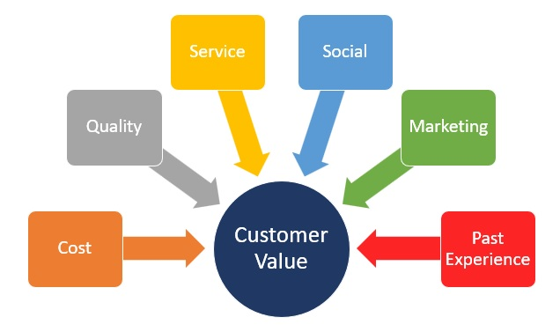
Source: (Pepper, 1993)
Nestle provides differentiated products based on customers which increase high customer value. Because differentiated products help to attract customers and increase satisfaction. If the quality of product and service is high, it provides high value for customers. Nestle tries to provide quality products for providing high value. Price also helps to provide high vale. Some customers want quality products and low price. (Pepper, 1993) But few wants value by providing high cost. Customer service provides high customer value because if the service provides in different time, it increases value of customers. Marketing increasing customer value by operating all activities for customer satisfaction. Brad products also provide high customer value. So, nestle focuses on managing marketing activities and managing high band in their products. CRM has strong influences over customer value. Because if CRM exist in organization, it will increase sales, service and experience. Finally, it will impact on the value of customers. (Starbird and Cavanagh, 2011)

Value and purpose of customer relationship management (CRM).
Customer is the key person of an organization. The main goal of an organization is to attract customers towards their products and satisfy them in terms of value. Another target for organization is to build up long term relationship with customers to make them loyal. Customer relationship is the process where organization uses strategies, tools, and technologies for managing customers and increase their interaction to the organization from the starting of value gaining and providing high level of customer service to increase their satisfaction. (Rokes, 2002) So, it is the system where organization tries to provide value to customer to develop customer relationship. Nestle provides food products and focuses on quality of service to satisfy their customers. Because Nestle wants to increase customer satisfaction throughout the customer lifecycle and develop customer relationship. Customer relationship management has great value over the market. CRM is like an investment for an organization. This relationship provides value to Nestle company. Several values are showing here:
Improved informational organization: Organization needs to know about their customers to provide superior value to them. Nestle focuses on understanding the customers for providing them value and it will help Nestle to increase profit. For increasing value for Nestle, it uses advanced technology and sticky notes for identifying customers and allocate data about them to identify their needs. (Rokes, 2002) From identification of customers, nestle will be able to target customers and reduce time of delivering products which customers want. CRM helps to enhance communication among customers, employees and organization. After getting data, employee can understand about customer and segmented those data for providing service. Nestle can easily contact with single and multiple customers at a time by CRM. CRM also understand about how to communicate with customers and provide service to satisfy them. So, nestle uses cloud-based method for identifying the communication ay through internet throughout world. CRM helps Nestle to improve customer service.
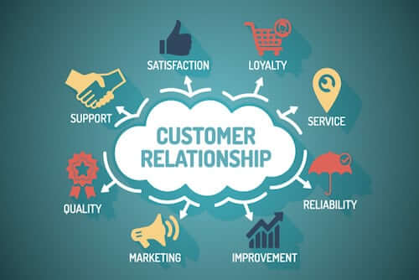
Source: (Shelton, 1998)
If CRM includes in the marketing function, it helps to provide high level of service for customers to satisfy them. Customer service will improve if organization can understand the needs, preferences of customer before and after purchase. (Shelton, 1998) CRM includes good involvement among customers and organization. Nestle can easily understand the needs of customers though contacting with them and provide service and reduce losing customers. Automation of activities help an organization to understand the customers through tracking their information. So, it reduces the manual task of organization. As Nestle has strong product line it needs to maintain all automatically to increase efficiency. So, CRM helps to track customer’s information, analyse their needs, track feedback. Improving data analytics and reporting, CRM also helps an organization to identify data needed for organization and experience for customers about products. CRM stores information about customers and mining data to take experience about customers. After miming, nestle makes report about data to provide value to them. (Shelton, 1998)

Purposes of customer relationship management:
Nestle company focuses on CRM for increasing their sales and growth rate through satisfying their customers. There are several reasons behind managing customer’s relation of Nestle. They are-
Customer details: Nestle can identify the information about customer like customers’ needs, age, contact number, email and address etc. Nestle has website which helps it to track customer personal information through software and authorization. It will help nestle to loss customers in future.
Ownership Responsibilities: CRM also helps to understand the responsibilities of each stakeholders working in the organization like customers, employees, sales representatives, managers etc. It helps Nestle to identify roles and distribute to provide high value.
Deal Information: CRM also helps Nestle to track information need for ordering and delivering products. (Shelton, 1998) To provide products within time, nestle maintain some mathematical analysis. CRM helps to provide how to manage customers.
Interactions & Progress: CRM also helps Nestle to track customers and their needs. Tracking customers is complex task and Nestle promotes products through several ways and CRM helps to provide information about products to customers. Nestle use contact information to promote products with customers.
Action Items: Finally, it helps Nestle to tale actions when they need to track customers. If any sales representative makes mistakes about delivery, CRM will help to provide information and reduce losing customers

Buyer seller relationships
Buyer and seller relations hip has strong influence over customer service in an organization. Most of the organization tries to develop a positive customer-seller relationship which indicates high customer service. Buyer and seller relationship exist in marketing function. Long term buyer-seller relationship improves the value of organization. Buyer seller relationship also impacts on psychology which moves a customer to get superior value from organization. In e-commerce perspective, buyer-seller relation has developed for better connectivity among customers and organization. Most of the organization focuses on how to provide better service and it needs good relation with buyers. (Welsh, 2008) Buyer and seller relation relates with a cycle which includes several methods. A buyer also wants to develop long term relationship with sellers to get value from organization. Value and relationship depends on each other. This relationship doesn’t develop in a day. It needs long time to develop. Nestle use several technologies to track customer information to develop relationship. There are several ways used in buyer-seller relationship and they are describing based on technological and traditional way of business for Nestle company.
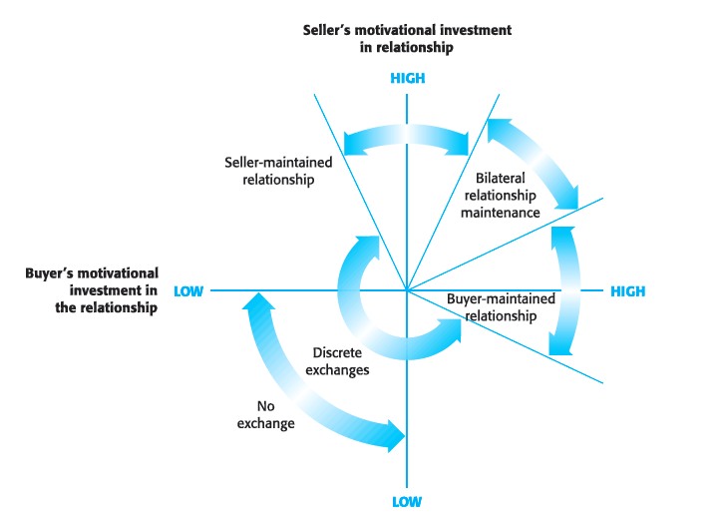
Source: (cosimoaccoto.com/2013/03/04/relationship-investment-buyer-and-seller)
Transactional relationship is the relationship when buyers and seller meets for transaction not regular basis. Nestle company faces their type of relation hip for higher competition in online business and retailing business. In recent markets, there are various competitors of Nestle exist like Amazon, Walmart etc. it increases transactional relationship. But Nestle faces little complexity over market. Seller gets priority over making decision about products and services. Nestle provides low price foods to customers to develop long term relationship with buyers. Value added relationship is another type of relationship between seller and buyer where buyer and seller exist at moderate level in the market. The main target of this relationship is to fulfil the customer demands and satisfying them to increase value. Nestle focuses on how to fulfil customers need to increase value. (Welsh, 2008) Seller of Nestle wants to increase their market share and get string market position. Collaborative relationship is the contract between buyer and seller where they develop relationship based on trust and commitment. Both wants to increase length of this relationship because of getting value. Buyer don’t have much choice or seller in the market and they want to continue it for a long time. (Welsh, 2008) Seller continue it for increasing their profit from loyal customers. Nestle can easily understand customer needs and can use several delivery methods like home deliver, online ordering etc.

2) Identify the systems that supports your organizations quality processes and provide a critical understanding of the extent to which you think those systems are effective in meeting customer requirements.
Quality module is the tool which indicates how to measure the performance of a product or service and track communication way to fulfil all requirement. Quality module is important for organization for understanding the performance of product or service. Several modules related to quality management for an organization. Quality module indicates certification of a product. It measures the value of a product. Every product must be internationally recognized for proving them to customers. Quality standard is the international method of identification and certification of a product. Several international standard of product exist in market such as ISO 9001, ISO 22000:2002. (Digital Sense, 2015) All those standard focuses on the quality of foods for Nestle. Quality and safety ensures by quality standard. Nestle focuses on foods and safety issues for ensuring the quality of foods deliver to consumers. WHO and UNFAO also provide rules about food safety and quality. Nestle must follow those to ensure quality of foods for children health. Nutrition must need to ensure by standard quality. (Gad, 2015) Several NGOs and government of UK provide rules for ensuring high level of quality in food producing for consumers.
Appreciation of the importance of quality control
Quality must improve to increase value of customers. In quality control, organization needs to focus on ethical and sustainable improvement of customers. Nestle focuses on ethical issues in improving product quality. In food product quality must improve to satisfy customers. Nestle also need to focus on sustainable improvement of quality. (Goodman, 2012) Quality must control for increasing customer satisfaction. Nestle is a retailer of food products and it needs to control its quality. First of all, nestle focuses on the use if one approach to ensure quality of foods. If any organization maintains quality control, it will help to measure the performance of products. We can easily track the quality of team working for providing value of customers. As nestle ensues quality improvement, it needs to production process and follow one process for tracking the performance of employees. One approach helps Nestle for using appropriate policy in production which ensures quality of products. So, nestle focus on monitoring the team, analyse production process and delivery methods for improvement of quality of foods like milk, bottled foods etc. Nestle can use quality management ream to increase quality. To improve the quality of food for Nestle, it needs to follow ISO. ISO 9001 describes about the quality of foods and how to ensure sustainable quality for foods. Nestle promotes certified foods to the market to measure heath issues and reduce unethical behaviour with customers. (Goodman, 2012) ISO helps to ensure high quality management for Nestle and gaining customer value. Supply chain also impacts on the quality of foods for Nestle.

Source: (Gad, 2015)
To ensure the quality of foods, nestle must use quality raw materials in production. So, managing suppliers is another issue for maintaining quality. To manage suppliers for raw materials, nestle have to focus on monitoring and applying inspection in each stage of raw materials. Nestle collects raw from external suppliers and needs to follow ISO standard for identifying their quality of raw. Auditing can be another issue to measure the quality of suppliers and their raw materials. So, nestle ensures to focus on poor performance, newer suppliers, improvement of quality of raw materials etc. Production process must improve for improving quality of foods for Nestle. Nestle uses skilled employees in production of foods and servicing to customers. (Gad, 2015) So, it is important for them to look at quality of production, nestle provides training to employees to improve quality of foods. So, development of new product is crucial part for nestle to launch it to market. As Nestle want to launch new child products, nestle has to follow the production process and how employee follow the quality method. So, maintaining quality is long process and Nestle focuses on the quality management to increase customer value for Nestle.

Buying decision making process:
Buying decision making process is very important for understanding the needs of a customer and how to fulfil their needs. Every organization ensures a process to fulfil, customer needs. Going the understand and maintain buying decision process, organization must focus on several ethics and sustainable trade sides which influence over buying decision. buying decision also important for nestle as it is food related organization. So, it needs to maintain several nutrition issues, sustainability and ethical issues for ensuing higher product value. Ethical responsibilities must ensure to foods for reducing risk of health of customers after consuming foods. Seasonality impacts on the busying decision for customer. Customers preferences change based on season. Environmental factors also influence over buying decision. if customers get positive environment in getting products and sellers get favourable environment to provide products, it will increase buying. But negative influence of environmental factor decrease buying decision. if customers face product packaging based on polythene, it will decrease its selling. Nestle should produce products based on welfare of animals. If product doesn’t provide welfare of animals exist in the earth, it will reduce selling for Nestle. (Leboff, 2016) On the other hand, nestle should use new resources in production to ensure quality of products and maintain sustainability in quality. Nestle can use skilled employees, provide training to understand their responsibilities. But if they don’t know about the use of resources in quality., it will decrease buying decision of buyers. So, nestle must use new resources and reduce using non-renewable resources. Trade also impacts on the buying decision for buyers. Nestle must need to follow appropriate trade policy to sell products. If Nestle use unfair trade issue, it will increase conflicts and customers will get dissatisfied and reduce satisfactory level which decreases its sales. So, buying decision is based on far trade policy. UK trade policy is appropriate and Organization should use this for increasing sales. Nestle should deliver products not only from outside suppliers but also it has to use local supplier to ensure ethics in market. because all parties have rights to get facility from market. If customer know that Nestle provides product from local suppliers, it will increase attraction among buyers and increase selling and buying decision for consumers. (Leboff, 2016) Waste management is another important issue for consumers. Nestle provides product with low fat, proper packaging and maintain waste manager, supplying water in production maintaining proper rules and regulations. As Nestle focuses on reducing wastage from their organization, it increases customer’s attraction and increase buying decision for foods as their products maintain high quality. Buyer maintains a process for taking decision about purchasing products. Nestle also focuses on maintain process to understand the consumer buying decision. It has five stages that are describing here.
Needs identification: In this stage, buyer identifies the needs what they need to fulfil their demand. Here, buyer always wants qualitative produces and focuses on internal and external factors before identifying the needs. Based on season, Nestlé’s product and service is different. In summer, nestle provides cold drinks and ice-cream.
Information Search: In this stage, buyer searches for getting information about their needs and focuses on how to get information. They collect information about organizational and product from two sources like primary and secondary. They also focus on ethical issues before going to buy a product.
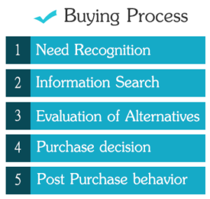
Source: (Leboff, 2016)
Evaluation of Alternatives: this stage relates with identification of several alternatives from data. Here, buyers focus on which product is appropriate based on several factors like seasonality, environmental favourable, quality, price etc. (Heinonen, 2015)
Purchase Decision: Here, buyer take decision about buying product which can fulfil the needs and satisfy them by providing value. Buyer also focuses on their income, price, benefits before going to purchase.
Post-Purchase Behaviour: In the final stage of buying decision for buyers, Buyers focuses on the value from products, if customers being satisfied after consuming products, buyer will purchase this product again and it will increase loyalty of buyers. (Reason et al., 2015)

Customer expects better quality with lowest price. One the other hand, organization tries to satisfy them by providing high quality products and gain profit. Appropriate use of relationship can provide value and fulfil customer expectation. Nestle always focus on how to fulfil customer needs and increase satisfaction level. (Metz, 2012) Nestle estimates about 70 percent or above customer are satisfied about their product for quality and price. So, nestle needs to maintain quality from beginning to ending to ensure customer expectations. B2B and B2C are two common methods used in delivering product. Nestle uses several strategies for managing customer expectations.
Open discussion for solution: Nestle know about their customer what they want, when they want and how to satisfy them. So, nestle opens a department of KMS for supporting customers to increase their satisfaction. (Metz, 2012) Nestle focuses on solution about problem of customers. Nestle openly discuss about problem of food products with customers which provides probable solution to Nestle. After finding out solutions, nestle empower their agents to increase production quality and solve problem. It increases value of customer’s and make them loyal.
Provide clear timeliness: For any kind of errors, mistakes and faults of foods can reduce customer expectation. To understand the customer expectation, nestle use software and track their information. To understand the clear needs of customers, nestle provides information to employees which to produce and how to produce to satisfy needs. Nestle gets information about products through phone call, open discussion and others way.
Ensures honest and transparency: To fulfil customer expectation, Organization must need to focus on transparency of customer needs. (Metz, 2012) Nestle and customers must trust each other. It will increase transparency in production and get positive customer experience about a problem. Nestle ensures sales representative has enough knowledge about products and customer behaviour.
Optimistic and realistic: These two concept are helpful for customer satisfaction. Optimistic helps Nestle to be positive over customer expectation. Realistic helps to understand the policies, processes and production to use customer needs. Nestle uses team to increase production and deliver products within time.
Follow up regularity: It is another strategy used by Nestle company for managing customer expectation. Nestle develops team for supporting customers and understand their expectation. Nestle maintain is a process where they focus on customer’s involvement in problem solving. (Leboff, 2016) Customers want best from organization to fulfil their needs. After communicating with customers, customers can understand the needs, solve the problem and empower clients to find out an optimal solution. Nestle manages its customers and expectation though this process and increase customer value.

Conclusion:
Customer is the key part of an organization. Organization needs to provide superior value to customers for increasing their satisfaction. Customer satisfaction is based on several factors such as customer service, customer preferences, needs etc. Nestle is the organization who provides foods products for customers through delivering quality and low price. In buying decision, buyers have to follow the several factors in taking good decision. (Berridge, 2016) on the other hand, nestle should deliver ethical behaviour with customers and other stakeholders to tenure high value. Customer value relates with quality of product and service. To ensure quality, nestle should maintain the quality module and standard which provides certification about a food for launching to the market for satisfying customers.

References
Christopher, M. (1979). Customer service. Bradford, England: MCB Publications.
Duteurtre, B. and Benderson, B. (2008). Customer service. Brooklyn, N.Y.: Melville House.
Fuchs, E. (2001). Customer service. New York: McGraw-Hill/Professional.
Garber, P. (2005). 25 reproducible activities for customer service excellence. Amherst, MA: HRD Press.
Machado, R. (2016). Customer service.
Overton, R. (2007). Customer Service. Murwillumbah: Martin Books.
Pepper, M. (1993). Customer service. New York: Glencoe.
Rokes, B. (2002). Customer service. Cincinnati, OH: South-Western/Thomas Learning.
Shelton, K. (1998). Best of class. Provo, Utah: Executive Excellence Pub.
Welsh, K. (2008). Happy about customer service?. Cupertion, CA: HappyAbout.info.
Gad, T. (2015). Customer Experience Branding.
Goodman, G. (2012). Engagement marketing. Hoboken, N.J.: Wiley.
Heinonen, K. (2015). Maintaining engaged customer relationships in financial services.
Leboff, G. (2015). Stickier marketing.
Metz, A. (2012). The social customer. New York: McGraw-Hill.
Reason, B., Lvlie, L., Flu, M., Lai, W., Gates, M. and Leeuvan, W. (2015). Service design for business.
Solomon, M. (2012). High-Tech, High-Touch Customer Service. New York: AMACOM.
Starbird, D. and Cavanagh, R. (2011). Building engaged team performance. New York: McGraw-Hill.

