Module Title - Problem Solving and decision making

Student name – Diana Elena Calin
Student ID number - 2113991
Module Code - BMSW4004
Lecturer: Hossein Shokri

Table of contents

Introduction 3
Define a complex problem in the workplace including its scope and impact. 3
PESTEL Analysis: 4
Analyze information on the identified problem, to help inform the decision-making process 5
Propose a range of alternative solutions to the problem. 6
Use a decision-making technique to evaluate a range of solutions to identify the most appropriate option. 8
Develop a plan for implementing the solution 9
Communicate the plan to stakeholders 9
Assess appropriate monitoring and review techniques to ensure successful implementation of the solution 9
Personal reflection 10
Conclusion 10
References: 11
Apendix 12

Introduction
Even though many workers are satisfied with the working culture and environment provided by the owners of their businesses there are still some employees that are not satisfied with the working environment, especially in the retail, management and consultant, and automotive industry because of various factors which include absenteeism, work overload, not being appreciated for their work, poor workplace relationship, and so on which results in job dissatisfaction. Job dissatisfaction takes place when the workers of a particular company are not happy or do not feel content in their work. According to Roberthalf (2022), in the UK the workers have to work for 34 hours per week and 1791 hours in a year which causes the workers to overwork in the workplace which harms some of the employees. The objective of this report is to analyze the problems that arise due to the overload of work and based on this analysis implement a plan to resolve these issues.

Define a complex problem in the workplace including its scope and impact.
Overwork- When the workers of the company have to work for additional hours in the office by exceeding their limit and capacity to fulfil the workplace environment for an extended period is termed overwork (Attendencebot, 2022).
According to Darmody (2022), in 2019, a survey was conducted where more than 1400 employees of the UK participated in which it is found that the workers have to spend their time of about 6.3 hours a week at the workplace in the UK without being paid for their additional work. This overworking has a numerous impact on the workers and almost three-quarters of the workers feel that their unhappiness in the working environment has harmed their well-being whether it is physical or mental health, as the workers claimed that they lose 44% of their sleep and lack 43% of their energy which may result in their body immune system not to function properly and they can be exposed to viruses and diseases. One-third of the dissatisfied employees have already faced physical symptoms such as headaches and migraines in most of the scenarios. Moreover, because of overworking most workers are unable to spend their time with their family members, partners, and friends and enjoy their life. According to the report in 2018, it is observed that 1,600 employees have claimed that they are suffering from stress due to overworking in the workplace in the US and UK.

PESTEL Analysis:

Political  - The company is shifting their business focus from physical shop to home delivery during the pandemic.  - Due to financial fall, there is a difference in the wages that are paid to the employees.  - The company is charged with breaching the well-being of its workers in 2018 (Rahman et al. 2022). | Economic  - Due to the lockdown, the business has to face an economic crisis.  - There was a drop in the business turnover and sales dropped by 22% which harmed the growth of the business (Rahman et al. 2022).  - The company has to lay off their workers to manage the economic output.
Social  - Due to the new rules and regulations introduced by the government regarding the pandemic, the workers have to maintain physical social distance from the other members.  - To maintain the social distance, the company adopted the scheme of 50% of employees working in the company on consecutive days. | Technology  - Technologies are more imperative during the lockdown as it helps the business to continue their work without affecting their supply chain and productivity.  - The company started delivering food services to their customers' homes.  - They use modern and advanced technologies such as Kiosks while taking orders on an online platform. Ad acquired Apprentice a voice-based technology to replace their workers who serve food (Rahman et al. 2022).
Environmental  - While travelling back and forth to deliver the food to their customers at home, has a detrimental effect on the environment.  - Carbon footprints are emitted from the delivery bike which causes air pollution.  - The company has taken action to reduce the cause (Rahman et al.  - 2022). | Legal  - During the Covid-19 pandemic, there were a lot of changes in the structures of the business, and the company had to follow new compliances of the government and new guidelines of social distance due to the pandemic.  - They made numerous changes in the legal contract of their workers.  - The salary of the workers was deducted by 50% as they were working in the company on consecutive days.  - The dissatisfaction of employees leads to resigning themselves from the workplace.

Analyze information on the identified problem, to help inform the decision-making process

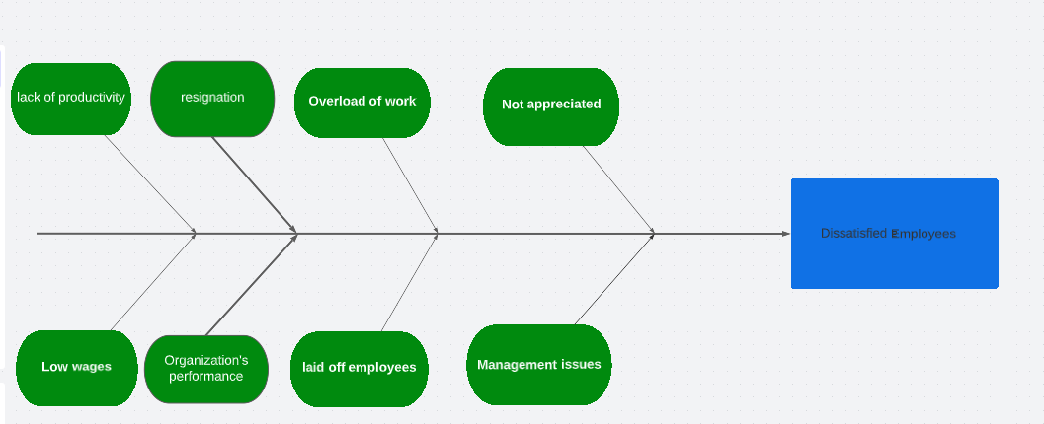

Figure-Fishbone analysis
(Source: Self-Developed)

Causes- From the analysis, it is observed that especially during the Covid-19 pandemic outbreak in 2020-2021, the company faces an economic crisis which harms their business turnover due to the lockdown declared by the government across the world globally. Therefore, to manage the economic condition of the business, the company heavy-heartedly has to lay off their staff members which causes additional work for the other staff members. When the workers are working for an extra hour, they are not paid for their extra work by the managers of the workplace which causes dissatisfaction among the workers on the management side. Sometimes the very low wages were not paid in time, and they were not even appreciated by their managers for their additional work.
Effect- It has an adverse effect of overworking on the workers concerning their physical and mental health of the workers. The low wages or not being paid on time resulted in many of the workers resigning from the workplace and the poor management and not being appreciated for their work are still making other workers unhappy. The causes of overworking result in low productivity among the employees which harm the performance of the company and the productivity and supply chain of the business operation. Therefore, the company should develop strategies as well as the structures of the business that would help them to evaluate a wide range of solutions to these problems by using appropriate decision-making techniques.

Propose a range of alternative solutions to the problem.
SWOT Analysis of McDonald's:

Strength:  - Strong brand name, image and reputation (SEOAves, 2022).  - Specialized training for the employees and managers (SEOAves, 2022).  - Innovative with technology and services (SEOAves, 2022). | Weakness:  - Dissatisfied franchisees (SEOAves, 2022).  - Employee dissatisfaction issue (SEOAves, 2022).
Opportunities:  - Hiring new employees.  - Increase the pay.  - The additional bonus to the employees who worked extra hours. | Threats:  - High-intensity competitors (SEOAves, 2022).  - High employee turnover rate (SEOAves, 2022).

Summary:
McDonald’s is one of the world's largest fast food retail companies which operates globally. The strength of the company shows the strongest aspects of the company and the strength which gives competitive advantages to the company in the market. The weakness of the company shows the aspects the company needs to improve to sustain itself in the market. Opportunities are the positive aspects for the company to gain an advantage in the market. Treat refers to the factors that stop the company from gaining advantages from the available opportunities of the company (SEOAves, 2022).
Hiring new employees- The reason for the dissatisfaction of the employees is mainly because of the workload of the employees of the company. It can be solved very easily if the company hires new employees into the company which will divide the workload and lead to employee satisfaction.
Increase the pay- One of the important reasons for the dissatisfaction of the employees in the McDonald’s is the low pay scale for the employees. The company provides relatively low wages to the employees compared to the other competitive companies in the same sector. Therefore, the company should increase the pay structure of the company to meet the requirements of the employee in the high competition.
The additional bonus to the employees who worked for extra hours- The employee in the company is dissatisfied due to the high workload and working for extra hours. The company needs to provide additional bonuses to the employees who work extra hours. It encourages and motivates employees to engage more in the work to earn more money as the satisfactory element.

Use a decision-making technique to evaluate a range of solutions to identify the most appropriate option.
PMI technique: -
It is a decision-making tool to identify possible solutions by examining the ideas and concepts from more than one perspective (VirtualLibrary, 2022).
An additional bonus to the employees who worked extra hours.
Plus | Minus | Interesting
- Increased motivation.  - Increase productivity.  - Employee satisfaction.  - Reduces employee turnover rate. | - Working extra hours can bring a low quality of work despite a bonus.  - Not always effective. | - Creates friendly competition among staff.  - It provides recruitment benefits to the company.

Among all the solutions for the employee dissatisfaction above, the most effective and easy method for the company is providing additional bonuses to the employees who worked for extra hours. McDonald’s will be benefited from this measure as it will motivate the employees instead of dissatisfaction from the heavy workload leading to employee satisfaction with more money. Motivated employees always deliver high productivity in the workplace. The strategy of giving extra bonuses will also reduce the high employee turnover rate faced by the company and build a positive environment in the work culture of the company. Therefore, the solution is beneficial for providing satisfaction to the employees as well as advantages to the company with reduced employee turnover and recruitment benefits.

Develop a plan for implementing the solution
SMART objective
Specific - The goal of our company is to offer an additional bonus to our workers who work hard during our tough times, especially during the pandemic.
Measure - We will survey our employees every 2-3 months to understand their level of satisfaction.
Achievable - This goal is achievable as after suffering from the economic crisis and drop in business turnover during the pandemic, the economic condition of the company has been stable thus, we can provide additional bonuses to our workers who work extra hours.
Relevant - The implementation of this plan is very relevant as most of the workers suffer from stress, headache, no personal life, etc., which affected the productivity level of the workers and the performance of the company. Through this plan, the company will be benefited as it will motivate the employees instead of being dissatisfied from the heavy workload.
Time-bound - This plan will be initiated within the time-bound of one month.

Communicate the plan to stakeholders
There are various ways for a business to communicate or discuss its plan with the other stakeholders of the company. The first way to communicate with the stakeholder of the plan is the email and newsletter and they can also monitor the progress. The other virtual ways include email automation, utilization of online platforms for communication, organizing the meeting to discuss the plan, and lastly, they can use a video call facility to communicate their plan with other stakeholders (Swift Digital, 2022). McDonald’s discusses their plan with the other stakeholders through their numerous communication channels and they communicate its plan to other stakeholders through the weekly newsletter and the intranet communication channel to discuss their plan (David et al. 2022).

Assess appropriate monitoring and review techniques to ensure successful implementation of the solution
The company needs to ensure that the plan which is implemented is successful or not they will continuously review and monitor their plan. They will survey their employee every 2-3 months to understand their level of satisfaction. A decrease in workload and getting an additional bonus for their extra work may indicate that the plan of the company which was implemented has benefitted them and they use this strategy for further improvement based on their employees' performance. They can also monitor or review their plan by assessing the productivity level of the employees (Catchpoint, 2022).

Personal reflection
In this section I will describe my reflection about my presentation.
Reflection, in my opinion means to be able to understand, think and talk about yourself as a person and as a learner.
In my presentation I had to play a role as a consultant, so my partner came with a problem from his work which was: low salary. He worked for Mc Donald’s for 5 years and despite he enjoying working there he still feels unappreciated and unmotivated because of the salary. So he bring this problem to me and I had to bring the best solution for him.
In my opinion I had a good presentation, because I used different methods and techniques to solve my partner problem and also my colleagues give me a positive feedback and they said that my solution was very constructive. Also my lecturer mentioned about my fish diagram that should be more complex and I should prepared myself more in the future. I am agree with the lecturer that I should prepared more in advance and also because of emotions I think I had a minus.
I reflected about my presentation and my threats are public speaking, improve my fish diagram and also work more on finding solutions for the problems.

Conclusion
To sum up, from this report it is concluded that job dissatisfaction can arise in organizations, businesses, or companies because of various factors such as work overload, stress level, not being appreciated, wages not paid in time or low wages paid, management issues, absenteeism, and so on. Here, this report discusses the overworking of the workers and low salary in the company which leads to dissatisfaction among the workers and its impact on the organization by analyzing the fishbone analysis of cause and effects. Then the company from the three solutions to resolve this problem applied an additional bonus to the worker's plan to address this problem. The company implemented this plan using the SMART objective and lastly to monitor whether this plan is successful or not they conducted a survey of their employees and assess the productivity level of their workers.

References:
Attendancebot. com2022. [online] Available at: <https://www.attendancebot.com/blog/overworked-employees/> [Accessed 27 July 2022].
Catchpoint.com. 2022. 10 Tips for an Effective Monitoring Strategy. [online] Available at: <https://www.catchpoint.com/blog/monitoring-strategy> [Accessed 27 July 2022].
Darmody, J., 2022. Two-thirds of UK employees are overworking by six hours per week. [online] Silicon Republic. Available at: <https://www.siliconrepublic.com/careers/overworking-unpaid-labour-uk-workers#:~:text=Overworking%20can%20lead%20to%20increased,said%20they%20suffer%20from%20stress> [Accessed 27 July 2022].
David, J., Rahman, M. and David, J., 2022. Stakeholders of McDonald’s (Analysis of McDonald’s stakeholders). [online] howandwhat. Available at: <https://howandwhat.net/stakeholders-mcdonalds-analysis-mcdonalds-stakeholders/#:~:text=How%20does%20McDonald's%20communicate%20with,to%20communicate%20with%20the%20employees> [Accessed 27 July 2022].
Oberlo.in. 2022. 10 Powerful SMART Goal Examples to Help You Achieve Your Dreams. [online] Available at: <https://www.oberlo.in/blog/smart-goal-examples> [Accessed 26 July 2022].
Rahman, M., Rahman, M. and David, J., 2022. PESTEL analysis of McDonald’s. [online] howandwhat. Available at: <https://howandwhat.net/pestel-analysis-mcdonalds/> [Accessed 27 July 2022].
Roberthalf.co.uk. 2022. The 6 main causes of unhappy staff and job dissatisfaction. [online] Available at: <https://www.roberthalf.co.uk/advice/people-management/6-main-causes-unhappy-staff-and-job-dissatisfaction> [Accessed 27 July 2022].
SEOAves, 2022. McDonald’s SWOT Analysis 2022 | SEOAves. [online] Available at: <https://seoaves.com/mcdonalds-swot-analysis/> [Accessed 26 July 2022].
Swift Digital. 2022. 5 Tips on How To Communicate With Stakeholders Effectively [Free Template Plan]. [online] Available at: <https://www.swiftdigital.com.au/blog/how-to-communicate-with-stakeholders/#:~:text=1.-,Email%20and%20Newsletter,monitor%20engagement%20and%20open%20rates> [Accessed 27 July 2022].

Appendix
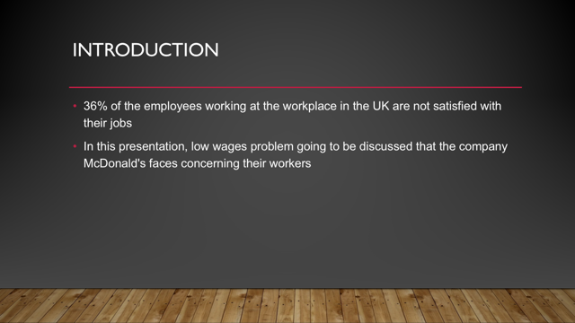
Slide 1

Slide 2

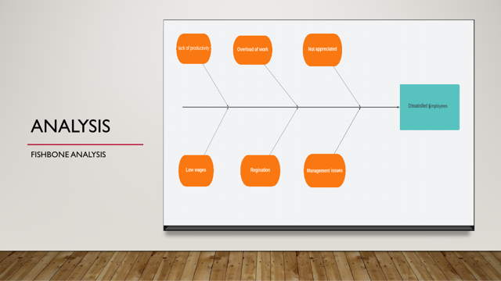
Slide 3

Slide 4
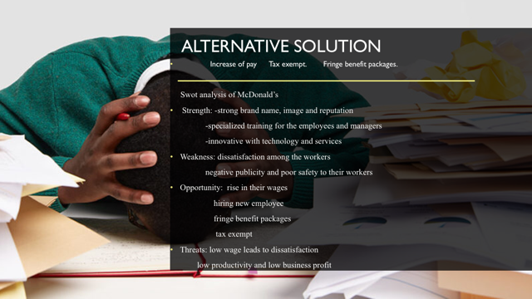
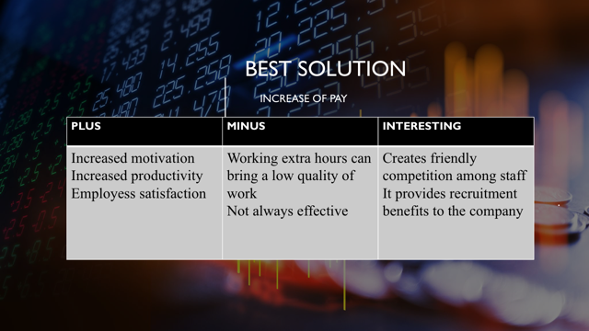
Slide 5

Slide 6
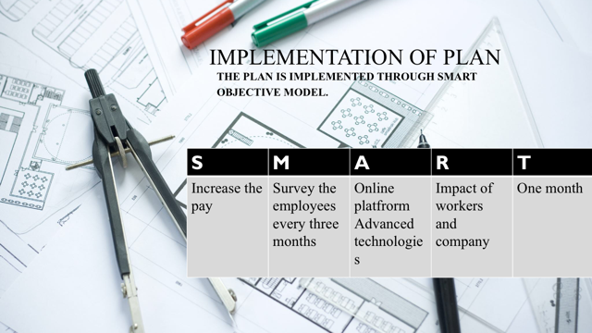

Slide 7
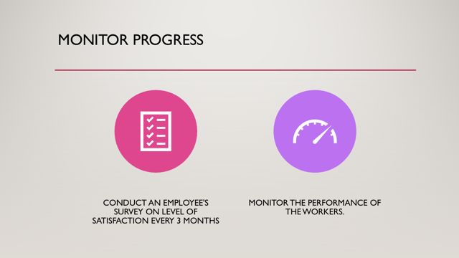
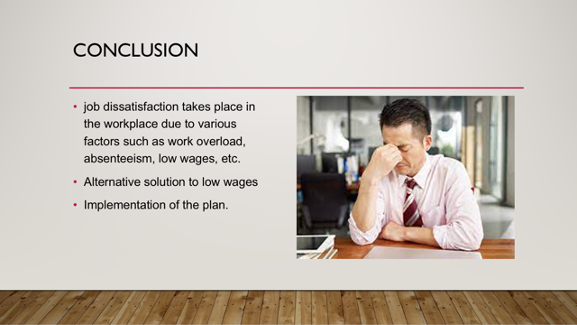
Slide 8

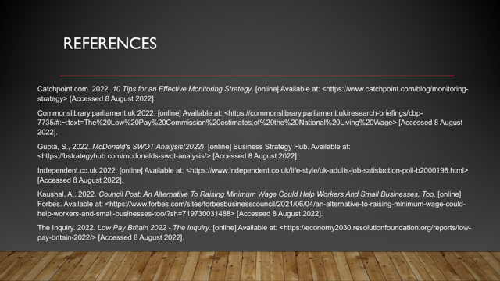
Slide 9

