ACMA4000 - Materials and Introduction to Processing: Rubber Properties



Name: Colten Jones Student Number: 2114369

Introduction
Elastomers are a class of polymeric materials with a flexible nature which enables these materials to return to their original shape after being stretched and/or compressed to great extents. Elastomers contain a low number of intermolecular forces which enables such materials to have high degrees of elongation. Elastic modulus, also termed modulus of elasticity, is the unit of measurement of a materials resistance to being deformed elastically (i.e., non-permanent change) when a force is applied to it.
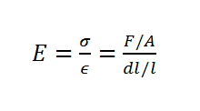

Figure 1: Modulus of elasticity (E) (also termed Young’s Modulus) is a property of the material defined as the ratio of tensile stress (σ) to tensile strain (ε). Tensile stress is the amount of force applied per unit area (σ = F/A) and tensile strain is extension per unit length (ε = dl/l).
In basic terms a material with a high modulus of elasticity has a high level of stiffness and permanent deformation is likely to occur when forces are applied. A material with a low modulus of elasticity is a pliable substance that exhibits versatile mechanical characteristics. Unlike brittle materials such as metals and plastics, elastomeric materials do not exhibit a yield point following their elastic region on their stress-strain curves, instead they will continue to deform elastically until breaking point (Jones & Ashby, 2019). Elastomers are in an amorphous state (non-crystalline more random formation) and often contain cross-links. Cross-linking defines the forming of covalent bonds between polymer chains, hence forming a single networked molecule. These cross-links provide elastomers with the ability to return to their original shape and form once the applied stress, either dynamic or static, is removed (Özdemir, 2020).
This report will investigate the key properties of rubber by conducting an experiment to attain the stress/strain curves of this material. The underlying chemistry behind the shape of these
curves will be explained, and the experimental accuracy of the chosen methodology will also be assessed.

Experimental Method
The methodology used during this experiment was an adaptation of a method described in The Principles of Polymer Systems written by Rodriquez et al., in 2014, it was adapted to suit materials/equipment that I had available to hand.
Materials list:
- 2 identical rubber bands (60mm length x 2mm width, measured before use)
- 30cm length of rope
- Two x 1.5 litre empty plastic bottles
- Fly-tying vice
- 100ml graduated cylinder
- T-bar
- Water
- Tape measure
- Measuring balance
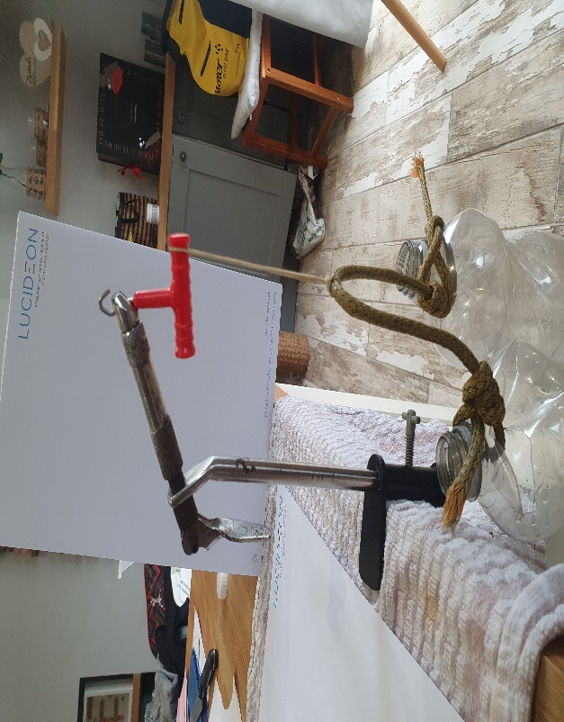
Each end of the length of robe was attached to one of the plastic bottles and these were then weighed and the combined was recorded. The rubber band was then looped over the rope, ensuring it was directly at the centre, at then the top of the band was looped over the handle of the T-bar that was fixed in the jaws of a fly-tying vice (see figure 1 below).
Fly-tying vice T-bar

Elastic band
Plastic bottles

Figure 1: Setup of apparatus during experiment.

The length of the rubber band with the weight of the plastic bottles was then recorded. Water was then added to each bottle using a graduated cylinder in increments of either 100ml or 200ml split equally between each bottle to ensure even spread of weight to prevent the rubber band from slipping on the length of rope. The mass pulling on the rubber band and length of the band was recorded at every time water was added until the point at which the band snapped.
Results and Discussions
Table 1: Raw data collected from experiment of rubber band.
Water (ml) | Force (gf) | Length (mm)
0 | 0 | 60
0 | 110 | 91
100 | 210 | 138
100 | 310 | 189
100 | 410 | 224
200 | 610 | 291
200 | 810 | 343
200 | 1010 | 383
200 | 1210 | 399
200 | 1410 | 410
200 | 1610 | 419
200 | 1810 | 427
100 | 1910 | 433
100 | 2010 | 447
100 | 2110 | 454
100 | 2210 | 454

Table 1 shows the volume of water added to the bottles, the accumulated force exerted on the rubber band and the length of the band when exerted to these varying levels of tension. This data enabled the experimental strain and stress and true strain and stress to be calculated and the complete data set can be seen in the appendix.

Figure 2: Relationship between length of the rubber band and the tension exerted on the band.

Figure 3: Engineering stress/strain curve of rubber band in experiment.

Figure 3 shows the engineering stress/strain curve of the rubber band used in the experiment. Figure 3 shows us that the rubber band had the capacity to withstand 3.45 N/mm² of engineering stress before the point of which it snapped. This figure also shows us that the rubber band withstood an engineering strain value up to 6.56 before it broke. This means than the band stretched to 6.56 times its original length before snapping. From this figure the Young’s modulus can also be attained, this can be obtained from the elastic region of the graph, this region displays the values at which the material can be deformed and when released will return back to its original shape. This is possible because in the early portion of stress/strain graphs many materials obey Hookes’s law to an acceptably approximation, this means that the stress is proportional to the strain and this constant of proportionality in terms Young’s modulus (Roylance, 2001). Young’s modulus was obtained by drawing a line of best fit in the elastic region of figure 2 and obtaining the gradient of this line, this is shown in figure 4 below.

Figure 4: Elastic region of engineering stress/strain curve of rubber band with line of best fit and its line equation displayed.
Figure 4 shows that the gradient of the line of best fit is 0.2679, as the stress is displayed in N/mm² this equates to a Youngs modulus of 267,900 N/m².

Figure 5: True stress/strain curve of rubber band in experiment.
True stress is defined as the instantaneous stress of the load acting on the cross sectional area.
Figure 5 shows that the rubber band can withstand up to 26.1 N/mm² of true tensile stress before breaking, this is the ultimate tensile strength of the material. The curve exhibits no tangents (no necking or drawing) and this tells us that rubber is a material that will fracture before it yields. Depending on factors such as temperature this fracture can be either be brittle or ductile as rubber exhibits a brittle-ductile transition phase at low temperatures (Varlamov et al., 2018).
Rubber is often described as an incompressible material that deflects stress/strain by changing shape rather than volume. Rubber being a natural polymer consists of long chains of molecules that without any strain they are arranged in a state of relative disorder and are termed to have a high entropy. When stretched these polymer chains become aligned in one direction with intermolecular forces holding these polymers in position, this ordered arrangement is termed a crystal structure and has a much lower entropy. The second law of thermodynamics states that a system will want to move from a state of order (low entropy) to disorder (high entropy), this partly explains why rubber will return to its original shape when released of any tension (Flory, 1979).
When stretched these molecules form crystals and heat is given off to the surrounding environment due to exothermic reactions, when released off tension the molecules will absorb energy causing the surrounding environment to become cooler, this phenomenon is called Gibbs free energy. Gibbs free energy means that elastomers do not store any potential energy when work is applied to them, instead all the work done appears in the form of thermal energy.

Effects Of Temperature on Elasticity Of Rubber
As temperature decreases rubber will become harder, stiffer, and less resilient. This is a result of a reduction in the free volume between neighbouring molecules (due to contraction) and hence a reduction in the fluid mobility of the elastomer molecules (Schaefer, 2010). As a result of this when approaching the glass transition phase, the material becomes leathery as a pose to rubbery and will eventually change to a hard brittle glass.
In contrast, as temperature increases so too does the rate of thermal expansion and the free volume between neighbouring molecules, this increases the fluid mobility of these molecules and provides them with the ability to withstand greater forces as a result of an increase in elasticity.

Experimental Accuracy – Improvements for Future Studies
Overall, I am happy with how the experiment went and think the data achieved is a fair representation of the true mechanical properties of the material used, however, this section will discuss areas of improvement for future experiments.
Firstly, how the rubber band was attached to the rope and bottles during the experiment is an area of slight concern. The rubber band was looped over the length of rope and this looping will have reduced the maximum length to which the band was able to stretch too when exerted to varying levels of force, this will have inherently affected the stress and strain data collected and resulted in a data set that is not a truly accurate/reliable representation of the material. An improvement would be to invest in a heavy based stand and secure a hook to the stand where the rubber band can be directly attached to prevent the need for looping the band.
Another potential adaptation to my methodology would be to draw two marker lines of a known distance apart on the band when no tension is applied, say 2cm for example, and then measure the distance between these two lines when weight is added. This would be more reliable than measuring the length of the whole band as was conducted in this experiment as it would prevent the need of looping the band and inherently skewing the results.
Furthermore, due to lack of time the experiment was only conducted on one rubber band therefore an improvement would be to repeat the experiment several times to obtain a larger data set. Repeating the experiment would make the findings more reliable and increase their accuracy as it would allow any anomalous results to be identified and ignored, this would reduce the likelihood of any anomalous results effecting any final conclusions made. Another potential improvement would be to partner up with a fellow student and complete the same experiment using the exact same methodology individually. These two data sets could then be compared to confirm the repeatability of the experiment and to determine the efficacy of the trial method.

Conclusion
To conclude, this experiment has identified the key characteristics and fundamental capabilities of rubber. The experiment has allowed us to construct a stress/strain curve for both engineering and true stress. These have highlighted that ability of rubber to deflect strain by changing its shape rather than its volume, the rearrangement and alignment of molecules creates a crystalline structure with a lower entropy. The second law of thermodynamics states that a system will move from an organised system with lower entropy to a disorganised system with higher entropy. This in part explains why rubber returns to its original shape once relieved of any tension.

References
Flory, P. J. (1979) ‘Molecular theory of rubber elasticity’, Polymer. Elsevier, 20, pp. 1317–1320.
Jones, D. R. H. and Ashby, M. F. (2019) ‘Elastic Moduli’, Engineering Materials 1. Butterworth-Heinemann, pp. 31–47.
Özdemir, T. (2020) ‘Elastomeric micro- and nanocomposites for neutron shielding’, in Micro and Nanostructured Composite Materials for Neutron Shielding Applications. Woodhead Publishing, pp. 125–137.
Rodriguez, F. et al. (2014) Principles of polymer systems, sixth edition, Principles of Polymer Systems, Sixth Edition.
Schaefer, R. J. (2010) ‘MECHANICAL PROPERTIES OF RUBBER’.
Varlamov, A. A., Rimshin, V. I. and Tverskoi, S. Y. (2018) ‘The modulus of elasticity in the theory of degradation’, IOP Conference Series: Materials Science and Engineering, 463, p. 022029.

