

Module Title: ENTREPRENEURSHIP
Module Code: LCBB5001
Assessment Component 1
Business Plan
On
Paws and More
Student: Elena Vasileva 2115092
Lecturer: Dr. David Jenkins

Contents
Introduction 3
Overview of the Business 3
Legal Format of Paws and More 4
Management of the Company 5
Target Market and Marketing Strategies 5
Use of Social Media and Website to Promote the Company 6
Evaluation of Business Idea 7
Cashflow Forecast 8
Conclusion 8
Reference 9

Introduction
A sound business plan is essential for an entrepreneur and his management team to follow in order for them to be successful in bringing their vision for the firm into fruition (DaSilva and Trkman, 2023). One possible way for a company to get an advantage over its rivals is to have a business plan that has been well considered. An organization may be able to foster innovation inside itself, which may result in enhancements to the company's products and services that are more appealing to the organization's clients. The knowledge of who your ideal customers are might also prove to be beneficial. It might be helpful in the process of generating marketing strategy and making improvements to products. This paper provides an in-depth analysis of a company's strategy. The opening of a store in Bristol that specializes in the sale of products for animals is the principal objective of this business plan. First, a description of the current state of the firm has been provided. The organizational structure of the company, management, the target demographic of customers, and the advertising strategies have all been mapped out. The manner in which the product will be promoted on the internet and via other social media platforms has been discussed. After doing a SWOT analysis on the company idea, we have now completed the last step of detailing the cashflow projections for the first year of operations as well as the potential sources of funding.

Overview of the Business
In the long run, the company wants to leverage the business to launch a local Bristol pet supplies shop. Currently, Bristol is home to twenty different pet supply shops. Some of them are quite popular with buyers. The goal of this company is to create a single, central destination where customers can get everything they need for their pets. There will be pet collars, entertainment, clothing, and other necessities for them to enjoy daily life. The increasing number of dog owners in the area, along with the area's established reputation as dog-friendly, bodes well for the future of this particular company concept (Aegerter, et al., 2021). The company could provide a hand if it means better satisfying customers. The name "Paws and More" will be used for the pet supply store once it opens. It will be in a convenient position, near both areas that welcome pets and those with a big population of animal enthusiasts. The retail establishment will be laid out in a way that gives the impression of being appealing to people who own pets. In addition to that, it will include a variety of subcategories representing various pet accessories. The employees of the store will be outfitted in headwear featuring cat ears, which will provide customers with a one-of-a-kind impression of the establishment. In addition, there will be a play area for pets inside the store, where customers will be able to bring their own animals so that they can interact socially with other animals' pets.
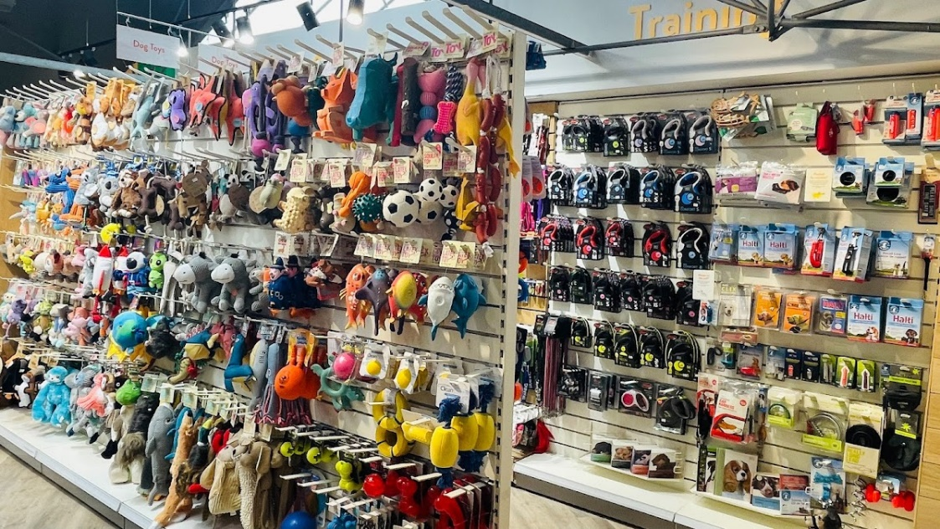
Figure 1: Pet Accessory Store (Pets Corner, 2023)

Legal Format of Paws and More
The partnership structure will serve as the basis for the company's legal structure. The organization is going to be structured as a general partnership. In a general partnership, each of the partners has the same amount of ownership over the business, and they also each have an equal share in the responsibility for paying off any debts incurred by the shop (Lamoreaux, 2022). As this is initially just a small startup, this is the ownership structure that should be used because it will be very difficult to find more than three or four partners. In addition, the procedure for establishing a corporation is extraordinarily drawn out and convoluted. If the company anticipates that it will need more money and more space in the near future due to the expansion of the business, then it may wish to investigate forming either a corporation or a limited liability company. The process of utilizing this type of legal format is well-known among newly established small businesses due to the fact that it is an inexpensive and straightforward form. In addition, they call for an exceptionally low number of legal requirements, which is beneficial for new company proprietors. It is also advantageous from a tax perspective because the company itself does not have to pay taxes; rather, the proprietors are the only ones who are required to do so through their individual tax returns. Additionally, the owners have a greater degree of control over the company and the decisions that pertain to the company (Swais, 2019). The proprietors of new businesses tend to favor this type of organizational structure for their companies. In addition to this, it offers proprietors increased leeway in the management of their companies.

Management of the Company
The company will be organized in a hierarchical manner from top to bottom. A hierarchical structure where there is a chain of command and each person reports to the person above them in the hierarchy. It will have a Chief Executive Officer (CEO). A person who has previous experience in the manufacture of pet accessories will serve as a director in this company. There will be different departments such as finance department, marketing department, HR department, customer service department etc. Other workers will report to them and work under their direction. A person, head of the finance department, with a master's degree in finance and experience working in the finance department. A person who leads the marketing department, with a master's degree in marketing and has worked in this industry. Human resources manager, with a master's degree in management and experience. Customer service manager with a master's degree in communications. Other employees are required to have either prior experience in these departments or a relevant bachelor's degree to be hired. On the other hand, retail employees may have little or no previous experience, but will quickly pick up best practices as they gain experience on the job.

Target Market and Marketing Strategies
A company's target market consists of the individuals it believes will be the most enthusiastic consumers; the term "target market" describes this group of people. Understanding the target audience is necessary for efficient resource allocation, targeted marketing, and meeting the requirements of individual customers (Cahill, 2020). Paws & More has a goal of catering to dog, cat, and bird owners in the area. The age group will be from 18 years to 50 years. The target group is comprised of people with a middle-class income or above. Customers in this segment are more concerned about the well-being of their pets than the average consumer. Partnerships with local pet-focused companies like vet offices, grooming parlors, and adoption organizations may boost the store's profile and reputation in the industry (Parwath, 2019). Meeting prospective consumers face to face and spreading the word about your company may be done at pet-related events such as pet shows, adoption fairs, and charity fundraisers. Participating in a customer loyalty program, in which customers can win prizes for making purchases or recommending friends, is one way to increase the likelihood that a customer would buy with the company again. Establishing connections with consumers on a consistent basis by sending them tailored emails, newsletters, or targeted offers helps keep the shop at the forefront of their thoughts anytime they have a need for new pet supplies (Mules, 2021). By using these different advertising techniques, the pet business has a higher chance of gaining more customers, being more well-known in the neighborhood, and luring more people who own pets.

Use of Social Media and Website to Promote the Company
Thinking about the routes that will be most effective in reaching the target audience and how the product stands out from the competition. Due to their large user populations and emphasis on visual content, social media platforms like Facebook and Instagram are ideal for pet-related companies (Coughlan, 2020). Before committing to a certain platform, research should be done in order to find out the most used social media platforms of the target customers. A Facebook page for the company to spread the word about sales, new products, and other news is a god idea. Using Instagram will help the company share photos of the products and videos on how to use these products (Evans, et al., 2021). Creating a unique hashtag to use along with the posts of the company will help to generate a buzz among the customers. Creating an easy-to-navigate and purchase-friendly website that highlights the products and gives in-depth explanations of them. Optimizing the site for search engines like Google and Bing will increase its exposure to potential customers. To improve the company’s website’s credibility, include reviews and testimonials from satisfied clients can be included (Abdallah and Jaleel, 2021). The social media updates may not reach all of the followers unless payment is made to these platforms in marketing or advertising. If customers are unhappy with the service they get, their feedback might spread rapidly over social media. So it is important to solve the problems of the customers and give them the best customer service. Customer data collection and storage is not risk free. Steps have to be to ensure the safety of the website and social media accounts against hackers and other security threats.

Figure 2: Social Media Platforms (Your Story, 2023)

Evaluation of Business Idea
To evaluate the business idea a SWOT analysis has been done. SWOT analysis helps to identify the strengths, the weaknesses, the opportunities, and threats of the idea.
Strengths: This refers to the capabilities which help the business which makes it stand out among its competitors (GURL, 2021). The main strength of the idea is that it will provide unique pet accessories at an affordable price. The various customer loyalty programs will help to retain the current customers.
Weaknesses: This refers to the flaws of the company due to which they can have a competitive disadvantage. As the company is a startup it has limited brand recognition. So, it will have to work hard to gain the attention of its target customers. There are also limited financial resources to grow the business.
Opportunities: This refers to instances which the company can take advantage of to increase the growth of the business. The rate of pet ownership is increasing so the number of customers is increasing and hence by using efficient marketing techniques the company can attract more and more customers.
Threats: This refers to situations or causes which can disadvantage the business (Teoli, et al, 2019). The competition in this industry is very high so differentiating factors are needed. The change in the economic condition can impact the income of the business. Due to a change in customer preferences the company’s products can quickly become outdated.

Cashflow Forecast
Starting a business requires capital and often this comes from the owners or some other sources of funds. For Paws and More two types of fund options will be used. The first is the personal investment which comes from the owners. This can be in form of cash or other assets which will be used for the initial investment of the business (Garg and Shivam, 2021). Then the second type of investment that will be used in bank loans. It is the second most viable option for the business. The banks assess the credibility of the business owners and the credibility of the business idea. But this might require collateral to secure the loan (Menon and Malik, 2022). The cashflow forecast for the first twelve months of Paws and More is given below.
Month | Cost (£) | Sales (£) | Net Income (£)
1 | 25000 | 10000 | -15000
2 | 3000 | 12000 | 9000
3 | 2500 | 14000 | 11500
4 | 2500 | 16000 | 13500
5 | 2000 | 18000 | 16000
6 | 2000 | 20000 | 18000
7 | 1500 | 22000 | 20500
8 | 1500 | 24000 | 22500
9 | 1500 | 26000 | 24500
10 | 2000 | 28000 | 26000
11 | 2000 | 30000 | 28000
12 | 2500 | 32000 | 29500

Conclusion
This report is a business plan based on the business idea of a pet accessories shop in Bristol. This idea is a viable one as the number of pet owners is increasing. This report gives a overview of the business, the legal format of the business, the management of the company, the target market and marketing strategies. It also consists of the use of social media to promote the brand, the evaluation of ideas and lastly the cashflow forecast for the business.

Reference
Abdallah, S. and Jaleel, B., 2021. Website appeal: development of an assessment tool and evaluation framework of e-marketing. Journal of theoretical and applied electronic commerce research, 10(3), pp.45-62.
Aegerter, J., Fouracre, D. and Smith, G.C., 2021. A first estimate of the structure and density of the populations of pet cats and dogs across Great Britain. PLoS One, 12(4), p.e0174709.
Cahill, D.J., 2020. Target marketing and segmentation: valid and useful tools for marketing. Management Decision.
Coughlan, A.T., 2020. Marketing channels. Pearson Education India.
DaSilva, C.M. and Trkman, P., 2023. Business model: What it is and what it is not. Long range planning, 47(6), pp.379-389.
Evans, D., Bratton, S. and McKee, J., 2021. Social media marketing. AG Printing & Publishing.
Garg, A. and Shivam, A.K., 2021. Funding to growing start-ups. Research Journal of Social Sciences, 10(2), pp.22-31.
GURL, E., 2021. SWOT analysis: a theoretical review.
Lamoreaux, N.R., 2022. Partnerships, Corporations, and the Theory of the Firm. The American Economic Review, 88(2), pp.66-71.
Menon, K.S.V. and Malik, G., 2022. Funding options for startups: A conceptual framework and practical guide. Notion Press.
Mules, R., 2021. The pet industry and'petrepreneurship. Busidate, 22(1), pp.5-8.
Parwath, R.R., 2019. Pet showroom.
Swais, N., 2019. Understanding the Partnership Structure (Part 1): The General Partnership. LawNow, 23, p.59.
Teoli, D., Sanvictores, T. and An, J., 2019. SWOT analysis.

