Comparative Performance of Advanced Modulation Schemes

Experimental
report

Contents
Introduction 4
Design 6
Simulation results 9
Analysis 11
References 14

List of Figure
1. Voltage divider circuit 1
2. Zener diode characteristic curve 2
3. Second-order active low-pass filter circuit 3
4. Operational Amplifier 4
5. Inverted closed-loop amplifier 4
6. Non-inverted closed-loop amplifier 5
7. block diagram 5
8. Simulation circuit diagram on proteus 6
9. Voltage divider circuit 6
10. Protection circuit 7
11. Filter circuit 8
12. Level shifting circuit 8
13. Operational Amplifier circuit 9
14. Simulation results one 10
15. Simulation results two 10
16. Simulation results three 11
17. Response time 11
18. Active Low-Pass Second Order Filter 12

Comparative Performance of Advanced Modulation Schemes

By Xuyuan Liu

ABSTRACT
This paper analyzes the modulation and demodulation principles of ASK, PSK, QPSK, QAM and 64QAM signals. The Simulink simulation tool of MATLAB software is used to simulate the modulation method of the above signals under noise, and the waveform diagram of each stage in the modulation process is obtained. And plot graphs of BER against signal to noise ratio.

Introduction
- Time domain representation of ASK signals
Binary amplitude shift keying (2ASK) means that the amplitude of the high frequency carrier is controlled by the modulated signal while the frequency and phase remain unchanged. That is to say, the "1" and "0" of the binary digital signal are used to control the on and off of the carrier, so it is also called on-off keying. Assuming a carrier signal , it is assumed that the transmitted binary symbol sequence is composed of 0 and 1 sequences, the probability of transmitting 0 symbols is P, and the probability of transmitting 1 symbol is 1-P, and is independent of each other. The binary baseband symbol sequence can be expressed as
Where is the time interval of the binary baseband signal sequence (symbol), and g(t) is the pulse expression of the modulated signal. For the convenience of discussion, it is set as a unipolar rectangular pulse waveform of width with an amplitude of 1 .
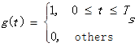
The expression of 2ASK can be obtained as
It can be seen that the 2ASK signal can be represented as a unipolar rectangular pulse sequence multiplied by a sinusoidal carrier. The time waveform of a typical 2ASK signal is shown in Figure 1.
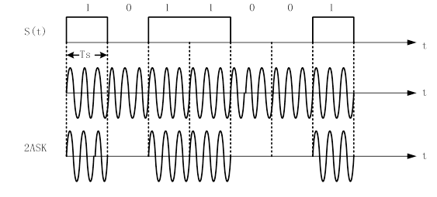
Figure 1. Time waveform of 2ASK signal
2) Time domain representation of PSK signals
Phase shift keying is the use of carrier phase changes to transfer digital information, which can be divided into absolute phase shift keying (2PSK) and differential (relative) phase shift keying (2DPSK). Here, only the modulation and demodulation of the absolute phase shift keying signal is discussed.
If the digital signals "1" and "0" of the binary sequence are represented by two discrete values of carrier phase pi and 0, respectively, and their amplitude and frequency remain unchanged, this modulation is called binary absolute phase shift keying. In other words, absolute phase shift keying means that the phase of the modulated signal is directly controlled by the digital baseband signal. The general expression of the 2PSK signal is
The typical time waveform of the 2PSK signal is shown in the figure. All digital signal "1" codes in the figure correspond to the PI phase of the carrier signal, and the "0" code corresponds to the 0 phase of the carrier signal.
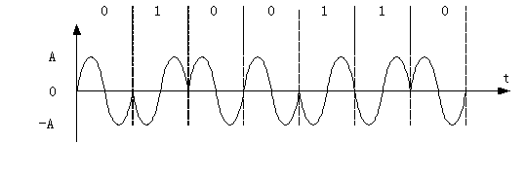
Figure 2. PSK time waveform
- Time domain representation of QPSK signals
Quadrature phase shift keying is four-phase phase shift keying (4PSK), which is a modulation method that uses digital signals with four different phases of the carrier. Assuming that the duration of two binary symbols is Ts, it is orthogonal. The time domain expression of the phase shift keying signal can be expressed as
Among them, A is the adjusted phase, there are four different values; A; A. The quadrature phase shift keying signal can be described by a vector diagram in which the unadjusted carrier phase is typically used as a reference vector. The phase configuration of the QPSK signal is usually in two ways:
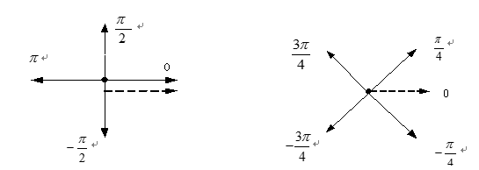
Figure 3. Two ways of QPSK
4) Time domain representation of QAM signals
Quadrature Amplitude Modulation (QAM) is a modulation method of amplitude and phase joint keying (APK), which can improve system reliability and obtain high information band utilization. It is a widely used digital signal. Modulation. Quadrature amplitude modulation is to suppress the two-band modulation of two mutually orthogonal co-frequency carriers by two independent baseband digital signals, and realize the two-way parallel by using the orthogonality of the modulated signals in the same bandwidth. Digital information transmission. Currently the most commonly used communication systems are 16QAM and 64QAM, so only two orthogonal amplitude modulation methods are discussed here.
The APK refers to the amplitude and phase of the carrier. The two parameters are controlled by the baseband signal at the same time. The general expression of the APK signal is

Design
- Simulink simulation of ASK signals
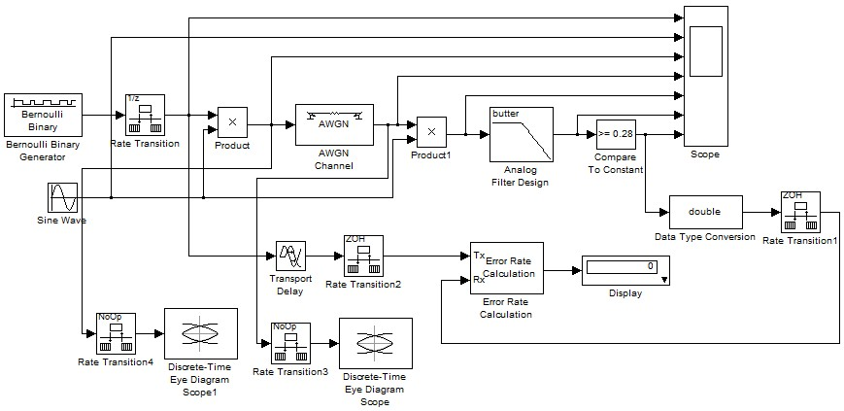
Figure 4. 2ASK signal simulation module diagram
Among them, the simulation step size during simulation is set to fixed step mode, and its value is 0.001s.
In this paper, the modulation of the 2ASK signal adopts the analog modulation method. The source is the Bernoulli binary sequence generator, which is multiplied by the sinusoidal carrier generated by the sinusoidal carrier generator to obtain the 2ASK modulated signal.
Regarding the parameter setting, the source frequency is 4 Hz, that is, the 1-second source generates 4 bits, wherein the probability of 0 and 1 is equal, both being 50%. The binary sequence is a random sequence, which satisfies the basic characteristics of the random process, and therefore conforms to the conditions of the actual communication system, and is suitable for the simulation of the communication system. The sinusoidal carrier has an amplitude of 1 and a frequency of 20 Hz.
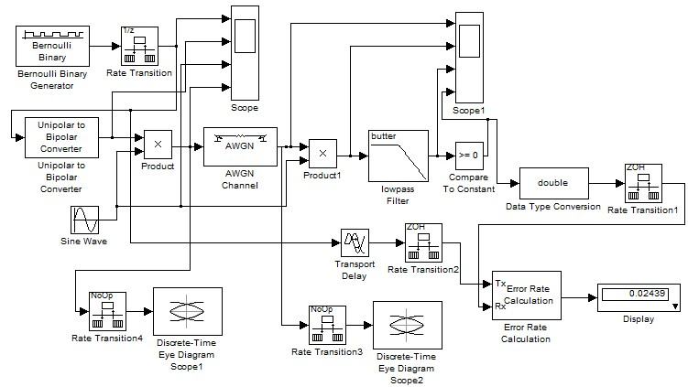
- Simulink simulation of PSK signals
Figure 5. 2PSK signal simulation module diagram
The phase of the 2PSK signal is not continuous, but consists of two-phase values. After the binary source sequence is subjected to polarity transformation, it becomes a bipolar non-return-to-zero signal, and the bipolar non-return-to-zero signal is multiplied by the carrier. After that, a binary phase shift keying signal composed of two-phase values can be obtained.

3) Simulink simulation of QPSK signals
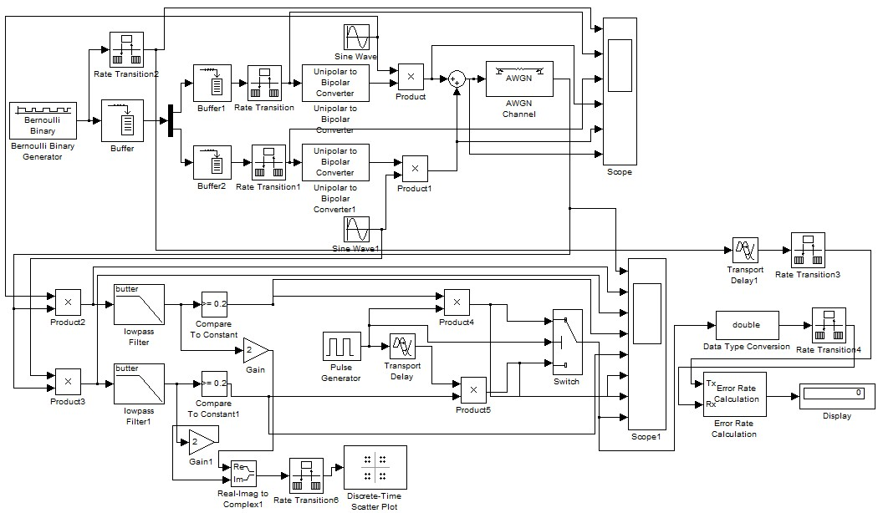
Figure 6. QPSK signal simulation module diagram
The source used for QPSK signal modulation is still the Bernoulli binary random number generator.
4) Simulink simulation of QAM signals
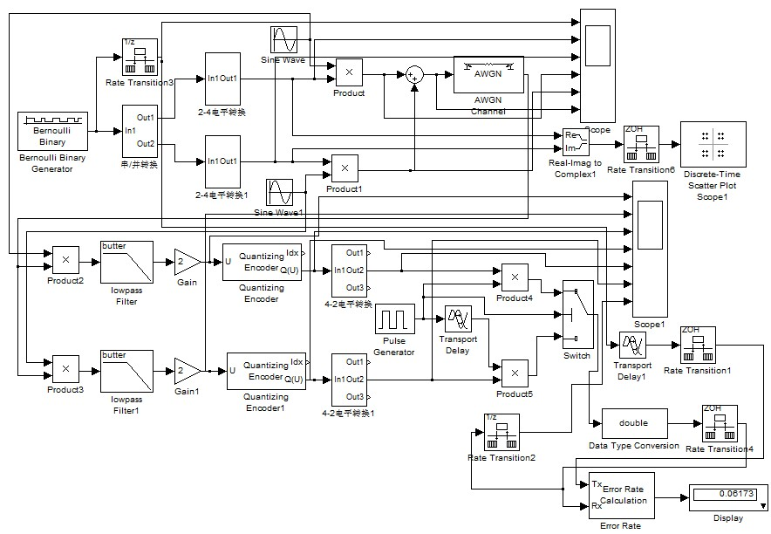
Figure 7. 16QAM signal simulation module diagram
The source of the 16QAM signal modulation is the Bernoulli binary random sequence. The source is first subjected to serial/parallel conversion, and then 2-4 level conversion is performed for each signal separately. The two signals after level conversion are respectively multiplied by two mutually orthogonal carriers, and then the signals output by the two multipliers are added to obtain a 16QAM modulated signal.

Simulation results
1)Simulation result of ASK

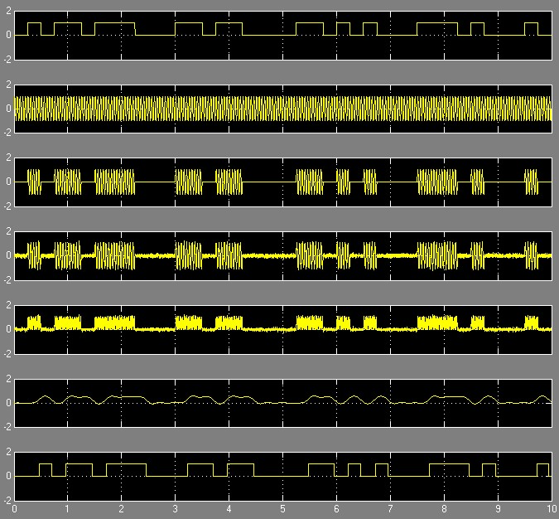

Figure 8. ASK modulation waveform
After the signal passes through the Gaussian white noise channel, the waveform will be distorted and inter-code crosstalk will also occur, which will reduce the performance of the communication system and increase the bit error rate. In this simulation method, an eye diagram oscilloscope is used to observe a waveform eye diagram before and after passing through a Gaussian channel.
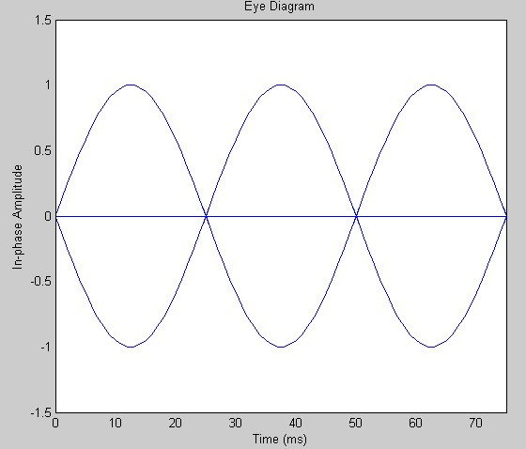
Figure 9. Eye diagram before the Gaussian channel
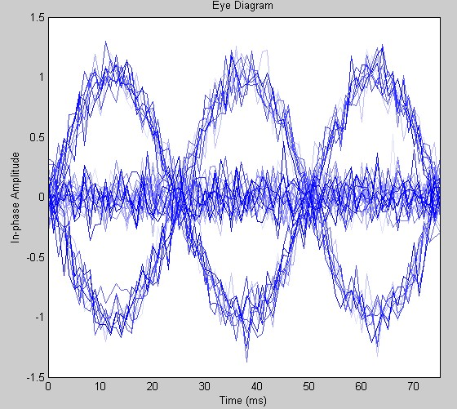
Figure 10. Eye diagram after the Gaussian channel

2) Simulation result of PSK
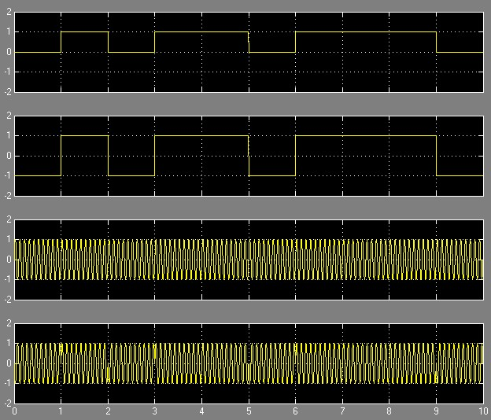
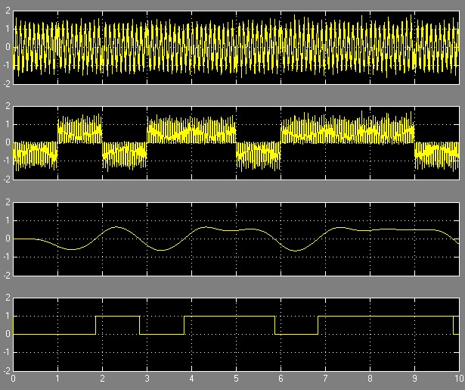
Figure 11. PSK modulation waveform
Figure 12. PSK demodulation waveform
After the signal passes through the Gaussian channel, it will be distorted by the influence of noise. This can be observed through the eye diagram. The channel module parameter settings and the observed eye diagram are as follows.
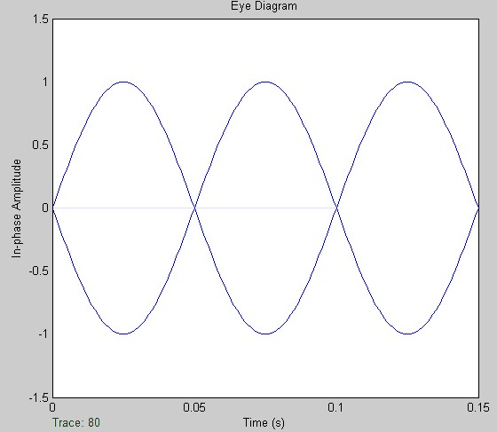
Figure 13. Eye diagram before the Gaussian channel
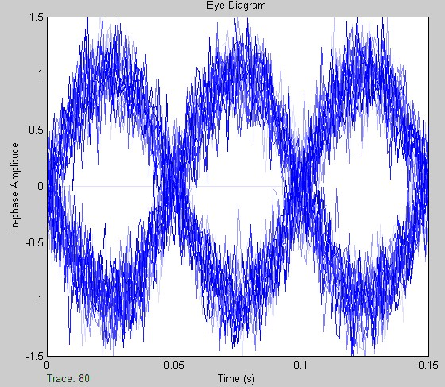
Figure 14. Eye diagram after the Gaussian channel
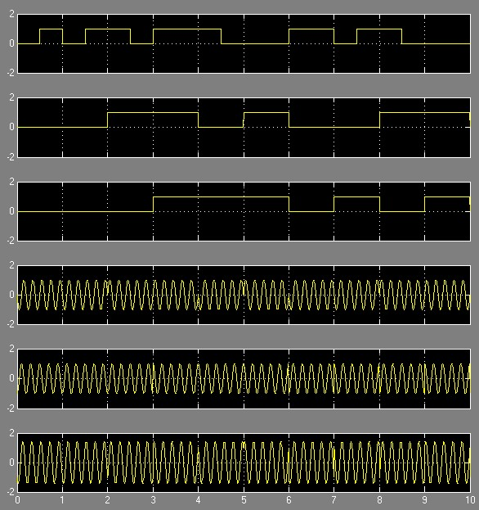
3) Simulation result of QPSK
Figure 15. QPSK modulation waveform

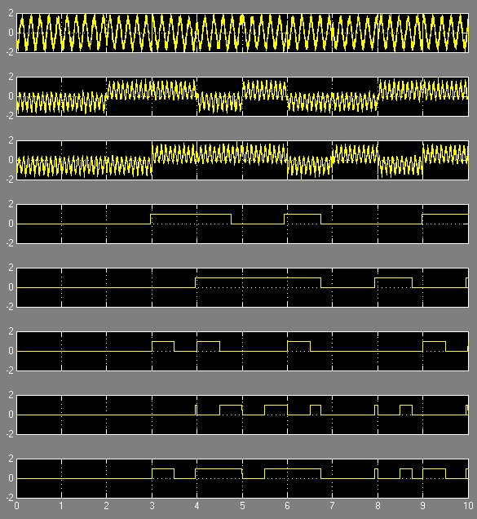
Figure 16. QPSK demodulation waveform

4) Simulation result of QAM
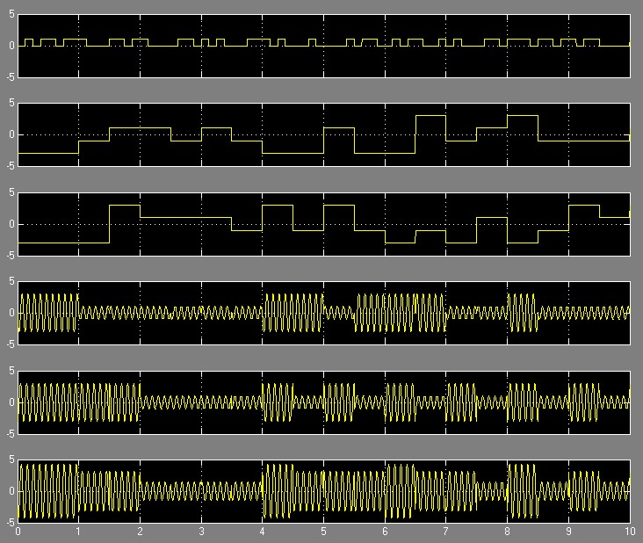
Figure 17. QAM modulation waveform

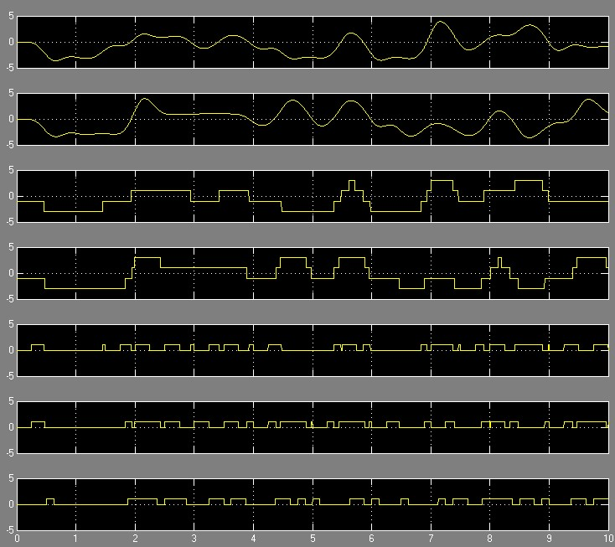
Figure 18. QAM demodulation waveform

Analysis
1)ASK signal
The final calculated bit error rate is shown in the table. In order to make the calculation result of the bit error rate more in line with the actual communication system, when calculating the bit error rate, the frequency of the source and the carrier is increased, and the source frequency is set to 50 Hz. The carrier frequency is set to 500 Hz, the simulation time is 10 s, and the simulation step size is set to 0.0001 s. Therefore, 500 bits are sent in total to calculate the bit error rate.
signal to noise ratio | -20 | -15 | -10 | -5 | 5
BER | 0.4072 | 0.3673 | 0.3214 | 0.2455 | 0.0519
signal to noise ratio | 10 | 15 | 20 | 25 | 30
BER | 0.01996 | 0.01597 | 0.01597 | 0.01597 | 0.01597
Figure 19. ASK Table of BER against signal to noise ratio
The data shown in the table is drawn by plotting to obtain the curve of the error rate of ASK signal with the signal to noise ratio.
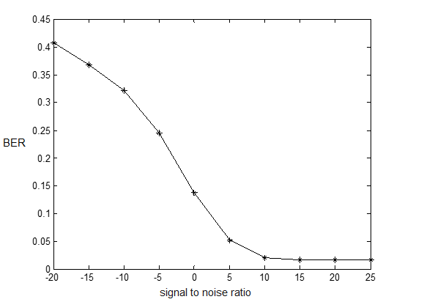
Figure 20. ASK signal error rate with signal to noise ratio curve
Conclusion: It can be seen that the bit error rate of the ASK signal decreases as the signal to noise ratio increases. When the bit error rate is reduced to a certain extent, the signal-to-noise ratio no longer decreases, and the bit error rate is no longer reduced.
2)PSK signal
Signal to noise ratio | -20 | -15 | -10 | -5 | 0
BER | 0.5075 | 0.4975 | 0.4577 | 0.393 | 0.2687
Signal to noise ratio | 5 | 10 | 15 | 20 | 25
BER | 0.1642 | 0.0398 | 0.00995 | 0.004975 | 0.004975
Figure 21. PSK Table of BER against signal to noise ratio
The data shown in the table is drawn by plotting to obtain the curve of the error rate of PSK signal with the signal to noise ratio.
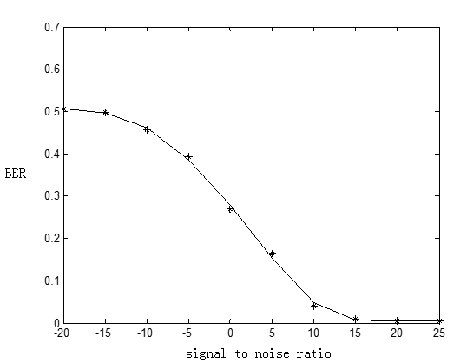
Figure 22. PSK signal error rate with signal to noise ratio curve
Conclusion: The bit error rate of the 2PSK signal decreases as the signal to noise ratio increases. When the bit error rate is reduced to a certain extent, the signal-to-noise ratio no longer decreases, and the bit error rate is no longer reduced. This suggests that when designing the actual communication system, we can only reduce the bit error rate as much as possible, and it is difficult to eliminate the bit error rate, and it is even impossible to eliminate the bit error rate.
3)QPSK signal
Signal to noise ratio | 10 | 15 | 20 | 25 | 30
BER | 0.06965 | 0.05473 | 0.0398 | 0．02985 | 0.02488
Signal to noise ratio | 35 | 40 | 45 | 50 | 55
BER | 0.02488 | 0.0199 | 0.0199 | 0.01493 | 0.01493
Figure 23. QPSK Table of BER against signal to noise ratio
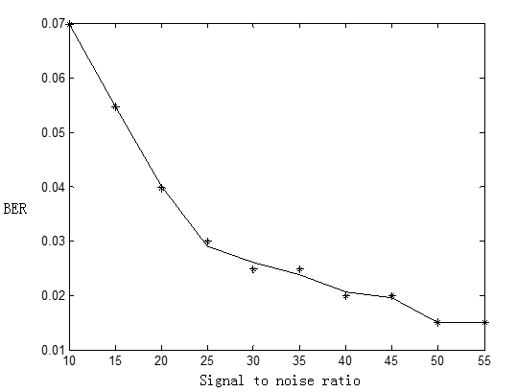
Figure 24. QPSK signal error rate with signal to noise ratio curve
Conclusion: The bit error rate of QPSK signal decreases with the increase of signal-to-noise ratio. When the bit error rate is reduced to a certain extent, the signal-to-noise ratio will not decrease anyway, no matter how the signal-to-noise ratio increases.
4)QAM signal
Signal to noise ratio | 5 | 10 | 15 | 20 | 25
BER | 0.1852 | 0.1378 | 0.0952 | 0.0788 | 0.07207
Signal to noise ratio | 30 | 35 | 40 | 45 | 50
BER | 0.06711 | 0.06334 | 0.06209 | 0.06173 | 0.06173
Figure 25. 16QAM Table of BER against signal to noise ratio
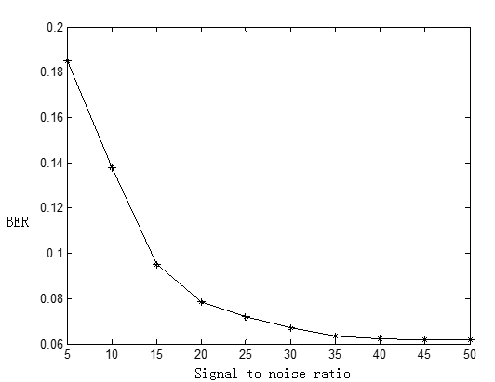
Figure 26. 16QAM signal error rate with signal to noise ratio curve
Conclusion: The bit error rate of the 16QAM signal decreases with the increase of the signal-to-noise ratio. When the bit error rate is reduced to a certain extent, the signal-to-noise ratio is no longer reduced, and the bit error rate is no longer reduced.

References
[1] Paul Horowitz;Winfield Hill. The Art of Electronics[M] Cambridge University Press,1989-07-28.
[2] Wang Jinzhi. Radio Foundation [M]. Beijing: Higher Education Press, 1994.
[3] Yang Suxing, et al. Analog Electronic Circuit [M]. Beijing: Central Radio and Television University Press, 2000.
[4] Xie Zimei. Electronic Circuit Design Experimental Testing [M]. Wuhan: Huazhong Science and Technology Press, 2000.
[5] Zhao Zhenchu. Radio Technology Foundation [M]. Tianjin: Tianjin University of Science and Technology Press, 1982
[6] Cheng Yuanchu, Xu Dehong, etc. SVC low-pass filter based on instantaneous reactive power theory is not counted and applied [J]. Journal of Electrical Engineering, 2008, 23(9): 138 — 143.
[7] Peng Liangyu, He Yigang, etc. Tunable current mode fifth-order ellipsoid low-pass filter design (JJ. Chinese Journal of Circuits and Systems, 2008, 13(6): 16-I8.
[8] Yuan Shiwen, deputy Kaiyu. A current type universal active source filter [J]. Journal of Instrumentation, 1998, 19(1): 6-9.
[9] Tian Shuqing, Li Muchunfu. A high frequency high Q current type active filter circuit [J]. Journal of Instrumentation, 1995, 16 (4): 398-401.
[10] Tan Jiajie, You Kaiming, Tang Jianfeng, etc. Based on EWB high-order active filter design research [J]. Journal of Hengyang Normal University, 2007, 28(3): 55-57.

