Step 1 : nmap localhost
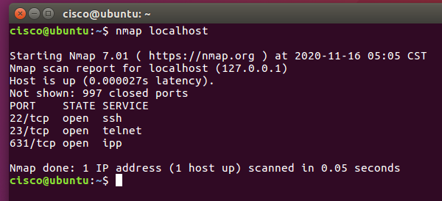

Step 2 : Replace the above command with your IP address and other hosts (if connected/else ignore) in your network to check the outcomes.
- Type the command you used to find out your host IP address
  - ip address
- Type the command you used to scan after finding your host IP Address
  - nmap 127.0.0.1
- Record the outcomes of the above command here
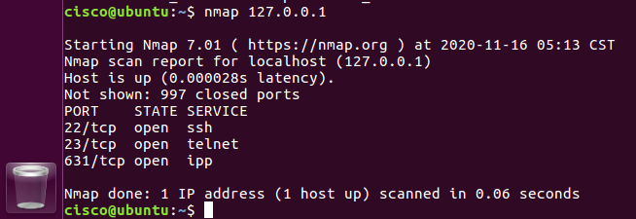

Step 3 : Analyse the outputs/outcomes from Step 1 and 2 and record your reflections.
The outputs are no different

Step 4 : Why is the nmap scan only scanning the first 1000 ports? What will be the command to scan all the ports?
This is the default setting of nmap.
Nmap -p- 127.0.0.1 will scan all ports (0 to 65335) of the given IP.

Step 5 : sudo nmap -sU localhost
Record the outcomes of the above command here
The command prompts for the password to run
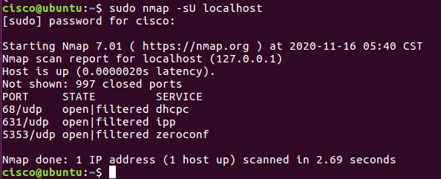

Step 6 : sudo nmap -p631 localhost
Record the outcomes of the above command here, also record use of -p command
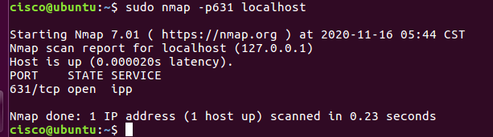
The port is open as the ipp service is running on it
The -p command scans the port(s) specified and returns the network information on them.

Step 7 : Try other port related commands and record the purpose.
- Sudo nmap -p631 localhost
  - Scans port number 631 of localhost only
- Sudo nmap -p0-6000 localhost
  - Scans port numbers 0 to 6000 of localhost
- Sudo nmap -p0,631 localhost
  - Scan port numbers 0 and 631 of localhost
- Sudo nmap -p- localhost
  - Scan all TCP ports of localhost
- Sudo namp -SU -p- localhost
  - Scan all UDP ports of localhost
- Sudo namp -p- localhost -T5
  - Faster scan of all TCP ports of localhost

Step 8 : Try to find out the version, nmap -sV localhost, Record the outcomes of the above.
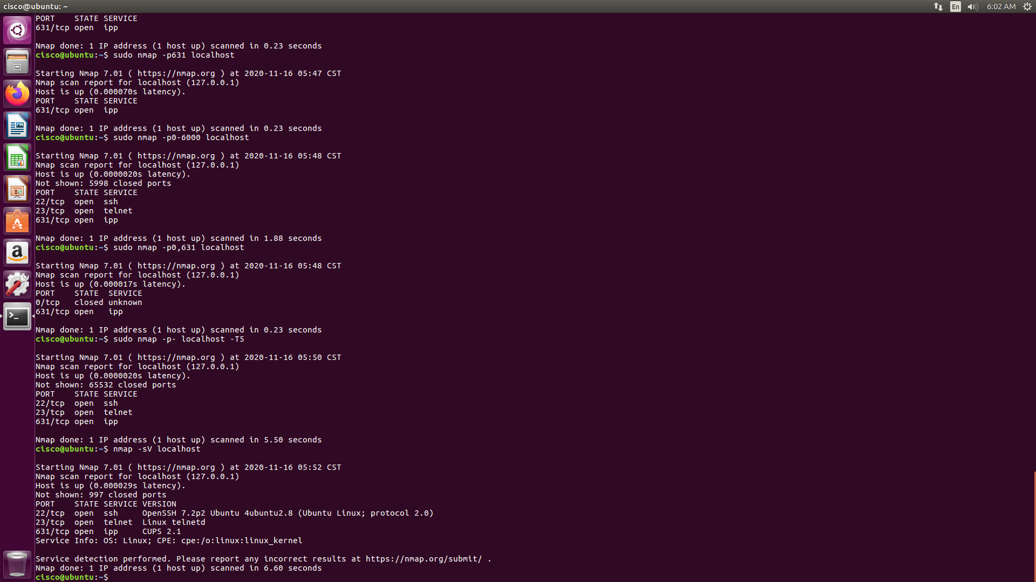
Returns the port information and what they are being used for, but also now tells us the version of software’s being used on each.
Also tells us operating system info.

Step 9 : Try other commands to detect other versions and record its purpose
Identify operating system version and service version
- Nmap -A localhost
  - Aggressive scan that enable OS detection, version detection, script scanning and traceroute.
- Nmap -O localhost
  - Operating System detection

