Foreign Languages & Cultural Awareness
Task 1 Portfoli
Lecturer: Giulia Chifari
Student name: Florentina Raluca Iamandi
Student ID: 2246151

Table of Contents
Component 1 - Professional Reflection 3
Component 2 - Training Plan 6
Component 3 - Student self-reflection 10
Component 4 – Training presentation 13

Component 1 - Professional Reflection
The following portfolio will be entirely based on the concept of foreign language which will eventually describe a scenario in which I have witnessed a cultural misunderstanding occur. Foreign language has great significance in the operations of different industries and businesses (De Leersnyder et al., 2022). In the business organisation where I last worked that is The Bentley Hotel London, I have acted as a manager. That was the time when I witnessed the occurrence of a misunderstanding due to the involvement of a foreign language. The Bentley Hotel London is quite renowned for its excellent features of 64 luxurious and spacious appointed bedrooms along with the classic chrysolite or peridot restaurant area. It is also matched with a cosy Malachite cocktail lounge area including Le Kalon Spa, a unique marble hammam, and a gym. Due to the many facilities provided by this hotel, it is considered to be a perfect place for business leisure that involves foreign customers. I was working as a manager in this hotel when I often encountered situations where conflict arose due to a misunderstanding in language or any cultural misunderstanding between foreign customers and staff members (Dominique, 2020). One of those situations had created quite a ruckus on a working day disturbing a few other customers as well. In that situation, a guest had ordered his breakfast from his hotel room through a phone call and was told to add extra spice and to provide sauce as well. The staff member from the hotel restaurant received the order and as per the guest's wish, he delivered his breakfast to his room. After receiving the food, the guest got angry and filed a complaint against that employee stating that he had received the wrong breakfast and not the one he had offered. He also added that the staff member behaved quite rudely during that phone call which made the guest more angry to complain about it or else he would have let it go. As the situation got worse instead of resolving it, I went to attend to that guest and listened to all of his complaints. I did a similar thing with the staff and after listening to him I understood the issue that occurred due to a misunderstanding. Actually, the breakfast ordered by the guest had a similar name to another English food which the staff had failed to acknowledge leading to a misunderstanding. As for the rude behaviour, the staff always speak loudly during a phone call while attending to his customers to make the communication clear (DABOU et al., 2021). He did not have an ounce of the idea that it can become rude to other customers and in this case, that is the exact thing that occurred leading that misunderstanding to a bigger conflict in the restaurant area. To mitigate that conflict, I made the staff realise this situation and asked for forgiveness with that staff from the guest for such inconvenience. The customer was quite generous as he let that pass and for that, I offered him his preferred food at free cost with a special spa facility. After the whole mess was solved, I asked my seniors to look into it so that they could come up with a solution to avoid erasing such misunderstandings in the future.

References
DABOU, S.P., HAMMOUDI, A. and CHIBANI, R., (2021). Teachers and students’ attitudes towards the integration of the target culture in the English as a foreign language class: A case study. International Journal of Linguistics, Literature and Translation, 4(4), pp.253-266.
De Leersnyder, J., Gündemir, S. and Ağirdağ, O., (2022). Diversity approaches matter in international classrooms: how a multicultural approach buffers against cultural misunderstandings and encourages inclusion and psychological safety. Studies in Higher Education, 47(9), pp.1903-1920.
Dominique, V., (2020). Business cultural training in a globalised economy. Training, Language and Culture, 4(1), pp.33-43.

Component 2 - Training Plan
A cultural misunderstanding or misunderstanding in language often occurs within a hotel business between its staff members and customers. To deal with such situations, the employees need to be prepared almost always and for that, a set of skills can be useful for them to get included in their training plan.
Skills to be  improved | Training format | Important  stakeholders | Training  partner | Allocated  budget
Communication Skills | There is a certain etiquette and process for communicating appropriately with people and more specifically with the hotel guests (Christiansen et al., 2020). For that, developing communication skills is quite important and it will require a few workshops, debates and sessions to develop. | Including multiple significant stakeholders such as managers, and customers, it also includes staff members of a business. | To develop this skill, the senior workers and colleagues as well as the manager can be involved stakeholders. | Developing this skill can cost around 1000 British pounds as it will require a few workshops, debates or sessions for it.
Language Knowledge | Learning a few foreign languages is one of the most important factors for working in this industry. To deal with foreign customers generally requires a basic knowledge of various languages and for that, a few learning sessions will be provided. In those sessions, a few expert mentors will be provided to offer their knowledge in different languages so that employees can effectively understand foreign languages on a basic level to the least. | Along with a few higher-ups, there can be managers, team leaders and employees. | There will be guides or mentors, staff members, team members and managers. | Providing foreign language training can cost about 1200 British pounds for giving the relevant guidance and mentors to the employees.
Active Listening Skills | Active listening skill is a vital skill in the hotel industry and for developing it a few workshops and learning sessions will be generated (Maheshkar and Sharma, 2018). By practising these skills effectively and specifically with the customers, active listening can be developed properly. | For this skill, customers play a vital role along with employees, managers or team leaders. | Including expert mentors, there can be managers, team leaders and colleagues. | This skill will also involve workshops and learning sessions that will cost around 1000 British pounds.
Conflict Resolution Skills | At certain times when conflict arises, conflict resolution skills will help the employees to come up with a solution themselves without relying on their higher-ups or managers (Abramson and Moran, 2018). A few training sessions and similar arbitrary situations will be provided to the employees to develop this skill. | The manager, team leaders, and workers are the main stakeholders involved in this training. | Along with colleagues, there can be senior staff, expertise meteors, or team leaders. | For this, 600-800 British pounds will be enough as it will require training sessions.
References
Abramson, N.R. and Moran, R. (2018) Managing Cultural Differences: Global Leadership for the 21st Century. 10th Ed. Abingdon: Routledge
Christiansen, B., Branch, J.D. and Karmowska, J. (2020) Cultural Factors and Performance in 21st Century Businesses. Hershey : IGI Global.
Maheshkar, C. and Sharma, V. (2018) Handbook of Research on Cross-Cultural Business Education. Hershey: IGI Global.

Component 3 - Student self-reflection
The major elements related to the hospitality industry are culture and society as the main purpose of this sector is entirely dependent on these two factors. For this reason, considering the aspects of culture and society is extremely necessary for maintaining business ethics in this business sector. The term cultural awareness explains the way of appreciating several cultural elements such as traditional differences and different language patterns. The knowledge of cultural awareness builds up a sense of etiquette and empathy towards wide cultural variances in the world (Oriade et al., 2021). The employees of organisations in the hospitality industry need to interact with numerous customers who belong to different cultural backgrounds and in order to serve them with the best experiences, the workers must have the knowledge of cultural awareness. My understanding of the positive impact of cultural awareness within this industry can be elaborated with the help of Kolb’s reflective cycle (Morris, 2020). Regarding the language-oriented issue that occurred in The Bentley Hotel London, I developed a basic sense of the significance of cultural awareness. It made me realise that having a basic knowledge of various languages is very important for the employees working in the hotel industry. It also helped me to understand that knowledge of different languages in hospitality employees is required to serve consumers ethically and enhance their overall experience. Later, I faced a quite similar situation as described previously and due to the pastly experienced scenario, resolving the problems was quite easier for me. The incidents guided me towards a better understanding of cultural awareness and the significance that I have learned includes improved customer experiences, enhanced employee engagement and prevention of conflicting situations (Oriade et al., 2021). For example, if employees face a situation where they are unable to understand the language spoken by their customers, it is impossible for them to provide services to them according to their needs and demands. This further can negatively affect the fame and reputation of organisations decreasing their mass of overall consumers. With improved expertise in different languages in workers, organisations can provide their consumers with the best services and good experiences (Koc, 2020). By implementing the plans for cultural awareness development, business bodies can enhance the organisational environment with improved cross-cultural communication reducing the chances of misunderstandings between the authorities and the customers. My newly developed consciousness related to this particular topic helped me massively in resolving various conflicting situations and will guide me to deal with such challenging circumstances in future as well. Due to the experiences that I have gathered, I learned that for upgrading cultural recognition in employees factors like a better understanding of cultural differences, respecting every kind of communication style and respecting several traditions are highly essential (Koc, 2020). For example, I started learning about various traditions and their significance to the people following them. This thing effectively supported my learning process till now. Following these aspects, I can increase my knowledge of cultural awareness and learn more about the practical applicability of the subject as well.
References
Koc, E., (2020). Cross-cultural aspects of tourism and hospitality: A services marketing and management perspective. Routledge.
Morris, T.H., (2020). Experiential learning–a systematic review and revision of Kolb’s model. Interactive learning environments, 28(8), pp.1064-1077.
Oriade, A., Osinaike, A., Aduhene, K. and Wang, Y., (2021). Sustainability awareness, management practices and organisational culture in hotels: Evidence from developing countries. International Journal of Hospitality Management, 92, p.102699.

Component 4 – Training presentation
Slide 3:
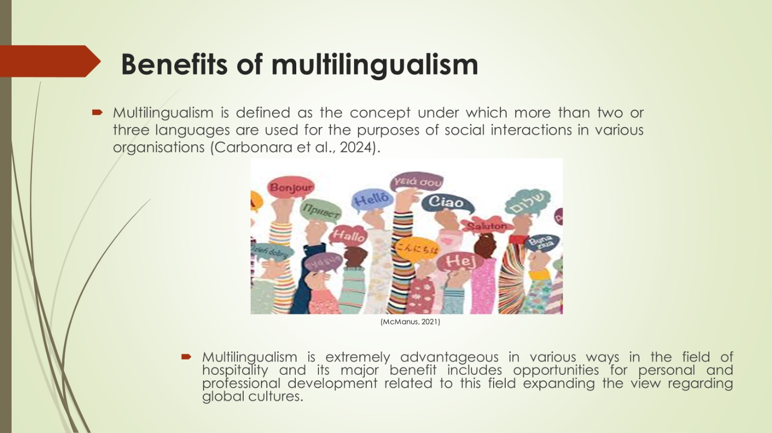
Notes:
Benefits of multilingualism
Multilingualism is defined as the concept under which more than two or three languages are used for the purposes of social interactions in various organisations (Carbonara et al., 2024). Multilingualism is extremely advantageous in various ways in the field of hospitality and its major benefit includes opportunities for personal and professional development related to this field expanding the view regarding global cultures. It is also beneficial for improving social skills such as active listening and conflict management which are considered a very important skill for the workers in the hospitality industry, especially for hotel staff (Steurs, 2020).

Slide 4:
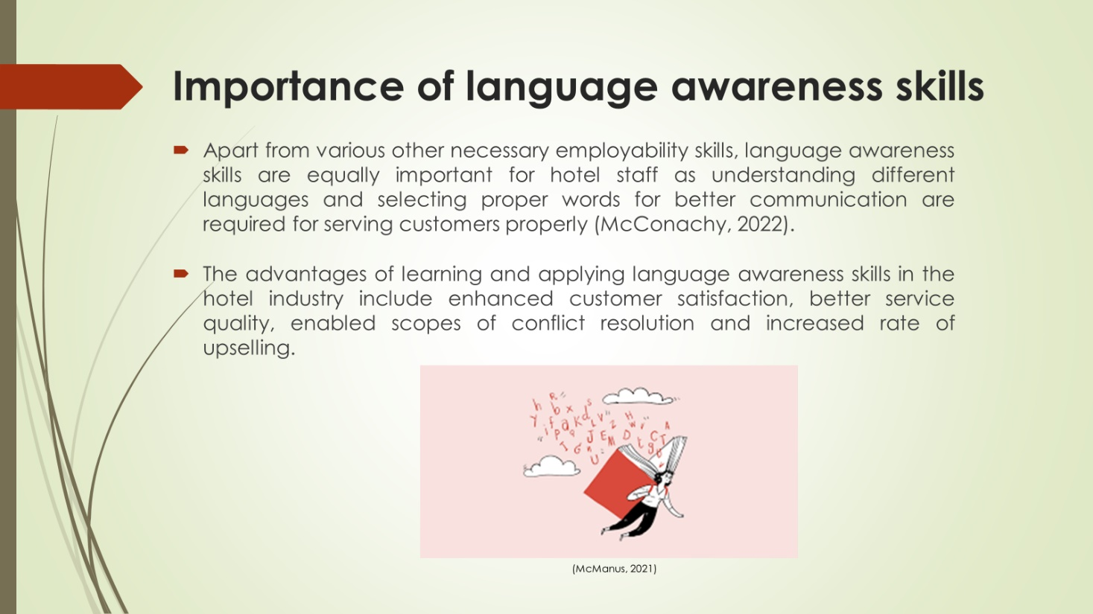
Notes:
Importance of language awareness skills
Apart from various other necessary employability skills, language awareness skills are equally important for hotel staff as understanding different languages and selecting proper words for better communication are required for serving customers properly (McConachy, 2022). The advantages of learning and applying language awareness skills in the hotel industry include enhanced customer satisfaction, better service quality, enabled scopes of conflict resolution and increased rate of upselling. It is helpful for inter-organisational communications, cross-departmental interactions and gathering constructive feedback regarding hotels as well (Steurs, 2020).

Slide 5:
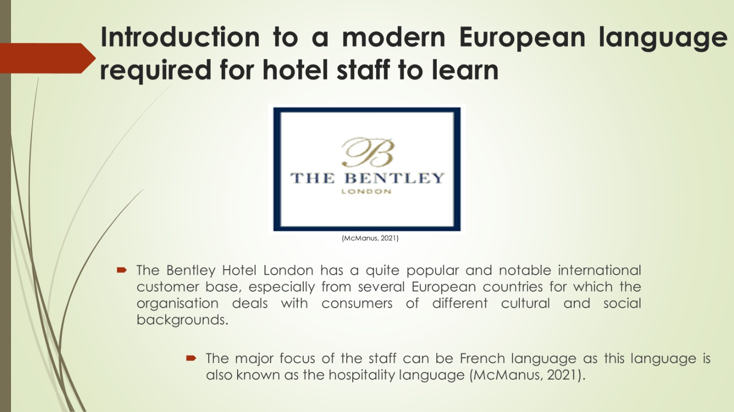
Notes:
Introduction to a modern European language required for hotel staff to learn
The Bentley Hotel London has a quite popular and notable international customer base, especially from several European countries for which the organisation deals with consumers of different cultural and social backgrounds. This is why, focusing on the development of European languages is necessary for the staff of The Bentley Hotel London. The major focus of the staff can be French language as this language is also known as the hospitality language (McManus, 2021).

Slide 6:
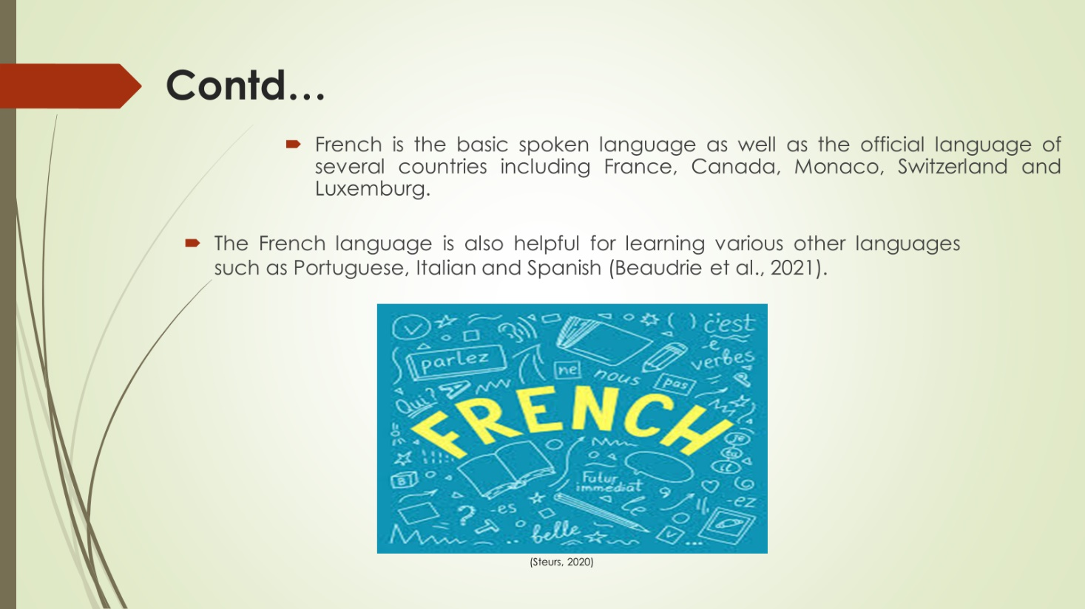
Notes:
Introduction to French language
French is the basic spoken language as well as the official language of several countries including France, Canada, Monaco, Switzerland and Luxemburg. It is also the major communicative language of the economic community in Europe (McManus, 2021). Due to such wide expansion of this language throughout Europe, learning the language is fruitful for the hotel staff of The Bentley Hotel London. The French language is also helpful for learning various other languages such as Portuguese, Italian and Spanish (Beaudrie et al., 2021).

Slide 7:
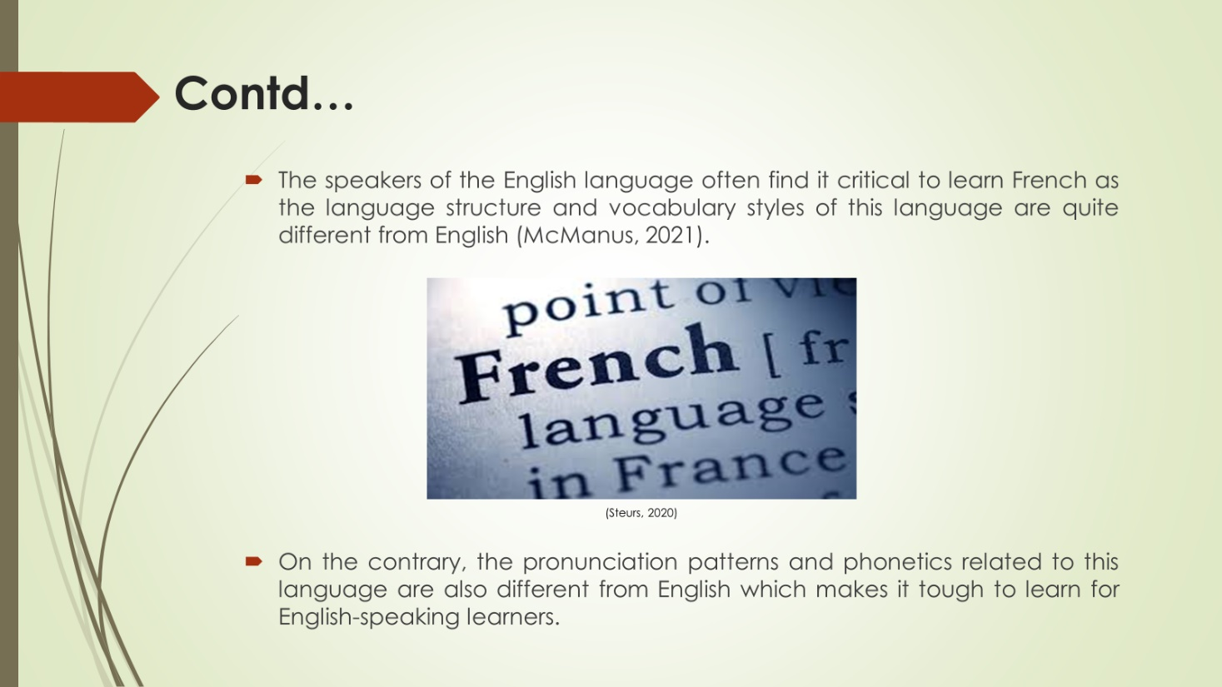
Notes:
Difficulty in learning the French language
The speakers of the English language often find it critical to learn French as the language structure and vocabulary styles of this language are quite different from English (McManus, 2021). On the contrary, the pronunciation patterns and phonetics related to this language are also different from English which makes it tough to learn for English-speaking learners.

Slide 8:
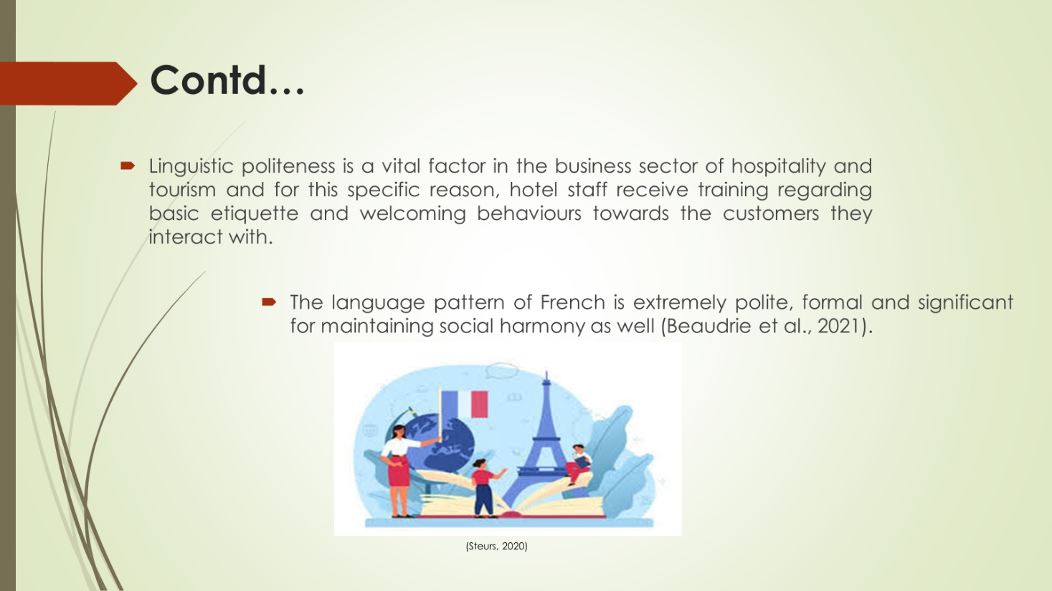
Notes:
Reasons behind considering the French language polite in business contexts
Linguistic politeness is a vital factor in the business sector of hospitality and tourism and for this specific reason, hotel staff receive training regarding basic etiquette and welcoming behaviours towards the customers they interact with. The language pattern of French is extremely polite, formal and significant for maintaining social harmony as well (Beaudrie et al., 2021).
References
Beaudrie, S., Amezcua, A. and Loza, S., (2021). Critical language awareness in the heritage language classroom: Design, implementation, and evaluation of a curricular intervention. International Multilingual Research Journal, 15(1), pp.61-81.
Carbonara, V., Scibetta, A. and Torregrossa, J., (2024). The benefits of multilingual pedagogies for multilingual children’s narrative abilities. International Journal of Multilingualism, 21(2), pp.645-669.
McConachy, T., (2022). Language Awareness and Intercultural Communicative Competence: Revisiting the Relationship. Intercultural Learning in Language Education and Beyond: Evolving Concepts, Perspectives and Practices, pp.22-40.
McManus, K., (2021). Crosslinguistic influence and second language learning. Routledge.
Steurs, F., (2020). Language is business. The challenges of a single digital market in a multilingual society. Language and Economy, p.39.

