ROXANA NICOLETA MORARU( 2120441 )
DIGITAL SKILLS AND RESEARCH METHODS
BMSW4003_BIRM
ABDI RAHMAN

Digital skills & Research Methods
REPORT- RESEARCH REPORT

Digital skills are a set of skills and knowledge that enable the safe and efficient use of information technology. They are considered essential in the information society we are in.

Digital skills, also known by many people as electronic skills due to their English concept, are those technical knowledge and skills that allow the use of different computer media correctly and efficiently.

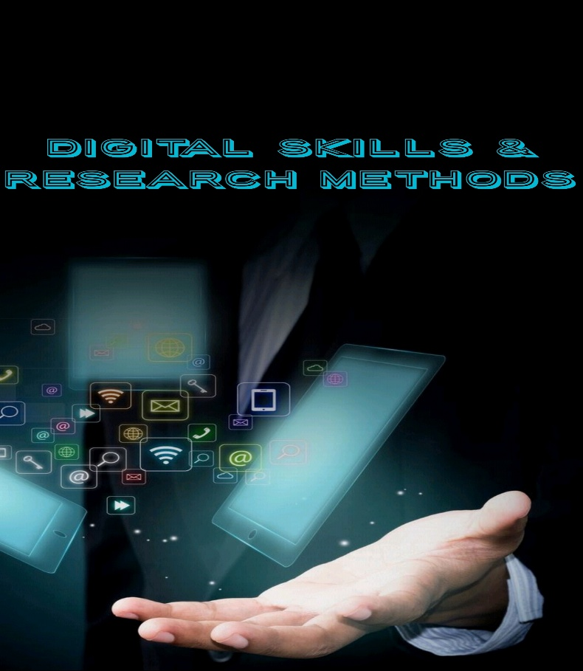

Technology has revolutionised every aspect of life, including interpersonal interactions, the economics, the entertainment sector, and even education. Students appear to be confronted with changes that not only profoundly alter the way they learn, but also their everyday lives, today more than ever. It's impossible to deny that modern technologies have had a profound impact on new generations of pupils. Children have long been prepared for the modernisation of education, having grown up with computers, tablets, other gadgets, and sophisticated digital systems. With this in mind, the value of technology in education becomes even more apparent. Learning styles have evolved over time, with new technologies that have the potential to improve instruction gradually being introduced.
The readiness of students for technology in the classroom is great news, because the digital age presents new challenges not only in education, but in all aspects of life. As a result, it is critical that children learn to harness all of modern society's potential while still in school.

The use of advanced technologies, such as software and hardware, to facilitate modern teaching methods is referred to as educational technology. Pupils and educators will have access to a variety of digital and instructional materials, which will facilitate mutual cooperation and make it easier for students to grasp the topic. Changes have occurred at all levels of education, from elementary school to college, as a result of this new approach.
Student needs and living habits are strongly tied to improving the learning experience. Children expect information to be delivered in a similar manner at school because they utilise social media, the Internet, and video games on a daily basis. The content of the lesson should be visual and interesting, capturing the students' attention and containing as little redundant material as possible.

It is obvious that teachers must understand their students' requirements, how they communicate with one another, and what can be done to capture their attention and pique their interest in the educational topic. Instead of causing intergenerational conflict, youngsters will wish to use their knowledge for educational objectives. Surprisingly, modern technologies and instructional methods assist instructors as well, because many aspects of their jobs have been simplified.

In this report, we will assess and explore how technology is used to cooperate at UWTSD, why it is used, and the benefits and cons of using technology in the classroom in this study.
It will contain a hypothesis, which is an assumption that must be present in order to be tested as true or false, an argument for, an argument against, data collected, results, and a conclusion.

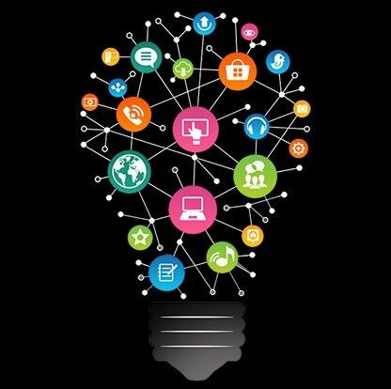

What is a technology and why is so important?
The basic goal of technology, which brings together tools to promote development, use, and information sharing, is to make chores easier and to solve many of humanity's issues. We must emphasise how beneficial technology is to our lives as it advances and makes our lives even more convenient.
Technology has an impact on how people communicate, learn, and think. It contributes to society and influences how individuals interact on a daily basis. In today's world, technology plays a critical role. It has both beneficial and negative repercussions on the planet, as well as a direct impact on people's lives.

In reality, technology has had a significant impact on how we live in the world today and how we communicate with everything in our environment. The impact of technology is more than we anticipated. As a result, we're working on new inventions to help us live a better, more standardised existence. Some of this technology aids rising countries in developing stronger infrastructure, which includes better transportation, schools, hospitals, and other municipal services, as well as healthcare access. Small and medium-sized enterprises. (Why Technology Is Important In Our Daily Life? 2021)

How do we use technology to collaborate at UWTSD?
Students have access to a plethora of online resources thanks to technology, which encourages them to conduct research and so become more self-sufficient. It also makes learning easier by making concepts more consumable, such as through the use of an instructional film.

I believe that, while technology is widely accepted, there are still some misunderstandings and worries; yet, students and faculty are confident enough to use it in the classroom. In a classroom, phones can be incredibly distracting, and teachers may be unable to get their pupils to put them down. On the other hand, teachers can use their phones to check their students' work, providing immediate feedback or truly checking on them. Life has become easier as a result of technological advancements, because technology is no longer new and is found everywhere, the premise was that it would be generally accepted, despite its misconceptions and worries. Because technology has become such an integral part of everyone's day-to-day lives and people rely on it heavily, the hypothesis is that because it is a constant in everyone's lives in one way or another, students and faculty in the educational world (university, college, or school) are confident in using technology to collaborate.

The hypothesis of the question was that because technology is no longer new and is found everywhere, it is largely accepted, despite its misconceptions and worries. Because technology has become such an integral part of everyone's day-to-day lives and people rely on it heavily, the hypothesis is that because it is a constant in everyone's lives in one way or another, students and faculty in the educational world (university, college, or school) are confident in using technology to collaborate.

Secondary and primary research were chosen to argue for or against the question. Secondary research, often known as desk research, is a research approach that uses previously obtained data. Existing data is collated and summarised in order to increase the research's overall efficacy. Research information that has been published in research reports and other comparable papers is considered secondary research. These materials can be found in public libraries, on websites, and in data from previously completed surveys, among other places. Data can also be retrieved and used for study by some government and non-government organisations.

Primary research, on the other hand, is characterised as a method by which researchers collect data directly rather than depending on data from prior studies. They "own" the data in a technical sense. Primary research is undertaken for the primary purpose of addressing a specific problem that requires in-depth investigation.

We used primary research, and because there are various types of primary research methods to choose from, I decided to go with questionnaires with closed questions that are multiple-choice because they are quick and easy, and because I realised that people are not going to stand there and complete a 20-minute write-up on anything, so quick and easy, so basically five minutes would get me the answers I want, and comparison with secondary research.

The results we got were that, with 45 people participating in this, the results showed that 98 percent of the people who took part had phones and couldn't live without technology; they believe that teachers incorporate technology in the classroom; however, they believe that a challenge they face as teachers is that students can't get off their phones. With this survey, we discovered that both students and teachers have similar feelings. The 98 percent does not apply to the entire globe because this was a small case study, and other people may have achieved different results than we did.

Because technology was developed to communicate in order for relationships to perish and flourish, students and staff are confident in using technology to interact. As a result, everyone gained confidence in using it, regardless of whether it was utilised for good or harm. Teachers, as educators, provide support, criticism, thought, and opportunities. They use technology to support their students with tasks or help outside of college, university, or school hours, and, as I previously stated, they instil confidence in their students. Because technology is now so readily available and freely supplied, people have gotten accustomed to having it.

In conclusion, digital skills are those knowledge and skills that allow us to surf the web or use electronic devices safely and efficiently in everyday life, study and work.



