Spaces and Places to Learn – Educational Visit.

Outdoor Learning can open a wide range of opportunities and experiences for pupils. The institute for Outdoor Learning (No date) would agree as they state that “taking the curriculum outside can improve attainment, increase engagement, and develop a wide range of skills including problem solving, communication and resilience..”. (Institute for Outdoor Learning, Helping teachers deliver outdoor learning in the curriculum). This implies that outdoor learning should be enriched within the curriculum and should be encouraged, to provide new skills and provides personal, educational and social experiences. Outdoor learning should be promoted as the outdoors provides opportunities to focus on the aims of the curriculum. Donaldson (2015) notes that one of the aims of the new curriculum is to ‘prepare pupils for experiences later in life’ and he states that the curriculum should ‘interest all learners and enable them to achieve’ (Donaldson, 2015, Successful Futures) and I believe the outdoors could provide these opportunities.

This assignment focuses on taking pupils on an outdoor, educational visit to a forest which could provide opportunities for pupils to develop skills. This assignment will discuss all aspects that should be thought of prior, during and after the educational visit. The visit will focus on taking a class of pupils from ‘John’s Community Primary School’ in Haverfordwest, a class of 24 pupils to Scolton Manor in Haverfordwest. This location is perfect for the visit as it has a forestry area and an indoor house and café if the weather is not suitable for the activities. An educational visit can provide wider experiences “where learners will benefit from the best possible learning opportunities both inside and outside of school” (Welsh Government, Education in Wales: Our National Mission – 2017-21, pg.19). The National Justice Museum (No Date) would agree that educational visits are vital for pupils as they suggest that they encourage pupils to engage with places and people in different ways. They also suggest that by taking pupils on educational visits it provides ‘kinaesthetic learning’ which is unique. Learning in a different environment, the outdoors, instead of the classroom is valuable for every pupil, implying that learning environments have an influence of pupil learning.

In today’s modern society, the classroom is widely used, and is the most prominent learning environment, however, the classroom has not changed significantly to what they were hundreds of years ago. To produce the best possible outcomes and provide pupils with effective teaching, learning environments need to be adapted to the needs of the pupils. Building Futures (No Date) suggest that schools need to realise that schools are not the places where learning is present, therefore, schools need to be flexible and embrace innovation and creativity. The Glossary of Education Reform (No Date) state that a learning environment “refers to the diverse physical locations, contexts, and cultures in which students learn” (The Glossary of Education Reform, Learning Environment, no date). In order to create effective teaching and stimulate pupils’ interest to learn, a positive learning environment is essential. Racoon Gang (No Date) suggest that in order to achieve a positive learning environment, factors need to be present such as the wellbeing and safety of each pupil, providing a supportive environment and attending to learners needs. Waldman, C (2016) would agree as she suggests also that pupils need to feel safe and they need their learning to be personalised.
Furthermore, Clint (No Date) suggests that there are four types of ‘learning environments’; He suggest that there is a student/learner learning environment which focuses on building on prior knowledge; A knowledge centred learning environment which enables students to learn information with a deep understanding; An Assessment centred learning environment which stresses the need for feedback and lastly, a Community centred learning environment which “utilize the outside community and it’s given resources..” (Kountz, No Date). From research, students learn through a variety of learning environments, from the outdoors to an outside of classroom setting which would focus on a community centred, student/learner and knowledge centred learning environment. The term ‘learning environment’ is used to present a preferred alternative to a classroom setting, but does an alternative setting provide opportunities for pupils to develop their skills?. Schools need to be more diffuse in their operations, and they need to provide more opportunities which offer a wider range of educational experience and I believe that the outdoors offer these opportunities. Educators argue that learning outdoors both have an indirect and direct influence on student learning, including pupil’s motivation to complete activities and learn, their engagement regarding what is being taught, their sense of wellbeing, also their personal safety. The learning environment clearly benefit a variety of groups, especially outdoors. Estyn (2011) suggest that outdoor play can benefit groups significantly as their research implies that all children are benefiting to a degree. They suggest that boys do however gain the most out of outdoor learning as they learn from an active-learning style. Although, they are undecided whether outdoor learning benefits more able and talented pupils. The outdoor learning environment is clearly seen to be beneficial to multiple pupils and Bell et al. (2009) suggest that an outdoor learning environment can interest and motivate them to learn new things. Additionally, Peacock (2006) believed the learning environment to provide more memorable and stimulating learning experiences.

Outdoor learning can provide multiple opportunities for all pupils, as it offers an alternative learning environment to the traditional, and well used classroom. However, for a teacher or supervisor, there are many considerations that need to be discussed if an outdoor visit is planned for pupils. Firstly, the aims of the visit need to be considered in order to know where the learning is heading and what should be achieved by the end of the visit. For this particular outdoor visit, the aims that I believe that are suitable are as follows; To develop pupils communication skills with others by sharing their knowledge as this will focus on the Language, Literacy and Communication, the strand of ‘Oracy’ and the skills of “talk about things they have made or done, explaining the process” and “listen to others, with growing attention, usually responding appropriately, e.g. carrying out instructions “ (Welsh Government, Foundation Phase Framework 2015, pg. 14/15). Another aim of this educational visit is to ensure that pupils are confident and fully engaged with an outdoor environment. This will therefore enable pupils to feel safe outdoors and enable them to be more confident outdoors, which will hopefully encourage pupils to utilise the outdoors more often. By encouraging pupils to get outdoors it will enable them to learn and develop skills and the Welsh Assembly Government (No Date) would agree as they state that “being outdoors enhances all aspects of children’s development..” which supports the view that an outdoor visit would be beneficial for all pupils (Welsh Assembly Government, Foundation Phase – Outdoor Learning Handbook, no date, pg. 2). Another aim for this specific visit would be to encourage pupils to use the sensory activities to explore and investigate, and to develop fine motor skills. Focusing specifically on the skill of ‘Physical Development, the range being “exploring and investigating their indoor and outdoor learning environments” and the skill of “developing sensory awareness” (Welsh Government, Foundation Phase Framework 2015, pg, 44). Developing aims for an outdoor visit enables the best possible outcomes for all pupils, to develop their skills further and increase confidence outdoors.

“Taking the curriculum outside can improve attainment, increase engagement, and develop a wide range of skills including problem solving, communication and resilience” (Institute for Outdoor Learning, Helping Teachers deliver outdoor learning in the curriculum, no date). Outdoor learning can provide endless opportunities for learning and that is why an outdoor environment should be used more frequently. For this visit, I have chosen an outdoor environment to provide an opportunity for pupils to develop prior knowledge and extend skills. I have chosen to take pupils to a forest location in the locality, so the travelling distance is minimal but provides the same opportunities to increase learning. The location is called ‘Scolton Manor’ and is placed in the area of Bethlehem, Haverfordwest, which is a short 15 minutes from the school that I have previously mentioned. The location is perfect for the activities that I have planned for the pupils as is surrounded by sixty acres of park and woodland, with plenty of open spaces. The Board of Education (1933) would suggest that this is a great opportunity for pupils as they state that “the open air provides the best environment for the physical well-being” (Board of Education 1933, p.125). Due to the location having a lot of space for pupils to explore, it will excite them and hopefully, make them want to learn. By the outdoors not only exciting pupils as it’s an alternative environment, it will provide pupils to connect with nature; Dr Ahmed Djoghlaf (No Date) would agree as he suggests that pupils need to be educated about nature as they can preserve it. They need to be educated today to use tomorrow. Froebel (in Lilley 1967) suggests that pupils should experience nature and all its qualities. Focusing on ‘Scolton Manor’ once again; the location is additionally extremely adaptable to all weathers as it has an indoors facility which will accommodate the activities even if the weather is inclement. I have visited the location prior to planning this visit and have taken pictures to show how adaptable the location can be, with the vast amount of forestry area and an indoor area (Appendix 1). However, the location is not the only aspect that needs to be considered.

The Foundation phase outdoor learning handbook states that “the Foundation Phase and the outdoors are inseparable” (DCELLS 2009: 2). They suggest that the outdoors is ideal as it offers unique opportunities; opportunities to be creative, be noisy and move around, which is perfect for the Foundation phase. I have chosen to focus on the Foundation Phase for my outdoor visit as I believe that they work extremely well outdoors. I have specifically focused on a year one class as they are at the stage where they can develop prior knowledge and develop new skills also. The outdoors can offer young pupils a range of exciting and new opportunities and is extremely important. Effective Practice: Outdoor Learning (2007) would agree as they suggest that for young children, the outdoors support the development for freedom, movement physical activity. The class that I have chosen to take are educated in ‘John’s Community Primary School’. The class specifically that I will take will consist of 24 pupils, including a child who is wheelchair bound. I will have to consider the pupils needs and adapt the activities that I have planned to suit them; This will ensure that they can participate in all the activities. The Department for Education and Employment (No Date) suggest that all pupils have the right to have equal opportunities, irrespective of medical needs, sex, educational needs or religion, every effort should be made to ensure that all pupils needs are catered to.

“An emotionally powerful experience need not be spectacular, it may be a well-read story, a visit to the playground pond or reminiscences by the school ‘lollypop lady’. It might equally be a trip to the swimming pool, museum or the local wood”. (Barnes 2015, An introduction to Cross Curricular Learning, pg. 265). Focusing again on the visit that I have planned, the theme that I have focused on is ‘the senses’. The activities that I have planned for the pupils will focus on developing pupils ‘Five Senses’, I believe that this theme will be beneficial to all pupils as they are the primary means we use to gain new knowledge. When pupils are outside, there are many sensory experiences that can occur. Semerda, U (2015) would agree as she suggests that the outdoors offers endless opportunities and experiences for sensory experiences. The theme is not the only aspect that needs to be considered prior to the visit.

Prior to the visit, aspects need to be considered. Firstly, I will have to plan for all aspects on the visit such as what will be taught and focused on before the visit happens. I have planned that prior to the visit, I will focus on the theme of senses in order to introduce the activities ready for the visit. The pupils will be asked to draw a picture of what they think the forest will be like, completing the picture with any raw materials that they have found. By giving the pupils free choice, I believe that this will engage them more. Anderson, M (2016) would agree that this is a great way to engage learners as he suggests that by giving pupil choices, it will boost their learning. Furthermore, using different raw materials will provide them with an introduction to utilising the outdoors. After the drawing is created, I will ask the class to join in with a class discussion and come up with sentences regarding each sense (Spoken about further in ‘Appendix 1’). By discussing idea’s, I will focus on a social constructivist teaching approach as pupils will be discussing idea’s and developing teamwork skills. A range of skills will be focused on throughout the activities prior to the visit such as ‘Oracy’ as pupils are expressing their views and ‘Creative Development’, focusing on ‘Art, Craft and Design’ (Welsh Government, Foundation Phase Framework 2015). Furthermore, National Guidance (OEAP) suggest that ‘SAGE’ needs to be considered during the planning of the visit. (Document in ‘Appendix 2’). First, staff needs to be considered. I will focus on the ratio of adult to children. I will ask some parents if they can volunteer, so there is more adult supervision during the visit. Plan my School Trip (No Date) suggests that this consideration is extremely important. The group, so if any pupils have medical or individual needs, then they need to be catered to and the environment. The SEN and Disability Act (2001) suggests that schools are required to ensure pupils with disabilities are not treated differently. This will mean that I will have to think about my activities and develop them to suit the needs of the pupil. Another aspect that needs to be considered before is to plan the activities that will occur during the visit, the activities are spoken about previously. Planning for the is essential as it will enable you to focus on any aspects that need to be looked at. The environment needs to be considered by assessing risks and what the location includes. I have produced a risk assessment which focuses on any specific risks that could occur and how to control the risks. (Appendix 3). Lastly, I will need to prepare pupils and adults for the visit. However, I will have to prepare adults further as once the groundwork has been done, I will send them a letter to let them know details regarding the trip. Parents will be advised on how their children ought to be dressed and advise them to bring packed lunches. I will also have to send out a consent form for all parents to sign, which will indicate what pupils can attend the trip (Appendix 4).

After every aspect has been considered, the pupils will attend the trip. The activities will be focusing on the theme of ‘The Senses’ and pupils will be instructed by myself and the other adults to perform activities developing their sensory awareness. The pupils will be set in different ability groups and supervised by an adult, with an adult to pupil ration of 1:8. OEAP (2018) recommends this ratio for Early Years Foundation Phase, considering how every child will be supervised. Before the pupils can begin their activities, I will gather all pupils to inform them of dangers and risks within the forest and ask them to be vigilant throughout the day. The pupils will be using the forest land in ‘Scolton Manor’ to complete 4 activities. The activities will focus on ‘Smell’, the pupils will have to make ‘Woodland Perfume’ out of the raw materials that they can find within the forest grounds; ‘Sound’, the pupils will have to stand quietly in an open area and listen to the sounds around them, they will consequently produce a listening map (Appendix 5); ‘Touch’, the pupils will hug a tree, feeling the textures and they will produce a drawing which portrays what they have felt and Sight, the pupils will be asked to use colour swatches (Appendix 6) to match the colours on the swatches to the colours that they see in the forest. Due to the pupils being active in their leaning, I will focus on a Constructivist Teaching Approach as pupils will be involved in direct experiences. I have completed a lesson plan which expands on the activities (Appendix 7). During the visit, there will be a range of skills covered, such as ‘Physical Development’, ‘Language, Literacy and Communication’ and ‘Personal and Social Development, Well-being..’ and each skill will benefit each pupil greatly (Welsh Government, Foundation Phase Framework 2015). The pupils will be encouraged to speak with peers and they will be asked constant questions throughout the day, which will focus on a Social Constructivist Teaching Approach. By questioning the pupils, it will stimulate interest and Delamont (1976) suggests that questioning is positive as they are a staple of classroom life.

Subsequently to the pupils attending the visit, the learning will carry on, focusing on what happened and what they experienced. Post to the forest visit, where a range of skills were focused on and developed, pupils will be asked to discuss with eachother what they have done, focusing on their day at the forest. This will focus on developing their ‘Oracy’ skills as pupils will “talk about what they have made or done..” (Welsh Government, Foundation Phase Framework 2015, pg. 14). It focuses on a Constructivist Teaching Approach as pupils will be starting from their understandings. Additionally, the pupils will use an application on the Ipad’s, working in pairs to write a short story about their time at the forest. I will ask the pupils to focus on each of their senses that they focused on throughout the visit, to get the full experience and learning out of the visit. By using the Ipad’s and working in pairs, pupils will develop Digital Competence skills as they are collaborating with “others on a piece of work” (Welsh Government, DCF Framework – Year 1 2016). Teamwork skills can benefit pupils greatly as pupils will be able to use the ability to work simultaneously in every aspect of later life. Additionally, by developing teamwork skills, I am focusing on a Social Constructivist Teaching Approach as I am encouraging pupils to collaborate and discuss ideas. I have produced a lesson plan which advances on the ideas previously mentioned (Appendix 8).

By providing an exciting and new experience for pupils, it will stimulate pupils’ interests and provide an opportunity to develop skills further. Outdoor learning focus on pupils being active and Griggs (2010) suggests that active learning is valuable for the Foundation Phase as young children need to play and be actively involved in activities. Due to pupils being active in learning, Dewey, a constructivist focuses on experimental learning, suggesting that experience should be at the heart of pupils learning. Therefore, by taking pupils on an outdoor trip, it offers pupils an opportunity to experiment with their learning, take risks and be involved in different types of play which Foundation Phase pupils should be entitled to. By providing pupils with this visit, I hope to inspire pupils and develop a sense of awe regarding nature. Montessori believed that pupils should be inspired by the feeling of nature.

Appendix.

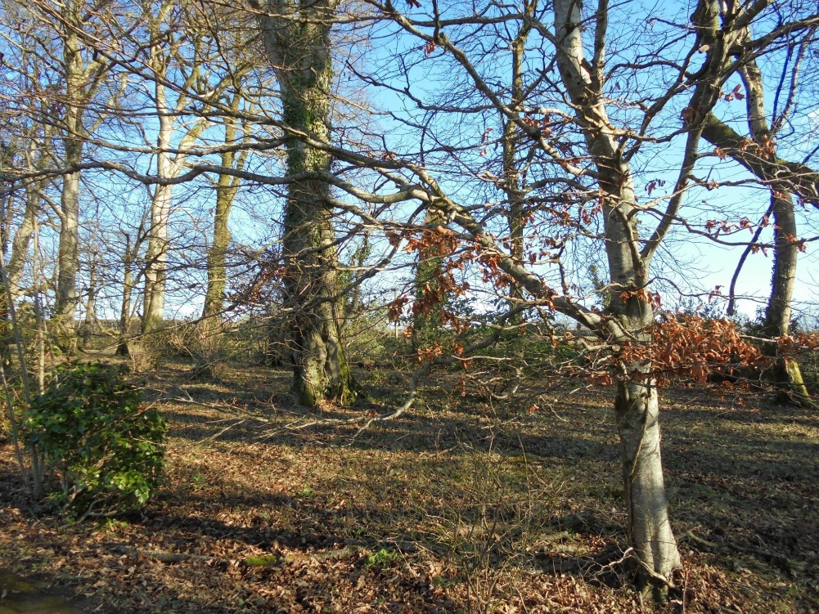
Appendix 1 – Images of Forestry Area/Woodland and Indoor House (Scolton Manor).

Images of the Woodland/Forestry Area in the grounds of Scolton Manor.

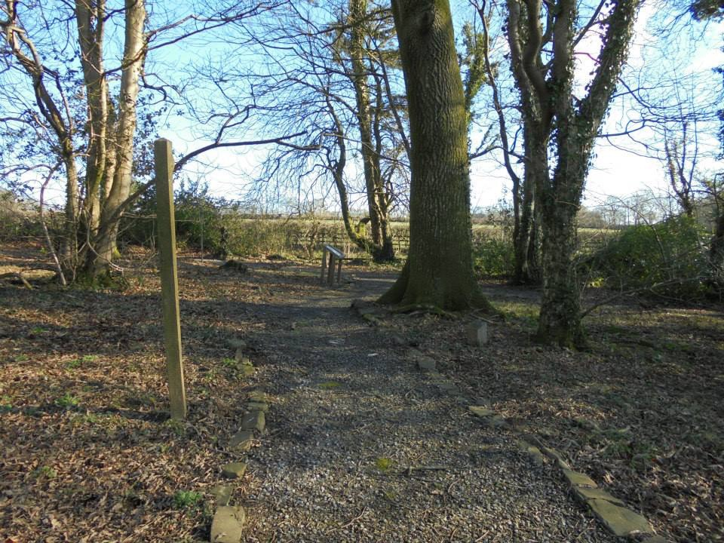

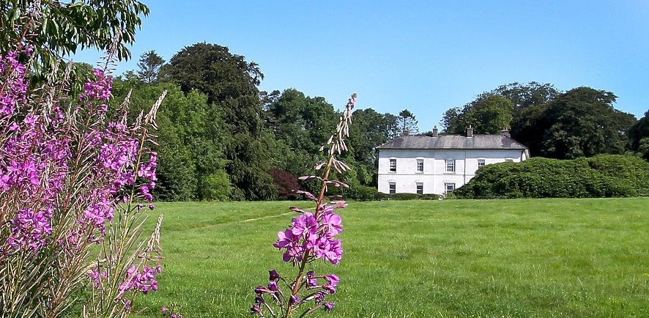

Image taken of the grounds of Scolton Manor and an image of the indoor house by which activities can take place.

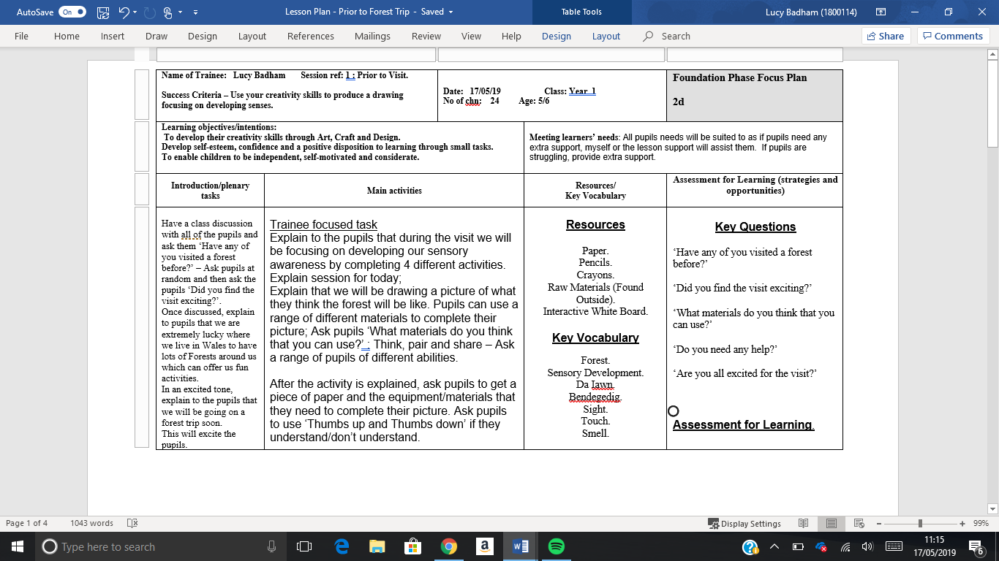
Appendix 2 – Lesson Plan prior to the visit.
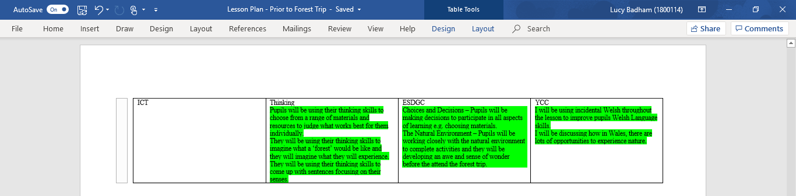
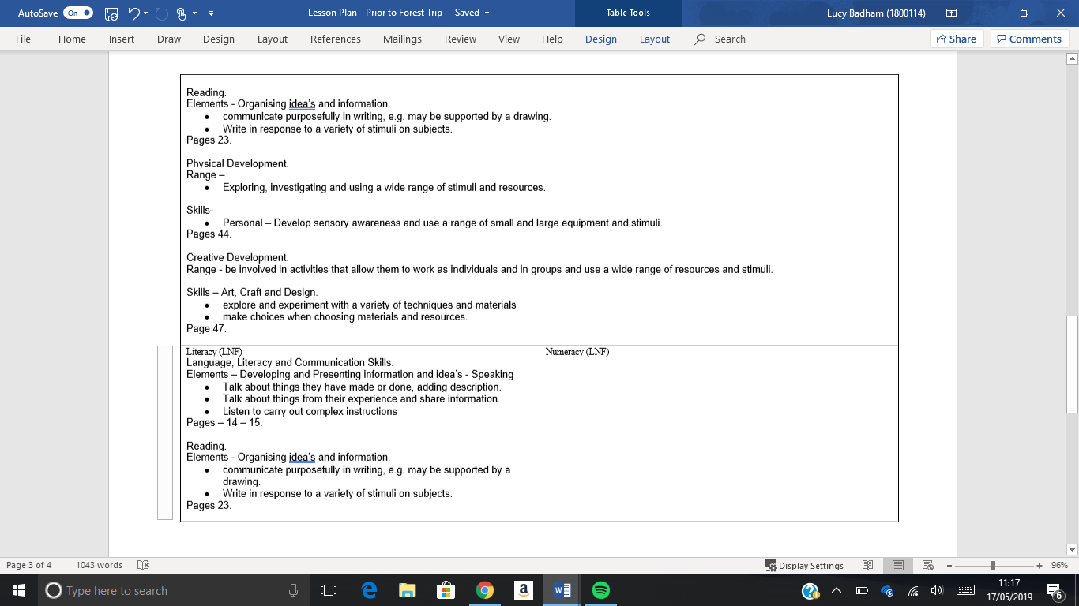
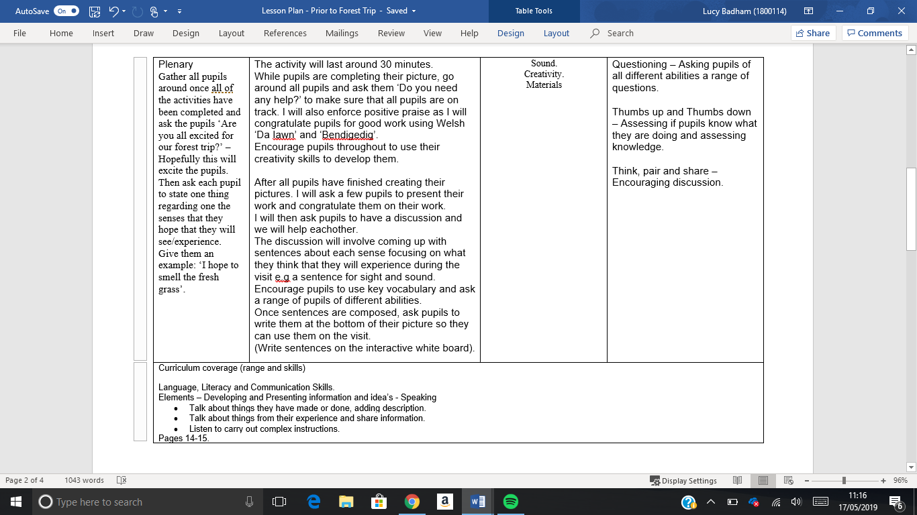

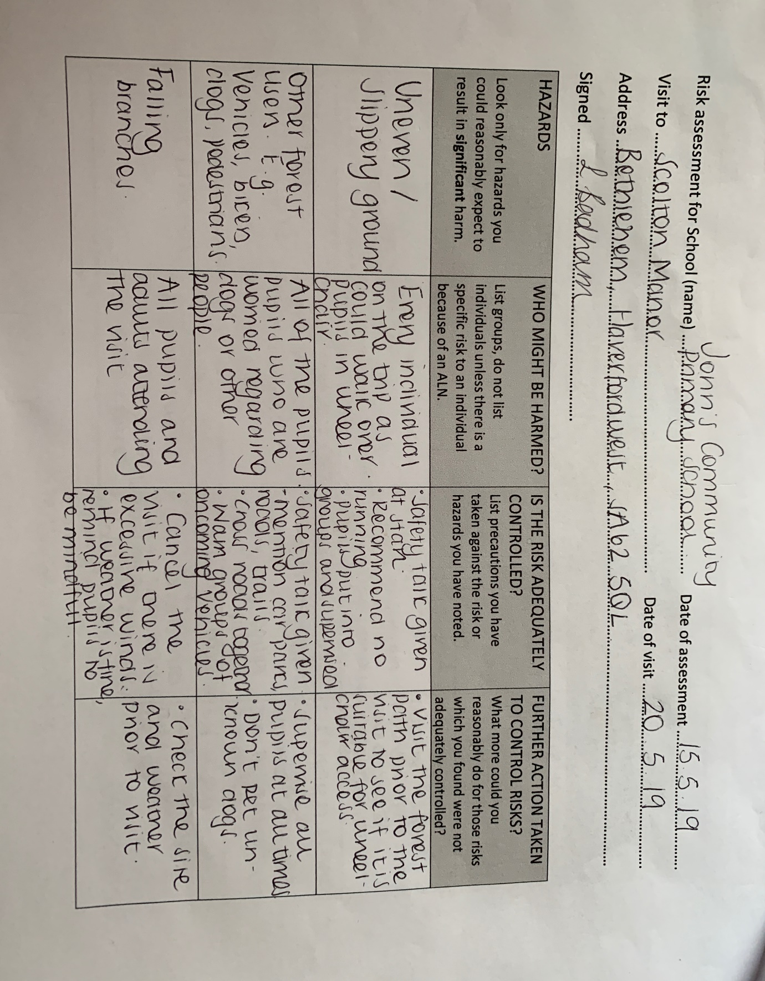
Appendix 3 – Risk Assessment.

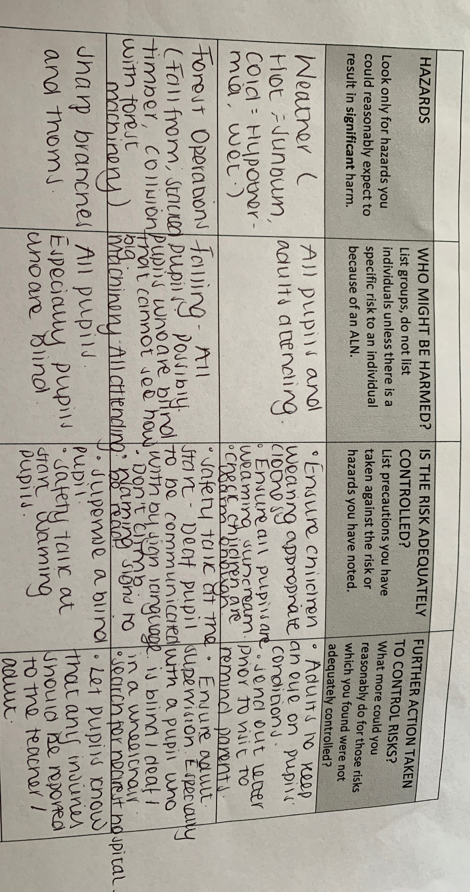
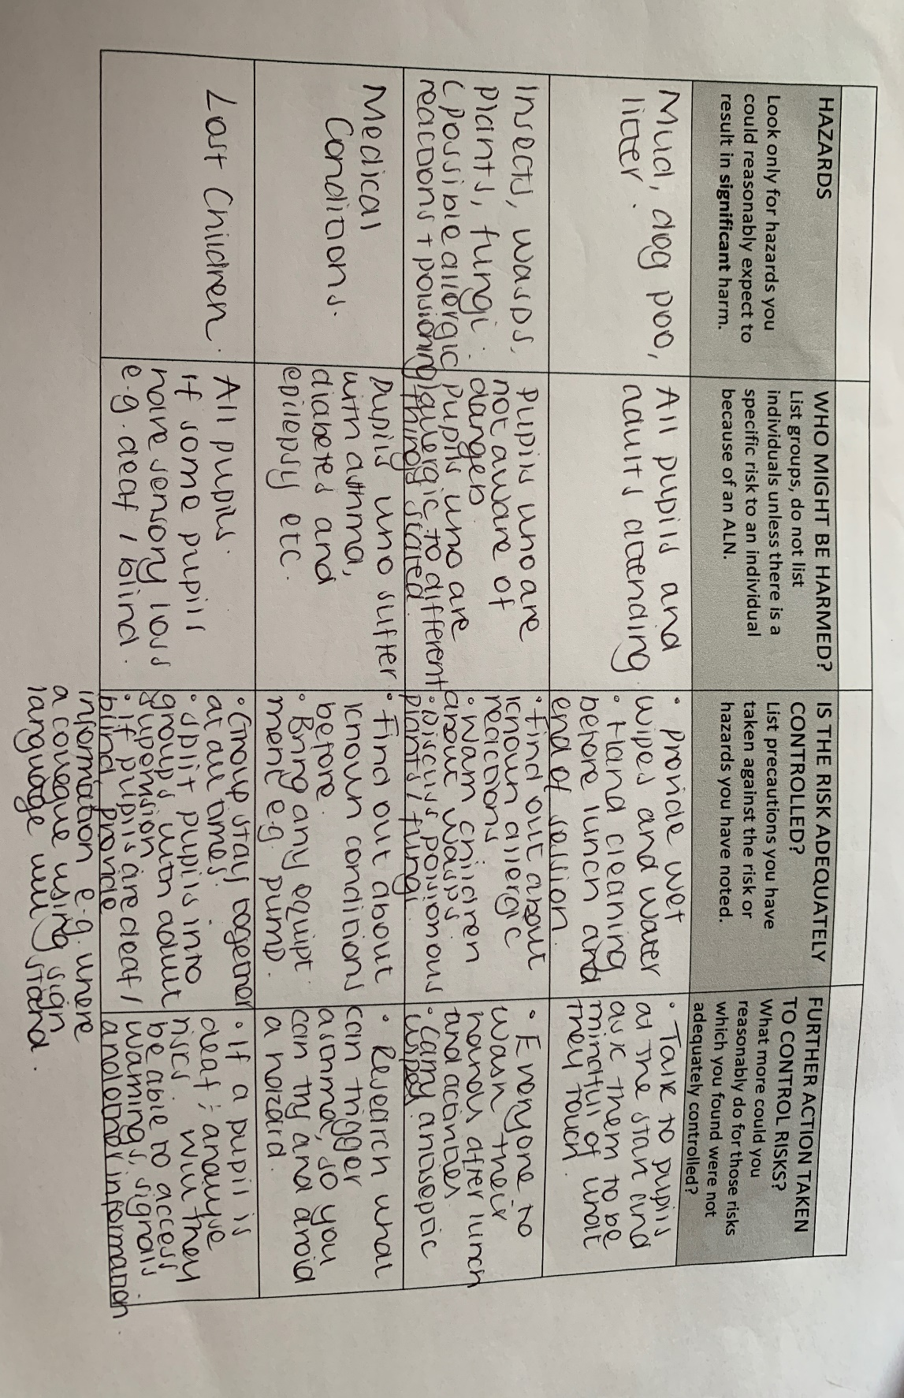
Appendix 4 – Consent Form.

Consent Form – Visit to Scolton Manor.

Dear Parent/Carer,
Your child has the fantastic opportunity to attend ‘Scolton Manor’ to experience nature and the outdoor environment in a safe, secure and hands on way on the 20th May 2018. The visit will last for the day and pupils will be ready to be collected from school at 3.00pm. Children learn best from first hand experiences. Exploring, playing and so learning using a wide range of activities, is what learning outdoors is all about. Building a sense of independence and team work are important parts of learning outdoors, however, health and safety considerations are always of paramount importance.
‘Scolton Manor’, located in Bethlehem, Haverfordwest is only a short 15 minutes bus journey from John’s Community Primary School. There will be a bus provided for the pupils which will leave at 9.00am promptly from the front gates of the school.

The woodland that we will use is fairly dry, but has some sticks and nettles underfoot, therefore for the comfort and wellbeing of your child the following clothing and equipment is recommended:
- Sturdy Trainers, Wellies, Boots and Socks.
- Long Trousers, Long Sleeve Top, Waterproof Jacket and Waterproof Trousers (Another pair if it is raining).
- Water Bottle.
- Rucksack with packed lunch inside (Possibly put lunch inside plastic bag, so pupils can dispose of bags following lunch).
- Hat and Sun cream.
No matter the weather, the visit will go ahead as there is an indoor facility which the pupils will use if the weather makes it unsuitable to be outdoors.
If pupils can attend the visit, please return form to class teacher by 15th May 2018.

Name of Pupil –
Parent/Carer’s Full Name -
Emergency Contact Number -
Does your child have any medical conditions? YES or NO
If YES, can you provide details of the condition -

SIGNED - DATE -

Appendix 5 – Listening Map.

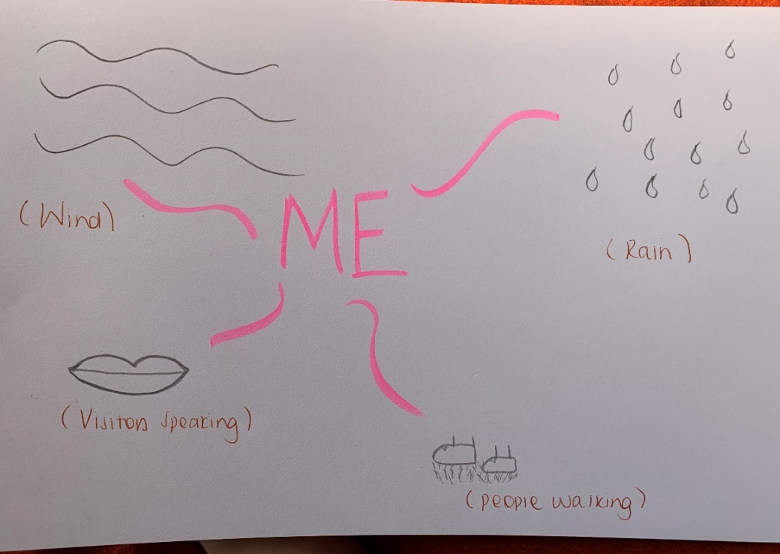
Listening Map for Sound Activity Exemplar.


Appendix 6 – Colour Swatches.

Colour Swatches will be used for the ‘Sight’ Activity – They will be used to match colours that are present in the forest.

Appendix 7 – Lesson Plan for Visit.

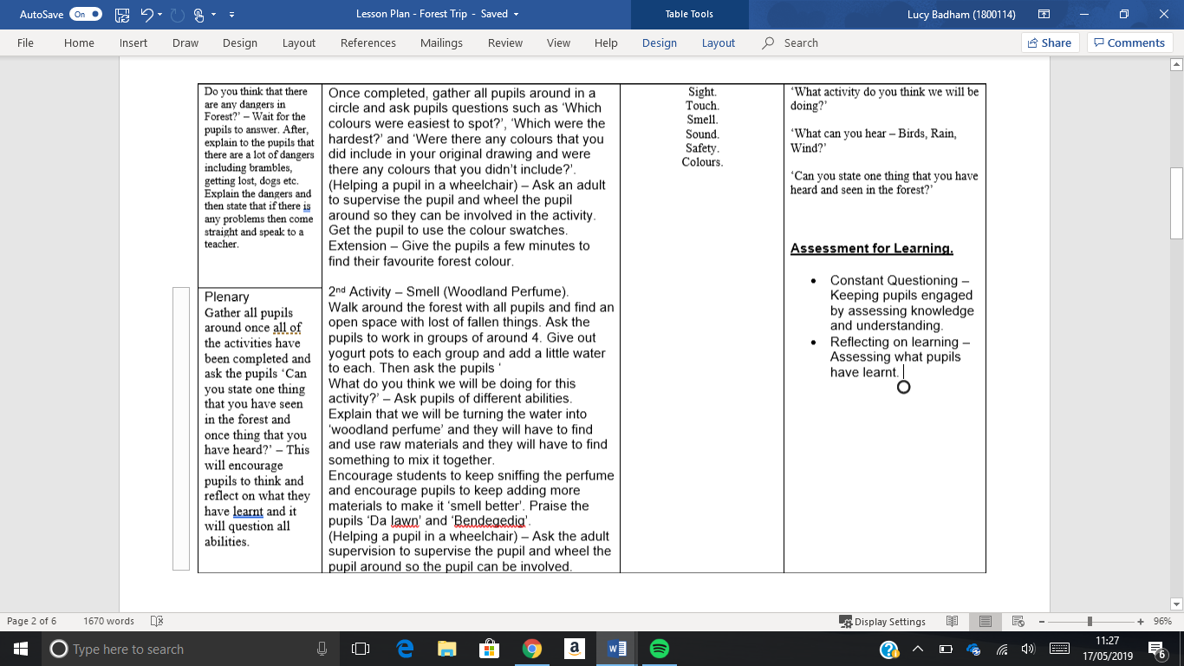
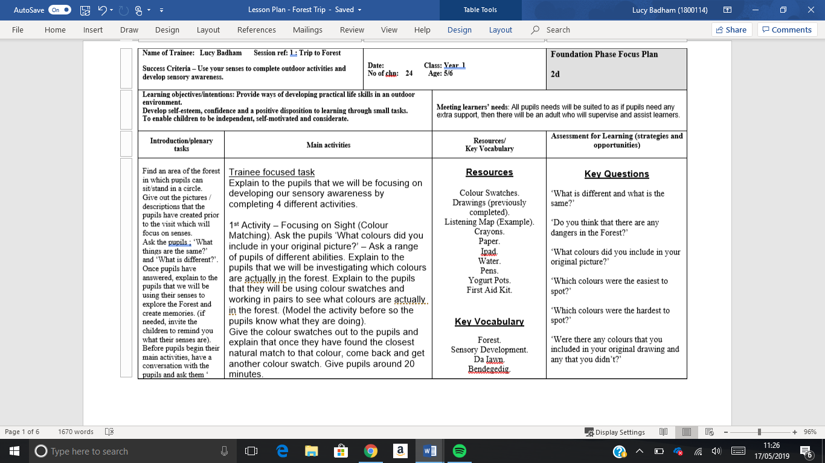

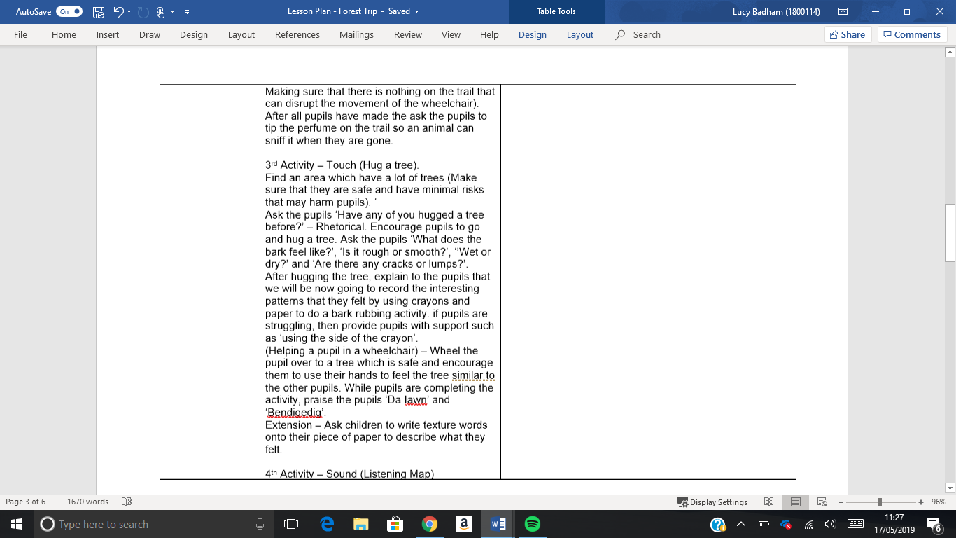

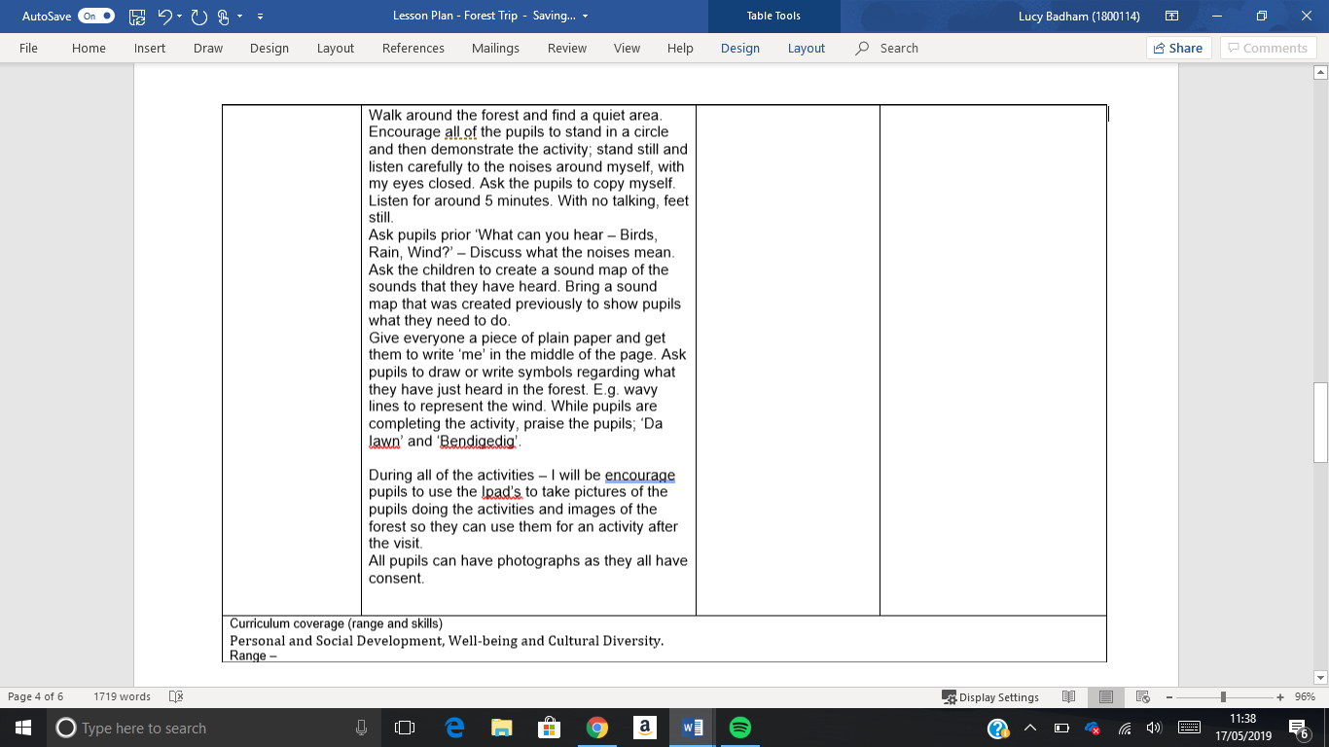

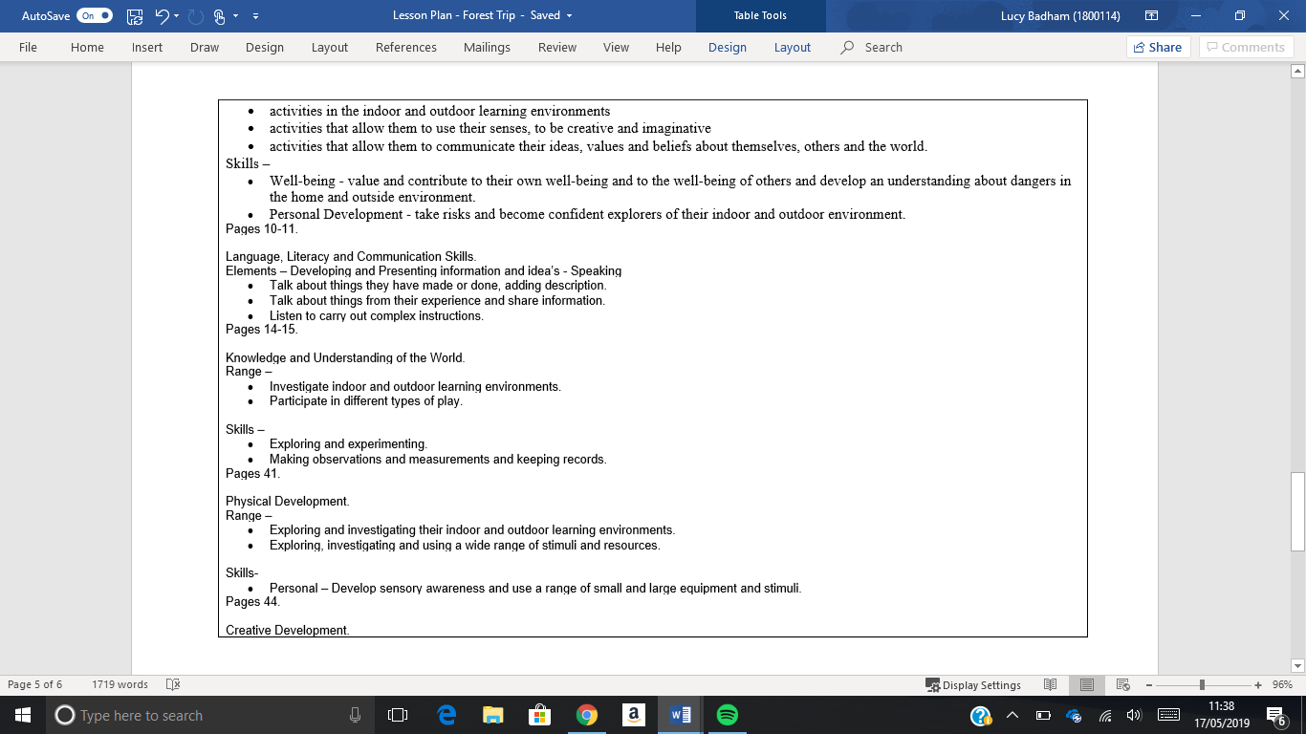

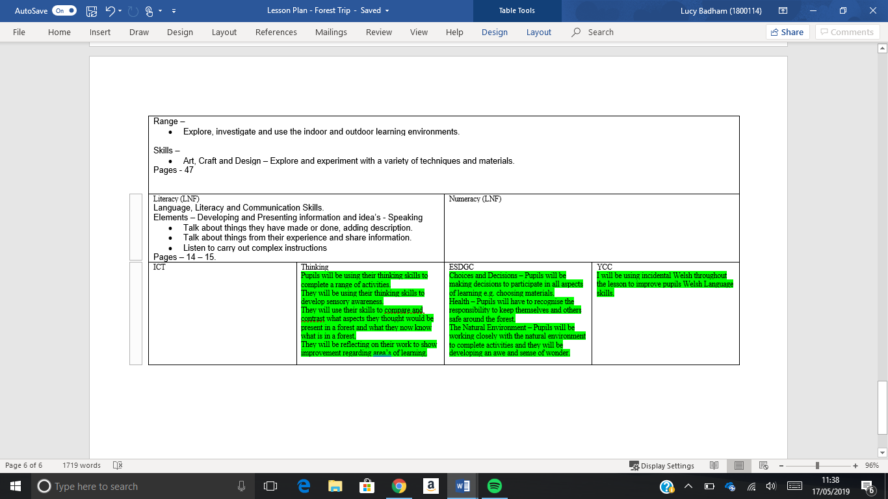

Appendix 8 – Lesson Plan – Post Visit.

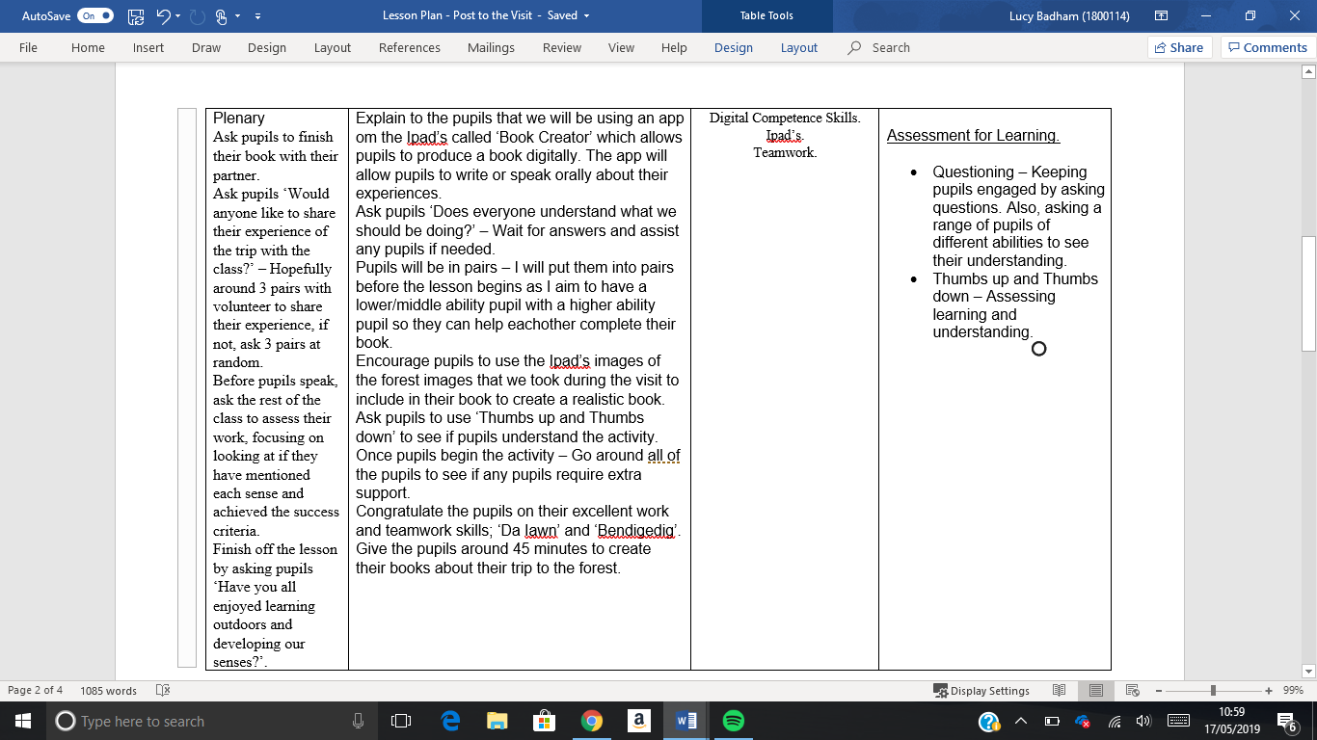
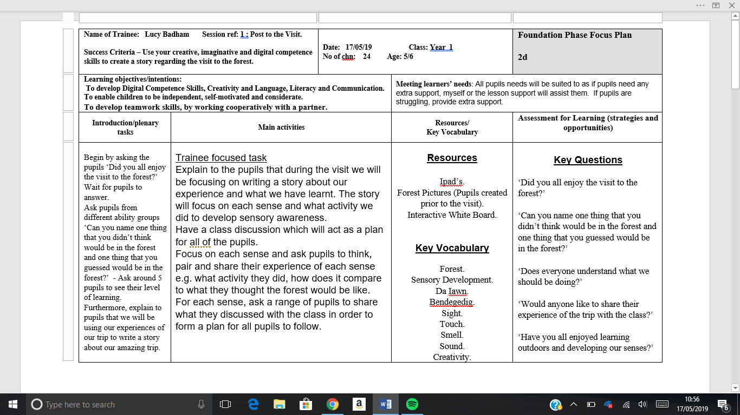
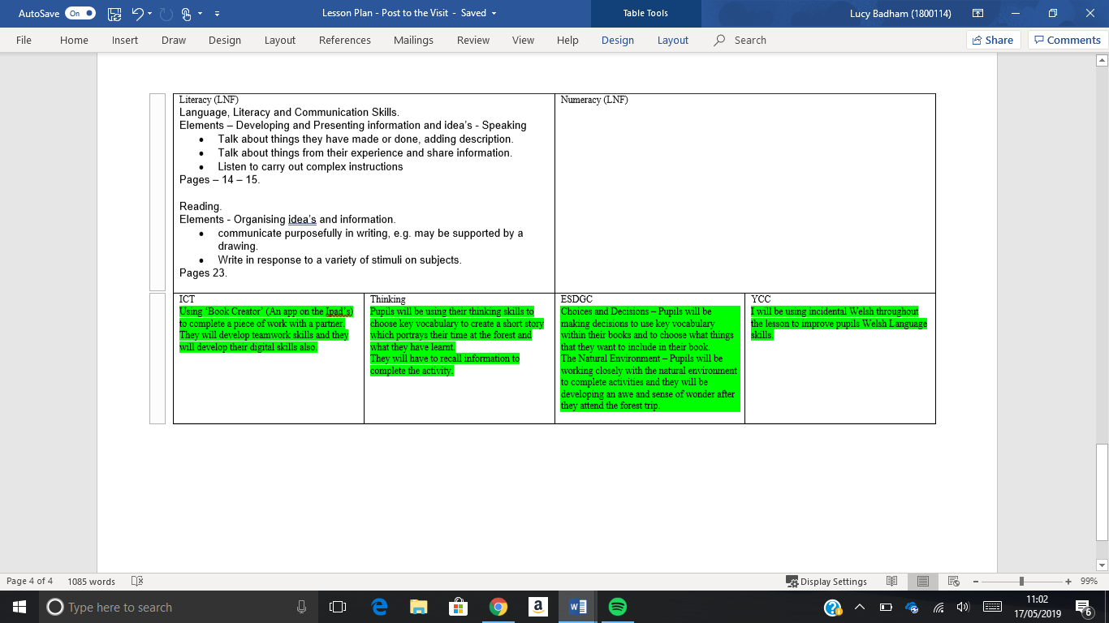
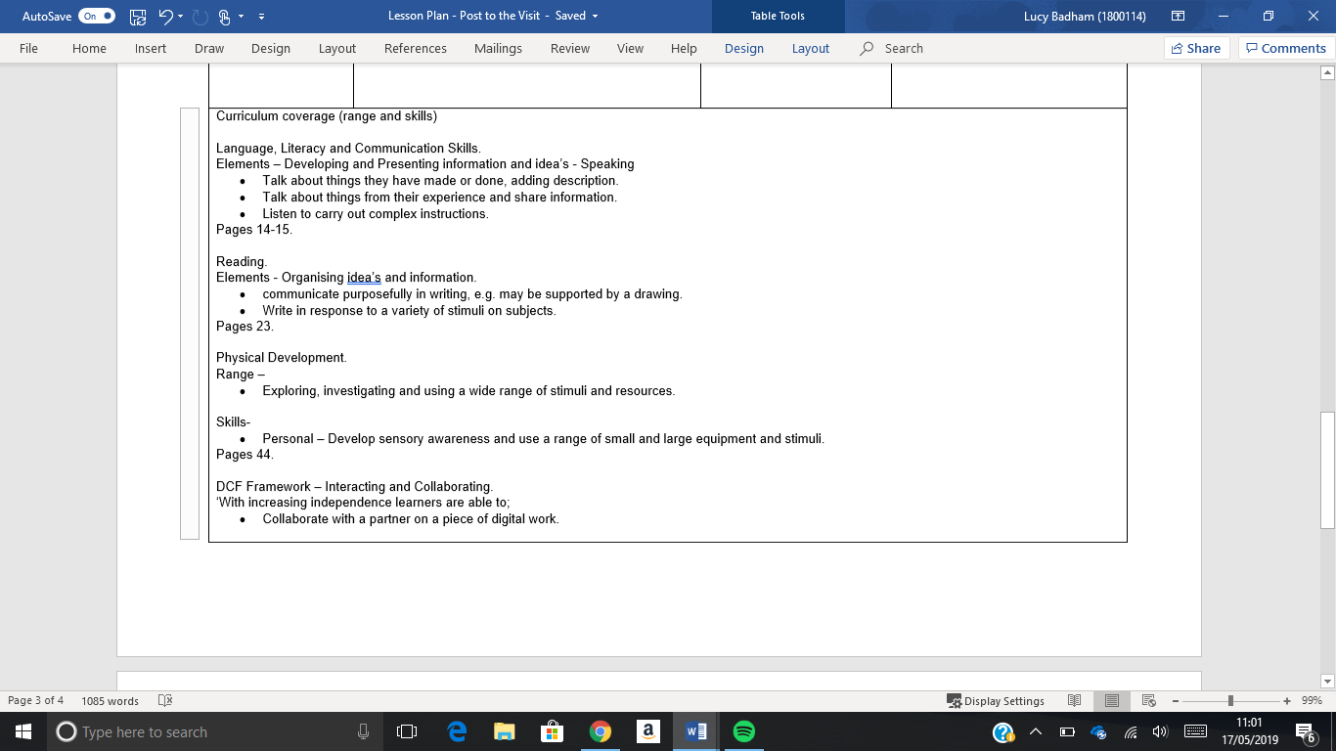

References.

Barnes, J. (2011) Cross-Curricular Learning 3-14. 2nd edn. London: Sage Publications.

Board of Education (1933) Report of the Consultative Committee on Infant and Nursery Schools (Hadlow Report). London: HSMO.

Building Futures (No Date) 21st Century Schools: Learning Environments of the Future. Available at: https://webarchive.nationalarchives.gov.uk/20110118205716/http://www.cabe.org.uk/files/21st-century-schools.pdf (Accessed: 4th May 2019).

Cultural Services Pembrokeshire (No Date) Scolton Manor. Available at: http://www.culture4pembrokeshire.co.uk/content.asp?nav=8 (Accessed: 14th May 2019).

DCELLS (2009) The Outdoor Learning Handbook. Cardiff: Welsh Assembly Government.

Delamont, S (1976) Interaction in the Classroom. London: Methuen.

Department for Education and Employment (No Date) Health and Safety of pupils on outdoor visits. Available at: https://www.zsl.org/sites/default/files/document/2014-02/haspev-1179.pdf (Accessed: 12th May 2019).

Estyn (2011) Outdoor Learning. Available at: https://www.estyn.gov.wales/sites/default/files/documents/Outdoor%20learning%3A%20%20an%20evaluation%20of%20learning%20in%20the%20outdoors%20for%20children%20under%20five%20in%20the%20Foundation%20Phase%20-%20September%202011.pdf (Accessed: 5th May 2019).

Institute for Outdoor Learning (No Date) Helping teachers deliver outdoor learning in the curriculum. Available at: https://www.outdoor-learning.org/Good-Practice/Develop-your-Organisation/Outdoor-Learning-in-Schools/Teaching-Outdoors (Accessed: 2nd May 2019).

Isaacs, B. (No Date) Outdoor Learning in Montessori Education. Available at: https://www.teachearlyyears.com/enabling-environments/view/outdoor-experiences (Accessed: 5th May 2019).

Kountz, K (No Date) Community Centred Learning Environments (Video). Available at: https://youtu.be/rSKSDmTx_Hk (Accessed: 4th May 2019).

Lilley, I. (1967) Friedrich Froebel: A Selection from his Writings. Cambridge: Cambridge University Press

Mike Anderson (2016) Learning to Choose, Choosing to Learn. Available at: http://www.ascd.org/ASCD/pdf/siteASCD/publications/books/Learning-to-Choose-Choosing-to-Learn-sample-chapters.pdf (Accessed: 7th May 2019).

National Guidance (2016) Foundations. Available at: file:///C:/Users/Lucy/Downloads/1b-Foundations1.pdf (Accessed: 7th May 2019).

National Guidance (2018) Ratio’s and Effective Supervision. Available at: file:///C:/Users/Lucy/Downloads/4.3b-Ratios-and-effective-supervision.pdf (Accessed: 18th May 2019).

National Justice Museum (No Date) The benefits of educational visits for SEN students. Available at: http://www.nationaljusticemuseum.org.uk/school-trip-benefits-sen-students/ (Accessed: 2nd May 2019).

Outdoor Matters (No Date) Effective Practice: Outdoor Learning. Available at: http://outdoormatters.co.uk/wp-content/uploads/2011/03/EYFS-Effective-PracticeOutdoor-Learning.pdf (Accessed: 6th May 2019).

Pembrokeshire Outdoor Schools (2019) What is an outdoor school?. Available at: http://pembrokeshireoutdoorschools.co.uk/ (Accessed: 17th May 2019).

Plan my school trip (No Date) Planning your school trip. Available at: https://www.planmyschooltrip.co.uk/about.php (Accessed: 4th May 2019).

Racoon Gang (2018) What makes a good learning environment. Available at: https://raccoongang.com/blog/what-makes-good-learning-environment/ (Accessed: 7th May).

RSPB (No Date) Every child outdoors Wales. Available at: https://www.rspb.org.uk/globalassets/downloads/documents/positions/education/every-child-outdoors---wales.pdf (Accessed: 18th May 2019).

Griggs, R. (2010) Becoming an outstanding primary school teacher. London: Routledge.
Semerda, U. (2015) Exploring Outdoors : Sensory experiences at your fingers. Available at: https://www.sensorylifestyle.com/activities/exploring-outdoors-sensory-experiences/ (Accessed: 10th May 2019).

Waldman, C (2016) Four Elements for creating a positive learning environment. Available at: https://all4ed.org/four-elements-for-creating-a-positive-learning-environment/ (Accessed: 7th May 2019).

Welsh Assembly Government (No Date) Outdoor Learning Handbook. Available at: https://learning.gov.wales/docs/learningwales/publications/140828-foundation-phase-outdoor-learning-handbook-en.pdf (Accessed: 18th May 2019).

Welsh Government (2015) Education in Wales: Our National Mission 2013-21. Available at: https://gov.wales/sites/default/files/publications/2018-03/education-in-wales-our-national-mission.pdf (Accessed: 1st May 2019).

Welsh Government (2015) Foundation Phase Framework Revised 2015. Available at: https://gov.wales/sites/default/files/publications/2018-02/foundation-phase-framework-revised-2015.pdf (Accessed: 7th May 2019).

Welsh Government (2016) Digital Competence Framework. Available at: https://learning.gov.wales/resources/browse-all/digital-competence-framework/framework?lang=en&year=year_1&selectedYear=col_7&lang=en (Accessed: 10th May 2019).

