Factors influencing employee engagement

  - Primary research report

Viktoriya Stoyanova
|Student ID: 1808144|Digital Skills and Research Methods|
28 April 2019

Introduction
This report is based on Employee Engagement Questionnaire, which consists of five close-ended questions in the form of Likert 5-Point Scale based on quantitative research.
Aim:
To find some factors influencing work engagement in a local GP clinic in London, United Kingdom, in order to suggest areas for improvement of the work environment, which will possibly lead to increase of employee`s performance level at work.
Objectives:
- I will perform primary research, questioning employees from a local GP clinic regarding their opinion on which could be some factors influencing their engagement with their work.
- I will take a sample of 30 employees from whom I will collect data, the results of which I will analyze by using Bar-Graphs and Pie-Charts in order to allocate areas for future improvement of the employee engagement in this particular clinic.
- I will compare my findings to secondary sources to better understand the relationship between employee engagement and performance at work.

Literature review
Employee engagement is defined by the level of enthusiasm and dedication of an employee towards their job, the amount of passion and effort they put in their work and the extent to which they feel a commitment to their workplace. An engaged employee cares about the outcome of his or her work and wants to feel that their work contributes actively towards the goals of the company (Heryati, 2019).
When employees feel encouraged by their employer and the employer recognizes their involvement and supports their creativity and efforts, they feel respected and as a result, employees show commitment. Furthermore, a strong commitment is a factor influencing performance, leading to increased job satisfaction (Alshammari, et al, 2016). Research shows that employees who feel happy with their work perform better and justifies the growing need for organizations to determine the factors that influence the increase of employee engagement.
A Case study Analysis involving approximately 10 thousand NHS employees indicates that many aspects of working life are related to employee engagement levels, however, the main and most important driver for increased commitment level is the sense of being valued (Robinson, Perryman and Hayday, 2004).
Other researchers found career development opportunities and opportunities for learning to be among the strongest factors for employee engagement, although the relationship between the managers and the workers is argued to be most important as it is of crucial importance to the successful retaining and engaging the employees (Heryati, 2019).

Research Methodology
Qualitative and Quantitative Research Methods:
Qualitative research is a method of research, which is focused on exploring a problem, an idea and the underlying opinions, reasons and experiences related to it with the aim to create a holistic picture. Furthermore, it is an investigative approach which provides new thoughts and individual views and helps in developing concepts or theories for potential quantitative research (Carol, 2016).
When performing qualitative research, different techniques for generating data from individuals are used, such as group discussions, individual interviews, focus groups, case studies, and observations. The preferred one is the semi- or unstructured open-ended questions, informal interviewing as it provides for flexibility and allows both the interviewer and the respondent to explore new underlying themes and interpretations. (Jackson II, Drummond, and Camara, 2007).
On the other hand, Quantitative Research Method is applied to gather numerical data and it relies on numbers to formulate the problem. This method is more structured and uses close-end statements (questions) in various types of surveys such as telephone, paper, online questionnaires and face to face interviews (DeFranzo, 2011).
For this research, I will use the Quantitative method as the time provided for completion of the research and the resources allocated for it are limited and therefore the quantitative method is more appropriate.

Population
A research population is a large number of people which is unknown and therefore impossible to use as a focus group for data research, although in terms of terminology it remains the main focus of the researcher. That term refers to the entire group of people, which the researcher is interested in, however, due to its large size, researchers cannot test every individual and rely on sampling techniques ( Hasan, 2018).

Sample and sample frame
The sample group is defined as a subset of the population, which is manageable and used to represent the entire population and therefore, sample frame is the list of identified members of the population which are representing the population (Hasan, 2018).

Findings, Analysis and Discussion

The findings of the primary research presented below, are in graphs and charts as each question is represented by two Figures – one showing the number of sample units for each answer, and another showing the percent correlation between them. Analysis of the graphs and charts and discussion follow each question. The questionnaire used for conducting this research is found in Appendix A.

Question 1:

Figure 1

Figure 2

Q1) Graph Analysis and discussion:

The majority - 33.3% strongly agreed and further 40.00% have chosen to agree with the statement; on the other hand, only 6.60% disagreed strongly, another 10.00% disagreed, and 10.00% did not know or had no opinion.
Overall, from 30 interviewed employees at the GP clinic, 22 agreed to a different extent, and only 5 disagreed. This result points out that challenges are influencing positively the employee engagement and employers should consider this as an area of improvement.

Question 2:
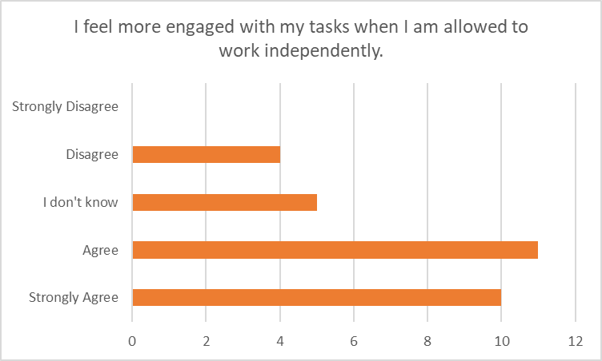
Figure 3

Figure 4

Q2) Graph Analysis and discussion:
As the pie chart indicates, 36.66% of the respondents agreed, that they feel more engaged when they are allowed to work independently, another 33.33% strongly agreed, only 13.35% disagreed, no one from the interviewed indicated strong disagreement, and 16.66% did not indicate their preference.
Otherwise said, 21 people consider independent work as more engaging and only 4 out of 30 would not prefer to have more autonomy at their workplace, whilst 5 people did not know whether they would or would not feel more engaged if allowed independence.
The analysis of the results here shows undoubtedly that more than half of the employees prefer to have autonomy at their workplace, therefore employers should consider this factor as relevant for increasing employee engagement.

Question 3:

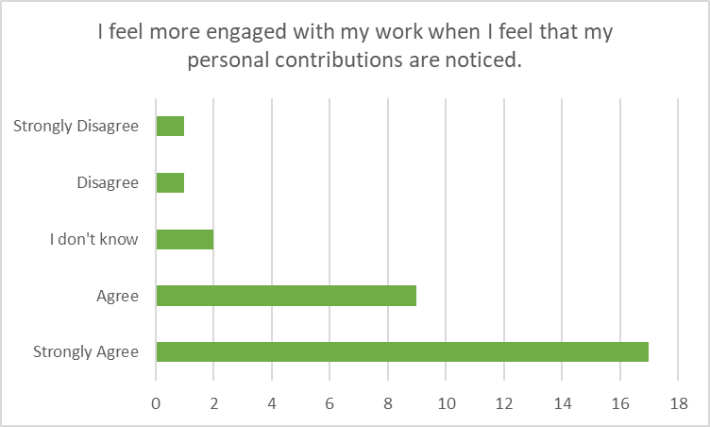
Figure 5

Figure 6

Q3) Graph Analysis and discussion:

The findings point out that recognition is considered important by 26 employees at the clinic and only 2 people reported that they disagree with the statement. Furthermore, the findings show that 2 employees do not know if their engagement with work is influenced by the recognition factor.
According to Figure 6, more than 2/3 of the employees agree to a different extent that appraisal and recognition would be an influencing factor for their engagement level.

Question 4:

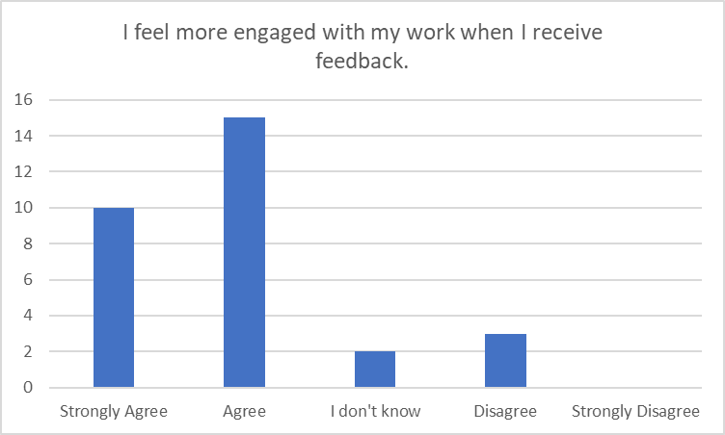

Figure 7

Figure 8

Q4) Graph Analysis and discussion:
10 employees strongly agreed, that feedback encourages their work engagement, another 15 agreed, 2 out of 30 said they do not know and only 3 disagreed and nobody strongly disagreed. This result – 83.30% positive reply and 10.00% negative, shows that the feedback should be considered for a very important factor influencing employee engagement.

Question 5:

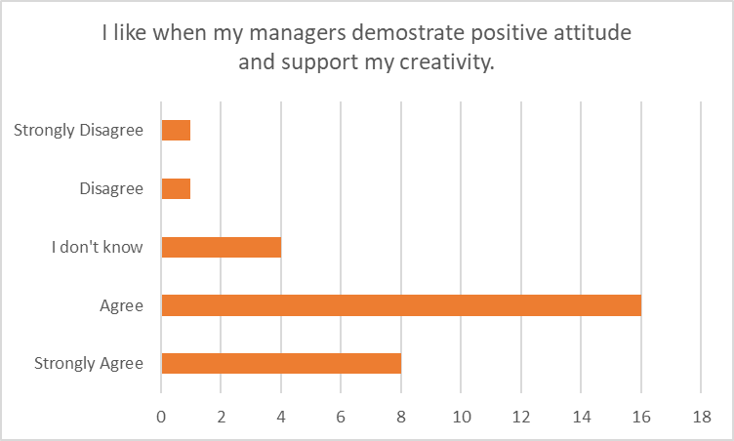
Figure 9

Figure 10

Q5) Graph Analysis and discussion:

The numbers shown in Figure 9 confirm that positive attitude and support for creativity is another way of increasing employee engagement: 16 people agreed and 8 strongly agreed with the statement, whilst 2 people disagreed to a different extent and 4 of the interviewed did not know or did not have an opinion.
The percent correlation in Figure 10 shows that for more than 75% of the employees would benefit of their manager`s positive attitude and support, therefore, this is another strongly influencing factor.

Summary of the findings:

Figure 11

From this analysis, I can draw the conclusion that all of the factors listed above have significant influence over employee engagement at this local clinic. Figure 11 shows clearly that the majority of the employees agree with all the statements in the questionnaire and only very few of them would not benefit from a future improvement of the workplace environment. It is safe to say that employers should consider all these factors in order to achieve increased employee engagement and increased performance as a result of that.

Limitation of the research

Although all the employees of the GP clinic have taken part in this research, this research cannot be considered a full or comprehensive account of the relevant factors influencing employee engagement due to the following limitations:
- The questionnaire consists of only five statements, therefore many other possible factors have not been considered;
- The report is limited to only 2000 words;
- The research is restricted to only the Qualitative method;
- The time and resources allocated to this research are limited;

Recommendation for future research

In order to improve the quality of this research some recommendations for future research should be considered:
- Increase of the word count for the report;
- Increase the number of questions asked;
- Increase the literature review;
- Use of Qualitative Research Method or mixed Method;

Ethical Consideration of the research
All the employees participated voluntarily in this research and have granted their consent prior to conducting the interviews.
To minimize the risk of harm and in order to comply with the legislation for data protection the following ethical considerations have been observed:
- Right to privacy:
- The name of the GP clinic is not revealed;
- Participants in the research are anonymous;
- Right to safety:
- No physical or psychological harm has been caused during conducting the research;
- Right to be informed:
- Participants have been informed about the goals and purposes of this research;
- Participants have been informed about how their data will be used and kept safe;

Conclusion
This research explored five factors influencing employee engagement – a challenging work environment, the opportunity for independent work, recognition of personal contribution towards company goals, positive and supportive leadership and feedback. The findings and analysis of the collected information suggest that employers should take into consideration their relevance towards improving employee engagement in the future. Compared to the literature review, this research confirms that the most important factor for increasing employee commitment is recognition. In conclusion, the 21st-century employers must strive to provide for the increase of employee engagement in order to raise productivity by creating room for creativity, positivism, support, and autonomy at the workplace, and furthermore, by recognizing each employee`s value.

Reference list

Alshammari, M. A. Qaied. B. A.,Mawali, H. and Matalqa M.(2016). `What Drives Employee’s Involvement and Turnover Intentions:Empirical Investigation of factors influencing employee involvement and turnover intentions?`. International Review of Management and Marketing, 6(2), pp. 298-306[Online] Available at: https://www.researchgate.net/publication/301678453_What_drives_employee's_involvement_and_turnover_intentions_Empirical_investigation_of_factors_influencing_employee_involvement_and_turnover_intentions
(Accessed 25 April 2019).

Carol, T. (2016) Why Choose Qualitative Research over Quantitative Research [Online] Available at: https://medium.com/@thomascarol1988/why-choose-qualitative-research-over-quantitative-research-8cf3141d99a5
(Accessed 25 April 2019).
DeFranzo, S.E. (2011) What’s the difference between qualitative and quantitative research? [Online] Available at: https://www.snapsurveys.com/blog/qualitative-vs-quantitative-research/
(Accessed 25 April 2019).
Hasan, M. A. (2018). Research Population. [Online] Available at: https://www.academia.edu/5563491/Research_Population
Accessed 25 April 2019).
Heryati, R. (2019) The Definition of Employee Engagement [Online] Available at: https://inside.6q.io/the-definition-of-employee-engagement/
(Accessed 25 April 2019)
Heryati, R.(2019) 10 Factors Contributing to Employee Engagement [Online] Available at: https://inside.6q.io/10-factors-contributing-employee-engagement/
(Accessed 25 April 2019).

Jackson II, R. L.; Drummond, D.K., Camara, S. (2007)'What Is Qualitative Research?', Qualitative Research Reports in Communication, 8(1) pp. 21-28 [Online] Available at: https://www.researchgate.net/publication/233325570_What_Is_Qualitative_Research
(Accessed 25 April 2019).

Appendix A

Employee engagement questionnaire
 | Employee engagement
No | Item | Strongly Agree | Agree | I don't know | Disagree | Strongly Disagree
1 | I like my work because it provides me with challenges. | 10 | 12 | 3 | 3 | 2
2 | I feel more engaged with my tasks when I am allowed to work independently. | 10 | 11 | 5 | 4 | 0
3 | I feel more engaged with my work when I feel that my personal contributions are noticed. | 17 | 9 | 2 | 1 | 1
4 | I feel more engaged with my work when I receive feedback. | 10 | 15 | 2 | 3 | 0
5 | I like when my managers demonstrate a positive attitude and support my creativity. | 8 | 16 | 4 | 1 | 1

Gender Age Experianse

