
Skills for the Workplace
Module Assignment Submission
Student Name: | Rachel Witheridge
Student Number: | 2106781
Module No: | BMSK5011
Module Title: | Developing Workplace Critical Thinking

Statement of Confirmation of Authenticity
By the act of making this submission, the student declares that this is the work of the student named above. The work has not, in whole or in part, been knowingly presented elsewhere for assessment, or where assessment has been built on a previous assessment, this has been identified. Where materials have been used from other sources it has been properly acknowledged. If this statement is untrue, the student acknowledges that an assessment offence has been committed.
Attention is drawn to the plagiarism and unfair practice policies of both the University and of ILM.

Contents
INDUCTION 4
Section 1: Critical Thinking 4
Section 2: Values, Attitude, Beliefs & Behaviours 6
Section 3: My own values, beliefs & attitudes 9
Section 4: Management Theory’s 10
Section 5: identifying a management theory in own workplace. 15
Section 6: Conclusion 15
References 16

INDUCTION
Throughout this course I will examine the values, beliefs, attitudes, and behaviour at my job in this assignment and their effects. I'll discuss my own personal principles, outlook, and views while taking into account how they impact others. I'll go over the benefits of critical thinking. I'll think about the many management ideas before choosing two that I think fit my role. I will look at the many types of management schools to have a better idea of how they might help my workplace.

Section 1: Critical Thinking

Critical thinking is the capacity to assess data and be conscious of biases or presumptions, including your own. It entails assessing arguments, finding, and solving issues objectively and methodically, as well as effectively presenting your thoughts. This is similar to information literacy.

How to critically think
The capacity to consider information logically and rationally is just one of the numerous abilities and characteristics that make up critical thinking. A person with good critical thinking skills would challenge the evidence supplied and attempt to comprehend it rather than accepting the arguments and conclusions put forth. Students will search for logical links between concepts, take into account various informational interpretations, and assess the persuasiveness of the arguments made.

Everyone naturally has some unconscious bias in their thought processes. One can go over these and distinguish between facts and views with the aid of critical thinking abilities.

To aid in my critical thinking, I shall use the RED model, the core of the Watson Glaser critical thinking assessment. Below shows how the RED model is used.

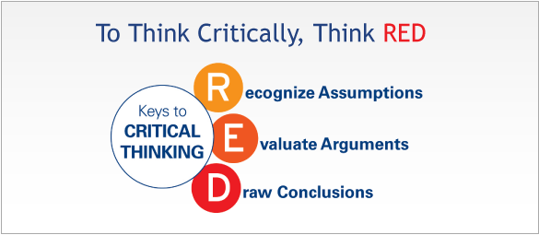

Recognize assumptions: It's all about understanding here. Understanding what is being said in its genuine context and evaluating if the information being offered is accurate and whether any supporting documentation has been provided. Being able to critically evaluate the validity of these assumptions, ideally from a number of various perspectives, can assist discover any gaps in knowledge or logical errors. Accurately recognising when assumptions have been made is a crucial aspect of this.

Evaluate arguments: The systematic evaluation of the arguments and supporting data is what this competence is all about. the capacity to consider arguments and data logically while maintaining objectivity. When an argument has an emotional impact, it can be difficult for someone to suspend their judgement when evaluating it critically. Instead of objectively evaluating all of the evidence, it is all too easy to subconsciously look for material that supports a preferred viewpoint.

Draw conclusions: This is the capacity to assemble a variety of data and draw a logical inference from the facts. If new information surfaces that supports a different conclusion, someone with good critical thinking abilities will be able to change their conclusion.

('+Caption.byline+', Not lucky but trained: AFROTC students respond during active shooter)

Why is critical thinking important?
For evaluating information sources and creating your own arguments, critical thinking is crucial. It places a strong emphasis on taking a logical, impartial, and self-aware approach that can assist you in locating reliable sources and supporting your views.
In all fields of study and at all phases of the research process, critical thinking is crucial. Although the types of evidence employed in the sciences and the humanities may differ, both fields can benefit from critical thinking skills.

(2020Reply et al., What is attitude? definition, types, components, formation, functions, characteristics, importance 2021)

The benefits of critical thinking
There are 6 benefits of critical thinking, and I've described four of them along with the reasons why below.
- It promotes curiosity - In order to better understand both the world around us and the elements that are important to our perception of it, curiosity is a natural human trait. This applies to both the academic subjects we study and the subjects that we believe are pertinent to our daily life.
- It enhances creativity- People with greater imaginations challenge numerous presumptions. Instead of fighting against restrictions, creative thinkers ponder "how" or "why not?" Because creativity is timeless and has boundless potential, we as creative beings are also boundless.
- It reinforces problem-solving ability - Critical thinkers frequently have an innate ability to solve problems. This is arguably the most significant ability we can assist our students develop. As today's youth will be tomorrow's leaders, they will need to be able to think critically in order to come up with creative solutions to complicated problems.
- It fosters independence- Independent thinking abilities are crucial to developing into a great leader as well as a great thinker. These abilities show our students how to interpret their observations of the outside world and how to use that understanding to make important, well-informed decisions. As a result, individuals develop self-assurance and the capacity to learn from errors as they lead successful and fruitful lives.

(6 benefits of critical thinking and why they matter)

Section 2: Values, Attitude, Beliefs & Behaviours

What are values, attitudes, beliefs and behavious?
Our views, values, and attitudes continuously interact with those of our peers, friends, family, and teachers in our varied positions. We appear to automatically "like" those who share our fundamental principles and ideas. Success in any kind of connection, whether it be personal, academic, or professional, depends on the alignment of our value systems.
In order to acquire competence and greatness, according to proponents of adult learning, one must be able to teach and analyse not only information and skills but also attitudes. We need to be able to recognise the underlying values and belief systems that support attitudes if we want to achieve excellence.
The only way to improve performance is to acquire the necessary knowledge and abilities. The appropriate value and belief systems may have an impact on our motivation, intention, and participation with a particular task.
Although there may be people who appear to have the information and abilities necessary to complete a task, only those who have a good attitude towards the task will be motivated, engaged, and want to do it.
(The relationship between beliefs, values, attitudes and ... - owlcation)
Values
Values are essential and fundamental ideas that direct or inspire behaviours. They assist us in deciding what matters to us. Values are the character traits we decide to live by to direct our behaviour. They also characterise the type of person we want to be, how we treat ourselves and others, and how we interact with the outside world. They offer the fundamental rules of behaviour.
Value describes the connection between a person and a purpose. It is relational in the sense that, even in the same circumstance, what one person values may not be what another person values. For instance, someone who values honesty might come forward with information about financial malfeasance by a boss, whereas someone who values loyalty might keep quiet. A case of a clash of values is this. The faithful person can think there are boundaries to loyalty and that keeping silent about wrongdoing might hurt others. Because to the trusting relationship, the devoted person may think it is important to maintain one's confidence even if doing so could damage others. (What are values? 2018)
Beliefs
Your worldview may not always be accurate or true. Curiously, because you don't want to be wrong, you will instinctively search for proof or other experiences that will support and strengthen your ideas. Your vision of the world and what you hold to be true are frequently reflected in your beliefs. But this does not necessarily imply that your belief is accurate.
From a very young age, you begin to build your views. These opinions are influenced by your surroundings, including what you were told, heard, saw, and experienced. The conclusions you make from these experiences become part of your beliefs. You develop beliefs about who you are, what other people think, and how the world works.
Individuals cling to their beliefs despite the fact that they are restrictive or contradictory evidence. This is why it is so difficult to rationally argue with those who have strong convictions that are supported by a "sense of knowing" rather than by logic and scientific data. absolutely necessary if you wish to alter your beliefs.
(Haas, 2021)
Attitude
An attitude is a person's persistent positive or negative sentiments, actions, and cognitive assessments of a certain thing or idea. Humans have opinions about practically everything, including politics, religion, clothing, music, and food.
An individual's attitudes develop into a consistent pattern and altering one may necessitate challenging changes in numerous others. So, a business would be wise to fit its product into people's current attitudes rather than attempting to change people's opinions.
(2020Reply et al., 2021)
There are three components to attitude.
Three things make up attitudes: feelings, actions, and thoughts. Affective, behavioural, and cognitive are frequently referred to as the "ABC" paradigm for these three elements.
One's emotional reaction to a task or an entity is known as a "affective" response. The difference between the "cognitive" and "behavioural" responses is that the "cognitive" response refers to the cognitive assessment of the thing based on an internal belief system. Although there is a significant amount of overlap in the semantics of beliefs, values, and attitudes, they are also separate structures.
We are at the mercy of our expressed behaviours, which is one of the most important lessons to learn. We "assume" opinions about both ourselves and other people based on observed behaviour.
For instance, it may be assumed that someone is not particularly organised or punctual if they consistently appear late. However, this same person might spend time providing care for someone who is gravely ill, and their ability to arrive on time for work or class may suffer as a result. They might be seen differently in light of this fresh information.
Our judgements will also be influenced by our views about witnessed behaviour. For instance, if someone shows up for an interview in shabby clothing, we would assume they did not take the time to prepare. Yet, if the aforementioned person thinks that their abilities and skills, not their appearance, should be praised, this viewpoint affects their attitude towards dressing "smart" and, in turn, affects their behaviour.
Behaviours
One needs to be conscious of capability when evaluating behaviour. Due to a raised voice or the absence of explicit idioms and phraseology, including expressing "thank you" and "please," a person may be perceived as being "rude" in certain circumstances. However, if the individual or people being observed have never had any instruction in speech modulation or in learning the idioms and phraseology of the language they are speaking in, they might not be able to express the appropriate behaviour for the circumstance. Those who are able to show more suitable behaviour can interpret this as having a "poor attitude" as a result. These internalised systems (attitudes, beliefs, and values) are reflected through behaviours.
(The relationship between beliefs, values, attitudes and ... - owlcation)

Section 3: My own values, beliefs & attitudes
My values demonstrate what is significant to me. I completed the Barrett Personal Values Assessment to further examine this. Results are shown below.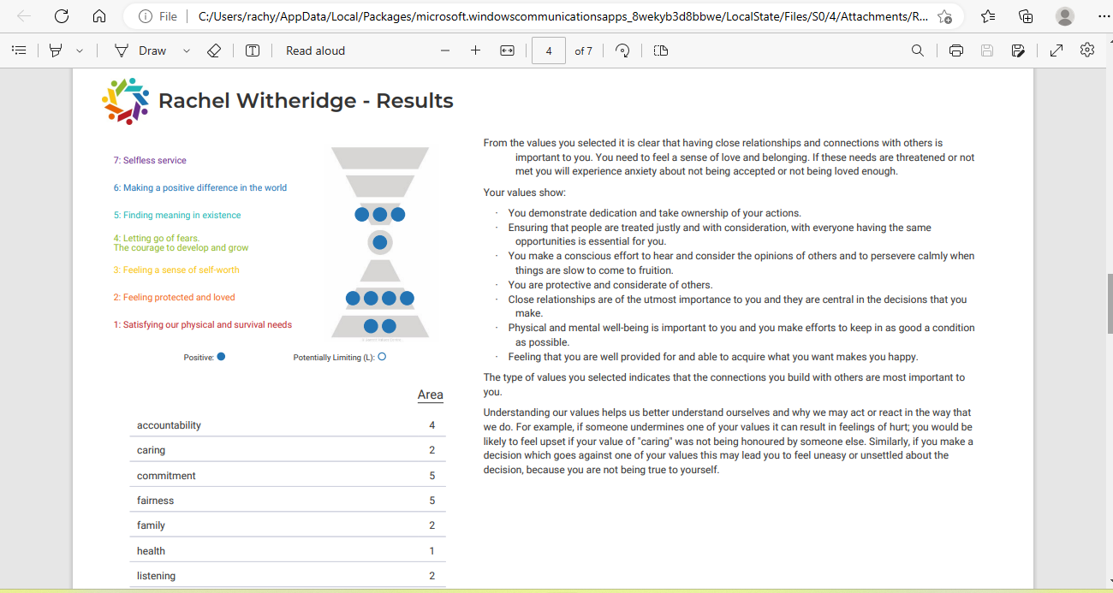

It is evident from the values I chose that I value relationships and connections with other people. I need to experience affection and a sense of community. I will feel anxious about not being loved or accepted enough if these needs are jeopardised or not addressed.

My values show:
- I demonstrate dedication and take ownership of my actions.
- Ensuring that people are treated justly and with consideration, with everyone having the same opportunities is essential for me.
- I make a conscious effort to hear and consider the opinions of others and to persevere calmly when things are slow to come to fruition. I am protective and considerate of others.
- Close relationships are of the utmost importance to me, and they are central in the decisions that I make.
- Physical and mental well-being is important to me, and you make efforts to keep in as good a condition as possible.
- Feeling that I am well provided for and able to acquire what I want makes you happy.
- The type of values I selected indicates that the connections I build with others are most important to Me.

The findings above show my values, beliefs, and attitudes at work, which demonstrate that I take responsibility for my own job. Having the same opportunities as me, in my opinion, is crucial. I pay attention to what others have to say. I am a responsible and kind person. My greatest objective is building relationships with other people.

(Personal values assessment (PVA) 2023)

Section 4: Management Theory’s
More goes into managing a team than what first appears. You must use a variety of strategies to entice employees to work for your company, including both financial and emotional rewards. While some of the early management theories didn't encourage compassion or work-life balance, employees tend to like supervisors who value them as individuals and professionals.
A science and an art, management is a profession that is always evolving. To assure the best possible employee production, the majority of modern workplaces use a variety of management theories. There are a few well-known techniques that managers have studied for years, despite the fact that many of these systems are composites of different theories and tactics.
Benefits of using theories
You may enhance workplace functionality and develop your leadership skills by learning about management ideas and putting them to use in the workplace. There are many advantages to learning and using several management principles, even if you probably won't stick with just one management approach. Examples of advantages would be:
- Improved productivity: By motivating employees and implementing workplace tactics, leaders may make the most of their teams. As a result, performance and productivity improve.
- Decision-making is made easier because to theories that give leaders guidance on how to respond and act in various workplace scenarios. As a result, decision-making processes move more swiftly, and leaders are more effective. This trains leaders to think quickly and solve problems effectively.
- Collaboration will increase as a result of this since leaders will have learned how to persuade team members to participate and collaborate well through management theory studies. In order to foster greater workplace collaboration, leaders may also study dispute resolution techniques.
- Improved objectivity: Theories give you tested leadership techniques. When theories are put into practise, management outcomes can become more predictable than when you rely just on your own judgement.
(Types of management theories (with tips and benefits))
The four major schools of management theories
- Scientific management
- Classical
- Behavioural
- Modern

Types of management theories
There are seven different categories of significant management theories at work. These ideas include:
- Scientific management theory
- Administrative management theory
- Bureaucratic management theory
- Human relations theory
- Systems management theory
- Contingency management theory
- Theory X and Y
Scientific management theory
Taylor Frederick released "The Fundamentals of Scientific Management" in 1909. [1] In this, he made the claim that productivity would rise as a result of job optimization and simplification. He also promoted the idea that collaboration between employees and managers was essential. Compared to how work was normally conducted in firms in the past, this was significantly different. The factory manager at the time had minimal interaction with the staff and relied on them to create the required goods on their own. There was little uniformity, and the only goal for a worker was frequently to keep their job, therefore there was no incentive to work as swiftly or effectively as feasible.
Taylor championed the idea of "a fair day's compensation for a fair day's work" because he thought that all workers were driven by financial gain. In other words, a worker didn't deserve to be paid as much as someone who was very productive if he didn't accomplish enough during the course of a day. (Home)

Administrative management theory
Henri Fayol (1841-1925) originally developed the administrative theory of management in his works and publications, Fayol's 14 Principles of Management (1888) and Administration Industrielle et Generale (1905). (1916).
French mining engineer Fayol documented his business practises. In the end, he developed into a management theorist, maybe having the largest impact of all previous management theorists.
Administrative management theory, often known as process theory or structural theory, is credited to Fayol as its originator. In contrast to Taylor, who concentrated on worker efficiency, Fayol's work was distinct because it was a part of the classical theory movement. Fayol put more of an emphasis on the structure and organisation of job duties. He focused on how management and employees are set up within a company to enable job accomplishment.
He suggested setting up functional departments and work groups where various tasks are carried out. These activities assist in completing larger tasks that advance business goals. Fayol's strategy for maximising organisational effectiveness was top-down. He thought that the efficiency of management would eventually affect the output of workers at the operational level. The scientific management theory, which proposed that worker efficiency would increase managerial efficiency, contrasts with administrative management theory. (Administrative theory of management - explained)
Bureaucratic management theory
The bureaucratic theory, which was developed by Max Weber, contends that a bureaucratic structure will make an organisation more effective. The perfect business, according to Weber, is structured using accepted norms and practises. He thought that this approach was particularly useful in huge operations.

The theory includes the following five principles:
Task specialisation: Weber emphasised the value of each person playing a distinct role inside an organisation.
Hierarchy – Each organisation should have a distinct structure inside it, according to Weber.
Formal selection - Organizations look at a candidate's credentials when choosing leaders. They shouldn't be elected by vote; rather, they should be appointed to specified positions based on qualifications.
Rules and requirements- They make sure that everyone is aware of the expectations. Rules are necessary to meet Weber's goal of having uniform standards in business.
Impersonal - A company structure is made impersonal by the rules and regulations. Promotions are based on performance, not on sentiment or relationships.

This theory's components make sense. Any organisation definitely needs certain rules and standards. On the other hand, many of these concepts are challenging to put into practise. There is a disconnect between theory and practise. It's very impossible to avoid emotions when making business decisions, and emotions are occasionally necessary.

Human relations theory
The focus on relationships in the human relations theory contrasts sharply with Weber's bureaucratic theory of management. According to Elton Mayo, productivity rises when people experience a sense of belonging to a team and appreciation from their coworkers.

The human relations theory places a strong emphasis on teamwork and appreciation as motivating elements. The bureaucratic theory is fundamentally opposed by this. Although stressing personal elements is a good idea, it is possible to go beyond. Relationships are important but prioritising them above other things can result in awkward circumstances like office romances and promotions based more on personality than work performance.

Systems management theory
According to Ludwig von Bertalanffy's systems theory of management, every company is an interconnected system that functions like a live creature thanks to a variety of factors. Both a company and a person are more than simply their CEO or brains. Other organs and essential components are required for a person to survive. A company cannot survive with simply a CEO.

The parallel holds true even though the organism analogy is a tad over the top because most company operations aren't life-or-death situations. According to the systems theory, everything must function as a whole for a firm to prosper. (A guide to popular management theories)

Contingency management theory
in line with Lorsch (2010) Managers can respond to the causes of specific problems using a contingency management style rather than overreacting to the problem itself. Managers who recognise the significance of contingency theory will endeavour to comprehend all of the forces that contributed to the problem rather than concentrating on its outcomes. For instance, a warehouse manager who is concerned about diminishing productivity when it comes to loading and unloading items may take a closer look and discover that improper ventilation is making warehouse personnel fatigue easily and require frequent breaks. The manager may not have identified the root cause of the decline in production if he had only relied on incentive theories as an instinctive solution to productivity issues.
(Binji & Author: Abubakar Binji Abubakar Binji is an expert in news publishing, 2020)
(A guide to popular management theories)

Theory X and Y
In his 1960 book "The Human Side Of Business," American social psychologist Douglas McGregor formulated the X-Y theory, which has since become widely accepted. McGregor's XY Theory continues to be crucial for organisational growth and enhancing organisational culture. McGregor's X-Y theory is a helpful and straightforward reminder of the basic norms for managing people, which are all too readily lost under the pressure of day-to-day business.

According to his theories, there are two basic methods for managing people:
Many managers follow Theory X and typically produce subpar results.
Theory Y, which improves performance and results while fostering individual growth, is employed by wise managers.

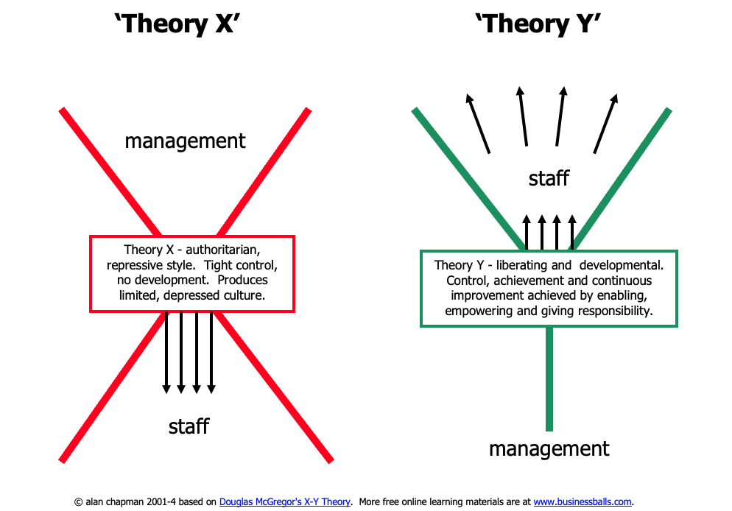

Section 5: identifying a management theory in own workplace.

There are two types of management theories I can identify within my own workplace. The first one being my manager as McGregor's theory X . McGregor's X-Y theory is a helpful and straightforward reminder of the basic norms for managing people, which are all too readily lost under the pressure of day-to-day business. Within my job roll I manage patient waiting list, staff mandatory training and update education request and numbers are the highly important My manager primarily makes certain that I have finished all the checks, have the information needed. She immediately has a negative effect on me when she enters the room and doesn't really engage in discussion or interaction with to get to know us properly.

This has significantly altered my feelings at work and altered my values, beliefs, attitudes, and behaviours. My attitude will alter if I don't feel respected as a person, and it will have an effect on how I behave.

Theory 2 is my team lead, she follows McGregor's theory Y. She will bring treats as a thank you for working hard and check on my health. She is prepared to adjust my schedule in the event my child’s emergency. I believe I have more accountability, and she will support my efforts to better my abilities. She is content with the independent work I do. I feel more invested in the decision-making process, which gives me the drive I need to finish things. I would feel respected as a person, succeed in my attitude towards work and others, and behave better, therefore this theory would have a better impact.

Section 6: Conclusion

Working in the care setting reflect my own attitudes, convictions, and beliefs. Because of the principles I learnt from my upbringing and because I believe in the adage "Treat people the way you want to be treated," I, for example, treat the service user as if they are a member of my family based on my experience. Even if we can't please everyone, the positive attitude and behaviour we have displayed to others will come back to us positively. Even when working with a good mindset, there may still be conflicts due to our differing beliefs and moral standards. The lesson I learned from this event is to try to work out any differences as soon as possible because doing so will result in a successful resolution. In the healthcare environment, teamwork is crucial.

References
'+Caption.byline+'. (n.d.). Not lucky but trained: AFROTC students respond during active shooter. Air University. Retrieved March 15, 2023, from https://www.airuniversity.af.edu/
2020Reply, R. 17 N., Geektonight Team 17 November 2020ReplyI m glad you liked it. Thanks, 2020Reply, G. T. 17 N., 2021Reply, E. 11 J., 2022Reply, B. E. 2 F., 2023Reply, dreslam 14 J., &amp; Enter your name or username to comment. (2021, April 17). What is attitude? definition, types, components, formation, functions, characteristics, importance. Geektonight. Retrieved March 6, 2023, from https://www.geektonight.com/what-is-attitude-meaning-functions-types-importance-components/
2020Reply, R. 17 N., Geektonight Team 17 November 2020ReplyI m glad you liked it. Thanks, 2020Reply, G. T. 17 N., 2021Reply, E. 11 J., 2022Reply, B. E. 2 F., 2023Reply, dreslam 14 J., &amp; Enter your name or username to comment. (2021, April 17). What is attitude? definition, types, components, formation, functions, characteristics, importance. Geektonight. Retrieved March 6, 2023, from https://www.geektonight.com/what-is-attitude-meaning-functions-types-importance-components/
6 benefits of critical thinking and why they matter. Future Focused Learning Insights. (n.d.). Retrieved March 8, 2023, from https://blog.futurefocusedlearning.net/critical-thinking-benefits
A guide to popular management theories. business.com. (n.d.). Retrieved March 18, 2023, from https://www.business.com/articles/popular-management-theories-decoded/
Administrative theory of management - explained (no date) The Business Professor, LLC. Available at: https://thebusinessprofessor.com/en_US/management-leadership-organizational-behavior/administrative-theory-of-management (Accessed: March 12, 2023).
Binji, A., &amp; Author: Abubakar Binji Abubakar Binji is an expert in news publishing. (2020, March 30). Home. Healthcare Issues &amp; Trends. Retrieved March 18, 2023, from https://researchcor.com/what-is-contingency-theory-of-management-ctm/
Discover your personal values: Free online test. Your top 5 personal values. (n.d.). Retrieved March 15, 2023, from https://personalvalu.es/results/b5e29d3d-412b-43cf-9a89-3f85cea748f5
Haas, T. de. (2021, November 13). What is a belief? About my Brain Institute. Retrieved March 5, 2023, from https://www.aboutmybrain.com/blog/what-is-a-belief
Home (no date) MindTools. Available at: https://www.mindtools.com/anx8725/frederick-taylor-and-scientific-management (Accessed: March 12, 2023)
Personal values assessment (PVA). Barrett Values Centre. (2023, March 7). Retrieved March 16, 2023, from https://www.valuescentre.com/tools-assessments/pva/
The relationship between beliefs, values, attitudes and ... - owlcation. (n.d.). Retrieved March 5, 2023, from https://owlcation.com/social-sciences/Teaching-and-Assessing-Attitudes
Types of management theories (with tips and benefits). (n.d.). Retrieved March 11, 2023, from https://uk.indeed.com/career-advice/career-development/management-theories
What are values? Ethics Sage. (2018, August 8). Retrieved March 5, 2023, from https://www.ethicssage.com/2018/08/what-are-values.html

