Business (Wales): Observations from data

Undergraduate non-degree students are those enrolled on programmes such as a Certificate or Diploma of Higher Education (CertHE or DipHE), a Graduate Certificate (GCert) or a CIPD Level 3 programme. Undergraduate first degree students are those completing one of the BA programmes.

Student numbers
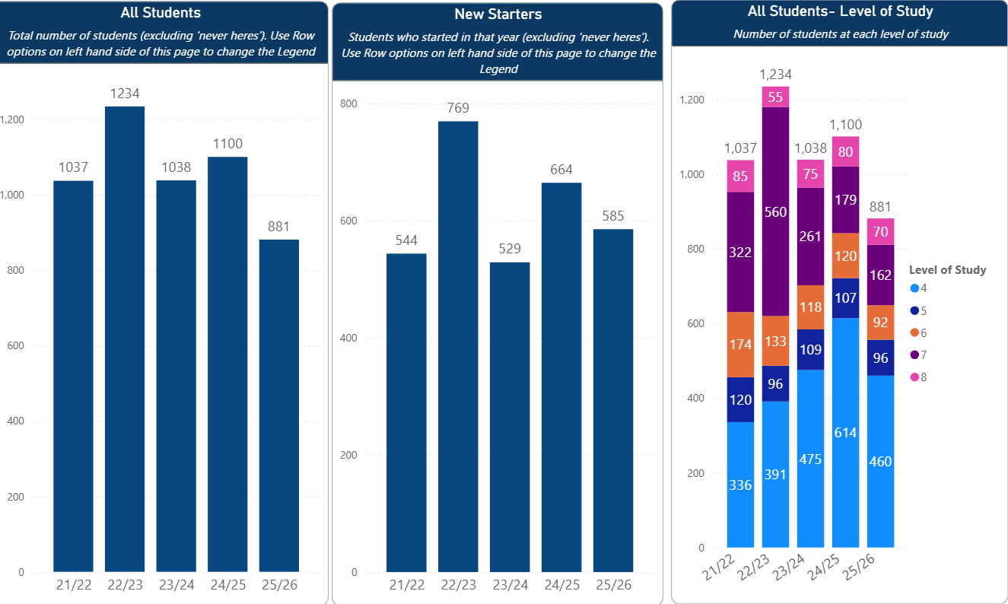
- The number of new starters has remained broadly similar over the years, with peaks in AY22/23 and AY24/25
  - AY22/23 peak – primarily due to spike in new starters on the MBA (43.5FTE 195.5FTE) at Swansea.
  - AY24/25 peak – mainly attributable to spike in new starters on the CertHE Employability Skills (160FTE 255FTE) – 78FTE at Swansea, compared with 42 the previous year, and 177 at Cardiff, compared with 117 the previous year.
- There has broadly been a reduction in the number of Level 7 and Level 6 students over the years.

Mode (part-time/full-time) and method (on-campus/distance) of attendance
Mode of attendance
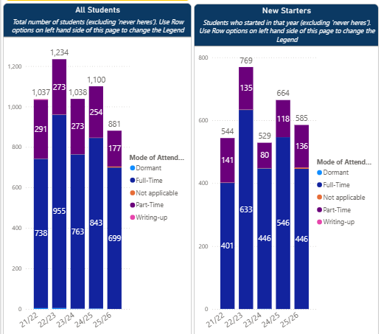
Campus | Part-time
Campus | Undergraduate | Postgraduate
Carmarthen | 53% | 100%
Swansea | 2% | 13%
Cardiff | 0% | 10%

- Overall, the majority of students are full-time, with only 20% part-time, however this varies across different campuses and levels of study.
- Currently, around 25% of undergraduate non-degree students are part-time, compared with only one undergraduate degree student.
- A third of postgraduate taught students are current part-time, as are 61% of PGR students.
- Currently, 70% of Business students are studying part-time at Carmarthen, compared with 5% at Swansea and 0.5% at Cardiff.
- Most part-time undergraduates at Carmarthen are on the Consolidation of Social Work Practice and People Management programmes.
- Part-time PGT students at Swansea are on the Leadership, MBA and Strategic People Management programmes, but only make up a considerable proportion of the cohort (currently 64%) for Strategic People Management. The number of part-time Business undergraduates at Swansea is very small, compared with 16% of undergraduates across the Swansea campus as a whole.
Mode of attendance for distance and on-campus learners
- Overall, 54% of distance learners are part-time, compared with 8% of on-campus students.
- Over time, there has been an increase in distance learners at Carmarthen, and 80% of these students are currently studying part-time. Carmarthen accounts for the majority of part-time and distance learners. Approximately 50% of the on-campus students in AY24/25 were part-time, compared with 6% at Swansea.
Method of attendance
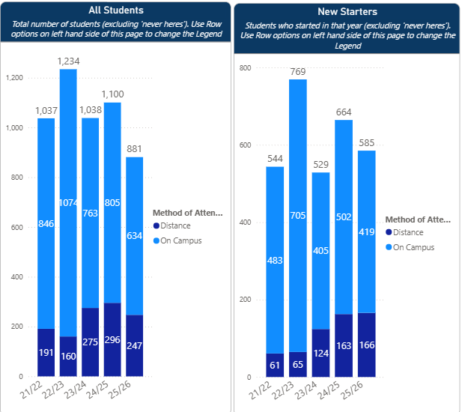
- On-campus enrolments have declined but new enrolments to study at distance have increased. Overall, distance learners currently make up about a third of students at postgraduate level and 27% at undergraduate level.
- For the past two academic years, an average of 83% of new enrolments at Carmarthen have been for distance programmes, compared with 10% at Swansea. There are no distance learners in Cardiff. All but one first degree student in Carmarthen are on campus, compared with 92% of PGT students.
- 100% of undergraduate non-degree and postgraduate students at Swansea are on campus, along with 70% of first degree students. The part-time undergraduates are enrolled on the Ducere programmes and the BA Human Resource Management.

Entry Routes and Tariffs (Undergraduate)
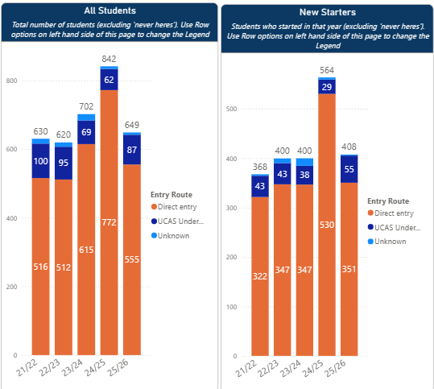
- Last year, 94% of undergraduate students in Business (Wales) joined the University via direct entry, with only 5% of students making a UCAS application. 74% of first degree students are direct entry, whereas across the UK HE sector, almost all undergraduate first degree recruitment is via UCAS. Student recruitment occurs via agencies.
- The majority of students come to us with zero or unknown tariff points.

Home and Overseas
- The only undergraduate programmes with high proportions of overseas students are the BA International Finance and BA International Business Management. Other undergraduate programmes have predominantly, or 100%, Home students.
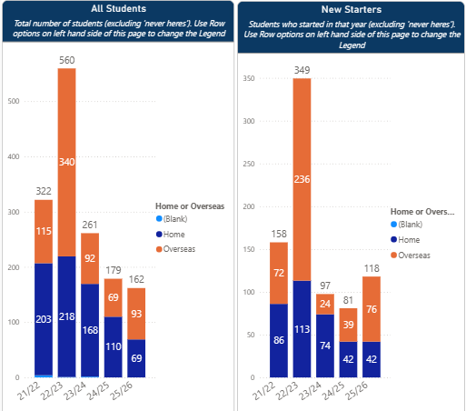
- The proportion of postgraduate students (shown in the graph above) from overseas has increased, although actual numbers have been declining.
- 94% of the students on the MBA during the spike in numbers in 22/23 were overseas, and that programme currently has 87% overseas students.
- 90% of DBA students are overseas. Only 2% of Doctorate in Professional Practice students are overseas.

Low Participation (Undergraduates)
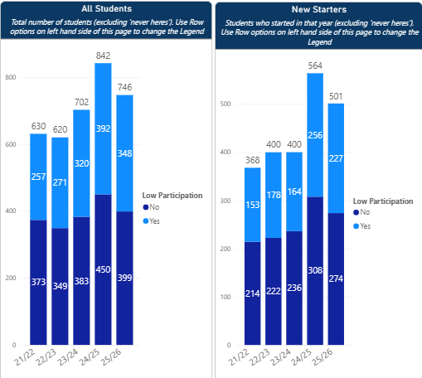
- In the current academic year, 46% of undergraduate students in Business (Wales) are from low participation backgrounds, comparable to the rest of IMH (44%) and UWTSD as a whole (49%).
- This is comprised of approximately 50% of non-degree students and 38% of degree students. More non-degree students than degree students come from low participation backgrounds, overall.
Campus | Non-degree | First degree
Carmarthen | 38% | 39%
Swansea | 70% | 37%
Cardiff | 40% | 53%
Proportion of students from low participation backgrounds.
- There is a relatively small number of students enrolled on community-based programmes, but a large proportion of these are also low participation.
- Currently, 65% of students on the community-based Applied Leadership and Management in the Workplace CertHE and 66% of students on the BA Applied Leadership and Management in the Workplace programme are from low participation backgrounds.

Age
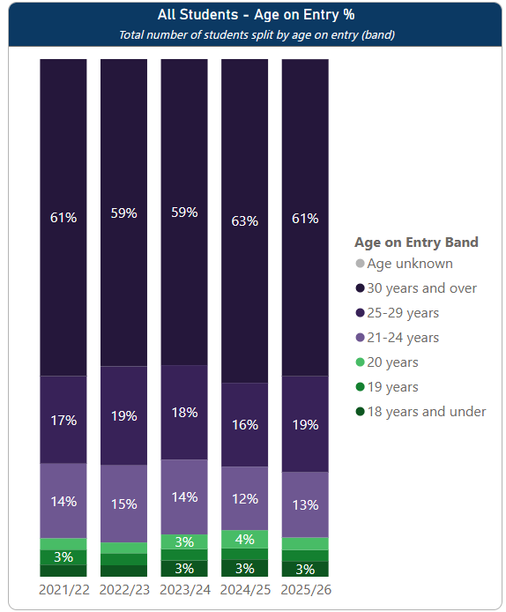
- 80% of students are over 25 years old.
- At postgraduate level, the only programmes with a considerable number of under 24s are the MSc Financial Management (21/46 students = 46%) and the MBA (35%). This is not accounted for by many students progressing onto this from our own BA programmes, which most students on these programmes new to the university. Only 184/492 (37%) of students on the MBA are over 30.
- 26% of postgraduate students in Swansea are under the age of 24, but students in this age bracket are uncommon in Carmarthen and not present at all in Cardiff.
- This year, 63% of undergraduates are over 30. A higher proportion of younger students at Swansea is also observed for undergraduates, but the majority of undergraduate students are over 21 on all campuses, with at least 50% over 30.
- A large proportion of the younger students on PG programmes are Asian. The majority of these students are from overseas.
- Overall, overseas students are more likely to be younger. At undergraduate level, 90% of overseas students are under 24 years old when they start.

Gender
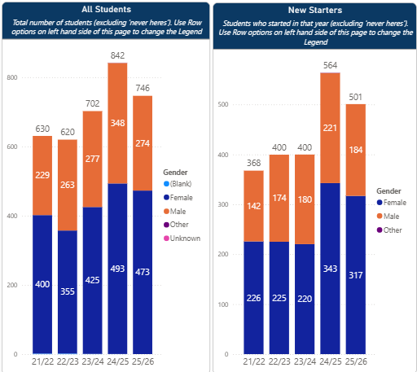
- There are more female than male students, a pattern that has remained stable over the past five years. Currently, 63% of Business students are female, which is slightly high than the rest of IMH, which currently has 57% female students, and UWTSD as a whole, which has 56% female students.
- In Business, two thirds of students on undergraduate non-degree programmes are female, whereas postgraduate programmes currently have equal numbers of men and women overall.
- The MA Professional Practice (Voice Pedagogy) and GCert Consolidation of Social Work Practice have particularly high female:male student ratios – 163/190 (86%) and 274/312 (88%), respectively.
- Carmarthen has a much higher proportion of female students (78%) on non-degree programmes, compared with the other campuses, where the ratio is much closer to 50:50.
- On first degree programmes, there is a much greater proportion of female students at both Carmarthen and Cardiff.

Ethnicity
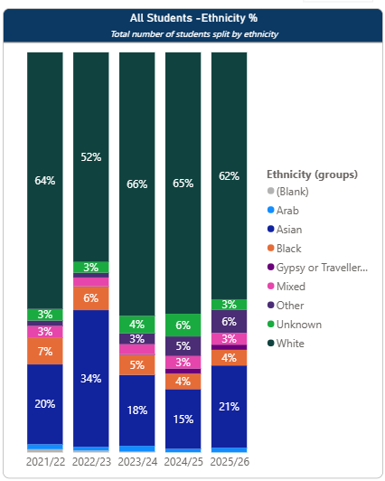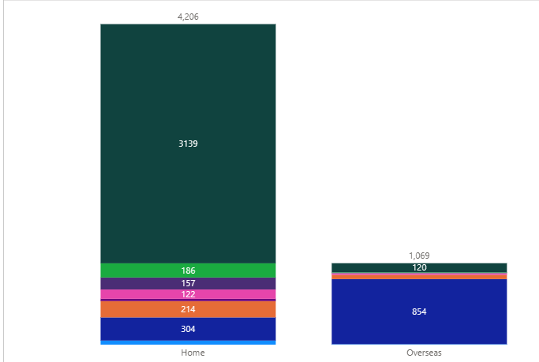
- In the current academic year, 62% of students are white, with the next most common ethnic grouping being Asian. 21% of current students are Asian – 7% of Home students and 80% of Overseas students.
- 27% of Home undergraduates are not White (around 30% for non-degree and 23% for first degree). Currently, 7% of Home Undergraduates are Asian, 70% are White and 3% are Black.
- The majority ethnicity of students on postgraduate programmes is Asian (51% of current PG students), followed by White (37%). 30% of postgraduate Home students are not White.
- The level of ethnic diversity amongst Home students is much higher than for the rest of IMH (currently 84% white) and the geographical areas around the Welsh campuses.

Disability
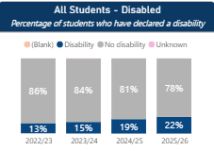
- There has been an increase in students declaring a disability. Currently, 22% of the cohort has declared a disability. This figure is in line with the average for students at Welsh HE institutions, which was 19.5% in AY2023-24 (HESA latest figures), and the figures for Business reflect the pattern seen across IMH as a whole.
- The proportion of autistic students and those with learning difficulties (which includes Specific Learning Differences such as dyslexia), mental health conditions and long-standing illnesses has increased, accounting for most of the increase seen in the proportion of disabled students. The proportions of different disabilities seen in Business are broadly reflective of IMH as a whole.
Level of study | Proportion of students disclosing a disability | Notes
Undergraduate | 25% | A larger proportion of students on non-degree programmes have declared mental health conditions, learning difficulties, long standing illnesses and autism
Non-degree | 28%
First degree | 19%
Postgraduate | 15% | Mental health conditions and learning difficulties account for two thirds of disclosures
- The number of students disclosing a disability is higher in Cardiff, primarily accounted for by a much higher disclosure of mental health conditions (17% of students), which has been increasing over time.
- The proportion of students declaring a disability is higher in Carmarthen than Swansea, primarily accounted for by larger numbers of students disclosing autism and mental health conditions.
- The lower proportion of postgraduate students declaring a disability follows national trends but may be primarily attributable to lower numbers of overseas students declaring a disability.
- Female students are more likely to declare a disability than male students across all levels of study, in line with national trends.

Welsh Language
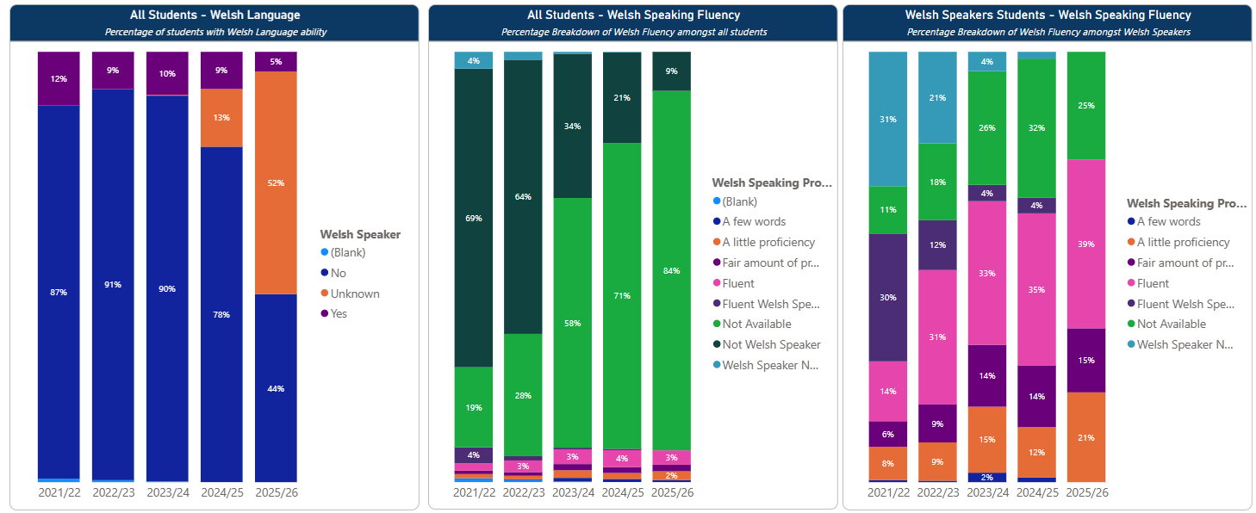
- For most students, we do not have data on their level of Welsh language fluency. Of those for whom data are available, approximately 10% are Welsh speakers, and for those we do know speak Welsh, 40% of the current Business cohort are fluent.
- The proportion of Welsh speaking students, and the level of fluency of Welsh-speaking students, is much higher in Carmarthen than Swansea. Number of Welsh speakers is very low in Cardiff.

Home student recruitment and commuter students
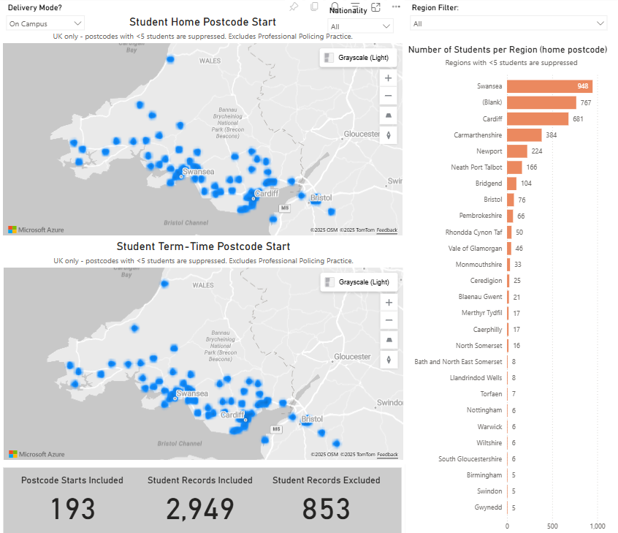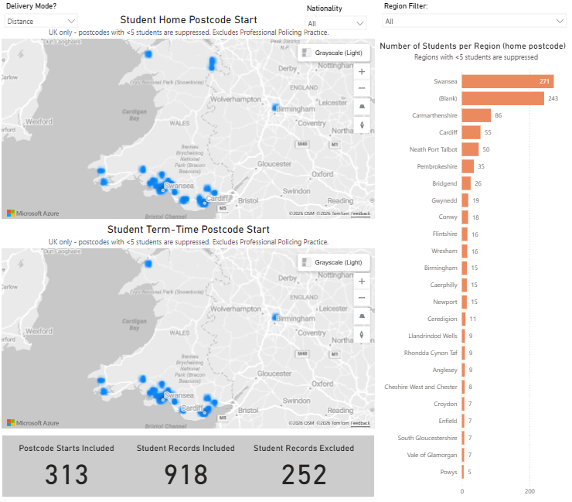
- On-campus students (b) Distance students

- The geographical pattern of Home student recruitment is reflective of IMH as a whole, excluding International Hotel Management.
- Postgraduate taught distance learners are based locally.
- Many on-campus students are travelling to campus from areas not easily accessible by public transport.
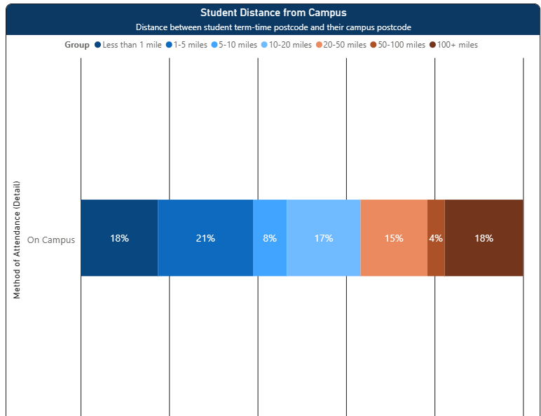
Distance travelled to campus
- 58% of undergraduates at Carmarthen are travelling over 20 miles to campus, compared with 23% at Swansea and 16% at Cardiff.
- At postgraduate level, there is a high proportion of commuter students in Carmarthen and Swansea. At Carmarthen, 81% of PGT students are travelling over 20 miles. At Swansea, this is 54%, but the majority (45% of the total) are travelling over 100 miles.

Retention
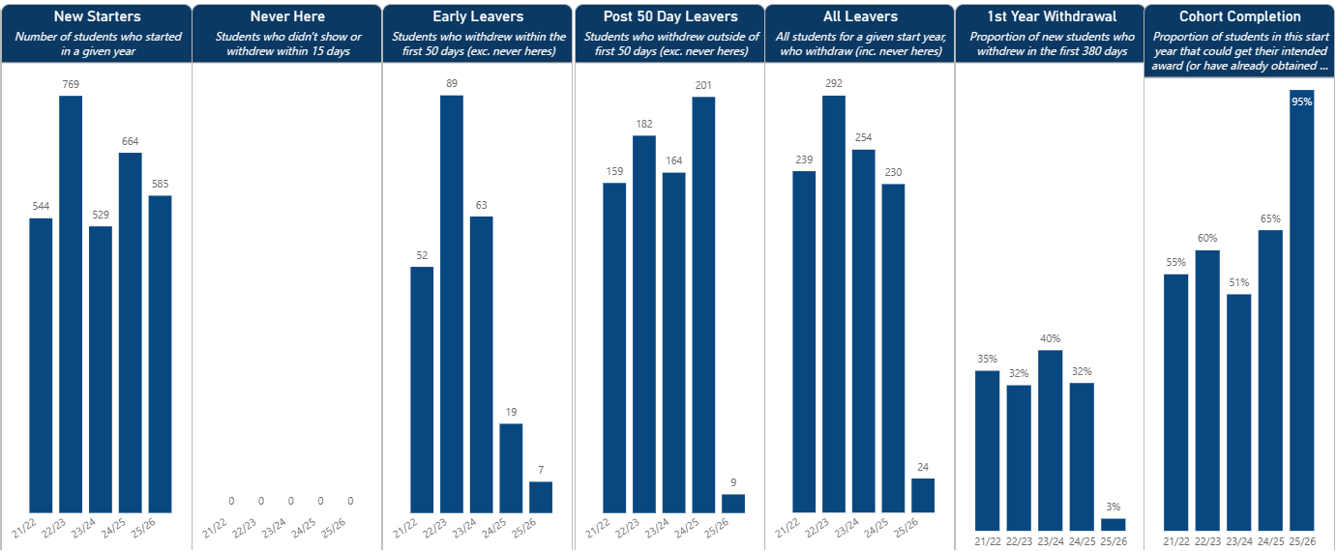
- In most academic years, around a third of students withdraw in their first year, which is comparable with IMH as a whole.
- Last year, 36% of undergraduates withdrew in their first year – 40% of non-degree students and 22% of first degree students. Withdrawal rates are lower for postgraduates.
- Academic failure accounts for most withdrawals at both undergraduate and postgraduate level, but financial, health and family reasons are also relatively common.
- The proportion of withdrawals due to academic failure is much higher for non-degree undergraduates, accounting for 80% of withdrawals in AY24/25 (compared with 42% for first degree students)
- Undergraduates who are younger, male, from low participation backgrounds or whose parents did not go to university are more likely to withdraw.
- Withdrawal rates for young students were particularly high last year for undergraduate non-degree programmes (around 77% for those under 20).
- Home students are much more likely to withdraw than overseas students.
- Gypsy and Traveller students make up a low proportion of the cohort but have consistently high withdrawal rates. Withdrawal rates for Arab, Mixed and Black students are also relatively high. Withdrawal rates are lowest for Asian students – except for undergraduate non-degree programmes, where they are comparable to those of Black, Arab and White students.
- Withdrawal rates at postgraduate level have broadly been falling for both home and overseas students.

Good Honours and Module Outcomes
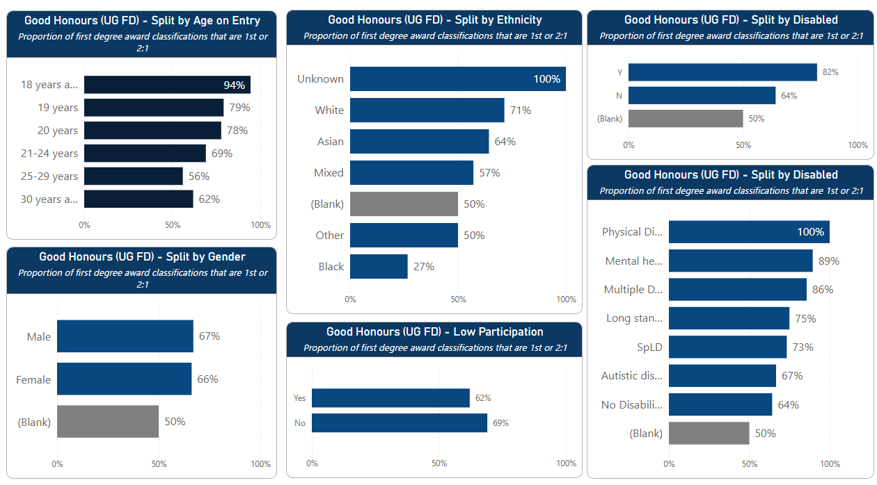
Module level | Failure rate
4 | 17%
5 | 6.5%
6 | 4%

- The most notable awarding gap is that only 11% of Black men have achieved good honours since AY21/22 (around 8/75), of which none of them were from low participation backgrounds (0/28).
- There were 30 Gypsy and Traveller students enrolled on Business undergraduate degrees during this period, with an average module mark of 17.8.

Assessment Types
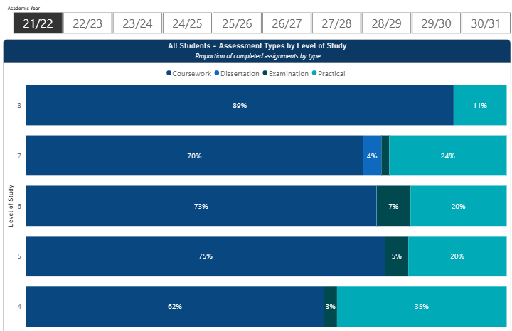

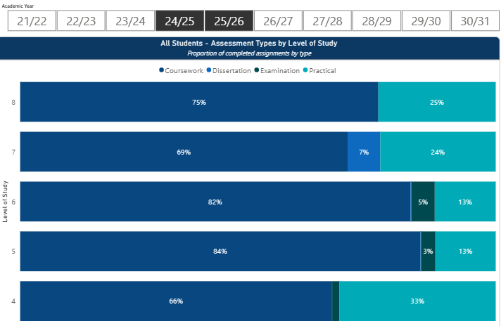

Level of study | Proportion of practical assessments
Level of study | AY21/22 | AY25/26
4 | 35% | 33%
5 | 20% | 13%
6 | 20% | 13%

- There has been an increase in coursework and decrease in practical assessments on undergraduate programmes since AY21/22.
- Programmes in Cardiff have a higher proportion of practical assessments than Carmarthen and Swansea.

