ACCA6011
Artificial Intelligence and Machine Learning

Assignment
Search and Machine Learning Clustering

1809125 Thomas Pritchard 04/01/21

Contents
1. Abstract 1
2. Section one: Task 1: Search 1
2.1. Report discussion 1
2.2. User guide and screenshots 2
2.3. Testing plan 4
2.4. Program listing 7
3. Section 2: K-means 18
3.1. Task 2: Evaluation 18
3.1. Task 3: Calculation 20
3.1.1. Starting data 20
3.1.2. Examples of hand calculation 20
3.1.3. Complete calculations 22
3.1.4. Result 24
4. Bibliography 25

Abstract
The following report compiles work completed to meet the three tasks as set within the assignment brief for ACCA6011. Section one comprises of Task 1, a solution to a problem involving searching a hospital map for signs. It includes a discussion of techniques employed, a user guide and screenshots, testing schedule and a program listing. Section two cover Tasks 2 and 3 in relation to K-means algorithms.

Section one: Task 1: Search

Report discussion
The solution delivered for this task utilises two algorithms; the first being a depth first search algorithm to initially search the hospital map and identify and record all signs, the second being Dijkstra’s algorithm to allow a user to find the shortest route to a sign.
Looking first at the depth first search, once the user has loaded a map, and the starting square has been identified, the user can select to run the search. The search utilises stacks to hold a variety of information, namely a stack of squares left to be searched, squares where decisions have been made, and squares traversed since the last decision point to allow reversal. Stacks have been selected for this use case due their first in, last out functionality – in all cases it is the last added item to the stack which needs first focus, before working back through. As an example, taking the squares where decisions have been made stack, each time a decision point is reached, the coordinates of the square are added to the stack, the search then continues deeper, adding further decision points as it reaches them. Once the search has reached full depth for this path, it can take the square from the top of this stack which directs the search back up one level, and then allows exploration of further options from that point down, repeating until all paths have been explored.
Within this algorithm, queues have also been utilised, namely to record the path taken by the search, which is displayed to the user as a series of coordinates on discovery of a sign – this is also displayed graphically in real time. When a sign is discovered, the first in, first out functionality of a queue allows for easy output of all elements in the right order to the user. In this scenario, the user is interested in the journey from the source to the destination, meaning moves need to be recorded and displayed from the oldest to the newest.
A further data structure used within this section, is vectors, to recorded signs identified and their locations, as well as list of nodes and their locations identified during the search. The nodes vector is later utilised by Dijkstra’s algorithm, and comprises of start positions and sign positions, as well as decision points and corners. Vectors have been selected for this purpose due to their flexibility in working with dynamic data, as until the search is completed the number of elements that may be required is not known.
Djikstra’s algorithm is implemented to allow a user to find the shortest path to a destination, as can be seen by the agent as it traverses the map, the DFS search does not seek to provide the most direct route. Once again vectors are utilised for recording data such as an assigned number to each node alongside it’s x y coordinates for later lookup, and additionally a 2D array is utilised which stores identified valid vertices between the nodes, with each dimension representing a node and the value being equivalent to the distance between the nodes. This is then rotated through with a further vector used to store the states of each node as the algorithm runs, identifying shortest routes and marking permanency once all options have been explored. The resulting path is then displayed to the user both in coordinate form and graphically by making use of comparisons between new and previously created vectors and their elements. Structures have been used throughout both algorithms to hold multiple sources of data relating to the same element, as in the example above with a list of identified nodes being stored in a vector of structures, allowing grouping of their coordinates, sign and other information where applicable.

User guide and screenshots
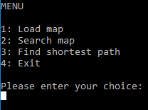
On program load, the user is presented with a main menu which provides a variety of options – the first step is option 1: to load a map.

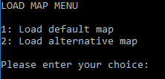
Once selected, the user can choose open the default map (floor0.lay), or an alternative map.

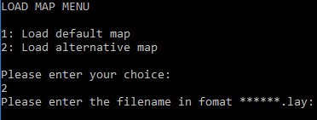
If the alternative option is selected, the user can enter their own filename – the file must be in the same location as the program to be found.
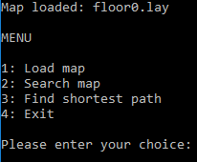

On successful file load, the user receives a confirmation message and is directed back to the main menu, if a file load is unsuccessful they will receive an error message and be directed back to the main menu to retry. The next step is to select option 2 to search the map.
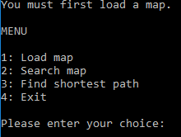

If a map has not yet been successfully loaded before option 2 is selected, an error message is received and the main menu displayed again.
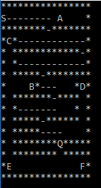

Otherwise, the search begins. The map is loaded and displayed to the user graphically, an agent (Q) is animated traversing the map utilised the DFS. For the purposes of demonstration, the map reprints with the new location at 75ms delays which makes the animation more visible. The order of the search is left first, followed by up, then down and finally right. As the map is traversed, visited squares hyphenated to show the path taken. However signs remain on the map even if visited.

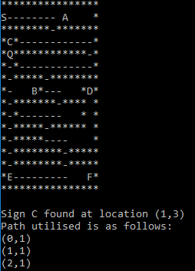

When a sign is discovered (in this example ‘C’ has been found), the map and agent will pause at the location so the path can be seen. Additionally, a display is output as coordinates showing the path taken by the agent to reach the sign. The user is instructed to ‘Press enter to continue’ once they have reviewed the data.

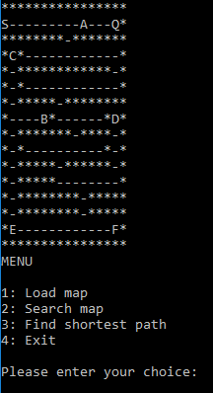

On completion, a final map is displayed to the user and they are returned to the main menu. If no signs have been found, a message is displayed to advise of this.

The next option is number 3, which will take the user on to the shortest path function.

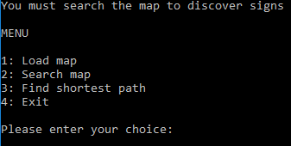
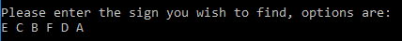
If no map has yet been loaded or searched, the user will receive a message to advise them to complete this first.

Otherwise, they are presented a list of signs found to choose from.
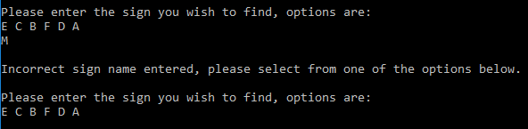
If an incorrect value is entered, they will receive an error message and are asked to input a correct sign from the provided options
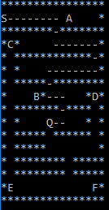

The shortest path is calculated using Dijkstra’s algorithm, and once again, a blank version of the map is drawn on screen. An animation displays the agent traversing the map using the shortest path as identified. As before, the path remains on screen to allow the user to visualise the directions.

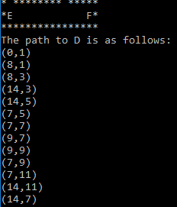
Additionally, coordinates are displayed to show the route taken non-graphically. As an improvement to the DFS which displayed every traversed square, this stage on displays traversed nodes, which are equivalent to turns on the map – either when a corner is hit or a square is reached which has more than one turn off.

The user is finally displayed the main menu where they can choose to re-run some of the above functions on different data or signs, or otherwise exit.

Testing plan
Due to the requirements of the module, coding has been focused on implementation of logic of the algorithms, but does include some other features such as error handling in some places. Testing has been completed throughout both on the logic of the code in small sections, and the wider software running as a whole. Where a fix has been reasonable within the timescales and high enough priority compared to the requirements of the module, it has been implemented, however if more time were available some user experience improvement could be considered. As an example, earlier testing on using Dijkstra’s algorithm showed successes for some signs, but the code was looping for others. It was determined that signs not directly in line with the source node could not be found, and this was determined to be down to the way nodes had been collected. Originally nodes were collected at points where a sign was found, or a direction choice made – however for areas of the map where a corridor turned a corner, but no decision was required as there was only one path, this meant the algorithm would not be able to find a connection from one node to the next. This was fixed by evaluating the last, and next move of a current square, to determine whether it resulted in a switch between vertical or horizontal movement, and if so record the location as a node.
Below are some further example test scenarios.
Title | Main menu selection
Pre-conditions | Program loaded to main menu
Inputs | Test for each selection 1 - 4
Outputs | Next stage of selected option begins
Description | Test the functionality of the main menu to ensure all options direct where expected.

Title | Main menu check pre-conditions
Pre-conditions | Program loaded to main menu, no map loaded
Inputs | Test for selections 2 and 3.
Outputs | Error message, returned to main menu.
Description | Test the functionality of the error handling for if a file is not yet loaded or has not yet been searched.

Title | Load map
Pre-conditions | Program loaded to main menu, no map loaded
Inputs | Select to load map, then test:  - Load default map  - Load alternative map where no file exists  - Load alternative map where file exists
Outputs | - Floor.0.lay loads  - Error, and returned to menu  - Test file loads
Description | Test whether files load as expected, or that otherwise an error is thrown.

Title | Search map
Pre-conditions | Program loaded to main menu, map loaded
Inputs | Select to search map
Outputs | Map displayed on screen, agent begins traversing map
Description | Test whether map search begins.

Title | Sign found
Pre-conditions | Map search underway
Inputs | Sign within map file
Outputs | Sign found, search pauses, map and traversed coordinates displayed.
Description | Test whether expected behaviour occurs if a sign is found.

Title | Search complete
Pre-conditions | Program loaded to main menu, map loaded, search finished
Inputs | Map file
Outputs | Every blank element of map showing as visited, every sign found.
Description | Test whether map search begins.

Title | Sign found
Pre-conditions | Map search underway
Inputs | Sign within map file
Outputs | Sign found, search pauses, map and traversed coordinates displayed.
Description | Test whether expected behaviour occurs if a sign is found.

Title | Shortest path start
Pre-conditions | Map search completed
Inputs | - Select find shortest path  - Sign names  - Enter incorrect sign name  - Enter correct sign name
Outputs | - Next menu loads  - Names of all signs displayed  - Error message  - Path finding begins
Description | Test whether a shortest path search can be started as expected.

Title | Shortest path end
Pre-conditions | Map search completed, shortest path search started
Inputs | Test with multiple valid signs
Outputs | Path displayed both graphically and by coordinates, check whether shortest path has been found.
Description | Test whether shortest path is found.

Program listing
#include <iostream>
#include <fstream>
#include <string>
#include <stack>
#include <thread>
#include <vector>
#include <queue>
#define WIDTH 16
#define HEIGHT 16
#define MAX_NODES 1024
#define INFINITY 10000000
int distarr[MAX_NODES][MAX_NODES];

using namespace std;

typedef struct {
int x;
int y;
char sign;
} position;
std::stack<position> tosearch, choice, cursearch;
typedef struct { //a vertex between node 1 and node 2
int n1;
int n2;
int dist;
} vertex;
typedef struct { //a node with unique identifier, to be used for lookup
int nodenum;
int x;
int y;
} node;
//find starting position on map
position findstart(char t[]) {
position s;
s.x = -1;
while (s.x == -1) {
for (int y = 0; y < HEIGHT; y++)
{
for (int x = 0; x < WIDTH; x++)
{
if (t[WIDTH * y + x] == 'S') {
s.x = x;
s.y = y;
s.sign = 'S';
}
}
}
}
return s;
}
//check whether the currently selected square contains a sign
position checkforsign(char t[], position c) {
position sign;
sign.x = -1;
if (t[WIDTH * c.y + c.x] != 'S' && t[WIDTH * c.y + c.x] != ' ' && t[WIDTH * c.y + c.x] != '-') {
//store sign in vector
sign.x = c.x;
sign.y = c.y;
sign.sign = t[WIDTH * c.y + c.x];
}
return sign; // return location and name of sign
}
//print out the coordinates traversed so far within the DFS when sign found
void printpathtaken(position s, position c, std::queue<position>& p) {
cout << endl << "Sign " << s.sign << " found at location (" << c.x << "," << c.y << ")" << endl;
cout << "Path utilised is as follows:" << endl;
queue<position> pathprint;
pathprint = p;
while (!pathprint.empty()) { // print each value from the queue
position pp = pathprint.front();
cout << "(" << pp.x << "," << pp.y << ")" << endl;
pathprint.pop();
}
cout << "(" << c.x << "," << c.y << ")" << endl;
cout << endl << "Press Enter to Continue";
cin.ignore(); //await user input to continue
}
//print the map using current location
void printmap(position c, char t[]) {
std::this_thread::sleep_for(75ms); //delay set to demonstrate map animation, can be adjusted
system("cls");
for (int y = 0; y < HEIGHT; y++)
{
for (int x = 0; x < WIDTH; x++)
{
if (x == c.x && y == c.y) {
cout << "Q"; //if current square, print Q as marker
}
else {
cout << t[WIDTH * y + x];
}
}
cout << endl;
}
}
//check if square is empty
bool checkforempty(char t[], position c, position tc) {
if (c.x < WIDTH && t[WIDTH * tc.y + tc.x] != '*' && t[WIDTH * tc.y + tc.x] != '-' && t[WIDTH * tc.y + tc.x] != 'S') {
return 1;
}
else {
return 0;
}
}
//look around current location for empty squares
int findemptysquares(position l, position c, char t[]) {
position tc;
int i = 0;
for (int x = 1; x >= -1; x--) { //for all x values -1 to 1
for (int y = 1; y >= -1; y--) {//for all y values -1 to 1
tc.x = -1; //set square to check outside of range
tc.y = -1;
if (x == y || x == (-1) * y) {} //Don't check current square or diagonals
else if (x == 0) { //if x = 0, potential move is vertical
tc.x = c.x;
tc.y = c.y + y;
}
else if (y == 0) { //if y = 0, potential move is horizontal
tc.x = c.x + x;
tc.y = c.y;
}

if (tc.x != -1) { //if square found
if ((tc.x != l.x || tc.y != l.y) && checkforempty(t, c, tc)) { //check square is not last square, and is empty
tosearch.push(tc);
i++; //record number of potential options
}
}
}
}
return i;
}
//Depth First Search
vector<position> completedfs (char text[]) {

position start = findstart(text), current = start, sign; //get start position
vector<position> signs;
vector<position> nodes;
queue<position> path;
int nodei;

tosearch.push(current); //add start position to search list
nodes.push_back(start); //record as node

while (!tosearch.empty()) { //while there are squares to be searched

current = tosearch.top();
tosearch.pop();
cursearch.push(current); //make last square added the current
current.sign = text[WIDTH * current.y + current.x]; //retrieve value from text file
nodei = 0;

//check whether square contains sign
sign = checkforsign(text, current);
if (sign.x >= 0) {
signs.push_back(sign); //record sign
nodes.push_back(sign); //record as node
nodei++; //mark node as already recorded
printpathtaken(sign, current, path); //print path travelled so far
}

//print map
printmap(current, text);

//set current square visited if blank
if (text[WIDTH * current.y + current.x] == ' ') {
text[WIDTH * current.y + current.x] = '-';
}

//set last visited position (ignores last position for following search, prevents issues if value of square not changed i.e sign located)
position last;
last.x = -1; //set dummy values
last.y = -1;
if (!path.empty()) { //take last value from path if available
last = path.back();
}
path.push(current); //record current square on path

//find possible moves, return number possible
int end = findemptysquares(last, current, text);

//if more than one possible move, record current location to be revisisted
if (end > 1) {
for (int i = 0; i < end - 1; i++) { //add as multiple times if multiple possible moves
choice.push(current);
if (nodei == 0) { //record as node if not already
nodes.push_back(current);
nodei++;
}
}
}

//if turning a corner, record as node
if (!tosearch.empty() && nodei == 0) { //ignore start, end, or if node already added
position next = tosearch.top(); //look forward to next positon
if (last.x != -1 && last.x == current.x) {
if (next.x != current.x) { //if last move vertical and next horizontal
nodes.push_back(current); //record node
}
}
else if (last.y != -1 && last.y == current.y) {
if (next.y != current.y) { //if last move horizontal and next vertical
nodes.push_back(current); //record node
}
}
}

//if end reached, display position moving back to last choice
if (end == 0 && !tosearch.empty()) {
position check = choice.top(); //get next position to be searched
choice.pop();
while (check.x != current.x || check.y != current.y) { //reverse through currentsearch list until reached next position
printmap(current, text);
current = cursearch.top();
cursearch.pop();
}
printmap(current, text);
}

}

//print message if no signs found
if (signs.empty()) {
cout << "No signs found" << endl;
}

return nodes; //return nodes found
}
vector<node> getnodepairs(vector<position> n, vector<node> nodes, char t[]) {

int d1, d2, dist, block;
//check for possible vertices based on nodes within the map, nodes are either a sign, a corner, or a square with multiple options to turn
for (size_t i = 0; i < nodes.size(); i++) { // check every node against every other
for (size_t j = i + 1; j < nodes.size(); j++) { //don't check against self, or node pairs already checked
if (nodes.at(i).x == nodes.at(j).x) { // check if two elements in same column
if (nodes.at(i).y > nodes.at(j).y) { //check for smaller value, assign as d1
d1 = nodes.at(j).y;
d2 = nodes.at(i).y;
}
else {
d1 = nodes.at(i).y;
d2 = nodes.at(j).y;
}
dist = abs(d1 - d2); //get distance between nodes
block = 0; //set check for whether path blocked
for (int k = 1; k < dist; k++) { //check if path blocked
if (t[WIDTH * (d1 + k) + nodes.at(i).x] == '*') {
block = 1;
}
}
if (block == 0) {//if path clear, valid vertex
distarr[i][j] = distarr[j][i] = dist; //store in array
}
}
if (nodes.at(i).y == nodes.at(j).y) { // check if two elements in same row
if (nodes.at(i).x > nodes.at(j).x) { //check for smaller value, assign as d1
d1 = n.at(j).x;
d2 = n.at(i).x;
}
else {
d1 = n.at(i).x;
d2 = n.at(j).x;
}
dist = abs(d1 - d2); //get distance between nodes
block = 0; //set check for whether path blocked
for (int k = 1; k < dist; k++) { // check if path blocked
if (t[WIDTH * nodes.at(i).y + d1 + k] == '*') {
block = 1;
}
}
if (block == 0) {//if path clear, valid vertex
distarr[i][j] = distarr[j][i] = dist; //store in array
}
}
}
}

return nodes;
}
//Run dijkstra on given nodes, start and destination
void shortest_path(int n, int s, int f, int path[])
{
struct state { //current node state
int predecessor; //previous node
int length; // length from source to this node
int label; // 1 = Permanent, 0 = Tenatvie LABEL state
} state[100];

struct state* p;
int i, k, min;

for (p = &state[0]; p < &state[n]; p++) { //current node states
p->predecessor = -1;
p->length = INFINITY;
p->label = 0;
}

state[s].length = 0; state[s].label = 1; //set starting point as first permanent state node
k = s; //set start node

do { //check for best path
for (i = 0; i < n; i++) { //rotate through all available nodes
if (distarr[k] != 0 && state[i].label == 0) { //check temporary state nodes
if (state[k].length + distarr[k][i] < state[i].length) { //if current length + dist to new node, shorter than new node
state[i].predecessor = k; //set current node as previous to new node
state[i].length = state[k].length + distarr[k][i]; //set new discovered path length
}
}
}
// Find the tentatively labeled node with the smallest length
k = 0; min = INFINITY;
for (i = 0; i < n; i++)
if (state[i].label == 0 && state[i].length < min) { //rotate through all temporary state node, if length less than current lowest found
min = state[i].length; //set new minimum
k = i; //make this node the current
}
state[k].label = 1; //mark node state as permanent
} while (k != f); //repeat until destination found

//extract path taken
i = 0; k = f;
do {
path[i++] = k;
k = state[k].predecessor; //move back along using predecessor references
} while (k >= 0);
}
//Start shortest path lookup
void rundijkstra (vector<position> n, char t[], char b[]){

int numnodes = n.size(); //determine number of nodes found
int p[MAX_NODES*2]; //to store returned path
int findn;
char finds;

//find start position
position startn = findstart(t);

//initialise array with max values
for (int i = 0; i < numnodes; i++) {
for (int j = 0; j < numnodes; j++) {
distarr[i][j] = INFINITY;
}
}

vector<node> nodes, pathnodes;

for (size_t i = 0; i < n.size(); i++) { //create vector of all nodes and their xy locations, assign a number, to be used for lookup
node temp;
temp.x = n.at(i).x;
temp.y = n.at(i).y;
temp.nodenum = i;
nodes.push_back(temp);
}

nodes = getnodepairs(n, nodes, t); //get all valid node pairs and their distances

system("cls");

//ask user for sign to find
bool valid = 0;
while (!valid) {
cout << endl << "Please enter the sign you wish to find, options are:" << endl;
for (int i = 0; i < numnodes; i++) {
if (n.at(i).sign != ' ' && n.at(i).sign != 'S') { //get all signs from node list, ignore start and corner/choice squares
cout << n.at(i).sign << " ";
}
}
cout << endl;
cin >> finds;
for (int i = 0; i < numnodes; i++) { //user input as char, lookup in signs to get equivalent ref number
if (n.at(i).sign == finds) {
findn = i;
valid = 1;
}
}
if (!valid) { //if invalid name entered, error and retry
cout << endl << "Incorrect sign name entered, please select from one of the options below." << endl;
}
}

//get shortest path from source to destination
shortest_path(numnodes, 0, findn, p); //p is path returned from function

//get x y values in the path
cout << endl;
node tn;
for (int i = numnodes - 1; i > -1; i--) { //reverse path
for (int j = 0; j < numnodes; j++) {
if (p[i] == nodes.at(j).nodenum) { //find x y values from node reference
tn.nodenum = nodes.at(j).nodenum;
tn.x = nodes.at(j).x;
tn.y = nodes.at(j).y;
pathnodes.push_back(tn);
}
}
}

//Animate path on map
position cur, next;

for (int i = 0; i < pathnodes.size() - 1; i++) { //iterate through each node on path (except last)
cur.x = pathnodes.at(i).x; //set current node to relevant loop value
cur.y = pathnodes.at(i).y;
if (b[WIDTH * cur.y + cur.x] == ' ') { //if current node blank, overwirte to show visited
b[WIDTH * cur.y + cur.x] = '-';
}
printmap(cur, b); //print map
next.x = pathnodes.at(i + 1).x; //set next values (cannot be bigger than size due to for loop)
next.y = pathnodes.at(i + 1).y;
if (cur.x == next.x) { //check if in same column
int dif = next.y - cur.y; //get distance between
int absdif = abs(dif); //calculate absoulte as may be negative
if (dif > 0) { //check for direction down
for (int j = 1; j < absdif; j++) { //for each square between current and next, print map with marker and set as visited
cur.y = cur.y + 1;
printmap(cur, b);
if (b[WIDTH * cur.y + cur.x] == ' ') {
b[WIDTH * cur.y + cur.x] = '-';
}
}
}
else { //direction up
for (int j = 1; j < absdif; j++) { //for each square between current and next, print map with marker and set as visited
cur.y = cur.y - 1;
printmap(cur, b);
if (b[WIDTH * cur.y + cur.x] == ' ') {
b[WIDTH * cur.y + cur.x] = '-';
}
}
}
}
else { //in same row
int dif = next.x - cur.x; //get distance between
int absdif = abs(dif); //calculate absoulte as may be negative
if (dif > 0) { //check for direction right
for (int j = 1; j < absdif; j++) { //for each square between current and next, print map with marker and set as visited
cur.x = cur.x + 1;
printmap(cur, b);
if (b[WIDTH * cur.y + cur.x] == ' ') {
b[WIDTH * cur.y + cur.x] = '-';
}
}
}
else { //direction left
for (int j = 1; j < absdif; j++) { //for each square between current and next, print map with marker and set as visited
cur.x = cur.x - 1;
printmap(cur, b);
if (b[WIDTH * cur.y + cur.x] == ' ') {
b[WIDTH * cur.y + cur.x] = '-';
}
}
}
}
}

//print path coordinates
cout << "The path to " << finds << " is as follows:" << endl;
for (int i = 0; i < pathnodes.size(); i++) {
cout << "(" << pathnodes.at(i).x << "," << pathnodes.at(i).y << ")" << endl;
}

}
int main(void) {

int choice = 0, choice2 = 0, loaded = 0, searched = 0;;
char text[WIDTH * HEIGHT], blank[WIDTH * HEIGHT], bcopy[WIDTH * HEIGHT];
vector<position> nodes;

while (choice != 4) {//run until user exits
cout << "MENU" << endl << endl; //user selection
cout << "1: Load map" << endl;
cout << "2: Search map" << endl;
cout << "3: Find shortest path" << endl;
cout << "4: Exit" << endl << endl;

cout << "Please enter your choice:" << endl;
cin >> choice;

switch (choice) {
case 1:
{
system("cls");
cout << "LOAD MAP MENU" << endl << endl; //second user selection
cout << "1: Load default map" << endl;
cout << "2: Load alternative map" << endl << endl;

cout << "Please enter your choice:" << endl ;
cin >> choice2;

switch (choice2) {
case 1:
{ //load file
string line;
ifstream myfile("floor0.lay");
if (myfile.is_open())
{
int count = 0;
while (getline(myfile, line))
{
line.copy(&text[WIDTH * count], WIDTH, 0); //input to working version and keep blank copy
line.copy(&blank[WIDTH * count], WIDTH, 0);
count++;
}
myfile.close();
loaded = 1; //mark file as loaded
searched = 0; //mark file as not searched
system("cls");
cout << "Map loaded: floor0.lay" << endl << endl;
}
else cout << "Unable to open file." << endl << endl; //error
break;
}
case 2:
{
string filename; //ask user fo filename
cout << "Please enter the filename in fomat ******.lay:" << endl;
cin >> filename;
//load file
string line;
ifstream myfile(filename);
if (myfile.is_open())
{
int count = 0;
while (getline(myfile, line))
{
line.copy(&text[WIDTH * count], WIDTH, 0); //input to working version and keep blank copy
line.copy(&blank[WIDTH * count], WIDTH, 0);
count++;
}
myfile.close();
loaded = 1; //mark file as loaded
searched = 0; //mark file as not searched
cout << "Map succesfully loaded." << endl << endl;
}
else cout << "Unable to open file." << endl << endl; //error
break;
}
}
break;
}
case 2:
{
system("cls");
if (loaded == 1) { //if file loaded, start search
position start = findstart(text); //find start position
nodes = completedfs(text); //commence DFS
searched = 1;
}
else { //error
cout << "You must first load a map." << endl << endl;
}
break;
}
case 3:
{
system("cls");
if (searched == 1) { //if map searched
memcpy(bcopy, blank, WIDTH * HEIGHT); //make copy of blank text array
rundijkstra(nodes, text, bcopy); //start to find shortest path
}
else { //error
cout << "You must search the map to discover signs" << endl << endl;
}
break;

}
case 4:
break;
}
}
return 0;
}

Section 2: K-means

Task 2: Evaluation
The K-means clustering algorithm is an unsupervised learning algorithm that’s primary purpose is to group similar data points from a large group into smaller subsets, referred to as clusters [1]. This concept has a wide variety of use cases, examples include making product recommendations for similar items, grouping users into categories to allow for targeted promotions, and allowing analysis of similar types of data without needing to consider every piece individually [2].

The algorithm can be described by the following steps:
- Determine number of clusters required (referred to as k)
- Randomly set k number of locations (referred to as centroids)
- Calculate distance of each data point from each centroid
- From these distances, determine the closest centroid for each data point, and assign it to this cluster
- For all data points in each cluster, calculate the centre of gravity (mean), this is the new centroid for that cluster
- Repeat steps 3-5, algorithm completes once either data points do not change between iterations (therefore centroids remain the same), or until another stopping criteria has been met e.g. number of iterations, compute time.

Determining the similarity of data points and the disparity of clusters can be calculated by looking at two features of clusters - the intracluster distance and the intercluster distance [3]. Intracluster looks within each cluster to determine the inertia of the data points, by calculating the sum of the squared distances within a cluster of each data point to the centroid - a lower value shows data points are close together, therefore demonstrating similarity between the data points [4]. A second measure is the intercluster distance which is a measure of the distance between clusters, which can be calculated using the Dunn index by dividing the smallest distance between two centroids, by the largest distance between two centroids for all clusters - here a higher value represents clusters which are dissimilar from each other, indicative of good clustering [4].

A common difficulty with K-means is determining the most appropriate value for k, or the number of clusters required [5] - as this has to be defined by the person looking to use the algorithm. A K-value that is too low may result in clusters containing very different pieces of data, whereas a K value that is too high will be resource intensive and may break very similar data points into separate clusters. A method of finding an appropriate K value looks at the aforementioned inertia, calculated at multiple numbers of clusters, plotting the results on an elbow graph [6]. By taking a representative of potential cluster numbers and calculating the resulting inertia, a graph can be generated which shows inertia as cluster numbers increase. A good choice for a K value will fall within the location where the values for inertia begin to level off - it is at this point where adding further clusters will increase computational requirements, whilst not providing considerably tighter clusters.

Another consideration looks at step 2 above - determining the location of starting centroids, depending on the complexity of the data to be clustered, it is possible that different randomly selected starting locations will provide different resulting clusters - meaning the first result may not be the best fit for the data [3]. One solution to this is to run k-means multiple times with different random starting centroids, using the above measures to determine the best outcome [3]. Another alternative utilises a slightly different algorithm called K-means++ [7], which can more intelligently select starting centroids by randomly selecting only the first centroid, and then determining the likely best fit for the others by calculating squared distances from each following centroid to each data point, and placing the next centroid where there is the furthest possible distance - making for a more even spread of starting centroids. A combination of the two methods is most likely to provide a better outcome [7].

K-means can be an effective method of clustering data points with spherical or elliptical distribution [8], but does come with limitations, especially around cluster sizing and density [9]. Firstly, where data has multiple natural clusters which are dramatically different sizes in terms of area, a k-means algorithm is likely to group data points into more approximately equally sized clusters, which may not result in accurate or useful splits [10]. Additionally, where natural clusters might have dense clusters of relatively similar data points, and larger sized clusters with a lower density - k-means may result in an unnatural split of the larger cluster. Multiple improvements can be made in this area by generalising the data [10], such as setting varying widths across clusters based on density, or even carrying the dimensions so k-means does not necessarily look around a centroid spherically - utilising K-means in tandem with an alternative clustering algorithm such as Gaussian Mixtures can provide improvements [11], [12].

Task 3: Calculation

Starting data
The starting data provided for this exercise are the below centroids and data points:
Centroids
C1 |  | C2
x | y | x | y
4.71 | 2.69 | 1.62 | 1.26

Data Points
x | y
5 | 5
0 | 5
2 | 3
2 | 2
5 | 1
3 | 3
1 | 4
5 | 3
1 | 2
4 | 2

Examples of hand calculation
Below are manual calculation examples of determining which cluster centroid a data point belongs to, and of recalculating new centroids once all data points have been assigned to their new clusters.
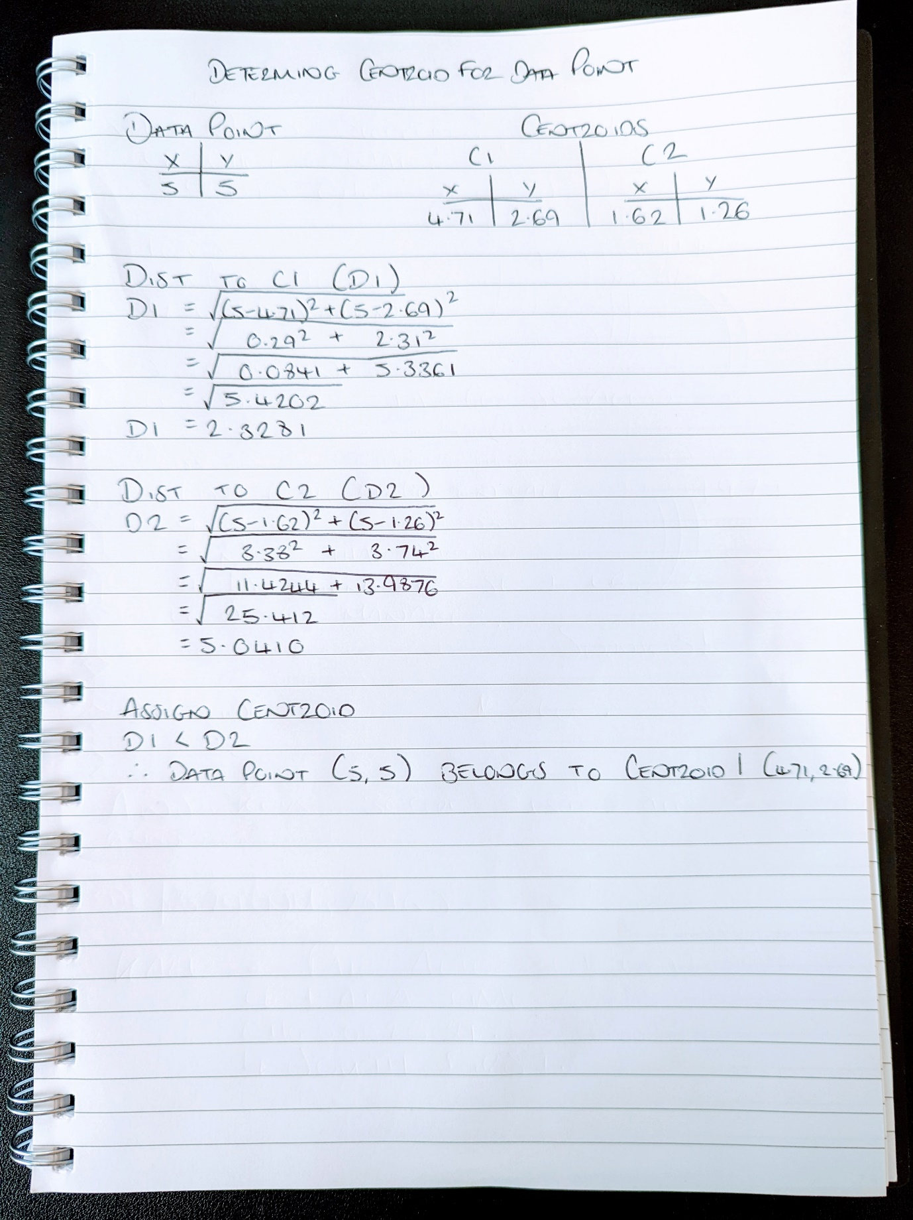
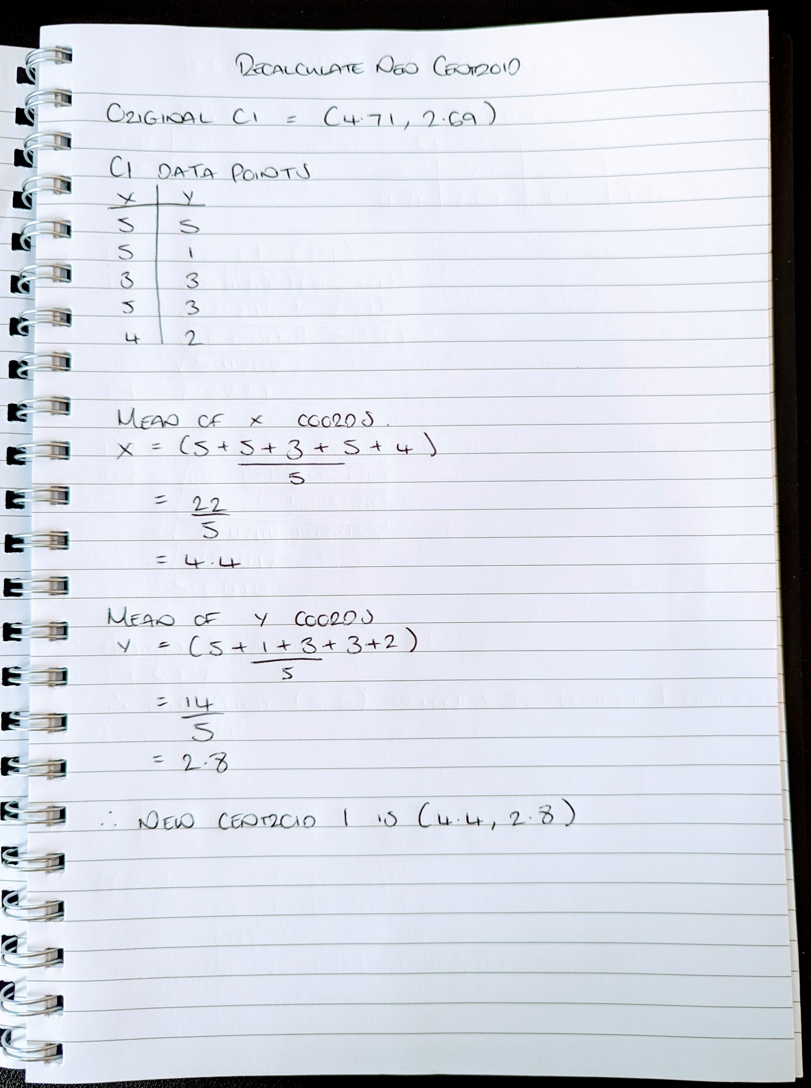

Complete calculations
The following screenshots show the full calculations as computed by excel and double checked, demonstrating a first and second iteration, after which there were no changes to the clusters or centroids, therefore no further iterations required. Also below, is an expanded view showing the mathematics used for the calculations.
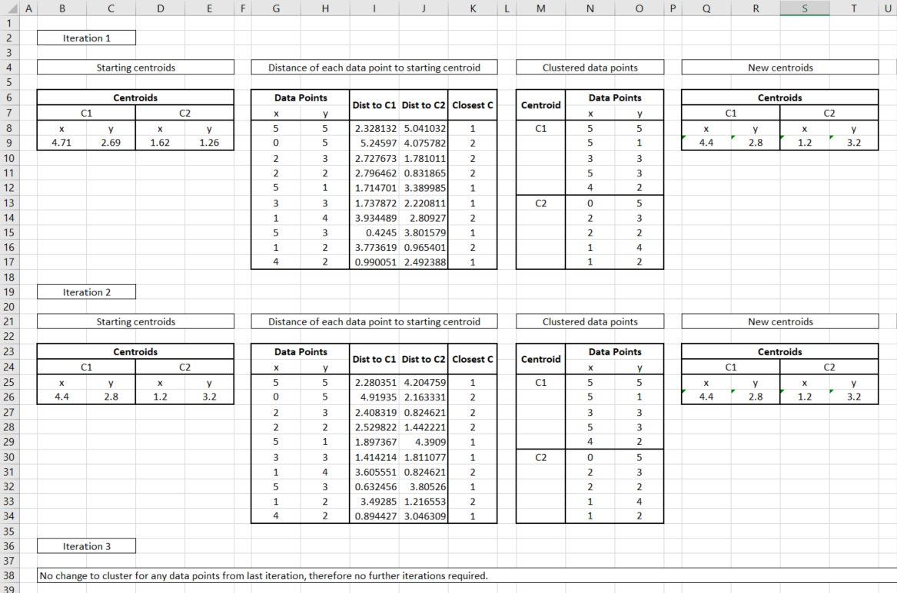
Results of calculations

Underlying maths (split into LHS and RHS for legibility)
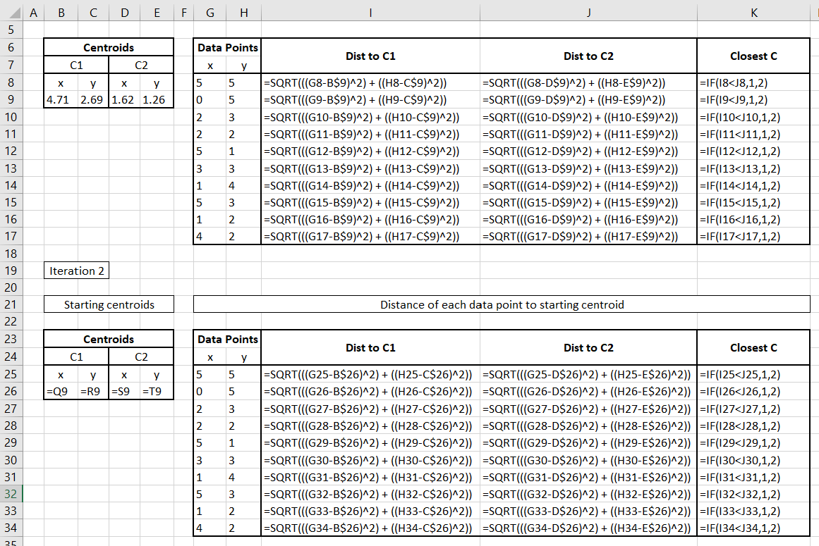
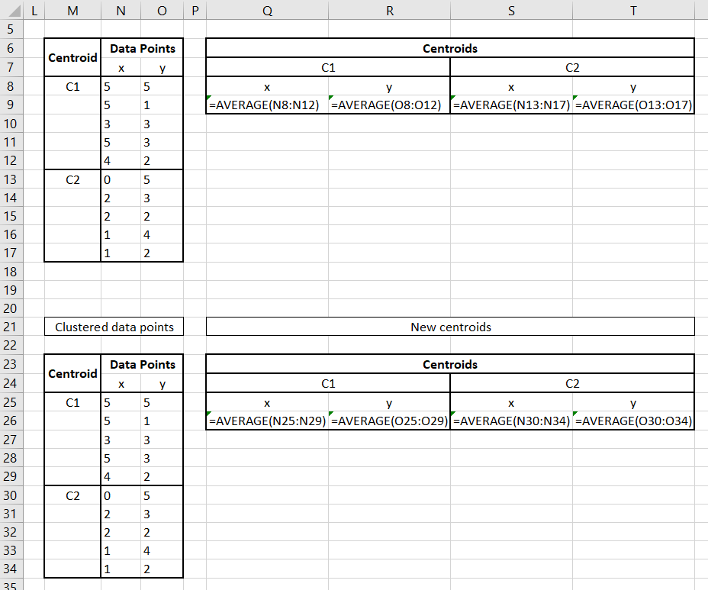

Result
The result gives the following clusters and centroids, a graphical representation is also presented below.

Centroids
C1 |  | C2
x | y | x | y
4.4 | 2.8 | 1.2 | 3.2

Centroid | Data Points
Centroid | x | y
C1 | 5 | 5
 | 5 | 1
 | 3 | 3
 | 5 | 3
 | 4 | 2
C2 | 0 | 5
 | 2 | 3
 | 2 | 2
 | 1 | 4
 | 1 | 2

Bibliography
[1] Douglas. Steinley, ‘K-means clustering: A half-century synthesis’, Br. J. Math. Stat. Psychol., vol. 59, no. 1, pp. 1–34, 2006, doi: 10.1348/000711005X48266.
[2] J. Wu, Advances in K-means Clustering: A Data Mining Thinking. Springer Science & Business Media, 2012.
[3] ‘K Means Clustering | K Means Clustering Algorithm in Python’, Analytics Vidhya, Aug. 19, 2019. https://www.analyticsvidhya.com/blog/2019/08/comprehensive-guide-k-means-clustering/ (accessed Jan. 03, 2022).
[4] A. Kassambara, ‘K-Means Clustering in R: Algorithm and Practical Examples’, Datanovia. https://www.datanovia.com/en/lessons/k-means-clustering-in-r-algorith-and-practical-examples/ (accessed Jan. 03, 2022).
[5] T. Kodinariya and P. Makwana, ‘Review on Determining of Cluster in K-means Clustering’, Int. J. Adv. Res. Comput. Sci. Manag. Stud., vol. 1, pp. 90–95, Jan. 2013.
[6] T. Alade, ‘Tutorial: How to determine the optimal number of clusters for k-means clustering’, Cambridge Spark, Dec. 23, 2019. https://blog.cambridgespark.com/how-to-determine-the-optimal-number-of-clusters-for-k-means-clustering-14f27070048f (accessed Jan. 03, 2022).
[7] S. Yıldırım, ‘Two Challenges of K-Means Clustering’, Toward Data Science, Apr. 06, 2020. https://towardsdatascience.com/two-challenges-of-k-means-clustering-72e90bdeb0da (accessed Jan. 03, 2022).
[8] K. Hornik, I. Feinerer, M. Kober, and C. Buchta, ‘Spherical k-Means Clustering’, J. Stat. Softw., vol. 50, pp. 1–22, Sep. 2012, doi: 10.18637/jss.v050.i10.
[9] Y. P. Raykov, A. Boukouvalas, F. Baig, and M. A. Little, ‘What to Do When K-Means Clustering Fails: A Simple yet Principled Alternative Algorithm’, PLOS ONE, vol. 11, no. 9, p. e0162259, Sep. 2016, doi: 10.1371/journal.pone.0162259.
[10] ‘k-Means Advantages and Disadvantages | Clustering in Machine Learning’, Google Developers. https://developers.google.com/machine-learning/clustering/algorithm/advantages-disadvantages (accessed Jan. 03, 2022).
[11] C. Guestrin, ‘Unsupervised learning or Clustering – K-means Gaussian mixture models’, Carnegie Mellon University, Apr. 04, 2007. [Online]. Available: http://www.cs.cmu.edu/~guestrin/Class/10701-S07/Slides/clustering.pdf
[12] K. Kubara, ‘Gaussian Mixture Models vs K-Means. Which One to Choose?’, Towards Data Science, Oct. 08, 2020. https://towardsdatascience.com/gaussian-mixture-models-vs-k-means-which-one-to-choose-62f2736025f0 (accessed Jan. 03, 2022).

