BOUNDARIES OF PERFORMANCE

ALL THE WORLD'S A STAGE,
AND ALL THE MEN AND WOMEN MERELY PLAYERS;
THEY HAVE THEIR EXITS AND THEIR ENTRANCES,
AND ONE MAN IN HIS TIME PLAYS MANY PARTS,
HIS ACTS BEING SEVEN AGES. AT FIRST, THE INFANT,
MEWLING AND PUKING IN THE NURSE'S ARMS.
THEN THE WHINING SCHOOLBOY,
WITH HIS SATCHEL AND SHINING MORNING FACE,
CREEPING LIKE SNAIL UNWILLINGLY TO SCHOOL.
AND THEN THE LOVER, SIGHING LIKE FURNACE,
WITH A WOEFUL BALLAD
MADE TO HIS MISTRESS' EYEBROW.
THEN A SOLDIER, FULL OF STRANGE OATHS AND BEARDED LIKE THE PARD,
JEALOUS IN HONOR, SUDDEN AND QUICK IN QUARREL,
SEEKING THE BUBBLE REPUTATION
EVEN IN THE CANNON'S MOUTH. AND THEN THE JUSTICE,
IN FAIR ROUND BELLY WITH GOOD CAPON LINED,
WITH EYES SEVERE AND BEARD OF FORMAL CUT,
FULL OF WISE SAWS AND MODERN INSTANCES;
AND SO HE PLAYS HIS PART.
THE SIXTH AGE SHIFTS INTO THE LEAN AND SLIPPERED PANTALOON,
WITH SPECTACLES ON NOSE AND POUCH ON SIDE;
HIS YOUTHFUL HOSE, WELL SAVED,
A WORLD TOO WIDE FOR HIS SHRUNK SHANK, AND HIS BIG MANLY VOICE,
TURNING AGAIN TOWARD CHILDISH TREBLE, PIPES AND WHISTLES IN HIS SOUND.
LAST SCENE OF ALL,
THAT ENDS THIS STRANGE EVENTFUL HISTORY,
IS SECOND CHILDISHNESS AND MERE OBLIVION,
SANS TEETH, SANS EYES, SANS TASTE, SANS EVERYTHING.

William Shakespeare

Performance can describe activity and ability in many genres, from the performance of an engine, the performance of an athlete in sport, to the performance of sexual activities. As human beings we perform daily, whether it is in everyday rituals and roles or in the seeking of acceptance. The sense of consciousness, ego and portrayal of our identities is paramount in how we choose to project ourselves and how we wish to be perceived. It is our presentation and representation. Our performance.

Performance is present in all cultures, religion, tradition, it is the construct of our societies. It is an all pervasive and all-encompassing aspect of life.

Schechner’s (2002) research into performance found that there were seven main features to how we perform. It comprises different qualities of activity and their functions in accordance to who we are and their importance to us. They can be overlapping and can be changeable due to time, place and circumstance.

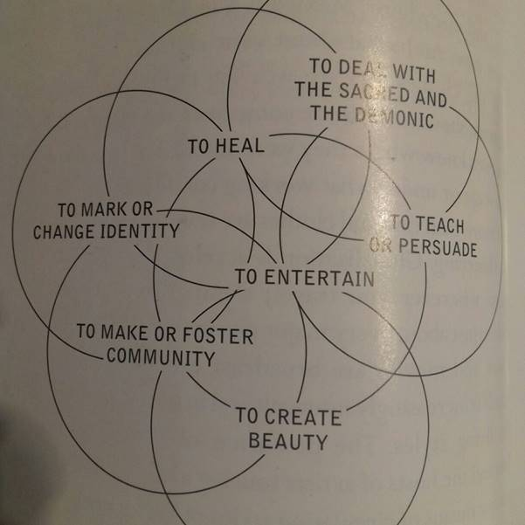

The seven interlocking spheres of performance
(Richard Schechner 2002)

These seven qualities are a natural part of human societies.

All human behaviour can be defined as performance as it is learnt reproduced and repeatable action. This is called re-stored behaviour or twice-behaved behaviour.

“That making art involves training and rehearsing is clear. But everyday life also involves years of training and practice, of learning appropriate culturally specific bits of behaviour, or adjusting and performing one’s life roles in relationship to social and personal circumstances.” (Schechner, 2002, pg. 28)

Our behaviour is learnt from the onset and it is repetitive, we are influenced, and we influence. When a human being encounters difference in another, outside of the influences and patterns of behaviour learnt so far in their lives, they can become disarmed, the fabric of their constructed stage becomes fragile. I believe this accounts for racial and xenophobic attitudes in individuals. We feel comfortable when all players are on the same team and the performance follows its design.

The performance of the self in society is very interesting and it is the essence of what is placed into theatrical performances, as this is what we truly have to work with.

As theatre makers, we shape our work to reflect what concerns us in life and our philosophies, and we also respond and react to the audience according to their reaction of us as the performer.

Connection and representation of intention and spontaneity in the present moment are key elements of theatrical performances and life.

“I have been using the term “performance” to refer to all the activity of an individual which occurs during a period marked by his continuous presence before a particular set of observers and which has some influence on the observers.” (Goffman, 1956).

Performance in society is acted upon due to the culture and constrictions we are subjected to. We change to fit in and perform consciously to the status we feel will benefit us in situations. We are generally in the second circle of attention that a, Stanislavski (1897) speaks of, we have an awareness of others, this is our audience, we are watched, and we are the watcher’s and we act in response.

Beuys (1963) a follower of the Fluxus Movement believed that everyone was an artist and that everyday activity can be seen as performance as long as it is a conscious act. The very act of doing something with awareness is performance.

Within the framework of Live Art, performances of seemingly everyday activities are shared and ask an audience to question the meaning, to engage in a relationship and find their own meanings.

I am questioning whether mindfulness is the highest platform of performance as the commitment to awareness and presence in activity, to be, is the jewel. In performances of high quality, the engagement from the audience is ignited when the performer is present, connected and bare in essence.

My own working definition currently of performance from a personal explorative perspective is through the development of my own creativity in crafting visual, physical, conceptual and emotional worlds for an audience. Presently I consider performance to be a personal exploration and sharing of the self through expression, a gift of one’s own inner world to an audience to establish a dialogue and relationship that can further our understandings and broaden the horizons of concepts, society and art and yes, to entertain. Primarily, I would conclude that performance enables and asks the performer and the audience to question how we perceive the world and how we interact with it.

Performance seems to be an unavoidable and practical way to experience the human condition and as the artistic performer you reflect and offer an audience a lens through you. Ultimately, I believe performance to be ambiguous, it can be anarchic and do anything a human being wishes to design and share, and it will always be individually and collectively interpreted. It is a gift and the author is dead. But performance undoubtedly is not.

“THOU ART”

Through the exploration of boundaries in performance, I have questioned what is performance and explored the narrative of performance art as a medium. I introduced myself to the book entitled Live Art And Performance by Adrian Heathfield (2004) from the University library and was profoundly inspired.

Through the investigation of Live Art, the inspiration for “Thou Art” (I am Art) developed. It was influenced by Marina Abramovic (2004) in the naming of her performance the ‘The Artist is Present’ and from the idea that performance art is live, the forth wall is broken and the unpredictable can happen. In this section of the performance, the intention was to show that art or the performance art, that the audience is viewing is not simply an artefact or object or motionless picture or a conventional piece of drama with script and stage but is, the ‘artist’ themselves.

The seemingly ordinary idea of making art is turned on its head. Thus, challenging the perception of what is art and performance, and pushing the boundaries of the audience to critically see the performer as a creative individual and not as an actor. The aim was to push the boundaries of conventional art and theatre by the means of the live art platform. In ‘Thou Art,’ my perspective of the ‘artist’ is present, is in the sense that they ‘are’ the living art making the work.

I consider the human being to be a living manifestation of art in progress. Art is life and life is art, and when we look at different movements of performance art we can see this to be true. From the early developments of art and performance movements such as the Dada movement, The Futurists, Allen Kaprow’s - Happening to George Maciunas - Fluxus, we can determine that performance is a varied and developing expression of life and art, and how we interact and react within the current social climate and our place and questions within this realm of humanity.

For centuries we have viewed paintings and sculptures in galleries and town centres, of dressed and undressed subjects. I chose to break with this tradition and to undress with only an art apron on and draw my clothes as a live performance. The nakedness represented the naked and authentic, creative and live, artistic self and not the production of art on canvas. The image on canvas signifies the static image of art, and not the present and performative artist, whilst the clothes are characterizing the image we conform to and create for ourselves and how we wish others to perceive us. Ethically I considered that nudity and the use of strong language later in the sharing would need to be brought to the attention of the unsuspecting public and audience and a warning poster stating thus was placed on the doors.

Ideally, I would have liked to be completely naked to push my boundaries as a performer, but this was far too uncomfortable an idea, and as it was wearing only the apron certainly pushed my personal boundaries. I considered wearing only underwear, but I felt this was lacking in artistic creativity and was lame in pushing my own boundaries in the performance and that of the audience, as I wished to induce some discomfort as to promote their questioning of why this was occurring. We see bare skin on billboards, bodies in bikinis on the beach regularly and we see nudity in performance frequently, although not my body and I intended to push the boundary of what we feel is acceptable in performances in public spaces. The reason for this is that I would like to see and generate dynamic, risky and innovative performance art, to take the ordinary and make it extraordinary.

In breaking with tradition and conformity which is the chosen filter for this work ’Thou Art’, we would have traditionally seen the model on a chair, on the canvas and not a chair with clothing on and especially not a naked artist reproducing this. It seems that Performance Art often aims to raise questions referring to what can be considered to be art and places the audience in uncomfortable circumstances thus pushing boundaries of vulnerability and perception.
Performance Art moves away from tradition to reflect on social and political climates with a live component and witness. Often using the body as the tool. Live art can push the boundaries of audiences as it can be unexpected and unavoidable. There is action and reaction. This area of performance appeals to me as it is available to a larger undefined class of audience depending on the chosen space and it is free. The reasoning to use the Live Art platform was to break away from conventional theatre and bring performance to a wider field of audience thus challenging my own performativity in an unpredictable environment and that of an audience’s outlook on what they have previously considered performance to be.
Marina Abramovic has been a great inspiration as her performance art uses her presence and body as a tool and her performance work can often only be effective with audience participation. Her work continually pushes boundaries and are often durational. My original intention was to perform ‘Thou Art’ as a stronger durational piece, throughout the day using duration as a boundary and the work to have been viewed more publicly in the same location.

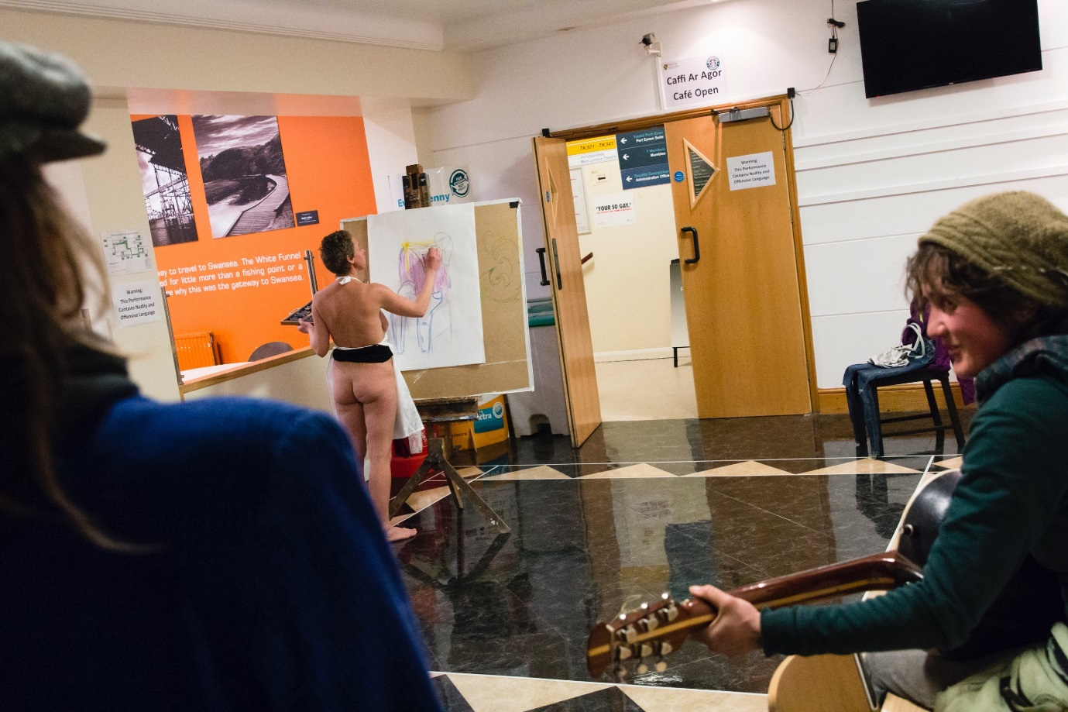

“We abolish the stage and the auditorium and replace them by a single site, without partition or barrier of any kind, which will become the Theatre of Action” (Artaud, 1938, pg. 96).

My understanding is that Antonio Artaud intended through his work and teachings, that there should be an uninterrupted exchange between the artist and audience, and I believe that Performance Art especially in public spaces can achieve this. As well as an interactive participation for the audience.

‘IMPRINT’

The concept of conformity as a theme for the work ‘Imprint’ was inspired from reading ‘Free to be Human’ by David Edwards (2000) where in the discussion, uncovers our unfortunate situation as submissive participants in a system that derives from capitalism and profit as the agenda. Although we might not live in a fascist state-controlled regime we are subjected unwittingly to a subtle system of control that powerfully effects how we live in a passive and conformist manner. The intention of this piece was to bring the awareness of how we are scarcely free and how readily we conform, whilst pushing the boundaries of performance by that of an audiences’ immersive engagement.

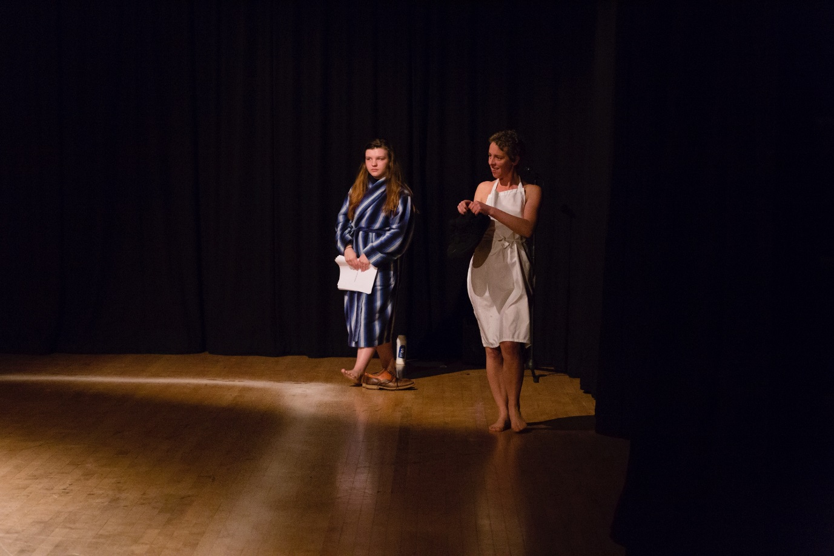

The audience are invited immediately to conform and they do, unaware of the direction of the performance they are to witness, only to find that they will be interacting and performing themselves.

The use of signs dictates immediately conformity for the audience to comply. In asking the audience to take off their shoes and place their phones in a box, I feel this instantly pushes their boundaries, as often this seems to leave people feeling vulnerable. The expectation of conventional theatre is immediately abolished, and the audience are provoked into disempowerment. But they discover engagement.

I elected to form the chairs for the audience seating into inward facing squares representing the symbol of infinity, lemniscate. This signifies the pattern of never ending conformity that we are subject to. The use of semiotics is a running theme in this work from ties, to my wearing of another’s shoes and walking in them, suggesting we often take on another attitude to fit in, to the use of numerous outfits as images and symbols of how we identify in society, to the use of salt, raffle number tickets, and the use of movement in my monologue and the lipstick imprint at the end. This performance pushed the boundaries of the audience often to read into the signs and form their own understandings.

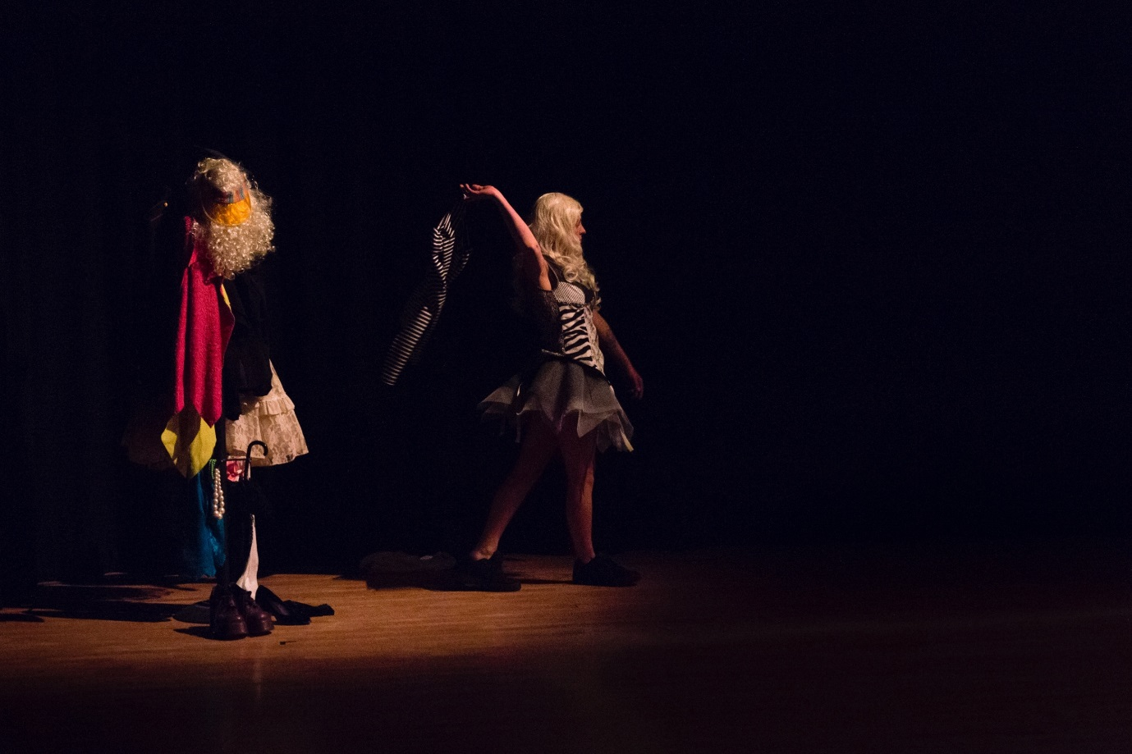

In working with Sophie Melville, I developed a greater understanding of the use of space in performance, of that between yourself and other performers and with the audience and the impact this can have in creating reaction and atmosphere.
Effectively, we created three performance spaces: the seated boxes, the performative arena within the salt line and the performative space outside of it. Here we are pushing the boundaries of conventional theatre and the stage and challenging the audience to be centre stage as such. Thus, the audience are left to face each other, they are now the performers. Aware of each other and themselves, in anticipation of a performance, but are left in this uncomfortable environment, with their expectations and suspense, whilst pushing their boundaries of what is considered to be performance.
The performance through their engagement has also become their own, by participating in the questionnaire and instructions on the cards. After completing the questionnaire in a short space of time, an audio medley is to be heard, and I used tracks and quotes to inform the audience of conformity. I feel some of these to be insulting and insinuating and yet informing, again I am endeavouring to push the boundaries of comfortability of the audience. The reasoning for this is that theatre is not only for entertainment but a tool for progression.
An ethical consideration to the participatory part of the performance was that it was voluntarily, and no one would have been forced to do anything they did not want to do.
The exploratory and experimental nature of this sharing is dependent on the audience’s participation and resonates with Jamal Harewood’s work ‘The Privileged’, where upon the audience are led to sit in a circle of chairs with envelopes on. He is silent, in a polar bear suit as a political statement with strewn chicken pieces on the ground and the audience are left to fulfil the instructions.

“I know I’m pushing people’s buttons” (Harewood, 2017).

His intention is to provoke the audience through instructions and to quietly allow the participants to grapple with their own consciousness. I feel my work is similar but differs in the sense of the political statement but similarly the audience are left to confront their discomfort and decisions to conform to the instructions whilst projected music, text and uncomfortable silences ensue. It is my hope that between the decision or struggle to act on the instructions and hearing the narrative and meaning of the lyrics referring to conformity, freedom and self-worth that the interactive nature of this style of performance made can active impressions that conventional styles of theatre may not be able reach.

“A direct communication will be re-established between the spectator and the spectacle, between the actor and the spectator, from the fact that the spectator, placed in the middle of the action is engulfed and physically affected.” (Artuad, 1938).

Immersive theatre is unravelling the given ideas and boundaries of what theatre is. This progression of interaction in theatre is engaging and is forming a deeper response in the relationship between performer and audience.

“But in interactive performances – where the set-up casts us not as passive spectators but as part of the show – perhaps we can no longer hide behind our passivity, claiming that what is happening has nothing to do with us. If the relationship between artists and audiences is built on a different kind of contract perhaps we, the audience, have to take responsibility. Maybe there are times when we shouldn’t follow the artist’s orders or bow to their artistry.” (Gardener, 2014)
In the workshops under the guidance of Sophie Mellville we undertook the beginnings of Stanislavski’s improvisation techniques. This consisted of sitting with Niamh Provan face to face quietly responding to each other, through eye contact. Aware of how the other affects you. I felt these exercises stripped away the performer element and allowed you to respond from your emotions as a human being, what do we feel, what do we read. As a performance technique I feel this engages you to require true emotions to share in performance and it is what an audience wants to feel, to experience truth and engagement.
Initially, I aspired to present myself in the boxes and mingle in the square space, only making eye contact and responding to what is present in the moment. This is inspired by Marina Abramovic’s work ‘The Artist is Present’ and her piece ‘The House with the Ocean View’. It concerns stillness and connection with the audience. The performance is dependent on audience participation. I believe Marina Abramovics work in these performances pushes the vulnerability of the artist and audience. It is present, and I consider this to be the embodying factor that is live art. It is in real time and it is unpredictable.
“I really believe the future of art is not with the object, but between the artist and the public. Everything now is immaterial. Feelings and emotional states have to be transformed in public without anything in between” (Abramovic, 2004, pg.151).
Within the seated boxes I wanted to bring these bare qualities to the performance. I also wanted to explore a performative boundary of being economical with movement and gesture, but I lost connection with this desire and as a personal performative boundary I feel I lacked dedication in exploring the work. This will serve as a reminder to pursue all ideas and stay connected throughout the process of developing work.
My lack of resolve to creatively direct my visions became a boundary in my own performativity. The eradication of doubt and lack of commitment to the development of my own work needs to become an anchor in my growth and realisation as a performer. Another personal performative boundary is my dependency within the technological field. My inability in the time frame to use Audacity as an audio tool left my intended audio impression at the mercy of Niamh Provan whom kindly and obligingly tried to cater for my needs.
The arena walk, outside of the salt line in numerous outfits was a representation of many layers of presenting the self, and our identification in society. It became an obscurity and juxtaposed the uniform responses to instructions. The different clothing and wig styles and abstract movements communicate alongside text, durations of silence and songs. The inclination within this frame work is to push the boundaries of the audience, not only are they conforming to instructions, they are performing themselves and they are being insulted by the lyrics in the songs and yet being invited to have a further reaching awareness of how readily we all conform, whilst a performative wave of changing costumes is in the periphery.
An additional juxtaposition fell between my monologue and the controlled phone call by Niamh inspired by Jana Sterbeck’s piece titled “Remote Control” (1989) whom created a large skirt where upon she could not reach the floor and was remotely controlled. The immense and yet subtle density of this performance certainly pushed the boundaries of orthodox theatre.
Another boundary that is created for the audience is the lack of continuous viewing and different instructions on the cards, this is breaking with the conventional idea of theatre and the intention is to create a disparate visual and performative experience for each member of the audience.
I believe the layers of conformity and control inter-weaved between myself and Niamh in our performance brought an inventive originality that embraced the boundaries of performance and was inspired by our predecessor’s and fellow artist.

References
Abramovic. M (2004) cited in Heathfield, A. (2004) Live: Art and Performance. New York: Routledge.
Artuad, A. (1938)The Theatre and its double. New York: Grove Press, Inc.
Beuys. J (1963) cited in Skinner. F (2013) Frank Skinner on Performance Art. Available from: https://www.youtube.com/watch?v=CAz6a5FwZJQ Accessed 30th December 2017.
Edwards. D (2000) Free to be Human. England: Green Books.

Harewood. J (2017) cited in Saville, A (2017) Jamal Harewood: “I know I’m pushing people’s buttons” Available at: http://exeuntmagazine.com/features/jamal-harewood-interview/ Accessed 25th January 2018.
Heathfield, A. (2004) Live: Art and Performance. New York: Routledge
Gardener, L. (2014) Immersive theatre blog. Available at: https://www.theguardian.com/stage/theatreblog/2014/nov/12/immersive-theatre-audiences-take-responsibility-bordergame-the-privileged Accessed 25th January 2018.
Goffman, E (1956) The Presentation of Self in Everyday Life. New York: Doubleday
Schechner, R. (2002) Performance Studies. London: Routledge
Shakespeare, W. (1623) “As You Like It.” England: First Folio
Sterbeck, J (1989) cited in Peters. S (2016) Playing Up. England: Live Art Development Agency.
Stanislavski. C (1897) cited in Sawoski. P (No date) The Stanislavski System Growth and Methodology. Available at: http://pullen.yolasite.com/resources/The%20Stanislavski%20System.pdf Accessed 28th January 2017.

