
Skills for the Workplace
Module Assignment Submission
Student Name: | Abdul Qayum
Student Number: | 1818477
Module No: | BMSK4002 Group 7
Module Title: | Effective Teamwork and Communication
Lecturer: | Navami Sudarsan

Table of contents

- Introduction
- Effective Teamwork and Communication
- Models of communication
- Workplace Communication and challenges
- Conclusion
- Reference
- Appendix

Introduction
This report will be emphasizing what effective teamwork and communication means to me. The effect it has in my workplace, academic and social circumstances.

The main objective is to show that I have understood the differences in communication whilst being able to demonstrate situations in which models of theories were used and the outcome of those situations.

The overall outcome of everything I have learnt so far as well as key parts in which I can improve on using the methods and models in both teamworking and individual workplace circumstances.

Effective Teamwork and Communication
Effective communication is in the form of both verbal, non-verbal and digital messages. It has a receiver, sender and a channel of communication. Munodawafa. D, (2008).
Some of the fundamental verbal and non-verbal skills are:

Listening is one of the strongest forms of communicating, it proves a willingness to learn, share and communicate effectively. Developing this skill is not only beneficial to yourself but others will be affected by this as well. Active listening will make someone feel heard, cared for and important. You will gain to understand vital information which in turn makes hard things easier.

Non-verbal communication such as eye contact, body language, tone of voice and hand gestures informs the message you are delivering. Having a relaxed composure will give reason for coming across friendly, approachable, focussed, respectable and can be possibly a form of encouragement.

Seven C’s - clear, concise, correct, considerate, courteous, concrete and complete is a very good verbal communication which helps to talk to your receivers without confusing them. It allows you to show your confidence and understanding of you work.

Friendliness is a way to someone feel more appreciated. Your use of tone and body language will encourage the other person to be involved in communicating with you in an open and honest way. This skill is a transferable skill so you can use it both person and digitally.

Having the correct form of confidence benefits you a lot in your communications with other’s because it shows that you believe in yourself, idea and decision which makes the receiver feel confident in you.

Empathy is good to have because it shows you understand where someone is coming from.
It also demonstrates that you have heard and respect the other person

Open mindedness is a really good way to communicate because you will gain the understanding of the message and view point by listening and by not being judgemental. The fact that you can even have productive communication with someone that you disagree with shows the benefits of being open minded.

Respect is a way of appreciating someone through their work, message or even idea. It shows that you have made time and willing to be focussed on them whether it is in the simple form of listening, making eye contact or even remembering to use their names will make them feel appreciated and in turn you will earn their respect back.

Feedback is a way of knowing if you or someone has received the information correctly, it is important to both give and receive feedback as well as encourage it because it can greatly increase your learning and progression.

Picking the right medium allows you to know which correct form of communication to use at the right time for the right person. It shows you have a clear understanding of communicating on any level effectively.

Effective communication is one of the most important skills required for any given situation but especially when working within groups, your place of work or communicating with superiors and colleagues.

Digital communication skills knowledge is as important as communicating in person.
Listening to someone in any circumstance makes them see or hear you are aware and feel involved with what they are saying or showing. Effective teamwork is when a group or groups people come together to delegate, organise and plan for a specific outcome or end goal. Each member of the team will be assigned a task to complete with help from team mates if it is required.

Some of the benefits and advantages in which you get from working within a team are assigning a team leader, someone who can make the ultimate decision, problem solving effectively should there be a problem, mediate everything smoothly without it effecting the team or result and motivating the team when there is low self esteem within individuals and boosting moral.

Specialists in the team if available help extensively because they are the ones who will have either studied and worked in that line of work before. They will have prior knowledge in the industry about specific’s, idea’s and the know-how.

An organiser is someone who will be delegating the work or task at hand.
That person will be the one who is in control of time management, making sure everything is clear, concise, correct, considerate, courteous, concrete and complete before executing the finishing of the task. These are some of the crucial aspects of a team and can overall make a task easier for everyone involved.

The major disadvantages of working within a team can factor a lot of thing’s but mainly highlighting are, larger groups of teams have a lot of people so there tends to be more individual idea’s, the way someone will behave can also differ therefore cause heated arguments and disagreements. Strong personalities and poor communication are things which can negatively affect the overall performance losing moral and ultimately lose sight of the end goal.

Models of communication



The Berlo’s model follows the SMCR model, this model is not attached to any specific form of communication. Berlo’s model has several points of factors. Firstly, the source is where the message originates. The communication skills needed are the individual’s ability to communicate in the form of reading, writing, speaking and listening.

Having the correct attitude towards people, the topic and towards yourself. The knowledge and understanding of the query someone is going to communicate. The ability to communicate in any form consists of hearing, seeing, touching, smelling, tasting as channels.

Some of the disadvantages of this model are for clear effective communication to be executed you need the sender (encoder) and the receiver (decoder) to have the same if not similar level of communication skills in order for this model to work.
Some of the disadvantages of this model are it has no feedback so you won’t know about the result of your message, the model has no room for noise so at any point can disturb your message, it is very complexed and a linear model of communication also as everyone is very different from one another in the form of the ability to think, understand and analyze will differ.

Schram’s 1954 Model of communication
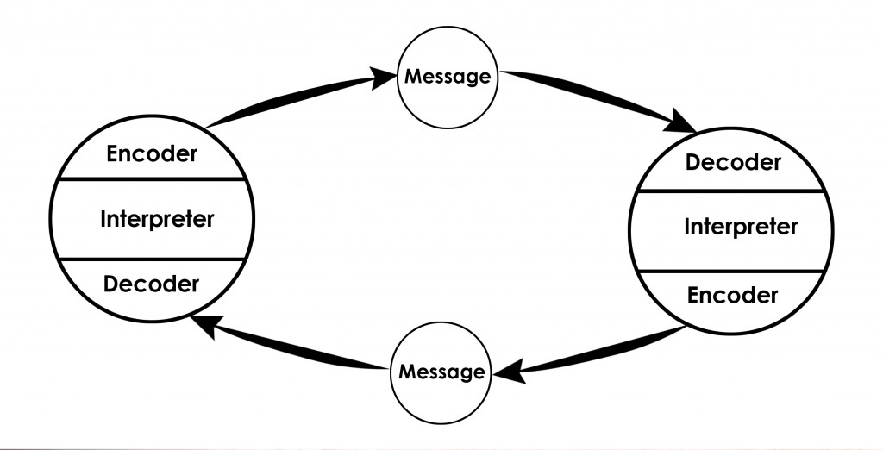
This dynamic model is one of my personal favorite forms of communication as it is very practical and not a very traditional type of model. It works on your own or a two people scenario, both the sender and receiver become the encoder, interpreter and decoder. The model has a significant attribute compared to other models as this one allows you to have a constant flow of feedback.
The downside to this model is that it does not allow for any concept of semantic noise, this makes interpretation and decoding a very difficult task. The actual meaning of the communication can be completely deviated if the words and phrases are too technical alongside the difference in language barrier.

Keys Strategy
Know yourself
Evaluate the professional context
Your communication interactions with others
Step back and reflect

This strategy is transferable in many aspects as it allows the user to listen and concentrate on the verbal and nonverbal messages which will help to determine the meanings if used effectively. It enables you to develop good interpersonal skills which will help form good rapport building skills in any academic or work place environment. The ability to step back and reflect is always a benefit as this allows you to make sure everything you are doing is correct and adequate.

Workplace communication and challenges

My former job was based in the public transport industry, i worked in the engineering department which had very strict rules when it came to health and safety regulations. My job role was to attend to breakdowns of mechanical buses, I had to take a safety checked bus from the bus garage to the driver to continue service and return to the bus garage with the faulty one.
Our form of communication was mostly done over the radio-controlled walkie talkies within the garage because of the vast amount of buses and space. There are three groups of communicators that used this were the first being the controllers who are the initial receivers of the mechanical breakdown, then secondly, they contact the vehicle allocations supervisors who collect the details of the bus, location and damage then thirdly the engineering department who receives this information and passes it to us.
Due to the noise of large vehicle instruments being used and the constant running of numerous buses in a confined space. I have had to use methods such as Schram’s 1954 and do quick Swot analysis to best describe what I had done to overcome these challenges and communication issues.
I used the Schram’s model of communication in my work place to communicate effectively because after receiving the information for the breakdown I will always make sure that I don’t waste time, recheck that I have all the correct information, location and breakdown details also I would take a final walk down to my manager to see everything is in order and accurate therefore receiving and giving feedback.
The Swot analysis was done to figure out the best way in order sort the mechanical breakdown, it helped me to configure how to strengthen the decision I made in the plan of retrieving the mechanical bus, find out if there were any weaknesses in the plan, find any opportunities that may help me in doing the task more easily and if there were any threats to make my task at hand more difficult, cost money and in affect waste time.

Conclusion
Upon completing my first term of effective teamwork and communication I have learned that I did have some of the skills required also that i can only develop more skills and knowledge.
The improvement I see mostly is in my confidence, I feel like I can now understand the difference in communicating effectively and base them on models that I researched about in class. When I was in class, I could see that I was picking up a lot of information from the lecturer’s form of communication. The in-class exercises helped me develop more in terms of critical thinking and analysing.
It has been a pleasurable term to learn in and looking forward to next term.

References

Janse, B. (2018). Berlo’s SMCR Model of Communication. Retrieved (29/08/2019) from ToolsHero: [https://www.toolshero.com/communication-skills/berlo’s-smcr-model-of-communication/]
Munodawafa. D, (2008), Oxford Academic, Health education research, volume 23, p369-370.
Oxford Learners Dictionary retrieved (27/08/19)
[https://www.oxfordlearnersdictionaries.com]
Quintanilla, K.M and Wahl, S.T. (2017), In Business and Professional Communication. Third Edition. Thousand Oaks: SAGE. Ch.3, p98-99.
Schramm, W. (1954). The process and effects of mass communication. Urbana, IL: University of Illinois Press.
Wallace. S et al (2008), Oxford Dictionary of Education, First edition, p61-71.

Appendix

