
Module Name: Marketing Management
Module Code: LCMB7024

Assessment component 1: Marketing Environment Analysis

Lecturer’s Name: Dr Laila Maazouz (London)

Student Name: Md Moinul Hasan Bappy
Student ID: 2503567

Work Count: 2744

Term 1

Table of Contents
1. Introduction 3
2. Task 1: Critical Analysis of the Macro Marketing Environment 4
2.1 Overview of the Macro Marketing Environment 4
2.2 Selection of Two External Macro Marketing Actors (Technological and Economic) 5
2.3 Critical Analysis of Each Actor 6
2.3.1 Technological Factors 6
2.3.2 Economic Factors 8
3. Task 2 Structure (Porter’s Generic Strategies) 10
3.1 Pioneering Organisation’s Strategic Response — Dyson 10
3.1.1 Dyson’s Differentiation Foundation 11
3.1.2 Influence of Technological Shifts on Dyson’s Strategic Choices 11
3.1.3 Influence of Economic Shifts on Dyson’s Strategic Choices 12
3.1.4 Strategic Implications Under Porter’s Differentiation Strategy 12
3.2 Follower Organisation’s Strategic Response — Shark 12
3.2.1 Shark as a Cost Leadership / Differentiation-Focus Hybrid 13
3.2.2 Response to Technological Shifts 14
3.2.3 Response to Economic Shifts 14
3.2.4 Strategic Implications Under Porter’s Generic Strategy 14
4. Conclusion 16
5. Reference List 17

1. Introduction
This report will explore the use of the macro marketing environment in strategic decision-making of pioneer and follower organisations in the same industry. The knowledge of the environmental forces has now become vital in strategic marketing management especially in fast moving industries like consumer electronics and personal-care technology. To maintain their competitiveness and direction in long-term positioning, organisations are progressively expected to make meaning of change in technology, socio-cultural expectations and economic circumstances (Bolocan and Savciuc, 2025).

Figure 1: Dyson and Shark Identity
Source: (Dyson, 2024); (Shark (UK), 2025)
This report compares Dyson and Shark as innovative and leader and follower firms in the home-electronics and beauty-technology sector in the United Kingdom. Dyson is known to launch disruptive technology in cordless vacuum and advanced styling products, with Shark usually following behind with value innovation based on expanded consumer segments (Euromonitor, 2024). The different ways in which each form of firm is influenced by the environmental pressure creates a bottom line of the competitive asymmetries and competitiveness.
The report is divided into two tasks. Task 1 uses PESTEL to critically analyse two macro-environmental actors technological and economic forces as opportunity and danger creators for Dyson and Shark (Dioba et al., 2025). Task 2 uses Porter's Generic Strategies to show how pioneering and follower companies adjust to stay competitive. This section builds on the environmental analysis to explain how external influences affect Dyson's pioneering and Shark's following strategies. The analysis shows the strategic necessity of continual environmental scanning and how pioneering and follower enterprises must compete in continuously changing markets.

2. Task 1: Critical Analysis of the Macro Marketing Environment

2.1 Overview of the Macro Marketing Environment
The macro marketing environment includes external factors that enterprises cannot influence. Environmental evaluation is crucial to strategic marketing management since these influences affect the industry, customer expectations, and long-term market behaviour. Bolocan and Savciuc (2025) say macro-environmental analysis helps organisations anticipate change. To assess external pressures, PESTEL categorises political, economic, social, technological, environmental, and legal consequences (Dioba et al., 2025).
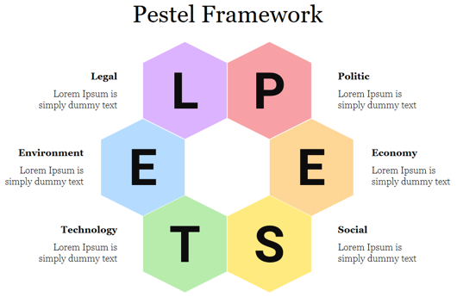
Figure 2: PESTEL Framework
Source: (Dioba et al., 2025)
PESTEL analysis is important in technologically based consumer products like home electronics and beauty-tech because fast innovation, changing societal taste, and changing economic conditions affect competitive positioning (Dioba et al., 2025). First mover companies like Dyson and follower companies like Shark must understand macro-environmental dynamics to discover opportunities, counter challenges, and develop competitive strategies.

2.2 Selection of Two External Macro Marketing Actors (Technological and Economic)
Both the technological and economic aspect of the macro marketing environment are chosen due to the strongest and immediate impact on the UK, premium home-appliance industry, in which Dyson (pioneer) and Shark (follower) conduct their business. The two actors also have a remarkable influence on product innovation, pricing policies, consumer adoption and sustainable competitive advantage (The Business Research Company, 2025).
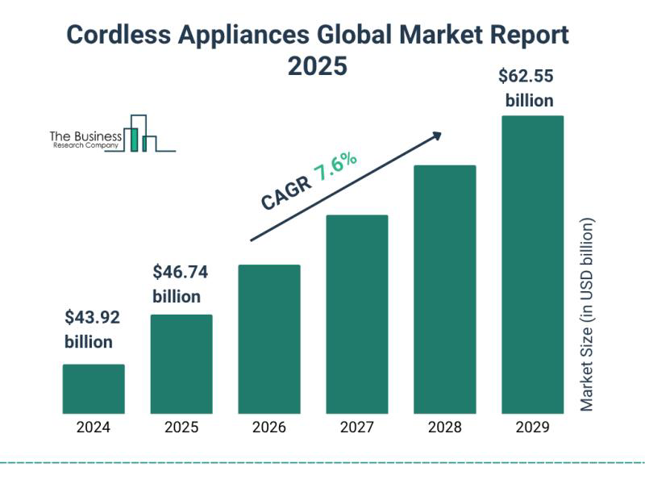
Figure 3: Cordless Appliances Global Market
Source: (The Business Research Company, 2025)
Since cordless appliances and personal-care gadgets are innovative, technological forces are acceptable. Innovations in battery efficiency, digital motors, and smart-sensor integration are changing market demand. Global reports predict the cordless appliances market would expand from 43.92 billion in 2024 to 62.55 billion in 2029 at a CAGR of 7.6 (The Business Research Company, 2025). This expansion follows Dyson's lead in high-performance cordless technologies and Sharks' quick imitation strategy. Competition increases as energy-efficiency limits and machine-learning gadgets expand. Technologically differentiated items like the Dyson Airwrap and Shark FlexStyle will benefit from rising consumer electronics spending through 2028 (Statista, 2024).
Economic issues including inflation, disposable income, and currency exchange rates affect global consumer spending. Economic instability affects price sensitivity and premium appliance uptake. Statista (2024) data show the consumer electronics market expanding, but with customers becoming more frugal, followers like Shark are focussing on affordability while leaders like Dyson enhance their luxury offerings. Inflationary pressures on raw materials, shipping, and lithium-ion batteries have raised industry operational expenses, leading to strategic pricing, product bundling, and promotional offers.
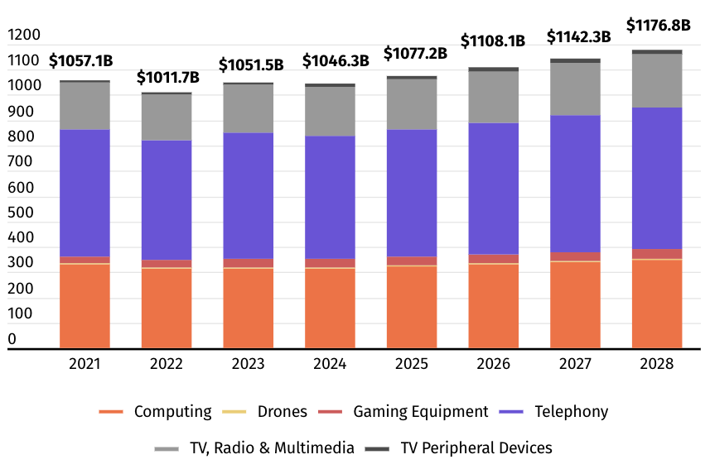
Figure 4: Global Spending on Consumer Electronics
Source: (Statista, 2024)
Technological and economic forces are the most strategic and influential macro-environmental forces for analysing pioneers and followers in this industry due to the level of innovation and economic forces that influence consumer decision-making (WIPO, 2025).

2.3 Critical Analysis of Each Actor

2.3.1 Technological Factors
One of the most powerful forces in the competition in the home appliances and beauty-tech industry is technological development. The global R&D expenditure has risen in Figure 5, which demonstrates that the procurement of innovation has been increasing faster in consumer electronics. WIPO (2025) states that since 2021, business R&D spending has been increasing steadily indicating a wider industry transition to the more technologically developed engineering, intelligent elements and digitalisation.
Dyson is a pioneering company that needs high technical intensity for strategy and competitiveness. Dyson invests about $3 million a week on R&D and has big engineering centres worldwide, giving it an advantage to enter the market first and avoid patents (Dyson, 2024). Dyson pioneered category-setting items like the cordless vacuum in 2016 and the Dyson Supersonic hair dryer in 2018. Advances allow Dyson to set high standards, build brand equity, and stay ahead technologically.
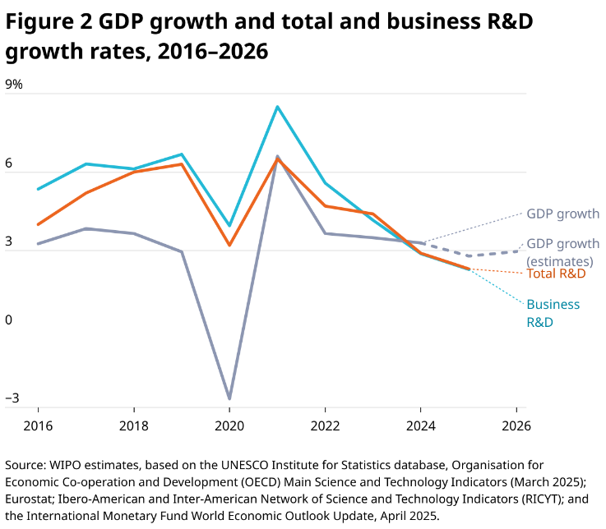
Figure 5: GDP Growth and Business R&D Growth
Source: (WIPO, 2025)
Dyson relies too much on R&D. Speed of technological dissemination reduces innovators' innovative advantage. Shark entered its industry quickly by copying or re-engineering Dyson innovations at a lesser cost. For instance, the Shark FlexStyle was half the price of the Dyson Airwrap but had the same multi-styling capability that won over value-sensitive clients (Crunchbase, 2025). This shows that technical advancement allows followers to gain market share by offering performance at minimal cost.
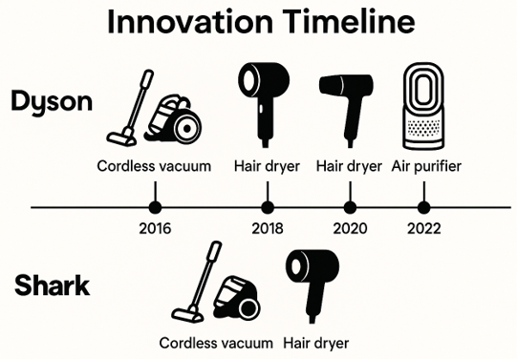
Figure 6: Innovation Timeline
Source: (Dyson, 2024)
Each firm has various strategy implications. Dyson must innovate radically, expand patents, and build product ecosystems to escape commercialisation. Shark, meanwhile, may employ incremental innovation and fast responsiveness to launch in new categories quickly with less R&D risk. New technologies like sustainable engineering, compact digital motors, and AI-expanded gadgets push the two companies to adapt.

2.3.2 Economic Factors
The forces of economy, especially inflation and the varying consumer confidence, have a powerful effect on the demand of products of the household electronics market. According to the data provided by ONS (2024), the growth of inflation in the UK was accompanied by weakening consumer confidence, which is a symptom of price sensitivity (Figure 7). Premium and value brands are not influenced by the same environment.
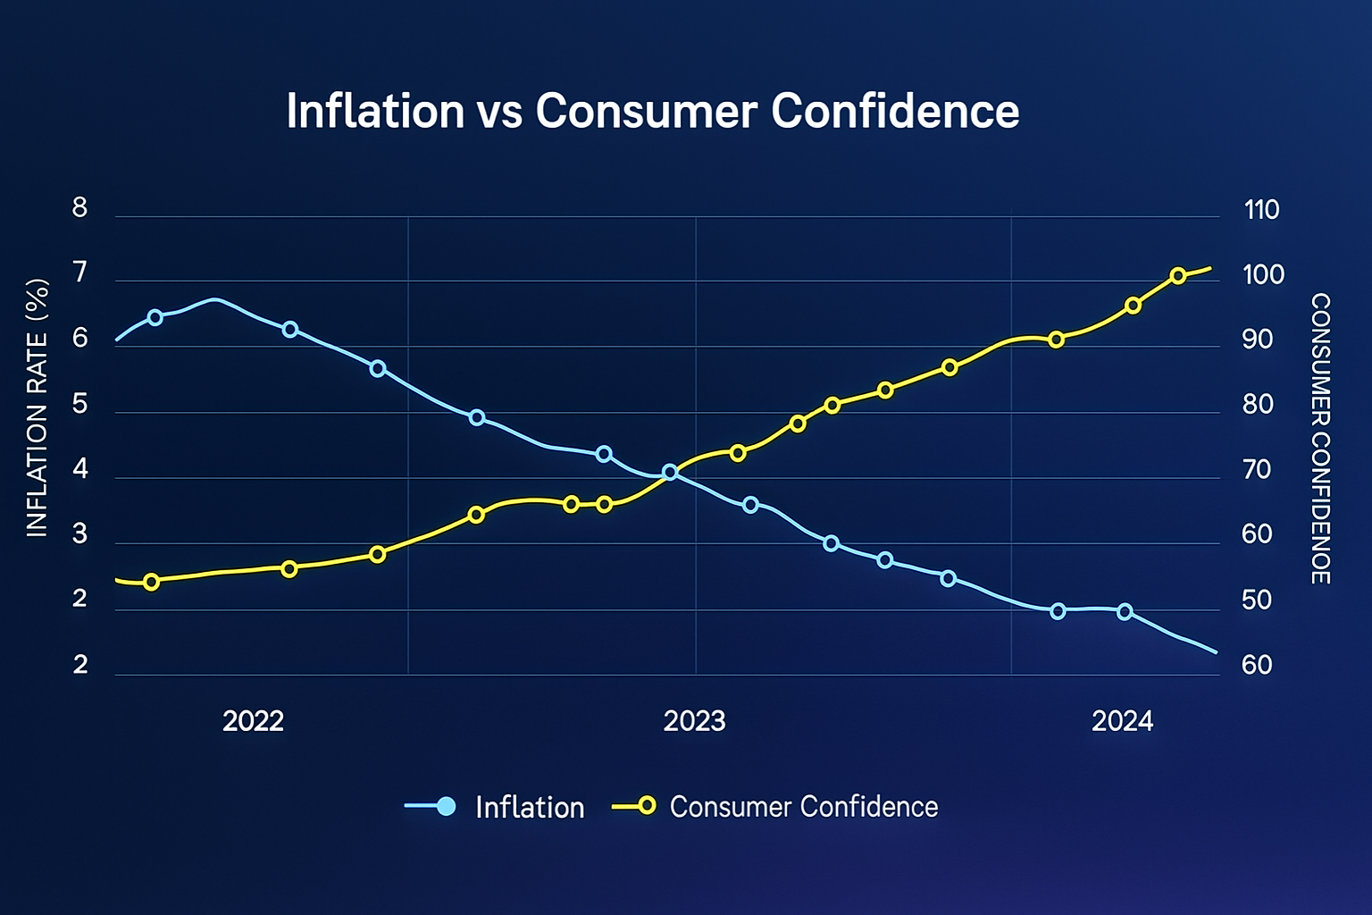
Figure 7: Inflation vs Consumer Confidence
Source: (ONS, 2024)
In the case of Dyson, economic recession poses risks as its products are based on high end pricing. Disposable income becomes smaller, and the consumers put off buying more expensive goods or replace them with middle-income products (PwC, 2024). Nevertheless, despite the frustrations of the time in economy, there is an opportunity as well, with Dyson being able to focus more on the long-term value, durability and energy efficiency features which are put into more focus in response to pressures on cost-of-living.
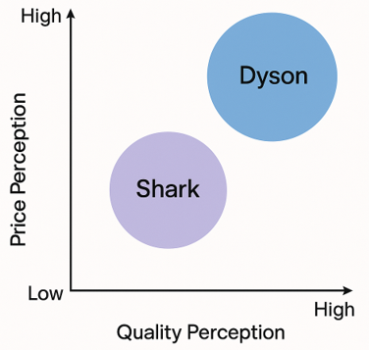
Figure 8: Price Perception Positioning Map
Source: (Statista, 2024)
Poor economies favour followers like Shark. Shark's price- and feature-based replacements complement consumers' trade-down efforts. Shark falls within the low-quality group on the price-quality positioning map (Figure 8), which is above restricted household budgets. Retailer collaborations, bundle deals, and special pricing will help Shark gain market share (Statista, 2024).
As higher-income clients spend discretionally, premium categories climb faster during recovery. Economic booms have raised demand backlash for Dyson (Euromonitor, 2024). Followers benefit from recessions and pioneers from booms. Dyson should employ flexible pricing, great value, and financing/pay choices during inflation. Shark must endure economic turbulence with inexpensive advertising and retail expansion. The two businesses should plan for long-term structural changes like rising living costs, online buying, and demand for durable and energy-efficient equipment.

3. Task 2 Structure (Porter’s Generic Strategies)
This is where Dyson, a pioneer, and Shark, a follower, will be analysed in terms of their strategic decisions regarding addressing the technological and economic forces (Task 1). This analytical lens will be the Porters Generic Strategies model in figure 9 that covers how organisations can create a competitive edge by leading in costs, differentiation, or focus (de Bruin, 2021).
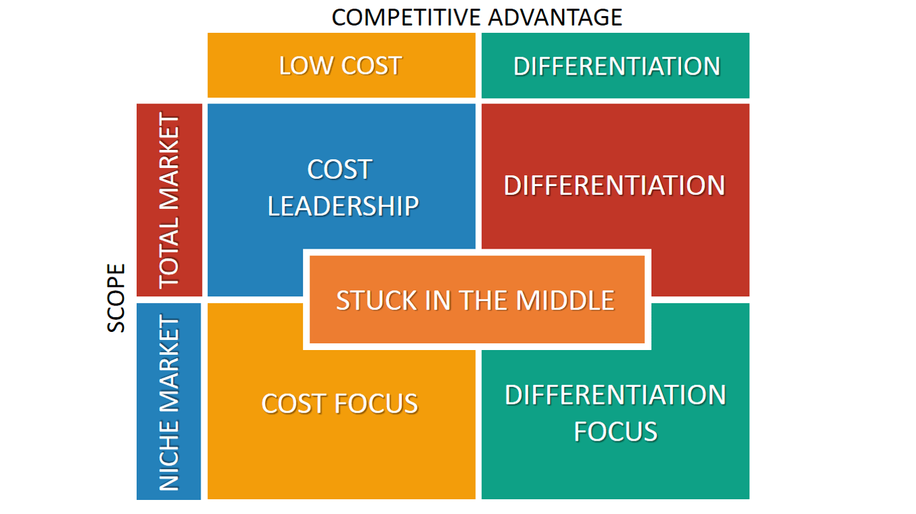
Figure 9: Porter’s Generic Strategies
Source: (de Bruin, 2021)
This strategy allows comparing Dyson and Shark to understand how an innovator develops and defends a difference position, and a competitor engages in a competition through cost leadership and differentiation focus on the same industry. The analysis highlights the disparities in how environmental forces affect pioneers' strategic decisions and how those choices affect their competitive situations (Gatimu and Amuhaya, 2022).

3.1 Pioneering Organisation’s Strategic Response — Dyson
In response to technological and economic demands, Dyson strengthened its differentiation strategy, at least the cornerstone of its competitive positioning, as in Porter's Generic Strategies. Porter suggests that differentiated organisations should innovate, design, perform, and brand to add value (Gatimu and Amuhaya, 2022). Dyson invests in greater engineering and product development to stay ahead in the home-appliance and beauty-technology markets.

3.1.1 Dyson’s Differentiation Foundation
- Dyson has a long-term differentiation approach, investing in research and development spending more than £3 million/week on engineering and innovation that underlies the development of patented technologies, including the digital motors and sophisticated airflow systems (Dyson, 2024).
- The product design and the engineering quality reinforce differentiation, as demonstrated by category-leading products, including the Dyson Supersonic hair dryer and the Dyson V-series cordless vacuums, which have features of performance that competitors have difficulty matching (Euromonitor, 2024).
- Brand equity is core to the differentiation at Dyson, which is a premium and innovation-based company backed by effective marketing narratives regarding its performance, engineering and technology leadership (PwC, 2024).
- The network of engineering centers all over the world also enhances the capacity of Dyson to provide distinctive value, prototyping fast and securing the most significant innovations in the form of patents to maintain long-term differentiation (WIPO, 2025).

3.1.2 Influence of Technological Shifts on Dyson’s Strategic Choices
- Dyson must accelerate product development to maintain first-mover advantages in consumer electronics due to global R&D expenditure (WIPO, 2025).
- Dyson is expanding its patent portfolio and creating integrated product ecosystems to differentiate its hardware, including smart sensors and app connectivity, to combat the growing threat of copying (Crunchbase, 2025).
- The combination of AI, energy-saving motors, and battery advancements allows Dyson to expand its product line into adjacent areas such as air cleaners, smart heating, and personal-care devices (Euromonitor, 2024).

3.1.3 Influence of Economic Shifts on Dyson’s Strategic Choices
- Dyson should maintain the image of long-term value of its high-end items due to economic reasons including inflation and consumer distrust, as discretionary spending is reduced (ONS, 2024).
- Dyson should prioritise durability, energy efficiency, and reliability to appeal to consumers during economic downturns and justify higher costs (PwC, 2024).
- To differentiate, Dyson prioritises supply chain optimisation, selected price increases, and flexible purchasing options, such as installment payments and package deals, due to high manufacturing and material costs (Statista, 2024).
- Dyson may capitalise on economic recovery by restarting demand in premium areas, as higher-income earners invest in high-quality home and beauty technology (Euromonitor, 2024).

3.1.4 Strategic Implications Under Porter’s Differentiation Strategy
Dyson must focus on breakthrough innovation to stay ahead of fast-follower competition, according to Porter's differentiation model, which requires constant technical leadership (Dixit, 2024). Dyson's strategic position is strengthened by client loyalty and higher switching costs in all haircare, air treatment and floorcare categories by establishing integrated product ecosystems. Dyson still needs premium pricing to fund its R&D, but in times of economic instability, the firm must emphasise excellent performance, long-term value, and product longevity to convince customers to pay more. Dyson's competitive advantage is its long-term capacity to protect its technological advantage through patents, strong brand equity, and product performance superiority, which boosts its differentiation-based market position.

3.2 Follower Organisation’s Strategic Response — Shark
Shark faces the same technology and economic strain as Dyson, but its strategy is more like Porter's hybrid cost leadership and differentiation focus. Porter says cost leaders want efficiency and lower operating costs, whereas differentiators want to offer unique value to a segment (Dixit, 2024). Shark combines the two tactics by offering Dyson-like features at a cheaper price, allowing it to attract price-sensitive yet quality-conscious home appliance and beauty-tech consumers. Shark has grown quickly and threatened Dyson with its merger strategy.
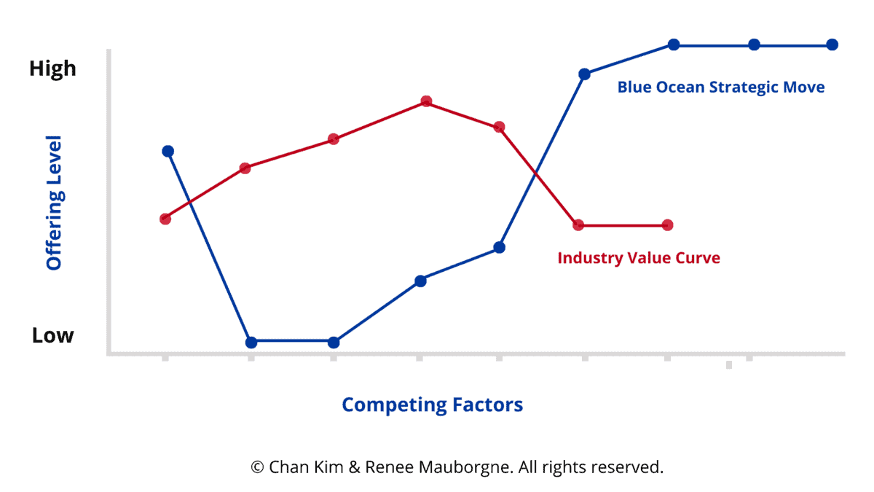
Figure 10: Industry Value Curve
Source: (Blue Ocean Strategy, 2021)
Figure 10 compares the industry value curve to a strategic move using Blue Ocean Strategy Canvas that gives fundamentally new value factors (Blue Ocean Strategy, 2021). Shark is not quite forming a blue ocean, but the graphic helps visualise how a quick follower might carefully increase and decrease offerings. Shark follows this trend by adding performance features like multi-styling, ease of use, and accessories and cutting costs by simplifying engineering and delivering value pricing. Shark may challenge Dyson's premium dominance by selling high-value features at a reduced price.

3.2.1 Shark as a Cost Leadership / Differentiation-Focus Hybrid
- Shark is a low-cost, high-performance product, which aims at consumers who are willing to pay a premium but cannot afford Dyson products, especially at the time of increasing inflation rates and falling consumer confidence (ONS, 2024).
- The multi-styling Shark FlexStyle, half the cost of Dyson Airwrap, is an example of reverse-engineering and fast-following Dyson innovation, which decreases the intensity of its R&D, without sacrificing performance (Crunchbase, 2025).
- Shark has a smaller market base as compared to Dyson because it is based on low cost and utilitarianism, and diversified to target underserved consumers (Dixit, 2024). The company has strengths in value-to-money, convenience, and competitive positioning, provision of long-term warranties, packages, and partnerships with the UK and US stores.

Response to Technological Shifts
- Fast-follower innovation instead of breakthrough discovery enables Shark to embrace proven concepts at reduced risk and capital costs, which is appropriate to its cost-leadership roots. Shark can benefit from technology diffusion by reducing the time needed to invent and implement advancements, allowing it to overcome Dyson's first-mover advantage (WIPO, 2025).
- Shark invests on technology that have a significant influence on consumers, such as heat-control in hair styling or cyclonic suction in vacuums, as a differentiation strategy (Crunchbase, 2025).
- Increasing product development pace allows the company to enter new markets and acquire niches quickly, redefining the value proposition for cost-sensitive clients (Blue Ocean Strategy, 2021).

3.2.3 Response to Economic Shifts
- Shark benefits from economic recessions, when shoppers prioritise high-value products over luxury brands. Its price model works in inflationary conditions, when affordability drives purchases (PwC, 2024).
- Shark has less R&D weight than Dyson, allowing it to maintain costs throughout cost-of-living pressures and remain affordable for middle-income households. Shark's hybrid advantage benefits from economic instability, as consumers want reliable and economical household technology to expand market share faster during recessions (Euromonitor, 2024).
- Shark's retail-intensive distribution strategy, including collaborations with Argos, Currys, and Amazon, enables efficient targeting of price-sensitive customers and operationalises Porter's cost-leadership reasoning based on scale and distribution economies of scale (Crunchbase, 2025).

3.2.4 Strategic Implications Under Porter’s Generic Strategy
Shark must balance cost effectiveness and differentiation in its strategic business positioning using Porter's Generic Strategies to sustain a competitive advantage (de Bruin, 2021). Managing a complete transition towards differentiation would increase production costs and devalue its value offer, and pure cost leadership would diminish Shark's performance-based advantages over low-end competitors. The competitive power of Shark lies in its capacity to bridge the innovation gap of Dyson in a short period and at a low risk of R&D. During economic instabilities, notably when inflation starts affecting the buying patterns of consumers, the relationship between retailers and affordability is significant (ONS, 2024). The low-cost/differentiation-based strategy combination of Shark implies that the hybrid-based strategies, notwithstanding their riskiness, can be effective when the operations procedures align with the strategic objective of the firm (Dixit, 2024).

4. Conclusion
This analysis shows that macro marketing environment study helps pioneers and followers survive competition in technology-driven sectors. Dyson and Shark face various strategic considerations due to technological and economic forces, which enables environmental scanning (WIPO, 2025). Dyson leverages distinctiveness, underpinned by R&D and a premium market position, while Shark uses a hybrid of cost-leadership and differentiation-focus to win value-driven consumers (Crunchbase, 2025). Porter's Generic Strategies allow for a good comparison of how each organisation generates and maintains a competitive edge. The analysis shows that pioneers and followers need distinct but equally adaptive tactics to compete in dynamic markets.

5. Reference List
Blue Ocean Strategy (2021) Strategy Canvas Tool. Available at: https://www.blueoceanstrategy.com/tools/strategy-canvas/ (Accessed: 19 November 2025)
Bolocan, E. and Savciuc, O., (2025). Evolution of Integrated Marketing Communication from Telecommunications Models to AI Frenzy.
Crunchbase (2025) SharkNinja – Organization Profile. Available at: https://www.crunchbase.com/organization/shark-2ac5 (Accessed: 15 November 2025)
de Bruin, L. (2021) ‘Porter’s Generic Strategies: Differentiation, Cost Leadership and Focus’, Business-to-You, 14 April. Available at: https://www.business-to-you.com/porter-generic-strategies-differentiation-cost-leadership-focus/ (Accessed: 19 November 2025)
Dioba, A., Schmid, A., Aliahmad, A., Struthers, D. and Fróes, I., (2025). Human excreta recycling in Sweden: a PESTEL-SWOT framework analysis–Review. Journal of Environmental Management, 389, p.126242.
Dixit, A.S., (2024). Exploring HR practitioner’s perspective on linking of employer branding and porter’s generic strategies: an alignment of business and HR strategy. International Journal of Organizational Analysis, 32(6), pp.1060-1072.
Dyson (2024) About Dyson – Our story. Available at: https://www.lb.dyson.com/en-LB/community/aboutdyson.aspx (Accessed: 17 November 2025)
Dyson (2024) Dyson Annual Innovation Report. Dyson Ltd. Available at: https://www.dyson.co.uk/discover/news/press-releases/dyson-financial-results-2024 (Accessed: 15 November 2025)
Euromonitor (2024) Global Home Appliances: Premium Market Trends. Euromonitor International. Available at: https://www.euromonitor.com/world-market-for-major-appliances/report (Accessed: 16 November 2025)
Gatimu, S.K. and Amuhaya, J., (2022). Effect of competitive strategies on the performance of SMEs in Kiambu county, Kenya. Journal of Business and Strategic Management, 7(1), pp.69-87.
Office for National Statistics (ONS) (2024) UK Inflation and Consumer Confidence Report. UK Government. Available at: https://www.ons.gov.uk/economy/inflationandpriceindices (Accessed: 18 November 2025)
Porter, M.E. (1980) Competitive Strategy: Techniques for Analyzing Industries and Competitors. New York: Free Press.
PwC (2024) Consumer Outlook Report 2024. PricewaterhouseCoopers. Available at: https://www.pwc.com/gx/en/issues/c-suite-insights/voice-of-the-consumer-survey/2024.html (Accessed: 17 November 2025)
Shark (UK) (2025) About Us – Shark UK. Available at: https://sharkclean.co.uk/page.aboutus-cms-page.aboutus (Accessed: 19 November 2025)
Statista (2024) Consumer Electronics Market: UK Price Trends. Statista. Available at: https://www.statista.com/outlook/cmo/consumer-electronics/united-kingdom?srsltid=AfmBOop9OquPgmGbRt3oqS7v_kiIxPKGc-A0DE9WyDhc5UUG41hV_DD- (Accessed: 18 November 2025)
The Business Research Company (2025) Cordless Appliances Global Market Report 2025. Available at: https://www.thebusinessresearchcompany.com/ (Accessed: 15 November 2025)
World Intellectual Property Organization (WIPO) (2025) Global R&D and Innovation Indicators 2025. Geneva: WIPO. Available at: https://www.wipo.int/web-publications/global-innovation-index-2025/en/global-innovation-tracker.html (Accessed: 15 November 2025)

