Nathan Price (1700540)

Leisure Marketing – M4X02102
Marketing Plan, Swansea Bay and the Gower Peninsula

Executive Summary
This report highlights the strengths and weaknesses of Swansea and the Gower Peninsula as a tourist destination. A focus is placed upon eco-tourism and how the destination is catering to the needs of these tourists. An internal and external analysis is showcased to discuss how different impacts can affect a tourism destination. An itinerary has been constructed and a marketing mix produced to showcase how Swansea and the Gower Peninsula attract eco-tourists and what they can develop to attract more holidaymakers. Reports and statistics from Swansea Council and other areas prove that tourism is an important contributor to the destinations economy and thus all aspects should be considered. Emphasis has been placed upon the key aims and objectives Swansea City Council should consider and how eco-tourism has shown to be on the rise in the south Wales destination within recent years.

Contents
Executive Summary 1
Destination and product description 3
Situation analysis 5
Analysis of key market segment 7
Marketing objectives 9
Marketing mix 10
Summary 13
References 14
Appendices 17

Destination and product description
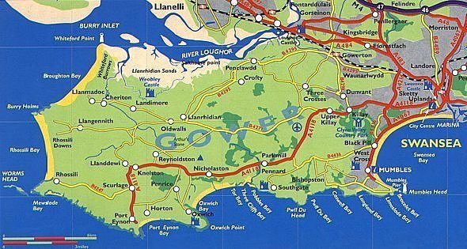
Located in the south of Wales is the county and city of Swansea and the Gower Peninsula which can be found within the county. With a population of 244,500 in 2016 (Swansea Council, 2018), Swansea is an up and coming destination with Wales and the UK as a whole. The growing destination has been classified as ‘Wales’ Waterfront City’; home to Swansea Bay beach which stretches over 5 miles in length. In contrast to this, busy Swansea city centre is a vibrant hub featuring over 230 retail outlets and a market, serving the population and its visitors on a daily basis (Visit Swansea Bay, 2018).
Source: Welsh Wales, 2004
Green spaces are prominent in Swansea and its surrounding areas, from Clyne to Singleton Parks, which feature hanging baskets, large green fields, play areas for children, allotments and wildlife (Swansea Council, 2018). Swansea County is notorious for being heavily sports-based. The county is home to Swansea City Football Club, whom are currently participating within the top-tier Premier League of British football, and Ospreys rugby team.
Within a short distance of Swansea city centre is the Gower Peninsula, which is currently celebrating ’62 years since becoming the UK’s first Area of Outstanding Natural Beauty’ (Visit Swansea Bay, 2018). The Gower consists of numerous beaches and various landscapes, also being home to a haven of wildlife and highlights of Welsh history. Castles, churches and woodlands make the Gower Peninsula a cultured and historical destination within south Wales, classed as a ‘sacred place, imbued with myth and ancient mysticism’ (Explore Gower, 2017). A true natural sanctuary close to a busy city centre, the Gower Peninsula features a number of Green Coast awarded beaches including Rhossili Bay (voted the best beach in the UK in June 2010) and Three Cliffs Bay; the Gower’s most popular beach destination for its outstanding views (Gower Holidays, 2018).
Swansea and the Gower Peninsula are highly visited tourist destinations. In a 2016 STEAM research report it was found that 4.59 million visitors flocked to these areas to indulge in the areas culture and facilities/services available, with an estimated spend of £400.3 million (Swansea Council, 2016).

Situation analysis
Research into the internal and external factors of Swansea and the Gower Peninsula is required for the researcher and reader to grasp a more in-depth look at the destination. A PEST analysis was undertaken for the external analysis (as shown in appendix) and discusses the political, economic, social and technological factors affecting not only Swansea and the Gower Peninsula, but the UK as a whole. Political factors affecting tourism include Brexit, the Tide Lagoon in Swansea and terrorism; economical factors include Swansea Councils debts and lack of funding for tourism-based projects; social factors include re-locating Swansea city-centre and riots/violence across the UK; technological factors include online booking and cyber-hacks. Brexit is a large political factor affecting the UK currently, with uncertainty as to what the outcome of such a large political event will be. The debts of which Swansea Council are currently in, along with lack of funding for tourism-based projects in the UK. Swansea Council have been in debt for many years and a report by Youle for WalesOnline in 2017 found that Swansea Council ‘spends £85,000 a day paying off its debts’ due to borrowing to develop schools and roads. This information however is to be argued, due to the lack of reliability from WalesOnline.
Re-locating Swansea city centre has been discussed by Swansea Council and is looking to go ahead in a few years, which can cause serious impacts on tourism. With the re-location of a city centre under way, tourists are less likely to visit an area due to construction work, noise and inaccurate information. Recent cyber hacks to the NHS system and regular hacking of customers bank details via online booking sites can deter holidaymakers. As the majority of tourism facilities/services in Swansea are to be booked online, tourists may be deterred by this and can therefore result in a loss of custom for the area.
A SWOT analysis was undertaken for this section of the report to find Swansea and the Gower Peninsulas strengths, weaknesses, opportunities and threats. The main threat for the city currently is the loss of Swansea City Football Club in the Premier League. A departure from the UK’s top football league could result in a loss of thousands of tourists each year whom travel to the city to watch their favourite teams play against one another. Opportunities for the destination include developments of the city, which could do with modernisation, while the mixture of a busy city centre and peaceful countryside/seaside areas allows all guests to be catered for primarily. Strengths of Swansea and the Gower include a variety of shops within the city centre, Green Awarded beaches, a community-based destination, a variety of attractions and links with educational establishments such as Swansea University. Weaknesses include the dismal weather conditions for the majority of the year, lack of promotion of Swansea as a whole, lack of large events such as festivals, anti-social behaviour from gangs and frequent drinkers within the city centre and a lack of major transportation links, such as an airport.

Analysis of key market segment
Eco-tourism is a growing market within the tourism industry, with more holidaymakers looking to become environmentally friendly when on holiday than ever before. Wearing and Neil (2013) explained this within their book, stating that: ‘the increasing global interest and exponential growth in ecotourism cannot simply be explained as another in a long line of recreational trends’. The authors claim that ecotourism is not a simple travel trend that will eventually fade away, but a concept that holidaymakers are highly interested in. In a report by Responsible Travel (2016), ‘A 2015 Good Travels survey by Tourism Cares found that 55% (1405 respondents) said that they volunteered or contributed financially or in-kind to a destination they visited in the last two years’, while the same report found that environmental and nature based tourism accounts for over ‘20% of the overall international tourism and travel industry’ (Rainforest Alliance, 2015). Both statements from the two sources agree that eco-tourism should be taken seriously within the tourism industry, growing each year and thus creating a demand for more environmentally friendly holidays.
Such a demand has been found for eco-tourism in Swansea and the Gower that Sustainable Swansea created Wales’ first green map for the area. Green maps are a ‘locally-made map that uses the universal Green Map® Icons to highlight the social, cultural, and sustainable resources of a particular geographic area’. Sustainable Swansea created and regularly updates the map (available both online and in print) ‘by working in different communities in Swansea’, showing their commitment and organisation importance in showcasing the best eco-tourism areas in Swansea and the Gower Peninsula (Sustainable Swansea, 2017). An example of the Sustainable Swansea Green Map can be found in appendix 1.
In a 2015 presentation published by Swansea Council, hundreds of tourists were provided with a survey regarding their purpose of visit to the area. It was discovered that the highest percentage of tourists, 20%, travelled to Swansea Bay for the coasts/beaches and a further 15% for the scenery and landscape. Another question asked visitors what activities that partook in while in Swansea/Gower, with 33% claiming to have mainly participated in walking. The report found that the some of the most popular attractions for tourists to visit within the area included Gower Heritage Centre (16%), Clyne Gardens (3%) and Singleton Botanical Gardens and Plantasia (both 1%) (Lydall et al., 2015). From these results, it’s clear that eco-tourism is in demand in Swansea and Gower Peninsula. Tourists recognise the destination as an environmental haven and thus should be taken advantage of by the Swansea tourist board and travel agencies across the globe.

Marketing objectives
Marketing objectives are ‘to be achieved, quantified in terms of order intake, sales turnover, market share and profit’ (Westwood, 2013). In basic terms, the purpose for setting marketing objectives for any organisation is to plan and set goals for the future that are measurable and realistic. The main marketing objective for this report is:
- To showcase eco-tourism services and facilities in Swansea and the Gower Peninsula to tourists across the globe.
Along with this marketing objective, other objectives must be set to provide further understanding and development of the main marketing objective. Secondary objectives set are:
- To promote Swansea and the Gower Peninsula as tourism destination as a whole.
- To encourage guests and Swansea Council to become more environmentally friendly/aware of their carbon footprint.
- To endorse eco-tourism in Swansea and the Gower Peninsula; leading to further development of eco-friendly facilities and services in the area.
- To ensure Swansea and the Gower Peninsula remain popular eco-friendly tourist destinations in Wales for the next decade.
These marketing objectives can be measured via reports and statistics annually recorded by Swansea Council to understand their tourism figures and key points.

Marketing mix
The marketing mix combines four phrases that describe the four key elements that businesses follow in order to achieve success in the marketing industry. These four phrases are: Product, Price, Promotion and Place, more commonly known as the ‘Four P’s’. The four P’s rely upon one another in order to achieve the highest amounts of success, with all four having to be combined for customers’ needs to be met effectively.
The product of this report is an itinerary for those wishing to visit Swansea and in particular the Gower Peninsula on holiday with eco-friendly facilities/services. As shown in appendix 2, the itinerary is showcased over a 5 day/4-night period. The customers would be staying at Corn Cottage. Corn Cottage is a newly renovated barn conversion situated within the Gower that sleeps up to 5 individuals and features solar panels among other amenities. (Gower Holidays, 2018). Public transport is an important form of transportation that the customers will use while at the Gower. The N.A.T. Group are a company that operates bus and coach services around the area of the Gower and Swansea, travelling to many of the destinations most popular areas and visitor attractions (N.A.T. Group, 2017). Less CO2 emissions and road congestion are the result of using public transport.
The Bike Hub are located on Swansea sea front in a perfect destination, offering up an extensive network of trails and paths that Swansea and the surrounding area has to offer from its doorstep. The Bike Hub offer visitors a chance to hire hybrid bikes for the day with ease, with a bike costing only £10 per day (The Bike Hub, 2017). The holidaymakers would be visiting the Gower Heritage Centre; situated in the heart of the Gower Peninsula it’s a visitor attraction and rural museum that is based on a working 12th century water-mill. The accredited attraction prides itself on sustaining the natural environment of the Gower Peninsula, using funds and profits made to benefit the local area and is home to many activities (Gower Heritage Centre, 2018). The centre charges £6.95 per adults and £5.95 per child, with tickets half price if travelling to the attraction via N.A.T. Clyne Gardens are a green flag garden containing a large amount of National Collections of plants and wildlife and is famous for its collections of Pieris, Enkianthus, Rhododendrons, interesting features and tranquillity. This attraction is free entry (Swansea Council, 2017).
Three Cliffs Bay is the bay on the south coast of the Gower Peninsula. The beach is of a high importance to the Gower and is of a Blue Flag status. In 2006, the beach was declared to be the best in the UK by BBC’s Holidays at Home programme. Three Cliffs Bay is perfect for those interested in the environment, as the area is mainly untouched by developments and free to visit (Visit Swansea Bay, 2018). Located within a short distance of the accommodation via bus, the North Gower Farmer’s Market is held within a big red barn daily and is free entry. The market has become a meeting place for both young and older members of the community, with local established businesses such as Heather’s Café operating daily. The main purpose for the market is to offer locals and visitors a chance to sample local produce and partake in activities that they would otherwise not experience (North Gower Farmers’ Market, 2018).
One of Swansea’s most popular tourist attractions is Plantasia, a tropical haven full of plants and animals typically located in rainforest environments. Plantasia is located in the heart of the city, as the City and County of Swansea Council wished to make a statement regarding how they take environmental responsibility seriously. They wanted to highlight the need and importance of looking after/protecting the world that we live in (Swansea Council, 2018). Entry prices for this attraction are £3.95 for adults and £2.95 for children. Oystermouth Castle is a Norman stone castle located on the east side of the Gower Peninsula, near Mumbles. The castle was built in the 12th century and was in use from 1106 until 1605. Prices for this attraction are £3.50 per adults and £2.50 per child (Swansea Council, 2018).
The total price for the accommodation and activities while at the Gower is considered highly reasonable by the author. The cost of Corn Cottage is £200 for 4 nights and with this price included, the total for two adults to partake in this itinerary would be £248.80 (excluding transportation to the Gower, bus transport, spending money and local restaurants visited). When considering the report published by Lydall et al. (2015), which states that overnight visitors from outsides of Wales spend £556 on average in the area while Welsh residents spend £299 for an overnight stay, the holiday to the Gower for 4-nights is extremely justified and reasonable.
Attractions within the trip are spread throughout Swansea and the Gower Peninsula, allowing the guests to view the county well during their stay. To market the itinerary, newspaper and social media marketing would be the most suitable. This is due to social media marketing being mainly free to use, while newspaper marketing would be useful as these are viewed daily by individuals of all ages and according to The International Ecotourism Society (2017), ‘ecotourism appeals to a wide range of travellers, of all ages’ (International Ecotourism Society, 2017). The itinerary will be mainly advertised to those within the UK as advertising abroad is commonly known to be typically more expensive due to set up fees and educating individuals outside the UK about the destination. However, it is important for Swansea and the Gower Peninsula to garner higher numbers of overseas tourists, which should be developed and looked at greatly in years to come.

Summary
Swansea and the Gower Peninsula are highly sought-after destinations for tourists. However, it is unclear how well the destination is at providing eco-tourism facilities to please all types of guests. It is certain that the range of facilities currently on offer are above standard compared to other segments of the UK, with Plantasia, the Gower Heritage Centre and numerous beaches/gardens being highlights of the destination. Recommendations for the area could be to involve more eco-friendly tourism attractions, with large scale events that are also eco-friendly being viable options for Swansea and the Gower Peninsula. Festivals such as the Green Man are examples that Swansea and the Gower should be basing future events upon, as it is clear that tourists travelling to the destination are keen to take explore the natural and environmental segments of the area. For its lack of funding and development, overall Swansea and the Gower Peninsula offer adequate facilities/services for eco-tourists.

References
Explore Gower. (2017), ‘Exploring the Gower Peninsula’, [Online]. Available: http://www.explore-gower.co.uk/, Last Accessed: [2018, March, 12].
Gower Heritage Centre. (2018), ‘Main’, [Online]. Available: http://www.gowerheritagecentre.co.uk/main.htm, Last Accessed: [2018, March, 13].
Gower Holidays. (2018), ‘Beaches’, [Online]. Available: https://www.gowerholidays.com/attractions-activities-in-gower-swansea/beaches/, Last Accessed: [2018, March, 12].
Gower Holidays. (2018), ‘Corn Cottage’, [Online]. Available: https://www.gowerholidays.com/accommodation/self-catering/corn-cottage/, Last Accessed: [2018, March, 13].
Lydall, A & Nesbitt, L & Thorley, D. (2015), ‘Swansea Visitor Survey 2015’, [PowerPoint Presentation]. Available at: https://www.swansea.gov.uk/article/6406/Tourism-research-and-statistics, Last Accessed: [2018, March, 13].
N.A.T. Group. (2017), ‘Bus Services’, [Online]. Available: https://www.natgroup.co.uk/bus-services, Last Accessed: [2018, March, 13].
North Gower Farmers’ Market. (2018), [Online]. Available: https://northgowerfarmersmarket.wordpress.com/, Last Accessed: [2018, March, 13].
Rainforest Alliance. (2015), ‘A Practical Guide to Good Practice for Tropical Forest-Based Tours’, [Online]. Available: http://www.rainforest-alliance.org/sites/default/files/publication/ pdf/good_practice.pdf, Last Accessed: [2018, March, 12].
Sustainable Swansea. (2017), ‘Swansea Growing Spaces Map’, Swansea: Swansea Environmental Forum.
Swansea Council. (2017), ‘Clyne Gardens’, [Online]. Available: https://www.swansea.gov.uk/clyne, Last Accessed: [2018, March, 13].
Swansea Council. (2018), ‘Key facts and figures about Swansea’, [Online]. Available: https://www.swansea.gov.uk/businessfactsandfigures, Last Accessed: [2018, March, 12].
Swansea Council. (2018), ‘Oystermouth Castle’, [Online]. Available: https://www.swansea.gov.uk/oystermouthcastle, Last Accessed: [2018, March, 13].
Swansea Council. (2018), ‘Parks and green spaces’, [Online]. Available: https://www.swansea.gov.uk/parks, Last Accessed: [2018, March, 12].
Swansea Council. (2018), ‘Plantasia’, [Online]. Available: https://www.swansea.gov.uk/plantasia, Last Accessed: [2018, March, 13].
Swansea Council. (2016), ‘Tourism research and statistics’, [Online]. Available: https://www.swansea.gov.uk/article/6406/Tourism-research-and-statistics, Last Accessed: [2018, March, 12].
The Bike Hub. (2017), ‘The Hub’, [Online]. Available: http://swanseabikeshop.blogspot.co.uk/, Last Accessed: [2018, March, 13].
The International Ecotourism Society (2018), ‘Who are eco-tourists?’, [Online]. Available: http://www.ecotourism.org/book/who-are-eco-tourists, Last Accessed: [2018, March, 13].
Visit Swansea Bay. (2018), ‘Swansea’, [Online]. Available: https://www.visitswanseabay.com/destinations/swansea/, Last Accessed: [2018, March, 12].
Visit Swansea Bay. (2018), ‘The Gower Peninsula’, [Online]. Available: https://www.visitswanseabay.com/destinations/gower-peninsula/, Last Accessed: [2018, March, 12].
Visit Swansea Bay. (2018), ‘Three Cliffs Bay’, [Online]. Available: https://www.visitswanseabay.com/listings/three-cliffs-bay-beach/, Last Accessed: [2018, March, 13].
Wearing, S & Neil, J. (2013), ‘Ecotourism’, Oxford: Butterworth-Heinmann.
Westwood, J. (2013), ‘How to Write a Marketing Plan’, (Fourth Edition), London: Kogan Page Limited.
Welsh Wales. (2004), ‘Swansea Map’, [Online]. Available: http://www.welshwales.co.uk/swansea_map.htm, Last Accessed: [2018, March, 12].
Youle, R. (2017), ‘Swansea Council spends £85,000 a day paying off its debts’, [Online]. Available: https://www.walesonline.co.uk/news/local-news/swansea-council-spends-85000-day-13028955, Last Accessed: [2018, March, 13].

Appendices
Appendix 1 – Green Map
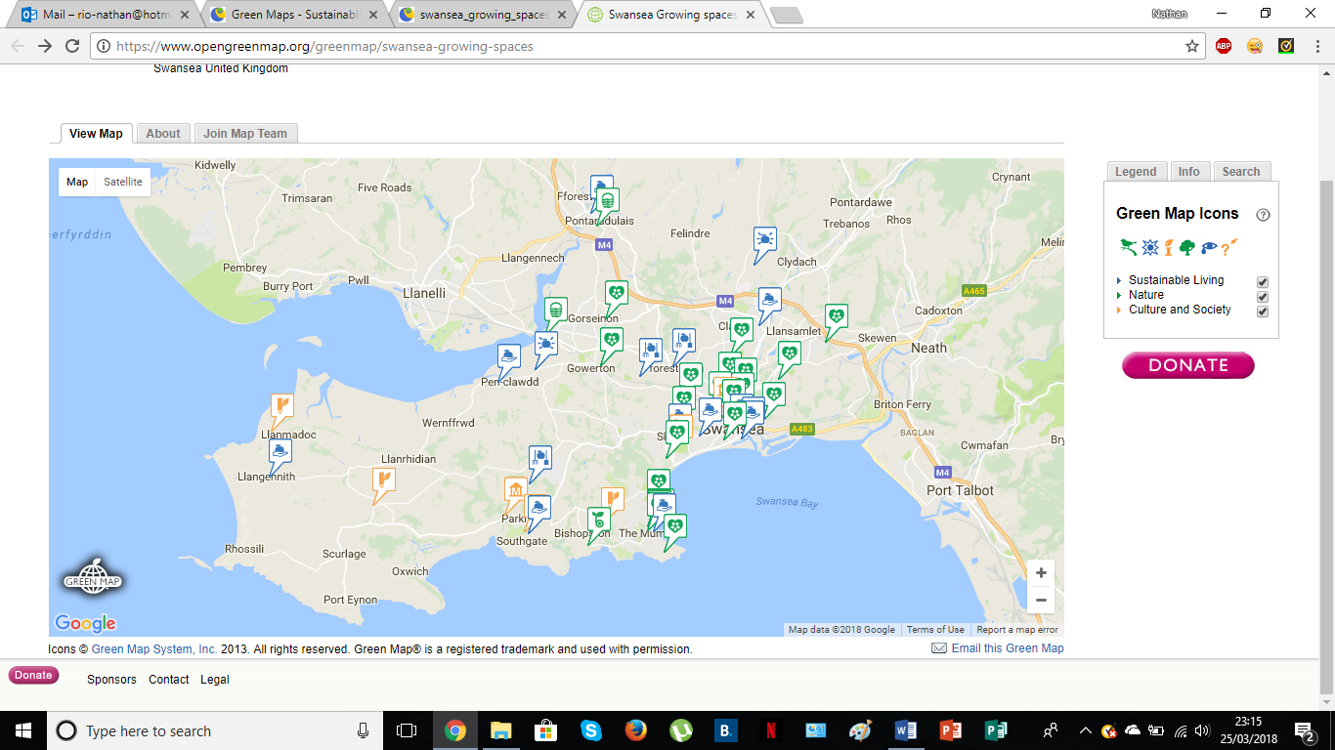

PEST Analysis
Political  - Brexit  - Tide Lagoon  - Terrorism | Economical  - Swansea Council debt  - Lack of funding for projects
Social  - Re-locating city centre  - Riots and violence | Technological  - Online booking  - Cyber-hacks

SWOT Analysis
Strengths  - Variety in city centre  - Fantastic beaches  - Community based destination  - Variety of attractions  - Links with educational establishments | Weaknesses  - Weather  - Lack of promotion of area  - Lack of large events  - Anti-social behaviour  - Lack of transportation links
Opportunities  - Developing city as a whole  - Mixture of both busy centre and peaceful countryside/seaside destination | Threats  - Swansea City Football Club relegation from Premier League

Appendix 2 – Itinerary
Monday
- The customers depart their hometown and head to the Gower Peninsula for their 4-night summer holiday
- Arrive at accommodation, Corn Cottage, in the evening
- After settling in to their accommodation, the family can explore nearby surroundings such as shops and landmarks at their leisure
- Visit one of many nearby restaurants/cafés for dinner
- Head back to the cottage for the night
Tuesday
- Depart the cottage mid-morning after breakfast and head to the Gower Heritage Centre via local bus service
- The customers can enjoy some time looking around the centre, learning about the history of the Gower. There are also opportunities to participate in a weaving/spinning woollen mill experience class
- Lunch within the Gower Heritage Centre’s Tea Room
- Towards mid-afternoon, the family could participate in a pottery class within the centre
- After this, the family could visit the animal park at the Heritage Centre
- Head back to accommodation via bus to get ready for an evening meal
- Visit a local restaurant for dinner
- Head back to the cottage for the night
Wednesday
- Depart the cottage mid-morning after breakfast and head to the North Gower Farmers Market via bus
- Enjoy some free time to look around the farmer’s market, trying some local produce
- Participate in making jewellery, art, woodwork and much more with talented artisans
- Lunch within Heather’s Café on site at the farmer’s market
- Depart the farmer’s market and head to Clyne Gardens mid-afternoon via bus
- Spend some time within Clyne Gardens, taking in the breath-taking views and landscapes within the area
- Head back to accommodation via bus to prepare an evening meal from local produce purchased from the farmer’s market
- Enjoy a meal at the cottage before having a relaxing night in the confinements of Corn Cottage
Thursday
- Depart the cottage mid-morning after breakfast and head to The Bike Hub via bus
- The family could hire bikes and as The Bike Hub is located on Swansea sea front, they could use these bikes to travel to Three Cliffs Bay via bike routes, beach fronts and Gower woodlands
- Arrive at Three Cliffs Bay at mid-day before having lunch in a nearby café
- After lunch, explore Three Cliffs Bay via cycling
- Visit Pennard Castle within Three Cliffs Bay before relaxing on the beach
- Travel back to The Bike Hub to drop off hired bikes
- Catch a bus back to Corn Cottage to get ready for an evening meal
- Visit a local restaurant for dinner
- Head back to the cottage for the night
Friday
- Depart the cottage mid-morning after breakfast and head to Oystermouth Castle via bus
- Explore the castle and learn about its history within the Gower Peninsula
- Depart the castle just after mid-day and head to Swansea city centre via bus for lunch in a nearby café
- After lunch, walk to Plantasia
- Enjoy a few hours within Plantasia, learning about a number of animals and the rainforest that is in desperate need of help
- Depart Plantasia in the evening and catch a bus back to the accommodation
- Have an evening meal within the cottage from leftover food purchased from the farmer’s market
- After dinner, depart Corn Cottage and head back home

