ACCA4023 - HTML & CSS Web Development
Hasan Sivas
Student no. 2421062
Table of Contents
1.1 Introduction 1
2 Requirements 1
3 Implementation 2
4 evaluation 6
5 bibliography 7
6 appendices 8

Introduction
This report will go over the details of the creation of a website (5 pages total) for the fictional medical tools producing company M.I.Y.W (Medical Intervention You Want). The report will detail the reasoning behind each design choice, describe its implementation and after give an evaluation of the finished product based on its usability, accessibility and SEO.

Requirements
M.I.Y.W is a company that aims to sell custom made medical tools to medical professionals and companies. The website’s goal is to briefly inform visitors of what it is and facilitate easy switching of pages to get to where they want (presumably, the products page). Therefor it would be optimal for the website’s design philosophy to be ‘being concise and to the point’. The 5 pages that were designed on initially were ‘main’, ‘about’, ‘products’, ‘staff’ and ‘contact’.

Implementation
‌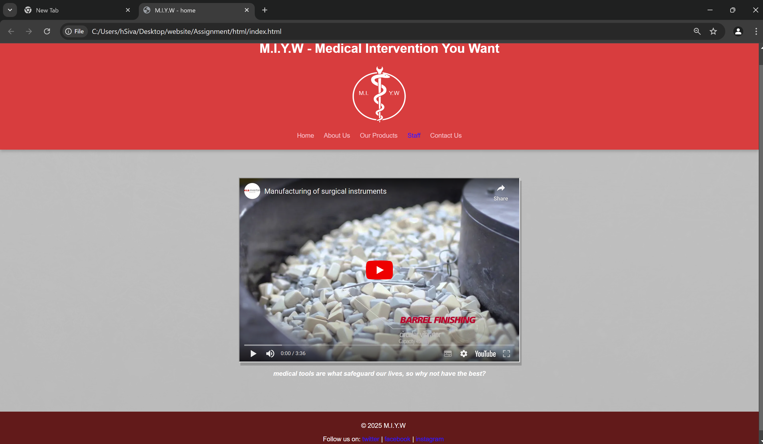
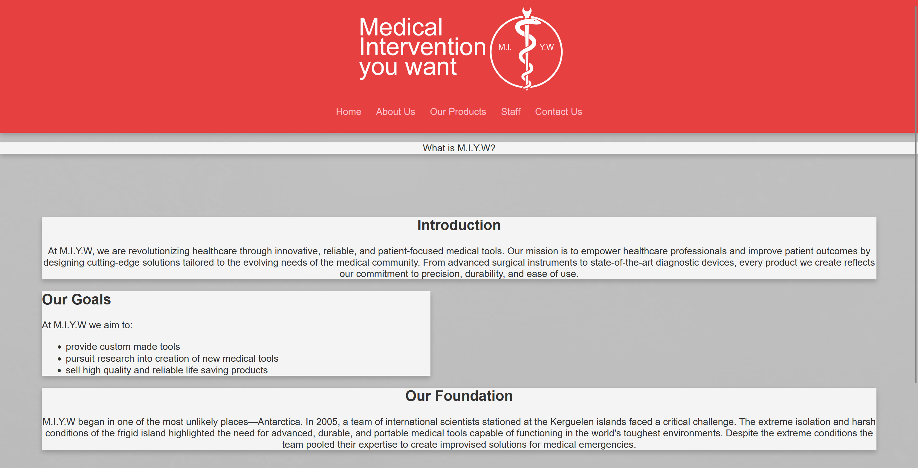
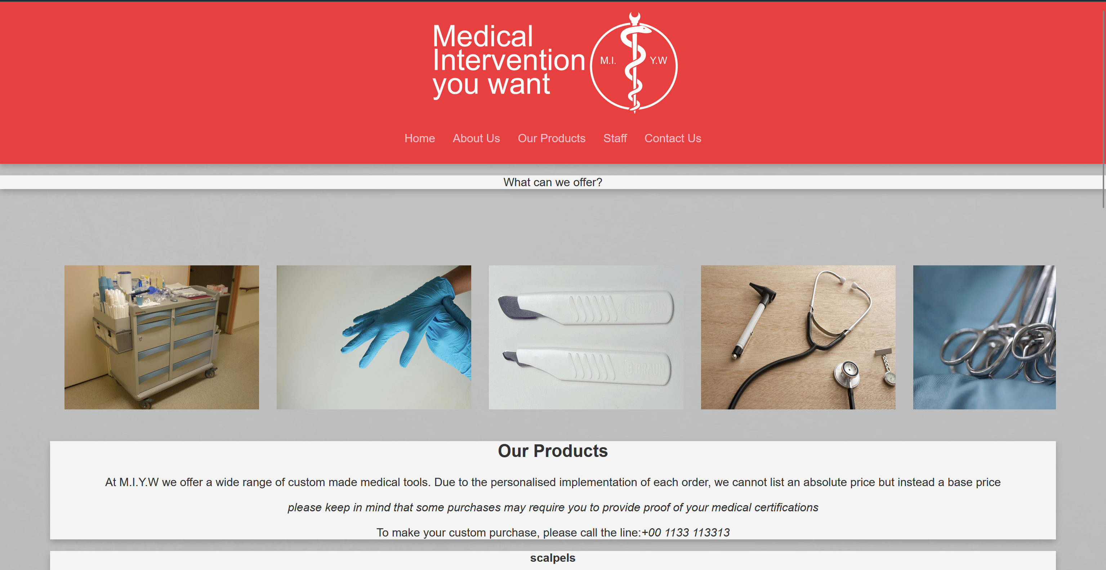
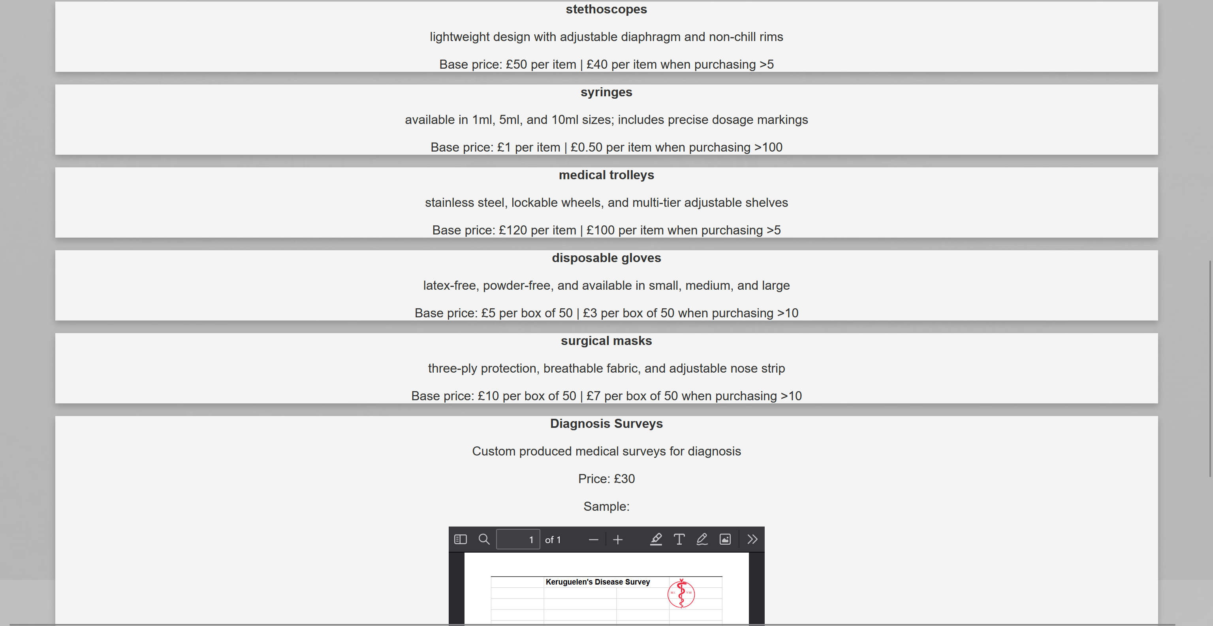
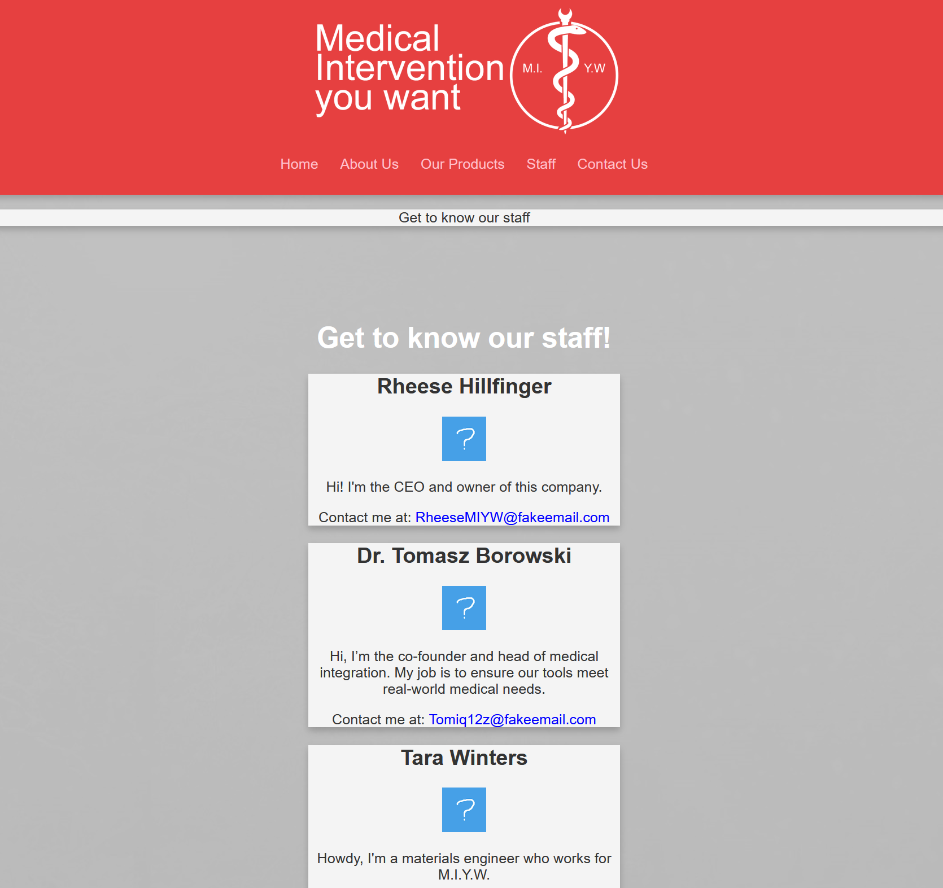
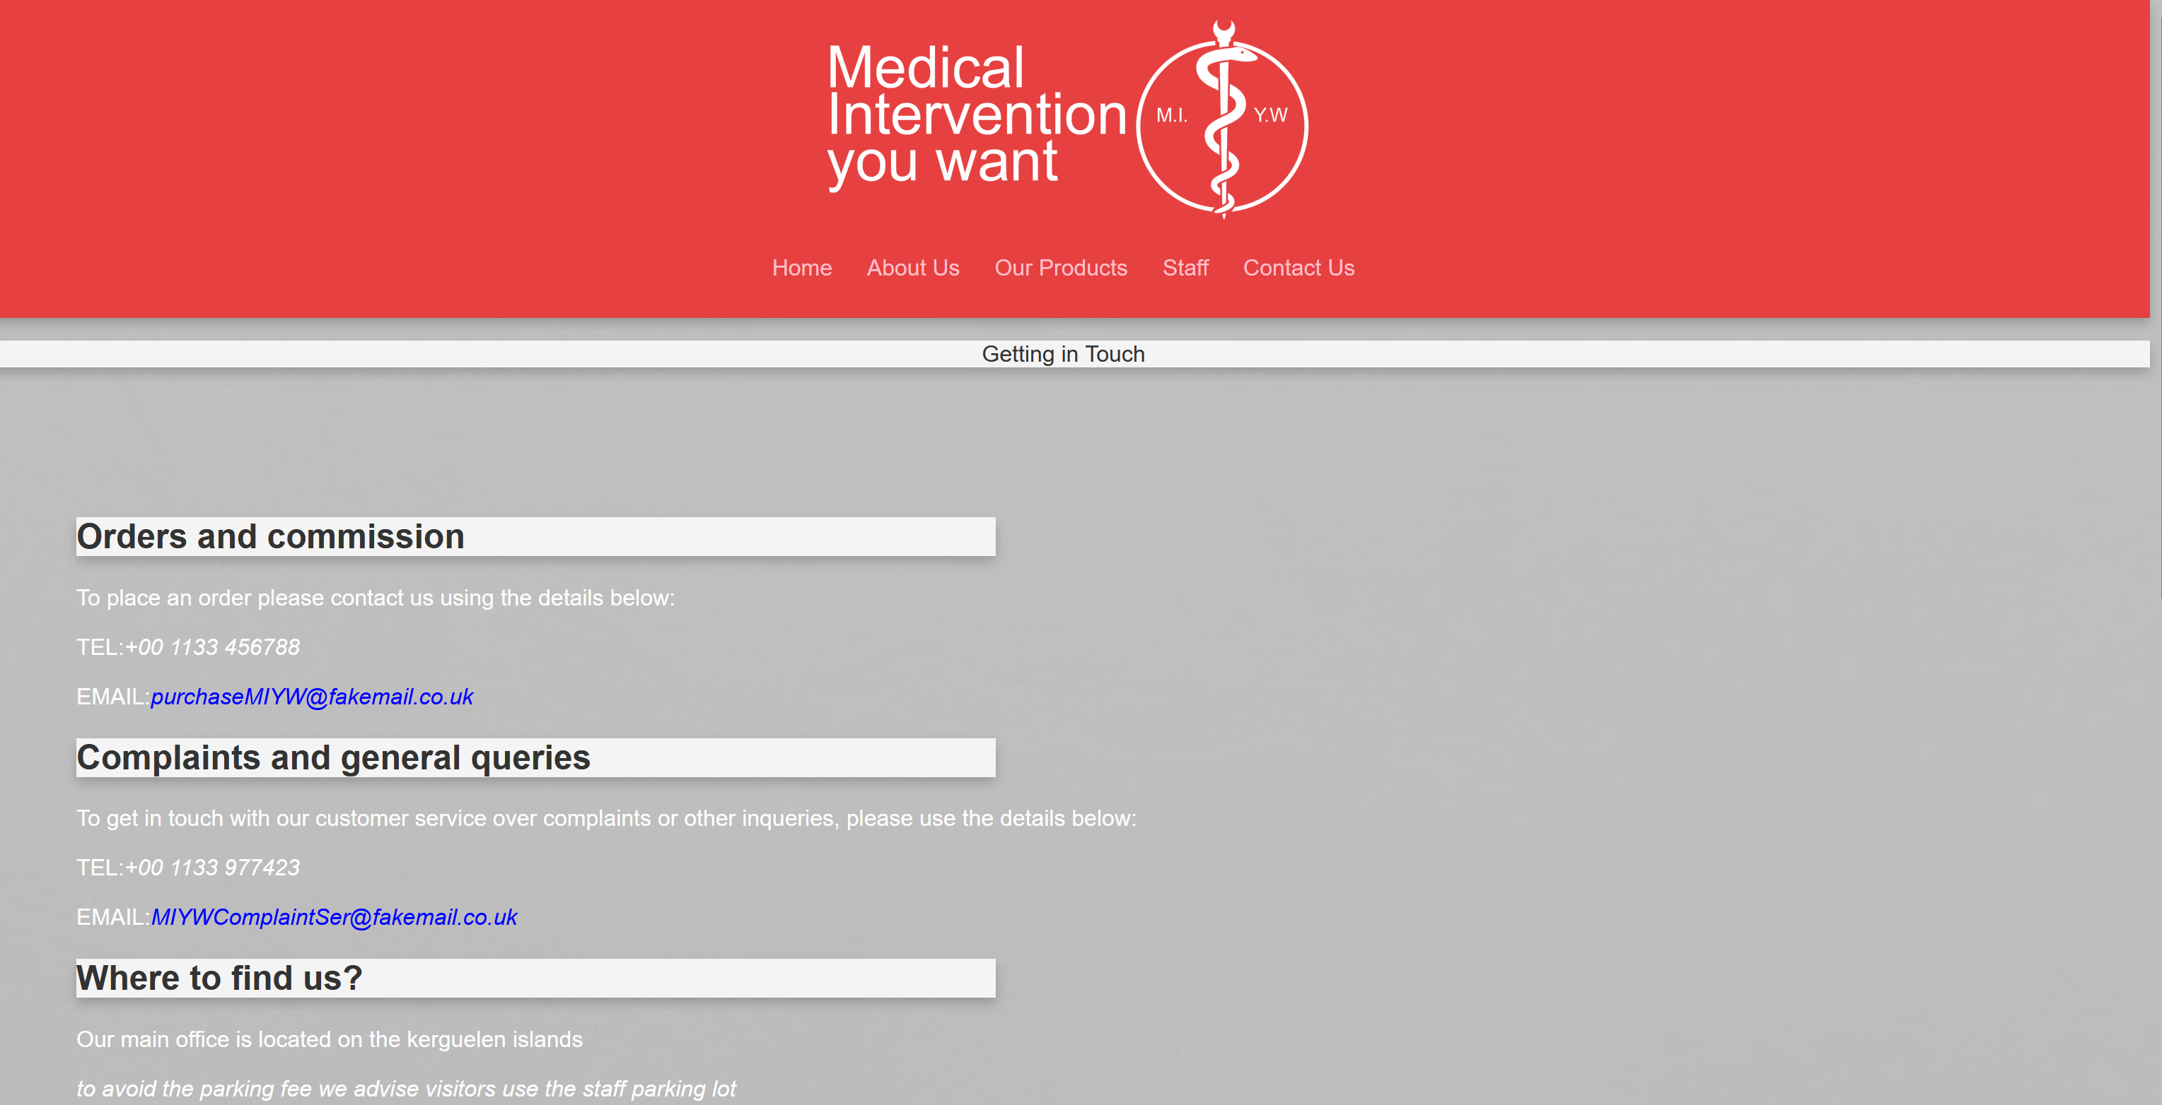
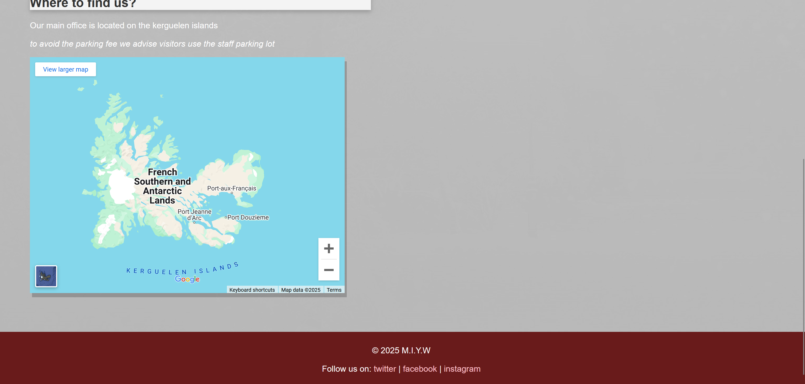
Figure 1. Screenshots showcasing all of the website’s pages
Firstly, it may be appropriate to discuss the visual design of the website. The pages consist of a most red and white colour scheme (which was chosen to be reminiscent of an ambulance’s colour scheme): light grey backgrounds with red headers and a dark red header if you scroll down to the bottom. In some areas, text is contained in white boxes to emphasise and separate it from the background or from other text.
Taking a cue from websites with similar objectives, such as SAEYANG and Medtronic [3][4], M.I.Y.W opts to have a very simple splash page with just a singular video and the links to the other pages in its header. The video currently embedded here is about medical technology but can be considered a placeholder; it would be beneficial to have a custom-made video about M.I.Y.W autoplay on this splash page.
The products page is fairly simple and lists several items the company offers in sectioned boxes underneath a gallery that displays several of these items, there is also an embedded PDF at the end which serves as a sample for the custom questionnaires that can be commissioned.
The staff page indexes several members of staff and their email address.
The contact page displays phone numbers and email addresses for its two branches that interact with customers, as well as an I frame embedded map for those who might want to visit its headquarters at the bottom.

Using the HTML validator [5], each of the website’s pages were examined for errors in their code.
No noteworthy errors were produced by index.css (unsurprising due to its small size.) , the validator did suggest to use CSS to define the I frame’s centre position (which it is however it does not seem to work without the HTML declaration).
The only error identified in about.html was a warning that the section at the top (used as a flavour text descriptor between the heading and body of the site) had no heading. This manner of presentation is intentional however, so this warning was disregarded.
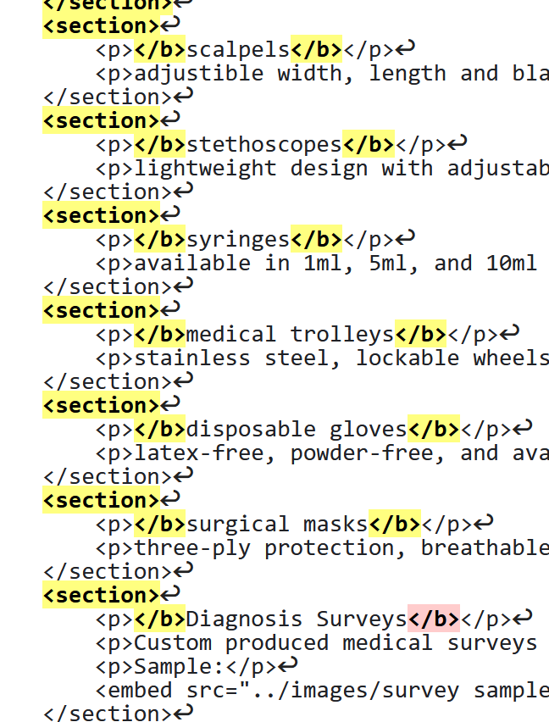
A significant error was identified in the products.html page wherein two closing tags for </b> were used, resulting in the item names not displaying bold, this was promptly rectified so that there were <b> tags opening to </b>s.
Another issue with this page was an unclosed italics tag which had caused all text afterwards t be italicised.
Analysis of the staff.html and contact.html pages did not identify any noteworthy errors.
A CSS error validator [6] was also used on the website’s stylesheet styles.css but it identified no errors. However, some obsolete definitions for a collapsible from earlier in the site’s development were spotted and promptly removed.

evaluation

A 2008 study by R. J. Nathan and P. H. P. Yeow [8] identified several important factors that contribute to a website’s perceived usability, among these are: aesthetics (proper use of colour contrast and backgrounds) and easy to read text. Likewise, another important facet of usability is a website’s ease of navigation. On the M.I.Y.W site, the navigation bar always being at the same spot (at the top of the page) makes it essentially impossible to get lost. If the website were to expand further and acquire more subpages it may be beneficial to include dropdowns from the navigation bar to maintain its current level of usability. Another way to significantly enhance the website’s usability could be to integrate placing orders into the website itself rather than simply listing a number you can call.
User testing could potentially be used to further assess the websites usability a more objective manner by giving the users qualitative metrics to score it on [8].

Accessibility is a very important facet of modern day website design, there is a well established set of recommendations to adhere to known as the WCAG ‘ Web Content Accessibility Guidelines’ to make one’s site usable for everyone [9]. WCAG’s four main principles are that a website must be: perceivable, operable, understandable and robust.
A lack of understanding of contrast can lead to webpages that are difficult to perceive, especially for people who are hard of sight or colourblind, the page should rely on only separate hues but separate tones and levels of darkness too. M.I.Y.W’s fonts and colours are given proper contrast in order to make sure the website is accessible and easy to read and all images are given a descriptive alt text.
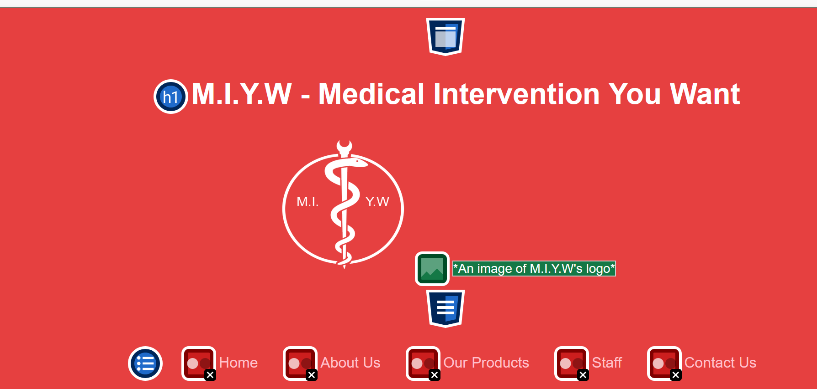
Fig 2. Screenshot of the webpage viewed through WAVE
Using the browser extension WAVE however, a few issues were identified with M.I.Y.Ws perceptability. Notably, clicked links are set to pink, which for the buttons on the header makes them harder to read; a suitable improvement would therefore be to choose another colour for clicked links, such as blue or purple. overall fills the ‘perceivable’ aspect well.
In terms of ‘operatability’ the website can easily be navigated with just a mouse, or just a keyboard via use of the ‘tab’ key.

The website has several features that make it well optimized for SEO. Firstly, there are many mentions of relevant phrases in the about and products section such as ‘medical tools’, ‘scalpels’ or ‘disposable gloves’, however these are not used to the point of being unwieldy for the user or irrelevant [7]. There are also meta tags in the head section of each document listing relevant keywords. These keywords and phrases will increase the chances of web crawlers finding and listing the website when a search engine user is looking for medical tools.
In conclusion the M.I.Y.W page does a reasonable job of fulfilling its goal of being easy to navigate and explaining the company’s existence. The page is overall fairly usable but could do with some improvements such as a built in ordering system. In terms of accessibility the page is quite accommodating with only a few minor issues and some reasonable attempts at SEO have already been implemented.

bibliography
[1] Robbins, J., 2018, Learning Web Design: A Beginner’s Guide to HTML, CSS, JavaScript, and Web Graphics, O'Reilly Media
[2] W3Schools, “W3Schools Online Web Tutorials,” W3schools.com, 2019. https://www.w3schools.com
[3] “SAEYANG,” Saeyang.com, 2024. https://www.saeyang.com/#section1 (accessed Jan. 03, 2025).
‌[4] Medtronic, “Medical Technology, Services, and Solutions Global Leader | Medtronic,” www.medtronic.com. https://www.medtronic.com/uk-en/index.html (accessed Jan. 03, 2025).
[5]W3C, “The W3C Markup Validation Service,” W3.org, 2013. https://validator.w3.org/
‌[6] W3C, “The W3C CSS Validation Service,” W3.org. https://jigsaw.w3.org/css-validator/
[7] C. Silva, “9 SEO Best Practices That You Should Follow in 2020,” SEMrush Blog, Nov. 13, 2022. https://www.semrush.com/blog/seo-best-practices/(accessed Jan. 04, 2025).
‌[8] R. J. Nathan and P. H. P. Yeow, “An empirical study of factors affecting the perceived usability of websites for student Internet users,” Universal Access in the Information Society, vol. 8, no. 3, pp. 165–184, Nov. 2008, doi: https://doi.org/10.1007/s10209-008-0138-8.
[9]World Wide Web Consortium, “Web Content Accessibility Guidelines (WCAG) Overview,” Web Accessibility Initiative (WAI), Jul. 2005. https://www.w3.org/WAI/standards-guidelines/wcag//(accessed Jan. 04, 2025).

appendices
index.html
<!DOCTYPE html>
<html lang="en">
<head>
<meta charset="UTF-8">
<meta name="viewport" content="width=device-width, initial-scale=1.0">
<meta name="keywords" content="M.I.Y.W, medical tools, medical tools company, scalpels, medical trolley, custom tools, custom medical tools">
<meta name="description" content="M.I.Y.W's website for ordering custom made high quality medical tools.">
<title>M.I.Y.W - home</title>
<link rel="stylesheet" href="styles.css">
<style>
body{
background-image: url("../images/bg-main.jpg");
font-family:Arial, sans-serif;
color:#FFFFFF;
}
</style>
</head>
<body>
<header>
<h1>M.I.Y.W - Medical Intervention You Want</h1>
<img src="../images/miywlogo.png" alt="An image of M.I.Y.W's logo" width="150" height="150">
<nav>
<ul>
<li><a href="index.html">Home</a></li>
<li><a href="about.html">About Us</a></li>
<li><a href="products.html">Our Products</a></li>
<li><a href="staff.html">Staff</a></li>
<li><a href="contact.html">Contact Us</a></li>
</ul>
</nav>
</header>
<main>
<center><iframe width="700" height="460" src="https://www.youtube.com/embed/inZczv3bLu4?autoplay=1"></iframe>
<p><i><b>medical tools are what safeguard our lives, so why not have the best?</b></i></p></center>

</main>
<footer>
<p>&copy; 2025 M.I.Y.W</p>
<p>
Follow us on:
<a href="https://twitter.com" target="_blank"> twitter</a> |
<a href="https://facebook.com" target="_blank"> facebook</a> |
<a href="https://instagram.com" target="_blank"> instagram</a>
</p>
</footer>
</body>
</html>
about.html
<!DOCTYPE html>
<html lang="en">
<head>
<meta charset="UTF-8">
<meta name="viewport" content="width=device-width, initial-scale=1.0">
<meta name="keywords" content="M.I.Y.W, medical tools, medical tools company, scalpels, medical trolley, custom tools, custom medical tools">
<meta name="description" content="M.I.Y.W's website for ordering custom made high quality medical tools.">
<title>M.I.Y.W - about</title>
<link rel="stylesheet" href="styles.css">
<style>
body{
background-image: url("../images/bg-main.jpg");
font-family:Arial, sans-serif;
color:#FFFFFF;
}
</style>
</head>
<body>
<header>
<img src="../images/miywlogowide.png" alt="An image of M.I.Y.W's logo" width="360" height="150">
<nav>
<ul>
<li><a href="index.html">Home</a></li>
<li><a href="about.html">About Us</a></li>
<li><a href="products.html">Our Products</a></li>
<li><a href="staff.html">Staff</a></li>
<li><a href="contact.html">Contact Us</a></li>
</ul>
</nav>
</header>
<section>
<p>What is M.I.Y.W?</p>
</section>
<main>
<section>
<h2>Introduction</h2>
<p> At M.I.Y.W, we are revolutionizing healthcare through innovative, reliable, and patient-focused medical tools. Our mission is to empower healthcare professionals and improve patient outcomes by designing cutting-edge solutions tailored to the evolving needs of the medical community. From advanced surgical instruments to state-of-the-art diagnostic devices, every product we create reflects our commitment to precision, durability, and ease of use.</p>
</section>
<div class="leftbubble">
<h2>Our Goals</h2>
<p>At M.I.Y.W we aim to:<p>
<ul>
<li>provide custom made tools</li>
<li>pursuit research into creation of new medical tools</li>
<li>sell high quality and reliable life saving products</li>
</ul>
</div>
<section>
<h2>Our Foundation</h2>
<p>M.I.Y.W began in one of the most unlikely places—Antarctica. In 2005, a team of international scientists stationed at the Kerguelen islands faced a critical challenge. The extreme isolation and harsh conditions of the frigid island highlighted the need for advanced, durable, and portable medical tools capable of functioning in the world's toughest environments. Despite the extreme conditions the team pooled their expertise to create improvised solutions for medical emergencies.</p>
</section>
</main>
<footer>
<p>&copy; 2025 M.I.Y.W</p>
<p>
Follow us on:
<a href="https://twitter.com" target="_blank"> twitter</a> |
<a href="https://facebook.com" target="_blank"> facebook</a> |
<a href="https://instagram.com" target="_blank"> instagram</a>
</p>
</footer>
</body>
</html>
products.html
<!DOCTYPE html>
<html lang="en">
<head>
<meta charset="UTF-8">
<meta name="viewport" content="width=device-width, initial-scale=1.0">
<meta name="keywords" content="M.I.Y.W, medical tools, medical tools company, scalpels, medical trolley, custom tools, custom medical tools">
<meta name="description" content="M.I.Y.W's website for ordering custom made high quality medical tools.">
<title>M.I.Y.W - Products</title>
<link rel="stylesheet" href="styles.css">
<style>
body{
background-image: url("../images/bg-main.jpg");
font-family:Arial, sans-serif;
color:#FFFFFF;
}
</style>
</head>
<body>
<header>
<img src="../images/miywlogowide.png" alt="An image of M.I.Y.W's logo" width="360" height="150">
<nav>
<ul>
<li><a href="index.html">Home</a></li>
<li><a href="about.html">About Us</a></li>
<li><a href="products.html">Our Products</a></li>
<li><a href="staff.html">Staff</a></li>
<li><a href="contact.html">Contact Us</a></li>
</ul>
</nav>
</header>
<section>
<p>What can we offer?</p>
</section>
<main>
<div class="scroll-container">
<img src="../images/trolley.jpg" alt="trolley" width="270" height="200">
<img src="../images/gloves.jpeg" alt="gloves" width="270" height="200">
<img src="../images/scalpels.jpg" alt="scalpels" width="270" height="200">
<img src="../images/stethoscope.jpg" alt="stethoscope" width="270" height="200">
<img src="../images/surgin1.jpg" alt="surgicaltools" width="270" height="200">
<img src="../images/syringe.jpg" alt="syringe" width="270" height="200">
<img src="../images/dental.jpg" alt="dental tools" width="270" height="200">
</div>
<section>
<h1>Our Products</h1>
<p> At M.I.Y.W we offer a wide range of custom made medical tools. Due to the personalised implementation of each order, we cannot list an absolute price but instead a base price</p>
<p><i>please keep in mind that some purchases may require you to provide proof of your medical certifications</i></p>
<p> To make your custom purchase, please call the line:<i>+00 1133 113313</i></p>
</section>
<section>
<p><b>scalpels</b></p>
<p>adjustible width, length and blade types</p><p>Base price:£15 per item | £8 per item when purchasing >10</p>
</section>
<section>
<p><b>stethoscopes</b></p>
<p>lightweight design with adjustable diaphragm and non-chill rims</p><p>Base price: £50 per item | £40 per item when purchasing >5</p>
</section>
<section>
<p><b>syringes</b></p>
<p>available in 1ml, 5ml, and 10ml sizes; includes precise dosage markings</p><p>Base price: £1 per item | £0.50 per item when purchasing >100</p>
</section>
<section>
<p><b>medical trolleys</b></p>
<p>stainless steel, lockable wheels, and multi-tier adjustable shelves</p><p>Base price: £120 per item | £100 per item when purchasing >5</p>
</section>
<section>
<p><b>disposable gloves</b></p>
<p>latex-free, powder-free, and available in small, medium, and large</p><p>Base price: £5 per box of 50 | £3 per box of 50 when purchasing >10</p>
</section>
<section>
<p><b>surgical masks</b></p>
<p>three-ply protection, breathable fabric, and adjustable nose strip</p><p>Base price: £10 per box of 50 | £7 per box of 50 when purchasing >10</p>
</section>
<section>
<p><b>Diagnosis Surveys</b></p>
<p>Custom produced medical surveys for diagnosis</p><p>Price: £30</p>
<p>Sample:</p>
<embed src="../images/survey sample - Sheet1.pdf" width="400" height="400" type="application/pdf">
</section>

</main>
<footer>
<p>&copy; 2025 M.I.Y.W</p>
<p>
Follow us on:
<a href="https://twitter.com" target="_blank"> twitter</a> |
<a href="https://facebook.com" target="_blank"> facebook</a> |
<a href="https://instagram.com" target="_blank"> instagram</a>
</p>
</footer>
</body>
</html>

Staff.html
<!DOCTYPE html>
<html lang="en">
<head>
<meta charset="UTF-8">
<meta name="viewport" content="width=device-width, initial-scale=1.0">
<meta name="keywords" content="M.I.Y.W, medical tools, medical tools company, scalpels, medical trolley, custom tools, custom medical tools">
<meta name="description" content="M.I.Y.W's website for ordering custom made high quality medical tools.">
<title>M.I.Y.W - staff</title>
<link rel="stylesheet" href="styles.css">
<style>
body{
background-image: url("../images/bg-main.jpg");
font-family:Arial, sans-serif;
color:#FFFFFF;
}
</style>
</head>
<body>
<header>
<img src="../images/miywlogowide.png" alt="An image of M.I.Y.W's logo" width="360" height="150">
<nav>
<ul>
<li><a href="index.html">Home</a></li>
<li><a href="about.html">About Us</a></li>
<li><a href="products.html">Our Products</a></li>
<li><a href="staff.html">Staff</a></li>
<li><a href="contact.html">Contact Us</a></li>
</ul>
</nav>
</header>
<section>
<p>Get to know our staff</p>
</section>
<main>
<center><h1>Get to know our staff!</h1></center>
<div class="staffprofile">
<h2>Rheese Hillfinger</h2>
<img src="../images/profileimage.png" alt="This staff member has opted to keep their appearance private" width="50" height="50">
<p>Hi! I'm the CEO and owner of this company.</p>
<p>Contact me at: <a href="mailto:RheeseMIYW@fakeemail.com">RheeseMIYW@fakeemail.com</a></p>
</div>
<div class="staffprofile">
<h2>Dr. Tomasz Borowski</h2>
<img src="../images/profileimage.png" alt="This staff member has opted to keep their appearance private" width="50" height="50">
<p>Hi, I’m the co-founder and head of medical integration. My job is to ensure our tools meet real-world medical needs.</p>
<p>Contact me at: <a href="mailto:Tomiq12z@fakeemail.com">Tomiq12z@fakeemail.com</a></p>
</div>
<div class="staffprofile">
<h2>Tara Winters</h2>
<img src="../images/profileimage.png" alt="This staff member has opted to keep their appearance private" width="50" height="50">
<p>Howdy, I'm a materials engineer who works for M.I.Y.W.</p>
<p>Contact me at: <a href="mailto:T_Win10@fakemail.co.uk">T_Win10@fakemail.co.uk</a></p>

</div>
<div class="staffprofile">
<h2>Cal Owen</h2>
<img src="../images/profileimage.png" alt="This staff member has opted to keep their appearance private" width="50" height="50">
<p>I am in charge of health and safety at M.I.Y.W. I ensure that all custom made tools produced here adhere to strict standards.</p>
<p>Contact me at: <a href="mailto:Calloween@fakemail.co.uk">Calloween@fakemail.co.uk</a></p>
</div>
<div class="staffprofile">
<h2>Aidan O'Connor</h2>
<img src="../images/profileimage.png" alt="This staff member has opted to keep their appearance private" width="50" height="50">
<p>Hi, I’m a mechanical engineer at M.I.Y.W., focusing on designing durable tools that withstand extreme conditions.</p>
<p>Contact me at: <a href="mailto:Aidonner@notarealemail.com">Aidonner@notarealemail.com</a></p>
</div>
<div class="staffprofile">
<h2>Zoey Nguyen</h2>
<img src="../images/profileimage.png" alt="This staff member has opted to keep their appearance private" width="50" height="50">
<p>Hi! As the head of customer relations, I make sure your feedback shapes the tools we create.</p>
<p>Contact me at: <a href="mailto:Zoeyn62@fakemail.co.uk">Zoeyn62@fakemail.co.uk</a></p>
</div>
<div class="staffprofile">
<h2>Sasan Hivas</h2>
<img src="../images/profileimage.png" alt="This staff member has opted to keep their appearance private" width="50" height="50">
<p>I am in charge of web development at M.I.Y.W. I designed this webpage!.</p>
</div>
<div class="staffprofile">
<h2>Eric Trucker</h2>
<img src="../images/profileimage.png" alt="This staff member has opted to keep their appearance private" width="50" height="50">
<p>I'm Erick Trucker, I'm in charge of production management here.</p>
<p>Contact me at: <a href="mailto:Truckerman123@notarealemail.com">Truckerman123@notarealemail.com</a></p>
</div>

</main>
<footer>
<p>&copy; 2025 M.I.Y.W</p>
<p>
Follow us on:
<a href="https://twitter.com" target="_blank"> twitter</a> |
<a href="https://facebook.com" target="_blank"> facebook</a> |
<a href="https://instagram.com" target="_blank"> instagram</a>
</p>
</footer>
</body>
</html>
Contact.html
<!DOCTYPE html>
<html lang="en">
<head>
<meta charset="UTF-8">
<meta name="viewport" content="width=device-width, initial-scale=1.0">
<meta name="keywords" content="M.I.Y.W, medical tools, medical tools company, scalpels, medical trolley, custom tools, custom medical tools">
<meta name="description" content="M.I.Y.W's website for ordering custom made high quality medical tools.">
<title>M.I.Y.W - Contact</title>
<link rel="stylesheet" href="styles.css">
<style>
body{
background-image: url("../images/bg-main.jpg");
font-family:Arial, sans-serif;
color:#FFFFFF;
}
</style>
</head>
<body>
<header>
<img src="../images/miywlogowide.png" alt="An image of M.I.Y.W's logo" width="360" height="150">
<nav>
<ul>
<li><a href="index.html">Home</a></li>
<li><a href="about.html">About Us</a></li>
<li><a href="products.html">Our Products</a></li>
<li><a href="staff.html">Staff</a></li>
<li><a href="contact.html">Contact Us</a></li>
</ul>
</nav>
</header>
<section>
<p>Getting in Touch</p>
</section>
<main>
<div class="leftbubble">
<h2>Orders and commission</h2>
</div>
<p>To place an order please contact us using the details below:</p>
<p>TEL:<i>+00 1133 456788</i></p>
<p>EMAIL:<i><a href="purchaseMIYW@fakemail.co.uk">purchaseMIYW@fakemail.co.uk</a></i></p>
<div class="leftbubble">
<h2>Complaints and general queries</h2>
</div>
<p>To get in touch with our customer service over complaints or other inqueries, please use the details below:</p>
<p>TEL:<i>+00 1133 977423</i></p>
<p>EMAIL:<i><a href="MIYWComplaintSer@fakemail.co.uk">MIYWComplaintSer@fakemail.co.uk</a></i></p>

<div class="leftbubble">
<h2>Where to find us?</h2>
</div>
<p>Our main office is located on the kerguelen islands</p>
<p><i>to avoid the parking fee we advise visitors use the staff parking lot</i></p>
<iframe src="https://www.google.com/maps/embed?pb=!1m10!1m8!1m3!1d611635.4777290658!2d69.74971663267273!3d-49.23011087134783!3m2!1i1024!2i768!4f13.1!5e0!3m2!1sen!2suk!4v1736263448629!5m2!1sen!2suk" width="600" height="450" style="border:0;" allowfullscreen="" loading="lazy" referrerpolicy="no-referrer-when-downgrade"></iframe>
</main>
<footer>
<p>&copy; 2025 M.I.Y.W</p>
<p>
Follow us on:
<a href="https://twitter.com" target="_blank"> twitter</a> |
<a href="https://facebook.com" target="_blank"> facebook</a> |
<a href="https://instagram.com" target="_blank"> instagram</a>
</p>
</footer>
</body>
</html>

