

PROGRAMME: MASTER OF BUSINESS ADMINISTRATION
MODULE: MARKETING MANAGEMENT
MODULE CODE: LCMB7024
Name-Monika Singh
Student id-2504364

Table of Contents
Element 1: Segmentation, Targeting, Differentiation and Positioning (STDP) Analysis for a New Brand Concept 3
1.1 Introduction 3
1.2 Segmentation 4
1.3 Targeting 4
1.4 Differentiation 5
1.5 Positioning 5
Element 2: Marketing Mix (7Ps) for IKEA FlexiHome 6
2.1 Introduction 6
2.2 Product 7
2.3 Price 8
2.4 Place 8
2.5 Promotion 9
2.6 People 9
2.7 Process 10
2.8 Physical Evidence 10
Element 3: Marketing Strategy Pitch 11
Element 4: Reflection 11
4.1 Reflection on Developing the New Brand Concept 11
4.2 Reflection on Creating the Marketing Strategy 12
4.3 Retrospection on preparing and delivering the Pitch. 12
4.4 Essential Competencies and Future Enhancement. 12
References 14

Element 1: Segmentation, Targeting, Differentiation and Positioning (STDP) Analysis for a New Brand Concept

1.1 Introduction
IKEA is a low-price, functional design, and flat pack products, and is an international retail company dealing with home products. It caters to over 60 countries and has a good brand loyalty. The recent research demonstrates that the brand values of IKEA affect the purchasing behaviour of younger generations that seek style, functionality, and cost (Brandão and Côrte-Real, 2024). According to the existing retail climate, the new sub-brand that will be proposed is IKEA FlexiHome. This is a small home-based brand that targets modular and technology-based compact furniture. A lot of consumers are currently based in smaller apartments, which are frequently 20-45 square meters. These are customers who desire space-saving and user-friendly dynamic furniture to assist them in their day-to-day activities. Studies also indicate that there is an increase in the level of interest in sustainable products and effective home design (Chen and Song, 2023). FlexiHome reacts to this situation by providing everyday useful furniture to cherish modern living.
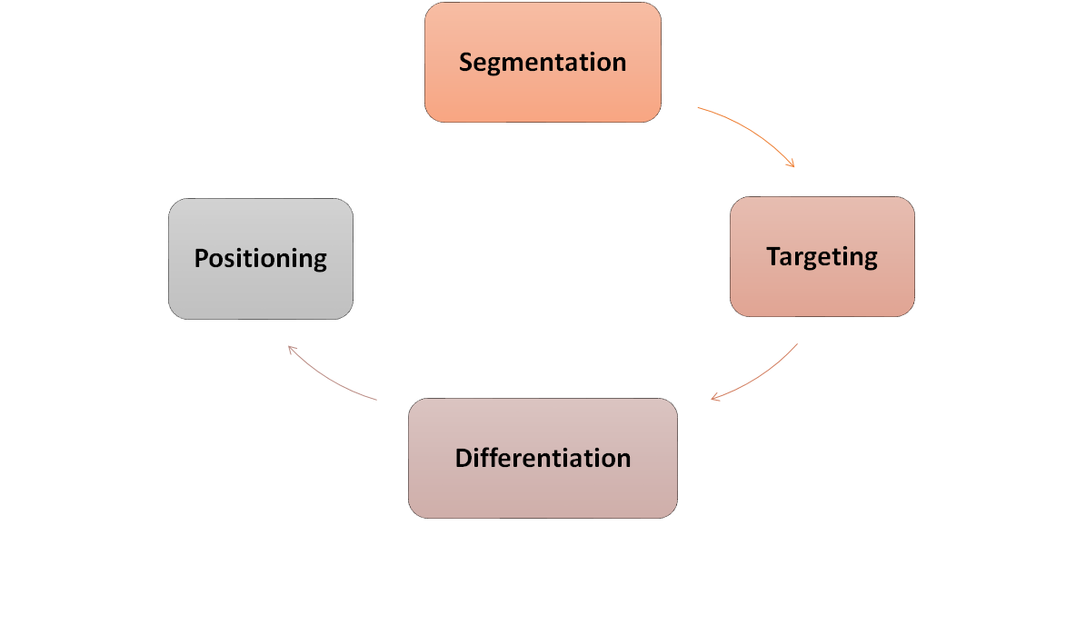
Figure 1: STDP Analysis
(Source: Self-created)

1.2 Segmentation
FlexiHome segmentation incorporates demographic, behavioural, and lifestyle segmentation. Among the main segments, there is a group of young professionals between the ages of 22 and 35 who reside in cities. They are given expensive rent and poor accommodation. It has been found that this segment is highly sensitive to simple design and low-cost products (Rodrigues and Brandao, 2021). These clients also take longer to plan the purchase of homes online.
The second segment consists of students who frequently change their locations and would require low-cost and movable furniture. Young consumers were highly active online during the period of the pandemic at IKEA (Ruljova and Stenberg, 2021). These habits continue today.
A third target market will consist of small families, as they require storage and space-saving solutions. Research indicates that a sustainable and efficient supply chain of IKEA facilitates production, which is attractive to the families that attach importance to responsible selection (Hossain and Sultana, 2024). Numerous families also plan their homes with the help of digital devices.
The fourth segment consists of foreign clientele that will react to uniform design and definite prices. Research indicates that IKEA has a few issues in other international markets, yet customers value the unchanging product characteristics and product reliability (Liu, 2023). This section will also be applicable to the FlexiHome range.
FlexiHome does not exclude the changes in the shopping behaviour. Research notes that the digital capabilities of the IKEA brand have become better, and the customers perceive the products with fewer complications (Yani, Muhdiantini, Firdaus, and Muhammad, 2025). These parameters define the market segments of the new brand.

1.3 Targeting
The major market segment of the target market is young professionals (urban) in the middle-income category. They dwell in limited spaces, and they require flexibility in their furniture to fit their way of life. Studies indicate that this customer segment is price-conscious and convenience-conscious in choosing furniture (Hagberg and Jonsson, 2022). Most of them in this category like to make use of online applications like virtual room planners and the use of mobile applications.
The other target market will be students who desire low-priced and moving items that are simple to transport. This group is backed by the global image of IKEA as a low-priced brand. Research indicates that the strategic plans of IKEA demonstrate affordability and a convenient experience as key strengths (Miller and Smith, 2021).
The other secondary target incorporates small families who desire long-lasting furniture at reasonable prices. IKEA is the perfect product brand to reach the above audience since its sustainability history vindicates the fact that most families like responsible products. Studies indicate that IKEA has been making sustainable initiatives throughout its supply chain (Enquist and Sebhatu, 2023). FlexiHome will use these advantages to live up to the expectations.
FlexiHome is also focused on a consumer who is environmentally conscious. Numerous young adults and families would like to minimize waste and would use recycled materials. Research proves that IKEA has reinforced its environmental practices, and this boosts the confidence of customers (Saad and Alzoubi, 2023).

1.4 Differentiation
FlexiHome will be differentiated using modular design, intelligent functionality and green materials. The modularity facilitates the small home layout and the ability of the customers to customize furniture. Bright has features like simple technology that assist customers in utilizing space better. It has been demonstrated that customers demand a higher online presence in the shopping process and the choice of products (Zhou, 2024).
Another strength that is utilized by FlexiHome is the sustainability and the supply chain advantages of IKEA. Research indicates that there is a high demand in responsible production and reuse of products (Qiao, 2024). These are some of the aspects that make FlexiHome stand out of the market.
The flexibility of the forms of different countries is also emphasized by international research (Jia, 2024). The products of the FlexiHome will be crafted in response to the different needs without compromising the IKEA style.

1.5 Positioning
FlexiHome will be positioned as a safe and affordable compact living brand in modern small homes. It will bring out value, flexibility, and simple design. The studies indicate that the customers of IKEA are responsive to low prices and pragmatic solutions (Yani, Muhdiantini, Firdaus, and Muhammad, 2025). FlexiHome shall also emphasize environmental responsibility. Research indicates that customers have confidence in the sustainability path of IKEA and require serious measures by the company (Chen and Song, 2023).
FlexiHome will assist in convenient shopping with the help of virtual planners and digital guidance. This is influenced by the demand of the recent digital retail transformations (Hagberg and Jonsson, 2022). These decisions will make FlexiHome a preferred destination for individuals whose homes are of a small size.

Element 2: Marketing Mix (7Ps) for IKEA FlexiHome

2.1 Introduction
The IKEA FlexiHome marketing mix is based on the 7Ps framework since the new brand will consist of physical products along with service-based components, which reinforce the overall experience of the customer. FlexiHome places the objective of providing small homes with small modules of furniture, which is sustainable. The 7Ps are useful in demonstrating how the brand will fulfil the demands of young professionals, students, and small families that desire affordable and flexible living.
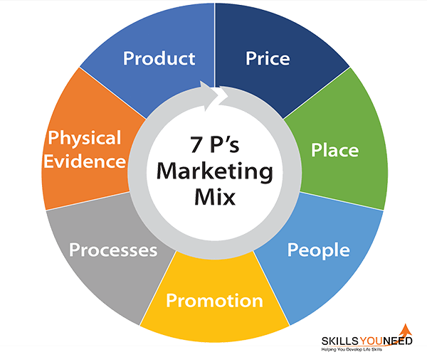
Figure 2: Marketing 7Ps
(Source: Self-created)

2.2 Product
FlexiHome will also include modular furniture and space-saving furniture that will serve homes of between 20 and 45 square metres. That is in reaction to the tastes of the younger generation that values straightforward and practical design, as it has been researched in terms of the brand values at IKEA (Brandão and Côrte-Real, 2024). Foldable beds, adjustable desks, and storage units that can transform into any shape depending on the layout of the rooms will be added to the product line. These products will serve individuals who reside in small apartments and need a better ability to control their environment.
Digital aspects will also be employed by FlexiHome. Simple smart functionality will be added to some of their products that will be linked to a mobile application. It is observed that customers of IKEA anticipate the availability of digital assistance when planning their furniture (Yani, Muhdiantini, Firdaus, and Muhammad, 2025). This enhances convenience and constructs the customer's personalisation of rooms.
Material and construction will rely on the concept of sustainability. The published article on sustainable operations by IKEA puts forward the necessity of having responsible sourcing and low-waste production (Chen and Song, 2023). FlexiHome will also recycle materials and provide recycling points for the products to help achieve such objectives.

2.3 Price
FlexiHome would adopt value-based pricing, to the long-term approach of affordability applied by IKEA. There are a lot of young city people who have some budget constraints and prefer not to spend their cash beyond their means. The study indicates that sufficient and transparent pricing influences purchasing in IKEA markets (Rodrigues and Brandão, 2021). FlexiHome will have three price divisions, depending on the materials, functionality as well as digital capabilities.
There will also be room set packages. These packages enable customers to create complete layouts at a reduced combined price. This plan is based on the IKEA standardised model that is observed in such foreign markets as China where uniform prices facilitate the preservation of customer loyalty (Liu, 2023).
FlexiHome can also launch a 10 to 15 percent discount on full room packages during the launch period. It has been established that customers tend to be more responsive to promotions, particularly those who subscribe to IKEA on social media (Ruljova and Stenberg, 2021). Such discounts help in rapid adoption and awareness.

2.4 Place
Online and physical channels will be used by FlexiHome. Before coming to a store, customers now do the majority of their research on products online. According to research, IKEA has enhanced the online channel and currently offers superior planning services to its clients (Hagberg and Jonsson, 2022). FlexiHome will have a room planner and mobile capabilities that will help in product selection online.
The bodily presence is not irrelevant. FlexiHome exhibits will be in small urban shops in small rooms designs ranging between 20 and 30 metres. This assists the customers in visualizing the way furniture can fit in spaces. Research indicates that IKEA demonstrations impact the buying decisions that customers make by using practical demonstrations in the showrooms (Miller and Smith, 2021).
It will be delivered in the model of a flat pack at IKEA. This will reduce the logistics expenses and maintain prices at a low rate. The literature states that IKEA's supply chain could help these objectives by effectively packaging and transporting the products (Hossain and Sultana, 2024). These are the strengths that favour the international growth of FlexiHome.

2.5 Promotion
Social media, digital, and in-store demonstrations will be used as the promotion strategy. Young viewers consume much time online and react to images. Studies in the past years indicate the intense use of IKEA content on social platforms like Instagram (Ruljova and Stenberg, 2021). FlexiHome will include the use of short videos that demonstrate room changes and modular design.
Specific advertisements in search engines and shopping platforms will also be used by the brand. Studies report that the success of online retailing lies in clear information and easy communication (Zhou, 2024). FlexiHome will adopt explanatory descriptions, quantifiable measurements, and room illustrations.
They will have stores that contain guided demonstrations in which the staff will demonstrate how each item will fit into various layouts. It has been found that the physical experiences during retail enhance comprehension and aid in making purchases (Jia, 2024). This helps in creating clarity and ease of understanding of the promotion.

2.6 People
People element emphasizes personnel who assist in the choice of the product and the serving of the customer. FlexiHome will educate personnel on the application of the digital planning and modular design principles. Research indicates that the service delivery of IKEA increases when employees offer straightforward guidance in the process of shopping (Enquist and Sebhatu, 2023). This is beneficial to customers because the staff is able to explain room plans and product packages.
Online support will involve chat support and a booking system for virtual planning. It has been explained that customer trust is elevated due to the support of staff when shopping online (Saad and Alzoubi, 2023). These measures ensure that the level of interactions with customers is maintained.

2.7 Process
FlexiHome will be under the clear process model of IKEA. Customers will browse the internet, get their layout, and gather their order in the store. The study indicates that the systematic approach adopted by IKEA facilitates a good performance in the market and assists consumers to make sure that they make the right decisions (Qiao, 2024). FlexiHome will incorporate the use of digital planning in every step of the process.
Flat pack delivery makes it easier and allows assembly on its own. Studies have proven that the standardised instructions used by IKEA decrease confusion and assist clients in going through the process without complications (Jia, 2024). The convenience and simplicity strategy of the brand is supported in this system.

2.8 Physical Evidence
Showrooms, packaging, and brand images are physical evidence. Small room setups will be displayed at the flexiHome stores, demonstrating the way the modular items are assembled. It has been found that a display of physical objects can affect customer cognition and enhance a purchase decision (Miller and Smith, 2021).
Simple graphics and recycled materials will be used to package it. It is a display of IKEA being a sustainable brand and contributing to the results regarding the significance of responsible product presentation (Chen and Song, 2023). The extra support of the brand experience will be provided by digital evidence, such as room planners and mobile images.\

Element 3: Marketing Strategy Pitch
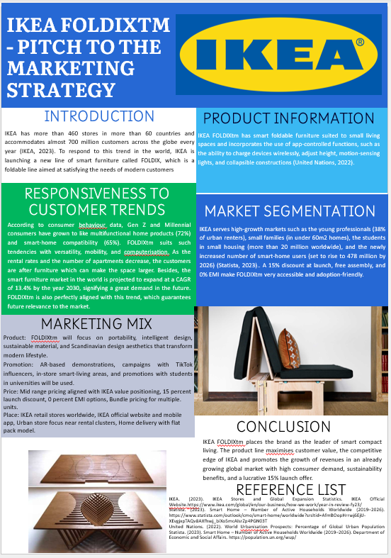

Element 4: Reflection

4.1 Reflection on Developing the New Brand Concept
The concept development of the FlexiHome brand allowed me to gain a better impression of how a business organization can align with the actual needs of customers. I concentrated on the modern life of people, particularly in small houses, when developing the concept. I discovered that most of the clientele desire space-saving systems, easily designed and environmentally friendly materials. In the process of conceptualizing the concept, I attempted to connect these requirements with IKEA's strong points of being cheap, sustainable, and practical. This has made me understand the need to develop a brand concept that is responsive to customer expectations as well as the capabilities of the company. This stage also taught me to learn more about customer behaviour and consider the impact of lifestyle patterns on the kind of product an individual buys.

4.2 Reflection on Creating the Marketing Strategy
Developing the entire marketing plan also made me realize the importance of order and repetition. Using the 7Ps, I had to ensure that every decision that was made related to the FlexiHome concept. This encouraged me to be keen regarding the way I defined product features, price, promotion, and the other factors. Developing the strategy made me stronger when it comes to organising ideas and clarifying decisions. I also realized that a good marketing strategy should not only be based on understanding the customer, but good business decisions should be taken. This section made me realize that brands should be creative and take practical measures like pricing and distribution.

4.3 Retrospection on preparing and delivering the Pitch.
The planning of the pitch provided me with the knowledge of the criticality of mind to pitch the ideas in a straightforward and persuasive manner. I needed to minimize the entire strategy to a brief message that would not lose the worth of the idea. The latter process enhanced my self-esteem when it comes to the ability to make the most vital points and explain them in a transparent manner. The pitch gave me increased insight into the significance of tone, timing, and clarity when I gave it. I also understood that the visual examples have a significant difference in making an audience clarify a brand story within a short time.

4.4 Essential Competencies and Future Enhancement.
In this assignment, I was able to enhance some of my skills, such as research, critical thinking, planning, and communication. I am more confident about the connection between theory and practical decisions, as well as what the customer sees. To address the issues, I would like to work on my methodology in the future and use small surveys or interviews to collect primary feedback. I would also rehearse the pitch to peers to have initial feedback and perfect my presentation. The following steps would assist me in the development of better strategies and the transfer of my ideas more efficiently in the work in the future.

References
Brandão, A. and Côrte-Real, A. (2024) ‘Understanding the role of IKEA Portugal’s brand values in millennials’ purchase decisions’, Comunicação e Sociedade, 45, pp. 117–139.
Chen, S. and Song, Y. (2023) ‘Research on the problems and optimal countermeasures in IKEA’s sustainability-based management’, Journal of Education, Humanities and Social Sciences, 17, pp. 84–89.
El Dameh, M. and Al Ghadeer, F. (2021) ‘The impact of traditional direct marketing on creating brand awareness: Case study on IKEA in Jordan’, International Journal of Business and Management, 14(3), p. 130.
Enquist, B. and Sebhatu, S.P. (2023) ‘SDGs and strategic priorities of MNEs for sustainability transformation: Lessons from IKEA’, in van Tulder, R., Giuliani, E. and Álvarez, I. (eds.) International Business and Sustainable Development Goals. Progress in International Business Research, 17. Leeds: Emerald Publishing, pp. 111–131.
Hagberg, J. and Jonsson, A. (2022) ‘Exploring digitalisation at IKEA’, International Journal of Retail & Distribution Management, 50(13), pp. 59–76.
Hossain, T. and Sultana, R. (2024) ‘Sustainable supply chain management practices: A case study of IKEA’, in Fundamentals of Management: Selected Readings, pp. 361–368.
Liu, Z. (2023) ‘“Standardized” marketing strategies of IKEA? The challenges of China’, BCP Business & Management, 38, pp. 1023–1028.
Miller, D. and Smith, A. (2021) ‘IKEA strategic management plans in Europe’, Journal of Strategic Management, 5(2), pp. 1–7.
Örnhem, E., Weir, J. and Karlsson, N. (2021) ‘Leveraging brand co-creation in a digital era: An IKEA case study’, Master’s thesis, Stockholm School of Economics.
Qiao, H. (2024) ‘The influencing factors of international marketing strategy for IKEA Group’s products’, Master’s thesis, Siam University.
Rodrigues, C. and Brandão, A. (2021) ‘Measuring the effects of retail brand experiences and brand love on word of mouth: A cross-country study of IKEA brand’, The International Review of Retail, Distribution and Consumer Research, 31(1), pp. 78–105.
Ruljova, A. and Stenberg, A. (2021) ‘Social media marketing strategies and consumer engagement during the COVID-19 pandemic: An exploratory study of IKEA on Instagram’, Master’s thesis, Jönköping University, Jönköping International Business School.
Yani, M.F., Muhdiantini, M.N., Firdaus, L. and Muhammad, D.A. (2025) ‘IKEA: Enhancing customer experience through digital transformation’, Jurnal Inovasi Penelitian dan Inovasi Pendidikan, 10(2), pp. 1771–1779.
Zhou, H. (2024) ‘Analyzing IKEA brand’s media marketing strategies and improving customer experience through inductive reasoning approach’, Journal of Education, Humanities and Social Sciences, 27, pp. 138–145.

