Graveyard Report- St Peters Lampeter

“Evolution of floral iconography on gravestones between 1870 and 1890”

Reporter: Narantsatsralt Ganbaatar (2124049)
Lecturer: Quentin Drew, Ros Coard.

18.03.2023
Contents
- Introduction
- Graveyard Maps
- Methodology
- Graves in detail
- Comparisons and Conclusion
- Bibliography

- Introduction
I gathered the information for this research from 10 graves at Lampeter's Saint. Peter's cemetery. In this study, I want to highlight how flower arrangements on gravestones have changed over the past 20 years. For later comparison, I have also gathered data on graves on either side of this time frame. I learned after conducting some background study that the expanding horticultural and artistic movement in the 1800s inspired William Robinson to publish "the wild garden" around the 1870s. It seems natural that flowers were a common emblem on headstones at this period because people at the time were finding love for gardening from a societal perspective.

- Graveyard map

South
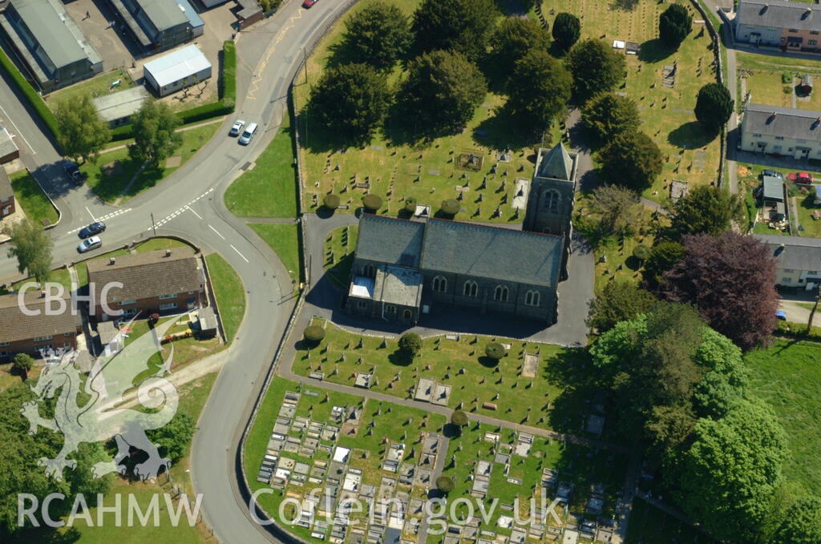
North
Coordinates for this site are 52°06′54″N 4°04′55″W.

  - Map of plots
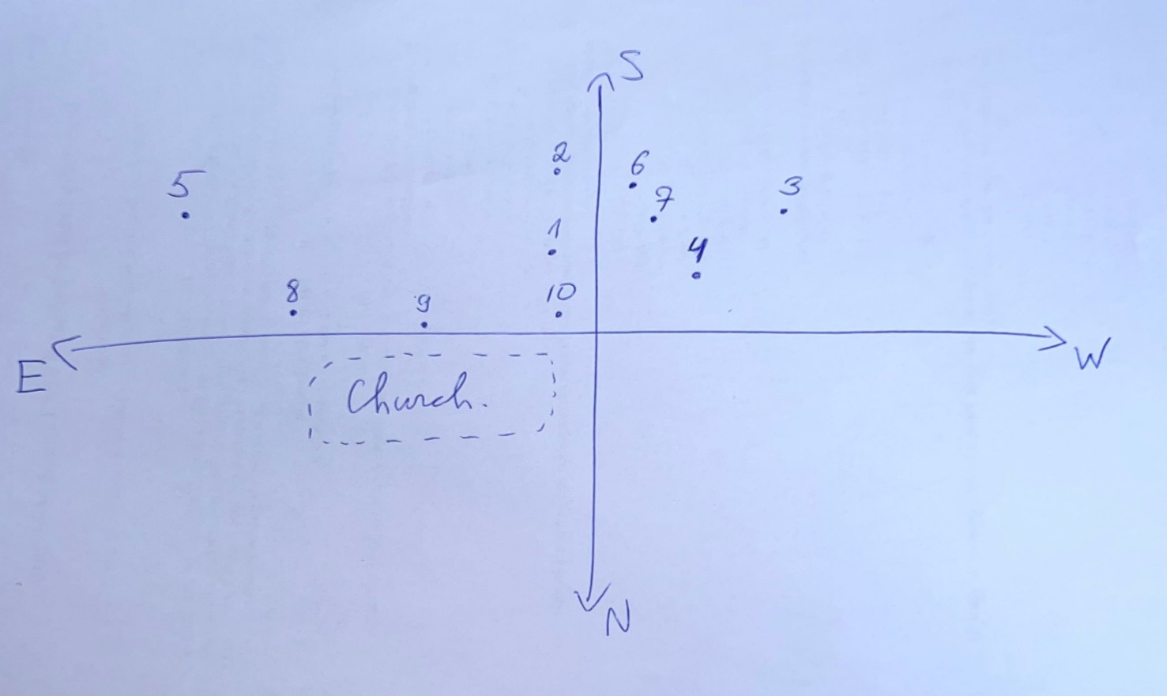
This graphic shows the locations of graves and numbers that I analysed at St Peter’s Church. To give brief information about the graves that I analysed, I inserted this graphic under the topic of ‘Map of plots’.

- Methodology
My class went to the graveyard to start the coursework practically on the 24th of February. Hence, for the first instance, I wrote 1, then gave a good description of the grave's location. To determine whether gender affects the iconography employed, I then made a note of the name(s) of the deceased. I also did the same for their age and the year they passed away. I took notes on the iconography and sketched out the design for some of them as a last step in this process. The engravings on the graves, which included the approximate location so I could map them, were also recorded using my phone to take photographs. After making a list of every grave, I used a sketch pad to make a rudimentary outline of every grave's location. I began sketching some of the iconographies I observed using the same sketchbook, and for this, I chose illustrations of the most typical flowers. I next went through every tomb utilising my photos to identify the flowers and seek the most well-liked ones. Also, those processes of the report were made by visiting the graveyard several times.

.

- Graves in detail
Grave 1:
In 1893, this grave was erected here in honour of a 41-year-old man. A rose is placed on the headstone, and various flowers are placed on either side of the arch. The fact that this rose has fully opened suggests that the person who died was in their prime A fern branch in the bottom left of the arch stands for privacy and honesty. The person was standing beneath the arch with a laurel wreath, which is symbolic of fame and victory. The two flowers on the gravestone-one on each side-are also a representation of how innocence can be recovered after death. Each flower on this incredibly decorative grave seems to have been placed there on purpose to symbolise the departed.

Grave 3:
An adolescent who passed away in 1900 is remembered by this grave. Regarding the death's age in this instance, using its symbolism would certainly suggest purity. This gravestone merely has a group of lilies of the valley as its iconography. For Victorians, another aspect of the lily of the valley was the return of love. Along with the widely held view among Christians that Eve's tears turned into lilies of the valley after she was driven from the Garden of Eden. Before the turn of the century, burials with lilies of the valley appeared to employ just one, but it appeared that graves were growing more complex as time went on.

Grave 4:
The next grave I looked at was grave 4 from 1887. One large lily stands out on this gravestone, and behind it are lilies of the valley. The lily of the valley would have stood for regeneration, innocence, and modesty. Lilies of the valley were also thought to be the ladder to heaven in the 19th century; such may have been chosen for this gravestone as a symbol of how the lived wanted the dead to have a smooth transition to the afterlife. Before being transported to their funeral, the deceased was displayed in their home until the late Victorian era, and lilies were used to cover the odour. Lilies began to emerge on gravestones as society's perspective on death evolved and the earlier traditions fell out of favour.

Grave 5:
This monument was built in 1871. A single daffodil is growing up the top arm of the Celtic cross grave's cross. Two girl toddlers, one who was 5 months old and the other who was 4 days old, are honoured by this monument. Although the geometry of the headstone is intricate, the symbology is straightforward, with a daffodil filling the cross' whole vertical axis and a banner across the horizontal axis. Daffodils are viewed as a symbol of youth, rebirth, and new life. Thus, as this is a monument for that children, it seemed fitting, moving for the bereaved.

Grave 9:
Grave 9 is a massive cross and is located next to one of the cemetery's main pathways. This grave, which was built in 1873, is for a male aged 21. Passionflowers are used as a representation of hope and the conviction that Christ's suffering was necessary to save the souls of the dead on the cross's arms. Due to the religious overtones of the cross and passionflower, it is very likely that the deceased was a Christian. Despite the fact that the stem's base contained 3 lilies heads that may be compared to the holy trinity and so support Christian beliefs. Although the elaborate symbolism, flowers are frequently used.

- Comparisons and Conclusion
Just before that 1870s period, I wanted to examine furthermore, Grave 6 was constructed in 1868. A willow is entwined into an infinite loop as part of the headstone's very straightforward design. The willow is a symbol of mourning, grief, and physical suffering. I noted that headstones with interwoven willows frequently listed multiple people. The tomb indicated above was a memorial to three members of the same family, which is likely why the branches were linked in this manner.
Grave 2, 1846, is the next one from earlier in the process. Three daffodils are simply arranged in a small bouquet on the grave's headstone's inside oval. The burial is dedicated to a 44-year-old woman, and as daffodils were a Victorian sign of unrequited love, it is likely that the husband placed the monument.
One example of a simple grave is Grave 7, which was built in 1849, with a daffodil headset inside a circle on top of the headstone. The second most common flower depicted in the cemetery’s symbolic representation is the daffodil. Although the cemetery is for a young girl aged 5, the daffodil was probably chosen as a symbol of innocence, beauty, and youth because it was frequently connected to those who pass away young.
Whereas, my conclusion:
My data analysis showed that lilies were the most frequently used flower symbolism. Graves started to get more complex near the end of the time period, which I observed as a pattern. Until 1880, the majority of cemeteries used a single flower as their iconography; but, in the 1880s, people began to utilize in flower numerous varieties with more specialised explanations. Moreover, I observed willows were the most frequently used in family tombs. I also observed that an individual's age could have an impact on the significance of a flower.

- Bibliography
Neighbors, J. (2011). Symbols: Flowers and the Frailty of Life. Agraveinterest.blogspot.com. Available at: http://agraveinterest.blogspot.com/2011/09/symbols-flowers-and-frailty-of-life.html
Snider, T. (2015). Historic Cemetery Symbols: What do Daffodils Represent? | Tui Snider - author & speaker. Tui Snider - author & speaker. Available at: http://tuisnider.com/2015/11/29/historic-cemetery-symbols-what-do-daffodils-represent/
Pate, E. (2018). Popular Flowers & Plants in the Late 1800s | eHow. Available at: https://www.ehow.com/list_7546639_popular-flowers-plants-late-1800s.html
Cwgc.org. (2018). Cemetery. Available at: https://www.cwgc.org/find-a-cemetery/cemetery/74945/lampeter-(st.-peter)-churchyard/
Taphy, C., Taphy, C. and profile, V. (2011). Pansies, Poppies and Passion Flowers. Callmetaphy.blogspot.com. Available at: http://callmetaphy.blogspot.com/2011/08/pansies-poppies-and-passion-flowers.html
Norman, A. (2018). Headstone Symbols. Headstonesymbols.co.uk. Available at: http://headstonesymbols.co.uk/
Orapweb.rcahms.gov.uk. (2018). Available at: http://orapweb.rcahms.gov.uk/coflein/A/AP_2006_2954.jpg

St Peter’s Church, Lampeter. (2015). St Peter’s Church, Lampeter. Available at: https://coflein.gov.uk/en/site/270 <Accessed 14/03/23>

