L4 - Introduction to Web and Database Concepts
HTML & CSS Web Development
Assignment 1
Jake Richards (2500967)
20th November 2025

Table of Contents
Introduction 2
Requirements 3
Implementation 4
Homepage Validation 7
Contact Validation 7
Products Validation 8
Evaluation 9
Useability 9
Accessibility 9
Search Engine Optimisation 10
Self-Evaluation 11
Usefulness 11
Search Engine Optimisation (SEO) 11
Accessibility 11
Comparison 12
Useability 12
Accessibility 12
Search Engine Optimisation 13
Mobile Friendliness 13
Conclusion 13
References 14

Introduction
The purpose of this assignment is to provide a comprehensive evaluation of a website while conforming to WCAG standards. The website in question was created as a direct comparison to an existing website from the same company that focuses on sim-racing equipment. The remainder of the assignment will consist of evaluating the website, validating and providing a comprehensive evaluation of the accessibility, usefulness and the search engine optimisation.

Requirements
The website created is a direct comparison to a currently utilised website produced by Puresims. The purpose of the website is to demonstrate the small percentage of products offered by the company which are primarily designed for sim-racing. The focus of this website is to enable sim-racers the ability to visualize the potential products they could utilise in the future with the forever expansion of the sim-racing community.

Implementation
Homepage:
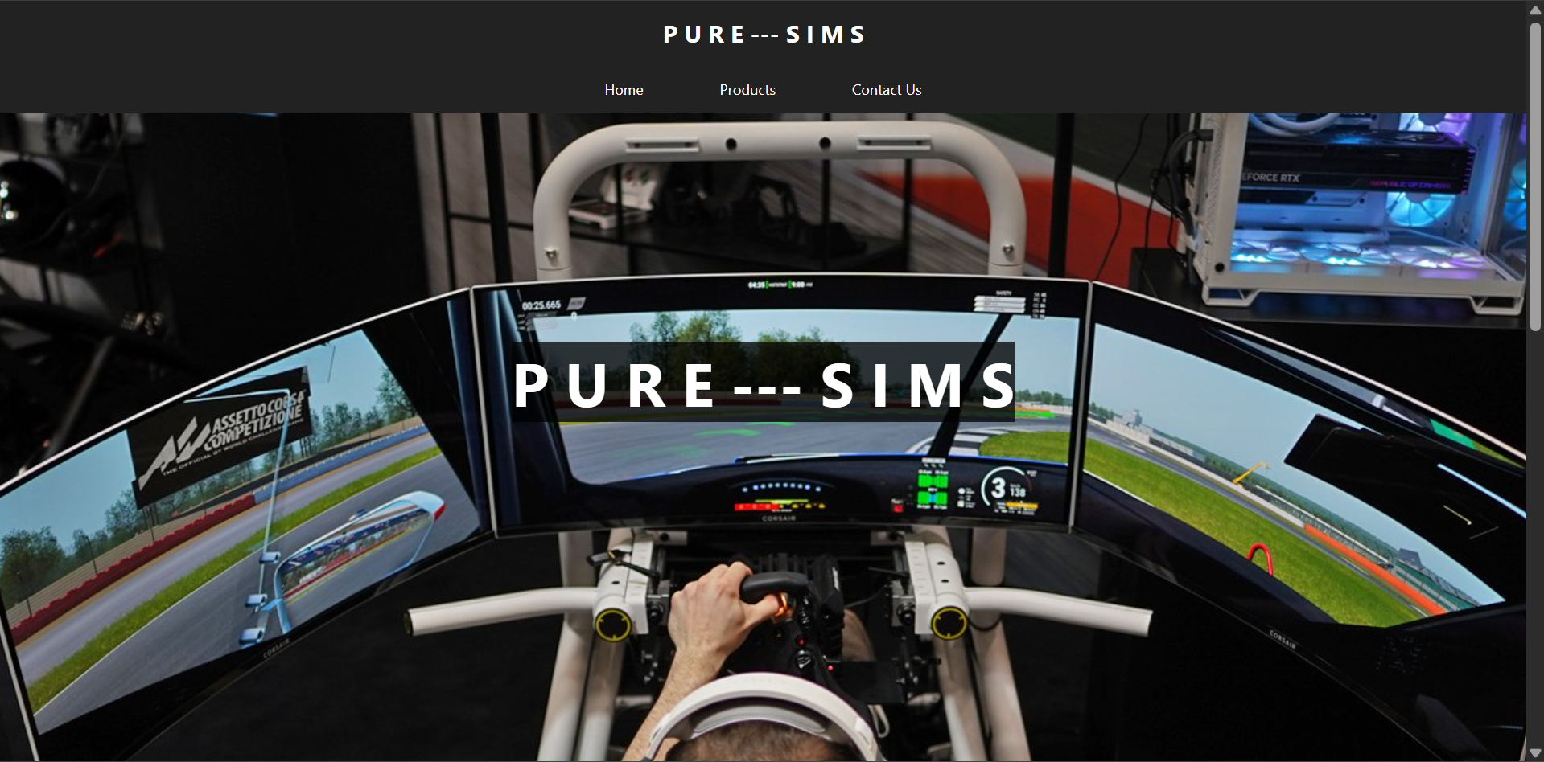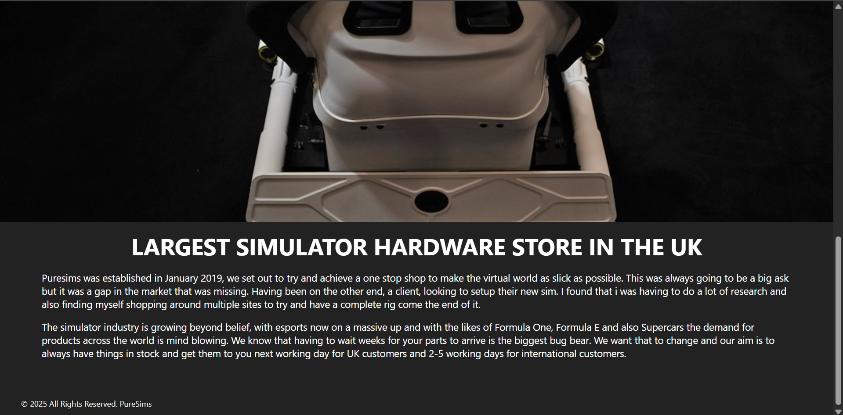

Products:
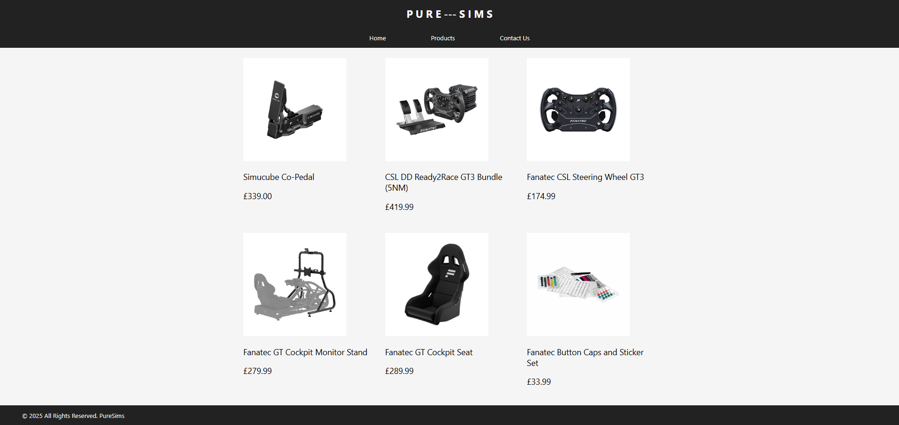
Contact Us: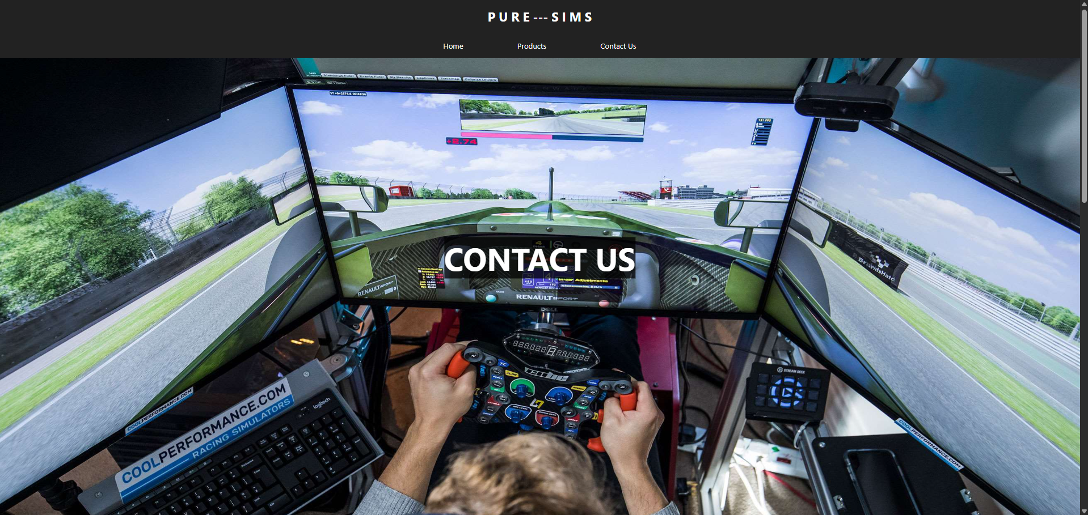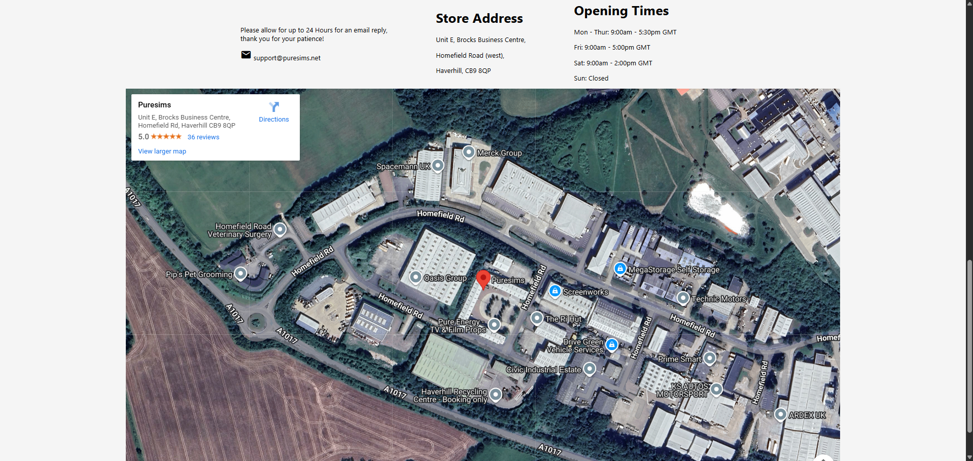

Homepage Validation
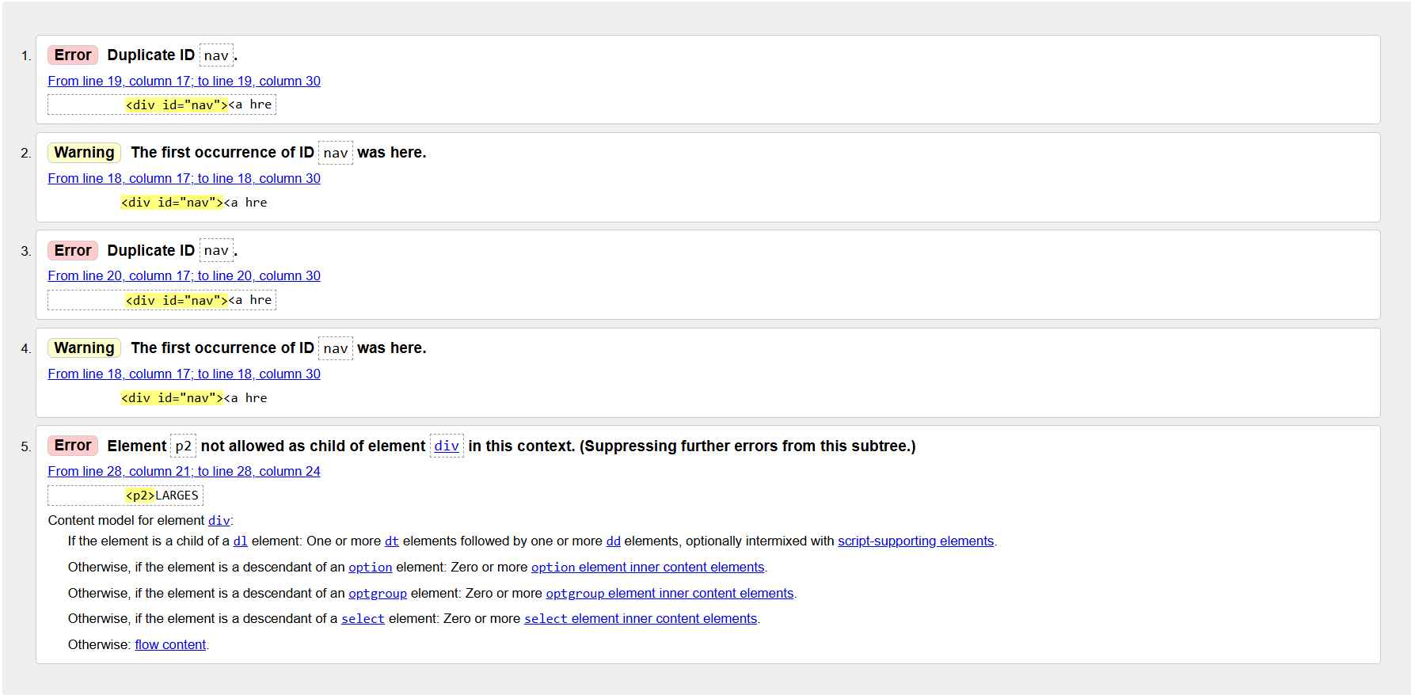
The Homepage provided a couple of errors, 4 of which are duplicates. The final error (5.) outlines an element which was quickly rectified when changed to h2. The p2 element is deprecated and no longer used. Errors 1-4 are duplicate ID errors which will not be fixed as it was purposefully chosen to reduce CSS code size.

Contact Validation
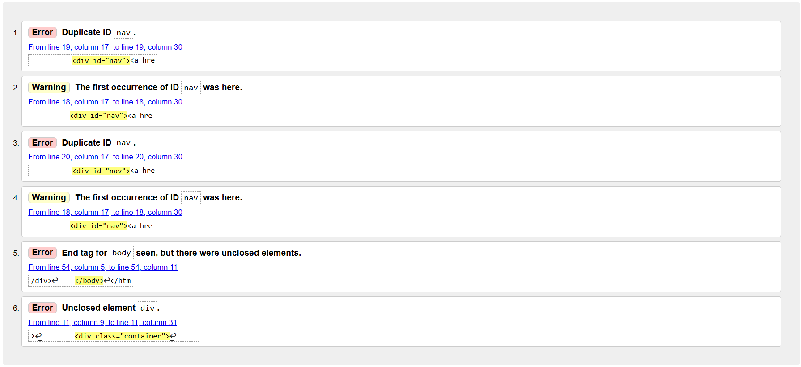
Contact page provided very similar errors but more importantly the missed factor of forgetting to end one of the elements (div). This was quickly rectified.

Products Validation
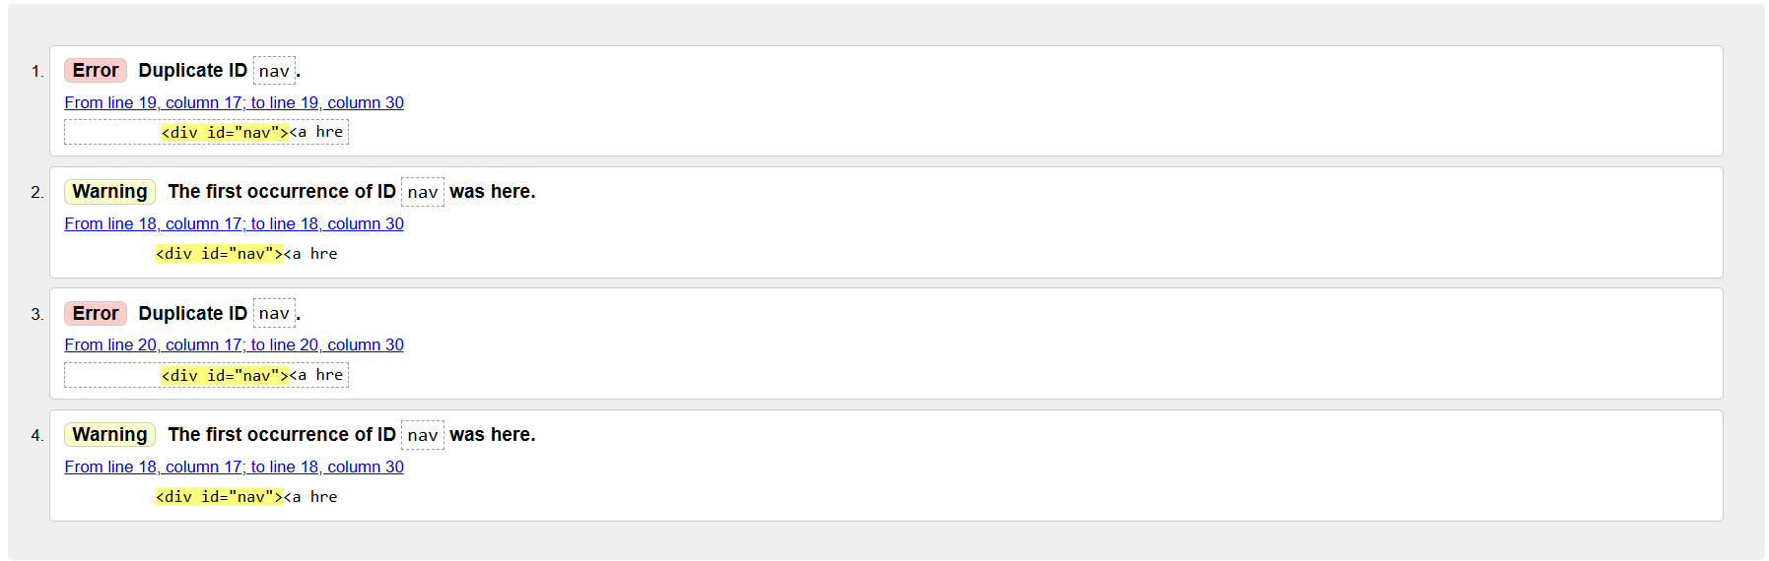
The products page had the same errors across all three pages. This will not be rectified.

Evaluation

Useability
Useability is a term to describe how easy it is to use a website, in other words, “How user-friendly is this site?” Useable websites are those in which users can achieve their goals. Achieving useability is focusing on design and development of the user experience. [1]
It is argued that the usability of a website often determines the survivability of the website. “If the website is difficult to use, people leave. If the homepage fails to demonstrate what’s offered, people leave. If people get lost, people leave.” [2]
The best way to excel in useability is by enabling the “power of a good and efficient website design by identifying and creating an easy-to-use yet effective user interface and elements to make your design meaningful.” This enables you to ensure that the website usability is focused on the visual design of a website which determines how easy the website is to use. [3]
Zara, a popular brand for clothes, performed a usability study on their website to determine how easy it was for customers to navigate their website. They concluded that the end-user had issues with the shopping cart (unable to edit items.) [4]

Accessibility
The accessibility of a website is defined by if people can “navigate, perceive, understand and interact with the site” while also being able to contribute also. Moreover, accessibility can also be determined by how it benefits people utilising smaller screens such as mobile phones or watches or even larger screens such as smart TVs. [5]
The Web Accessibility Standards Guidelines was developed to enable a roadmap for better web content that is accessible to everyone while also “enhancing the user experience” around key principles of web development. WCAG states that websites should be perceivable to all, in sound and vision while eliminating common design barriers that limit operability. WCAG continues to add that the information of the webpage must be understandable and the content contained within must be robust to be compatible with various types of devices. [6]
WebAIM performed a usability test on over 1,000,000 websites around the world and found that 50,960,288 accessibility errors occurred out of those 1 million websites. These errors conform to WCAG guidelines outlining the necessity of conforming to the latest standards for user accessibility. Moreover, it was identified that there was a 7.1% increase in homepage elements, increasing the likelihood of a user with a disability to encounter an error. [7]

Search Engine Optimisation
Search Engine Optimisation is where the development of a given website assists in the performance of the search engine in understanding the content of the website while also delivering relevant content and results based on search queries. SEO enables websites to compete for first spot on a search engine such as Google regardless of what products you offer, determining the level of traffic that a website receives. [8]
Nike, a highly rated clothing brand utilises a high amount of SEO throughout its entire e-commerce page. They utilise keywords which search engines hone in on to improve their site traffic while also utilising clear descriptions and including product names within URLs, headings and the body. [9]

Self-Evaluation

Usefulness
Looking into the website that was created for the purpose of this assignment, the general design for the website is plain, simple colours were utilised throughout (black, grey and white). The functionality of the website is very basic, users are unable to purchase products, are only able to click on the navigation bar and have no additional redirects to any further pages beyond the navigation bar.
The ease of use of the website is simple in nature, navigation bar only for all website redirects but the colour clashes could use additional work for easier reading.

Search Engine Optimisation (SEO)
Within the website, various alt texts were applied across all images in relation to the product that was being displayed. The background images for both the homepage and contact us page both include alt text for further clarification for search engines.

Accessibility
Across the website, some accessibility techniques have been applied. The use of WAVE (Web Accessibility Evaluation Tool) enables the developer to view a more accessible view of the website to conform within WCAG. Within this website in particular, WAVE identifies only 1 potential problem with the alt text within the background image as it “is likely insufficient or contains extraneous information.”
WAVE also notes the added features of headers for easier reading and the addition of the language tag within the html file for improved user experience for accessibility.
Overall, the accessibility of the website conforms to the WCAG standards, the information contained within the site is readable and understandable, components are somewhat operational but are unable to purchase products. Assistive technologies can read all data presented to the respective software with no issues.

Comparison
The following section will cover the comparison of two live websites. The two websites in question will be Nike and Puresims. Both of these companies utilise “e-commerce” websites which are similar to the assignment website. Each of these websites will go through a comparison of:
- Useability
- Accessibility
- Search Engine Optimisation
- Mobile Friendliness
- Conclusion

Useability
To start off, both websites utilise a similar layout across all webpages. Nike utilise a more broad approach by displaying their offerings right at the homepage whereas Puresims utilise a calmer approach. Both webpages have similar navigation (both top and bottom navigation bars) but readability is more of a focus for Nike where they have images clearly defining the relevant section for products with a simple 2 tone colour scheme.
Puresims follow suit with a simple 3 tone colour scheme but require the user to click on the navigation bar before proceeding to the purchasable products. All other products featured on the homepage are “enquiry only”. The fonts for both pages are simple but Puresims utilises more than 2 differing fonts.

Accessibility
For the Nike page, the WAVE software gives the webpage an 8.1 out of 10 score for AIM. It highlights the factors of the accessibility tools utilised across the site but does note the deprecated feature of them in older browsers. However, there were a few errors of missing image alt text and improper buttons. No contrast errors were detected.
On the Puresims page, it got a score of a 1.9 out of 10 for AIM. The primary issues were contrast errors where it picked up a huge plethora of issues around the blue/white scheme surrounding the buttons and other items. It made a note of the accessibility attempt with 419 detections (vs 816 for Nike)

Search Engine Optimisation
Both websites contain a variety of different meta tags, alt attributes and more importantly heading structures. Both sites utilise relevant SEO techniques maximising site traffic.
Important note, Puresims has utilised a SEO Service (RankMath) to perform their SEO effectively.

Mobile Friendliness
By selecting a mobile version of both websites, it was automatically identifiable that Nike took extra effort to cater towards Mobile users. The webpage immediately responded to the change and the website was easy to use with no accessibility issues.
On the other hand, Puresims had immediate issues in displaying images, text and other items causing inaccessibility issues. Navigation Bar was accessible at all times but products were skewed, images invisible due to additional images not responsive to resolution change.

Conclusion
Overall, the option for the easiest, responsive and optimised website is Nike. Their entire webpage is built around the WCAG standard, focused on accessibility and single colour schemes allows for useability, accessibility and also the mobile friendliness is a positive, enabling improved site traffic with the boom of mobile devices.

References
[1] C. Holst. "Website Usability Best Practices (Backed By Research) – Baymard." https://baymard.com/learn/website-usability. https://baymard.com/learn/website-usability (accessed Nov 20).
[2] J. Nielsen, "Usability 101: Introduction to Usability," January 3 2012. Accessed: Nov 20, 2025, [Online]. Available: https://www.nngroup.com/articles/usability-101-introduction-to-usability/
[3] A. Mika. "Website Usability: Definition, Principles and Methods | Ramotion Agency." https://www.ramotion.com/blog/website-usability/ (accessed Nov 20).
[4] W. Ng. "Zara: A Usability Case Study." https://uxdesign.cc/zara-a-usability-case-study-981b7ca93db8 (accessed Nov 20).
[5] W. W. A. Initiative (WAI). "Introduction to Web Accessibility." https://www.w3.org/WAI/fundamentals/accessibility-intro/ (accessed Nov 20).
[6] M. Haplin, "The Top 10 Web Accessibility Best Practices," Accessed: Nov 20, 2025. [Online]. Available: https://reciteme.com/news/website-accessibility-best-practices/
[7] WebAIM, "WebAIM: The WebAIM Million - The 2025 report on the accessibility of the top 1,000,000 home pages," Mar 31 2025. Accessed: Nov 20, 2025, [Online]. Available: https://webaim.org/projects/million/
[8] Search Engine Land, "What Is SEO - Search Engine Optimization?", Search Engine Land, https://searchengineland.com/guide/what-is-seo (accessed Nov 20, 2025).
[9] A. Stephan, "12 Actionable SEO Examples to Inspire Your Strategy", SEO.com, https://www.seo.com/blog/seo-examples/ (accessed Nov 20, 2025).

Appendices
homePage.html
<!DOCTYPE html>
<html lang="en">
<head>
<link rel="stylesheet" href="https://fonts.googleapis.com/icon?family=Material+Icons">
<meta charset="utf-8">
<title>PureSims</title>
<meta name="viewport" content="width=device-width, initial-scale=1">
<link rel="stylesheet" href="style.css">
</head>
<body>
<div class="container">
<div class="header-container">
<div class="text-header">
<h1>P U R E --- S I M S</h1>
</div>
</div>
<div class="nav-container">
<div id="nav"><a href="homePage.html"><p>Home</p></a></div>
<div id="nav"><a href="products.html"><p>Products</p></a></div>
<div id="nav"><a href="contact.html"><p>Contact Us</p></a></div>
</div>
<div class="img-container">
<img src="img/cockpitview.png" alt="Image of sample cockpit">
<div id="image-title"><p>P U R E --- S I M S</p></div>
</div>
<div class="body-container">
<DIV class="main-body">
<h2>LARGEST SIMULATOR HARDWARE STORE IN THE UK</h2>
<p>Puresims was established in January 2019, we set out to try and achieve a one stop shop to make the virtual world as slick as possible. This was always going to be a big ask but it was a gap in the market that was missing. Having been on the other end, a client, looking to setup their new sim. I found that i was having to do a lot of research and also finding myself shopping around multiple sites to try and have a complete rig come the end of it.</p>
<p>The simulator industry is growing beyond belief, with esports now on a massive up and with the likes of Formula One, Formula E and also Supercars the demand for products across the world is mind blowing. We know that having to wait weeks for your parts to arrive is the biggest bug bear. We want that to change and our aim is to always have things in stock and get them to you next working day for UK customers and 2-5 working days for international customers.</p>
</DIV>
</div>
<div class="footer-container">
<footer>
<p>&copy; 2025 All Rights Reserved. PureSims</p>
</footer>
</div>
</div>
</body>
</html>

contact.html
<!DOCTYPE html>
<html lang="en">
<head>
<meta charset="utf-8">
<title>PureSims</title>
<meta name="viewport" content="width=device-width, initial-scale=1">
<link rel="stylesheet" href="style.css">
<link rel="stylesheet" href="https://fonts.googleapis.com/icon?family=Material+Icons">
</head>
<body>
<div class="container">
<div class="header-container">
<div class="text-header">
<h1>P U R E --- S I M S</h1>
</div>
</div>
<div class="nav-container">
<div id="nav"><a href="homePage.html"><p>Home</p></a></div>
<div id="nav"><a href="products.html"><p>Products</p></a></div>
<div id="nav"><a href="contact.html"><p>Contact Us</p></a></div>
</div>
<div class="img-container">
<img src="img/cockpitview2.png" alt="Image of sample cockpit">
<div id="image-title"><p>CONTACT US</p></div>
</div>
<div class="title-container-border"></div>
<div class="contact-container">
<div id="contact-info">
<p>Please allow for up to 24 Hours for an email reply,<br> thank you for your patience!</p>
<i class="material-icons" style="font-size: 20px;">email</i> support@puresims.net
</div>
<div id="contact-address">
<h1>Store Address</h1>
<p>Unit E, Brocks Business Centre,</p>
<p>Homefield Road (west),</p>
<p>Haverhill, CB9 8QP</p>
</div>
<div id="contact-open">
<h1>Opening Times</h1>
<p>Mon - Thur: 9:00am - 5:30pm GMT</p>
<p>Fri: 9:00am - 5:00pm GMT</p>
<p>Sat: 9:00am - 2:00pm GMT</p>
<p>Sun: Closed</p>
</div>
</div>
<div class="contact-iframe">
<iframe src="https://www.google.com/maps/embed?pb=!1m18!1m12!1m3!1d2908.976770021351!2d0.4248860769059489!3d52.073292069206055!2m3!1f0!2f0!3f0!3m2!1i1024!2i768!4f13.1!3m3!1m2!1s0x47d89b6e82e9fc45%3A0xca9b162d3f22f6ae!2sPuresims!5e1!3m2!1sen!2suk!4v1763592463818!5m2!1sen!2suk" width="1280" height="720" style="border:0;" allowfullscreen="" loading="lazy" referrerpolicy="no-referrer-when-downgrade"></iframe>
</div>
<div class="footer-container">
<footer>
<p>&copy; 2025 All Rights Reserved. PureSims</p>
</footer>
</div>
</div>
</body>
</html>
products.html
<!DOCTYPE html>
<html lang="en">
<head>
<meta charset="utf-8">
<title>PureSims</title>
<meta name="viewport" content="width=device-width, initial-scale=1">
<link rel="stylesheet" href="style.css">
<link rel="stylesheet" href="https://fonts.googleapis.com/icon?family=Material+Icons">
</head>
<body>
<div class="container">
<div class="header-container">
<div class="text-header">
<h1>P U R E --- S I M S</h1>
</div>
</div>
<div class="nav-container">
<div id="nav"><a href="homePage.html"><p>Home</p></a></div>
<div id="nav"><a href="products.html"><p>Products</p></a></div>
<div id="nav"><a href="contact.html"><p>Contact Us</p></a></div>
</div>

<div class="products">
<div class="product-card">
<div class="product-image">
<img src="img/Simucube-Co-Pedal-1.png" alt="Image of a Simucube Co-Pedal">
</div>
<div class="product-info">
<p>Simucube Co-Pedal</p>
<p>£339.00</p>
</div>
</div>
<div class="product-card">
<div class="product-image">
<img src="img/CSL-DD-Ready2Race-GT3-Bundle-5-Nm-1.png" alt="Image of a CSL DD Ready2Race GT3 Bundle (5NM)">
</div>
<div class="product-info">
<p>CSL DD Ready2Race GT3 Bundle<br>(5NM)</p>
<p>£419.99</p>
</div>
</div>
<div class="product-card">
<div class="product-image">
<img src="img/CSL-Steering-Wheel-GT3-1.png" alt="Image of a Fanatec CSL Steering Wheel GT3">
</div>
<div class="product-info">
<p>Fanatec CSL Steering Wheel GT3</p>
<p>£174.99</p>
</div>
</div>
<div class="product-card">
<div class="product-image">
<img src="img/Fanatec-GT-Cockpit-Monitor-Stand-1.png" alt="Image of a Fanatec GT Cockpit Monitor Stand">
</div>
<div class="product-info">
<p>Fanatec GT Cockpit Monitor Stand</p>
<p>£279.99</p>
</div>
</div>
<div class="product-card">
<div class="product-image">
<img src="img/Fanatec-GT-Cockpit-Seat-Black-1.png" alt="Image of a Fanatec GT Cockpit Seat">
</div>
<div class="product-info">
<p>Fanatec GT Cockpit Seat</p>
<p>£289.99</p>
</div>
</div>
<div class="product-card">
<div class="product-image">
<img src="img/Fanatec-Button-Caps-And-Sticker-Set-1.png" alt="Image of a Fanatec Button Caps and Sticker Set">
</div>
<div class="product-info">
<p>Fanatec Button Caps and Sticker Set</p>
<p>£33.99</p>
</div>
</div>
</div>

<div class="footer-container">
<footer>
<p>&copy; 2025 All Rights Reserved. PureSims</p>
</footer>
</div>
</div>
</body>
</html>

