DS 1 Template

My Screenshots/Photos
- Please add 4–6 screenshots or photos of your digital life.
- You can use your phone or laptop.
calendar
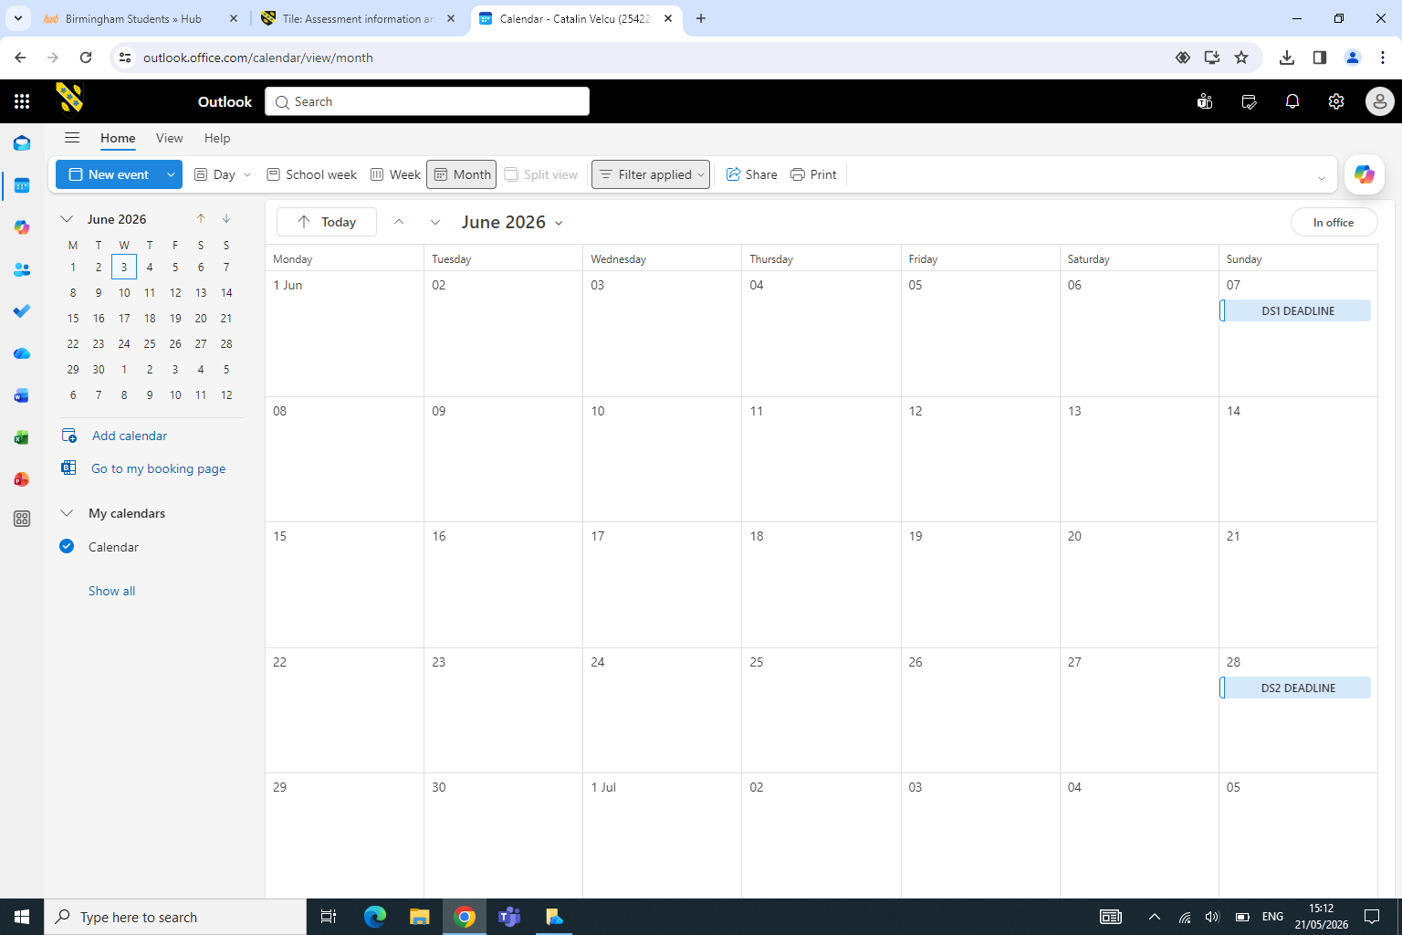
I feel good about using the calendar because it helps me stay organized and remember important school dates. I want to improve at checking the calendar regularly, so I do not miss homework or events. These skills matter because being organized and prepared helps me do well in school.

For each Screenshot/Photo 1
- screenshot, write one or two sentences explaining what it shows.

Screenshot/Photo 2
Google Maps

Google maps help me get to locations easier and helps me find different restaurants with reviews and ratings in a very simple and quick way. This app matters for different reasons such as getting to a place faster so you won’t be late it helps new drivers who don’t know how to get to places with a car these are just a few examples.

Screenshot/Photo 3
Reddit
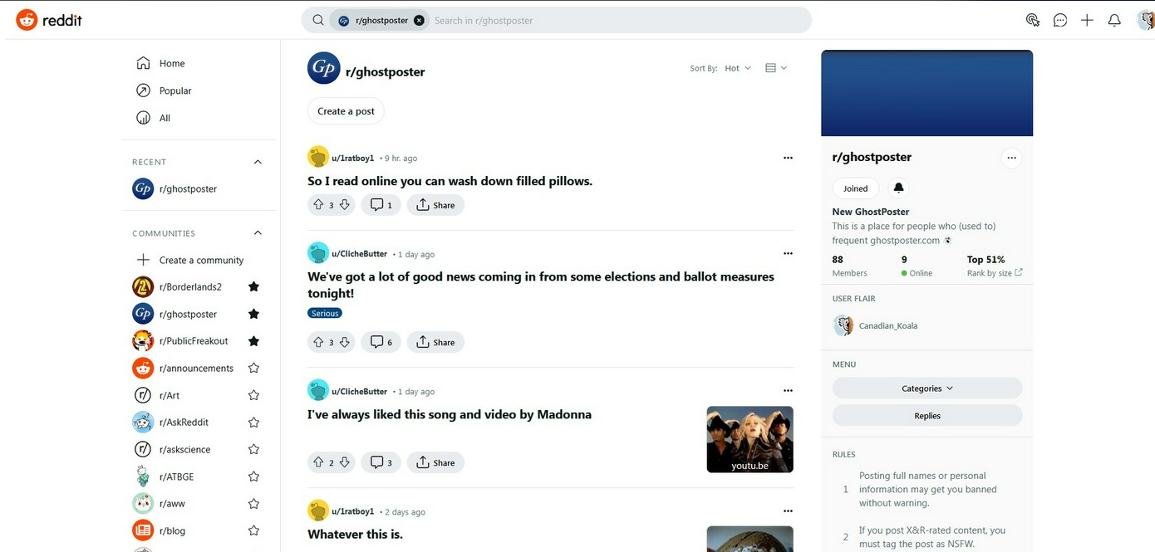
Reddit is an app where people share posts and talk about different topics in subreddits. You can upvote, comment, and join discussions. It’s useful for learning, hobbies, keeping up with news, or just having fun.

Screenshot/Photo 4
HSBC mobile banking
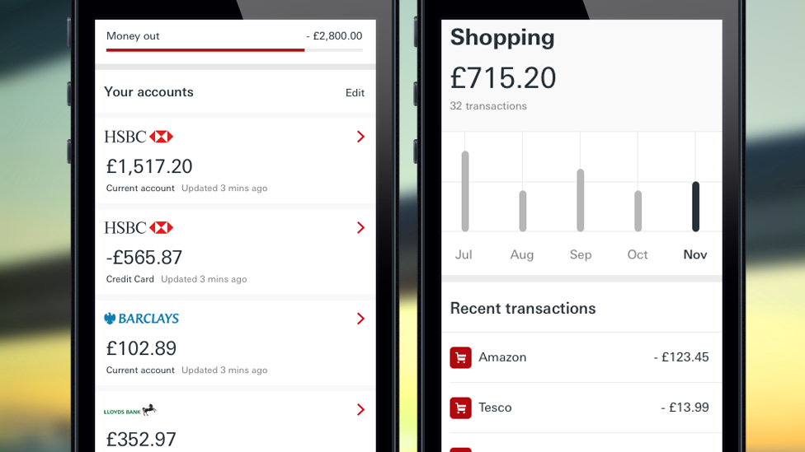
T he HSBC Mobile Banking app is useful because it is secure, fast, and easy to use. Customers can check balances, transfer money, pay bills, and view transactions on their phone anytime. The app also helps users manage their money more easily without visiting a bank branch, saving both time and effort.

Screenshot/Photo 5
Uber
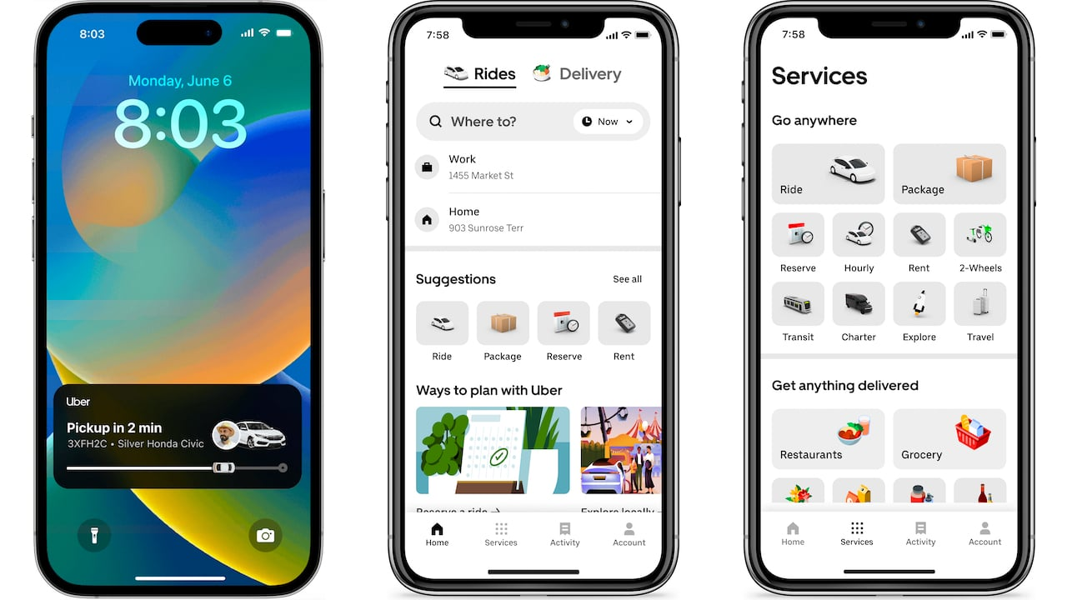
The Uber app is helpful because it makes traveling quick and easy. People can book rides anytime, track drivers, and pay online, making transportation simple and convenient. It also helps save time and is useful for people who do not have their own car.

Screenshot/Photo 6
Just Eat

Just Eat is a food delivery app that lets people order meals online from local restaurants. It is easy to use and allows customers to browse menus, pay online, and track their delivery. It is useful for people who do not drive or need food delivered to their workplace or home.

My Short Reflection
- Write 5–8 simple sentences about your digital life.
- You can use the sentence starters below if helpful.
I use digital tools to communicate with my family and friends.
I often use these tools: reddit, uber, and hsbc.
I feel confident when I use my phone and the internet.
I want to improve my computer skills.
I sometimes feel nervous about online scams and fake websites.
I hope this module will help

Sentence starters
- I use digital tools to …
- I feel confident when I …
- I want to improve …
- I often use these tools: …
- I sometimes feel nervous about …
- I hope this module will help me …
- Digital skills are important for me because …
You can write more if you want.

Submission Checklist
Before you submit, please check:
​​​ ☐ I added 4–6 screenshots
☐ I wrote short sentences for each screenshot
☐ I wrote my short reflection
☐ My work is my own
☐ My file opens correctly
​​☐ My file opens correctly

