University of Wales Trinity St David
School of Applied Computing

Worksheet 1: Building a Virtual LAN using type 2 Hypervisor Management Software
Network Operating Systems and Services
ACCA5023

Richard Lamnea
1802749
01/03/2021



Building a Virtual LAN using type 2 Hypervisor Management Software
Richard Lamnea
School of Applied Computing, University of Wales Trinity St David, Swansea, Wales
1802749@student.uwtsd.ac.uk

ABSTRACT
This report discusses the implementation of a disconnected virtual network and discusses research into hypervisor software, subnet masks and cloud computing.
TABLE OF CONTENTS
I. INTRODUCTION 1
II. IMPLEMENTATION 1
A. VM creation and Operating System Installation 2
B. Virtual Network Configuration 2
III. OBSERVATIONTIONAL TASKS 5
A. Hypervisor software 5
1) Type 1 Hypervisor 5
IV. TERMINOLOGY 9
1) Firewall 9
2) Remote Server Management 9
3) OOBE 9
4) ICMP 9
5) Virtualization 9
6) Containerization 9
V. CONCLUSION 9
VI. REFERENCE LIST 9

TABLE OF FIGURES
Figure 1 - Server Virtual Machine Configuration 2
Figure 2 - Client Virtual Machine Configuration 2
Figure 3 - Windows Installation 2
Figure 4 - Server1 PublicNet IPv4 IP Address Configuration 2
Figure 5 - Server2 PublicNet IPv4 IP Address Configuration 2
Figure 6 - Server1 PrivateNet1 IPv4 IP Address Configuration 3
Figure 7 - Client1 PrivateNet1 IPv4 IP Address Configuration 3
Figure 8 - Server2 PrivateNet2 IPv4 IP Address Configuration 3
Figure 9 - Client2 PrivateNet2 IPv4 IP Address Configuration 3
Figure 10 - Server1 and Client1 Disabled Firewalls 4
Figure 11 - Server1 and Client1 ping connection tests 4
Figure 12 - Server2 and Client2 Firewall configuration 4
Figure 13 - Server2 and Client2 Connectivity test 4
Figure 14 - Server1 to Server2 successful ping request 4

INTRODUCTION
This report outlines the implementation of two disconnected Virtual networks using Type 2 Hypervisor software to create 4 Virtual Machines (VMs). Two of which will use server operating systems and two will use client operating systems. The networks will be configured to enable the server systems to communicate with each other, and the server to client communications through Local Area Networks. The report also discusses hypervisor software, the significance of subnet mask within an IPv4 network and cloud computing.

IMPLEMENTATION
Oracle Virtual box was downloaded and installed on a host machine in preparation to create the VMs.

VM creation and Operating System Installation.
Four VM’s were created to implement the required task. Both server VM’s were configured to access 2GB of RAM, 128MB of Video Memory from the host system which can be seen in Fig 1.
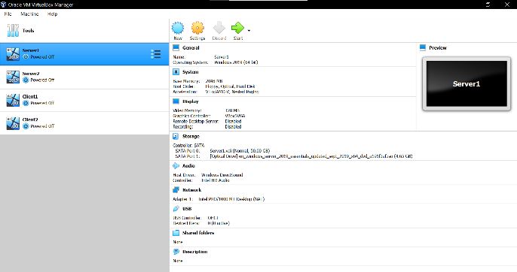
Figure 1 - Server Virtual Machine Configuration
Both client VM’s were configured to utilize 2GB of RAM, 128MB of Video Memory from the host system which can be seen in Fig 2.
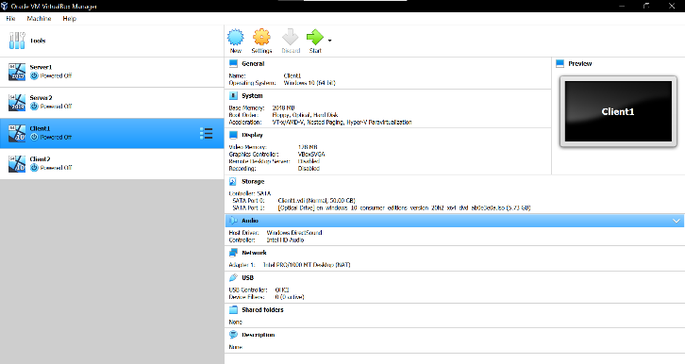
Figure 2 - Client Virtual Machine Configuration
Windows Server 2019 and Windows 10 Operating Systems were installed on both server VM’s and both client VMs, a snapshot can be seen of the installation interface in Fig 3.
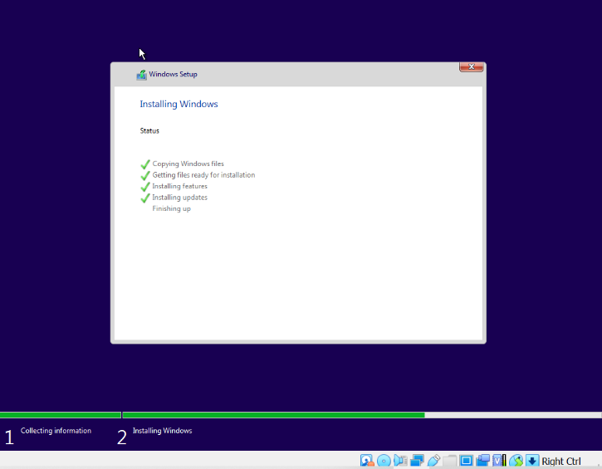
Figure 3 - Windows Installation

Virtual Network Configuration
When the task of creating 2 Server VM’s and 2 Client VM’s using Virtual Box Type 2 Hypervisor, each VM’s Network adapters was configured to create 3 Virtual local area networks. The first network created was named PublicNet which connects both Server VM’s in which to enable communication between both Servers. Server 1’s PublicNet network IP address was entered at 192.168.1.100 which can be seen in Fig 4.
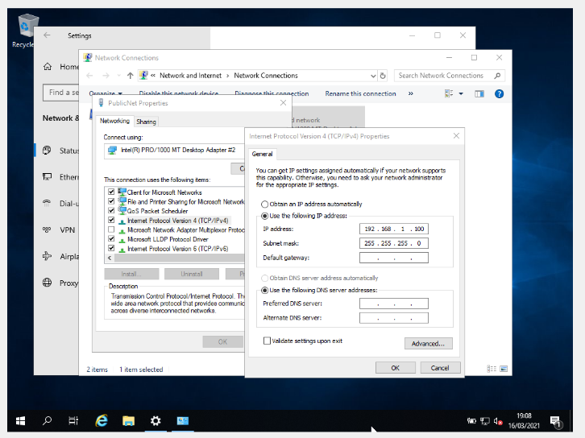
Figure 4 - Server1 PublicNet IPv4 IP Address Configuration
Server 2’s PublicNet network IP address was entered into its network adapter at 192.168.1.101 which can be seen in Fig 5.
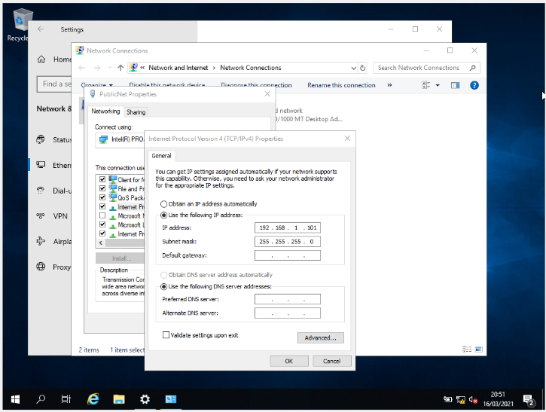
Figure 5 - Server2 PublicNet IPv4 IP Address Configuration
Once PublicNet IP addresses were configured for both Server1 and Server2 configuration of network adapters for Server1 and Client1 communication was started. Server1 PrivateNet1 network adapter was set up, and its IP address was set at 192.168.100.1 which can be seen in Fig 6.
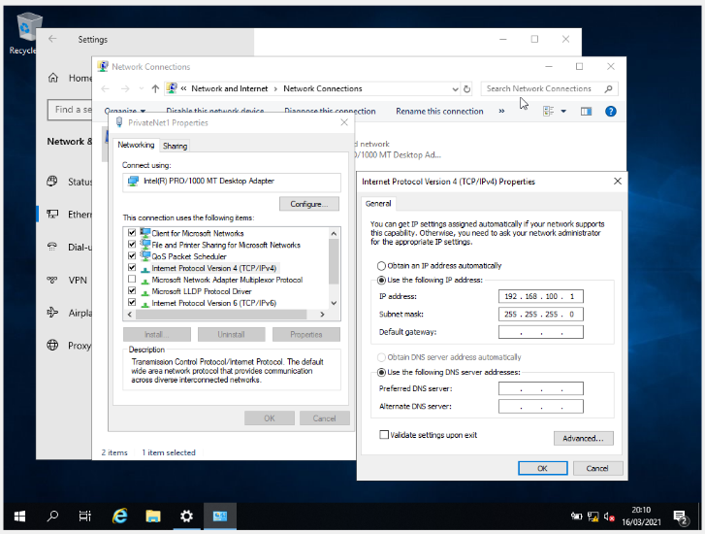
Figure 6 - Server1 PrivateNet1 IPv4 IP Address Configuration
Client1 PrivateNet1 network adapter was configured with the IP Address 192.168.100.2 which can be seen in Fig 7.
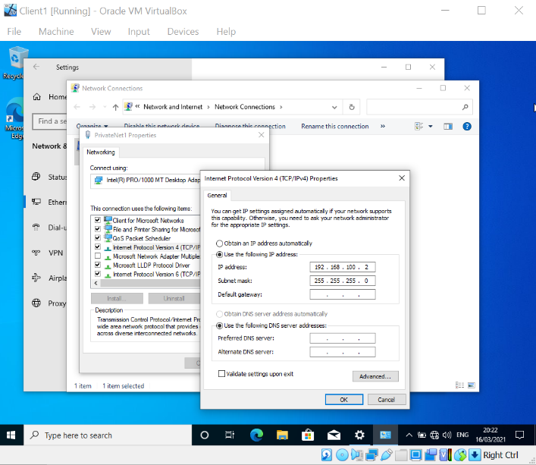
Figure 7 - Client1 PrivateNet1 IPv4 IP Address Configuration
Once Server1 and Client1 PrivateNet2 configuration was complete Server2 to Client2 network adapters were established. Server2 PrivateNet2 network adapter was configured with the IP Address 192.168.101.1 which can be seen in Fig 8.
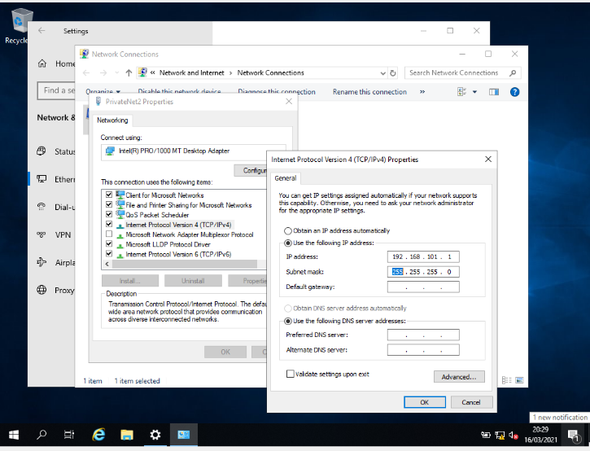
Figure 8 - Server2 PrivateNet2 IPv4 IP Address Configuration
Client2 PrivateNet2 network adapter was configured with the IP Address 192.168.101.2 which can be seen in Fig 8.
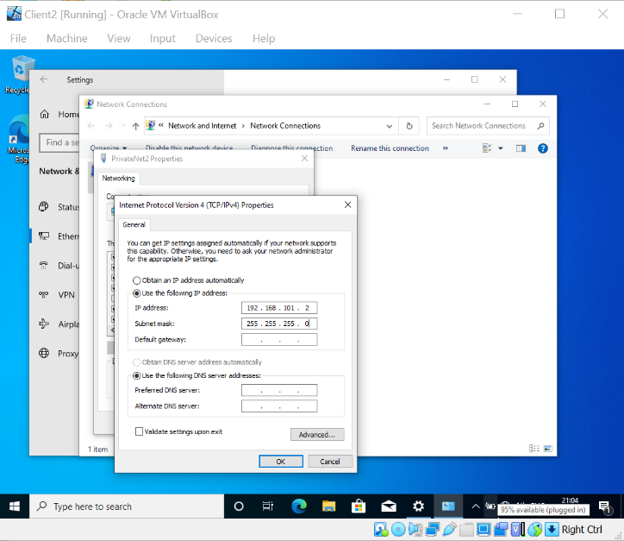
Figure 9 - Client2 PrivateNet2 IPv4 IP Address Configuration
To test if the networks were correctly configured the “ping” internet control message protocol (ICMP) command would be utilized to demonstrate connectivity however, by default the Out-of-Box Experience (OOBE) environments deny this protocol.
To circumvent this obstacle Windows Defender Firewall was disabled on Server1 and Client1 which can be seen in Fig 10.
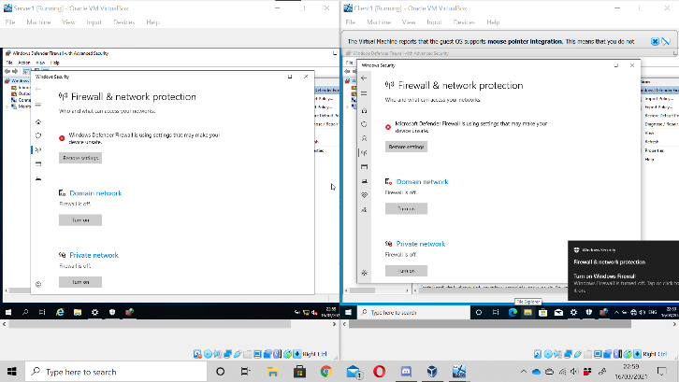
Figure 10 - Server1 and Client1 Disabled Firewalls
Once the firewall had been disabled the ping command was used via command prompt to test connectivity of Server1 to Client1 through PrivateNet1 and from Client1 to Server1, both ping requests were successful which can be seen in Fig 11.
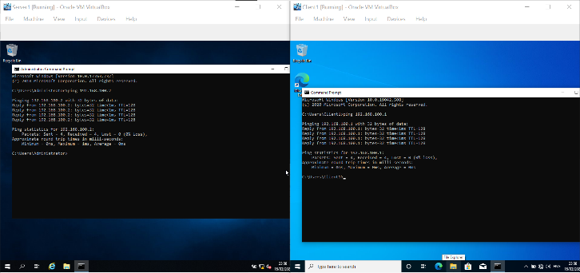
Figure 11 - Server1 and Client1 ping connection tests
The Windows Defender Firewall was disabled on Server2 and Client 2 to allow the ping command which can be seen in Fig 12.
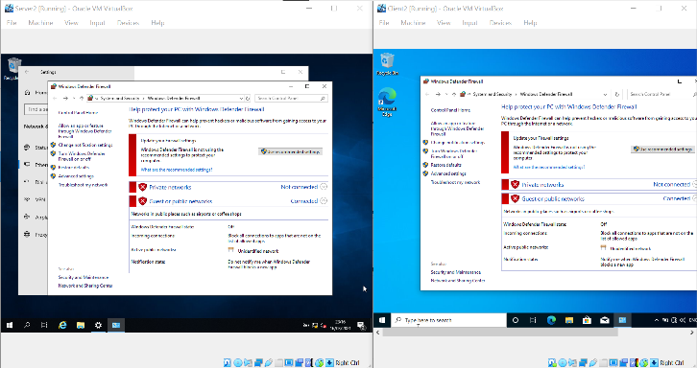
Figure 12 - Server2 and Client2 Firewall configuration
Connectivity was tested via the command prompt using the ping command on Server2 to Client2 and from Client2 to Server2 via PrivateNet2 network adapter and both completed successfully which can be seen in Fig 13.
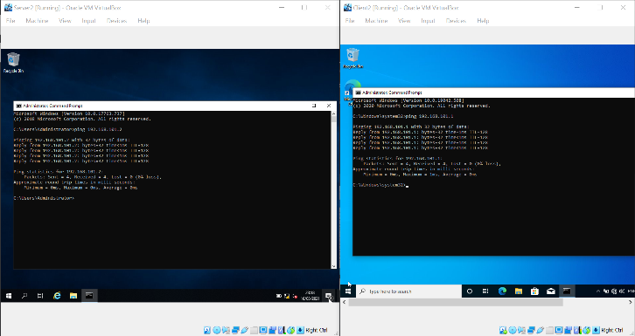
Figure 13 - Server2 and Client2 Connectivity test
To finalize and test the connectivity of the PublicNet network from Server1 to Server2 the ICMP protocol was used and proved to be successful which can be seen in Fig 14.
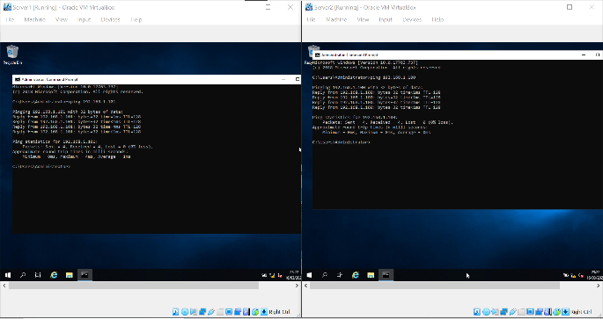
Figure 14 - Server1 to Server2 successful ping request

OBSERVATIONTIONAL TASKS

Hypervisor software
A Hypervisor is a software that has been designed to enable the creation of multiple virtual machines to run from a single host system in which to allow multiple isolated operating systems to run using the host systems physical resources. This software is also known as VMM (virtual machine monitor) [1]. Having multiple operating systems running on one host is known as virtualization [2]. Hypervisors allow the use of multiple system’s providing greater mobility for IT services. Since the Virtual machines (VMs) are independent of the host system they can be easily moved between other host systems and this can reduce many factors, such as IT expenses, reduced server downtime if a natural disaster affects the physical server and increase efficiency and productivity [3]. There are two main types of hypervisor software, Bare metal hypervisor (Type 1), and Hosted hypervisor (Type 2) [4].

Type 1 Hypervisor
The Type 1 hypervisor is a layer of software that is installed directly onto a physical server and its hardware without a third-party operating system in which to manage the virtualization. This provides improved performance and stability, and security since the VM’s have direct access to the physical hardware of the machine [5].
When a type 1 hypervisor is installed onto a physical server, access to the configuration is displayed through a command-line interface and will display hardware and network configuration details, such as CPU type, amount of memory, IP addresses, MAC addresses of the server and the VM’s configuration [6]. Configuration of this type of hypervisor is typically accessed through remote management software which allows management of the server’s virtual environment [7]. When configured correctly, the management software can move, create, and perform maintenance on the VM’s automatically and seamlessly. The greatest benefit of the type 1 hypervisor is that the software can enable the over-allocation of physical resources for the VM’s. Assuming the VM is not consuming all assigned resources, the hypervisor software will automatically assign the required necessary resources for that VM to perform its task and be fully functional [8]. This type of hypervisor software is typically found in enterprise data centres as it can be difficult to configure and expensive [9].
- Type 1 hypervisor vendors
There are many different variants of type 1 hypervisor software and these include:
- VMware ESX and ESXi [10].
This software offers advances features and scalability but requires licensing fees to use however they also provide a free version[11]. This bare-metal hypervisor software installs directly onto the physical server and allows direct access to the underlying resources of this system. VMware is the industry leader for this type of software [12].
The software features include:-
- A small operating system size of 150MB [12].
- Allows the configuration of up to 128 virtual CPU’s, 6TB of RAM and 120 VM’s simultaneously [12].
• Role-based security access for administration of the VM’s and provides logging and auditing statistics [12].
• HTML5 User-friendly user interface [12].
• Recovery and backup features [12].
• Live migration services [12].
• Remote connectivity [12].

- Microsoft Hyper-V [13].
Microsoft’s hypervisor software, Hyper-V does not offer as many advanced features that VMware offer however Hyper-V is one of the top used hypervisors. Hyper-V is available with a no GUI or virtualization rights version for free and 4 commercial editions which include graphical user interfaces, and virtualization rights [14].
The software features include:
- Live migration of virtual machines from one host to another [15].
- Disaster recovery and backup [15].
- Integrated optimization services [15].
- Remote connectivity [15].
- Citrix XenServer [16].
Citrix XenServer and XenCenter management hypervisor software are an open-source software project which allows it to be used freely however there is an enterprise version which has a cost [17]. The software features include:
Live-Patching [18].
Automated updates [18].
GPU Virtualization [18].
- Oracle VM Server [19].
Oracle VM Server hypervisor software is based on XenServer and is also open source however Oracle do not provide support or updates to the software without a cost [20]. This hypervisor software is limited in its abilities however it does provide the basics needed for Virtualization.
- Type 2 hypervisor vendors
A type 2 hypervisor software is installed on top of the operating system of a physical host system [4]. These hypervisor software’s are called hosted hypervisors which operate divergently to type 1 hypervisor which runs directly onto a host system’s hardware [1]. Type 2 hypervisors are typically used within environments with limited servers, and this makes it convenient to implement for small enterprises and single users [5]. Type 1 hypervisors do not require remote management applications or systems to create and manage virtual machines, this can be done from the initial host where it has been installed. When creating a VM on this type of hypervisor, the user must take caution when allocating resources as they do not dynamically allocate the available physical resources of the host system [21]. If resources are over-allocated to the virtual machines, the host system can become impacted and could crash or damage the host system. However, Type 2 hypervisors can be installed and set up quickly with a minimal cost which makes them highly convenient for testing software and research projects [6]. There are many different variations of type 2 hypervisor software and these include:
- Microsoft Virtual PC
Windows Virtual PC is included within Microsoft Windows operating system. The software allows a user to run applications within a virtual Windows environment directly from a Windows 7-based computer [22].
- VMware Workstation/Fusion/Player
VMware Workstation allows a user to run multiple virtual machines on multiple Operating systems such as Windows or Linux [23]. he software also includes many different operating systems to allow the user to run/build and test many forms of application.
- Oracle VM VirtualBox [24].
VirtualBox is an open-source Type 2 hypervisor software that is compatible with multiple operating systems such as Windows, Linux, Mac. This software can support several guest operating systems and is free to use [25].
- Red Hat Enterprise Virtualization
Red Hat’s Virtual Hypervisor software provides features of both a Type 2 and Type 1 hypervisor as the hypervisor can allow the VM’s to have direct access to the physical hardware, however, this is only applicable to the Linux Operating system [26].
- The Significance of the subnet mask
A subnet mask determines the networks IP address and host identifiers. A subnet mask is a 32-bit number that differentiates each octet of the IP address [27]. The subnet mask limits the number of valid IP address which can be applied to a network. When multiple subnet masks are applied to a network, they are called subnets and these subnets can directly communicate with each other through a router [28]. The subnet mask hides part of the IP address and only reveals the host machine identifier address. The subnet mask number can only contain a number from 0 to 255 [28].
Historically there were 3 classes of subnets, Class A, B and C corresponding to 8, 16 and 24 bits reserved for network addresses [28].
- Class A subnet mask can be identified as 255.0.0.0
- Class B subnet mask can be identified as 255.255.0.0
- Class C subnet mask can be identified as 255.255.255.0
The values of each octet represent the total amount of bits available to the network. For example, A Class C network with a mask of 255.255.255.0 would allow 254 hosts and a Class B network with a mask of 255.255.0.0 would allow 65,534 hosts within the network [29].
The newer notation widely used to denote subnets is CIDR notation where a /× expression is used to identify the number of network bits versus client bits [28]. The formula to calculate the available hosts on the subnet is:
(2 ^ (32– CIDR)) – 2.
For example, A network with /24 CIDR notation would calculate to: -
(2^ (32 – 24)) – 2 = 2^8 – 2
= 254 available hosts.
The reason the formula removes two from the result is due to reserved address, One for the network address, and one for the broadcast address. Typically, .0 and .255, respectively.
256 available hosts are typically enough for most standard households which is why /24 is a common subnet mask.

- Cloud Computing
Cloud computing is on-demand computer system resources without the need for direct active management by the user typically provided through data centres. Cloud computing is also known as the Cloud has the potential to change how enterprises and businesses operate, as the data centres can virtually provide powerful computer systems, data storage, and remote access to these systems [30]. This can alleviate the costs and IT infrastructure needed for enterprises to operate and allow users to virtually connect anywhere in the world [31].
- The benefits of cloud computing
- Reduced IT Infrastructure costs
Using cloud computing can reduce the cost of management and maintenance of IT systems as expensive servers and equipment do not need to be purchased as they can be hired for us through the cloud service provider[30]. These benefits can include: -
- Reducing the cost of purchasing expensive server equipment.
- Reduce the cost of new hardware and software for systems.
- Reduce the cost of upgrading existing hardware/software.
- Scalability.
Clouding computing enables the operating of virtual systems to scale up or down dependent on the demand for system resources. The development of the service itself must support a micro-service architecture and containerization to allow it to take advantages of these features [32]. This in turn can also reduce the operational costs of the provided service and allow for potentially near-unlimited concurrent users of the service.
- Disaster recovery
Cloud computing vendors provide continuity and protection of the servers for the enterprises who use these systems[30]. This protects the data and services from natural disasters, power failure and other crises. The cloud vendors ensure redundancy, not only at the data level by using features such as RAID but also at the data centre level such as AWS using 2 redundant servers at every availability zone [33].
- Effective collaboration.
Collaboration using the cloud service enables the ability for data to be shared easily worldwide and supports CI/CD (Continuous integration, continuous delivery, and continuous deployment) principles [34].

- The drawbacks of cloud computing.
Cloud computing has a few drawbacks which include:
- Hidden costs.
Cloud computing generally reduces the cost of infrastructure needed to support a business’s services however, acquiring staff with the needed skills to manage and develop these systems are incredibly difficult and rare [35]. One of the biggest challenges for enterprises is having engineers with cloud expertise and these members of staff can cost a significant amount of money [36].

- Security and vulnerability.
The benefits of cloud computing enabling collaboration and remote access brings risk to the security of data and breaches of the system [35]. The problems that can cause these risks include: -
- Misconfigured cloud storage.
- Security group misconfiguration.
- Lack of access restrictions.
- Insecure application user interfaces (API).
- Inadequate authentication.
- Insufficient authorization.
- Loss of theft of intellectual property. As the enterprises' system is completely online, this also leaves the system vulnerable to attack by cybercriminals.
- Internet connection issues.
Another drawback of cloud computing is the need for users of the service to require an internet connection. This also includes problems with Internet service providers (ISP)s and issues with their connections [37]. This does not only include the staff members who require the service for their work, but also public entities who require access to the system.
- Compliance.
Cloud computing services are also a cause for concern regarding compliance and legislation regarding personal data and data protection legislation [38]. Typically, data is protected through specific risk assessment strategies to ensure legislation and governance is followed regarding its protection [38]. However, many of these strategies can become difficult to ensure due to the nature of cloud computing and security implications and risks.
- Cloud computing Vendors
There are many cloud hosting vendors such as Amazon Web Services (AWS), Microsoft Azure, Google Cloud Platform and which offer many different services [39] [40] [41].
These services include: -
- Software as a Service (SaaS)
- Platform as a service (PaaS)
- Infrastructure as a Service (IaaS)
There are many other cloud hosting vendors and due to the rapid growth of the industry. New services and applications are constantly being released in this ever-changing digital landscape.

TERMINOLOGY
Below are descriptions regarding the terminology used within this report.

Firewall
The term firewall in this instance refers to software which filters communication packets between networked devices. Essentially it is a barrier that protects the network from outside communication.

Remote Server Management
This term refers to software that enables a user to control and monitor data from another device on the network.

OOBE
OOBE is an acronym for Out-Of-Box Experience and refers to what a user would encounter when a user first sets up an operating system or product.

ICMP
ICMP is an acronym for Internet Control Message Protocol. ICMP is a transport-level protocol within the Internet Protocol Suite (TCP/IP). In this instance, the command “ping” was used.

Virtualization
Virtualization is the process of running virtual machines on a hypervisor.

Containerization
Containerization is the process of packaging software code with its needed dependencies so that it can run on any infrastructure. Containerization is commonly used with virtualization or as an alternative.

CONCLUSION
In conclusion, the implementation of virtual networks discussed proved to be successful. The Research conducted highlighted virtualisation and its importance to the growth of the cloud and industries within the IT sector.

REFERENCE LIST

[1] ‘What is a hypervisor?’ https://www.redhat.com/en/topics/virtualization/what-is-a-hypervisor (accessed Mar. 17, 2021).
[2] ‘A summary of virtualization techniques - ScienceDirect’. https://www.sciencedirect.com/science/article/pii/S2212017312002587 (accessed Mar. 17, 2021).
[3] ‘5 Benefits of Virtualization’, May 11, 2020. https://www.ibm.com/cloud/blog/5-benefits-of-virtualization (accessed Mar. 17, 2021).
[4] ‘Hypervisors - an overview | ScienceDirect Topics’. https://www.sciencedirect.com/topics/computer-science/hypervisors (accessed Mar. 17, 2021).
[5] ‘hypervisors’, Jan. 15, 2021. https://www.ibm.com/cloud/learn/hypervisors (accessed Mar. 17, 2021).
[6] ‘How to Implement Validation for Restful Services with Spring’, Knowledge Base by phoenixNAP, Jan. 24, 2019. https://phoenixnap.com/kb/what-is-hypervisor-type-1-2 (accessed Mar. 17, 2021).
[7] S. R. Pasunuru, ‘KVM Based Virtualization and Remote Management’, p. 78.
[8] ‘Hypervisor Server Review | What is a Hypervisor?’, ServerWatch, Nov. 17, 2020. https://www.serverwatch.com/virtualization/hypervisor-server/ (accessed Mar. 17, 2021).
[9] ‘Data Center Virtualization Management and the use of Scripting for Automation’. https://ukdiss.com/examples/data-center-virtualization-management.php (accessed Mar. 17, 2021).
[10] ‘VMware UK - Delivering a Digital Foundation For Businesses’, VMware. https://www.vmware.com (accessed Mar. 17, 2021).
[11] VapourApps, ‘What is Hypervisor and what types of hypervisors are there?’, VapourApps Private Cloud, May 13, 2016. https://vapour-apps.com/what-is-hypervisor/ (accessed Mar. 17, 2021).
[12] ‘What is ESXI? | Bare Metal Hypervisor | ESX’, VMware. https://www.vmware.com/products/esxi-and-esx.html (accessed Mar. 17, 2021).
[13] BenjaminArmstrong, ‘Hyper-V on Windows Server’. https://docs.microsoft.com/en-us/windows-server/virtualization/hyper-v/hyper-v-on-windows-server (accessed Mar. 17, 2021).
[14] ‘The Top 5 Enterprise Type 1 Hypervisors You Must Know’. http://www.virtualizationsoftware.com/top-5-enterprise-type-1-hypervisors/ (accessed Mar. 17, 2021).
[15] BenjaminArmstrong, ‘Hyper-V Technology Overview’. https://docs.microsoft.com/en-us/windows-server/virtualization/hyper-v/hyper-v-technology-overview (accessed Mar. 17, 2021).
[16] ‘Citrix Hypervisor - Server Virtualization and Management Software - Citrix United Kingdom’, Citrix.com. https://www.citrix.com/en-gb/products/citrix-hypervisor/ (accessed Mar. 17, 2021).
[17] S. L. S. L. is a S. A. M. Manager et al., ‘XenServer 6.2 is now fully open source! | Citrix Blogs’, Jun. 25, 2013. https://www.citrix.com/blogs/2013/06/25/xenserver-6-2-is-now-fully-open-source/ (accessed Mar. 17, 2021).
[18] C. Edwards and X. Pmm, ‘Citrix XenServer 7.6 Feature Matrix’, Fact Sheet, p. 5.
[19] ‘VM Server for x86 | Virtualization | Oracle United Kingdom’. https://www.oracle.com/uk/virtualization/vm-server-for-x86/ (accessed Mar. 17, 2021).
[20] C. Rothe, ‘Xen Virtualization with Oracle: Commitment, Integration, Mission-critical Virtualization’, p. 30.
[21] ‘E.8: The Cloud and Virtualization’, Engineering LibreTexts, Oct. 19, 2020. https://eng.libretexts.org/Courses/Delta_College/Linux_-_The_Penguin_Marches_On/10%3A_Network_Management/5.08%3A_The_Cloud_and_Virtualization (accessed Mar. 17, 2021).
[22] ‘Description of Windows Virtual PC’. https://support.microsoft.com/en-us/topic/description-of-windows-virtual-pc-262c8961-90e5-1125-654f-d87cd5ba16f8 (accessed Mar. 17, 2021).
[23] ‘Workstation Pro - VMware Products : Windows Virtualization for Everyone’, VMware. https://www.vmware.com/products/workstation-pro.html (accessed Mar. 17, 2021).
[24] ‘Oracle VM VirtualBox’. https://www.virtualbox.org/ (accessed Mar. 17, 2021).
[25] ‘Oracle® VM VirtualBox®’. https://www.virtualbox.org/manual/UserManual.html (accessed Mar. 17, 2021).
[26] ‘Red Hat Virtualization’. https://www.redhat.com/en/technologies/virtualization/enterprise-virtualization (accessed Mar. 17, 2021).
[27] Digital Video Surveillance and Security. Elsevier, 2014.
[28] Cisco CCNA/CCENT Exam 640-802, 640-822, 640-816 Preparation Kit. Elsevier, 2009.
[29] IP Addressing & Subnetting INC IPV6. Elsevier, 2000.
[30] S. B. and T. Employment, ‘Benefits of cloud computing’, Jun. 15, 2011. https://www.business.qld.gov.au/running-business/it/cloud-computing/benefits (accessed Mar. 17, 2021).
[31] ‘Uses of Cloud Computing - Apprenda’. https://apprenda.com/library/cloud/uses-of-cloud-computing/ (accessed Mar. 17, 2021).
[32] nishanil, .‘NET Microservices. Architecture for Containerized .NET Applications’. https://docs.microsoft.com/en-us/dotnet/architecture/microservices/ (accessed Mar. 17, 2021).
[33] ‘Making Application Failover Seamless by Failing Over Your Private Virtual IP Across Availability Zones’, Amazon Web Services, Mar. 13, 2019. https://aws.amazon.com/blogs/apn/making-application-failover-seamless-by-failing-over-your-private-virtual-ip-across-availability-zones/ (accessed Mar. 17, 2021).
[34] ‘What is CI/CD?’ https://www.redhat.com/en/topics/devops/what-is-ci-cd (accessed Mar. 17, 2021).
[35] A. Apostu, F. Puican, G. Ularu, G. Suciu, and G. Todoran, ‘New Classes of Applications in the Cloud. Evaluating Advantages and Disadvantages of Cloud Computing for Telemetry Applications’, no. 1, p. 12.
[36] ‘the-cost-of-cloud-expertise.pdf’. Accessed: Mar. 17, 2021. [Online]. Available: https://www.lse.ac.uk/business-and-consultancy/consulting/assets/documents/the-cost-of-cloud-expertise.pdf.
[37] ‘Disadvantages of Cloud Computing for Networks’, dummies. https://www.dummies.com/programming/cloud-computing/disadvantages-of-cloud-computing-for-networks/ (accessed Mar. 17, 2021).
[38] J. Ruiter and M. Warnier, ‘Privacy Regulations for Cloud Computing: Compliance and Implementation in Theory and Practice’, in Computers, Privacy and Data Protection: an Element of Choice, S. Gutwirth, Y. Poullet, P. De Hert, and R. Leenes, Eds. Dordrecht: Springer Netherlands, 2011, pp. 361–376.
[39] ‘Amazon Web Services (AWS) - Cloud Computing Services’, Amazon Web Services, Inc. https://aws.amazon.com/ (accessed Mar. 17, 2021).
[40] ‘What is Azure – Microsoft Cloud Services | Microsoft Azure’. https://azure.microsoft.com/en-gb/overview/what-is-azure/ (accessed Mar. 17, 2021).
[41] ‘Cloud Computing Services’, Google Cloud. https://cloud.google.com/ (accessed Mar. 17, 2021).

