

Program | Master of Business Administration
Module Title | International Marketing: Principles and Practices
Module Code | LCMB7026
Assessment Title | International Marketing: Principles and Practices (Coca-Cola, UK vs Bangladesh)
Student Name | Ashraful Alam Rifat
Student ID | 2435252
Lecturer | Tushara Balendran (London)
Word Count | 5297

Table of Contents
Introduction 4
Background Information About Coca Cola 5
Founding & Founders 5
Mission Statement 5
Vision Statement 6
PESTEL Analysis 7
Political Factors 7
Economic Factors 7
Social Factors 8
Cultural Factors 9
Technological Factors 10
Environmental Factors 10
Legal Factors 11
PESTEL Comparative Analysis: Similarities and Differences 11
Segmentation, Targeting and Positioning Analysis 12
Segmentation Strategy 12
Targeting Strategy 13
Positioning Strategy 14
Perceptual Map of Coca-Cola and Others 14
Similarities & Differences 15
Marketing Mix: 7Ps 16
Product 16
Price 17
Place 17
People 19
Process 20
Physical Evidence 20
7Ps Similarities & Differences 21
Evaluation of Effectiveness for Both Countries 22
Sales 22
Social Media Presence 22
Customer Reviews & Perceptions 23
Ethical Issues 24
Recommendations & Conclusion 25
Recommendations 25
Conclusion 25
References 26

Introduction
Multinational companies often target markets where they can exert dominance and address key gaps to leverage as a dominant player in the newly found market. In this regard, MNCs generally opt for markets where the competition stays low or feasible for the company to accept the risks and turn in necessary returns. Coca-Cola, as a company, is a global beverage leader which currently operates across 200 countries around the globe. Moreover, Coca-Cola has already established itself as one of the most popular brands in the world. Now, as for this report, the focus will be to evaluate the international marketing strategies that the company employs in separate and distinct places of which one is the United Kingdom and the other is Bangladesh. The distinction between the two countries lies in the underlying economic, cultural and demographic contexts. As a result, analysing the marketing strategies can help understand how Coca-Cola, as a multinational corporation, adapts its marketing strategies to cater towards different environments. Now, to accompany the analysis, the emphasis will be given on examining the macro-environment of the two countries for Coca-Cola by using the PESTEL analysis, STP analysis, the 7Ps marketing mix, market entry strategies, ethical considerations and performance evaluation of the company in the two differing countries. By analysing the differences of the marketing strategies used by Coca-Cola in the two different markets, the useable insights will be applied to curate the recommendations so that the company can enhance its competitive positioning in both the countries. Again, before undertaking the in-depth analysis of the company, necessary background information will be provided for a more comprehensive view of the company’s strategic mindset.

Background Information About Coca Cola

Founding & Founders
The origin of Coca-Cola can be traced way back to 1886 when Dr John Stith Pemberton create the formula of the original Coca-Cola at the Pemberton Chemical Company. In response to the formula being created, the bookkeeper of the same organisation, Frank Robinson, came up with the brand name and designed the flowing script which has remained, till date, very iconic and popular around the world. In 1888, when Pemberton died, it was Griggs Candler who acquired the company at the cost of 2,300 USD and the acquisition was completed by 1991. It was Griggs Candler who incorporated The Coca-Cola Company in 1892, based in Georgia corporation with a capitalisation of 100,000 USD. Again, under the new owner of the brand, the company flourished through the USA very quickly and became available throughout the country by 1895 (Pivot, 2025).
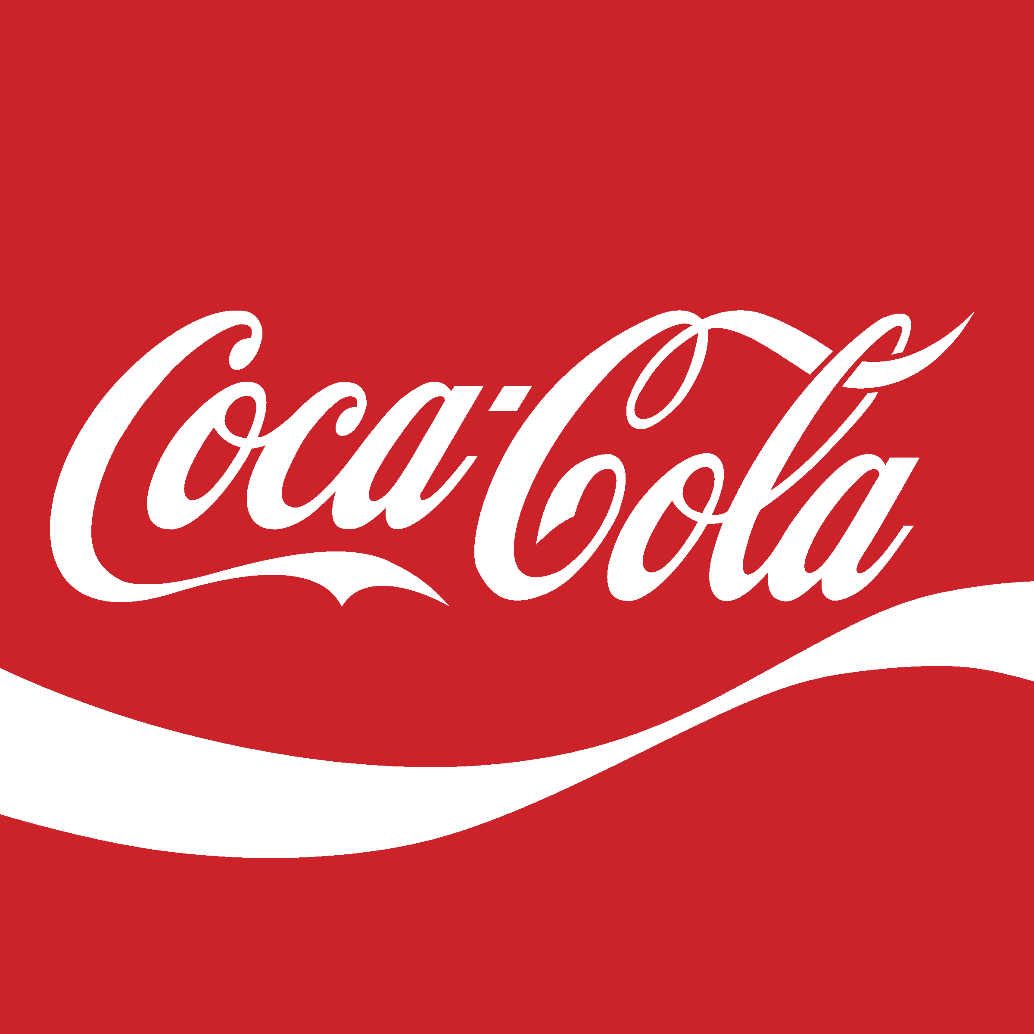
Figure: Logo of Coca-Cola (Pung, 2020)

Mission Statement
The mission statement of Coca-Cola directly illustrates the intention with which the company operates. Here, the mission statement by the company is to refresh the world, inspire moments of optimism and happiness and create value and make a difference (Coca-Cola, 2024). By analysing the mission statement of the company, the fundamental aspects of the company can be identified. Here, by refreshing the world, the company actually envisions its capacity to rejuvenate people mentally through its innovative products and experiences around the world and to move beyond its physical refreshment (The Coca-Cola Company, 2025). Moreover, by inspiring optimism and happiness, the company’s commitment to creating positive connections with its audiences emotionally gets reflected and that too, strongly. Lastly, as a company, the company will always want to create value for its audiences and to do so, the company is focused on generating sustainable value for all of its stakeholders (Coca-Cola, 2024).

Vision Statement
The vision statement shared by The Coca-Cola Company is, “Loved brands, done sustainably, for a better shared future” (Coca-Cola, 2024). In iterating the vision statement, the company has largely emphasized on three major pillars which include the company’s aim to craft brands and beverage choices which are loved by people while sustainability refers to the core commitment made by the company to address the challenges related to water stewardship, packaging circularity and climate action in a sustainable manner. Lastly, the vision of the company is to create a shared future that can positively impact people’s lives, communities they live in and the planet in which they reside (Coca-Cola, 2024).

PESTEL Analysis
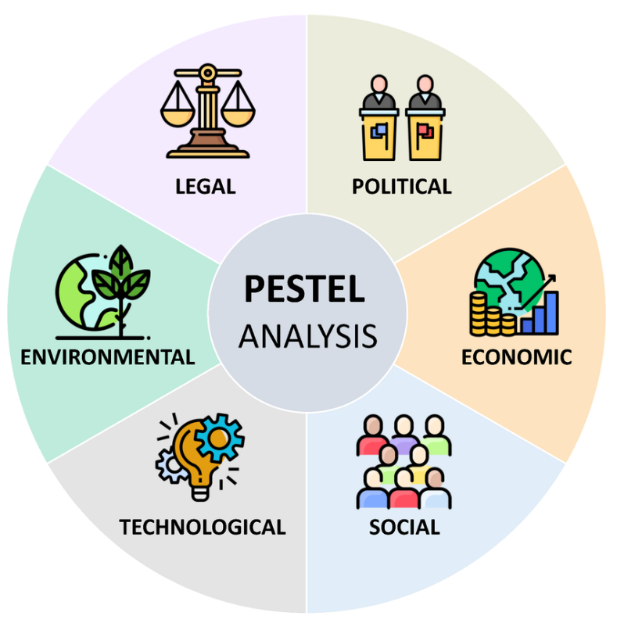
Figure: PESTEL Analysis (Segura et al., 2023)

Political Factors
The political environments in the UK and Bangladesh provides the company with both opportunities and challenges for Coca-Cola’s international operations with the UK being a stable, democratic, strong governance and secured country where the MNCs find it more favourable to deal with. However, due to decisions such as BREXIT, the uncertainty is also there. In Bangladesh, the political environment is quite volatile and unstable for which any company has to tread with care. The country has made economic reforms in the last three decades, however, political turmoil and corruption still run wild (J.Sheld, 2025).
Favourable Factor: In the UK, political stability, rigid regulatory and availability of open trade are the favourable ones.
Unfavourable Factor: In Bangladesh, higher volatility, unrest from time to time, uncertainty as well as corruption are the unfavourable ones (J.Sheld, 2025).

Economic Factors
The UK is one of the largest economies of the world which is characterised by the country’s high household purchasing power, low inflation over a long period of time, strong consumer base and a very mature retail infrastructure. But, the beverage industry of the country is highly competitive where the companies must address the slow economic growth, high competition as well as consumer price sensitivity to avoid getting out of business (FDF, 2025). In complete contrast, Bangladesh is one of the fastest growing emerging countries which is characterised by its moderate GDP growth, one of the youngest populations and rising disposable income. The UK has a big GDP of 3.64 trillion USD alongside a 3.61 trillion USD GNP whereas Bangladesh is a much smaller economy with a GDP of 347 billion USD alongside a 469.5 billion USD GNP. However, for Coca-Cola, both countries have enough potential for the brand considering its brand image and popularity among the customer audience base.
Favourable Factor: For the UK, high purchasing power, logistics networks and advance retail sector are favourable for the country (FDF, 2025).
Unfavourable Factor: For Bangladesh, currently high inflation, varied purchasing power and infrastructural constraints are the major unfavourable aspects for the company.

Social Factors
Health-consciousness has increased significantly over the years in the UK market where audiences have grown more wary about the practices of different companies. As a result, products such as low-sugar drinks, plant-based alternatives etc. have emerged greatly in demand. In line with the growing demand, the company has introduced its own line of products including zero-calorie products while incorporating sustainable packaging in the process (Attest, 2024). But the scenario is not the same in Bangladesh. The demand for sweet and carbonated beverages still is high. With a rapidly growing young population and middle-class, the demand is also quite high. Moreover, with a rise in social media use, the structural preferences are also being shaped by social media for which Coca-Cola must localize campaigns and flavours.
Favourable Factor: The UK market aligns more with health and sustainability trends (Attest, 2024).
Unfavourable Factor: Bangladesh is a more price sensitive market for the broader audience.

Cultural Factors
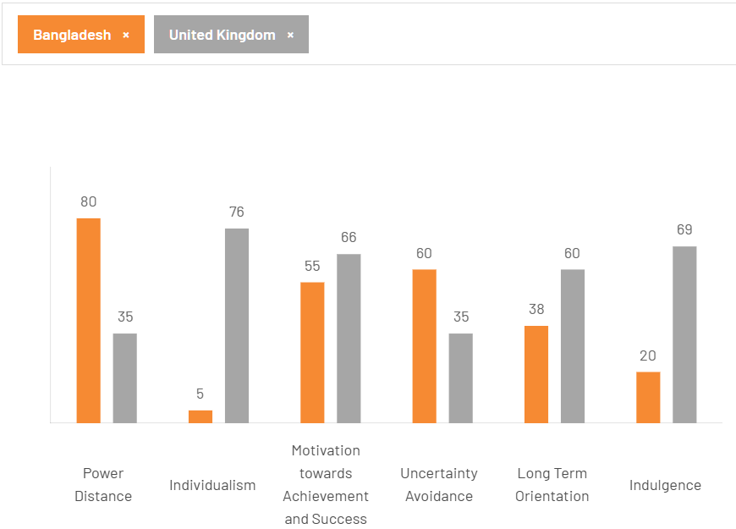
Figure: Hofstede Model Score for Bangladesh and the UK (The Cultural Factor, 2020)
When used the Hofstede model, the UK appears to be more individualistic and low power distance which constantly supports quick adoption of trends as well as open communication. When it comes to Bangladesh, it scores higher on collectivism and power distance which is characterised by high social conformity and respect for authority. As a result of this, local campaign remains to be effective because of community influencers, however, due to slow rapid adoption of new products, the traditional products emerge as victorious (Prothom Alo, 2018).
Favourable: Group values and traditions are more in favourable side in Bangladesh which helps it leverage personal identity that any brand will have created whereas in the UK, the scenario switches to that of an indulgent and individualistic society.
Unfavourable: There are differences in cultural dimensions which ultimately complicate the global branding consistency for any company willing to operate in both of the countries. Moreover, due to risk misalignment with local values, companies may run into constant uncertainties (Prothom Alo, 2018).
Advantages: Now, the advantage of using the Hofstede’s Cultural Dimensions framework is that it provides a clear and robust structure which can be utilised to effectively curve out a roadmap. Moreover, it has greater impact on the understanding of global conflicts and the cultural differences.
Disadvantages: It considers all nations to be the same and thus oversimplifies the process of understanding different cultures. More importantly, the framework considers all people within a country to be same which may not be the case as there are always variety of ethnicities in a country.

Technological Factors
The UK is one of the forerunners in terms of digital transformation as well as advanced retail analytics and omnichannel platforms. Due to the infrastructural advancements, the companies are quite advantageous to undertake targeted campaigns and execute operations efficiently. From the historical perspective, Coca-Cola has been leveraging these digital tools which is quite evident in its loyalty programs, social media engagement and real-time analytics (Beaming, 2025). In Bangladesh, internet access is spreading throughout the country with e-commerce still rising but digital infrastructure still remains to be a point of disparity in the rural areas. The use of digital media is increasing, but traditional channels still dominate in the semi-urban and rural areas.
Favourable Factor: The UK is equipped with cutting-edge technology adoption which is enabled by its omnichannel marketing by the company (Beaming, 2025).
Unfavourable Factor: Digital divide is still quite at large in Bangladesh with uneven technology access, especially in rural areas.

Environmental Factors
The UK is an environmentally rigid country in terms of regulations, sustainable sourcing, bottle recycling, carbon reduction as well as water stewardship. Moreover, with the changing climate and circular economy, the pressure on the MNC brands is also increasing for which Coca-Cola has been recycling and undertaking green initiatives largely. In Bangladesh, the regulations are tightening, however, they are still not quite widespread. Enforcement is still developing but MNC firms are expecting to be setting the standards for which Coca-Cola is also responsible (World Bank, 2025).
Favourable Factor: The UK has clear requirements and incentives for its sustainability measures.
Unfavourable Factor: Bangladesh is less developed in terms of regulations and resource management; however, the enforcement is getting better, creating pressure on Coca-Cola to set the standards (World Bank, 2025).

Legal Factors
The UK has very strict legal standards which cover a lot of the aspects which any company uses to operate legally there including food safety, advertising, consumer protection as well as sustainability. As Coca-Cola is one of the most popular brands, it faces frequent audits on labelling, nutritional information as well as advertising which are targeted towards children mostly. Again, the current standard is GDP compliance as well as carbon neutrality which is being targeted by most of the companies. In Bangladesh, the legal regulations are focused on compliances for import, product labelling as well as business laws. In this regard, Coca-Cola needs to remain agile in being compliant with the existing regulations (Al Jazeera, 2024).
Favourable Factor: The UK has one of the most rigid and robust consumer protection.
Unfavourable Factor: Bangladesh does not still have regulatory consistency with very fast-changing laws but there are still regulatory capacity gaps (Al Jazeera, 2024).

PESTEL Comparative Analysis: Similarities and Differences
With stable outlook for both the countries’ macroeconomics, investments are rising with increasing challenges for the company to operate due to varied reasons. The UK has major advantage in terms of economic and institutional maturity but the complexities arising from legal and environmental challenges create obstructions for Coca-Cola to operate effectively in the UK. As for Bangladesh, the market mainly relies on price, accessibility and acceptance of traditional brand image. However, as the legal and environmental regulations are still developing, sustainability requirements are still not enough challenging. Regardless, both the UK and Bangladesh are shaped by youth culture, urbanization as well as digital advancements.
Overall, the market for beverage drinks in both the UK and Bangladesh is growing although the markets are growing differently in terms of consumer perception and taste preferences. However, both of the countries still have greater potentiality for Coca-Cola to maintain its dominance in the market and create further value for itself.

Segmentation, Targeting and Positioning Analysis
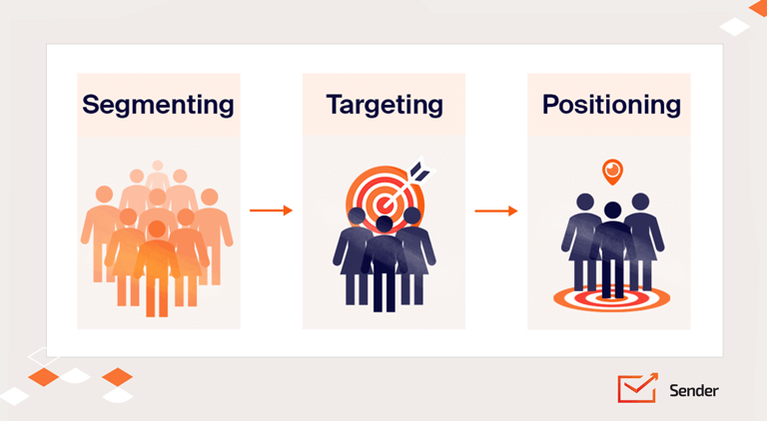
Figure: STP Analysis Framework (Sharma, 2024)

Segmentation Strategy
Segmentation strategy mainly depends on demography, geography and psychography of a particular market’s audience. They are discussed below in terms of the UK and Bangladesh for Coca-Cola.
Demographic: The UK and Bangladesh are segmented by Coca-Cola based on age, income and occupation as well as gender-specific factors. In Bangladesh, gender-specific campaigns are less relevant but for certain products of the company, Coca-Cola still segments on this basis (BoardMix, 2023).
Geographic: In Bangladesh, urban and rural markets are more targeted with various packs of its products as well as pricing, however, in the UK, the focus remains on cities, affluent areas as well as travel and tourism-centric locations, creating further scope of navigation (BoardMix, 2023).
Psychographic: In the UK, the company solely focuses on lifestyle and social status where the company focuses on the brand image as well as the experience associated with Coca-Cola. In Bangladesh, however, the brand is positioned as aspirational instead of lifestyle which aligns with the company more with different festivals, family events and as such (BoardMix, 2023).
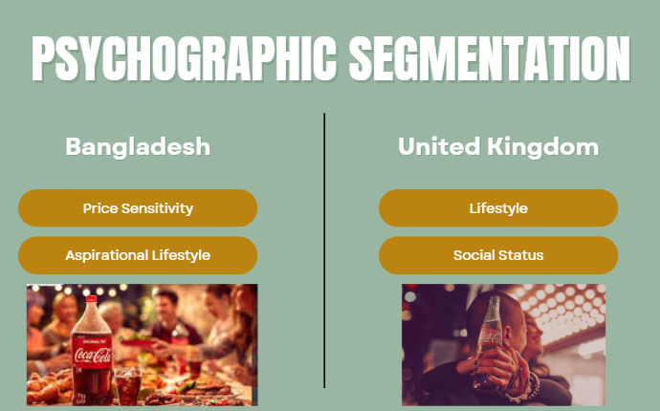
Figure: Psychographic Segmentation of Coca-Cola (Source: Own)
Segment | Demographic | Psychological | Geographic
The UK | Age, Income, Occupation, Gender, Health-Consciousness | Lifestyle Focus, Brand Experience, Social Status | Urban and Affluent Areas, Tourism Hubs, Cities.
Bangladesh | Age, Income, Occupation, Gender being Less Relevant | Aspirational, Festivals, Familial Events | Urban & Rural Areas, Local Markets, Price Sensitivity

Targeting Strategy
In the UK, the company utilises a differentiated marketing strategy, meaning it employs different campaigns for different consumer segments. By using digital data, the company targets audiences through personalization for which products such as Coke Zero have emerged to cater towards specific audiences. Moreover, the use of digital data enables Coca-Cola to target its traditional products towards the mass market even more effectively through on-pack personalization (Business Reporter, 2024). More importantly, Coca-Cola’s access to digital data in the UK helps the company to spot and leverage seasonal and sporting events more fruitfully.
In Bangladesh, the targeting strategy is different for Coca-Cola. Because the company divides its market in Bangladesh on an urban or rural basis, it adapts to differences to make the most out of each of the sections of geographical position. A strategy that Coca-Cola uses is to partner up with prominent local influencers while collaborating with local retail chains for extensive penetration into the market. Again, the company targets various cultural events such as festivals while leveraging its media reach to get to its targeted audiences. Again, because of the Bangladeshi culture, Coca-Cola does not focus much on differentiation and rather focuses mostly on its traditional products for inclusive availability as well as affordability as the income level and the disposable income are significantly lower in Bangladesh than it is in the UK.

Positioning Strategy
The UK is a classic and a modern destination for Coca-Cola where it positions itself as a responsible beverage choice where the company curates its brand image around heritage, health and most importantly, social value. Here, by health, the company focuses on zero or low-calorie promotion of its product. Again, in the UK, the campaigns of Coca-Cola are designed around emotional and ethical messaging around community, togetherness as well as sustainability to attract its audiences more effectively.
In Bangladesh, however, the positioning strategy of Coca-Cola changes drastically where the company poses itself as a symbol of westernization by promoting the modern youth culture through accessible refreshment. Moreover, by catering towards familial and festive moments such as Eid, Puja and others, they cater towards the traditional touch, too. As a result, the cultural resonance for Coca-Cola gets built through the localized slogans and campaigns the company uses regularly and by doing so, the company supports and leverages the community events.

Perceptual Map of Coca-Cola and Others
A perceptual map is an illustration where a company is positioned on a map as to how a company is perceived. In the UK, the company is seen as a classic and more as a premium one in the UK. When it comes to the Bangladeshi market, Coca-Cola’s competitor, Pepsi, is the one which is bolder and trendier than Coca-Cola. But, in both the countries, Coca-Cola has been able to maintain its brand image associated with emotion by resonating with a lot of festivals and events. Now, the perceptual position of the company alongside various competitors in both the UK and Bangladesh is presented below
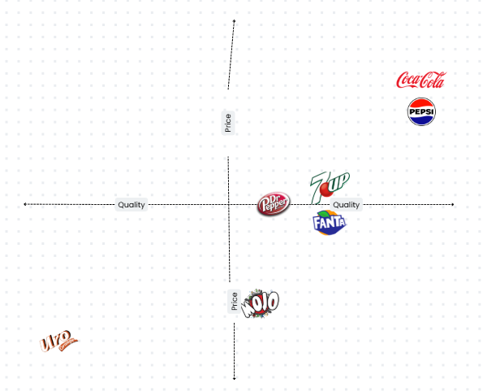
Figure: Brand Perception Map (Source: Own)

Similarities & Differences
In terms of the similarities, the STP for both the countries include the younger targeted consumers as well as urban populations. Moreover, the focus on brand heritage in both the countries remains to be similar. Lastly, the company focuses on heavy festivals and event marketing in both the markets for maximum traction.
Now, when it comes to the differences, the UK campaigns feature personalization, health as well as ethical values. However, when the picture turns to Bangladesh, the company focuses on mass reach, affordability as well as celebrity endorsements or simply known as influencer marketing to cater to the audiences of the market (Business Inspection BD, 2022).
Overall, the two different markets posit two different characteristics, requiring Coca-Cola to adapt to the differences more effectively and proactively so that it can maintain its dominance in both the markets. Lastly, the company remains largely successful in the UK and Bangladesh in maintaining its competitive position by utilising its differentiated STP strategies.

Marketing Mix: 7Ps
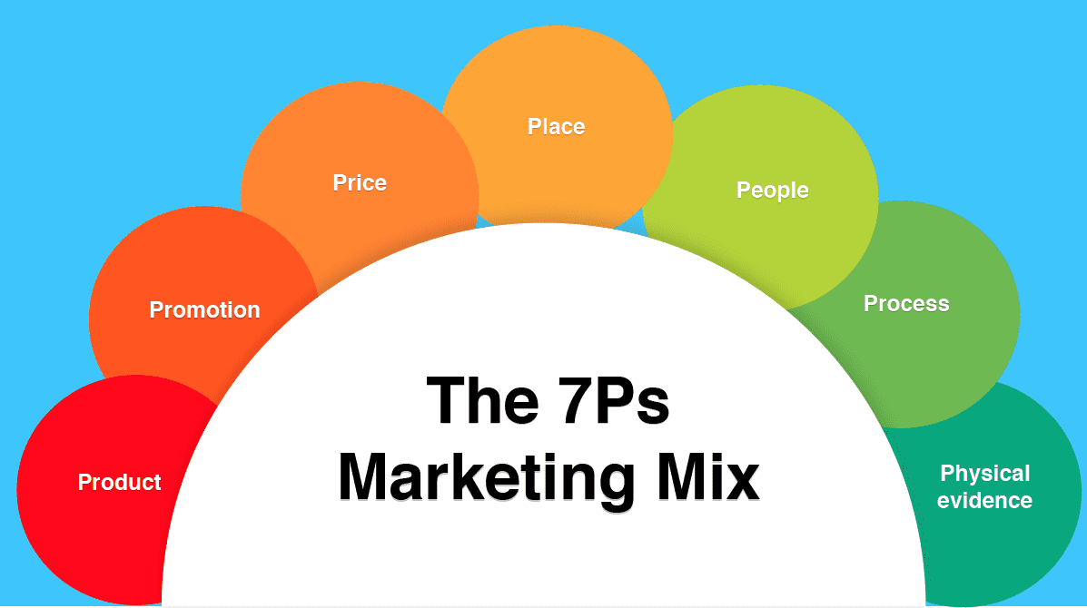
Figure: 7Ps of Marketing Mix (Hanlon, 2023)

Product
In the UK, the major products offered by Coca-Cola in the UK include Classic Coke, Diet Coke, Coke Zero Sugar as well as various forms of flavoured bottled and canned beverages. However, in Bangladesh, the scenario changes quite a bit. The company provides the market with Coca-Cola, Fanta, Sprite as well as some other local adaptations alongside Diet Coke, and Coke Zero Sugar although they are not that prominent in the Bangladeshi market (Statista, 2025).
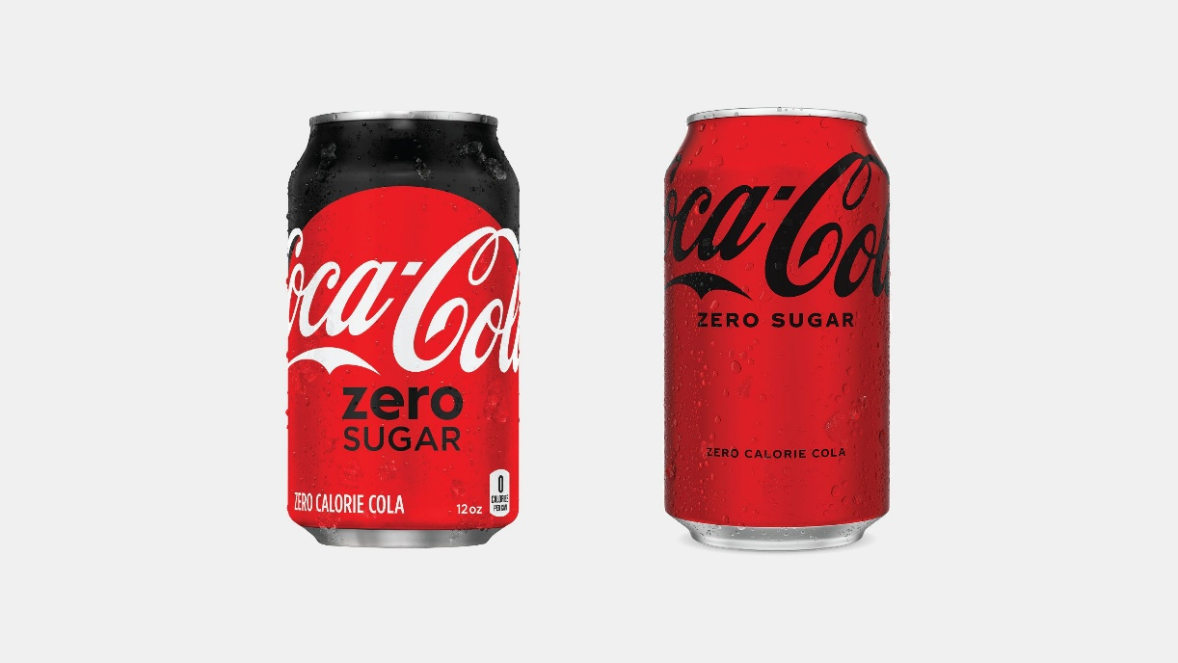
Figure: Coke Zero Product from Coca-Cola (Wiener-Bronner, 2021)
The most important differentiating factor between the UK and Bangladesh is the extent of product differentiation which is higher and more extensive in the UK but not as well diversified in Bangladesh. However, the company is constantly growing the number of differentiating products in Bangladesh, as well.

Price
The pricing in the UK is quite value-based while offering various multi-pack discounts. More importantly, the UK market is a premium one for Coca-Cola for which there are also premium lines in the market. Again, there is frequent number of price adjustments being introduced to the prices due to health taxes and dominant inflation in the UK for the last couple of periods (Statista, 2025). Now, when it comes to Bangladesh, the company focuses predominantly on pricing as the Bangladeshi market is more sensitive to pricing for which the company has to maintain market-penetration pricing. Again, the company provides the market with small-pack options to maintain affordability. However, the pricing changes based on economic volatility and competitiveness. Because there is too much competition in the marketing arising from local products such as Mojo, Clemon etc., the pricing has to be adjusted regularly.

Place
Coca-Cola has very effective distributive capacity when it comes to distributing its products to both the UK and Bangladesh. In the UK, the company utilises the wide range of supermarkets, cafes, restaurants as well as e-commerce so that the products can reach a wide range of customers effectively and fast. Moreover, the company utilises high-penetrative strategies to target urban and tourist-centric areas for broader distribution of its products. When it comes to Bangladesh, the company utilises local stores, tea stalls, rural outlets and as such distribution mediums to reach its intended audience. Moreover, the company partners up with various bottle manufacturers through joint ventures in order to reach the rural arenas for maximum market penetration. More importantly, the company faces many challenges in directly distributing its products to the mass due to the intermediaries, however, the company is working to resolve its supply chain challenges.

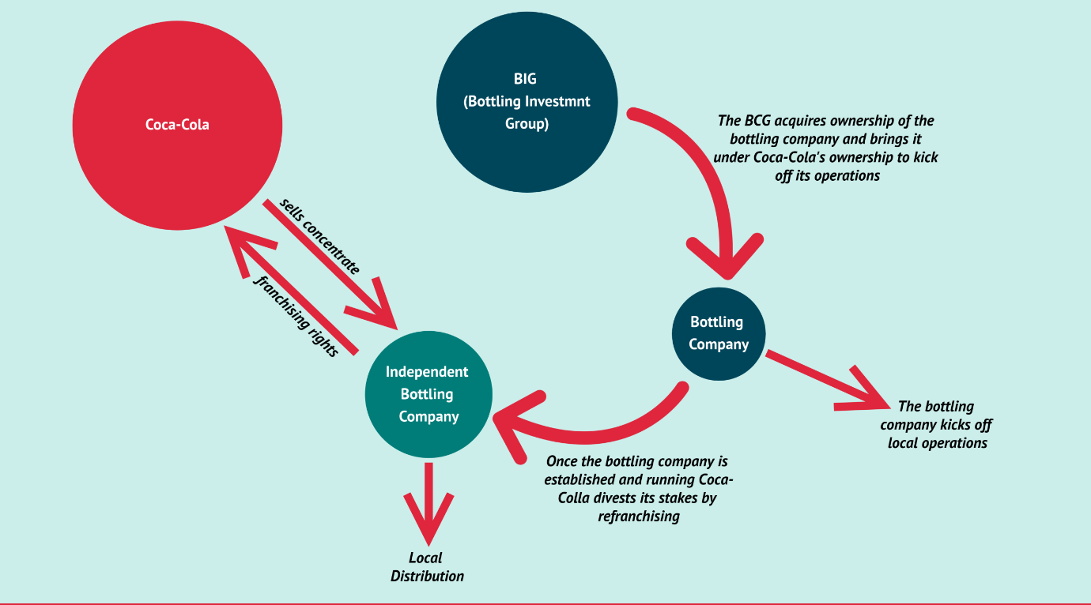
Figure: Distribution Channel Used by Coca-Cola (Cuofano, 2020)
International Market Entry Strategy
The internationalization of The Coca-Cola Company started in the early 1900s when the company made its first export in 1899 to Cuba which marked its first official global journey. However, the major expansion only came once Robert Woodruff took the presidency of the company and established that Coca-Cola needs to be always within an arm’s reach of the customers. Moreover, the company’s global footprint largely accelerated with World War 2 when President Robert Woodruff pledged to supply Coca-Cola to American service personnel wherever they are stationed at no cost to be borne by the country which led to the company establishing 63 bottling plants around the world and marked a significant event for the company’s international foray (Pivot, 2025).
Market Entry into the UK:
Advantage: As for the market entry method, the company utilises partnerships with bottling operations through the Coca-Cola Europacific Partners or CCEP in the UK. In the UK market, the company uses various tools such as mergers, acquisitions, collaborations with the retail chains etc. to ensure of greater presence in the market.
Disadvantage: It requires substantial investments in the building of an effective system and extensive maintenance cost to keep the system running.
Market Entry into Bangladesh:
Advantage: As for the Bangladeshi market, the company entered into the market through imports, however, due to cost constraints, the company went into franchising to local bottlers which now is the International Beverages Private Limited or IBPL. It is the major franchisee for Coca-Cola which has been established through a joint venture (The InCAP, 2022).
Disadvantage: The company cannot have extensive control over its operations as it has to rely on another party to maintain its distribution in the country.
Promotion
The promotional strategy used by Coca-Cola includes using seasonally themed, eco-conscious as well as health-centric advertising using its products such as Coke Zero Sugar for its premiumness in the UK market. More importantly, the company uses digital media, personalization, experiential marketing as well as cultural sponsorships to establish its brand presence in the market for its legacy and premium branding. However, in Bangladesh, the company uses mass media campaigns more than digital campaigns including TV and Radio campaigns. Moreover, Coca-Cola uses local event sponsorships more often than not in order to maintain its presence in the market and cater to the culturally aware audiences. In the country, the implementation of celebrity marketing is quite high for which the company uses cultural contents in order to promote its presence. On top of that, as the use of social media is on the rise, the company is also focusing on that part, however, the current level of marketing is now enough individualized (The Daily Star, 2025).

People
Coca-Cola employs trained staffs at all events and also in the retail channel with ongoing staff and stakeholder engagement to ensure of achieving the sustainability goals in the UK. Moreover, the company always ensures of diverse and inclusionary hiring practices for achievement of highest possible sustainability results and long-term brand image. In the Bangladeshi market, as the company has to rely on local agents more often who serve multiple brands at the same time, they may not achieve the highest possible quality to uphold the company’s brand image. However, the company takes CSR initiatives alongside remaining engaged with the communities to achieve greater results in both urban and rural communities while attracting the youth population, as well. Overall, the HR practices in Bangladesh are significantly different than the UK as the company has to rely on local agents instead of having its own trained staffs.

Figure: Number of employees employed by Coca-Cola in Bangladesh and the UK (TBS Report, 2021; CocaCola EP, 2025)

Process
Because of the UK has one of the most advanced technologies in the world, Coca-Cola directly leverages that and uses real-time data use and supply chain integration to ensure of fast and direct customer responses. Moreover, because of the availability of an omnichannel approach by the company, the company can ensure of efficient customer service. On the other hand, in Bangladesh, Coca-Cola is rather focused on distribution efficiency as well as maintaining product quality as the weather in the country is on the warmer side and the supply chain integration is not as robust as it is in the UK. As a result, the company is required to undertake initiatives to navigate through the rough logistics effectively. Overall, the process for the two different countries of Coca-Cola is quite different in terms of how the company maintains its logistics and how it interacts with the distribution channels in the two differing countries (ReportLinker, 2025).

Physical Evidence
In terms of physical evidence, in the UK, Coca-Cola maintains strong visual merchandising, sustainability reporting as well as brand presence in most of the major events across the country for reaching the targeted audience effectively. More importantly, the company now includes instructions for recycling in all of the packages of its products. Now, in Bangladesh, the company is dependent on the franchisee’s bottling facilities to conduct its operations. However, the company does not remain inactive in executing its CSR programs. Moreover, the company ensures that the retail channels maintain displays of the company significantly while maintaining its presence in community activities for ensuring of maximum exposure. In summary, Coca-Cola undertakes a more formal approach in the UK for its physical approach whereas it goes for an informal approach to ensure of its physical presence in Bangladesh (The Daily Star, 2025).
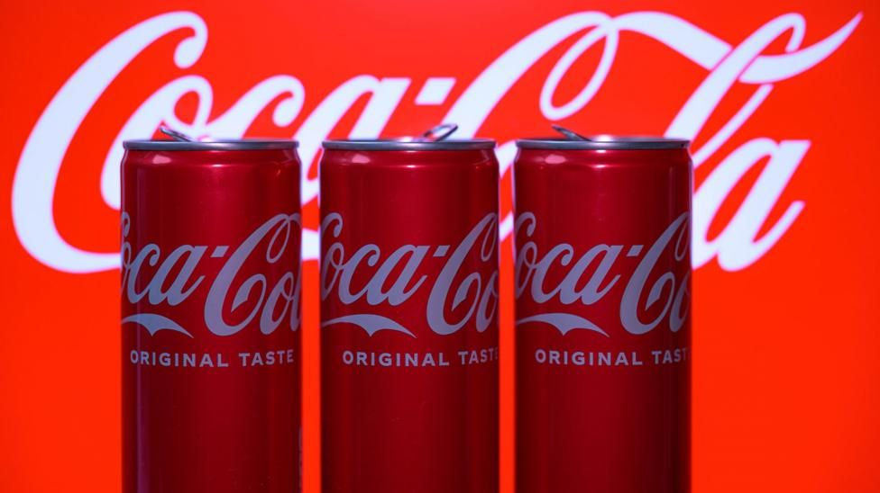
Figure: Cans Offered by CocaCola (Hooker, 2025)

7Ps Similarities & Differences
When compared the two different marketing mix of Coca-Cola for both the UK and Bangladesh, the differences become quite evident. At the core, Coca-Cola maintains its products and brand image similarly in both the markets. However, in the UK, the company integrates an additional layer of creativity and innovation to make up the portfolio and while doing so, the company individually positions each of the products. Moreover, the pricing of its products remains suited to the local economies to maintain market dominance. When it comes to the distribution of its products, Coca-Cola utilises high-tech and multi-channel methods whereas the company focuses on grassroot level expansion in Bangladesh. Again, to promote the products, the company utilises the digital channels more dominantly in the UK but in Bangladesh, the company uses the more traditional tools such as TV, Radio, Festival Engagement etc. Lastly, in terms of sustainability and transparency of its actions, Coca-Cola operates on an advanced level in the UK than in Bangladesh.

Evaluation of Effectiveness for Both Countries

Sales
In the UK, Coca-Cola maintains consistently high market share in the carbonated beverage market. However, the company has had to undergo major product innovation processes through which it has achieved products such as Zero-Calory and Zero-Sugar Coke alongside other eco-friendly ranges of products which have helped the company to drive sales in its premium segment sales (Statista, 2025). However, in Bangladesh, the company focuses on maintaining the sales growth by targeting the urban centres as the local competitors have become very competitive in terms of their market growth and share (Statista, 2025). The sales figure of Coca-Cola in the UK amounted to 2.7b Pounds in 2024, however, there is no data available for the Bangladeshi market (Grocery Gazette, 2025)

Social Media Presence
As the UK has very active and engaging audiences on different social media platforms including X, Instagram, Facebook and others, the company also remains active on these platforms. Moreover, the use of influencers and partnerships helps the company to maintain high reach and interactivity through its campaigns. More importantly, by using various sophisticated tools, the company ensures of real-time monitoring (Business Reporter, 2024). On the other hand, in Bangladesh, the dominance of social media platforms for Coca-Cola is still in the growth stage. By targeting the youth of the country, Coca-Cola is focusing more on its consolidation in the market.
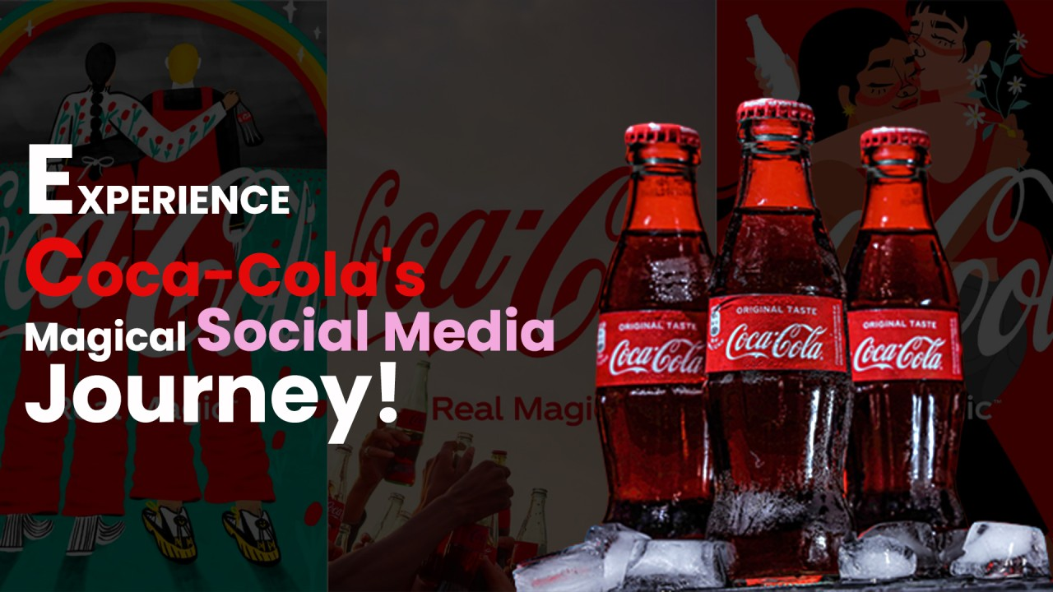
Figure: Social Media Branding of Coca-Cola (Sarkar, 2023)

Customer Reviews & Perceptions
In the UK, there are mostly positive reviews for the products of the company and especially, the company receives support for its sustainability reports. However, there are also criticisms of the company’s focus on sugary contents of its products alongside the price increases.
In Bangladesh, the brand image plays the biggest deal for the company, but as there is high level of price sensitivity, Coca-Cola needs to ensure of correct pricing to remain relevant to its audiences in the country.
Similarity of Both the Countries: In both the countries, the company has to maintain its brand image in order to remain competitive against other major players.
Difference between Both the Countries: In the UK, the company is more focused on its sustainability reports and the use of sugar in its products, however, in Bangladesh, the company is more focused on pricing of the product rather than other areas of concern.

Ethical Issues
Unethical Choice: In Bangladesh, Coca-Cola has recently been questioned for its associated with global geopolitical context and because of religious belief of the majority of the country, the company has faced severe backlashes. More importantly, Coca-Cola is not so active in Bangladesh when it comes to plastic recycling than it is in a more developed country such as the UK. As a result, the company has faced challenges in that regard, as well (The Daily Star, 2025). Overall, the two major areas where the company currently faces backlashes for its unethical approaches and its questionable ethical decisions include its advertising strategies and its marketing mix where it incorporate such elements which are incongruent.
Ethical Choice: In the UK, because of the stricter regulations and implementation of legal requirements as well as the overall consumer behaviour towards unethical brands, Coca-Cola remains to be ethical in its practices in the country.

Recommendations & Conclusion

Recommendations
For the UK market, Coca-Cola should focus on enhancing its responsibility, sustainability and marketing for ensuring of increased transparency for its sourcing of raw materials as well as introduction of more health-conscious products. More importantly, the company should reposition its STP strategies to emphasize on the minority subcultures in cities to offer new campaigns to celebrate the diversity found in the UK and capitalize on it.
For the Bangladeshi market, Coca-Cola must work on deepening its local engagement and invest in sustainable packaging and actually invest in recycling the plastic products back. Moreover, it must introduce more varied and differentiated CSR initiatives, focusing on youth education and water stewardship. This will help the company to achieve its targeted audiences turning into actual customers more easily.

Conclusion
For a company such as Coca-Cola, it has to effectively address both macro and micro elements of the business environment within which it operates for which it can utilise its PESTEL analysis and 7P analysis. As the UK and the Bangladeshi market are significantly different in terms of maturity, innovation extent and economic cycle. This is why the company has to invest more and more in its positioning strategies in different markets and while doing so, the company also must improve on its overall operations to make them more efficient and effective. Ultimately, when Coca-Cola will be able to adapt to the political challenges as well as economic turmoil better in emerging economies such as Bangladesh, it can effectively reach its targeted audience and capture greater share of the market more efficiently.

References
Al Jazeera (2024) 'Coca-Cola ad in Bangladesh sparks backlash for denying ties with Israel', 12 June. Available at: https://www.aljazeera.com/news/2024/6/12/coca-cola-ad-in-bangladesh-sparks-backlash-for-denying-ties-with-israel [Accessed 29 Oct. 2025].
Attest (2024) '2024 UK consumer trends report'. Available at: https://www.askattest.com/wp-content/uploads/2024/01/2024-UK-Consumer-trends-report.pdf [Accessed 29 Oct. 2025].
Beaming (2025) 'How are UK businesses driving digital transformation?'. Available at: https://www.beaming.co.uk/insights/how-are-uk-businesses-driving-digital-transformation/ [Accessed 29 Oct. 2025].
BoardMix (2023) 'Coca-Cola Segmentation, Targeting, and Positioning'. Available at: https://boardmix.com/analysis/coca-cola-segmentation-targeting-and-positioning/ [Accessed 29 Oct. 2025].
Business Inspection BD (2022) 'Top Beverage Companies in Bangladesh'. Available at: https://businessinspection.com.bd/top-beverage-companies-in-bd/ [Accessed 29 Oct. 2025].
Business Reporter (2024) 'The impact of technology on UK's business environment'. Available at: https://www.business-reporter.com/digital-transformation/the-impact-of-technology-on-uks-business-environment [Accessed 29 Oct. 2025].
Coca-Cola (2024) Coca Cola Mission Statement 2024 | Coca Cola Mission & Vision Analysis. Available at: https://mission-statement.com/coca-cola/ (Accessed: 22 October 2025).
CocaCola EP (2025) Great Britain. [online] Great Britain. Available at: https://www.cocacolaep.com/gb/ [Accessed 30 Nov. 2025].
Cuofano, G. (2020) Coca-Cola’s Business And Distribution Strategy In A Nutshell. [online] FourWeekMBA. Available at: https://fourweekmba.com/coca-cola-business-strategy/ [Accessed 30 Nov. 2025].
FDF (2025) 'State of Industry Report Q4 2024'. Available at: https://www.fdf.org.uk/fdf/business-insights-and-economics/state-of-industry-report-q4-2024/ [Accessed 29 Oct. 2025].
Grocery Gazette (2025). Coca-Cola Europacific sales fizz following price hikes. [online] Grocery Gazette - Latest Grocery Industry News. Available at: https://www.grocerygazette.co.uk/2025/02/14/coca-cola-sales-fizz-2/ [Accessed 30 Nov. 2025].
Hanlon, A. (2023) How to Use the 7Ps Marketing Mix. [online] Smart Insights. Available at: https://www.smartinsights.com/marketing-planning/marketing-models/how-to-use-the-7ps-marketing-mix/ [Accessed 16 Nov. 2025].
Hooker, L. (2025) Coca-Cola recalls drinks in UK due to chemical levels. BBC News. [online] 29 Jan. Available at: https://www.bbc.co.uk/news/articles/czxkn393rwwo [Accessed 30 Nov. 2025].
J.Sheld (2025) 'Bangladesh in 2025: Political and Economic Landscape Analysis', J.Sheld Insights. Available at: https://www.jsheld.com/insights/articles/bangladesh-in-2025-political-and-economic-landscape-analysis [Accessed 29 Oct. 2025].
Pivot (2025) The Legendary Story of Coca-Cola. Available at: https://pivot.uz/from-a-small-pharmacy-to-a-global-company-the-legendary-story-of-coca-cola/ (Accessed: 22 October 2025).
Prothom Alo (2018) '6-D model of culture and Bangladesh'. Available at: https://en.prothomalo.com/opinion/6-D-model-of-culture-and-Bangladesh [Accessed 29 Oct. 2025].
Pung, E. (2020) Famous logos: Part VIII — Coca-Cola. [online] sviiter.agency. Available at: https://medium.com/sviiter-blog/famous-logos-part-viii-coca-cola-4fce82bf5fb5 [Accessed 16 Nov. 2025].
ReportLinker (2025) 'UK Beverages Market Report- Q4 2024'. Available at: https://www.reportlinker.com/dlp/b187f696e91c5687f5ff9cf14323c1f1 [Accessed 29 Oct. 2025].
Sarkar, A. (2023) Sparkling Success: Unraveling Coca-Cola’s Social Media Marketing Magic. [online] Medium. Available at: https://medium.com/@the_digital_marketer/sparkling-success-unraveling-coca-colas-social-media-marketing-magic-24de20b69079 [Accessed 16 Nov. 2025].
Segura, E., Belmonte, L.M., Herrera, R.M. and Somolinos, J.A. (2023) A Strategic Analysis of Photovoltaic Energy Projects: the Case Study of Spain. Sustainability, 15(16), pp.12316–12316.
Sharma, S. (2024) STP Analysis. [online] Linkedin.com. Available at: https://www.linkedin.com/posts/saatvik-sharma-a39389314_in-digital-marketing-stp-stands-for-segmentation-activity-7269312100294955008-Bgqg [Accessed 16 Nov. 2025].
Statista (2025) 'Beverages - United Kingdom | Statista Market Forecast'. Available at: https://www.statista.com/outlook/emo/beverages/united-kingdom [Accessed 29 Oct. 2025].
Statista (2025) 'Consumption Indicators - Bangladesh | Market Forecast'. Available at: https://www.statista.com/outlook/co/consumption-indicators/bangladesh [Accessed 29 Oct. 2025].
TBS Report (2021). Coca-Cola creates 22,000 jobs in Bangladesh. [online] The Business Standard. Available at: https://www.tbsnews.net/economy/corporates/coca-cola-creates-22000-jobs-bangladesh-264478 [Accessed 30 Nov. 2025].
The Coca-Cola Company (2025) Coca-Cola Company Purpose Summary. Available at: https://www.coca-colacompany.com/content/dam/company/us/en/homepage/homepage-images/pdfs/coca-cola-company-purpose-summary.pdf (Accessed: 22 October 2025).
The Cultural Factor (2020) Country comparison tool. [online] Theculturefactor.com. Available at: https://www.theculturefactor.com/country-comparison-tool?countries=bangladesh%2Cunited+kingdom [Accessed 16 Nov. 2025].
The Daily Star (2025) 'Business climate improves, but remains challenging', The Daily Star, 16 Oct. Available at: https://www.thedailystar.net/business/news/business-climate-improves-remains-challenging-4012156 [Accessed 29 Oct. 2025].
The InCAP (2022) The Journey of Coca-Cola Bangladesh. Available at: https://theincap.com/the-journey-of-coca-cola-bangladesh/ (Accessed: 22 October 2025).
Wiener-Bronner, D. (2021) Coke is giving one of its most popular drinks a makeover. [online] CNN. Available at: https://edition.cnn.com/2021/07/13/business/coca-cola-zero-sugar-new [Accessed 30 Nov. 2025].
World Bank (2025) 'Bangladesh Overview: Development news, research, data'. Available at: https://www.worldbank.org/en/country/bangladesh/overview [Accessed 29 Oct. 2025].

