DR. PAUL JENKINS LECTURER
M.FOSTER – 1807714 – LONDON OVAL

Managing Projects in the Organisation
BMSW5104_LON.

Table of Contents

Introduction
- Project Management Techniques
- The Agantty Tool
- The Toggl Tool
- Project - Libre
The Implementation of the project in the workplace
Communication with stakeholders Plan & Organise
Scheduling
Closing the project `
Risk Management

Introduction
As people we are constantly doing various small projects every day in our daily lives without even realising that we are doing it, A project is simply a planned way of making something or doing something. With that in mind, this report will look into how doing something within an organisation on a larger scale is structured, a project management within an organisation requires five initial stages: what will be covered in a project (Scope), what will be used (Resources), task that are to be done and when (Time), the standard of the project and allowance of deviation (Quality), what could happen that will delay project plan and how will plan recover (Risk) all these stages have to be considered and put in place, in order for the project to be managed properly. The organisation used in this report is Rush who are a small family owned courier delivery driver company, whom have been competitive in this service industry for over 10 years. The project in this report will look at task where work has been outsourced to them to deliver on one particular day, for a potential customer, a 1500 parcel roll out within two-time frame slots, AM delivery and PM delivery.
Project Management Tools & Techniques
In today’s market there are many management software tools available and depending what suits your organisations or your requirements, it is worth looking and comparing what is out there as management tools have various techniques:

1.The Agantty Tool
With this project management tool, you can organize and plan an unlimited amount of projects, tasks and teams on the basis of a Gantt-chart. You can administer an unlimited amount of teams and tasks with a single account, as well as look up your To-Dos on a neat dashboard.
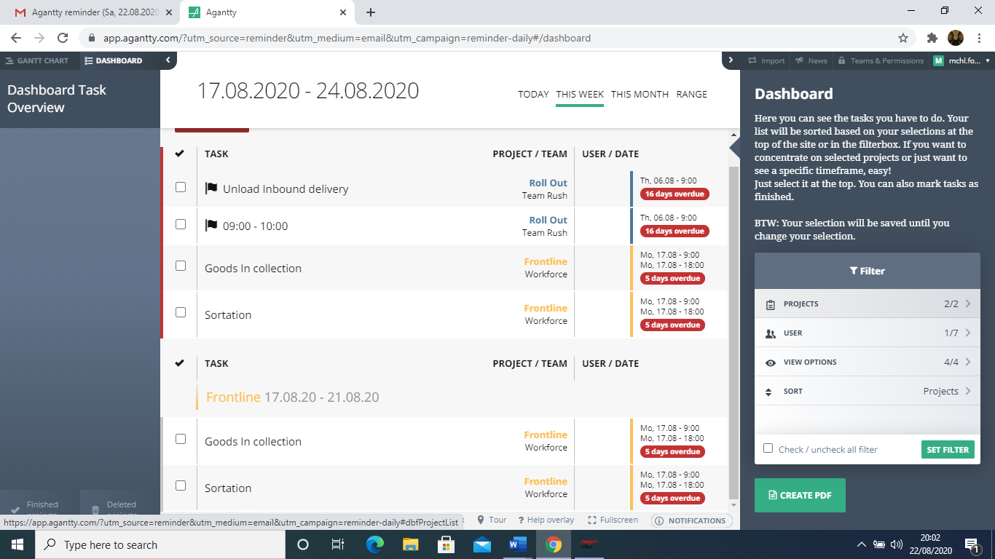
Figure:1
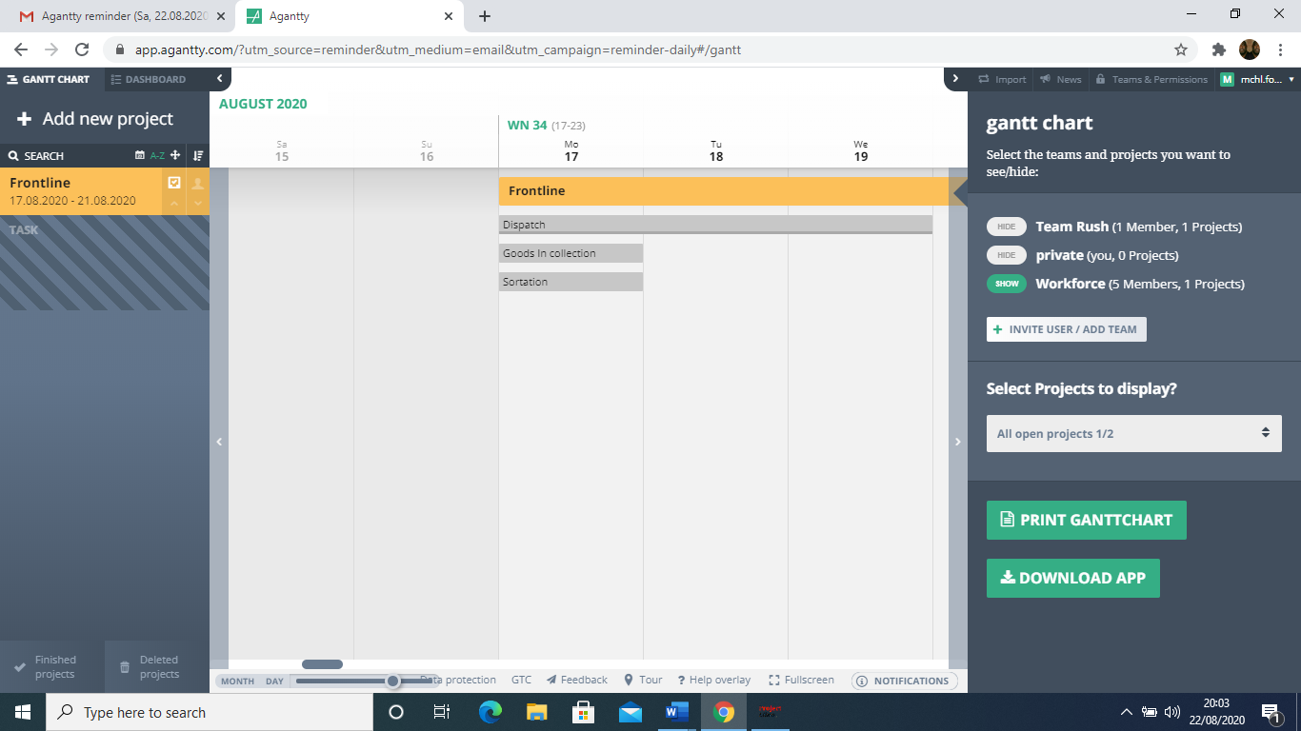Figure:2
2. The Toggl Tool
Toggl Plan is an effective project management tool to automate your task delegation process and visualize which project tasks have been completed, and which has not. If your team often collaborates with other departments on projects, this might be a useful tool for you.
Features include Gantt-chart visualization to track important deadlines and projects Integrations with Slack, Github, Evernote, and others. Team collaboration option through shared calendars and task notes
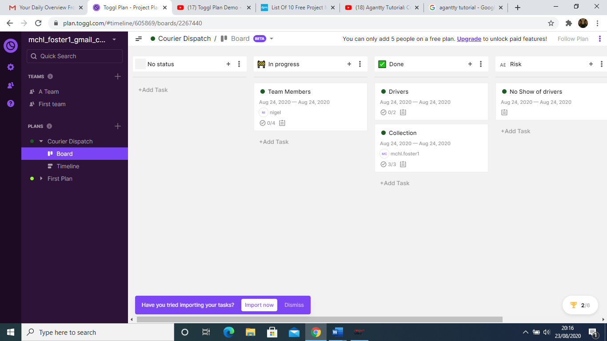
Figure:3 Figure:4
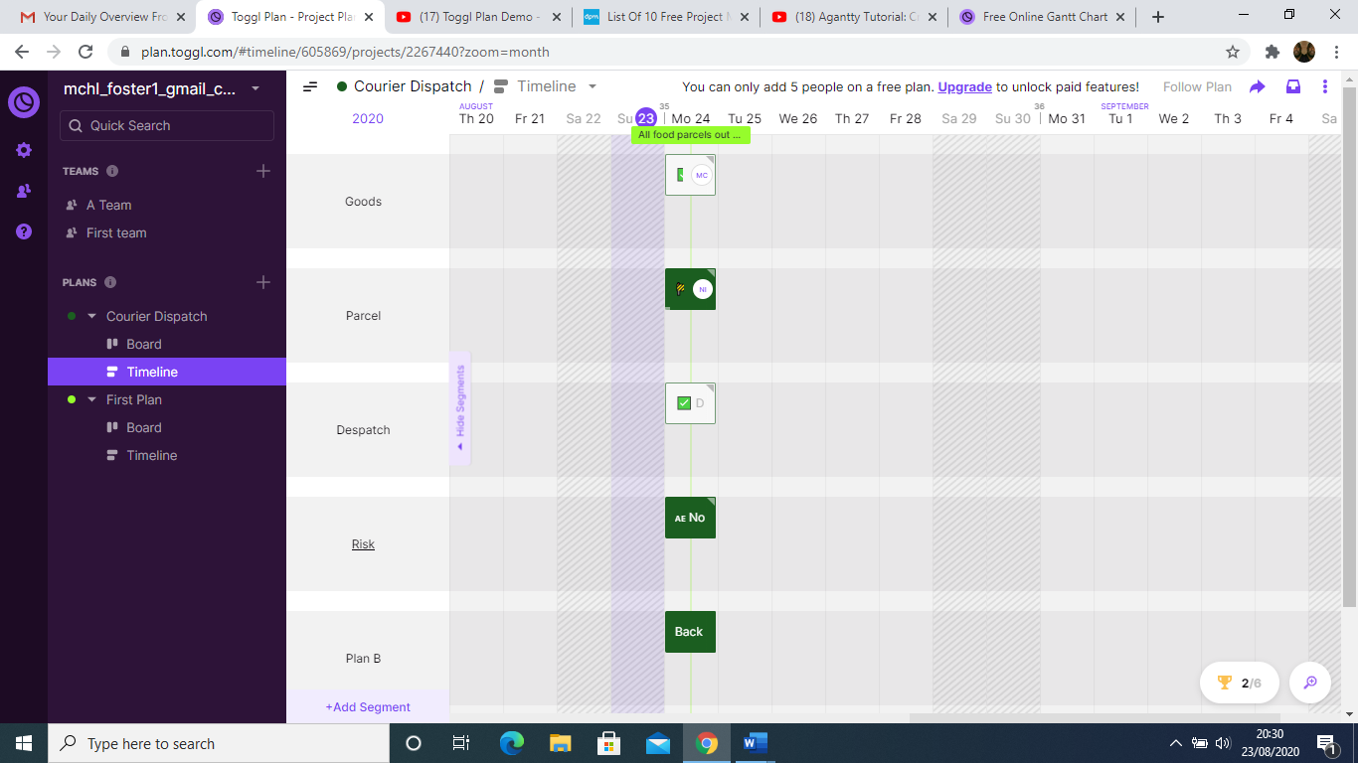
3. The Project Libre Tool
ProjectLibre is an open-source management project solution that gives options to Microsoft Project desktop Fundamentally considering areas, for example, government, non-benefits and little offices, it offers items involving ProjectLibre Cloud and ProjectLibre venture. With key highlights including Gantt outlines, arrange graphs, WBS/RBS diagrams, earned-esteem costing, organize chart, asset histograms, multi-venture asset pools and histograms. Furthermore, it gives basic procedures to making venture plans, including an indented task rundown or work-breakdown structure. (Projectlibre open source | Project - libre, 2020).
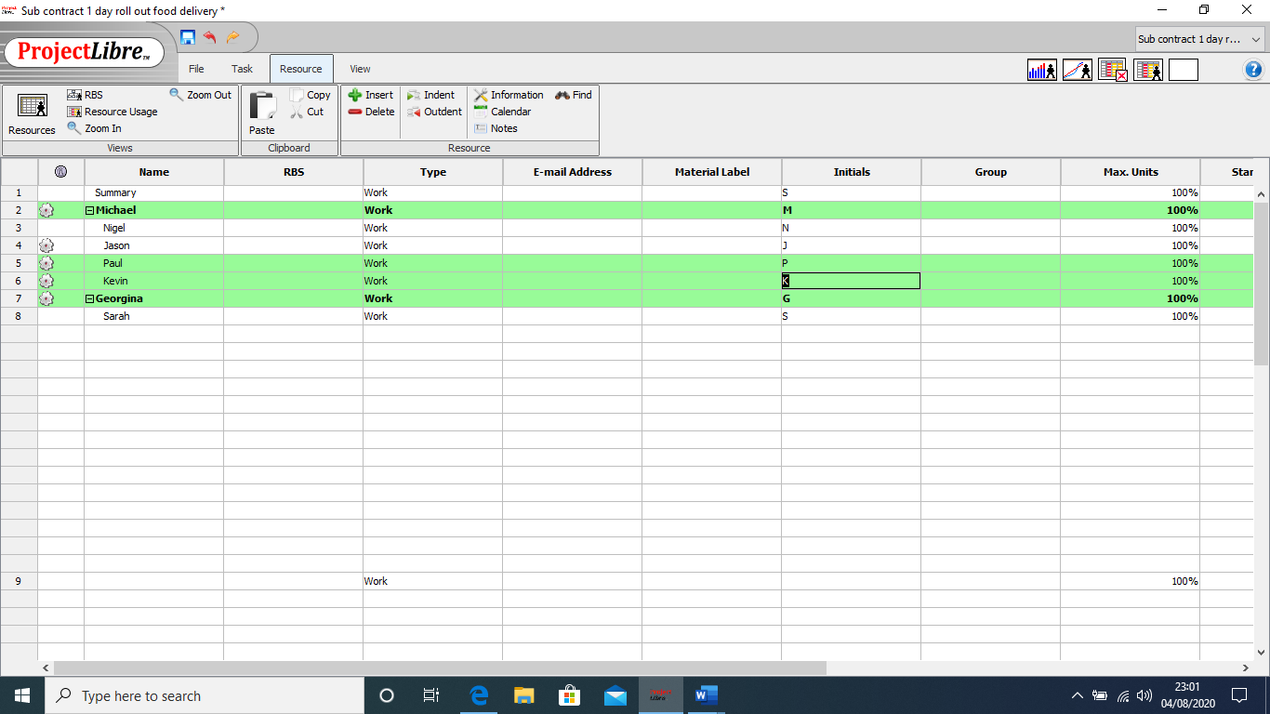
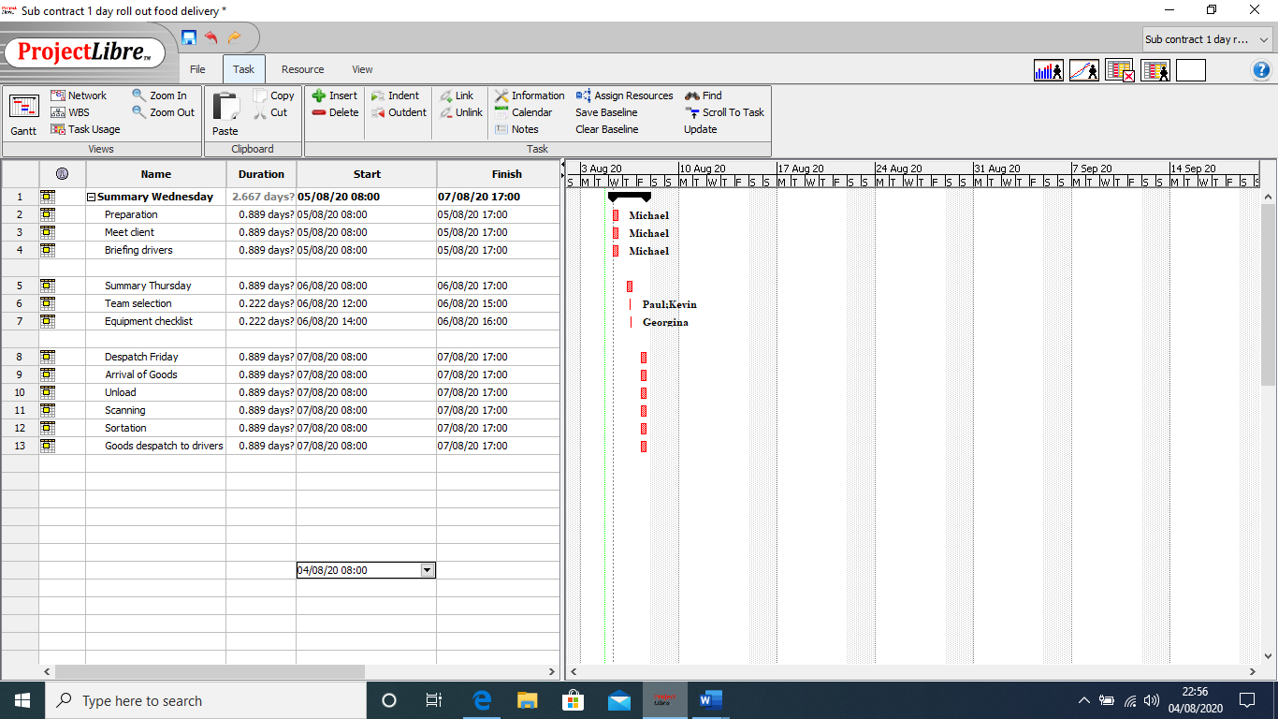
Figure:5 Figure;6
Figure:7 Project Management comparison chart
 | FREE DOWNLOAD OR ONLINE | GANTT  CHART | WBS  CHART | CRITICAL  PATH | HOURLY  TASK | DAILY  TASK | RBS  CHART
PROJECT  LIBRE | FREE |  |  |  | X
AGANTTY PLAN | ONLINE |  |  |  | X |  | X
TOGGL PLAN | ONLINE |  |  |  |  |  | X

The Gantt chart in all the above is simple and effective to use. The horizontal bars on the Gantt chart shows how dependant the timing is with the task so it can be completed. It allows planning time and resource management and provides indication on how long the project will take start to end. Research shows “Gantt Charts are the favourite project plan representation because it’s really easy to view.” (Smith, T., 2016). There are mixed reviews on this statement mutually Journal suggests Gantt Charts are losing their popularity, it argues that Gantt Charts pull a project manager’s focus aloof from the project and onto just making graphs look pretty and not matching the real objective. (Asoravala,2006). Others claim that the charts are created only to please higher organisations and therefore a distraction to the actual project. The Gantt Chart does not give costing detail, nor does it make replica plans, so would then need to be revised accordingly, the horizontal bars are not an indication that more resources are required. for instance, a bar may appear shorter compared to a different task it's going to require more resources than the longer bar which can only require one person to hold out the task. Critical path method (CPM) and the program evaluation and review technique (PERT) are other familiar techniques.

The Implementation of the project within the workplace.
The project being implemented at the workplace will be carried out by myself and a team of four, it’s a project from a potential customer who has outsourced some deliveries to us to further see if a partnership can be developed in the future. The customer has asked that 1500 boxes of prepacked food is collected from their premises and delivered to customers in the East of London within two time slots, that being AM delivery (9 – 12) & PM delivery (2pm – 6pm)

Start of Project & Stakeholder Communicating

End of Project delivering service
Project
Cycle
Plan, Organise & Control

Execution – Carrying out & Managing the work

Figure:8

Communication with stakeholders
To ensure the stakeholders are informed of project’s progress, a line of communicating needs to be in place. The stakeholders are the project manager, The warehouse team, The Admin team, Our Client and the customers. This element of the plan includes the processes required to create sure, timely and appropriate collection, distribution, storage, retrieval and supreme disposition of project information. In the Journal of Change Management (2004) Goodman and Tuss emphasise that employees need communication during times of change, by keeping them informed will reduce uncertainty.
Plan & Organise
Project – Delivering food boxes

Collection Sortation Despatch
Boxes delivered to Boxes scanned Boxes loaded on
Warehouse & sorted drivers for delivery
Sortation of parcels - Scheduling
This is where the project execution is administered, whilst procuring resources and managing stakeholders. Controlling/monitoring happens during this phase. the standard is monitored likewise as a scope creep, time allocations are watched. By following the project plan from the design stage, this may allow the project manager to match the achieve the project milestones and Gantt Chart/ Pert to confirm that tasks are being completed in timely manner and quality standards. Weekly calls and emails updates to be held between project manager and therefore the stakeholders, at each stage of the project. this can allow the Project Manager to speak and address issues. Once execution phase is complete, a phase review will happen to confirm that the project has met all planned objectives before entering the closure phase.
Despatch - Closing
We have delivered our services and got a result; however, this doesn’t mean the project is over. A formal sign-off from the customer on the delivered deliverables is required, only then thz project can be declared complete.

Risk Management
4a. dispatch drivers not turning up

I WAS UNABLE TO FINISH DUE TO PERSONAL PROBLEMS WITH MY FATHER SEVERE ILLNESS DURING THE ENTIRE TIME ON THIS COURSE. I HOPE I AM PERMITTED TO CONTINUE AND SHOW A BETTER PERFORMANCE.

