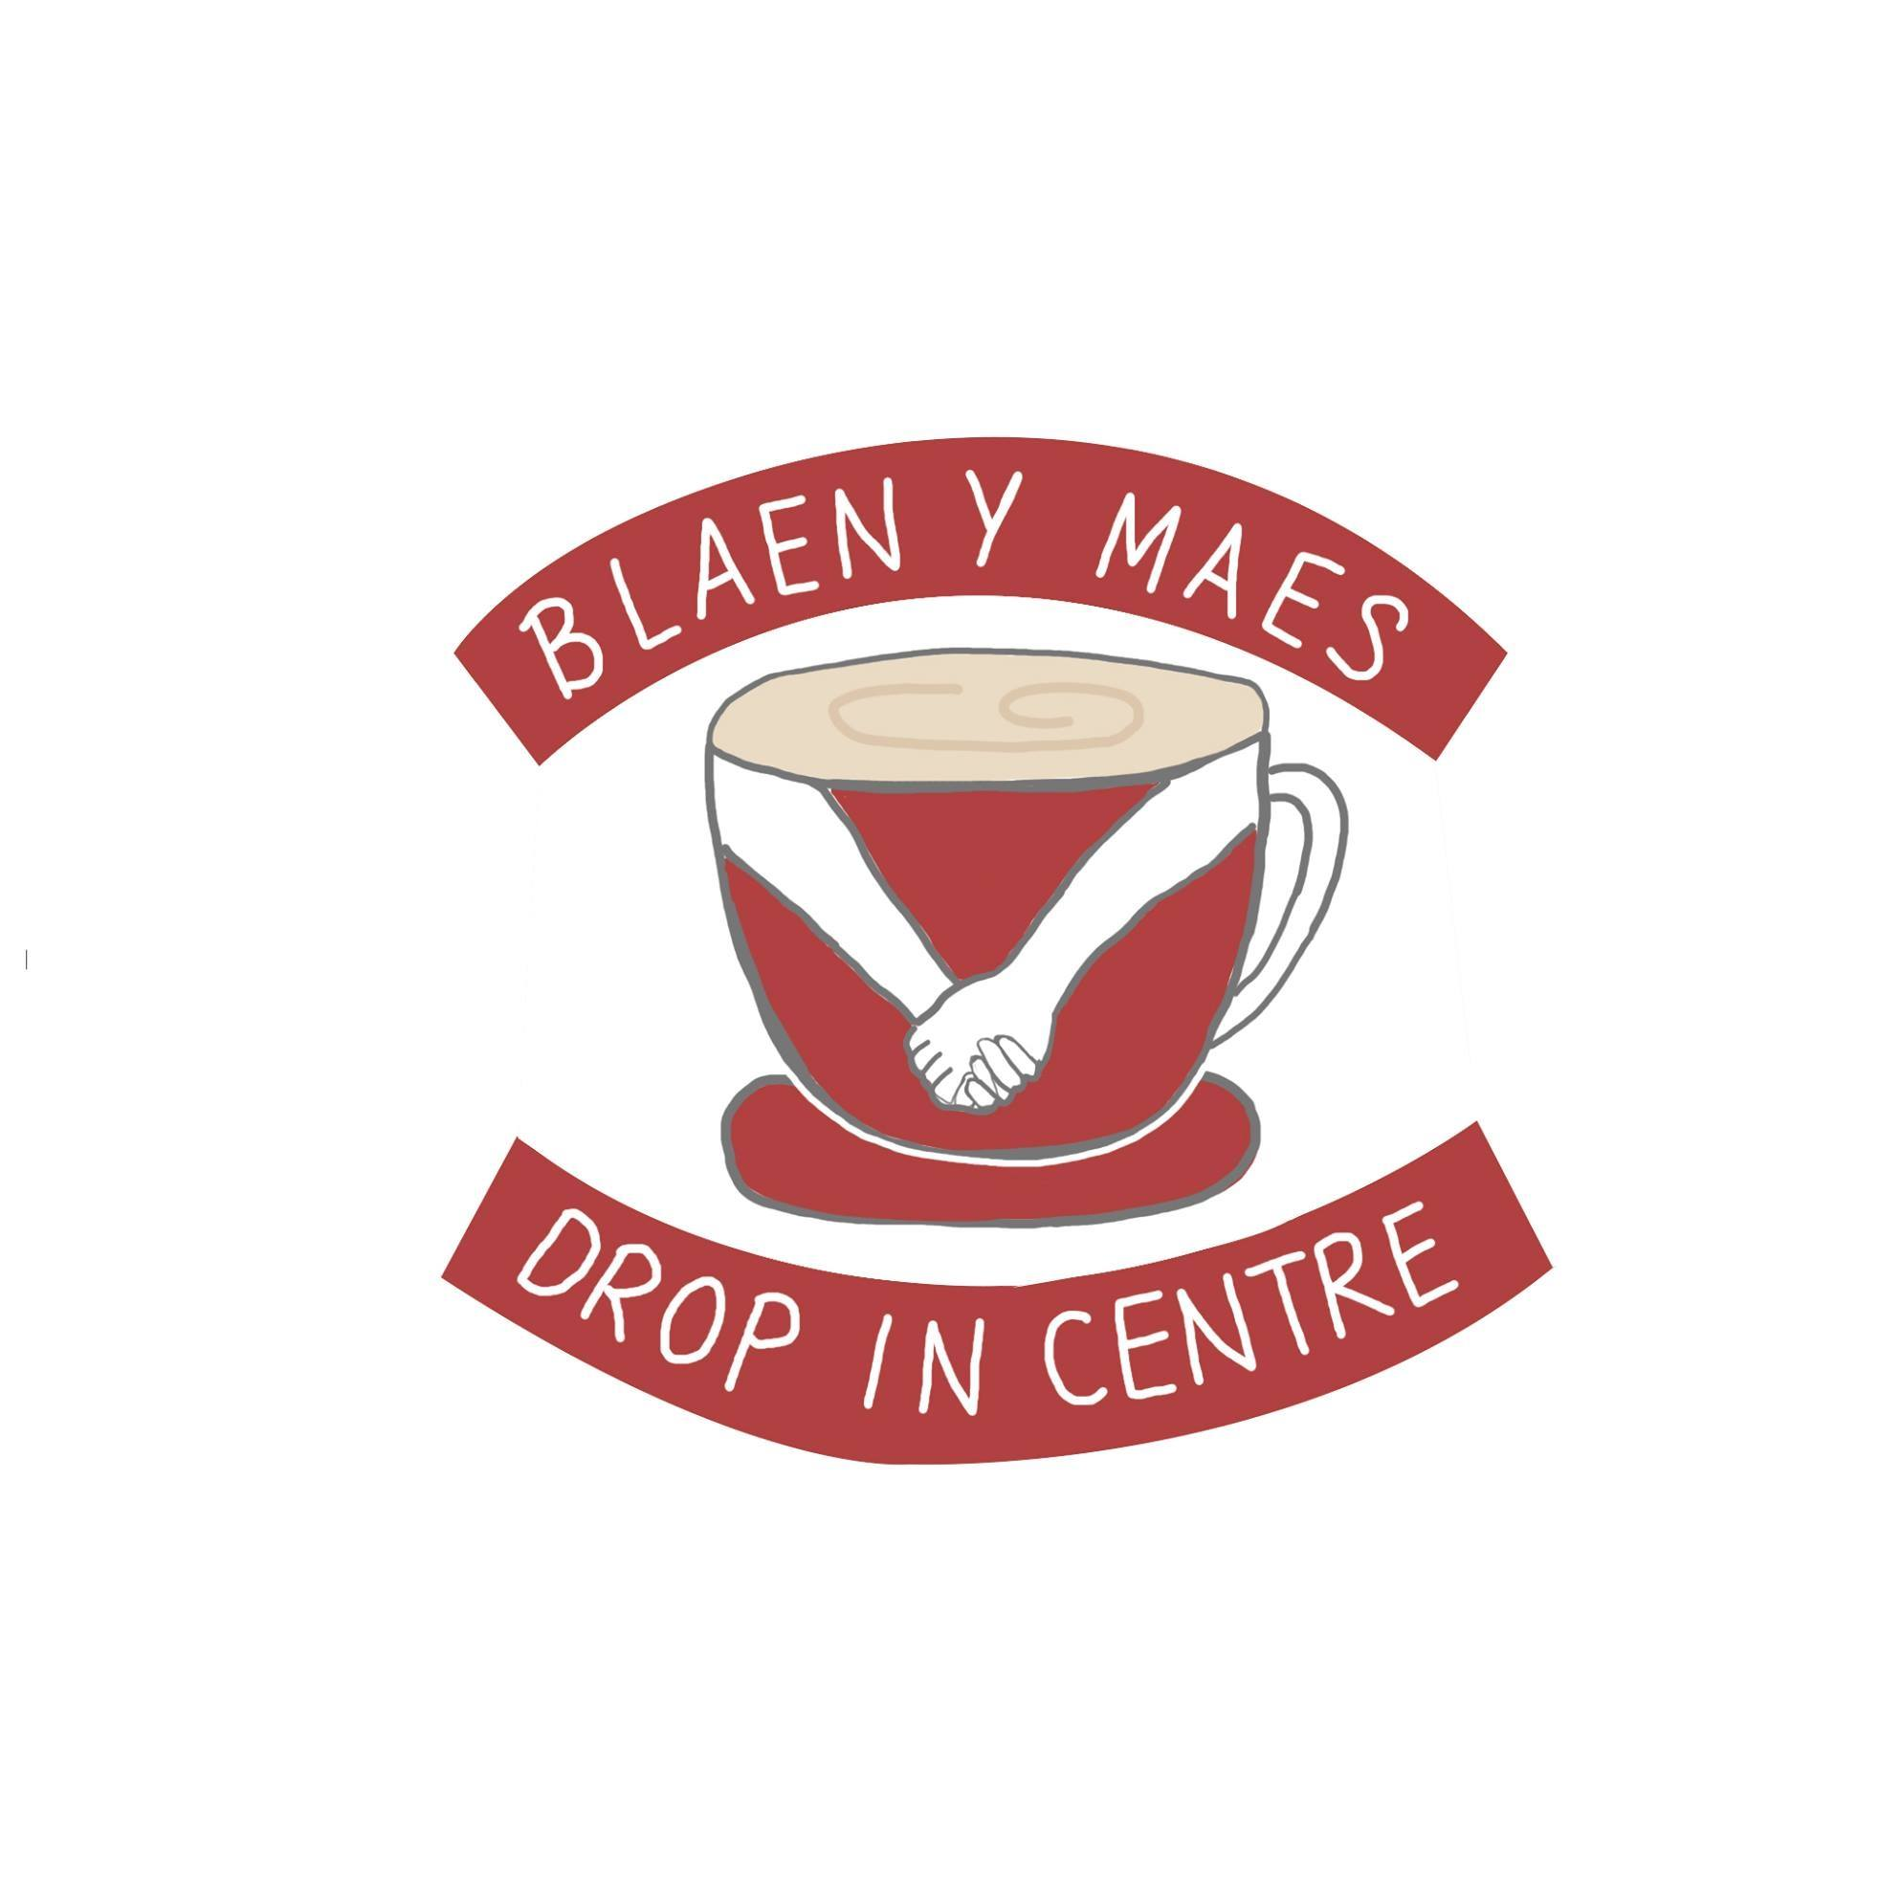
Volunteering Portfolio
JAN 2023
ECPS5010

Table of Contents

Reflective Commentary……………………………………………………………………………………3
References……………………………………………………………………………………………………….6
Portfolio of Evidence………………………………………………………………….……………………7
Evidence 1: Reflective Logs………………………………………….………………………………….7
Evidence 2: Engagement in Teamwork………………………………………………………….10
Evidence 3: Photos of Engagement…………………………………………………………….…11
Appendix……………………………………………………………………………………………………….13

Reflective Commentary
Using the Gibbs Reflective Cycle (1998) I will be reflecting on my time spent at a volunteering placement and how I was able to utilise the core counselling skills which I have learnt throughout my time studying Psychology and Counselling.
I started searching for an appropriate volunteering placement, I wanted to go somewhere that would be beneficial to the type of work I would want to do in the future, my interests being working with families or women. Unfortunately, out of the three placements I reached out to two were unable to provide placements and another I did not hear back from. I then spoke to my module lead about possible placement and if they were able to help me in finding somewhere suitable, this is when the module lead suggested spending my time at the Blaen Y Maes Drop-in Centre. My module lead then set up a time I was able to go down and meet the staff at the drop in centre and to find out what their role is and what services they provide. The Blaen Y Maes Drop-in Centre is a not-for-profit community organisation, that runs services such as, food bank, food share and a community clothing store where anyone can purchase items as little as 10p, as well as this they also run activity days for families, adults, and children (Blaen Y Maes Drop-in Centre, n.d.).
When I first started to think about potential placements, I was nervous, this was down to worries of finding somewhere suitable and nervous about having to work with potentially emotionally vulnerable people. I think my biggest worry was making sure that I could use all the skills I have learnt in the counselling module and be able to make anyone feel comfortable if they were to open up to me, as I find in the past, I have been anxious when speaking to new people and I worried if this was to happen how would it come across to someone. I soon realised when starting my placement that this was not the case at all, and most of my worries were not real and instead I found being put in a setting where I am meeting various people improved my confidence. I was very happy when working at the centre, many times I would leave and be happy about the day I had, working here made me feel like I had made a difference to numerous people’s lives, no matter how small.
My experience at the centre went very well, at no time did I feel I had any concerns or was unhappy. I got to experience working in the different services they provide. Most of my time spent at the centre I worked in the community clothing store, here I would help organise any donations and serve many people within the community. I also found working in the store meant many people would come in and want to just have a chat about things which were on their mind. The topic which arose the most was financial struggles, many people would open up about how they can not afford to feed their families let alone buy new clothes, I was then able to suggest the food bank service we provide, and introduce them to other staff which were able to help them further, as well as this i spoke to staff about their concerns and I was then able to provide them with any clothing they needed for their children or themselves.
I feel there are many factors as to why this placement went well, the most important being the staff and the centre and their values. Every person in the centre was a volunteer and gave their time to help others in the community. I found because of how approachable and warm everyone was in the centre it made me feel at ease and that I no longer felt anxious and nervous when speaking to people who came into to use the service. Also, another important factor being the tools I had already learnt throughout my time studying counselling skills, helped me massively when it came to speaking with numerous people in the community, many times throughout my placement men and women would approach me, whether this would be a simple question which I could help with or someone just needing someone to talk too. At these moments I would use active listening skills, this was to ensure that they always felt listened to and that I understand and empathic to their situation (Midwinter & Dickson, 2015). It was vital that I remained focused and engaged when someone would open up to me, as I never wanted to make someone feel that their concerns were not important. It was also important that I used the correct body language when speaking with people, ensuring that I used open hand movements, remained eye contact, and either stood or sat in a comfortable position and ensure they were comfortable too. I would not lead any conversations but instead allow the person to share what they felt they needed to share, one of the great values of the centre is that anyone can come in and use the service, it is not a referral hub, instead it does not matter if someone is working, highly paid or unemployed they can use the service as and when they want too. This meant that I was able to engage and practice my counselling skills with various people from all walks of life.
In conclusion, my volunteering placement was very insightful, I was able to gain experience working in a caring and helpful environment. I was able to utilise counselling skills in real life settings. As well as this I was able to gain experience working with in a team and share one common value of helping who ever was in need. Reflecting on my experience I would not change anything; I am happy with what I was able to learn and the skills that I gathered from being at the centre.

References

Midwinter, R., & Dickson, J. (2015). Embedding Counselling and Communication Skills: A Relational Skills Model. Routledge.

Gibbs, G. (1998). Learning by Doing: A Guide to Teaching and Learning Methods. Oxford Brooks University.

Blaen y maes drop-in centre. (n.d.). Facebook Group. Retrieved January 3, 2023, from https://www.facebook.com/BlaenymaesDropinCentre/about/?ref=page_internal

Portfolio of Evidence
Evidence 1: Reflective Logs
Below are two extracts from my journal that I have been keeping during my time at the Blaen Y Maes Centre.
DATE | 18/10/2022
Reflection | Today I worked I the community clothing store. I helped organise donations, cleaned up and helped steam the donations. Once the store opened, I spoke to various people and helped then with finding items and also informed them of the services we provide, such as the food share service. Today was very insightful, a women came into the store with her two children, the children were running around the store and asking their mother if they could various items, the mother then asked me the price on each items I explained that all children’s clothes are 50p, and you could see the relief on the mothers face, it was so warming to see how happy the mother was when she was able to tell her children that they could pick what they wanted. While the children were looking around the shop the mother came up to me and spoke about how she lost her job and has not being to find a suitable job since, she told me that she struggles with childcare and how she worried about Christmas coming and how shes concerned if she will be able to afford Christmas gifts, we spoke for a while, and I told her about our food share service, that she could come in and get free bags of food if she needed to, as well as showing her some of the children’s toys that we also have on sale. The children then came to the counter with all their items they had chosen and the mother looked distressed and said that she did not have enough money to cover all the items, I then spoke to the chairman Wendy and asked if it would be okay if this woman was able to bring in the remaining money when she got paid, Wendy agreed. I felt so happy to be able to help this woman and tell her that it was okay and that she could bring in the money at a later date and not to worry, I also introduced her to the other volunteers who would be able to signpost her to any other services that would benefit her. I really enjoyed today and am looking forward to working again on Friday.

DATE | 4/11/2022
Reflection | Today I helped out in the community clothing store, I worked with Bethany another volunteer. We started of the day by organising donations and going through clothes and items that had either been damaged or were not selling. Once the store opened, I worked on the till as well as answering any queries anyone had. I have found that every day that I work here I have a interaction where I can practice my counselling skills. Today a father and daughter came into the store, it was at a quiet time, and it was only me in the store. The daughter had £1 on her and wanted to buy a jumper and pair of jeans, the father asked me the pricing on the items, and I explained it was 50p, the daughter was happy and the father then offered his daughter to buy other items as he could afford to buy £2 more. As the daughter was looking at the items, the father interacted with me, explaining how expensive everything is now, and how he is struggling to afford to get his daughter nice things, especially as Christmas is coming up. I showed empathy when he was speaking and was engaged. I told him about the Christmas events we had organised at the centre, and how he could bring his daughter along, as well as telling him about our food bank and food share service, I did offer to introduce him to another volunteer who could help him further, but he declined. The daughter retuned with her items and it was so nice to see how happy she was with her new clothes and how happy the dad was that he could do that for her.

Evidence 2: Engagement in Teamwork
Below are some examples of the teamwork I was involved in at the centre.
Examples of Teamwork at the centre | - Organising donations  - Preparing the shop for opening  - Preparing raffles  - Coming up with ideas to help raise money  - Each volunteer being delegated a role  - Taking part in activities  - Attending events run by the centre  - Working together to help an individual’s needs

Evidence 3: Photos of Engagement
Below are some of the photos taken during my time at the Blaen Y Maes Drop-in Centre.
Christmas Event:
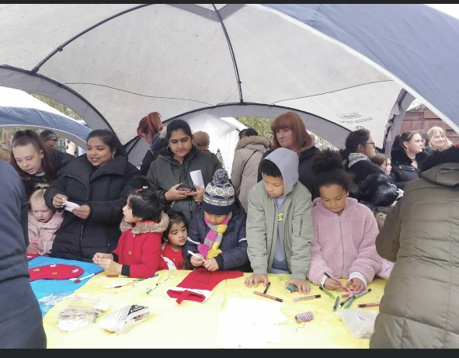
Christmas Raffle:
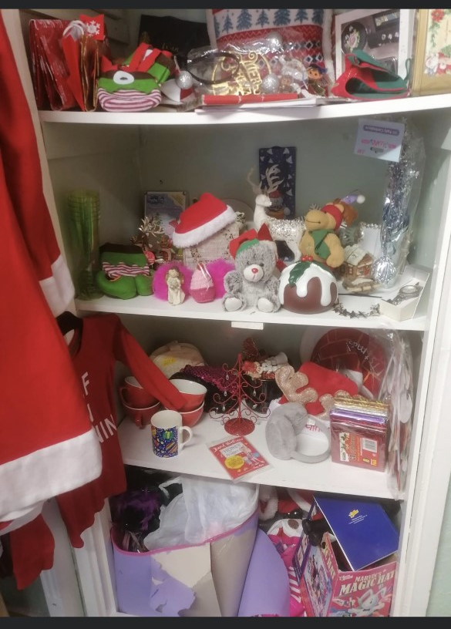

Halloween event:
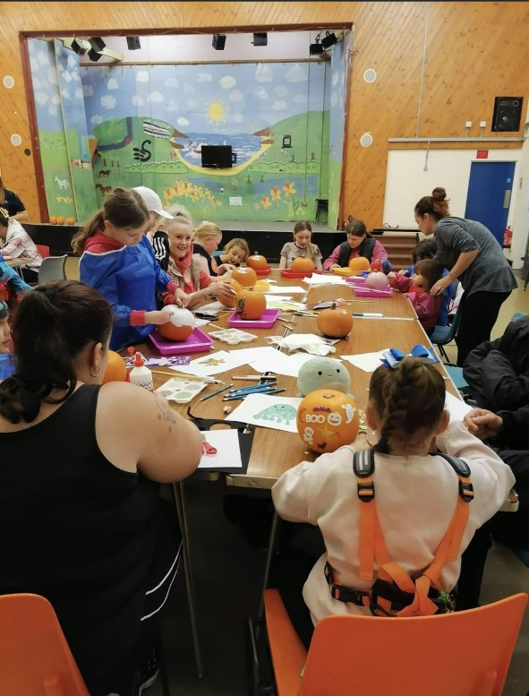

Sorting through Donations:
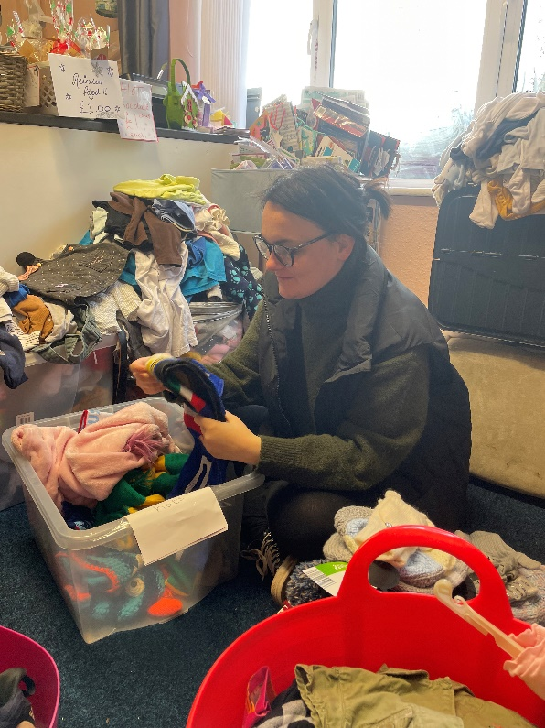
Appendix
A, Correspondence from module lead about placement opportunity.
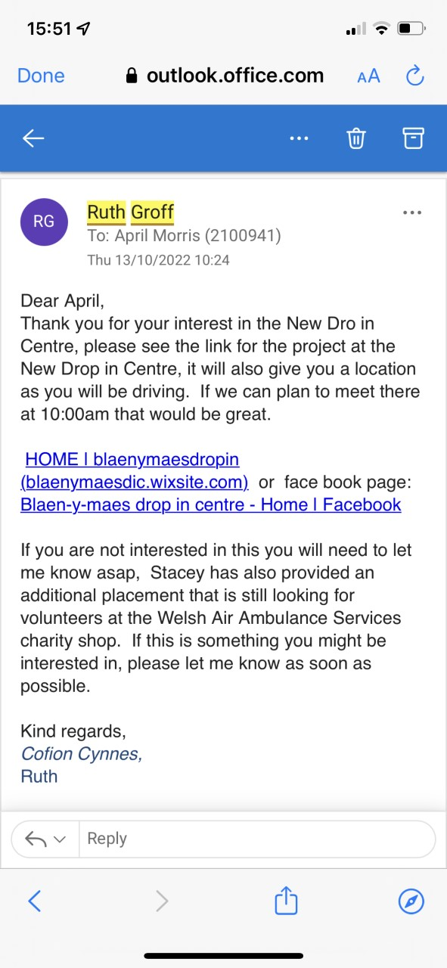

B, Placement Information Form
Placement Information Form
Name of Student: | April Morris
Proposed Placement Setting and Address: | Blaen-Y-Maes Drop In Centre  86-89 Blaen-Y-Maes Drive, Blaen-Y-Maes, Swansea SA55NR
Proposed Dates of Placement: | October 2022 – January 2022
Name of Contact for Venue:

Please also state their position:

Email Address: | Blaenymaesdic@yahoo.co.uk
Telephone Number for Contact at Placement: | 01792580905
Is a DBS required for you to attend this placement? | - Yes  - No  If Yes, have you applied for this?  - Yes applied on _________________  - No
Explain how your role in this organisation/on this placement meets the criteria for the assessment for the module  (e.g., what duties/tasks will you be undertaking that are relevant for the module assessment) | The placement involves preparing food parcels and working at a clothing store that provides low cost clothing for those in need. This placement will give me the experience of working within a community and helping others.

ALL information must be provided. Incomplete forms will be returned to the student.
Please return this form to Ruth Groff (ruth.groff@uwtsd.ac.uk) by Friday 1st July 2022.

C, Log of hours Spent
DATE | TIME | NUMBER OF HOURS
14/10/2022 | 10AM -1PM | 3 HOURS
18/10/2022 | 930AM-1130AM | 2 HOURS
21/10/2022 | 930AM-1130AM | 2 HOURS
25/10/2022 | 930AM-1130AM | 2 HOURS
1/11/2022 | 930AM-1130AM | 2 HOURS
4/11/2022 | 930AM-1230PM | 3 HOURS
8/11/2022 | 10AM-1PM | 3 HOURS
11/11/2022 | 10AM-1PM | 3 HOURS
15/11/2022 | 10AM-1PM | 3 HOURS
18/11/2022 | 10AM-1PM | 3 HOURS
22/11/2022 | 930AM-1PM | 3.5 HOURS
25/11/2022 | 10AM-130PM | 3.5 HOURS
29/11/2022 | 10AM-130PM | 3.5 HOURS
2/12/2022 | 930AM-130PM | 4 HOURS
16/12/2022 | 10AM-1PM | 3 HOURS
20/12/2022 | 10AM-130PM | 3.5 HOURS
 |  | 47 HOURS

