
Marking Management in Huawei Company

Course name:Marking Management
Course code:BMMB7012
Professor’s name:Gwyneth Jones
Student’s name:Wenxuan Liao
Student ID:2224763

Table of Contents
Executive Summary 5
Introduction 6
1. The concept and importance of marketing: what resources are invested in marketing by Huawei 6
Huawei's Marketing Investments 7
Advertising and Promotions 7
Research and Development (R&D) 7
Public Relations (PR) 7
Digital Marketing 7
Customer Relationship Management (CRM) 8
1.1 The Macro and Micro Environment of Huawei 8
PESTLE Analysis 8
Political Factors 8
Economic Factors 8
Social Factors 8
Technological Factors 9
Legal Factors 9
Environmental Factors 9
SWOT Analysis 9
Strengths 9
Weaknesses 9
Opportunities 10
Threats 10
1.2 Target Market 10
Product Differentiation 11
Digital Marketing Campaigns 11
Trade Shows and Exhibitions 11
Partnership with Telecommunication Providers 11
Effectiveness of the Marketing Strategy 11
Market Segmentation, Targeting, Differentiation, and Positioning 12
Marketing Mix Evaluation 12
Product 12
Price 12
Place 12
Promotion 12
1.3 Selection of Media 13
Social Media 13
Networking 14
Email 14
Search Engine Optimization (SEO) 14
1.4 Measuring Success 15
Key Performance Indicators (KPIs) 15
Return on Investment (ROI) 15
Customer Feedback and Surveys 15
Effectiveness of Marketing Strategy and Control Measures: 15
Data Analysis and Insights 16
Continuous Monitoring and Optimization 16
Agility and Adaptability 16
2. Conclusion 16
Lack of Transparency 16
Limited Brand Differentiation 16
Diversification of Target Markets 17
Improved Marketing Communication 17
Embracing Influencer Marketing 17
3.Recommendations 17
Strengthen Brand Differentiation 17
Enhance Transparency and Trust 18
Diversify Target Markets 18
Enhance Marketing Communication 18
Embrace Influencer Marketing 18
Invest in Data Analytics 18
References 19

Executive Summary
This report provides a critical assessment of Huawei's marketing operations, including an analysis of the resources employed, the micro and macro market environment, target market selection, media channels used, campaign effectiveness measurement, and recommendations for future work. The report analyzes fundamental flaws in Huawei's marketing strategy and presents practical recommendations to improve efficacy, develop brand distinction, improve transparency, broaden target audiences, strengthen marketing communication, and capitalize on influencer marketing. Huawei will be able to compete more effectively in the global technology market by putting these recommendations into practice.

Introduction
Huawei, with its headquarters in China, is a major international technological firm. Since its founding in 1987, it has rapidly grown to become a formidable competitor in the consumer electronics and telecommunications markets. Smartphones, tablets, laptops, networking equipment, and cloud services are just some of the many things that Huawei develops, manufactures, and sells. As a global tech giant, Huawei caters to both consumers and businesses in more than 170 countries. The corporation has made a name for itself by pushing the boundaries of innovation and research, particularly in cutting-edge fields like 5G and AI. Huawei has maintained a sizable global footprint and client base while struggling with issues in recent years.
This report offers a critical assessment of Huawei's marketing efforts, with a focus on the macro and micro marketing environments, target market selection, media selection, campaign effectiveness measurement, and suggestions for enhancing Huawei's marketing strategy.

The concept and importance of marketing: what resources are invested in marketing by Huawei
Marketing is crucial to the success of every business because it raises consumer awareness, boosts revenue, and fosters brand loyalty (Bala and Verma, 2018). Huawei is a global technology leader, and as such, it is essential to have a firm grasp of the company's marketing and investment strategies before making any judgments about its future prospects. The term "marketing" is used to describe a wide range of efforts made to find, serve, and keep customers while advancing an organization's objectives (Musarra and Morgan, 2020). Creating, conveying, and delivering value to customers ensures that the company's offerings satisfy those customers' wants and needs. When done right, marketing can do wonders for a company's bottom line by increasing brand recognition, customer loyalty, and sales.

Huawei's Marketing Investments

Advertising and Promotions
To increase brand awareness and reach a worldwide audience, Huawei has made considerable investments in advertising and promotions. Traditional media, internet platforms, and social media are only few of the channels that have been utilized by the corporation in its marketing initiatives (Dmitrijevs, 2020). Huawei has attempted to strengthen the reputation of its brand through the use of celebrity endorsements, sponsorships, and strategic collaborations.

Research and Development (R&D)
Research & development is another key area in which Huawei invests large funds. Huawei places a premium on innovation and product development, thus the company devotes a sizable percentage of its resources to research and development (Xi, 2021). The company is able to differentiate itself from the competition, launch innovative technology, and keep up with the market thanks to this strategy. Huawei's marketing efforts are in sync with its R&D endeavors since the company places an emphasis on its products' distinctive qualities.

Public Relations (PR)
Huawei understands the significance of public relations and values positive relationships with its various stakeholder groups. Public relations (PR) efforts are funded by the firm in order to influence public opinion, spread the company's core values, and respond to criticism. Huawei uses public relations, news releases, and events to foster openness, gain trust, and counteract any unfavorable publicity (Lin, 2017). Huawei's public relations efforts have helped to establish the company as a credible and ethical technology supplier.

Digital Marketing
For better exposure and client interaction in the digital sphere, Huawei has embraced digital marketing methods. This consists of things like SEO, SMM, content marketing, and working with influencers. Huawei is able to reach its intended audience more efficiently, tailor its marketing to that audience, and increase engagement with Huawei's digital channels by employing online mediums (Cao, 2017).

Customer Relationship Management (CRM)
Huawei invests in CRM systems and procedures to develop customer loyalty and satisfaction. In order to provide a better service, the company uses customer data analytics, customized messaging, loyalty programs, and after-sale assistance. Huawei's strategy of emphasizing customer relationship management is geared toward fostering enduring connections with customers and inspiring repeat purchases (Yeo et al., 2020).

1.1 The Macro and Micro Environment of Huawei
The macro and micro marketing environments in which a business operates have an impact on its marketing strategy. Understanding the aspects that determine Huawei's marketing strategy is essential for making an in-depth assessment of the international technology business. In this section, we analyze Huawei's macro and micro marketing environments by a PESTLE analysis and a SWOT analysis, respectively.

PESTLE Analysis

Political Factors
Huawei faces a number of political challenges because to its global reach. Huawei's marketing approach may be severely impacted by international political tensions and trade issues (Grigan, 2021). For instance, Huawei's market opportunities have been hampered by limits on the company's participation in the development of 5G infrastructure in several countries due to security concerns.

Economic Factors
Economic factors significantly affect Huawei's marketing strategy. Macroeconomic factors, such as consumer buying power and currency value, have an impact on customer interest in Huawei's products (Wang, 2022). Sales and marketing efforts by Huawei may suffer if economic downturns or currency changes reduce consumer purchasing.

Social Factors
Huawei's marketing strategies change depending on the current social and cultural climate. Consumers' perspectives on technology, digital adoption rates, and social media trends inform Huawei's marketing strategies and target demographics (Xuesong, 2016). To better match consumer expectations, Huawei takes social concerns into account while creating marketing efforts.

Technological Factors
Huawei uses cutting edge tech extensively in their marketing campaigns. Huawei is a leading-edge technology company that invests much in R&D to stay ahead of the curve (Al Shami et al., 2019). Huawei's focus in futuristic technologies like 5G, AI, and the IoT informs the company's marketing strategy and how it positions its products in the market.

Legal Factors
When planning their marketing strategies, Huawei takes the law into serious consideration. Intellectual property restrictions, data protection regulations, and laws regulating international commerce all have an impact on Huawei's business and marketing strategies (Raushan, 2019). Huawei's reputation and market standing depend on the company's ability to comply with legal regulations.

Environmental Factors
The importance of environmental concerns in commercial operations is growing. Huawei's marketing approach is driven by the growing concern for environmental protection among its target audience (Shamout and Elayan, 2020). Huawei's response to environmental factors includes adopting eco-friendly practices, advocating for energy-efficient products, and participating in corporate social responsibility projects.

SWOT Analysis

Strengths
Huawei's marketing approach is guided by its strengths, including its renowned brand name, diverse product catalog, and advanced technological know-how (Xi, 2021). This enables Huawei to position itself as a global technology leader, emphasizing product quality, dependability, and creativity in marketing.

Weaknesses
Security concerns and scandals surrounding Huawei's government relationships hinder its marketing efforts in some markets (Hanxin, 2018). Addressing these weaknesses requires open communication, proactive reputation management, and targeted marketing initiatives to regain trust.

Opportunities
Growing global demand for technology and digitalization create opportunities for Huawei to expand its customer base (Wang, 2022). Utilizing emerging market opportunities, collaborating with telecom operators, and entering new product categories like wearables and smart home products can be part of Huawei's marketing strategy.

Threats
Huawei faces threats such as intense competition from other tech businesses, evolving regulatory environments, and geopolitical issues (Lin, 2022). Market saturation, changing consumer preferences, and supply chain disruptions also pose challenges to Huawei's marketing efforts.
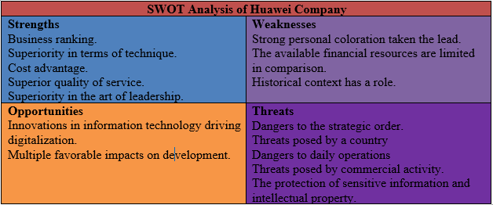

1.2 Target Market
The primary audience for Huawei is made up of tech-savvy consumers, enterprises, and telecommunications providers who value cutting-edge innovation and dependability in their technology products. Based on market research, consumer choice analysis, and the discovery of market gaps, the decision to target this audience was made. Huawei strives to meet the demands of people and businesses seeking cutting-edge technological goods and services.
Huawei employs a wide range of marketing channels and methods to successfully corner its target market. Among these are:

Product Differentiation
In order to stand out in the market, Huawei places a strong emphasis on the features of its products, technological developments, and affordable price (Dmitrijevs, 2022). The company's flagship smartphones, for instance, are marketed to people who are looking for premium mobile devices because they have superior cameras, longer battery life, and the latest and greatest processors.

Digital Marketing Campaigns
To reach its target audience, Huawei makes use of digital channels like social media, internet advertising, and influencer collaborations (Lin, 2017). Huawei is able to spread its brand's message, exhibit the features of its products, and interact with customers in a personal way through means of these mediums.

Trade Shows and Exhibitions
Huawei is able to reach a wide variety of potential clients by participating in industry trade fairs and exhibitions and showcasing its newest and most innovative goods (Zhang et al., 2018). Exposure and engagement with target audiences can be increased and new business can be generated by participation in such events.

Partnership with Telecommunication Providers
When promoting its products and services, Huawei often works with major telecommunications companies (Chacon and Rajawat, 2019). For instance, Huawei's leadership position in the telecommunications market is supported by collaborations with telecommunications providers for 5G infrastructure.

Effectiveness of the Marketing Strategy
Successfully penetrating its target market has been a primary goal of Huawei's marketing efforts, which have included product differentiation, digital marketing campaigns, trade exhibitions, and alliances. The company has expanded greatly and is now recognized as a top name in technology all around the world (Tao, 2022). The target audience has been impressed by Huawei's capacity for innovation and the competitiveness of its products.

Market Segmentation, Targeting, Differentiation, and Positioning
By targeting various consumer segments based on their technology requirements and preferences, Huawei uses a market segmentation strategy. Consumer and business segments are also included in this. With a focus on quality, innovation, and affordable price, the company positions itself as a source of cutting-edge technology (Huang et al., 2022). The ability of Huawei to provide a diverse selection of goods and services to meet the needs of its customers is the cornerstone of its differentiation strategy.

Marketing Mix Evaluation
Huawei's marketing strategy relies heavily on the four components of the marketing mix:

Product
Smartphones, tablets, wearables, networking solutions, and cloud services are just some of the items Huawei offers to meet the demands of its customer base.

Price
Huawei uses market-competitive pricing tactics to offer competitive value and low prices. Cost-conscious customers and enterprises can be attracted by this strategy (Jiang, 2016).

Place
Huawei's distribution networks span many nations, giving the company a significant international footprint (Ektoros et al, 2019). Because of its collaborations with other telecommunications companies, its offerings are easily accessible to consumers across the country.

Promotion
To raise awareness of the Huawei brand and interest in its products, the company engages in a variety of promotional activities, such as advertising, digital marketing campaigns, public relations, and partnerships (Chen et al, 2020).
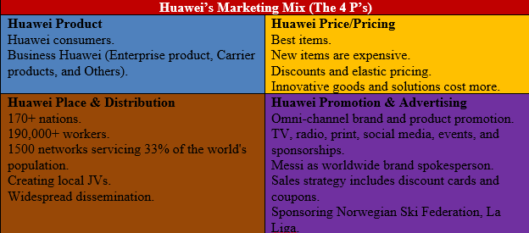

1.3 Selection of Media
Social media, networking, email, and search engine optimization are just a few of the channels and communication strategies used by Huawei for marketing. There are a number of reasons why these channels are thought to be suitable and efficient for connecting with their target audience.

Social Media
Huawei effectively utilizes various social media platforms such as Weibo, WeChat, Facebook, Twitter, Instagram, and LinkedIn to connect with its target audience and promote its products. Through these channels (Wang and Ma, 2021), Huawei engages in two-way conversations with consumers, resulting in increased brand recognition and visibility through visually appealing content and dynamic marketing campaigns.
The company employs content marketing strategies to share valuable information with users, using articles, images, and videos to engage and educate its audience. Huawei actively responds to user comments and feedback, organizes events and contests, and collaborates with influencers to enhance brand exposure and reach a wider audience. By leveraging social media, Huawei successfully raises brand awareness, establishes connections with users, disseminates product information, and participates in industry conversations.

Networking
Huawei is able to build contacts with professionals and enterprises through networking platforms such as LinkedIn and industry-specific forums. Huawei strengthens its position as a go-to technology partner by actively engaging in industry conversations and contributing insightful observations (Busch et al., 2020).

Email
Huawei's marketing strategy relies heavily on email marketing initiatives. Huawei is able to reach its existing client base and cultivate ties with them thanks to targeted and customised email communication (Trappey et al., 2018). Huawei keeps its customers interested and up-to-date on the latest products with email newsletters, product updates, and special offers.

Search Engine Optimization (SEO)
Huawei recognizes the value of high search engine ranks and has made investments in search engine optimization (SEO) strategies to raise its organic search rankings (Zhang, 2021). Huawei's goals for its website include raising the site's profile online, drawing in qualified visitors, and producing more qualified leads.
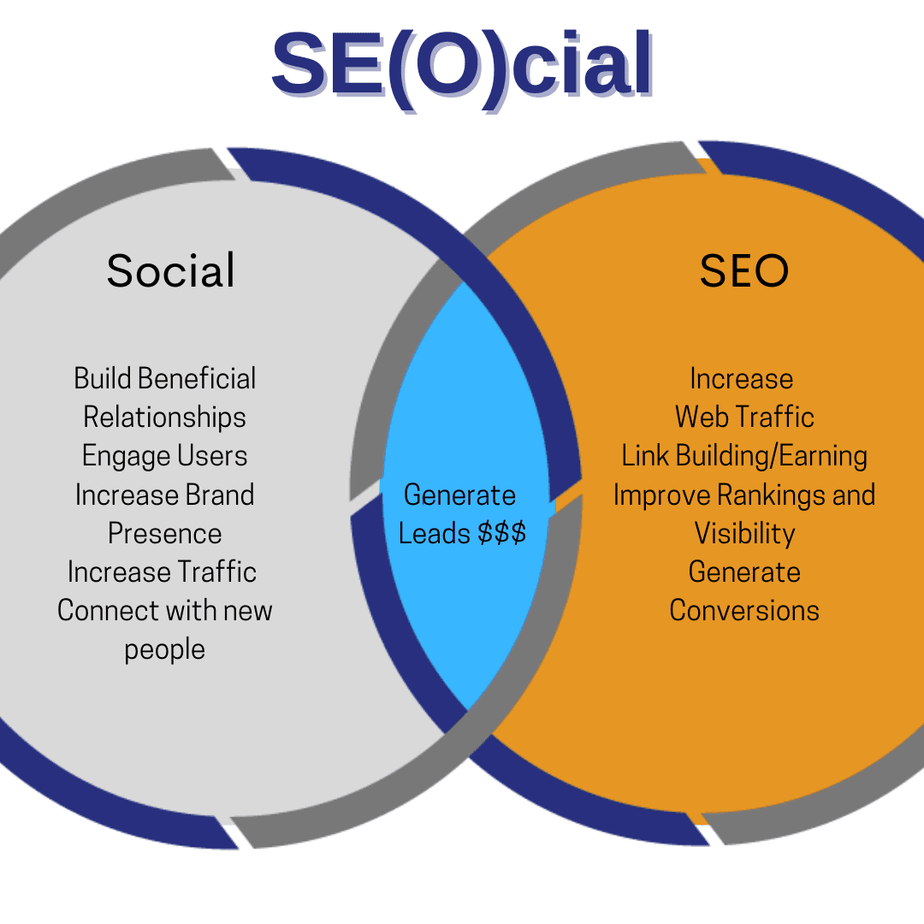

1.4 Measuring Success
Through several measurement metrics, Huawei evaluates the success of its marketing efforts. These metrics are crucial in gauging the efficacy of the marketing strategy as a whole. Huawei uses a number of different measurement techniques, including:

Key Performance Indicators (KPIs)
With its marketing goals in mind, Huawei establishes key performance indicators (KPIs). Metrics like brand awareness, social media traffic, social media engagement, lead generation, conversion rates, and customer retention are all examples of KPIs (Busch,2020). Huawei can measure the success of its campaigns and make informed decisions by keeping tabs on these metrics.

Return on Investment (ROI)
Huawei places a high priority on studying the effectiveness of their marketing campaigns. Huawei can figure out if its marketing strategy is profitable or not by comparing the money it makes to the money it spends (Guo et al, 2019). The performance of individual campaigns and channels can be gauged in part by calculating their return on investment.

Customer Feedback and Surveys
In order to better understand customer happiness, brand perception, and preferences, Huawei cherishes customer feedback and conducts surveys (Jackson, 2018). Huawei can learn how its marketing initiatives are being received by the public thanks to the company's sentiment analysis and customer feedback collection efforts.

Effectiveness of Marketing Strategy and Control Measures:
Huawei's marketing strategy will only be successful if the company meets its marketing goals and tailors its efforts to satisfy its target demographic. The efficacy of Huawei's marketing campaigns can be evaluated by regularly tracking and analyzing the aforementioned measurement metrics.
Following this analysis, Huawei uses a number of marketing control strategies, including:

Data Analysis and Insights
When examining the performance metrics, Huawei uses data analytics tools and techniques to draw useful conclusions (Dmitrijevs,2020). With the use of these insights, Huawei can fine-tune its marketing strategy, improve campaigns, and make wise choices based on data.

Continuous Monitoring and Optimization
In order to pinpoint areas for development, Huawei continuously monitors the efficacy of its various marketing campaigns and channels (Tao, 2022). Huawei's marketing campaigns may be fine-tuned in real time by monitoring relevant data and metrics.

Agility and Adaptability
Huawei continues to be adaptable and agile in response to market and consumer shifts. Huawei is able to keep its marketing strategy relevant and effective by keeping tabs on industry trends, technology developments, and customer preferences (Liefner et al., 2019).

2. Conclusion
The analysis above indicates that despite Huawei's significant success in the international technology sector, its marketing strategy has some shortcomings. To make Huawei's marketing efforts more successful, these shortcomings must be fixed.

Lack of Transparency
The lack of transparency regarding Huawei's security policies and interactions with governments is one of the major shortcomings of their marketing strategy. The company's reputation has taken a hit in various markets due to security concerns and controversies (Ojo, 2017). If Huawei wants to regain the trust of its customers and other stakeholders, it must prioritize open lines of communication, proactive responses to security issues, and clear information.

Limited Brand Differentiation
Huawei has a diverse product line, but it might benefit from greater brand differentiation. Huawei needs to forge a more distinctive and powerful brand identity in order to succeed in today's cutthroat industry (Guo et al, 2019). Huawei can better position itself against its rivals and develop a stronger brand image in consumers' eyes by concentrating on unique selling propositions and highlighting important differentiators.

Diversification of Target Markets
For a significant amount of its business, Huawei heavily depends on the Chinese market. Risks arise from putting too much emphasis on one market, especially in light of current geopolitical and market conditions (Dmitrijevs,2020). Huawei should increase its presence in other regions, target new markets, and create specialized marketing strategies to meet the demands and tastes of diverse consumer segments in order to reduce this risk.

Improved Marketing Communication
There remains potential for development in Huawei's marketing communication despite the company's use of numerous channels and strategies. Huawei's capacity to engage and connect with its target audience may be improved through the use of clear and consistent message, engaging narrative, and successful content development (Cao, 2017). Huawei can better connect with its customers on an emotional level by bolstering the human factor and emotional appeal of its marketing campaigns.

Embracing Influencer Marketing
Additionally, Huawei might gain from using influencer marketing to reach and sway its target audience. Huawei can increase its reach, boost its brand's image, and increase its reputation in the market by partnering with notable personalities and industry professionals (Fragouli, 2020). Huawei can improve the efficacy of its marketing campaigns by partnering with influencers that share both the company's brand values and its target audience.

3.Recommendations
The following suggestions can be implemented to improve Huawei's marketing strategy and address the highlighted shortcomings:

Strengthen Brand Differentiation
Huawei needs to improve its brand's differentiation and consistency. It can accomplish this by showcasing the company's dedication to innovation and quality as well as highlighting the distinctive qualities of your products and the technological strides your business has made (Tao, 2022). Huawei needs to make an effort to develop a unique brand story that will appeal to its target audience.

Enhance Transparency and Trust
Huawei's marketing efforts will thrive if the company addresses customers' security worries and increases its transparency. The company should be transparent about its security procedures, show that it complies with relevant industry standards, and open up channels of communication with its customers (Jiang, 2016). Huawei can lessen the impact of negative impressions and strengthen its reputation by forging trust through transparent communication.

Diversify Target Markets
Huawei should prioritize diversification of its target markets to decrease reliance on a single market. Specifically, this entails increasing its presence in developing regions, targeting new client segments, and modifying its marketing strategies to better suit the specific demands of each location (Ektoros et al, 2019). Huawei can better take advantage of growth opportunities and mitigate dangers unique to certain markets by increasing its presence around the world.

Enhance Marketing Communication
Huawei has to strengthen its marketing communication in order to more actively involve its target audience. Create captivating content that can be used across several marketing channels, and use storytelling techniques to make an emotional connection with your target audience (Wang and Ma., 2021). In order to customize its communication strategies appropriately, Huawei should also prioritize consumer feedback and carefully listen to client needs.

Embrace Influencer Marketing
A significant part of Huawei's marketing strategy could be played by influencers. Relevant influencers that align with the company's brand values and target audience should be sought out and worked with. Huawei may benefit from the reach, exposure, and credibility that these influencers can bring to the brand's marketing (Hanxin, 2018). Huawei can expand its audience and improve brand perception by utilizing the power of influencers.

Invest in Data Analytics
In order to better understand customer behavior, market trends, and campaign performance, Huawei needs strengthen its data analytics skills. Huawei can improve its marketing, strategy, and communication by using data analytics to guide their decisions (Lin, 2017). As a result, Huawei will be able to provide its consumers with more targeted and pertinent experiences.

References
Al Shami, D., Giraldo, C.C.M., Almekhlef, H.S. and Aldabbous, A.A., 2019. Huawei’s internationalization process and its competitive position in foreign markets: The demand for mobile devices in the modern era. Journal of the Community Development in Asia (JCDA), 2(2).
Bala, M. and Verma, D., 2018. A critical review of digital marketing. M. Bala, D. Verma (2018). A Critical Review of Digital Marketing. International Journal of Management, IT & Engineering, 8(10), pp.321-339.
Busch, M., Westphal, J. and Müller, T., 2020, August. Unearthing the TrustedCore: A Critical Review on Huawei's Trusted Execution Environment. In WOOT@ USENIX Security Symposium.
Busch, M., Westphal, J. and Müller, T., 2020, August. Unearthing the TrustedCore: A Critical Review on Huawei's Trusted Execution Environment. In WOOT@ USENIX Security Symposium.
Cao, X., 2017. Marketing Strategies of Chinese Mobile Phone MNCs in the European Market:-A Case Study of Huawei.
Chacon, M.D.M. and Rajawat, A., 2019. A case study on Huawei technologies. Journal of the Community Development in Asia (JCDA), 2(3), pp.29-36.
Chen, H., Dong, Z., Li, G. and Zhao, H., 2020. Joint advertisement and trade-in marketing strategy in closed-loop supply chain. Sustainability, 12(6), p.2188.
Dmitrijevs, R., 2020. Research on Marketing Strategy of Huawei Mobile Phone in European Market. Open Journal of Business and Management, 8(3), pp.1138-1150.
Dmitrijevs, R., 2020. Research on Marketing Strategy of Huawei Mobile Phone in European Market. Open Journal of Business and Management, 8(3), pp.1138-1150.
Dmitrijevs, R., 2020. Research on Marketing Strategy of Huawei Mobile Phone in European Market. Open Journal of Business and Management, 8(3), pp.1138-1150.
Ektoros, E., Gregoriades, A. and Georgiades, M., 2019. Online Consumers' Opinions Analysis for Marketing Strategy Evaluation. In ICEIS (1) (pp. 266-273).
Fragouli, E., 2020. A critical examination of the interaction of crisis leadership & corporate reputation. The Business & Management Review, 11(1), pp.97-111.
Grigan, N., 2021. Strategic analysis of Huawei in Russia: Swot and pest analysis. Norwegian Journal of Development of the International Science, (66), pp.3-17.
Guo, L., Zhang, M.Y., Dodgson, M. and Gann, D., 2019. Huawei's catch-up in the global telecommunication industry: innovation capability and transition to leadership. Technology Analysis & Strategic Management, 31(12), pp.1395-1411.
Hanxin, Y., 2018. Huawei''s SWOT analysis in the russian market. Научно-аналитический экономический журнал, (3), pp.2-2.
Huang, K., Madnick, S., Zhang, F. and Siegel, M., 2022. Varieties of public–private co-governance on cybersecurity within the digital trade: Implications from Huawei’s 5G. Journal of Chinese Governance, 7(1), pp.81-110.
Jackson, K., 2018. Huawei: leadership, culture and connectivity.
Jiang, Y., 2016. The global marketing strategy for high-tech companies which founded in the developing countries for entering the global market: Case study of Huawei Technologies (Bachelor's thesis, University of Twente).
Liefner, I., Si, Y.F. and Schäfer, K., 2019. A latecomer firm's R&D collaboration with advanced country universities and research institutes: The case of Huawei in Germany. Technovation, 86, pp.3-14.
Lin, C., 2017. The Analysis of HUAWEI International Marketing Strategy. Siam University.
Lin, C., 2017. The Analysis of HUAWEI International Marketing Strategy. Siam University.
Lin, H., 2022, April. The Strategy for Huawei Going Global. In 2022 7th International Conference on Social Sciences and Economic Development (ICSSED 2022) (pp. 349-355). Atlantis Press.
Musarra, G. and Morgan, N.A., 2020. Outside-in marketing: Renaissance and future. Industrial Marketing Management, 89, pp.98-101.
Ojo, T., 2017. Political economy of Huawei’s market strategies in the Nigerian telecommunication market. International Communication Gazette, 79(3), pp.317-332.
Raushan, B., 2019. Research on Marketing Strategy of Huawei Brand in Kazakhstan. International Journal of Engineering and Management Research.
Shamout, M.D. and Elayan, M.B., 2020. A Comparative Analysis of Strategic Planning Practices in Gulf Cooperation Council Region: A Case Study of Huawei and Samsung Companies. Journal of Talent Development and Excellence, 12(1), pp.4891-4910.
Tao, L., 2022. Huawei’s System for the Planning of Strategies. In Huawei Wisdom: Develop Strategy to Execution at Critical Moments (pp. 181-217). Singapore: Springer Nature Singapore.
Tao, L., 2022. Management of System and Strategies for Product Innovation. In Huawei Wisdom: Develop Strategy to Execution at Critical Moments (pp. 33-69). Singapore: Springer Nature Singapore.
Trappey, A.J., Trappey, C.V., Fan, C.Y. and Lee, I.J., 2018. Consumer driven product technology function deployment using social media and patent mining. Advanced Engineering Informatics, 36, pp.120-129.
Wang, B. and Ma, Y., 2021. Chinese media discourse analysis: A case study of the discursive strategies in the editorials in Global Times. The Routledge Handbook of Chinese Studies, pp.638-654.
Wang, J., 2022. Development of the Investment Strategy of Huawei Company.
Wang, J., 2022. Development of the Investment Strategy of Huawei Company.
Xi, W., 2021, March. Analysis of Huawei's International Marketing Strategy Based on the SWOT Analysis. In 2021 2nd International Conference on E-Commerce and Internet Technology (ECIT) (pp. 151-154). IEEE.
Xi, W., 2021, March. Analysis of Huawei's International Marketing Strategy Based on the SWOT Analysis. In 2021 2nd International Conference on E-Commerce and Internet Technology (ECIT) (pp. 151-154). IEEE.
Xuesong, L., 2016. ANALYSIS OF THE DEVELOPMENT ENVIRONMENT OF HUAWEI MOBILE PHONE IN THAILAND MARKET AND SOUTHEAST ASIA. E–Proceeding, 2016, p.93.
Yeo, C., Kee, D.M.H., Mo, X.Y., Ang, H.E., Chua, S.M., Agnihotri, S. and Pandey, S., 2020. Technology advancement and growth: A case study of Huawei. Journal of the Community Development in Asia (JCDA), 3(1), pp.82-91.
Zhang, H., Rao, H. and Feng, J., 2018. Product innovation based on online review data mining: a case study of Huawei phones. Electronic Commerce Research, 18, pp.3-22.
Zhang, Y., 2021. ‘Barbarising’China in American trade war discourse: the assault on Huawei. Third World Quarterly, 42(7), pp.1436-1454.

