Science Coursework Report

Introduction:
I was asked to perform an experiment on forces in equilibrium. The purpose of this was to investigate how an angle between 2 strings vary as the weight they are supporting increases.

Setup used for the practical:
On Moodle there is a video that was used to perform the experiment [1], To begin the first thing required was a table to record our results that we gathered during the experiment. The next step was to make sure all the equipment was secure and setup properly. Next, we began to measure the springs with no mass applied to the string. After this the next step was to add mass to the string and record the springs length and get the angle from the centre of where the weight was acting.
Method used:
During the test there was a few variables in place that may have stopped me from gaining accurate results. There were a few steps taken to avoid this such as taking the measurements at eye level. This allowed me to gain results accurately as it was it eye level and didn’t leave much room for not accurately gaining results. Another precaution I took was having my elbows rested on the table. This allowed me to gain accurate results because I wasn’t moving, and this made it so that the apparatus wasn’t moving because of me moving. The last precaution I took was to wait for the springs to stop moving when I added weight to it and this allowed me to gain results accurately as the springs weren’t moving.

Results:
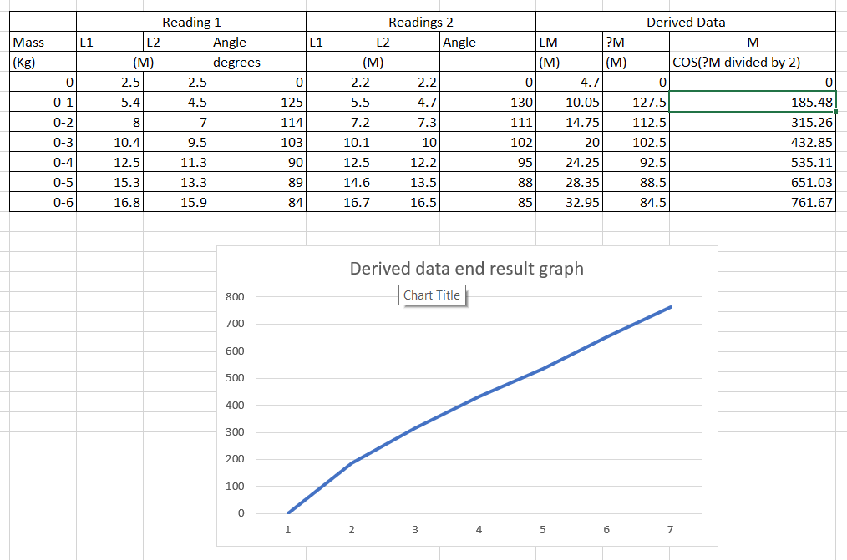
The screenshot above shows all my results and my graph after I had finished the practical as for the “?” slot I didn’t know what to call it as the video that I had referenced had a blurry picture and I couldn’t tell what to copy down into table form.

Conclusion:
From looking at my table and my graph my results got larger and larger as they gained more weight and the angle got smaller. The graph I ended up with was not straight and bent in the middle and had straightened near the top. Starting from the bottom is where the least amount of weight was, and the line goes further up the weight increases. There are 2 different gradients in my graph and the reasons for this happening are the fact that the weight increased every time because I added 100 grams per measurement and this made the springs longer giving me a longer measurement and the angle got shorter due to the increase in weight.

References:
[1] Moodle,Science,Greg Owen, forces in equilibrium, [Online] Available: https://sway.office.com/LTEchE9XegmLW5FA?ref=Link, [Accessed on: 26/01/19].

