Title: Business Report - Comparison of Two Hospitality Organisations

Student name: Carolina Zastavnitchi
Student ID number: 2233507
Programme: BA International Hotel Management
Module: Financial Management for the Hotel Industry
Module code: BMIH5007
Lecturer: Tristan Hawkins
Word Count: 1963

Table of Contents
1 Introduction: 3
2 Total Revenue: 3
2.1 Shangri La Hotel 3
2.2 Travelodge Hotel: 4
3 Market Position 5
3.1 Shangri La Hotel 5
3.2 Travelodge Hotel: 6
4 Growth Potential 7
4.1 Shangri-li Hotel: 7
4.2 Travelodge: 8
5 Financial Commitment to CSR (Corporate Social Responsibility): 9
5.1 Shangri-la Hotel: 9
5.2 Travelodge: 10
6 Bowmen’s strategy in Travelodge: 11
7 Bowmen’s strategy in Shangri-La Hotel: 11
8 Conclusion: 12
8.1 Recommendation: 12
9 References 13

Introduction:
This is the business report which compares the two hotels the one is Shangri-La Hotel and the other one is Travelodge Hotel. This report discusses both hotel's Total revenue, growth potential, Market positioning, and financial commitment to CSR, and also uses the Bowmen's strategy in both hotels. In the end conclude the overall report and also give the recommendation to both hotel for their business growth and expansion.

Total Revenue:

Shangri La Hotel
In 2023, Shangri La Hotel PCL’s total revenue was 2.186 billion. The fiscal year revenue of Shangrila Hotel from December 2019 to 2023 their average income was 1.391 billion. In December 2021, their revenue was 355.9 million, so Shangri La Hotel's revenue hit its 5-year low. The revenue decreased in 2019 that was 2.55 billion and its decrease was 6.9%, in 2020 its revenue was 663.3 million and it was -74.0%. Moreover, in 2021 the revenue was 355.9 billion and it was -46.3%. Additionally, in 2022 the revenue of Shangri La Hotel was increased to 237.5% and it was 1.201 billion (Shangri La Hotel, 2023).
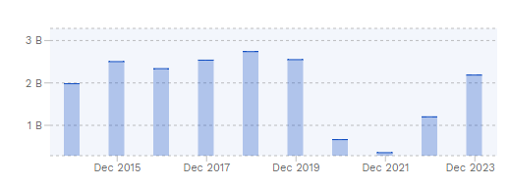
Figure 1: Shangri La Hotel revenue.
Source: (Shangri La Hotel, 2023).
They generate revenue from various sources like Hotel management services, Property development for sale, Hotel and investment properties, Commercial real estate, Office building, food and beverages, conference and function facilities and many other sources are used to generate their revenue (HE. 2024). Moreover, the COVID-19 pandemic is one of the significant factors that affect the overall hospitality industry, the Shangri La Hotel is also greatly effect by the COVID-19 pandemic, they suffered great losses in the first half of 2021 due to the lockdowns the travel restrictions, and reduction of travel demand cause to declines the revenue.

Travelodge Hotel:
Travelodge is one of the budget chains of hotels. 2023 became a record year for the Travelodge because in this year their revenue increased to 13.7% that is around £1,035.2 million, and the EBIDTA of the hotel adjusted that was increased to 14.6% became £243.9 million. The overall year 2023 is the first year in which the revenue of Travelodge surpassed £1 billion. Travelodge attributed their performance of 2023 to their strong demand of the customer in which both business customers and leisure customers are included, it also included the trading days of record-breaking and weeks during Eurovision and Wimbledon (Statista, 2023).
.

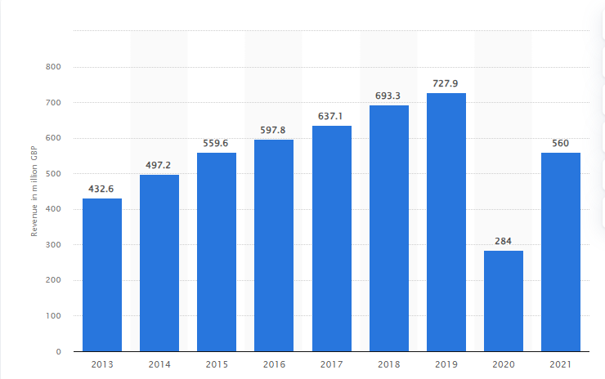
Figure 2: Travelodge revenue
Source: (Statista, 2023).
Moreover, their revenue is come from 598 hotels, and 46000 rooms in all over the United Kingdom. The factors that drive to increase in the revenue of Travelodge is the Hotel upgrade programme, they upgrade their hotel to the new premium budget luxe hotel design. In this hotel, the Bars, cafes and the next-generation concepts of the room are included. This helps to increase the revenue of the Travelodge. They also launched the Better Future sustainability strategy which also helps to increase their revenue (Travelodge, 2023).

Market Position

Shangri La Hotel
The market capitalization of Shangri-La Hotel in 2024 is $2.71 billion, by making the 3667th company in the world, the company are valuable in the world market through the market cap (Shangri-La, 2024).
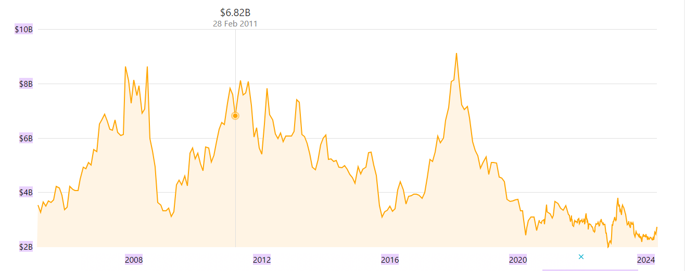
Figure 3: Market capitalization of Shangri-La Hotel
Source: (Shangri-La, 2024).
The Hotel targets upper-middle and upper-class individuals who have high incomes and want to enjoy a luxurious life, so they book the luxurious rooms of the hotel and the high quality of services (Baxter and Srisaeng, 2020). The Shangri-La group have three brands of Hotek that target the various customers according to their needs. The one is Shangri-La Hotels, this one is a five-star hotel that is established in a prime location in the city that targets high incomes and busy travellers. The next one is the Shangri-La Resorts, which is also five-star luxury hotels that are established in an exotic destination that targets elite-class families and high-income travellers. The other one is the Trader Hotel, which is a Four-star hotel that has a mid-price range of hotels and targets budget-conscious people (Shangri-la Group, 2017).

Travelodge Hotel:
Travelodge Hotels are used all over the UK, 27% of customers use Travelodge hotels, which means the Travelodge hotel brand is known by 91% of people to 30%. It is one of the budget hotel brands that have 46,000 rooms and they have 598 hotels around the UK, Spain, and Ireland (Page and Connell, 2020). Consequently, the customer demographic rate of Travelodge is 53.12% male and 46.88% female, in which the largest age group of people are included. The 25 to 34 years of old people are mostly the customers of Travelodge. The business travellers customers are also included give the high value to convince location of hotel. The Travelodge hotels are found in different cities and towns of the UK and provide an amazing experience to their guest. The leisure is also the customers of the Travelodge that want comfortable and high-quality value services for their stay.
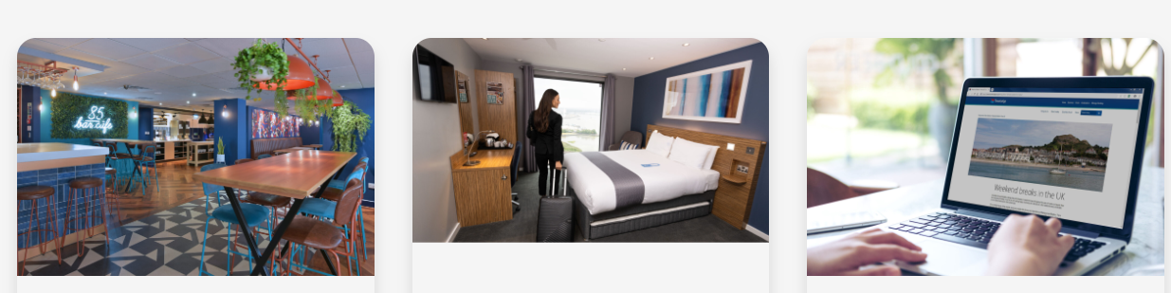
Figure 5: Travelodge hotel customer demographics.
Source: (Travelodge, 2024).

Growth Potential

Shangri-li Hotel:
Shangri-la Hotels and Resorts' expansion strategy is aggressive in that they identify the markets with high growth potential that increase revenue and enhance brand recognition. Their expansion strategy includes expansion and renovation of hotels and resorts, expand and improving the existing services of the hotel that help to attract customers. The other strategy is to acquire similar and complementary businesses (Alhemeiri et al, 2024).
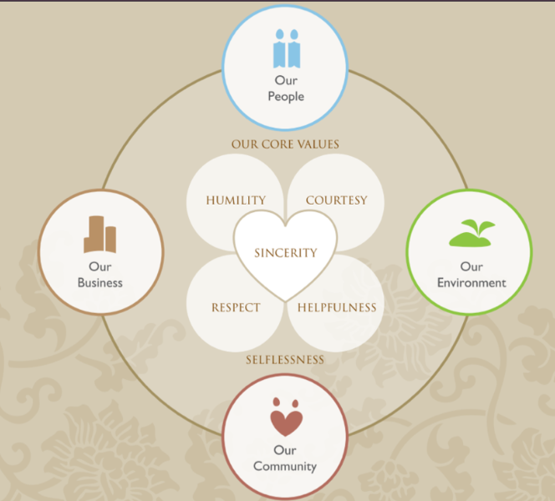
Figure 6: Market share of Shangri-la Hotel.
Source: (Shangri-La Group, 2024).
Shangri-la Hotel and Resorts has several opportunities for its future growth, they have planned to expand its business into various countries, which could help to attract the larger population (Pradini et al, 2022). Moreover, the Shangri-la positions itself as a customized choice for busy travellers. Shangri-La also expanded its business into emerging economies which helped to grow the consumption of luxury hotels. In addition, Shangri-la expanded their presence causing a unique challenge. In China, front-line employees are not accustomed to exercising the authority of decision-making. The empowerment and the effective delegation of local staff are important for the health operation in a country with various cultural organisations (KHAING, 2016). Moreover, Shangri-la faces competitive challenges due to the establishment of various hotel brands.
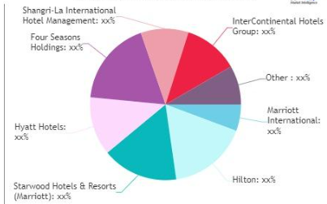
Figure 7: Potential Challenge
Source: (KHAING, 2016).

Travelodge:
It is one of the budget hotels that have various expansion strategies in which they plan to increase their portfolio in the UK, it has 35 hotels, that create 700 new jobs, and they aim to grow the 1,100 hotels by 2025. In 2021, they opened 12 new hotels bringing the 598 hotels to the end of the year (Górska-Warsewicz and Kulykovets, 2020). They also increased their presence, in which they are opening 60 new hotels in the centre of the city. They also increased their presence in the business park and the leisure destination. They also invest in their brand for long-term growth by enhancing the proposition of hotel location, the pricing, and the quality of the hotel. Moreover, Travelodge has several market opportunities in which they expand their hotel portfolio by opening new hotels in various locations (Williams, 2019). Travelodge also invest into the smaller markets because the smaller market has low rents and it also have less competitors. Furthermore, the potential barrier to the growth of Travelodge is UK market dependency, Travelodge are relying on the UK market which poses long-term growth risks. The macroeconomic factors is also one of the challenging backdrop for the Travelodge in which the ongoing inflation cost are remain concern. Travelodge needs to give careful attention to these factors (López-Andreu et al, 2019).

Financial Commitment to CSR (Corporate Social Responsibility):

Shangri-la Hotel:
Shangri-La Hotel and Resorts commit to operating the economic, environmental, and social responsibility sustainably. The social responsibility program of Shangri-la Hotel is called the “Shangri-La Cares” and this program has two components: “Sanctuary” and “Embrace” Embrace focuses on providing effective support in health and education that have underprivileged communities. Moreover, the Sanctuary focus on conserving and restoring biodiversity (Schroeder and Schroeder, 2018).
In 2022, Shangri-La donated 26,000 volunteers to the COVID-19 effort relief, which helped almost 200,000 people in disadvantaged communities. The Embrace project of Shangri-La Surabaya provides various training, activities, classes, and parental training to the children and also families of children in a rural school, at SD Tanwir (Maltese, 2020). In Bangkok, the Shangri-La hotel uses a heating system with solar water that helps to reduce the consumption of hot energy and liquefied petroleum gas which are mainly used up to 30%.
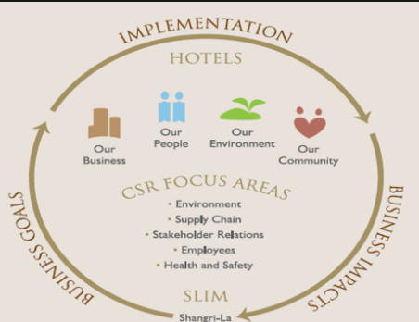
Figure 9: CSR of Shangri-La Hotel
Source: (Maltese, 2020).

Travelodge:
Travelodge introduced fundraising programs and it has a wider fundraising program their program is called a “Change for Charity” that was launched in 2010. Since the inception day of the fundraising program, around 6,000 employees raised thousands of pounds. For the funds raised their employees arrange fundraising events in various areas for different charities in which the British Heart Foundation, Kids Out, Cancer Research UK, and Macmillan are included (Wu, 2021).
For the sustainability program, they also worked on net zero carbon. In 2021 the net carbon footprint was 39,922 tonnes of carbon dioxide and equivalent gases (CO2e), 70.6 tonnes of CO2e with an intensive turnover of per £million (Travelodge, 2022).
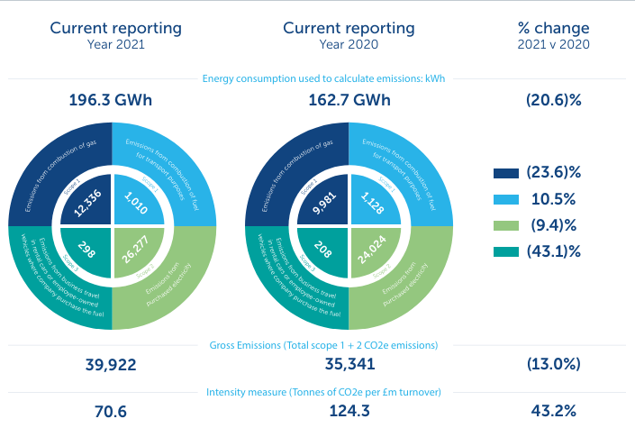
Figure 10: Carbon Footprint of Travelodge
Source: (Travelodge, 2022).

Bowmen’s strategy in Travelodge:
Travelodge is a budget hotel chain, that is primarily operating in the UK. The strategy that is aligned in the Travelodge with the “Low price” strategy. Because Travelodge focuses on cost efficiency that provide no frill accommodation to their customers in a competitive pricing. Their price is attractive to the cost-conscious travellers. They target budget-conscious customers and expand their business within the UK market (Lawson, 2018). Moreover, their demand curve and elasticity are Price elastic. The price of the hotel decreases the demand increases.

Bowmen’s strategy in Shangri-La Hotel:
Shangri-la Hotel is one of the luxury Hotels, so the “Differentiation” strategy is aligned with the Hotel. Shangri-La Hotel's guest satisfaction rate is high because it provides a high quality of services to its guests and provide unique experiences. They provide premium pricing to their customer for their hotel (Alhemeiri et al, 2024). The demand curve of the Shangri-La hotels is the price inelastic”. As the price of the hotel room increases it does not affect on the demand because their customers are high-income and the upper class, so customers always want high-quality of services over price.

Conclusion:
In this report compares the two hotels one is a premium hotel which is Shangri-la Hotel and the other one is a budget chain hotel which is Travelodge Hotel. The total revenue of Shangri-La Hotel and PLC in 2023 was 2.186 billion and the revenue of Travelodge Hotel was £1,035.2 million. The market capitalization of Shangri-La Hotel in 2024 is $2.71 billion, while the customer demographic of the Travelodge is 53.12% male and 46.88% female. The Growth Potential of Shangri-La Hotel is aggressive, they have high market growth potential that helps to increase their revenue and enhance brand recognition. While Travelodge's growth potential is to expand its hotels all over the world, it aims to develop 1,100 hotels by 2025. Additionally, the CSR of Shangri-La Hotel is to commit a sustainable economic, environmental, and social responsibility. The CSR of Travelodge is to reduce the carbon footprint and make the environment sustainable.

Recommendation:
- Shangri-La Hotel should focus on its growth opportunity, the hotel should enhance the personalized experiences for the guests. They implement preference tracking for their guest and provide personalised welcoming amenities to their guest.
- Travelodge should expand their hotel business from the UK to all over the world. Expansion into new regions helps to reduce the dependency on the UK and gives growth opportunities.

References
Alhemeiri, N., Ali, N., Alawlaqi, M., Almarzooqi, Y., Alshowab, A. and Nobanee, H., Financial analysis of Shangri-La Hotel.
Baxter, G. and Srisaeng, P., 2020. Environmentally sustainable hotel operations: The case of the Shangri-La Group. วารสาร เพื่อ การ พัฒนาการ ท่องเที่ยว สู่ ความ ยั่งยืน, 2(2), pp.1-26.
Górska-Warsewicz, H. and Kulykovets, O., 2020. Hotel brand loyalty—A systematic literature review. Sustainability, 12(12), p.4810.
HE. K, 2024. Online Available at: https://www.mingtiandi.com/real-estate/finance/shangri-la-returned-to-profit-in-2023-as-revenue-jumped-47-on-travel-recovery/ [Accessed Date [04/05/2024].
KHAING, M.I., 2016. A STUDY OF CUSTOMERS SATISFACTION AND CUSTOMERS LOYALTY OF SULE SHANGRI-LA, YANGON (Doctoral dissertation, SIAM UNIVERSITY BANGKOK, THAILAND).
Lawson, F., 2018. Hotels. In Metric Handbook (pp. 383-400). Routledge.
López-Andreu, M., Papadopolous, O. and Jamalian, M., 2019. How has the UK hotels sector been affected by the fissuring of the worker–employer relationship in the last 10 years?
Maltese, D., 2020. Ecotourism development in Shangri-La, Yunnan province, China: the case of Tiger Leaping Gorge (Master's thesis, Norwegian University of Life Sciences, Ås).
Page, S.J. and Connell, J., 2020. Tourism accommodation and hospitality services. In Tourism (pp. 216-241). Routledge.
Pradini, G., Eni, A. and Digdowiseiso, K., 2022. The Influence of Digital Marketing and Promotion on Visiting Interest in Shangri-La Hotel Jakarta. Budapest International Research and Critics Institute-Journal (BIRCI-Journal), 5(2), pp.12394-12409.
Schroeder, K. and Schroeder, K., 2018. The Last Shangri-La?. Politics of Gross National Happiness: Governance and Development in Bhutan, pp.51-73.
Shangri La Hotel, 2023. Online Available at: https://finbox.com/SET:SHANG/explorer/total_rev/ Accessed Date [04/05/2024].
Shangri-la Group, 2017. Online Available at: https://martinroll.com/resources/articles/asia/shangri-la-hotels-resorts-bringing-asian-hospitality-to-the-world/ Accessed Date [04/05/2024].
Shangri-La Group, 2024. Online Available at: https://thepurposebusiness.com/shangrila-strategy. Accessed Date [04/05/2024].
Shangri-La, 2024. Online Available at: https://companiesmarketcap.com/shangri-la/marketcap/. Accessed Date [04/05/2024].
Statista, 2023. Online Available at: https://www.statista.com/forecasts/1335657/travelodge-hotels-brand-profile-in-the-uk. Accessed Date [04/05/2024].
Statista, 2023. Online Available at: https://www.statista.com/statistics/429089/travelodge-total-revenue-united-kingdom-uk/. . Accessed Date [04/05/2024].
Travelodge, 2023. Online Available at: https://travelodge.co.uk/our-business/blog/press_release/record-full-year-performance-with-travelodge-well-positioned-for-long-term-growth/. Accessed Date [04/05/2024].
Travelodge, 2024. Online Available at:https://travelodge.co.uk/our-business/about-us/company-overview/ Accessed Date [04/05/2024].
Williams, S.M., 2019, October. Modern Central European Hotels and Spas in Cultural Criticism: Grand Hotel Nostalgia: An Introduction. In Forum for Modern Language Studies (Vol. 55, No. 4, pp. 415-425). Oxford University Press.
Wu, S.Y., 2021. A Study on Promotion Strategies and Purchase Intention during the epidemic situation-In the Travelodge Industry.

