

Module Title: Project Management
Module code: LCLM5003
Assignment Title: Project Management Plan

Student name: Maria Chelak
Student ID: 2414465
Lecturers name : Dr. Samson Oladejo

Part A: Poster – Rebuilding of the Major Transport Corridor.

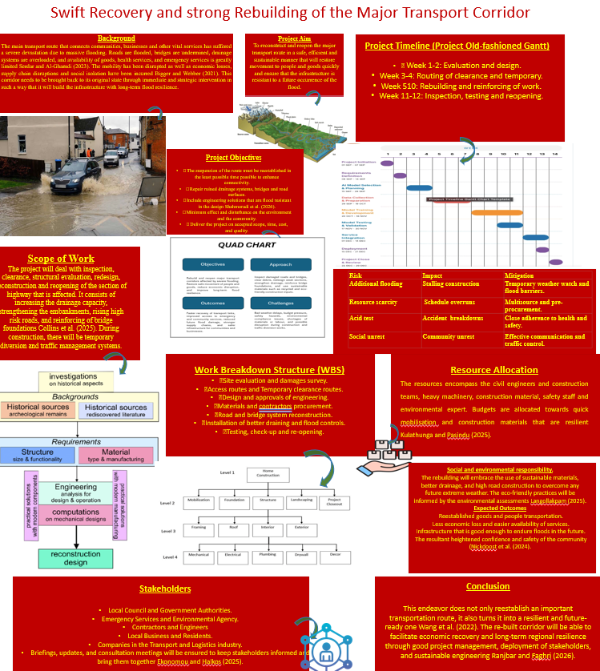

Table of Contents
Part B 3
Part C 5
1. Introduction 5
2. Project description 6
3. Scope 6
4. Work breakdown structure 8
5. Quad Chart 9
6. Gantt Chart 10
7. Stakeholders & involvement 11
8. Allocation of resources 13
9. Risk Analysis 14
10. Conclusion 16
References 17

Part B
Reflections according to the feedback given by the tutor and peers
Gibbs’ reflective cycle
Graham Gibbs (1988) has developed a reflective cycle to analyse past learning experiences and create a new learning experience from the successes and failures experienced in the past. The reflective cycle helps an individual to critically analyse their newly learned knowledge or experience and improve the outcome according to the analysis. It is a cyclic process that influences personal and professional growth. The feedback given by the teacher and peers are pointing out the shortfalls of the study conducted. The suggested improvements are going to be analysed with the help of six stages of Gibbs’ reflective cycle.
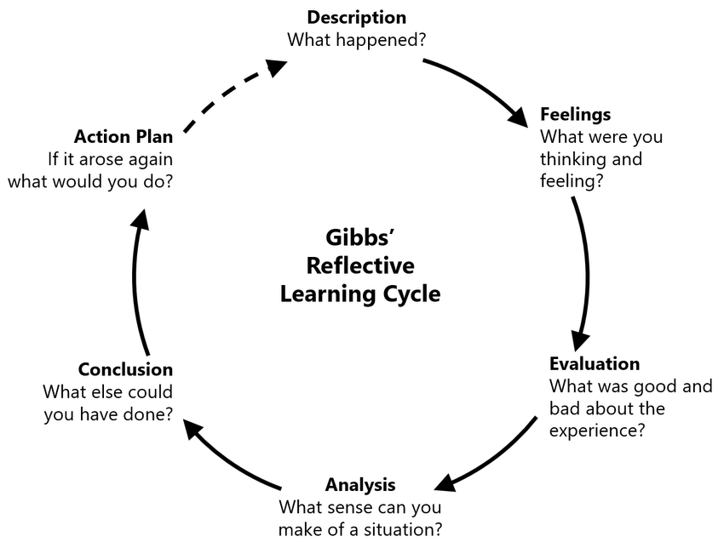
(Source: Galli and New, 2022)

Description
The restoration project of major transport corridor has emphasised on primary issues affecting the transport routes connecting communities and services, which has been disrupted by flooding. Hence, implementation of a robust infrastructure is important for flood prevention and decreasing the impact caused by rainfall or flooding. Additionally, the project has emphasised on highly elevated roads, reinforcement of embankments and upgradation of drainage systems. Therefore, the project has aimed to reconstruct the important transport routes in an efficient and sustainable manner that will ensure the free movement of goods and people. It also included risk analysis and the scope of the work breakdown structure. However, reflecting on the feedback from the teacher using Gibb’s (1988) helped me to better understand the quad charts. It will be required to support the foundational structure for the project. Additionally, a corresponding image and a different poster colour will be required.
Feelings
Through my lessons learned, I have identified some of the issues that were associated with Project A. Initially, I felt discouraged due to my lack of success with the original project materials. My peers and instructors were able to clearly articulate what I needed to do, which helped me to understand the benefit of reorganising the overall project and the need for a quad chart as well as a different graphic design to complete my work.
Evaluation
The first task has assisted me in gaining both positive and negative feedback. As I mentioned before, in the initial stage, I felt vulnerable and afraid as I lacked knowledge about quad charts and other frameworks. Overcoming this initial hurdle has helped me to effectively demonstrate an openness to learning and collaboration. I have used feedback and guidance from my peers and teachers. It was a significant part of academic development. I felt demotivated after receiving the critical feedback, which was a human interaction.
Analysis
The feedback given by my teachers and peers have helped me to identify the possible improvements and shortfalls of my project. The feedback has assisted me to integrate the quad chart in my final task and enhance the quality of the project. Besides, the colour that I used for my posters has affected the presentability and impacted the visual quality. Considering this, I will consider this feedback to enhance my future project and will include a quad chart to enhance the project quality and improve the presentability of the poster.
Conclusion
The project has assisted me in learning that a corresponding photograph will be important to guide the study regarding the project. This will allow for an honest representation of the project value and dependability as well as provide examples of how well something works based on the quad charts. The bright colours of the posters will also add to the overall quality of the project through the use of different styles created by each graphic designer.
Action plan
Based on Gibbs’ (1988), the action plan will involve the generation of new posters with a variety of colours, and the QUAD chart will be added within my final assignment, along with the required images that would help to enhance the submission of the overall assignment.

Part C

1. Introduction

This assignment will develop the core knowledge regarding project management development. The project will focus on rebuilding the principal corridors for the transportation of goods and people, providing emergency services, local councils, and community organisations which were overwhelmed (Cabinet Office, 2022). To start with, project management is a distinct endeavor with a start and finish,carried out by individuals to achieve predetermined objectives within constraints of budget,and quality (Project Management Institute, 2024). The environmental agency issues are included in the projects, as infrastructure resilience is increasingly shaped by climate-related risks (Environment Agency, 2023). With the help of a detailed proposal, management will have developed the entire project. This will include project descriptions, scope of the projects, work breakdown structures, quadrant charts, stakeholders' involvement, resource allocations, and risk analysis for the project development (APM, 2024). With these strategies, the entire project will be developed.

Based on the scenario, the project aims to reconstruct and reopen major transportation routes in a safe and efficient manner with sustainable practices, aligning with national infrastructure resilience frameworks (National Infrastructure Commission, 2023). It will restore movements of people and goods quickly and prevent the future occurrence of flooding, as resilient transport corridors can significantly reduce disruption (DfT, 2021). The proposed transportation corridor can be beneficial in managing floodwater and reducing water clogging (CIWEM, 2022).

2. Project description
This project will highlight the principal corridors in the transportation of people and goods with a core strategy, which could enhance economic growth, regional connectivity and logistic efficiency (OECD, 2020). The main processes include identification, ongoing monitoring, and selection of resources and risks (Kerzner, 2022). This project is aiming to improve the transportation situation during floods within the UK by reducing congestion, enhancing capacity, and increasing connectivity between economic hubs (DfT, 2023). Upgrading the infrastructure of the project makes it possible to handle higher volumes of people and goods, and the sustainable green spaces are focused on sustainability and enhanced transportation access for improved connectivity (UN Habitat, 2022).
The restoration project of the major transport corridor is concentrating on bringing back the transport routes within a short time period by ensuring a strong structural integrity of the transport corridor. According to the scenario, intense rainfall has affected the structural integrity of the transport corridors, consistent with national reports on climate-driven infrastructure degradation (Met Office, 2023). The reduced capacity of the sewage systems also contributed to the disruption of the roads (Environment Agency, 2022). Mobility systems have been disrupted, as well as economic losses and supply chain interruptions, which are common consequences of major flooding events (OECD, 2021). Local councils have initiated emergency services to restore communication and transportation services as much as possible (Local Government Association, 2023). The project is also aiming to connect communities and businesses with other services which have suffered from the massive flooding (NIC, 2023). This project approaches integrated structural improvement in engineering and sustainability design, reflecting best practice in climate-adaptive infrastructure (ICE, 2022). These are emergency measures that are planned to ensure longevity and minimise future disruption in the particular place (DfT, 2021).
This project will be completed within 11–12 weeks. The first 3–4 weeks are for routing clearance and project design. Weeks 5–10 rebuild the reinforcement of work, and the last two weeks will be used to evaluate the testing, inspection and reopening, following standard project lifecycle models (APM, 2024). Relevant resources will be allocated for the contractors, including civil engineers, project teams, heavy machinery, construction materials, and safety environment experts (Kerzner, 2022). Budgets are allocated for the materials that will be completed within the time. Re-established goods and people transportation will result in less economic loss and easier availability of service infrastructure to ensure resilience against floods (NIC, 2023).
3. Scope
The scope of the project includes inspection, structural clearances and evaluations, redesigns, and reconstruction of the project. It will reopen the sections of highways that are affected, aligning with standard scope definition practices (APM, 2024). This project will consist of increasing drainage capacities and strengthening them, which is essential for flood-resilient transport systems (CIWEM, 2022). It will embank the high-risk road segments and reinforce the foundations of bridges within the project (ICE, 2022).
The main scope of this project is that it is highly needed by communities and transportation services to address the issues. Based on this scope, the project will help in enhancing the drainage system, water management system and flood management system (Environment Agency, 2023). These key features will help in reducing water clogging and flooding within the transportation routes (DfT, 2021). Implementation of bioengineering solutions will include hydroseeding and geo-solutions with bamboo plantations to protect the hilly road segments from landslides and soil erosion (FAO, 2020).
The structural and operational upgrades will be the broader scope of the project, using modern materials and techniques such as fly ash and cement-treated sub-base, which improve durability and sustainability (ICE, 2021). This project will ensure all-weather motorable access for people and goods (NIC, 2023).

4. Work breakdown structure
Work breakdown structure is a key component within project management, which outlines the key tasks that will support the completion process of the project. This helps in assigning the overall scope of the project while outlining the methods and processes that will be considered (Cooke and Williams, 2025). The key work that will be considered includes surveying the site, assessing routes, materials and designing procurement, road and bridge reconstruction, installation of better drainage and flood control and testing.
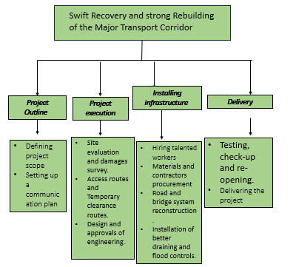
(Source: Author)

5. Quad Chart

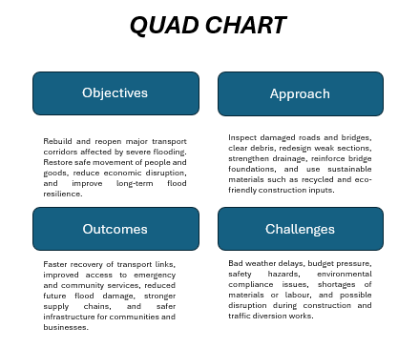
Source- (Self-created)
The above chart is relying on objectives, approaches, outcomes and changes for the project's development, based on ( Lean,2026 ) This chart contains a summary of the key aspects of the River Severn Transport Corridor Reconstruction Project. The chart helped to know the project’s advantages, like improved infrastructure, a faster recovery of the economy, improved access for emergency responders, and increased ability to withstand future floods. In addition, the chart identifies some of the key risks related to the project, including weather delays, budget constraints, labour shortages, environmental issues and safety concerns. The overall objective of the chart is to provide an easy-to-read format that can assist with rapid understanding and decision-making when considering the River Severn Transport Corridor Reconstruction Project. These are documents which provide concise and high-level project technology in the business proposal. It, with the help of four major elements, facilitates rapid decision-making for the project development. This cart has helps to deliver with a crisis and can make overviews with essential values projects without reading the full assignments.

6. Gantt Chart
A Gantt Chart displaying a project-management tool for stakeholders to comprehend scheduling, dependencies and overall project progress according to (Kerzner,2022)
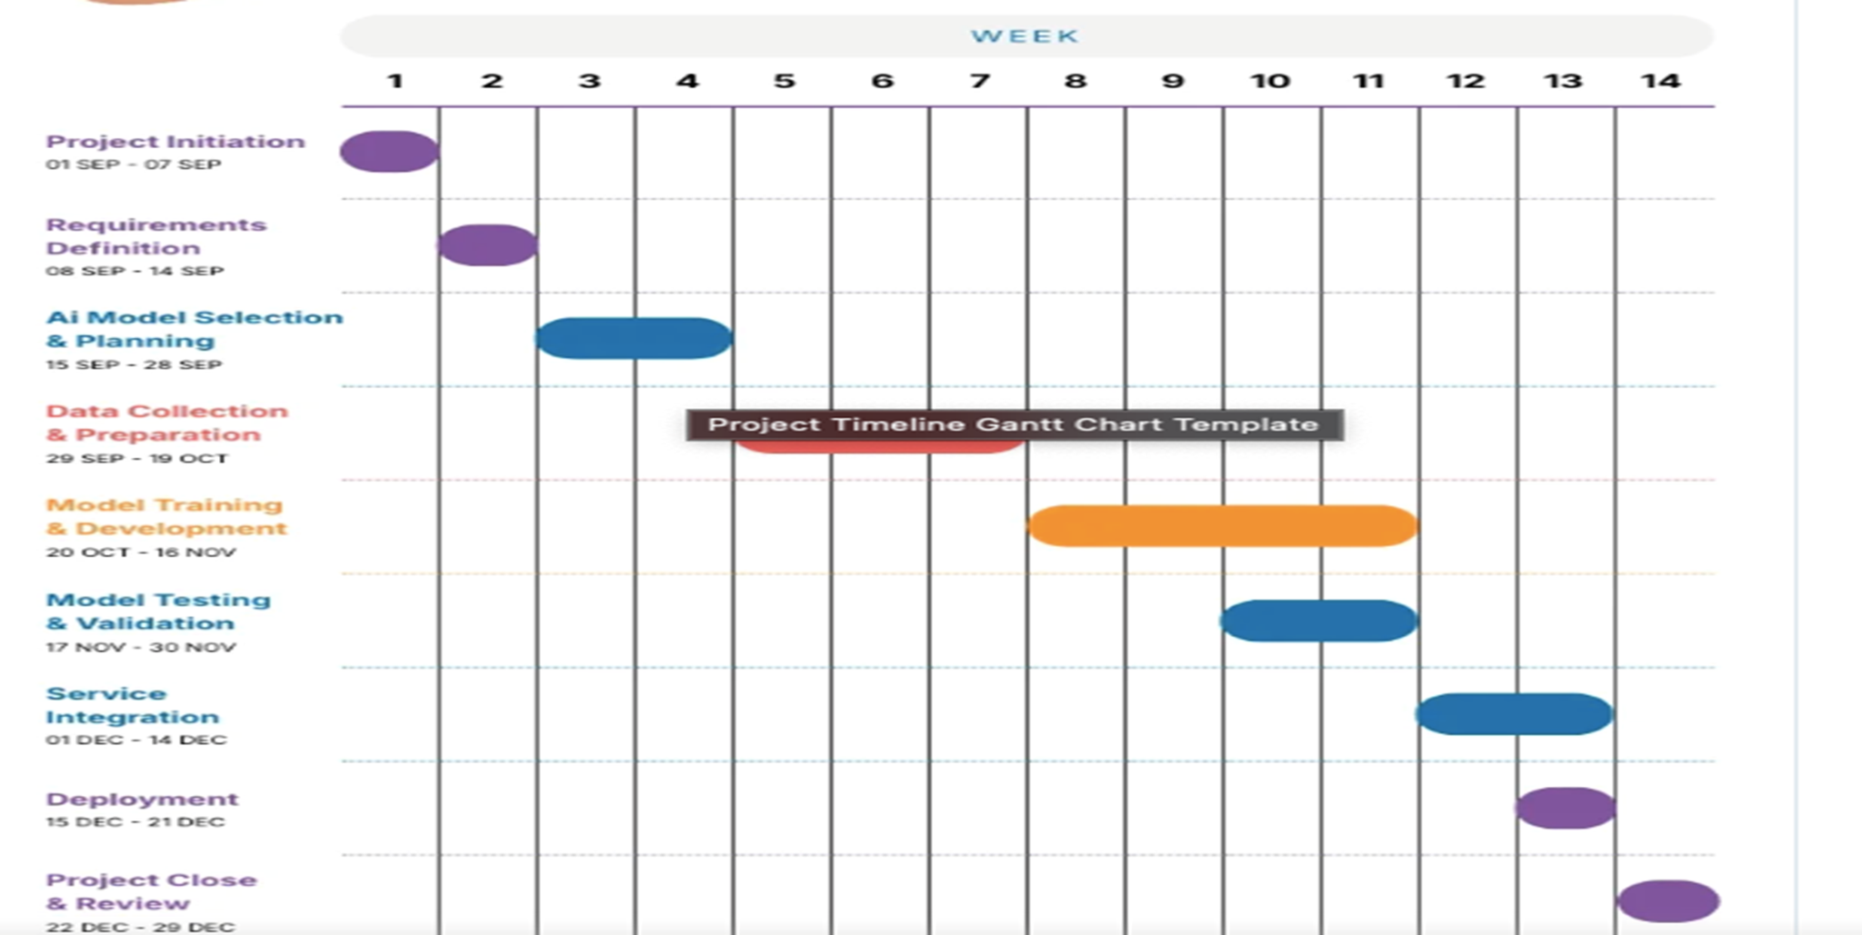
(Source: Author)
7. Stakeholders and involvement
In the scenario of the July 2025 catastrophic flooding across the West Midlands, the recovery process needs a multi-agency and coordinated approach. It can involve multiple stakeholders. The projects of reestablishing transportation corridors would be highly required by several stakeholders. This approach will be significant as it can help in managing surface water runoff. Besides, it will contribute to increasing resilience and preventing erosion. The learning alliance is a series of interconnected stakeholders (Fried et al., 2021). Stakeholder analysis in project management is the systematic procedure of identifying the individuals or groups. Stakeholder involvement to rebuild the UK transport corridor includes transport operators, governments, businesses, and local communities. These stakeholders' entire economic growth and project success are vital for managing environmental impacts, reducing risks, and gaining social acceptance.
Local councils
Integrating flood resilience into road reconstruction would help in reducing long term costs. Besides, it can assist in preventing repeat failures caused by extreme weather. Besides, they should lead the public consultations on re-establishing strategies.
Environment agency
The Environment Agency will be important in prompting ethical and sustainable operation within the project. These environmental agency aspects will help in promoting a sustainable structure and enhance the decision-making process. The environmental agency will help in using sustainable resources such as concrete, hydraulic materials and others. This is a key aspect that will allow this project to adhere to sustainability and environmental standards. They will be responsible for monitoring the progress and the impact of the construction project on nature. It will help in identifying risk factors, based on which risk measures will be taken to effectively complete the project. They can contribute to providing data on hydrological risks to inform where the transportation corridors need to be protected.
Contractors and engineers
The role of the contractors will be related to technical design and reconstruction of roads, bridges and transport hubs. By highly focusing on flood-resilient materials and adaptive design, the contractors may facilitate the passage of water. It can be achieved through implementing structures. The implementation can include several materials that enable stormwater engagement. They would be involved in consultations and provide design options to their local councils (Hillson, 2024). This project will also utilise flood-resistant and management materials which will help in enhancing the transportation routes. Moreover, the transportation corridors using sustainable measures and effective flood management design can help in managing water clogging.
Local business and residents
The role of the local business and residents involves immediate use of the transport infrastructure and those most impacted by its failure. Besides, local communities, residents and vendors will help in guiding the project in understanding the issues faced by them. This will help in improving the overall pavement infrastructure while enhancing the transportation services. They can help to adapt their daily logistics.
Organisations in the transport and logistics industry
Different companies in the transport and logistics industry act as direct stakeholders because they are involved in their day-to-day operations. They also include supply chain management and processes of storing, moving and delivering goods within the company. The direct stakeholders who have a dependency on the damaged corridors for moving goods and people. Besides, the logistics firms should effectively engage with the local authorities to recognise alternative routes and provide data on bottlenecks. Assessing the local environment and infrastructure will be important to rebuild the transportation corridor. To confirm the effective rebuilding, a collaborative framework should be implemented in the entire project plan. Regular updates would be provided to all stakeholders about the progress of repairs. It may help in ensuring transparency and managing expectations. On the other hand, active participation would be sought from the residents and businesses during the design phase of the new infrastructure. It can assist in ensuring community needs are met. Apart from this, combining data from the EA, local feedback, and engineering would result in better strategic decisions. The help of this collaborative approach may contribute to directly addressing the requirement to break the cycle of communities struggling to recover from the flood (Testorelli et al., 2024).

8. Allocation of resources
The project has focused on introducing advantageous solutions by rebuilding new routes and restructuring the existing pathways to enhance the transportation facilities. This solution will include damage-proof materials, flood-resistant materials, effective drainage systems and many more. Overall, the process requires sustainable materials, funding and heavy machinery to support the project development process. Considering this, the key resources that will be required for this project are labourers as core assets, like Civil engineers, construction teams, heavy machines, construction materials like bricks, cement, geotextiles, geogrids, interlocking concrete pavers, porous concrete, recycled asphalt and concrete and staff safety and environmental expertise. They will be responsible for managing the delivery of this project.
Construction materials
Construction materials that have been mentioned will be allocated based on the requirements and the project's progress. This will help in managing the budgeting process without creating pressure on the budget. Besides, materials will be recycled and reused to avoid excess expenditure.
Workers and staffs
Staff and workers are vital for the projects that highly influence the rebuilding of transportation corridors in the post-flood scenarios. They could lessen operations and implement resilience measures, and ensure continuity of goods and the movements of people. This is because the project manager is responsible for handling stakeholder engagement, resource allocation, budgeting and project planning (Kerzner, 2025). Meanwhile, ground staff will be responsible for building the transportation infrastructure. Meanwhile, the environmental expert will help in ensuring regulatory compliance and will conduct an environmental assessment to understand whether the infrastructure is suitable for the current condition or not. Apart from this, the safety staff will ensure that every worker is adhering to the safety regulations, and they will be responsible for managing emergency situations and uncertain accidental hazards (Osei-Asibey et al., 2021).
Budget
Budget will be the core resource for this project as it will support the overall phase of the project. Considering this, the budget will be allocated using a structured process. It will help in supporting the mobilisation and purchase of the construction materials. Besides, a budget will be allocated to support the delivery of the project by offering wages to the staff and preparing legal documentation to support the project.
9. Risk Analysis
Risk analysis is a significant process of recognising and evaluating threats. These risks are discussed below.

Risk | Impact | Mitigation
Additional flooding and river breach | Further submersion of homes in Worcester, failure of the electricity and transport network, and disruption. | Integration of temporary flood barriers, activation of the property flood resilience kits. Besides, it also involves monitoring of temporary flood defences.
Stalling construction | Another risk can include delays to regional development projects, damage to equipment, besides, it may also include loss of construction materials. | Suspension of work in the high-risk areas and securing site equipment will be vital. With the help of the proactive measures, it is possible to ensure that development projects are resilient.
Resource scarcity and supply chain | Supply chain disruption and ineffective management and allocation of resources can delay the project delivery time (Freeman, 2023). | Pre-positioning resources and establishing multiple sources for materials will be helpful for the overall project. Effective coordination between the project members can be a significant strategy. They can help in managing risks and confirm the rapid site access during emergencies, and establishing pre-planned communication protocols would be helpful.
Accident breakdowns | It includes structural damage to buildings. It focused on the emergency personnel, who are at risk of infections from contaminated waters. | Strict compliance with the H&S protocols and immediate structural assessments before reoccupying buildings would be significant.
Community unrest and safety | Potential for public frustration over barricades and social unrest can be a significant risk (Kujala et al., 2022). | Clear and timely communication from the local authorities, Transparent flood alerts, and traffic control for safe evacuation.

The region has experienced high water levels, with lessons learned from the previous February 2020, the overall scenario has implied a 20% increase in the flood risk estimates. It can make the event more common (Freeman, 2023).

10. Conclusion
The project can involve constraints like budgets, time, and quality. The project has enhanced the knowledge of Rebuilding the principal corridor for transportation of goods and people to mitigate the risk of “Severe Flood Warnings – Danger to Life.” This assignment has been provided with the scope of the project with a work breakdown structure, a Gantt chart and a Quad chart to know the project timeline. Some stakeholders who will be involved in the projects have been identified in the report. Resource allocations for the project have been provided in the report. Local communities and government authorities, emergency services and environmental agencies, contractors and engineers, and local businesses and residents will be the major stakeholders for the project. All these aspects have been provided for the project enhancements. This project has been effectively and rapidly conveyed to customers.

References
APM, (2024). What is project management?. [Online] Available at: https://www.apm.org.uk/resources/what-is-project-management/ [Accessed 17 03 2026].
.
Bigger, P. and Webber, S. (2021) ‘Green structural adjustment in the World Bank’s resilient city’, Annals of the American Association of Geographers, 111(1), pp. 36–51.
Cabinet Office (2022) National Resilience Framework. London: HM Government.
CIWEM (2022) Managing Flood Risk: Infrastructure and Community Resilience. Chartered
Collins, N., Anderson, J., Gartner, T., Hunter, R., Jongmanrtner, B., Jungman, L., Marsters, L., Onah, I., van Zanten, B., Vidad, G. and von Turkovich, N. (2025) Growing Resilience. World Bank.
Cooke, B. and Williams, P. (2025) Construction planning, programming and control. John Wiley &Sons.
DfT (2021) Transport Resilience Review: Climate Adaptation and Flood Preparedness.
DfT (2023) Future of Transport: Improving Connectivity Across the UK. Department for Transport.
Ekonomou, G. and Halkos, G. (2025) ‘Exploring the concept of tourism competitiveness across the OECD countries’, Current Issues in Tourism, 28(19), pp. 3148–3167.
Environment Agency (2022) Flood and Coastal Erosion Risk Management Strategy Progress
Environment Agency (2023) Climate Change Impacts and Infrastructure Vulnerability Report. En
FAO (2020) Bioengineering for Slope Stabilisation: Guidelines for Sustainable Land Management. Food and Agriculture Organization of the United Nations.
Freeman, R.E. (2023) ‘Managing for stakeholders: Trade-offs or value creation’, in R. Edward Freeman’s selected works on stakeholder theory and business ethics (pp. 295-299). Cham:
Springer International publishing.
Freeman, R.E. (2023) ‘The politics of stakeholder theory: Some future directions’, in R. Edward Freeman’s selected works on stakeholder theory and business ethics. (pp. 119-132). Cham: Springer International publishing.
Fried, T., Welle, B. and Avelleda, S. (2021) Steering a green, healthy, and inclusive recovery through transport. Washington, DC: World Resources Institute.
Galli, F. and New, K.J. (2022) ‘Gibbs’ cycle review: Emotions as a part of the cycle’, E-Motion: Revista de Educación, Motricidad e Investigación, (19), pp. 92–101.
Hartshorne, D., (2024). What is Project Management? The Complete Guide [2026]. [Online] Available at: https://monday.com/blog/project-management/guide-to-project-management/ [Accessed 18 03 2026]
Hillson, D. (2024) Managing risk in projects. Routledge.
ICE (2021) Modern Materials for Sustainable Road Construction. Institution of Civil Engineers.
ICE (2022) Climate-Resilient Infrastructure: Engineering Guidance for Flood-Prone Regions.
Kerzner, H., (2025). Project management: a systems approach to planning, scheduling, and controlling. John Wiley & Sons.
Kujala, J., Sachs, S., Leinonen, H., Heikkinen, A. and Laude, D. (2022) ‘Stakeholder engagement: Past, present, and future’, Business & Society, 61(5), pp. 1136–1196.
Kulathunga, M. and Pasindu, H.R. (2025) ‘Robustness-based optimization model for post-flood road network recovery’, in 2025 Moratuwa Engineering Research Conference (MERCon). IEEE, pp.(870-875).
Langollakpam, C. (2025) Strengthening disaster risk reduction and climate resilience in Global South coastal cities: Lessons from Global North approaches to climate change–induced urban flooding, coastal erosion, water stress, and heat risks in Accra, Cape Town, and Chennai. Doctoral dissertation. Politecnico di Torino.
Local Government Association (2023) Local Authority Emergency Response to Flooding: National Overview Report. LGA Publications.
Martins, J., (2025). What is project management? Benefits, process, and tools. [Online] Available at: https://asana.com/resources/benefits-project-management [Accessed 18 03 2026].
McDowell, Z., (2025). What is Project Management?. [Online] Available at: https://www.planview.com/resources/guide/what-is-project-management/ [Accessed 17 03 2026].
Met Office (2023) UK Climate Risk and Extreme Rainfall Assessment. Met Office.
National Infrastructure Commission (2023) Infrastructure Resilience Study: Preparing the UK for Future Shocks. NIC.
Nickdoost, N., Jalloul, H., Choi, J. and Smith, D. (2024) ‘Identification and prioritization of multidimensional resilience factors for incorporation in coastal state transportation infrastructure planning’, Natural Hazards,120(2),pp1603-1663.
.
OECD (2020) Transport Infrastructure for Regional Connectivity and Economic Growth. Organisation for Economic Co-operation and Development.
OECD (2021) Economic Impacts of Flooding on Supply Chains.
Osei-Asibey, D., Ayarkwa, J., Adinyira, E., Acheampong, A. and Amoah, P., (2021). Roles and responsibilities of stakeholders towards ensuring health and safety at construction site. Journal of Building Construction and Planning Research, 9(1), pp.90-114.

PMI, (2026). Project Management. [Online] Available at: https://www.pmi.org/about/what-is-project-management [Accessed 17 03 2026].
Project manager, (2026). What Is Project Management? Definition, Process & Tips. [Online] Available at: https://www.projectmanager.com/guides/project-management [Accessed 18 03 2026].
Project Management Institute (2024) A Guide to the Project Management Body of Knowledge (PMBOK® Guide). 8th edn. PMI
.
Ranjbar, E. and Faghri, A. (2026) ‘Urbanization and ecological repercussion on active transport and micromobility facilities’, World Journal of Engineering and Technology, 14(1), pp. 43–64.
Region, A. and Unit, P.S. (2022) World Bank Group. Washington, DC.
Serdar, M.Z. and Al-Ghamdi, S.G. (2023) ‘Resilience-oriented recovery of flooded road networks during mega-sport events: A novel framework’, Frontiers in Built Environment, 9, p. 1216919.
Shahmoradi, S., Eslamian, S. and Maleki, M. (2026) ‘Environment-mobility nexus’, Global Nexus Handbook,3.pp.1083-1102.
Testorelli, R., Tiso, A. and Verbano, C., (2024). Value creation with project risk management: aholistic framework. Sustainability, 16(2), p.753.
UN Habitat (2022) Sustainable Urban Mobility and Green Infrastructure Framework. United Nations Human Settlements Programme.
Wang, X., Mazumder, R.K., Salarieh, B., Salman, A.M., Shafieezadeh, A. and Li, Y. (2022) ‘Machine learning for risk and resilience assessment in structural engineering: Progress and future trends’, Journal of Structural Engineering, 148(8), p. 03122003.

