Case Study for a 5-year-Old Child, Critically Analysing the Inclusive Intervention and Support Provided for a Pupil in a Primary Setting
1503134

Introduction
This case study is going to critically analyse the inclusive support provided for a five-year-old child from a local setting. This will include policies practice and theories. The Welsh government (2018) recognises that children mainly need extra support for their learning and influence policies to ensure this happens. The UNCRC (UNICEF, 2009) recommends thinking of the child as an individual. The five-year-old child is in mainstream class and struggles with speech and language. Speech and language is one of the most common difficulties experienced by children, with 7 to 10% of children recorded with this problem (Hartshorne, 2018). Children in poverty, measured by receiving free school meals, are nearly twice as likely to have speech, language and communication difficulties. This can affect them throughout primary school, in 2017 only 15% achieved expectations compared to 61% of children without difficulties (Holtom & Bowen, 2016).
The areas the child struggles with our pronouncing sounds and has a lisp which makes it hard for him to speak. The child has been supported by speech and language therapist since they were two. This is good practice as the earlier a child gets support the better (Hartshorne, 2018). Now the child is five the speech and language therapist is given the class teacher and parents games to play that are more linked to the curriculum such as letter recognition and sound. This case study aims to support the child in an inclusive way. The interventions will be based on theorists such as Vygotsky. According to Vygotsky (1953) the child should not be overstretched as this can prevent them learning. From and LSA from a local school‘s point of view the involvement for supporting the child with speech and language difficulties is important. This is because the LSA role is to follow on from the speech and language therapist by supporting the child through games, activities and extra support when needed in lessons such as literacy.
In lower classes some of the activities the speech and language therapist offered and did with the child involved listening to sounds and matching games. This is recommended by Warwickshire NHS trust speech and language therapy department (2009). The LSA takes ideas from the speech and language therapist and makes them fun. This helps encourage the child to learn especially as it will involve Vygotsky (1978) scaffolding method and is aware of Piaget (1977) stages of cognitive development. The Welsh Government (2016) also recognise the importance of education through play.
This intervention will involve ethics. The parents would be involved. The child must be happy to cooperate. Also it is important to liaise with the teacher so the child is not being taken out of a core subject so the child is not missing out on anything important. The Welsh Government (2016) emphasises a child should take part in usual activities. It is also important child is not taking out of PE as it is vital for the child to be active. Vygotsky (1978) states that children should be social involved for learning. The child’s interests were investigated, to find out what they were interested in. Bruner (1973) believes that the child’s interests will help learning while skinner (1953) would encourage rewards. The child like drawing and colours so the game was designed to be colourful. A suitable moment was then found to meet the child. The aim was to do the activity twice a week (Mondays and Thursdays) for a short period. The activity would start with simple steps. It is important to try and learn as often as possible without overload (OSC, 2018).
The first stage would be the tongue activity story (appendix 1). As the child was getting to know the LSA, this was a game they had played before and enjoyed and helps with getting to know the child. The tongue activity story provides a number of different tongue exercise though out the story. When the Child Felt comfortable doing to book the LSA decided that to ask the Child if they would like to be recorded doing to book. The LSA came up with this idea because Technology is a good way for a child to learn. Donaldson (2015) recommends that the use of information and communication technology is included in the curriculum. Also the LSA thought it would be good idea if the child could see their self-doing it.
Before starting it was also important to make sure the child was in a quiet space for the one-to-one sessions. When working with the child the LSA made sure that they were at the child’s eyelevel with good lighting. Their name was used to get the child’s attention. Also gestures were used to support what was being said (NHS Warwickshire,2009). In the first session (appendix 3) the first half of the book with tongue movements and not the sounds were done. The child did this well but struggled with the quick tongue movements. As the child was struggling to do the action quickly, so they were encouraged to do it slowly at first. This is recommended by NHS Warwickshire (2009). The child was told to imagine a pen was the dogs tail and try to move their tongue with the pen while the LSA moved it from side to side. The child was then encouraged to use their finger and follow their finger with their tongue. This helped the child to become quicker. During the next session the child could move their tongue faster. As the child was able to move their tongue faster the LSA would add a bit of competition if a child wanted to. They would race the child with tongue movements. This was not encouraged earlier as it would have pushed the child outside his comfort zone (Vygotsky, 1979). At all times it was important to make sure the child was engaged and happy. One day the child was particularly tired and fed up so the child was encouraged to colour in the book instead as this was their interest. As the child was colouring they were asked about the tongue movements that were shown in the picture. This was used on other occasions as the child was happier to take part after colouring. The LSA felt that the child could now do the book at a comfortable level and that now was the right time to ask the child if they would like to be recorded. The LSA spoke with the speech and language therapist who had suggested recording the child (appendix 3). The LSA explained to the child about the recording and said that it would be a good idea for the child to watch himself so they could see his tongue movements. The child become a bit shy and was unhappy to do the recording. The LSA let the child record them first and show them that the video could be deleted and nobody else could see it. The child was still wary of the recording, so the LSA asked to record the child doing something they enjoy which was colouring. The child was happy to do this and then agreed to record his tongue movements. The LSA found that the child overcame the worries about the recording and really enjoyed this method of learning. This was then used in every session and was really important when the child got on to the sounds with the mouth movements. The child found the use of recording really good as they could hear themselves when they were going wrong. Towards the end of the sessions the child had asked is his class teacher could come and see how well he was doing (appendix 3). The reward at the end was to take the book home so that the child could carry on practising (appendix 3). The LSA came up with the idea of a reward as they agreed with Skinner (1953) theories.
It is important to keep to record and monitor progress. The child was encouraged to do a smiley face to show his feelings on the record sheet (Scottish Office , 2004).
Parental support is also important as it helps to support the child. Bronfenbrenner (1979) states that the parents are the closest help to children. Backhouse (2009) showed that parental interventions are one of the most successful interventions for children with language interventions. In practice parental engagement research shows that it helped children to catch up with development mental milestones (Hartshorne, 2018). Bruner (19) believes that children aged 1-6 use images to store information. The LSA has decided to provide parents with a picture of monkeys doing different tongue exercises to practice at home (appendix 2). This is sported by NHS Warwickshire (2009) who agree schools should liaise with parents and recommend simple vissual methords.
The support intervention was good because it used the child’s interests. It also invloved liaising with the class teacher so the child was working on something relevent. It also involve the speech and language therapist giving correct information such as what was the child’s srengths and weaknesses and saying what game to do with the child. The game was also made fun and used a number of multisensory styles. It is recommended to use multisensory methods for children with additional learning needs (Estyn, 2013). The child had to listen, touch, look, and speak, the only sensory mode not used was smell.
The things that could of worked better with this support intervention and would be changed if this was done again are the LSA could have different games prepared as sometimes the same game gets boring. However repation sould help with learning (Scottish Office , 2004). Also ideally this could carry on with his everyday litracy work in ther classroom. This would put more pressure on the teacher who did not have time in the day. The other idea would be to have a copy of the book inhis tray to remind him or selataped onto his desk. Also there should have been a record sheet from feedback from parents.
This case study, which aimed to critically analyse the inclusive interventions for a child wih speech and language difficulties, will now be concluded. It can be seen that no matter if a child is different they should still be included in evry day school curriculum (Welsh Government, 2018). It is also important to make sure they are treated as an individual (UNICEF, 2009). Bringing outside agencies into a school setting to support an individual is an essential part of helping children who struggle with the everyday school curriculum (Welsh Government, 2018).
To be able to design a support intervention it is important to look at theorists. Each theorist has different relevant points of view about a child’s learning. They are all good but in different ways. Bronfenbenner uses Ecological systems theory which is really important because it takes the individual at the centre (Paquette & Ryan, 2001). Vygotsky (1978) was also important as he states not to push the child too far out of their comfort zone. In the case study his method was used as the LSA allowed the child to be in control, allowing the child to do something they liked doing, like colouring. Skinner (1953) believes that giving a child rewards is a good idea. The LSA believes that only rewards that will benefit the child should be given and not treats as it is unfair on the other pupils. The child was given the Mr Tongue bok which will help him throughout his learning.
This case study was overall good for a child with speech and language difficulties as it involved the child, the parent, outside agencies and the class teachers to help a child with their struggles. It was important that the child’s speech and language was picked up at a yong age and worked with as it can affect them later on in life with GCSEs, higher education or work life (Holtom & Bowen, 2016). This case study worked for the individual even though there were struggles. The LSA used mutisonsory methods throughout the game as it is important for children to learn using their multisensory modes (Scottish Office , 2004). Technology is important to use throughout learning because it can be nore fun and helps to get the child learning and it helps to prepare them for the future (Donaldson, 2015).

References
NHS Warwickshire , 2009. NHS Warwickshire Speech and Language Therapy Service. [Online]
Available at: https://www.swft.nhs.uk/application/files/9714/5994/6466/speech_and_language_resource_file.pdf
[Accessed 2 March 2019].
Bourke, P., 2008. Procedures for gaining access to disability-specific supports (e.g., attendants, speech specialists, assistive technologies) and other resources needed for success in regular classrooms are typically restrictive and not available on an equitable basis. Th. [Online]
Available at: https://eprints.qut.edu.au/25910/1/Patricia_Bourke_Thesis.pdf
[Accessed 2 March 2019].
Bronfenbrenner, U., 1979. The ecology of human development: Experiments by nature and design. Cambridge,MA: Harvard University Press..
Bruner, J., 1973. The relevance of education. New York: Norton.
Donaldson, G., 2015. Successful Futures. [Online]
Available at: file:///C:/Users/Student/Downloads/Donaldson%20Report%20-%20Successful%20Futures%20-%20Independent%20Review%20of%20Curriculum%20and%20Assessment%20Arrangements%20in%20Wales.pdf
[Accessed 10 Febuary 2019].
Estyn, 2013. Supplementary Guidance for Additional Learning Needs. [Online]
Available at: https://www.estyn.gov.wales/sites/default/files/documents/Supplementary%20guidance%20-%20additional%20learning%20needs.pdf
[Accessed 30 january 2019].
Hartshorne, M., 2018. Mind the word gap: The difference in poor children’s language skills. [Online]
Available at: https://www.openaccessgovernment.org/mind-the-word-gap-the-difference-in-poor-childrens-language-skills/55066/
[Accessed 26 Febuary 2019].
Holtom, D. & Bowen, R., 2016. Study to map the current educational provision of speech, language and. [Online]
Available at: https://beta.gov.wales/current-speech-language-and-communication-educational-support
[Accessed March 3 2019].
OSC, 2018. The Science of Spaced Practice: Why Studying ‘Little and Often’ Works. [Online]
Available at: https://osc-ib.com/article/science-spaced-practice-why-studying-‘little-and-often’-works-0
[Accessed 4 March 2019].
Paquette, D. & Ryan, J., 2001. Bronfenbenners Ecological Systems Theory. [Online]
Available at: http://dropoutprevention.org/wp-content/uploads/2015/07/paquetteryanwebquest_20091110.pdf
[Accessed 19 February 2019].
Pembrokeshire County Council, 2018. Pembrokeshire inclusion Service. [Online]
Available at: Https://Pembrokeshireinclusionservice
[Accessed 12 Febuary 2019].
Piaget, J., 1977. The role of action in the development of thinking. . In: Knowledge and development. s.l.:Springer, pp. 17-42.
Pinterest, N.D.. Discover ideas about Articulation Therapy. [Online]
Available at: https://www.pinterest.co.uk/pin/376050637616172513/
[Accessed 28 Febuary 2019].
Scottish Office , 2004. A Manual of Good Practice in Special Education Needs. Edinburgh: Scottish Government .
Skinner, B. F., 1953. Science and human behavior. London: SimonandSchuster.
Stackhouse, J., 2000. Barriers to literacy development in children with speech and language difficulties . In: D. Bishop & L. Leonard, eds. Speech and language impairments in children. Hove, East Sussex: Psychology Press.
UNICEF, 2009. Child Friendly School's Manual. [Online]
Available at: https://www.unicef.org/publications/files/Child_Friendly_Schools_Manual_EN_040809.pdf
[Accessed 22 Febuary 2019].
Vygotsky, L., 1978. Mind in society: The development of higher psychological processes.. Cambridge, MA: Harvard University Press.
Welsh Government, 2016. The Foundation Phase Profile handbook. [Online]
Available at: http://www.cscjes.org.uk/CMSPages/GetFile.aspx?nodeguid=5bdd5ac9-78ef-48f7-a972-e55312ec9334
[Accessed 10 Febuary 2019].
Welsh Government, 2018. Addional Learning Needs and Education Tribunal. Cardiff: Welsh Governmenr .

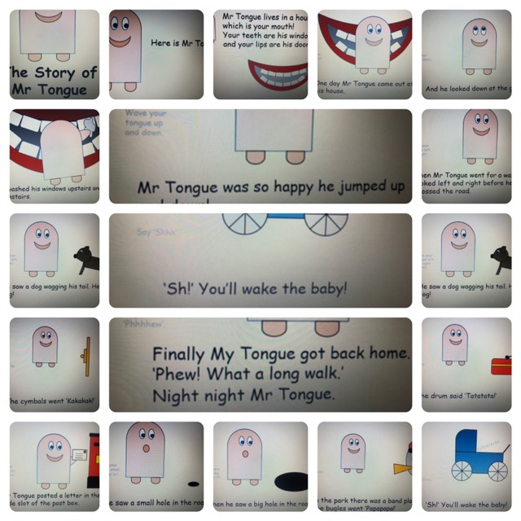
Appendix 1- Mr Tongue book

Appendix 2- Parents Monkey fun sheet of tongue exercises
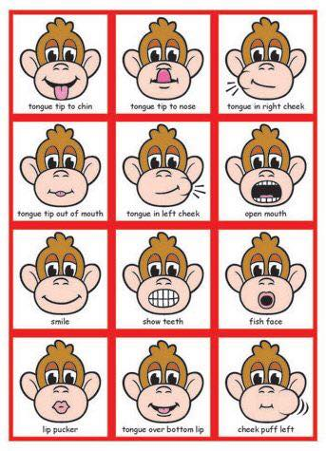

Date | Record of session | Sign | Child feelings
4/02/19 | Child completed first half of book, struggled on some tongue movement. Encouraged to do it slowly. | K.C
7/02/19 | Child repeated first half of the book and done well. Had a competition with LSA | K.C | ☺
11/02/19 | Started the next half of book. Child was tired and didn’t want to do it so did colouring instead | K.C | ☺
14/02/19 | Did the next half of book, the child had difficulty with pronunciation | K.C
25/02/19 | Tried second half again, brought in idea of recording so they could listen and see themselves. The speech and language therapist advised this | K.C
28/02/19 | The recording was repeated in this session; the child became more fluent | K.C | ☺
4/03/19 | The child wanted to invite his class teacher to show him how well he had done at learning Mr tongue | K.C | ☺
7/03/19 | The child came for a fun session. Was given the book as a reward | K.C | ☺
Appendix 3- Record sheet for Mr tongue

