Dissertation Plan

Key Words:
Textiles
Feminism
Equal rights

Statement-
Title? Exploration of historical and contemporary feminism within textiles

Textile industry remains female orientated
Textiles is not seen as an art form on the same standing as other disciplines, but is seen as a lower form of art for women.
Has feminism really happened? Or are we continuing to be marginalised into what are seen as ‘lesser’ courses.

Chapters
5,000 words total (+/-10%)

- Introduction (600-800 words)

Background and contextualisation- what is feminism? What does it mean? Examples?
(Talk about general feminist art –then narrow it down to textiles history.)

“Femininity, the behaviour expected and encouraged in women, though obviously related to the biological sex of the individual, is shaped by society. The changes in ideas about femininity that can be seen reflected in the history of embroidery are striking confirmation that femininity is a social and psychosocial product.” (Parker 1984)

It does not take much researching to discover there was a massive divided between genders through history, not just in the United Kingdom alone, but all around the world. Women historically were not seen as equal members of society to men, they had restrictions stopping them from fully embracing being part of everyday society, and were instead controlled by men and the beliefs in gender roles of the time.

There has also been a debate whether Textiles is considered craft or art. This can be seen throughout history. Very few women are mentioned when the history of art is discussed. Gaining acknowledgment for their work was almost unheard of. One female artist whose work was acknowledged is the work of Mary Beale, who worked in the 1600s, however her success was credited to her husband who would watch over her as she worked and she would paint using techniques he had created, therefore most of the recognition for her work would be given to him. “Women’s work, whether in the home or in the work place, has long been undervalued” (Cullen, 2017).

“One only has to leaf through the pages of an art history text or wander down the corridors of a museum of modern art in order to see the “natural” female, usually nude, displayed and framed into powerless by the modernist male artist. The inevitable conclusion is that bourgeois modern men manifest their social and cultural powers on the supine and helpless body of the objectified female to exhibit social prowess” (Willette, 2013). This quote is a perfect way to summarise the way women have been represented and been included into the history of art and particularly the way women have been signified in art galleries. As highlighted previously, women were very rarely acknowledged in the art world, therefore their work would not make it into galleries. A particularly controversial time in the history of art and especially female nudes is Western art where you will find all nude paintings of women were painted by men.

It may be a subject that is overlooked now, and assumed to not be as much of an issue because gender equality has defiantly improved throughout recent years however, there is an anonymous feminist activist group who go by the name Guerrilla Girls. One of their projects called ‘Do Women Still have to be Naked to get into the Met. Museum?’ supports the argument perfectly. On three separate occasions several years apart they went into the Met. Museum in New York and counted how many pieces of artwork were produced by women, they also counted how many contained a naked image of a female compared to naked males. The images below show the evidence displayed as campaign pieces they produced to be exhibited on billboards in New York (ref name &year).

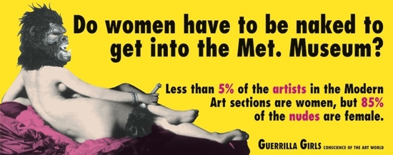(Guerrilla Girls, 1989)
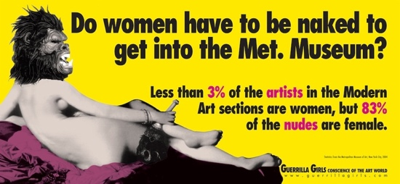(Guerrilla Girls, 2005)
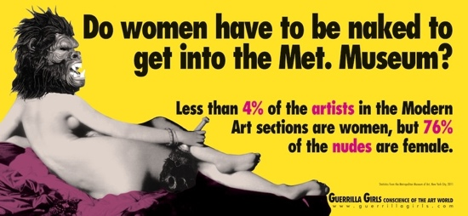(Guerrilla Girls, 2012)

It is shocking to see that between 1989 and 2012, that’s 23 years, where the statistics for the amount of women artists has dropped and there has only been 9% of a difference on how many nude images are female. This is what is going to be discussed, the idea that there is still an issue when it comes to women in art and craft. This is looking at the art industry as a whole rather than just textiles, however this is just evidence that further supports the issue surrounding women in the history of art. This will be mainly discussing and looking at textile practice and the idea that it has historically been a women’s practice and whether that is a misconception or whether things have developed and changed.

- History of textiles specifically women working within textiles industry, including social issues/views of this (feminism /right to vote etc.) 1,500ish words
(Maybe talk about Victorian history)

The history for British women is very different to men. Almost 100 years ago in 1918 women above the age of 30 were given the right to vote. Before this substantial change to politics in Britain, women were believed to be the unfit for political issues. Therefore, should not have a say in important decisions such as voting. Men saw it to be supporting the issue on whether men and women are equal, which could result in them loosing their compulsion to treat women as a lower status to themselves. It was also believed women were too engaged in family duties and household duties to be worrying about political debates. The issue regarding women being incapable of carrying out voting and any concerns surrounding politics backs up how women were not allowed to enter any skilled jobs and why sewing was seen to be the only thing they could be good at. The generation of men did not believe the women were capable of carrying out anything that suggested any intelligence.

When exploring the history of textiles, it would be hard to find much about many men involved or men famous for their stitch work. Rozsika Parker make the observation, “Music and embroidery were singled out as the ideal occupations for the lady.” (Parker 1996: 63) This is definitely evident when looking back through history. The concept that all women are naturally good at sewing and music based jobs does not make much sense in todays day and and age, because the concept that one gender were designed to do a particular job and all women should be good at it questions, where did this idea ever arise from? Also why should women be told what occupations to do, when men have the choice to do any job they want without it being an issue.

Rozsika Parker was a psychotherapist, writer, art historian but most famously a feminist. Her most famous creation is the book, The Subversive Stich: Embroidery and the making of the Feminine which was first published in 1984. The book explores the history of embroidery starting with medieval England and right through to the 19th century. It has then gone on to be used for inspiration by many artists since who would like to put a stop to the idea behind stitch being feminine and what can almost be describe as campaigning through their own work to start to make changes and hopefully end traditional views, suggesting stitch was only for women and was seen as the only activity they were able to do well.

When the book was published there was very little if any books which spoke so openly about the social and cultural problems that the act of stitch faced. All books about stitch before Parker’s did not explore social class and brought up a lot of unspoken topics, and opened up the inquiry: What is the meaning of stitch? The book starts off by suggesting embroidery was previously in history seen as an example of femininity therefore would not be considered as an art form. This backs up some previous research which looked at the lack off women artists exhibited in museums, because the majority of the work they were producing did not fit the classic description of ‘art’. The boundary between what was classed as art and what was classed as art came about because stitch and textile based practices were conventionally seen as something domestic and something you would make for a love one, whereas art was something created for money (REF).

A huge change in women’s rights took place in a Ford sewing machine factory in Dagenham in 1968. The women who worked in the factory went on a three week strike to protest over their pay. The women were paid 85% of what the men doing the exact same job were getting. The women sewing machinists were considered unskilled, whereas the male employees were graded semi-skilled. There strike was some what successful, it brought to light the issue over pay and how companies were not paying equal pay to all workers based on there job, but instead on the bases of whether they are male or female. The female’s workers also received an extra 7p per hour, which was Ford’s way of bringing them back to work and to keep them quiet about the topic for the time being. However, it took sixteen years and another strike which took place over a longer period of time, seven weeks, before Ford agreed to changing for their ‘skill grade’ to be the same as the males.

Around the same time as staff working in the Ford factory strike others related strikes were also happening around the country. For example, many years before the strike in the Ford factory a similar strike took place in 1918. A group of London transport women went on strike over equal pay. The image below is a newspaper article, Daily Mail (1918) written in 1918 reporting on the strike. The men who worked the same job were given a war bonus, which the women fought to also receive. This shows that the right to an equal wage to men was being debated well over 40 years before the Equal Pay Act 1970 was made official.

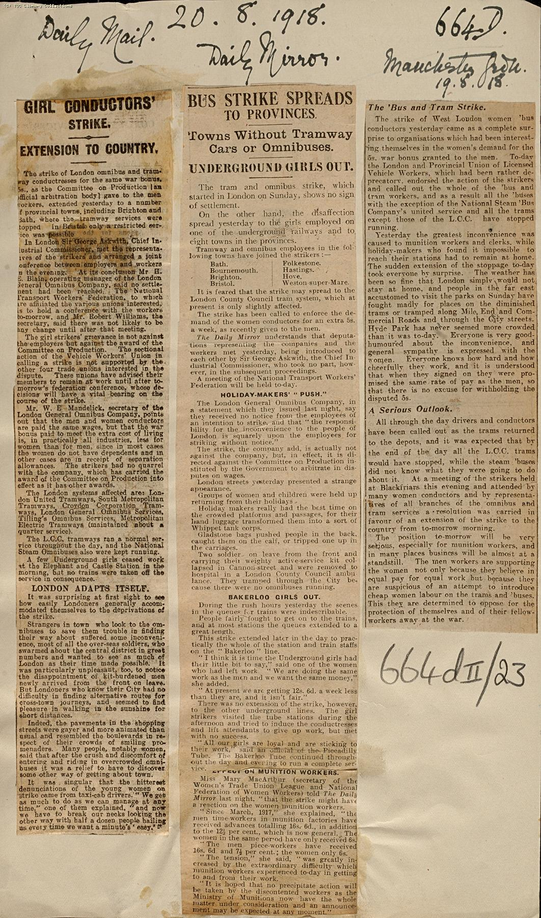
(Daily mail, 1918)

Luce Irigaray is a French philosopher who has wrote about the concept that men and women would be more alike if it was not for the social complications and how both genders should recognise the obvious differences between them. She also states that a women’s personality and character should be based on how their mother acts. She believes that women are unreasonable beings therefore women need to declare and be proud of their sexual difference in order to fight sexual difference. This theory is backed up through history.

“The social and economic forces that were to categorise embroidery, as a feminine, domestic art (and finally as almost a secondary female sexual characteristic) were set in motion in the sixteenth century” (Parker, 1996 :60)

This quote explains that women in the 16th century were said to be born ‘feminine’, therefore, they did not question whether sewing was something they wanted to do instead something they were supposed to do. They did not try to fight it, because it was a time when the majority of women accepted their place in society. If they were good at embroidery it would indicated how domesticated they were, therefore how suitable they were for marriage. This is mildly similar to Irigaray’s theory, because young girls growing up will follow suit what their mothers are doing, and because it was believed that men looked for a good embroidery in their potential partner would be told to them, therefore their natural instinct was to carry out the skill and learn to follow society.

“Pre-twentieth century needlework is often viewed as simply conventional and passive, but it is fundamentally important to remember that women’s lack of autonomy during earlier eras meant that the stitch had to be used covertly to remain undetected. Acts of ‘vanity’ and ‘immoral behaviour’ could have real and lasting consequences for a woman’s social standing.” (Emery 2017)
“Few men would risk jeopardising their sexual identity by claiming a right to the needle.” According to Parker (1984)
“Textiles, which have often been associated with decorative, the superficial, and the excessive. (Skelly 2017)
Rozsika Parker- Who was she? What did she do? Specifically look at her involvement in textiles and women’s rights. Why is she important?

Focus on UK but make links to other countries where relevant.

- Contemporary- Textile industry today and women within (1500ish words)
(80’s? Cut Cloth say gender roles have developed –find someone who disagrees or say how it hasn’t changed as much as they may think.)

The idea that women were born with natural sewing talent is absurd to think and just that statement alone shows how far gender equalities have come, however there are many pieces of evidence that still show society has not moved on completely.

Irigaray also makes a very good point in which it should not be seen as a problem for women to act like women. In other words, why are they rebelling over the fact historically women were told they were designed to do different jobs to men. She spoke about how women need to learn to love themselves, therefore, need to remain ‘women’. She thinks there is a risk woman will fall in to a trap to challenge social and cultural direction were so many people are fighting for equal rights that they start acting too much like men. She stands up for the idea that the difference between each genders have always been used in contradiction to women and if the world became a population of men, women would lose a lot which makes of importance in society. Therefore, activist who fight for women rights, and a change in society’s views control a lot attention pieces of this puzzle often get overlooked. Irigaray is one theorist who is campaigning from a slightly different angle, she focuses more on human rights as a whole.

“Feminist textiles artists bring into focus contemporary political issues and politicise the representation of self as a tactic of resistance, in the face of dominant cultural narratives.” (Emery 2017)

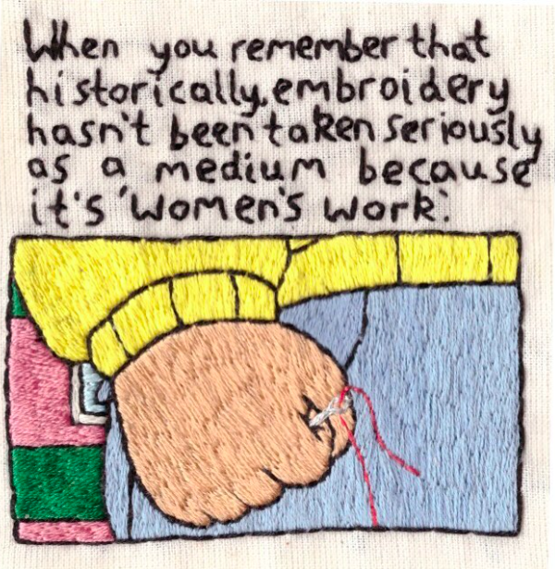
(Hill 2016)

Hannah Hill is an artist in her third year studying Fine Art at Guilds School of Art, she creates work investigating gender, mental health, social issues and feminism. One particular piece of hers that stands out is they recent work she created called Arthur’s Fist. This pieces show her frustration with society expressing her hate over the idea that embroidery is not taken as seriously as other art form purely because it is still seen as craft done by women. Meme’s may seem unconventional, and just a fun light hearted creation for social media, however they do explore and bring up elements of contemporary cultural and are a good way to bring up current issues to a wide audience, more importantly to younger people. The idea of creating this piece to look like a meme brings a very contemporary concept exploring a dated and old fashion perception on embroidery as a art. Hill challenges the idea that women’s work is misunderstood, because of old traditionally views attached to it. She talks about pushing the limits, rather than sticking to the pretty and dainty usually associated with stitch which she then uses a different style which opposes a lot.

-----(Split these two artist up write text inbetween)

Eleanor Edwards

Eleanor Edward’s is a recent graduate from Manchester School of Art in Embroidery she takes her inspiration from history, particularly the history of embroidery and the stereotypes of hand stitch. A lot of her work involves the use of old collected materials then stitching back into them to even them a new lease of life.

Cut Cloth is a book, exhibition and string of workshops that explores contemporary textiles and feminism. Their work contains several essays all written to show the theoretical respond to the subject, and also artwork that was created by artists who equally want to express their opinions and views in an artistic manner…

The use of Instagram and other social media platforms has been harnessed by feminist textile artists as a way to share the history of textile traditions, while simultaneously disseminating important political messages. (Emery 2017)

Research- to find individuals who support your theory that textile industry is a marginalised area of art, set as feminine lesser form.

Primary research- how many guys are on the SPD course in each year group (ask about ethics form) –Why is this? A subject that needs to be explored further

- Conclusion (600-800 words)
More of a discussion, doesn’t need to be a answer

Not much research into it
-why is that
-people think it’s better
-is it?

(Somewhere along these line This is where the debate on whether women’s rights are still an issue or not. The research for this essay ran dry the closer to the present day. Cut Cloth very much suggests the changes to women’s right and the change of opinion that stitch isn’t just women’s work has almost vanished. However, after finding such a lack of information and from the research found for this essay the evidence shows it hasn’t come as far as is to be believed.)

students today still looking at this matter shows something is still going on…

Theorists to look at
luce irigaray
Roziska Parker
Judith Butler
Betty Friedan
Simone de Beauvoir

Artists: modern day
Eleanor Edwards –little information but should be enough
Hannah Hill

Older day
Jane Botsten

One more?

spd- mainlygirls is it bc boys aren’t interested or don’t like the sterottpe behind it stigma

girls because it comes natural to them or because they have been taught to or because its still seen as a very feminine thing to do

2170 words so far

Artists exploring the concept of stitch being a very feminine activity and questioning whether this is still a problem speaks of a larger concern. The problem when assuming women were made for a certain job can be filtered down into other jobs classified as domestic, which have also been underrated through history. An example of this could be the idea women primarily became teachers in history compared to men. Women were expected to take on this job due to their nurturing natures and the job was said to be a satisfying job for them. This very well can be the case, however this can’t be explained due to one’s gender. The idea that women should work with children, or become a carer due to their biology relates heavily to the idea that stitch is an ideal job because women were born to do it. Both reasoning’s are very old fashion, and traditional views which came about a long time before equals rights became an everyday, well known debate.

