Prevention and intervention are significant factors in stopping child abuse before it starts. This is possible by multiple sector approaches.

Causes of child abuse
- Domestic violence within the household.
- Alcohol or Drug abuse by the parents/caregivers.
- Untreated mental illness of the parent/caregiver.
- Lack of adequate parenting skills.
- Stress or lack of support or information regarding support.

Is a Child a perfect victim? Where does the blame lay?
Children all over the world are more likely to become victims of abuse in their own homes rather than on the streets
Girls tend to be more paramount as victims of sexual abuse and kidnappings, but boys tend to be targeted more for all other crimes.
Children under the age of 12 are more likely to become victims of abuse, both sexual and physical and kidnappings.

Daniel Pelka case
An absence of senior support, successful management and training resulted in four social care assessments failing to recognize the risks presented by the murdered schoolboy Daniel Pelka.
The final analysis stated that social worker who did the primary assessment of the Pelka`s family situation has lacked the access to the data regarding the domestic violence within the family due to the delays within the social work records.
The delays within the records were explained as the overwhelming volume of data regarding domestic violence and the shortage of the administrative support within the children`s social care sector.
However, the lack of appropriate training has also been discovered.
The social worker that was assigned to the Pelka`s family and the one that did the main assessment of the family admitted that there has been no training received regarding substance misuse or mental health disorders. Additionally, it was stated that the training regarding domestic violence and interviewing and communicating with children has been inadequate.

The report stated that “this is not an adequate level of training for this complex work”.

Quality of training of social workers
A significant number of social workers are presumed to manage their workload while receiving training.
Number of the individuals within the social service sector have stated that the Community Care employers and managers should offer cover or manage the workload while the staff are receiving training to boost their learning opportunities. This can be achieved by:
- Dispensing protected time
- Providing cover for the staffs shifts
- Reducing caseloads
The chair of the Association of Directors of Children`s Services workforce development committee Rachael Wardell stated that the local authorities were constructing the environment for prominent social work, however the financial support is lacking.
Rachel Wardell explained: “Since 2010 our funding has been halved but need for our help and support has not,”
“A lack of resources in the system and rising need for statutory services is likely to be affecting the amount local authorities can spend on anything other than statutory services”

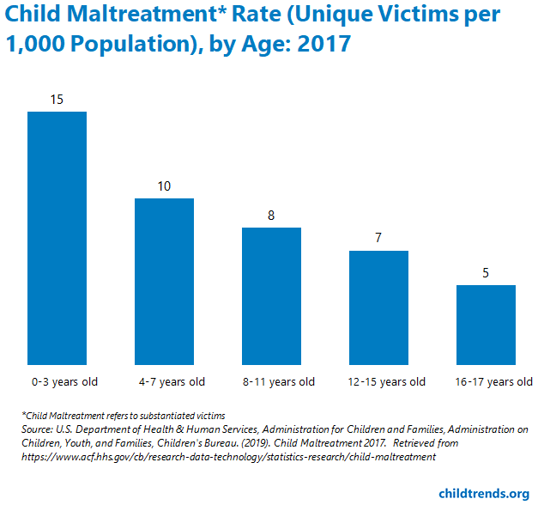

Consequences of child abuse and neglect

Approximately three in four children, between the ages of two and four have experienced regular physical and or emotional abuse from the parents or a caregiver.
The consequences from child abuse could differ from:
- Damaged lifelong mental and physical health of an individual
- A child that has been abused is more than likely to inflict some sore of abuse as an adult, this means that the violence and abuse is carrying on from one generation to another as never-ending circle.

Dealing with child victims
- Secure and comforting environment or a setting
- Time and effort to build trust and show empathy.
- Understanding that children more than likely to regress emotionally when under stress
- They may act or present themselves younger than their actual age.
- Significant amount of patience.
- Usage of age appropriate language to the victim.

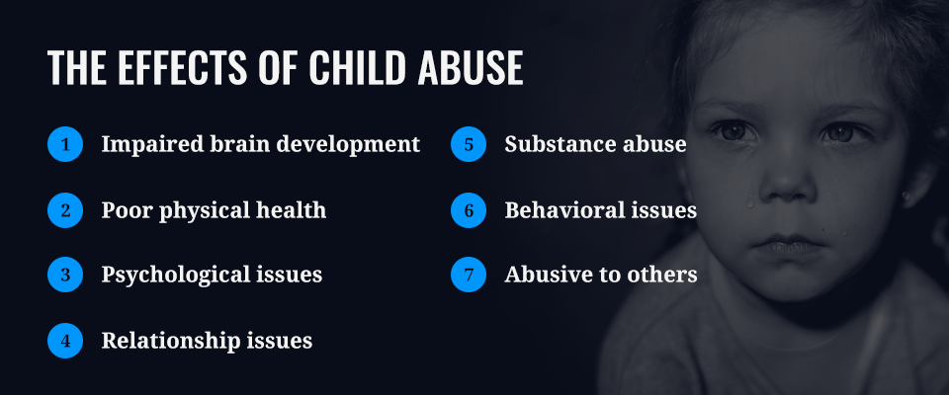
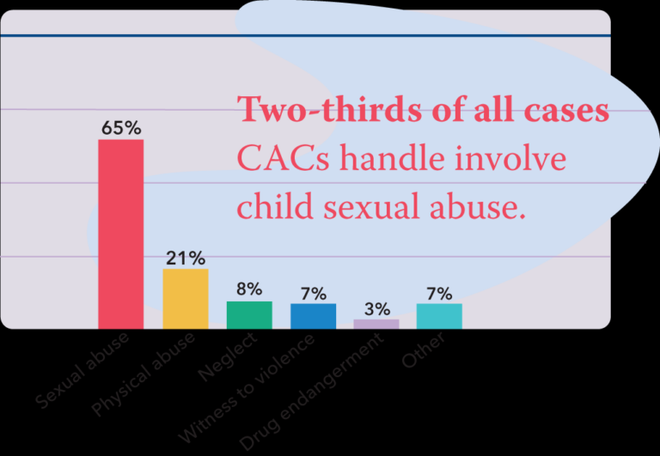
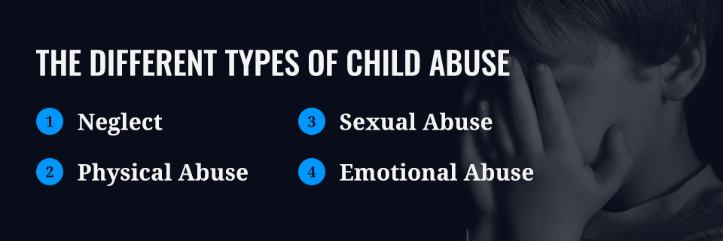
Bibliography
- Fifty States Survey (1997), Current Trends in Child Abuse Prevention, Reporting, and Fatalities. Chicago, IL: Prevent Child Abuse America.
- Hallsworth and Young (2004) Getting Real About Gangs. Criminal Justice Matters (55) p.12-13
- Donovan (2014) [online] Admin support and training gaps led to failures in Daniel Pelka case, finds review, Available at : https://www.communitycare.co.uk/2014/02/05/admin-training-gaps-led-failures-daniel-pelka-case/, [Accessed on 19th November 2020]
- Stevenson (2019) [online] Less than one in ten social workers have workload covered when they do training, survey finds, Available at : https://www.communitycare.co.uk/2019/07/25/less-one-ten-social-workers-workload-covered-training-survey-finds/, [Accessed on 19th November 2020].
- World Health Organisation (2020) [online] Child maltreatment, Available at: https://www.who.int/news-room/fact-sheets/detail/child-maltreatment, [Accessed on 19th November 2029]
- Hillside (2018) [online] Signs & Symptoms of Child Abuse and How to Help, Available at: https://hside.org/child-abuse-signs-symptoms/, [Accessed on 19th November 2020].
- Carpentier, Silovsky and Chaffing (2006) Randomized trial of treatment for children with sexual behavior problems: Ten year follow-up. Journal of Consulting and Clinical Psychology, 74, , p. 48
- Chitnis (2018), [online] Child Abuse – A Guide to Parents & Caregivers, Available at: https://parenting.firstcry.com/articles/child-abuse-a-guide-to-parents-caregivers, [Accessed on 20th November 2020].
- ACF (2017) [online] Child Maltreatment, Available at: https://www.acf.hhs.gov/cb/research-data-technology/statistics-research/child-maltreatment., [Accessed on 20th November 2020]
- Ovc Government (2020) [online archive] I.V Child Victims, Available at: https://www.ncjrs.gov/ovc_archives/reports/firstrep/chldvics.html, [Accessed on 20th November 2020].
- Daniele Pelka 2013

Other
Drug endergement
Witness to violence
Neglect
Physical abuse
Sexual abuse

