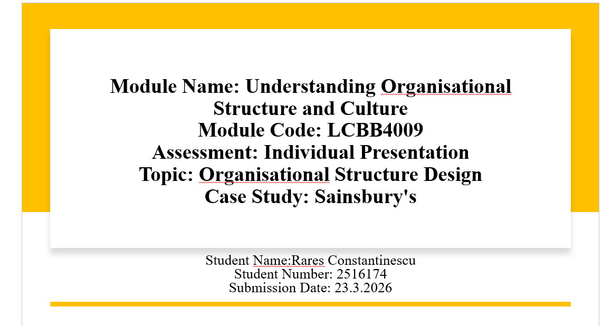
Module Name: Understanding Organisational Structure and Culture
Module Code: LCBB4009
Assessment: Individual Presentation
Topic: Organisational Structure Design
Case Study: Sainsbury's
Student Name: Rares Constantinescu
Student Number:2516174
Submission Date: 23.3.2026

Table of Contents
Slide 1: Outline 3
Slide 2: Organisational Structure 4
Slide 3: Functional Structure 5
Slide 4: Divisional Structure 6
Slide 5: Matrix Structure 7
Slide 6: Conclusion 8
Reference List 9

Slide 1: Outline
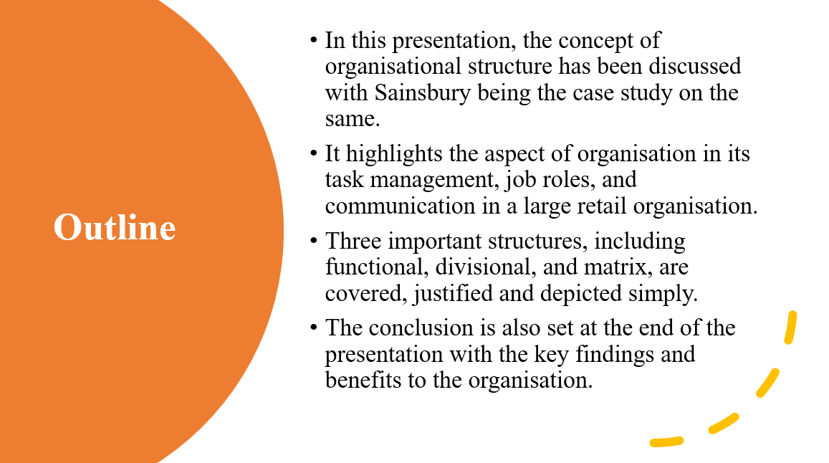
In this presentation, the structure of organisations will be described using the case of Sainsbury. It shall begin by defining the organisational structure and its significance to business in a short manner. Subsequently, it will make comments on three major forms of structures: functional, divisional and matrix. It will also explain how each structure will work in the case of Sainsbury's in simple examples. Finally, it shall also conclude the key arguments and mention the reason why structure is important to the success of a business.

Slide 2: Organisational Structure
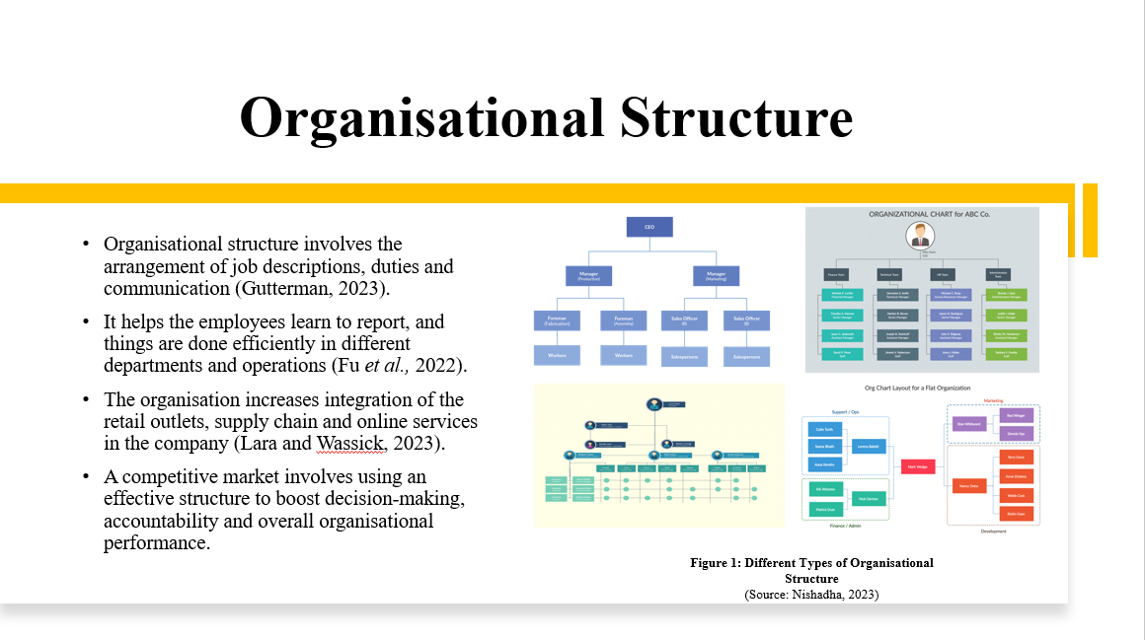
Organisational structure can be described as a manner through which the roles, duties and communication are structured. The structure is applied to control different departments of an organisation, such as the retail department, the supply chain department, and the online service department, in an organisation such as Sainsbury, which is large. It brings out the reporting lines and decision-making process. An effective structure will help in improving coordination and reducing confusion among the employees. It also helps in the efficient running of the company and responsiveness to the market changes in the competitive retail market.

Slide 3: Functional Structure
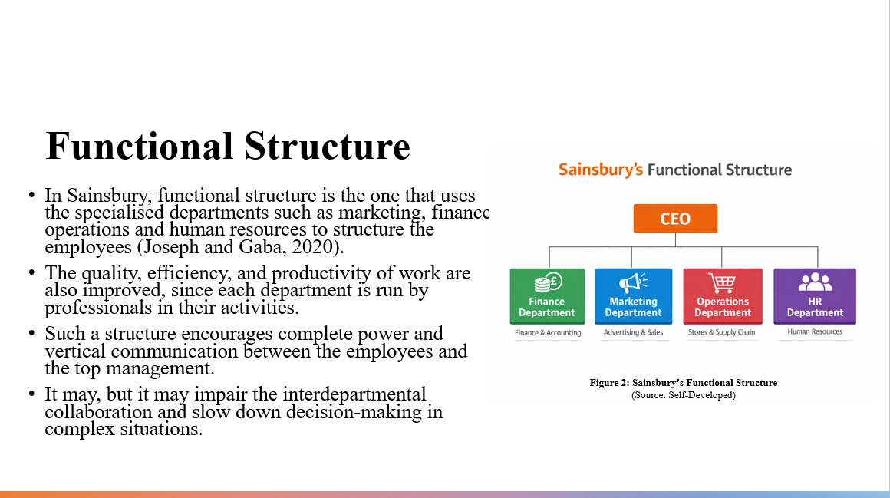
In Sainsbury, the functional structure is familiar as the employees are grouped based on their specialisation. One of them is the marketing, finance, operations and human resources departments. The different departments work under professionals, and this boosts efficiency and performance. It is highly simple to administer structure, especially in large organisations. The weaknesses however, include the fact that the interdepartmental communication is at times weak and thus, the decision-making process may be slow when departments have to interact.

Slide 4: Divisional Structure
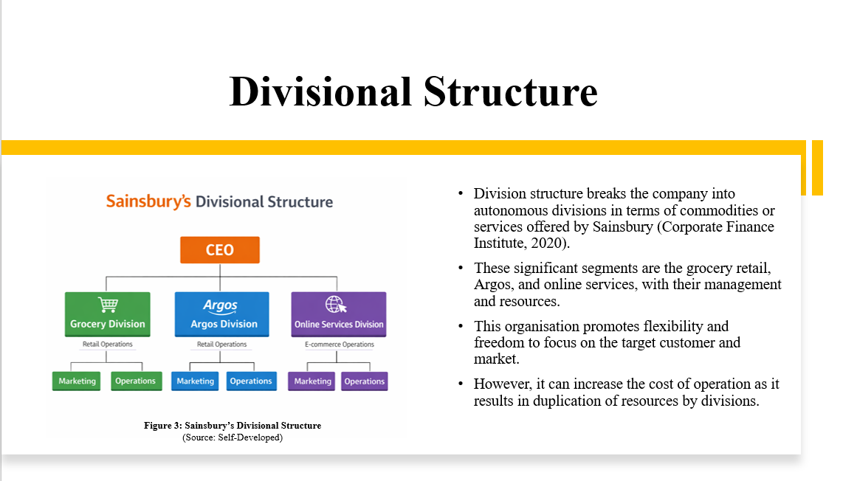
In Sainsbury, the divisional structure is the organisation that is segmented into different divisions based on the products or services. Sainsbury has such divisions as the online services, the online grocery retail, and the online services, for example. Each division is headed by a different team and has its own resources. This is in order to allow the company to specialise in the requirements of the customers and market demands. It enhances performance as well as flexibility. This is disadvantageous as it can increase the expenses because the same resources will be used in each division.

Slide 5: Matrix Structure
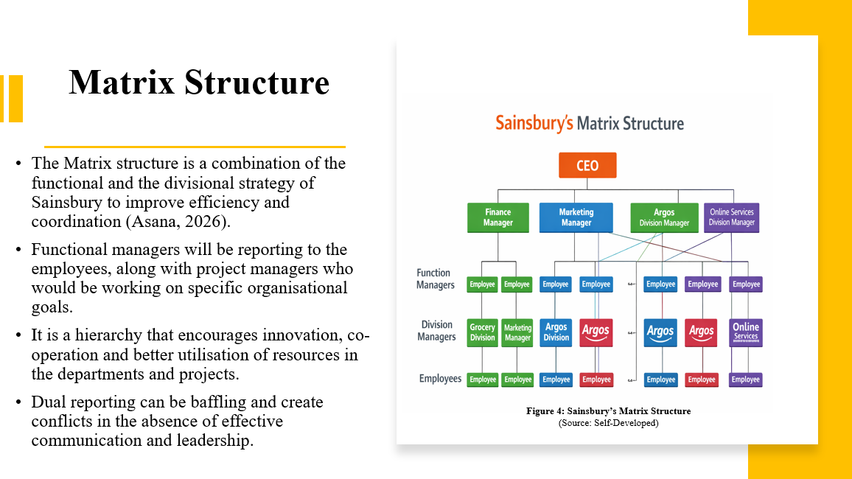
The Sainsbury organisation structure is a mixture of functional and divisional structure, also known as the matrix structure. In this system, the employees do not report to one manager, such as a functional manager and project manager. This will help in improving the interdepartmental teamwork, communication and innovation. It may be useful in these projects when it comes to digital transformation or the development of a new product. It is, though, also confusing, as the employees report to several individuals and may create antagonism if the situation is not addressed properly.

Slide 6: Conclusion
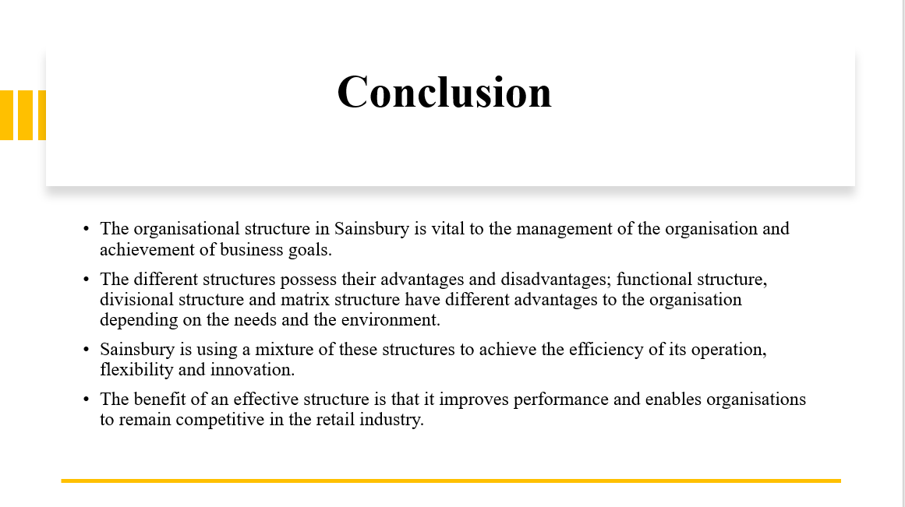
Organisational structure is highly connected with the success of Sainsbury. There are strong and weak points with each of the functional structure, the divisional structure, and the matrix structure. Sainsbury uses a combination of these structures so as to be able to improve efficiency, flexibility and innovation. The well-thought-out design will help the company to control the running of the activities and stay in the retail market. Therefore, it is important that the right structure is selected in order to achieve long-term business goals.

Reference List
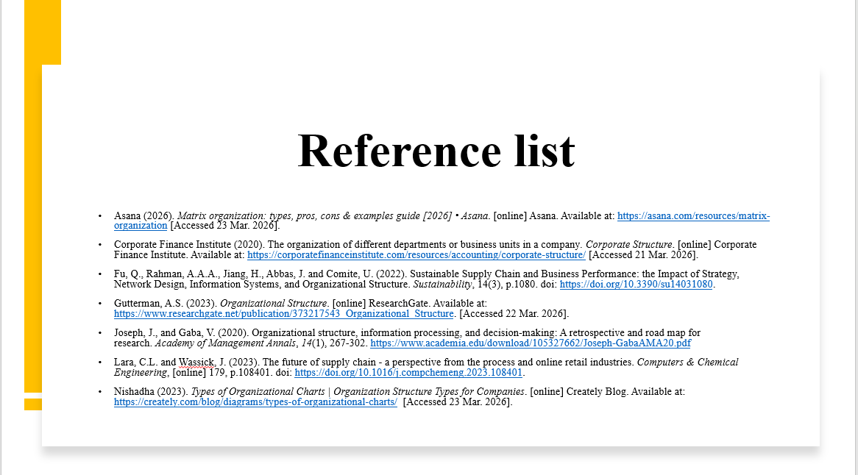
Asana (2026). Matrix organization: types, pros, cons & examples guide [2026] • Asana. [online] Asana. Available at: https://asana.com/resources/matrix-organization [Accessed 23 Mar. 2026].
Corporate Finance Institute (2020). The organization of different departments or business units in a company. Corporate Structure. [online] Corporate Finance Institute. Available at: https://corporatefinanceinstitute.com/resources/accounting/corporate-structure/ [Accessed 21 Mar. 2026].
Fu, Q., Rahman, A.A.A., Jiang, H., Abbas, J. and Comite, U. (2022). Sustainable Supply Chain and Business Performance: the Impact of Strategy, Network Design, Information Systems, and Organizational Structure. Sustainability, 14(3), p.1080. doi: https://doi.org/10.3390/su14031080.
Gutterman, A.S. (2023). Organizational Structure. [online] ResearchGate. Available at: https://www.researchgate.net/publication/373217543_Organizational_Structure. [Accessed 22 Mar. 2026].
Joseph, J., and Gaba, V. (2020). Organizational structure, information processing, and decision-making: A retrospective and road map for research. Academy of Management Annals, 14(1), 267-302. https://www.academia.edu/download/105327662/Joseph-GabaAMA20.pdf
Lara, C.L. and Wassick, J. (2023). The future of supply chain - a perspective from the process and online retail industries. Computers & Chemical Engineering, [online] 179, p.108401. doi: https://doi.org/10.1016/j.compchemeng.2023.108401.
Nishadha (2023). Types of Organizational Charts | Organization Structure Types for Companies. [online] Creately Blog. Available at: https://creately.com/blog/diagrams/types-of-organizational-charts/ [Accessed 23 Mar. 2026].

