University of Wales Trinity St David
Wales Institute of Science and Art



History of wind tunnels in World Rally Cars

Motorsport Engineering
Academic Skills (ACHA4005)

Joanna Lousie Shand
2411040
17th October 2024

Table of contents

Table of contents 1
Introduction 2
Contextual information 3

Introduction

The purpose of this report is to analyze, discuss and critique findings on the use of wind tunnels to calculate the Aerodynamics of world rally championship cars. Specifically, this report will focus on the article ‘Wind tunnels in the history of WRC’ published by author Llluis. The intent of this report is to analyze the history of wind tunnels in World Rally cars, and the variation across different disciplines.
In 1973 the FIA founded the WRC, being the second oldest championship after Formula 1. Each championship season lasts one calendar year, and separate championship titles are awarded to drivers, co-drivers and manufacturers. The WRC season consists of 3-4 days competing over 13 events a year, on a variety of surfaces such as gravel, tarmac, snow, ice and forestry. The WRC is classed as a staged event, so is usually split into 15-25 special stages. Up to a distance of 350 kilometers (220 miles).
The development of world rally cars has been a fascinating journey, greatly influencing their performance across every discipline. Initially, early rally cars were designed with minimal attention to aerodynamics, mainly focusing on power and durability. As the sport grew, the competition intensified, the importance of aerodynamics was recognized in enhancing speed and stability on diverse terrains

Contextual information

Since the moment manufacturers and engineers realized the importance of Aerodynamics, wind tunnels were introduced. A wind tunnel is a tubular stationary object, used for its specialized accuracy, analyzing the air flow patterns over the body and underside of a car. There are two different types of wind tunnels ‘open circuit’ and ‘closed circuit’. The difference between them is the open circuit has open air entry to the outside atmosphere, whilst the closed circuit does not. This is to prevent disturbance and distractions and offers a more uniform airflow pattern. Closed circuit wind tunnels are commonly used for the analysis of sports cars. Although, with the high running and installation costs, some prefer to operate an open circuit to focus money on other areas.
The Pininfarina wind tunnel located in Grugliasco Italy started operation in 1972. Being the first in the world, and the ability to test full size rally cars, it was soon to become a popular attraction for rally cars. Amongst others, the development of Aerodynamics on the Macia Stratos and Lanica Rally 037 took its place.
Lancia Stratos prototype at the Pininfarina wind tunnel – picture by Lancia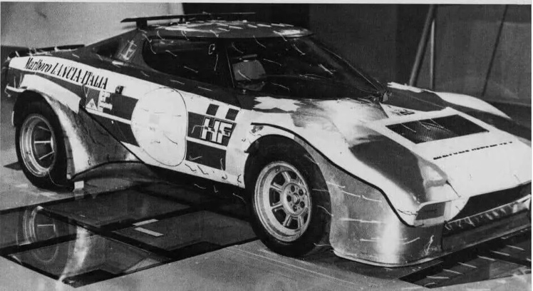
Lancia Rally 037 prototype at the Pininfarina wind tunnel, 1980 – picture by Lancia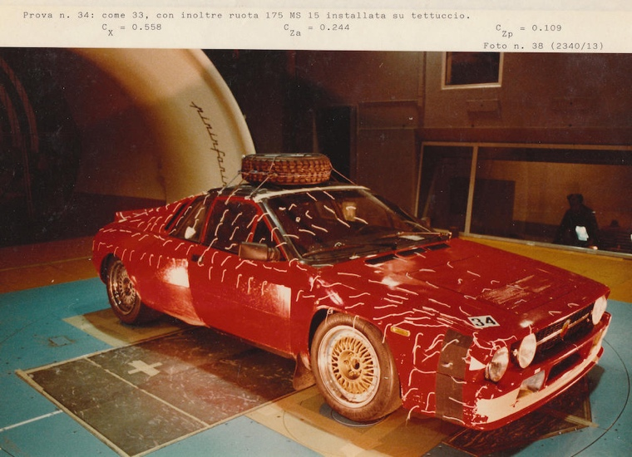
As pictured above, strands of wool can be seen attached to the car. Known as the ‘Tuft Technique’, this is one of the basic visual methods to be used. It allows engineers to gauge and calculate the path of the air flow, both over the car and on the underside. They used this method to evaluate the difference between the thought and final design of the Lacia Rally 037. Also seen above, the picture contains information of results the Lancia underwent in the wind tunnel – drag coefficient (Cx), and front/rear axis lift coefficient (Cza and Czp). The results obtained for the lift coefficient were positive, meaning the car was generating lift force.
As seen above, under the wheels are sensors. These were used to calculate the load cells, as it was not yet equipped with a rolling ground to calculate air flow with rolling wheels,

MIRA windtunnel
MIRA car
DriveAir car

Refrences
Wind tunnels in the history of WRC – WRCWings - page 3/

