Is critical analysis, issue-based learning and the communication of meaning in and through art sufficiently integrated and balanced with the acquisition of the craft skills of art making?

Introduction

Existing research within Art and Design education indicates that the Key Stage Three (KS3) curriculum in secondary schools is limited, in terms of the genres of art and cultures being covered within the classroom. I intend to further analyse the existing research as well as highlight any limitations there are regarding carrying out research within the art classroom. I will begin by exploring the title question: Are critical analysis, issue-based learning, and the communication of meaning in and through art, sufficiently integrated and balanced with the acquisition of the craft skills of art making? This title question was first identified by Downing and Watson (2004).

The purpose of this research project is to understand whether or not it is appropriate to maintain the current balance between attention to art skills and attention to meaning in art. This poses a further question which I will explore; would a greater focus on the content and meaning behind art alienate some pupils, or would it allow opportunities for the status of art to be elevated as a subject? Therefore, I intend to further research into whether the history and philosophies of art should have more consideration and a stronger focus as an aspect of the curriculum in all key stages, or whether we should just focus on teaching the practical skills and key elements of art and design at KS3. Elements such as: tone, texture, colour and line. My exploration into these questions will be supported by reviews of existing research along with analysis of School X’s classroom displays, student’s sketchbooks and departmental handbooks. In addition, the national curriculum for art and design, the digital competency framework, the literacy and numeracy framework and the school’s assessment policies have been considered throughout my research.
The national curriculum for art and design in wales at KS3 states that learners should be given the opportunities to develop many skills within art. The first being their understanding, this can be done by researching artists, craft-workers and designers to enrich and inform their work through: analysis, comparison and evaluation. These artists and designers should be from a range of cultures, places and periods. This is often done through homework tasks or by the introduction of a new topic. Secondly, Pupils should be given the opportunity to investigate, this can be done through observation, experience, imagination and memory. Developing learner’s investigative skills should also be informed by the world of imagination, the natural environment, as well as the man-made, along with the chance to use a variety of media. Furthermore, pupils should be given the opportunity to develop their methods of creating and making art through experimentation. They should also have the freedom to explore ideas and feelings whilst experimenting with and applying the visual, tactile and sensory language of art. This can be done through the exploration of themes chosen by the head of the art department, class teacher or the child, and all of this is usually recorded with in the pupil’s sketchbook.
I wish to highlight a section of this document which states “Pupils should experience a wide range of techniques and media to: realise their ideas, express their feelings, and communicate meaning.” (Welsh Assembly Government, 2008) This is important to note, especially in relation to, and exploration of the question- is ‘art theory’ sufficiently balanced with ‘art practise’ within the classroom? This document seems to suggest that the experimentation and processes used when making art, directly inform and develop an individual’s understanding of art theory and the meaning behind what they have created. “Art and design stimulates creativity and imagination by encouraging pupils to challenge assumptions, look at things in a new way, be receptive to new ideas and make informed judgments and practical decisions to communicate their ideas and feelings.” (Welsh Assembly Government, 2008)
Furthermore, L. Burgess made a comment on the topic, ‘since the introduction of the national curriculum and the requirement for knowledge and understanding to inform art making, art and design teachers have become progressively more skilful as critical educators, engaging students in the interpretation and analysis of visual and material culture through classroom dialogue.” (Burgess, 2009). Here burgess suggests and is in agreement with the guidelines given by the national curriculum, that critical analysis and investigation into artwork will not only allow a pupil to develop their knowledge and understanding, but it also allows room for teachers to grow and develop as practitioners.
Therefore, it could be proposed that the national curriculum indicates art and design lessons should allow learners to become increasingly independent in their choice of materials and processes, whilst gaining confidence in applying the use of artistic language. Ultimately learners should develop an appreciation and enjoyment in art and design that enriches their personal and future professional lives, as well as teaching them about culture and society.
Considering this, if art lessons were to include every aspect of the national curriculum highlighted above, then One could assume art theory is naturally taught, side by side with practise, coherently and evenly throughout education. Burgess goes on to suggest that ‘developing a discursive environment can be one of the hardest tasks for teachers, especially in subjects that, until recently, have concentrated on practise rather than theory, clearly there needs to be a unity between the two’ (Burgess, 2009). Both the national curriculum and Burgess are in agreement that art theory and art practice should be taught seamlessly and as a result, the line in between the two, which distinguishes them as separate subjects, should disappear. However, further research and examination of the sketchbooks, departmental displays, lesson plans and schemes of work within School X’s art department helps to indicate whether or not the way of teaching art theory, outlined by the welsh government, really is sufficiently balanced with the practical side of the subject. Along with an indication of whether there are enough opportunities for pupils to analyse and form their own personal opinions of art.
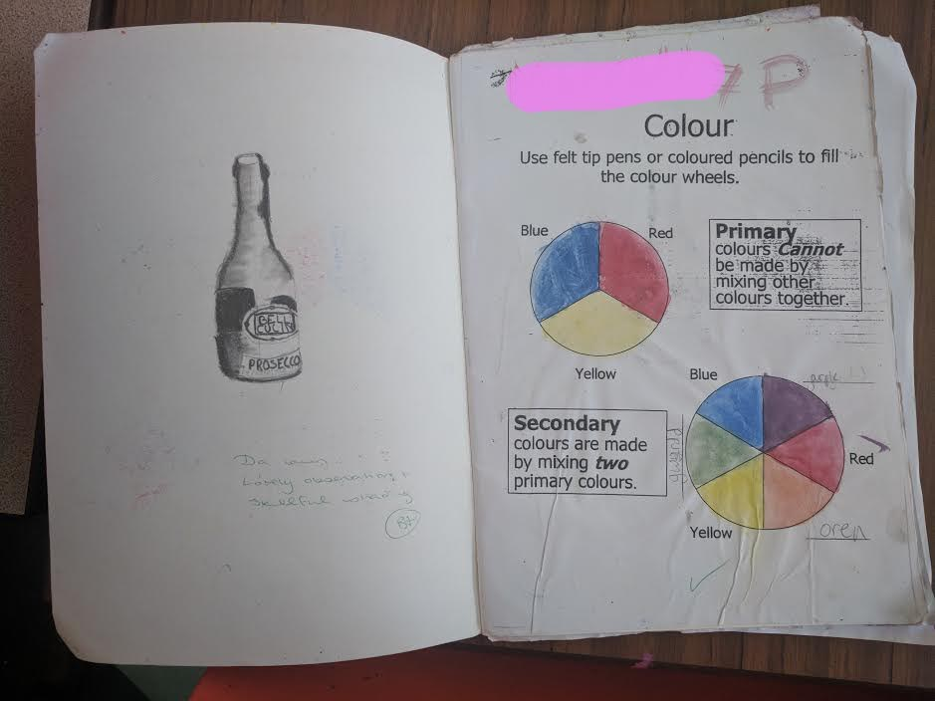
Figure 9 – A year 7 Pupils sketchbook at School X, showing the colour wheel and colour mixing.
Contrary to the guidance from the welsh government, the educationalist Michael Eraut believes that ‘beyond knowing how to mix paint’ or knowing the complimentary and harmonising colours on a colour wheel, a more fundamental and important element of artistic knowledge for teachers to address is that which enables learners to realise and understand their own ideas. This artistic knowledge he defines as ‘practical’ knowledge or ‘know how’. He also believes that this practical knowledge can be, and should be differentiated from more theoretical knowledge, or the ‘know what’ as he describes. “Theoretical knowledge informs practical knowledge although only when it is sufficiently integrated into or connected with personal practice” (Eraut, 1994). In other words, he believes that the art theory, and understanding of meaning in art, must come before the practical art making processes.

From my own experience and observations, it is clear to see that this way of working is addressed more so within GCSE, higher education and post 16, where learners are encouraged to first carry out initial research, isolate specific relatable artists and reference individual influences. This is done to prepare individuals for the processes involved in planning, and the creation or artwork. It is also taught, mainly in further education, that the most famous and well-known artists all had their own influencers, such as Warhol and Basquiat or Francis Bacon and Picasso. An example of how a professional artist can draw upon theoretical knowledge when integrated with practice, has been given by Esther Sayers during an interview for the Tate gallery, when she compared the approach art history students have in contrast to visual art students at university:
“There was a marked difference between someone who was doing an art history degree and somebody who was doing a fine art degree. The art historian wanted to collect the meaning and take it to the work whereas the fine art student wanted to go to the work and unlock what was there standing in front of them.” (Pringle 2009)

Again, art history is often mistaken to be something that is taught beyond KS3, where GCSE and A-level students can finally dip their toes and uncover a world of art theory as well as practise. Yet, as already outlined, this view is not entirely correct, as the national curriculum indicates that KS3 learners must be given opportunities to develop critical analysis and meaning within art, through their practise.

Nonetheless, basic elements of critically analysing artwork are being addressed within School X’s art department, this is done at KS3 with simple tasks. Such as: the completion of an artist comparison worksheet, or basic homework to research an artist, along with classroom activities titled ‘an interview with a painting’ where learners are given an image of a work of art made by a famous artist, to which they have to answer questions such as ‘How old am I?’, ‘What am I made From’ or ‘what message am I portraying’.
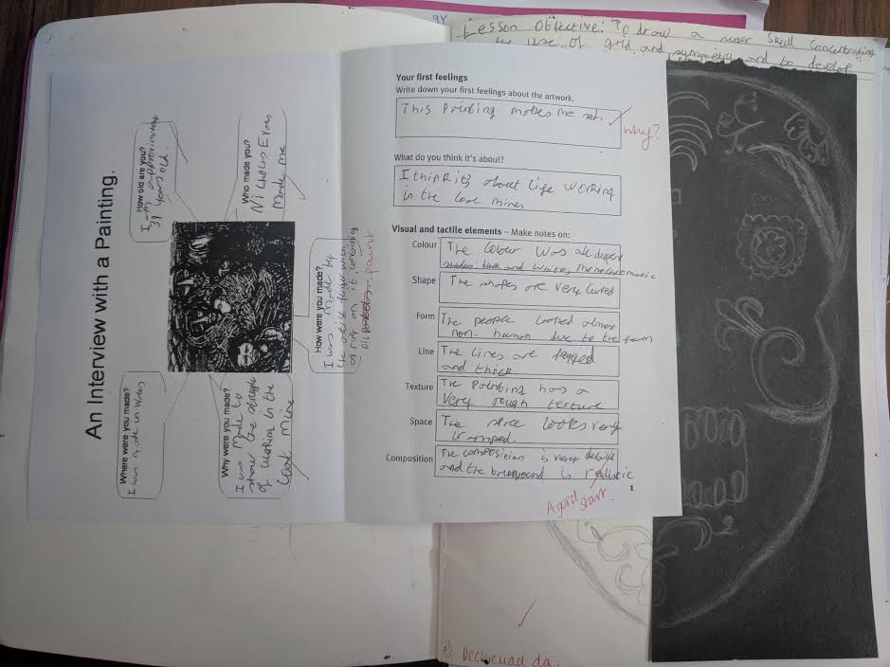
Figure 5 – An ‘interview with a painting’ worksheet, Photograph of year 8 sketchbook at school X

The evidence, which supports the practise of simple critical analysis, was recorded within the year 8 pupils sketchbooks. This is an example of how school X are addressing the need to provide an education of art theory and practise, working together in unison to prepare learners for art education beyond KS3. However, this was the only record of critical analysis recorded within KS3 sketchbooks and is a critical analysis of a famous artists work, and not a record of how pupils gather and find meaning within their own studies. In comparison to the amount of practical studies recorded within learner’s sketchbook, it could be concluded that there is a lack of balance between the two. Therefore, this evidence does also suggest that year 7,8 and 9 pupils are being introduced to the communication of meaning in and through art, almost as a tick box rather than to prepare learners for GCSE or further education. However, practical experiments, methods of art making, and skill-based learning experiences are easier to collate evidence for, within a sketchbook. Therefore, this could be a reasoning as to the lack of evidence of verbal evaluations and analysis within a classroom discussion for instance.
The processes involved in teaching learners about critical analysis and meaning in art, are not only beneficial within the subject specific, but could also help to prepare learner for realising their ideas and developing their understanding of how society has been both recorded through, and shaped by art. This is a view shared by Boyd (1994) he explains “Within society there is the conception that the arts product is more important than the artistic process of creation. Both artistic product and process are important because one cannot exist without the other.” Here he agrees with the ideas discussed so far, and outlined by the welsh Government, that art theory and art practise should be equally balanced. He also goes on to suggest that creating artwork encourages learners to be inventive, as the processes involved require the use imagination and problem-solving which help to develop an individual’s logical and rational thinking strategies. Regarding this, and as a recommendation, One could suggest that rather than asking pupils to conduct an ‘interview with a painting’ Critical analysis and developing an understanding of meaning within art work should allow learners to become aware of complexity within art, find underlying themes, allow learners to respecting cultural differences and different ways of thinking and being; tolerating different viewpoints, along with exploring their own identities and culture. And finally, art theory should allow learners to determine and articulate their feelings, values, judgements, likes and dislikes. (Boyd, 1994).
‘Theorizing art within education can appear to be difficult, as will often involve two conflicting forms of practice. Education- which seeks predicted learning outcomes; and art which seeks the unpredictable’ (Freedman, 2003) Here Freedman summarised quite simply the conflict facing art education within school, specifically relating back to the title question of whether critical analysis, issue-based learning and the communication of meaning in and through art is sufficiently integrated and balanced with the acquisition of the craft skills of art making itself. The keyword being discussed here is ‘sufficiently’. Evidence so far suggests that although critical analysis and meaning in art is a focal point to some lessons, there is not a sufficient balance of the amount of evidence being recorded within pupil’s sketchbooks, in comparison to the amount of evidence that shows the variety of practical based learning methods and art processes pupils are being taught. However, this may be a result of Art being subjective. Perhaps art theory, critical analysis, and meaning in art, are all aspects of the subject which cannot be evidenced so easily, these elements are not as tangible as the practical side of the subject and therefore harder to evidence within a sketchbook, school display or body of work.
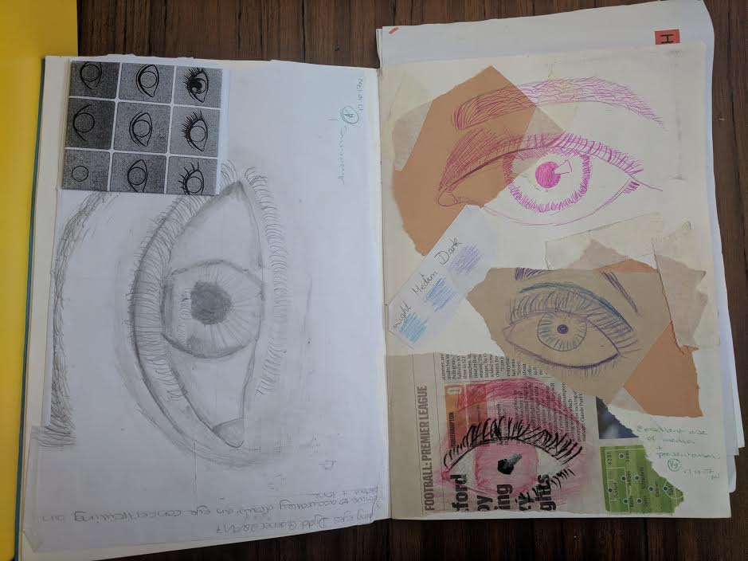
Figure 1- Photograph of year 7 pupils sketchbook at school X

Pupils who progress to study art post KS3 are often encouraged to ‘chase the wildebeest’. In other words, learners are encouraged to experiment with the processes and methods of making art without having a fixed idea or predetermined plan of how the outcome should look. 'It is this artistic process which challenges people to engage in arts making, define their ideas, encounter unpredicted problems and explore a variety of expressive media and creative alternatives' (Boyd, 1994.). In regard to this way of working, we can see how processes and theory can often be disjointed within the classroom, as learners are set targets, objectives, aims and outcomes for a lesson and yet asked on a deeper level to not predict the outcome of their work. This opinion is shared with Freedman, whom goes on to suggest that the potential contribution and the impact art theory may have in education is far reaching. Making the consideration that art theory within the classroom is critically important. (Freedman, 2003)
On the other hand, there is the argument that teaching such art theories would be extremely complex for a year 7, 8 or 9 Pupil to understand, and as a consequence, may also inhibit a learner’s interest and therefore development within art education. “leave art theory alone; teachers, let alone students, can’t make any sense of it”. (Delacruz 2015) “a seriously wrong understanding is worse than no understanding at all”. Teaching art theories should be done so with extreme caution and research, there should be no assumptions that by including a 20th century avent-guard artists images within a PowerPoint presentation within an art and design lesson at KS3, would be of interest and relevant to the growth and development of a younger child. Teaching art theory should be done so with purpose and not just as an afterthought.

So, what if we don’t teach it? There is an argument supported by John Deverell, that it would be a real danger if teachers neglect or supress the contextual ideas and theoretical issues surrounding art methodologies within KS3, as there will be confusion within the learning process when it comes to progression into KS4, and further continued art education, where learners are coached in how to critically analyse and make sense of the context behind works of art. “Many teachers... tend to avoid or ignore the arts in their teaching or, worse still, confuse art with entertainment, regarding arts activity, like play, as a non-serious past-time and therefore to be accommodated only on the fringe the curriculum” (Deverell, 1995)

Considering this, there is evidence to suggest that many art teachers neglect or avoid using contemporary art within the classroom. (Downing and Watson 2004). This is important to note as contemporary artists themselves see a clear connection between art theory and art practise. Why should they be two different things? Can they be integrated more freely in the classroom? Well, as highlighted earlier, the national curriculum is designed to incorporate both theory and practise side by side. One could suggest that this idea has been developed and is in connection with more constructivist theories. There was change in direction towards a more cognitive approach to arts education influenced by Vygotsky’s socio-cultural theory in the 1990’s. This meant that Teachers were encouraged to scaffold the process and provide a platform for pupils to observe, plan, create, develop skills, and reflect upon and evaluate their art works. Pupils were encouraged to explore more theoretical ideas within art education by problem solving and developing an appreciation of the arts, through critical analysis or, and exposure to, examples of relevant art that could also be used as the base for learning how to assess their own work. (Bamford, 2006; Bracey, 2003; Gunn 1998; Lewis, 1998/99; Project Zero, 2001; Thornton & Brunton, 2005; Visser, 2004, 2005). With this approach in the classroom, the arts can therefore be seen as a means of communication of concepts and ideas, and in turn a reflection of children’s thinking (Brownlee, 1983; Cox, 2005; Gunn, 1998; Lubawy, 2009).
In support of this view, there was a study taken by the take modern. What emerged very clearly from this study is that the artists interviewed, more often than not, viewed their practice as a process of enquiry into concepts, and as a means of presenting their thoughts and ideas, or as a process of making meaning within their work. One artist, Liz Ellis, for example, said:
“I would say that I see my practice much less as being about what media I use, than the approaches that I take … [it’s] about methods of investigation, I suppose, the kinds of questions I find myself asking and I want to find, not so much answers to, but to show that process of investigation” (Pringle, 2008)

Her use of the term ‘investigation’ is significant, this is a word that often appears within the national curriculum for art and design. Ellis words also indicate that she sees herself as someone who experiments, interrogates and conceptualises the concerns, issues and thoughts in which surround her, rather than simply being a maker of images, producing art for art’s sake. Ellis, and the other artist and educators interviewed within this study, tended not to identify themselves exclusively with a particular medium or technique, such as a painter or a print maker, but saw themselves as engaged in creative investigation and problem solving, a process that culminated in the artwork. While they might prefer the use of a certain medium, whether that be welding or digital photography, the artists view themselves as ‘visual artists’ who utilise their skills in order to articulate their ideas. Meaning, they would use which ever medium they feel would best reflect the concepts they wish to portray through the art, rather than letting the medium control what they create.

As previously highlighted, within the national curriculum for art and design, investigating is one of the key terms used, along with other terms such as, knowledge, understanding, experimentation and methodology. This should allude to the fact that theory and practise are designed to be taught side by side as part of the curriculum, rather than them being two totally distinguishable elements to the art curriculum. The national curriculum also explores the idea of contempory art being used within the classroom. (The welsh Assembly 2008)
Considering this, there was also a study taken during the year 2003-2004, by the national foundation for educational research (NFER), this study was designed to ascertain the content of the English art curriculum at KS3 and KS4, with a particular interest into the inclusion of contempory art practise. The study focused its research within ten randomly selected schools and in a further eight schools that were known to incorporate contempory art practise within their curriculum. Research was taken through interviews, the schools departmental plans, schemes of work along with detailed descriptions of the art modules. The study concluded that ‘The sensitivity of issues in contemporary art, and the culture of individual schools, were all cited as potential barriers to the inclusion of contemporary art, rather than restrictions in the curriculum at national level’ (Downing, 2004).
The importance of artistic research within art and design lessons is paramount, Pupils must develop their understanding and knowledge of art and the processes used in making art, by first exploring and critically analysing the work of others. The study also concluded that within schools there was a limited use of galleries, museum visits or professional artists and artists in residence. There was a limited requirement of pupils to engage in the creative thinking process. In addition, along with many other findings, the study concluded that there was an “importance placed on development of art form skills, including the use of art materials, the development of specific techniques and observational drawing” (Downing 2004). This therefore would provide evidence to support the view that there is not a suffient amount of balance between teaching art theory and teaching art practise, as the title question investigates. However, there are possible biases to the research carried out, as this study was commissioned by the Tate gallery and the Arts council for England, both of which have interest in promoting contemporary art, art analysis and meaning through art, within the classroom and education. The classroom displays at School X are evidence to support the findings from the study discussed above, Figure 6 is just one example of how GCSE artwork, which is predominantly observational drawing and painting, dominates the school classroom displays.

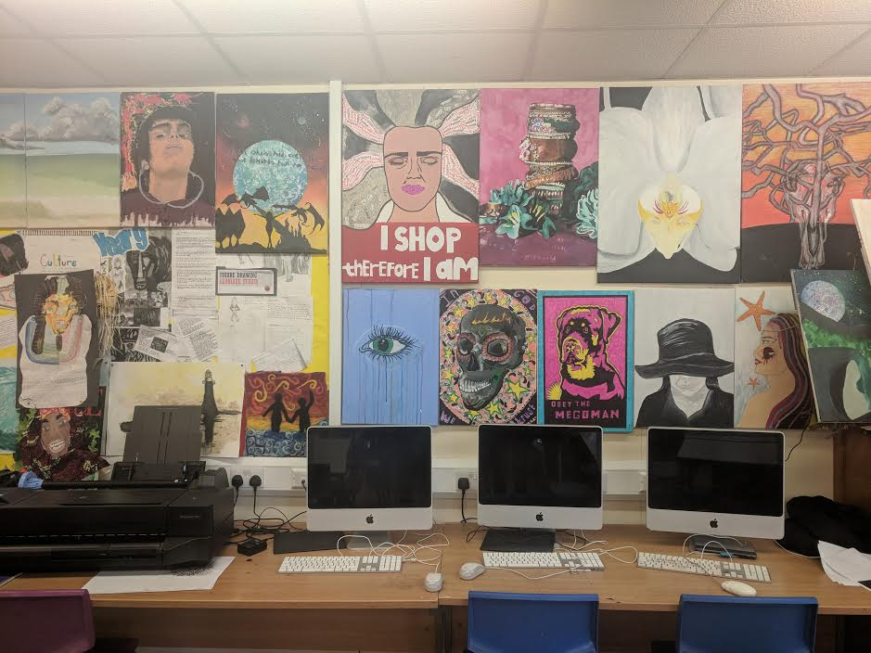
Figure 6 – Classroom displays at school X.

Recently, there has been a great deal of discussion about the importance of educational research, particularly its value to policy makers and its usefulness to teachers. The research carried out within School X therefore should add to existing research regarding art education and be a benefit by enhancing teaching and learning experiences. One of the key issues debated within the UK, in more present times, has been to what extent has the purpose of carrying out research in education been mainly directed towards the school improvement in general and, in particular, towards effective classroom practice. Hargreaves (1996) for example, believes that education is like medicine and should be an 'evidenced-based' profession. He believes that conclusions and findings uncovered by research should be used by teachers, However, practitioners should also take into account the individual needs of their school and the varying contexts in which different schools operate. This view correlates with that put forward by Simon (1994) who interpreted pedagogy as 'the science of the art of teaching'. He believed that teaching is a science due to the principles derived from theories such as social constructivism and behaviourism, which are mainly psychological, along with evidence-based practise. These principles and theories try to identify which methods are most effective in bringing about certain specified learning outcomes, however all learners work best and develop in different ways, what may work best for one pupil may not for another, and on a broader scale, what may work best for one classroom may not work best for the other, thus making teaching practise itself and art and a science.

For the purpose of carrying out the research within the art department at School X, key areas such as ethics and methodology had to be considered, as these are important aspects of carrying out classroom-based research, previous research also had to be considered in order to see what findings and conclusions could be added to existing findings, to benefit teaching and learning. There are many limitations when it comes to carrying out research within the art and design classroom. Art is subjective, as a consequence, it can be hard to judge the impact a certain way of teaching a topic has had on learner’s development by doing pre and post-tests alone. Considering this, any research carried out at school X was done so through the inspection of sketchbooks, departmental and school displays, along with their schemes of work and departmental plans. These have all been kept anonyms to protect identities and to keep in line with the ethics of carrying out classroom-based research. Unlike a subject that is deemed as more academic such as maths or science for example, where there is one set answer and a mark scheme which awards marks for workings out, but ultimately there is one correct answer. Within art and design, there are often many different projects going on simultaneously, with countless paths and methods of getting to the outcome, all pupils learn and produce work differently as outlined above, and because art is subjective, different processes may work best for different individuals when forming conclusions, as discussed earlier by the artist Ellis when she suggested that the process should inform the outcome rather than the other way round. This therefore limited my research in terms of pre and post testing individuals before implementing a strategy for teaching a specific topic, to gather data or statistics for evidence.
For educators, reviewing and collecting evidence on arts education provides an opportunity to reflect critically on what the aims are for the school and departments and how teachers can continuously strive to improve teaching and learning experiences. When discussing the question of whether or not teaching more art theory-based lessons would elevate the subject as a whole, Sir Kevan Collins, who is Chief Executive of the Education Endowment Foundation, suggested that instead of worrying whether or not the pupils are improving in their Literacy and Numeracy skills through art and design, we should teach the arts for its own sake. “for the intrinsic value of learning creative skills and the enjoyment they bring – while at the same time doing our level best to ensure our children and young people leave school with a good level of literacy, numeracy and scientific curiosity. In this respect, all schools should be art schools.” See, B. H. (2015).
There is the understanding that as we prepare learners to dig deeper within the art classroom, teaching them to analyse and be critical, teach them to recognise the meaning, as well as the processes behind works of art, then in turn there will be a positive effect on their understanding and the Cognitive mental processes they use for other lessons or activities. For example, learners may develop the cognitive processes such as: knowing, perceiving, reasoning, judging and imagining. This in turn should teach Pupils interchangeable skills which can be used across the curriculum, allowing them to be more critical and abstract thinkers outside of the art classroom.
Observing pupil discussions in the classroom, at school X, it could be suggested that they are able to form and sustain opinions when being questioned and are encouraged to enquire whilst sharing their personal view-points, especially regarding contemporary or abstract art. In addition, during observations and review of existing sketchbook work, pupils were often keen to share their opinions during peer-reviews, self-assessments, or when carrying out artist research within their sketchbooks. However, these elements of good practise are subject to the teachers questioning and prior lesson planning. Ultimately it is the responsibility of, and dependent on, the teachers interest or willingness to incorporate art theories into a lesson, as well as finding ways in which allow all learners to access the lesson when focusing on critical analysis and ‘meaning’ within art. This may be a reason as to why it isn’t done as regularly, as it may take more time and effort to plan for these types of lessons. Hickman (2000) agrees with this idea, that the individual art teacher remains the essential driving force for imaginative, creative and challenging arts education. He argues that the personal belief system of individual art teachers is the single most important factor in determining the nature of the school’s art activities.

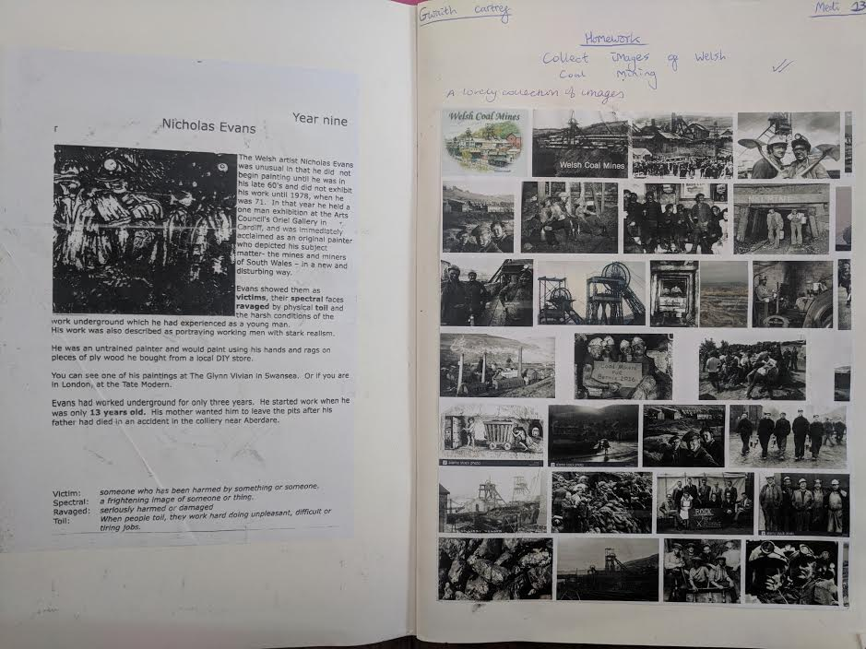
Figure 4 - Photograph of year 8 pupils sketchbook at school X

From figure 4 we can see an example of one of the themes chosen by the art department of school X for a year 8 class. Pupils were asked to collate images of welsh coal mining for homework under the theme of ‘culture’, having been inspired by the welsh artist Nicholas Evans, who was famous for creating paintings inspired by Christianity and coal mining. This links well to Cwricwlwm Cymreig as pupils have the chance to explore more of this history surrounding the coal mines and an artist whose work was dedicated to depicting this history. However, as a recommendation after carrying our research surrounding the use of contemporary art within classrooms, there is much more scope for learners to be introduced to another contemporary artist, alongside Nicholas Evans. This would allow the chance for learners to compare and contrast artwork and develop their ideas as they become critical and share their opinions.
‘recognising each classroom as different, that strategies must constantly be changed, invented, reconceptualised to address each new teaching experience’ (hooks 1994) Hooks’ theory of ‘engaged pedagogy’ encourages an approach in which experiences and reflective practise become fundamental to the development of a mutually supportive learning community. In other words, Teachers shouldn’t become stagnant in their teaching. Lesson plans, schemes of work and themes should be constantly adapting and revisited as society changes and the needs of the learners develop. This also links back to what David Hargreaves (1996) was suggesting in the above section, as each school, department and classroom is different, and therefore reflective practise, along with changes to pedagogy should be carried out in accordance with the individual department’s or classroom’s needs.

The themes chosen as topics for KS3 learners and explored by the art department at School X could be considered outdated, with less themes or consideration of contemporary artists being explored, or investigations into artists at all. The majority of the lessons I observed followed a similar pattern and primarily focused on allowing learners to practise with, and explore the properties of materials, focusing on the formal elements of art. The titles given to projects consisted of generic themes such as ‘pattern’ or ‘Graffiti’ which I found restricted learners room for experimentation and exploration of the theoretical Ideas, as learners are encouraged to focus on enhancing and improving their practical skills. Often omitting an introduction to relevant artists for inspiration or influences. The departments schemes of work are currently being updated however, currents projects include themes such as ‘Culture’ where learners are introduced, not only to coal mining as previously discussed, but to African masks, typography, still life and portraiture.

Whilst these skill-based art lessons have their place, there are so many more opportunities for the incorporation on new and contempory art, which would make teaching both art theory and practise so much easier. In addition to this, the departments chosen themes would hardly need changing if they chose to focus more on the inclusion of artist research and analysis, with contempory artists as influences and homework for learners to gather their own influences at the start of a project, rather than the focus primarily being on the classic seven elements of art and design, where pupils are taught how to shade, add colour, and different weights of line. When speaking about capturing children’s interest in art, Ellyn Berk, who was an educational consultant and a member of a group drawing up national standards for arts education, discussed "Children naturally learn this way, but teachers don't teach that way," (Chira, 1993). Here Berk explained that pupils will be naturally more inclined to participate and have greater interest in the subject, if the subject matter is of interest and is relevant to them, therefore incorporating themes such as digital design, game design, and focusing on more contemporary and digital art, may spark more of an interest with certain individuals, allowing them to develop more relevant skills which will be beneficial for their future.

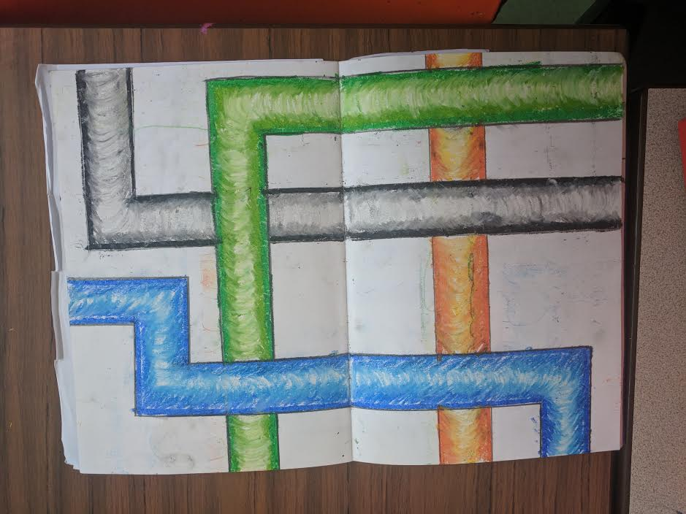Figure 2- Photograph of year 7 pupils sketchbook at school X

Figure 2 shows evidence from a year 7 pupils sketchbook of a final piece of art based on the seven formal elements of art and design where pupils were taught how to create tonal values including dark, middle and light tones, with oil pastels. Again, this is evidence to support skill-based learning and experimentation of media.
One key issue that has been highlighted throughout my research is the fear that promoting “visual Language” within the classroom may alienate certain learners and therefore cause limitations and barriers to arise for these individuals accessing a lesson. This links back to the sub question ‘would elevating art as a subject alienate certain pupils?”. Whilst acknowledging that a visual language and terminology is at the heart of the discipline and practice of Art and Design, there have been concerns expressed by GCSE awarding organisations, such as “the exclusive use of ‘visual language’ may cause a potential barrier to, for example, visually-impaired students.” (Department for education 2015) This is a valid concern and ultimately means that it is extremely important for appropriate differentiation to be provided to meet the needs for all students, along with other additional learning needs.
The subject content within figure 2 refers to a number of formal elements in which pupils have explored as a way of communicating through visual language. These formal elements include: colour, line, form, tone and texture. Whilst colour and tone may be more difficult for some visually impaired students to engage with, line form and texture would be more accessible concepts for these individuals. Lessons could be less centred around drawing and painting, and projects could include more tactile based learning such as sculpture for example. By adapting lesson plans and schemes of work to meet the needs of all learners, more research can be carried out with an emphasis on the benefits, for these students, of engaging within art and design. In support of this, the same awarding organisation whom expressed concerns, also suggested that, “Art and design students could be encouraged to organise, select and communicate ideas, solutions and responses, and present them in a range of visual, tactile and/or sensory forms.” With a wider range of resources use within the classroom, this would allow a visually-impaired student for example to use other means of communication including sculpture, installation and sound art. “We feel that work of this nature is not precluded by the proposed subject content and would expect such differentiation to be possible within specifications” (Department for education, 2015).
Continuing on, a second limitation to the incorporation of visual language and meaning within art, could be the sociological issued raised when teaching art and design. There is significant research evidence to show that more affluent children perform better than more disadvantaged children across school education in general, with low income a strong predictor of lower attainment. e.g. Hirsch, D, 2007, Experiences of Poverty and Educational Disadvantage, Joseph Rowntree Foundation.
The art department at School X address this concern quite well within the school setting. The art department is given a suitable budget to meet the needs of the learners. With a high number of Free School Meal (FSM) pupils within the school, learners are often provided with the materials and equipment needed to complete the tasks set within lessons. In addition, Homework that requires a pupil to use a printer at home is rarely given, as learners are given worksheets and access the Macintosh computers and coloured printers within the lessons. Learners also have access to IPad’s and other art materials which eliminate any limitations in which would disable them from accessing art and design lessons. However, the Government suggest there are a broad range of factors which contribute to this disparity, not all of which are direct consequences of access to resources. There has been no specific evidence found in which concludes that attainment in GCSE Art and Design is directly affected by economic barriers. (Department for education, 2015).
Regarding my classroom-based research, when examining the classroom displays and sketchbooks at school X, there is a clear bias to the use of mediums such as paint, pens, pencils and other drawing or painting-based techniques, just as there is when it comes to looking at the formal elements of art and design and the national curriculum for art and design. There is a lack of clay, sculpture, tactile or digital based learning. This is one area in which I have tried to develop during my teaching practise, due to my research which has indicated that not all learners are confident enough to even begin making a mark with a pencil or a paintbrush when faced with a still life observational drawing, a blank canvas and a pencil. Therefore, I have introduced a series of lessons based around paper-craft artists, to enable all learners have access to the lesson. In addition to this, I have explained and introducing them to the artist henry Matisse who lost his ability to draw and paint later on in life and instead used large scissors and paper to create his artwork. I chose to look at Matisse (figure 10-add pic of Matisse and Newman) in connection with the contempory artist Hatti Newman, whom works with advertising agencies and popular, well-known brands. Whilst discussing these two artists as influences at the start of the project, I was able to reflect back to the idea of experimentation and investigation of materials as a means of finding the end result, therefore allowing learners the opportunity to decipher and analyse which processes work best for their project. This way of working ultimately prepares learners for the real world of working within art and design industries. Contemporary art, how artists sell themselves now via Instagram, gif animation, digital media and online platforms.
Downing supports these choices and also explains that ‘The use of a wider range of artistic references and a wide range of media and materials may simply be more indicative of a broad and balanced art curriculum. The exploration of art as a visual communication tool may be more indicative of a curriculum that is not solely concerned with artistic technique and skill’ (Downing 2004)

In her book, Teaching Visual Culture: Curriculum, Aesthetics, and the Social Life of Art, Freedman (2003) poses the assumption that most people have no formal art education after adolescence, and not everyone who takes art for GCSE will continue their education within the arts, and it is fair to say that there is truth in this. As previously highlighted by Boyd (1994) art education can have an impact on an individual’s understanding of culture and society. For this purpose alone, perhaps it would be important for them to develop further understanding and be educated on the meaning and theory behind art, at a younger age. Insufficient art education is a concern according to Freedman, not only because the Visual arts have been historically important in shaping society, or because visual art is important in terms of human expression, but because much more contemporary culture has become visual in present times. Digital advertising billboards, television, computers, fashions and consumerism has become the norm. Furthermore, Global culture has become a lot less text based but rather saturated by imagery, including social media, for example, the social media platform Facebook is gradually being replaced by Instagram, snapchat and other photography or image-based platforms. As a result, learning about the complexities of a visual language and understanding of art has become increasingly more important and vital for human development and future prospects for designers.

One effective way to establish a mutuality of practise-based learning and theory-based learning within the curriculum could be through a collaboration with external arts agencies. For example, this could mean a guest speaker or visit from a practicing artist, a school trip to a gallery or a museum visits. “This makes it possible to develop a pedagogy situated somewhere between and across the school and external resources and institutions, art in-between space extending and enriching the role of all those involved” (Burgess, 2009). There is potential for problems to arise with this suggestion however, these problems could include: school funding, teachers organisation skills, availability of extra staff and cover staff, risk assessments including health and safety, the number of pupils attending and the appropriation of current exhibitions within galleries, or the availability and costs of having a guest speaker visit the school.
Another effective way to ensure a balance in the classroom would be the selection of artists and workshops. Using these specific findings within my own teaching practise and research, I decided to investigate whether I could engage a class in critical analysis and meaning in art by introducing them to a contemporary artist…. Using Francis Bacon and pointillism scale, miniature photography, use twisted selfies exercise, relate it to modern day technology, get learners to participate in discussions or artist comparison worksheets. Or the theory behind sculpture, also allowed those less abled… Contempry artists and exploration of media that isn’t just restricted to drawing and painting will ultimately and naturally lead to more pupil lead discussions of why they have chosen to work that way, whom they have been influenced by and ultimately this will allow learners to have a more balanced education in which develops they ability to critically analyse their own work and the work of others. Talk about school trips to gallery and whether that would help learners connect making art and analysing art. The purpose of art, so that they truly understand the importance of it and it is raised as a subject rather than deemed as a ‘free lesson’

Conclusion- limitations and future development.
As previously discussed, It is hard to collate evidence for theory within art, its subjective and also hard to indicate whether learners are understanding art theory as much as they grasp the practical knowledge by looking at sketchbooks alone, however as previously outline by various educators and professionals, these two often conflicting aspects of art education, work best when practised together, although there is insuffient evidence to say that the two are balanced at this present time, implementations such as the use of artistic influences, mixed media ect will allow for more fluidity between the two.
References

Addison, N (2009) Understanding Art Education: Engaging Reflexively with Practice (Teaching School Subjects 11-19) Routledge; 1 edition
Boyd, J. (1994) in Edwards, J. (Ed.) Thinking: International Interdisciplinary Perspectives. Hawker Brownlow Education.

Burgess, L (2009) Learning as a social practise in art and design. Understanding Art Education: Engaging Reflexively with Practice (Teaching School Subjects 11-19) Routledge; 1 edition

Chira, Susan (1993) Creativity vs. Academic Study: How Should Schools Teach Arts? New York Times archives.
Delacruz, Elizabeth Manley (2015) Multiculturalism and Art Education: Myths, Misconceptions, Misdirections, Art Education.

Downing, D. and Watson, R. (2004). School Art: What’s in It? Exploring Visual Arts in Secondary Schools. Slough: NFER.

Department for education (2015) GCSE and A-level subject content: equality analysis.

Eraut, Michael. (1994) Developing Professional Knowledge and Competence, Routledge
London.

Freedman, K (2003) Teaching Visual Culture: Curriculum, Aesthetics, and the Social Life of Art. Teachers college press.
Hargreaves, D. H. (1996). Teaching as a research-based profession: possibilities and prospects. London, Teacher Training Agency.
Hooks, B. (1994) Teaching to Transgress: Education as the Practice of Freedom (Harvest in Translation) Routledge; 1 edition (1 Dec. 1994)
Hickman, R. (2000). Meaning, purpose and direction. In Art Education 1 –18: Meaning, purpose and direction London: Continuum.

Hickman, R (2008) Research in art and design education, issues and exemplars. Published by Intellect books.
Pringle, Emily (2009) 'The Artist as Educator: Examining Relationships between Art Practice and Pedagogy in the Gallery Context', Tate Papers, no.11, Spring 2009

See, B. H. (2015). The impact of art education on the cognitive and non-cognative outcomes of school aged children. A review of evidence
Simon, B (1994) The State and Educational Change: Essays in the History of Education and Pedagogy. Lawrence & Wishart Ltd; First Edition edition (1 Oct. 1994)

Teaching Visual Culture: Curriculum, Aesthetics, and the Social Life of Art

Tuned in and Fired Up: How Teaching Can Inspire Real Learning in the Classroom
Welsh Assembly Government. (2008) Art and Design in the national curriculum for wales, Department for children, Education, lifelong learning and skills.
Histories of Art and Design Education: Collected Essays

Appendices

Figure 1- Photograph of year 7 pupils sketchbook at school X

Figure 2- Photograph of year 7 pupils sketchbook at school X

Figure 3 - Photograph of year 8 pupils sketchbook at school X
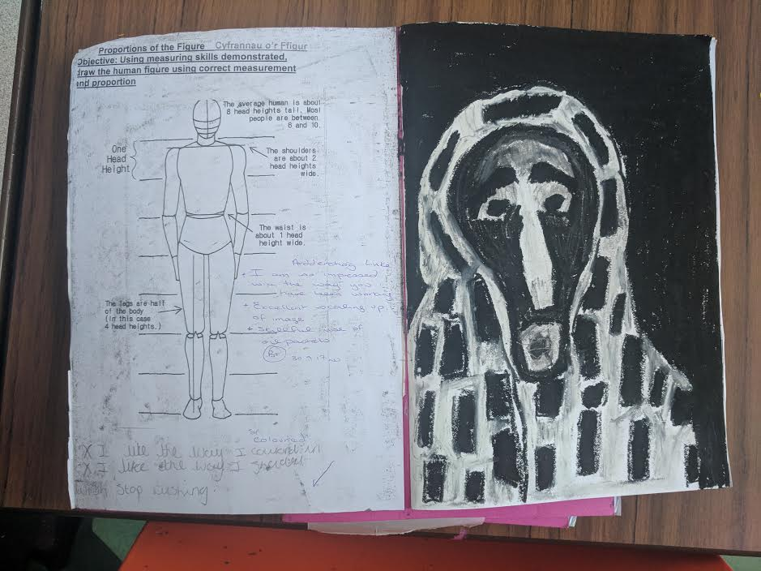

Figure 4 - Photograph of year 8 pupils sketchbook at school X

Figure 5 – An ‘interview with a painting’ worksheet, Photograph of year 8 sketchbook at school X

Figure 6 – Classroom displays at school X

Figure 7- classroom display at school X
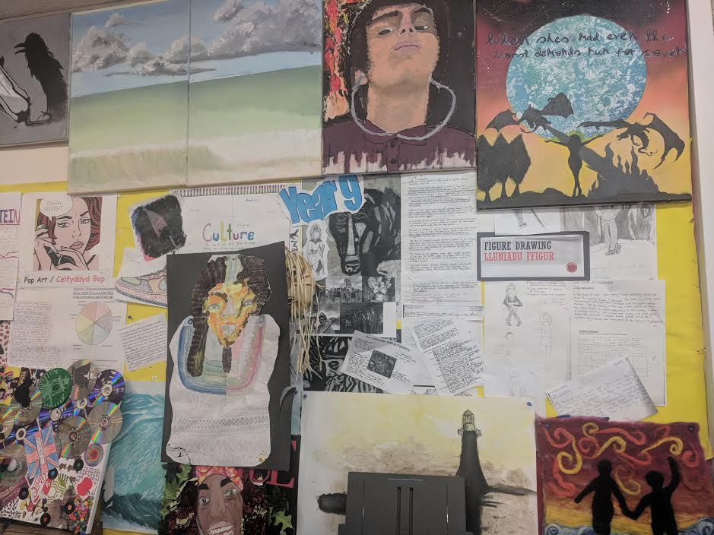

Figure 8 – Classroom display at School X
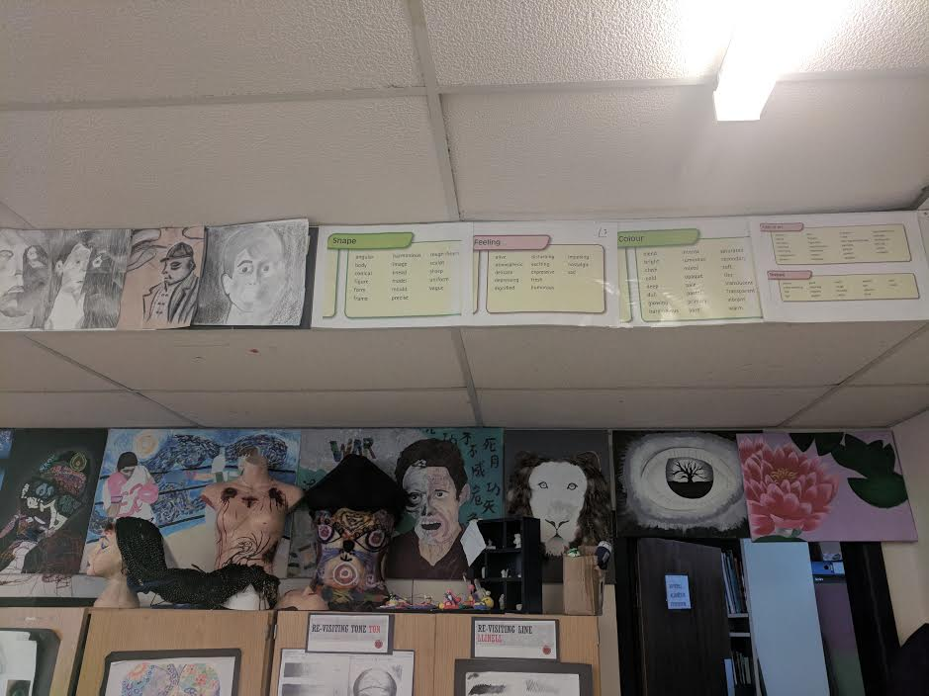
Figure 9-A year 7 Pupils sketchbook at School X

