Name: Faruk Uddin – 1805275
Group members name: 1) Angur Ali 2) Bitabrata Chowdhury
Email address: faruk1805275@gmail.com Password: dob18.07.76

EAT STREET
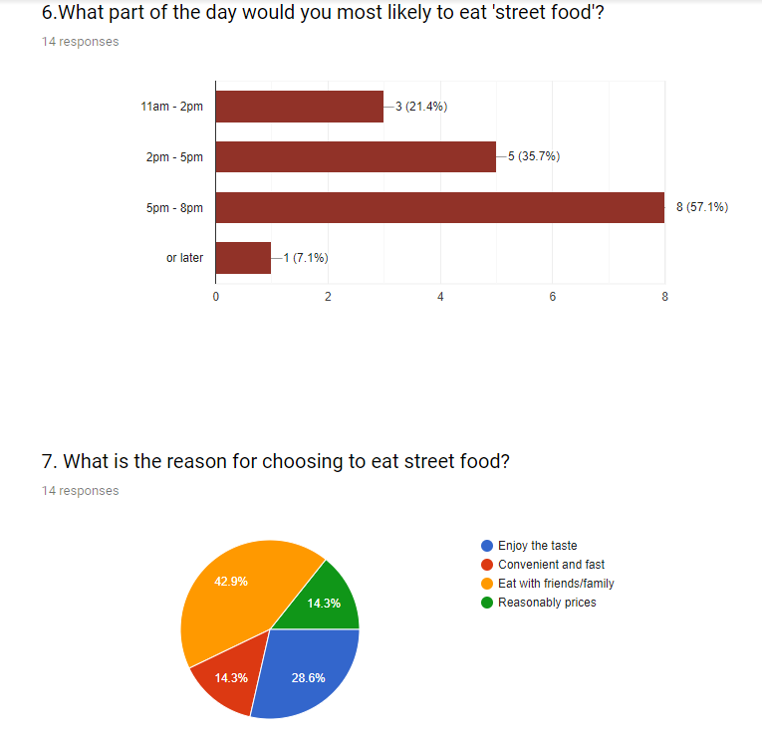
The bar chart on question 6 demonstrates our findings from the 14 respondenants giving us the following answers. The feedback we got back indicates to us that majority of them, i.e. 8 of them overwhelmingly would prefer to visit us between 5 – 8 pm, and second popular being score of 5 between 2 – 5 pm.
What these results is correlating, if we are to take at face value, signalling that our business is going to be visited the highest at those particular times. So the evaluation from this information can be put into practice by being prepared for our busiest period by implementing contingencies when to have greater staffing and to stock more produce and ingredients and hence when not to. This can reduce costage on staffing and wastage on materials and plan a better day to day rota.
The pie chart on q.7 reflects the mood of those respondents for choosing to eat this particular cuisine. Close to half (42.9%) chose option ‘eating with friends and family’ as their top reason to visit, while in second place (28.6%) being ‘enjoy the taste’. This is a clear indication that our customers needs are those two reasons, so it means we need to make our place very friendly and sociable and welcoming to families with children, secondly we‘ve got to keep the consistency and cooking quality to the highest standard.
Name: Faruk Uddin – 1805275
Group members name: 1) Angur Ali 2) Bitabrata Chowdhury
Email address: faruk1805275@gmail.com. Password: dob18.07.76
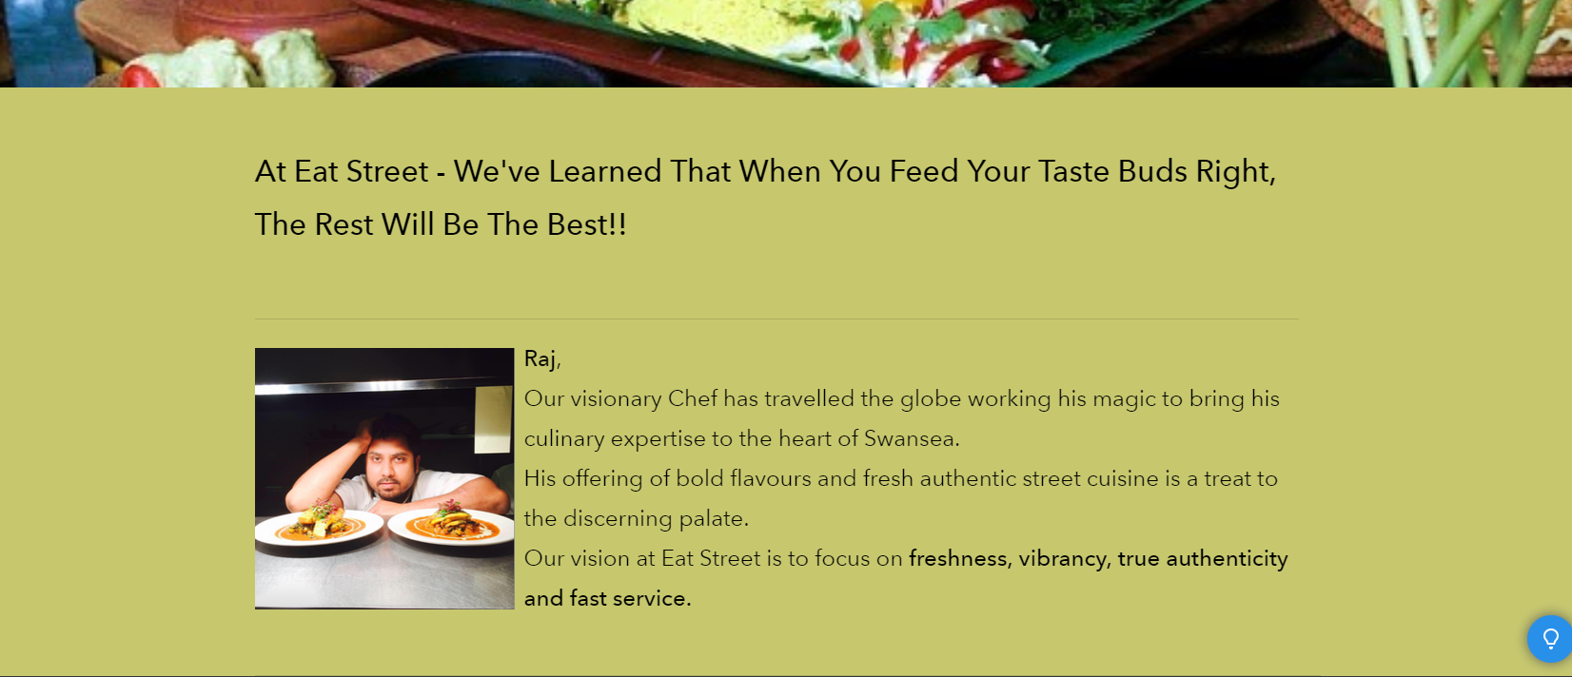
Web design
My particular section was to design and build the “ABOUT” segment of the website. We worked as a team to keep the uniformity and theme of background colour scheme matching. We used highly visual and eye-catching, clean and crisp photography pictures. We intentionally kept the script to a minimum so not to bore the user from unnecessary information. Its critical to keep the user gazed and captured to your product by going straight to the point, otherwise it’ll be another ‘fodder’ they’ll just flick pass. Our mission is to make the product speak for itself and the website to be a plain and simple but smart and user-friendly. Anybody coming into our site should be able to easily navigate through and have a pleasant experience, most importantly it should generate in sales figures.
Narrating a brief story of Raj, our chef draws a personal touch which attracts the viewer to trust our brand and product. I feel that with food businesses, consumers get lost and don’t know who to trust when it comes to eating out with friends and families. This solidifies more credibility and trust.
The section on customers emailing us in the box and giving comments, suggestions, advice or any complaints can be a beneficial tool to take on board. In this way we can build up our customer details and use it to target them with offers and promotions directly. We can also reply to complaints and address grievances before being badly portrayed in review sites and social media.

