Certificate in Higher Education Skills for the Workplace
Module: Professional and Career development
Module code: BMSW 4005
Assignment Title: Portfolio of work
Task 3
Lecturer: Nazmul Hasan
Nume: Iulian Neagu
Student ID: 2107401

Table of Contents
Question 1 3
Introduction 3
Personal SWOT Analysis 3
Skills and competencies audit 4
Required skills for career development 5
Evaluation of my own skills and comparison with career objectives 5
Question 2 7
Reflection on learnt lessons 7
Conclusion 9
Reference List 11

TASK- 3

Question 1

Introduction
Self-evaluation and continuous learning are two cognitive processes that can improve skills and talents in both the professional and personal spheres. A professional and personal growth plan is a constantly evolving diary that evaluates one's present skill sets. With the aid of this plan, candidates can construct practical career growth strategies that will improve their skills and abilities along with competencies. The major goal of this plan is to design a development path for me after assessing my existing skills. In order to begin a self-development program, I must first establish my goals. I will try to assess my talents through SWOT analysis and adjust my self-audit accordingly. A self-evaluation based on my work as a waiter in the hotel business will highlight my accomplishments and prior activities that complemented my academic modules.

Personal SWOT Analysis
Professional Development Program helps me to identify my strong and weak areas in my professional field. This identification also helps me to find out effective areas which I need to enhance immediately for further progress. Through SWOT Analysis, I am trying to analyse my strengths, weaknesses, opportunities and threats accordingly.
S-Strength:  - I have good analytical power which helps me to evaluate different types of situations properly.  - I can understand market trends effectively.  - I am a good listener which helps me to work in groups.  - I have strong knowledge of updated technologies. | W-Weaknesses:  - Lack of time management is my main weakness.  - I cannot work with lengthy tasks because of my impatience.
O-Opportunities  - I can develop my skills to identify customers' requirements.  - I can follow the success strategies of successful professionals  - I can learn skill development by following successful professionals. | T-Threats:  - Changes in the external market environment bring threats.  - Tight competition in the market.

Skills and competencies audit
Through different modules and lessons, I have learnt that to be a waiter, a person needs to have some essential skills and competencies in his professional life. For better understanding, I want to mention that customer dealing skills, willpower to help customers, the ability to accept criticism, active listening skills and some other skills are necessary to be a successful waiter. In order to get a job in this field, I need to analyze my skills and competencies through audit scores. These scores will help me to determine effective strategies for betterment. Through the self-audit program, I understand my actual position at the moment.
- I have identified as numeric which is very important for the role of a waiter. A waiter always keeps the numeric data of customers in the hospitality industry.
- I have a very good team working ability. It has been identified that inside a hotel or restaurant, employees are working as team members. I can easily handle teamwork for organisational growth.
- I have identified ‘good managing others’. My abilities in managing others will help me to work in organisational groups.
- I have identified as a good communicator and listener to attract customers. This ability will help me to make effective relationships with customers and other team members.

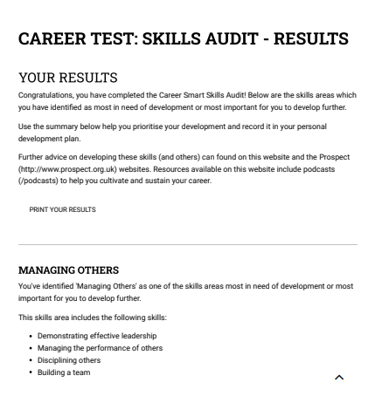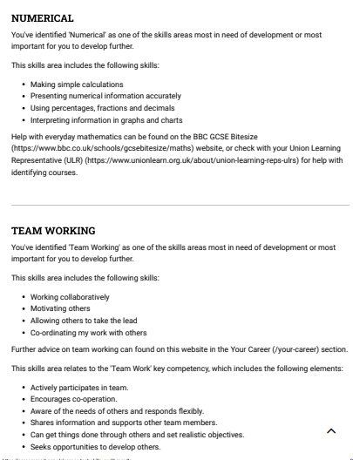

Required skills for career development
It has been seen that in the hospitality industry, customers expect rapid services and smart solutions within a very short time. Unnecessary delays make them irritated with the hospitality service providing company. Through proper time management skills, I can easily meet customers’ requirements properly. As per the viewpoint of Kharadze et al., (2022), it can be stated that Time Management refers to that skill by which a person can easily manage his entire tasks within fixed deadlines. On the other hand, it can be also stated that utilizing time properly for fruitful outcomes is also known as a time management skill. Apart from time management, Communication skill is also important to enhance professional abilities in the hospitality sector. As per the research work of Arnold and Boggs (2019), it is found that communication skills refer to the skill by which a person can easily connect with others through verbal and non-verbal methods. Communication skill is one of the most important considerations to becoming a successful professional in the hospitality sector.

Evaluation of my own skills and comparison with career objectives
From the module of my university classes, I have learnt that customers are more concerned about rapid solutions and customer support services. In order to touch their emotion successfully, I need to enhance my time management abilities accordingly. Moreover, I found that while completing complex and critical tasks, I get puzzled. In order to make a successful career, I need to overcome this drawback as early as possible. A successful professional in the hospitality industry needs to have the strong listening ability. I have identified that I am a good listener. My communication skill and listening ability are good. I can easily make a strong communication bonding with even strangers. In order to make a successful career in the hospitality sector as a waiter, I will get support from my communication abilities. On the other hand, I can say that I have a very good ability to identify the latest market trends and customer preferences. For instance, it can be said that today free wi-fi facilities, charging points, online booking, net banking, online transaction, mobile banking and other trends and facilities become unavoidable to make a customer-friendly ambience. I can understand what customers prefer by communicating with them. This skill will also help me to grab opportunities in the hospitality sector. I am a good listener. To be a good waiter, one needs to have the good listening ability. I think my good listening ability helps me to identify customers’ issues and determine effective solutions to them. After having several abilities, I also have some drawbacks which will bring challenges for me in my professional field. After completing the self-assessment and audit, I understand that I need to enhance my time management skills to grab opportunities in the hospitality sector. I cannot utilize time properly for productive purposes. I need to enhance my time management skills for developing my career and achieving success in an effective manner.

Question 2

Reflection on learnt lessons
I have learnt several topics and modules during my university program. During this time, I have learnt several chapters including, Digital Skills, Academic and Employability Skills, Problem Solving and Decision Making, Effective Team Working and Communication, Managing Enterprise in the 21st Century and Professional Career Development. These chapters mainly covered three different semesters. In this section of the study, I will discuss what I have learnt and how my experiences was within Professional Career Development module.
The aim of this module was to introduce students to strategies for personal reflection and career development planning and to gain confidence and competence as effective employees.
Expected outcomes for students after finishing the module were to understand the skills and knowledge needed for working effectively, to demonstrate readiness for employability and personal advancement through an understanding of personal strengths and areas for further development. Students will also have to be able to establish employment gools and develop a personal action plan.
During this module we had three tasks to complete.
First task was an Open Book Assessment that I found rather difficult to complete, once again because of my poor management of time. It was challenging for me because it was a first experience, researching and writing 500 words in 2 hours about a given case study. Unfortunately I couldn’t finish on time and this lead to a fail and I had to retake the task.
The second task was a mock interview, lasting 15 minutes. It was a rehearsal for a job application and I had to prepare my self with a CV and a cover letter. I have been given the possibility to choose from a various range of jobs advertisements from a job site called Indeed. However I chose a relatively simple job because I have experience as a waiter and I wanted my CV and job application to be in a very realistic manner. From my point of view this was the easiest task and I really enjoyed working and completing it.
Task three requires a reflective report of 2000 words. This is the hardest task and it is the one that I am working on now. I find myself in a challenging situation again, having to analyze my skills, strengths and weaknesses and find solutions where needed. I used many analyzing tools that I found on my reading and researching from various sources. One of them is Gibbs reflection model, probably the most accurate analyzing tool.
Through Gibbs reflection model, I will try to analyze and evaluate my learning and abilities.
- Description: In this module we discussed points to consider when exploring employment, the recruitment and selection process, we identified trends in future employment and how to build confidence in facing interviews. We also examined the process of creating a successful application, and conducted mock interviews.
- Feelings: At the beginning of this course I wasn’t very confident with my self but the teachers made a big difference. They interact with us, they were very patient and they help us understand by giving similar examples from daily life. I can strongly say that now, at the and of the course I fill a lot more confident and with a different perspective of the future.
- Evaluation: During this course I have gained a substantial amount of knowledge and improved my digital, academic and employability skills. I consider finishing this course as a personal achievement and an opportunity to progress with my career. This module helped me to understand the skills and knowledge needed for working effectively, improving the strengths I already have and fix my weaknesses. In this module I have also learned about many factors that can influence the development of a person or a business.
- Analysis: After completing the session, I analyzed my development and I found that I have some lack in time management skills which I need to overcome rapidly.
- Conclusion: In the conclusion stage, I can conclude that for enhancing my career in the hospitality sector as the position of waiter, I need to enhance my time management skills properly.
- Action Plan:
Area | Source | Tentative time
Time Management | By analysing successful professionals’ time management practices | 04-08 months
I cannot work with lengthy tasks because of my impatience | I will try to focus more on goals rather than the task length | 06-11 months

Conclusion
A personal and professional development plan will assist me in achieving my career objectives and the managerial position I have always desired. After completing the full plan, I have concluded that, as a waiter in the hospitality sector, I need to improve my teamwork skills if I want to overcome professional challenges. Additionally, I have a tone of responsibilities that must be finished in a short period and are becoming more important to me.

Reference List
Arnold, E.C. and Boggs, K.U., 2019. Interpersonal relationships e-book: professional communication skills for nurses. Elsevier Health Sciences.
Kharadze, N., Gulua, E. and Davit, D., 2022. Free-time management among master’s degree students of Georgia. Humanities Today: Proceedings, 1(2), pp.1-14.

