Introduction
The aim of this assignment is to discuss the principles of pedagogy and its effectiveness. The first section consists of a review of relevant research which has informed my professional practice and views the scope of opportunities and challenges which should be considered when developing a pedagogical approach for the New Curriculum for Wales. The second section is a detailed strategic plan that will be delivered to senior management for the implementation of one of the four purposes within the New Curriculum for Wales based on an initial SWOT (Strengths, Weaknesses, Opportunities and Threats) analysis. Thirdly, an academic poster intended to engage colleagues in a dialogue about the New Curriculum for Wales which includes a rationale and critical review of the poster.

What is pedagogy?
Times Educational Supplement (TES) (accessed 12/10/19) defines pedagogy as a method of teaching and practice which includes teaching styles, theory and assessment. TES editorial December 10th 2018 refers to how a teacher delivers the curriculum suggesting pedagogy can be placed into four categories. The four categories are: constructivism, behaviourism, social constructivism and liberation.

Montessori (1949) and Piaget (1952) were constructivists. Both had many similarities in their theories and both still have a major influence on education. Piaget (1952) like Montessori believed that children develop through progression, sequence or order. Both theorists originally put approximate ages to their stages, this has been criticised as later research suggested that although the stages were followed in the right sequence it was not necessarily at the approximate ages provided. The article Difference between Piaget (1952) and Vygotsky 2014 (accessed 12/10/19) states they took some influence from Montessori who originally took some influence from Froebel for example the use of structured play and the role of the adult. Boyd (1963) discusses Rousseau’s theory of education which has also influenced the theorists discussed above; Rousseau emphasized the importance of expression to produce a well-balanced, freethinking child. He believed that if children are allowed to develop naturally without constraints imposed on them by society they will develop their full potential, both educationally and morally. This natural development should be child-centered and focused on the needs and experiences of the child at each stage of development. Piaget (1952) believed in free play and role play and viewed learning from peers as important. This also contributed to the child’s social and emotional development he also believed that this was an important part of the child’s cognitive development. Montessori in Britton (1994) on the other hand was more regimented in her approach and did not allow much freedom for creative development or imaginary play therefore social interaction was limited in her theory. It’s important for children to enjoy being children and to enjoy learning through discovery. Bruce (1996) believed that giving children what they need when they are young is the best way to prepare them for adult life. For me viewing these theories emphasises the need to scrutinise current health & well-being provision for children. Social constructivism originally developed by theorist Vygotsky (everythingsociology.com) shows that information and new skills are not something that can be taught alone but rather developed through social interaction.

Macleod-Brudenell (2004) explains that ‘Behaviourism’ is advocated by theorists such as Pavlov and Skinner; Behaviourism is a learning theory that focuses on objectively observable behaviours and discounts any independent activities of the mind. Another aspect to be considered is that of Maslow’s Hierarchy of Needs (Kiel K, M 1999), where it is highlighted that if these needs are not met then learning is inhibited therefore self-actualisation will not occur. Maslow’s Hierarchy of Needs will be explored further later on in this assignment.

This brings us to liberation learning theory. Freire’s (2015) view noted that children need to become aware to allow them to become subjects of the environment rather than objects; he felt the best way to achieve this was through democratic thinking and questioning. Coupled with Maslow’s Hierarchy of Needs we can conclude that emotional well-being is essential to a child’s capability to learn.

Characteristics of effective pedagogy
Pedagogy has been defined as above however how can effectiveness be judged?
Effectiveness is a controversial term in itself. Ko and Sammons (2010:45) noted that “effectiveness” is both a political and emotional term and so the way in which it is measured varies from time to time and context to context.
Teacher effectiveness is judged by the professional teaching standards whilst schools are judged by Estyn which is the education and training inspectorate for Wales (ESTY) Its name comes from the Welsh language verb Estyn meaning "to reach, stretch or extend. An article written and published online 12th December 2018 by Teach Thought staff discusses what makes an effective teacher: they state that there are twenty observable characteristics which include being organised, hands on student learning, using a variety of instructional techniques and so on (teachthought.com). Nind (2015) conveys that The National Centre for Research methods identified ten principles for effective pedagogy, some of which include: recognising the importance of prior learning, scaffolding, assessment needs to be congruent with learning, engagement of the learner and recognise the significance of informal learning. Dr Jimmy Shaw (2018) identifies four key characteristics of pedagogy: clarity, inspiration, differentiation and self-reflection/assessment. In my opinion the characteristics I have pointed out above link to specific areas within the Excellence in Teaching Framework (e.excellenceteaching.co.uk). I feel these are behaviour, learning for well-being, subject knowledge, challenge, expectation and differentiation and assessment. The Excellence in Teaching Framework is a tool used to observe and assess teacher skills and professionalism.

Pedagogy in Wales

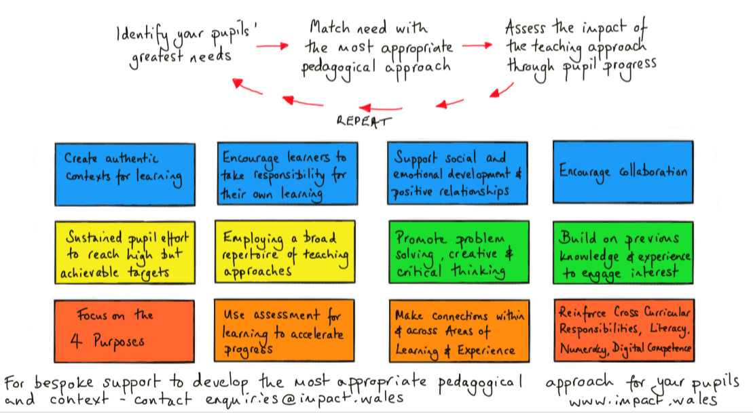
Diagram 1 12 pedagogical principles please see image below:
http://www.impact.wales/wp-content/uploads/2018/01/12-Pedagogical-Principles-1.pdf
For the purpose of this assignment I concentrated on chapter five and six of Successful Futures (2015).

Chapter 5
Donaldson, (2015) in Successful Futures chapter five does not recommend specific teaching methods; positives of this are the promotion of teacher autonomy and preference as well as trusting teacher’s professionalism. Some pedagogical principles relate to the four purposes but not all them, this could mean that full coverage is not met if a professional is rigid with the pedagogical practices set. The chapter does however promote the use of a balance of experiences and the use of teacher creativity. There is a consistent message for sustained effort, praise and support and learning from mistakes to build confidence. There are progression steps which set expectations however the negative aspect of this is that it could just become a tick-list activity and not covered comprehensively. It identifies that early intervention on the identification of struggling learners is integral therefore emphasising need of inclusive education. The chapter identifies that not one pedagogy should be favoured but rather a selection between modern and more traditional methods. This implies a need for a broad range of teaching and learning experiences. As a result not all traditional teaching methods need to be thrown away. It states that planning and preparation of investigations is an essential part of the critical thinking process; staff will need extra time and resources to enable this. Empirical evidence from several staff meetings and discussion within our trust group suggests budgets are currently very tight in education and therefore, will need to be supplemented to be able to fully engage with a new curriculum for Wales. References are made to Hattie (2009) who emphasises the need for clarity with objectives, success criteria and insightful feedback. Good teaching allows children to explore, problem-solve and make connections therefore enhancing resilience and promoting valuable life skills.

Chapter six
In this chapter Donaldson (2015) concentrates on assessment. Wiliam (2011) feels the only way to ascertain what has been learnt is via assessment. He acknowledges that it is beneficial for learners to be shown the types of errors made and what they can do to improve their work. He advocates that learner’s engage in improving their own work. Assessment can eat into a teacher’s time and therefore there needs to be a balance between formative and informative assessments. However, it progresses onto to say that schools need to be measured by their assessments results using progression steps and achievement outcomes as well as data performance, class observations and other sources of evidence to hold a true holistic picture of strengths and weaknesses of the school. During discussion with work colleagues it is felt that this is a contradictory statement see Donaldson (2015) recommendation fifty one (appendix A). It highlights that understanding of the curriculum is paramount to successful and meaningful assessment. It states the need for a nationally agreed assessment, as existing approaches in Wales have contributed to some confusion in this area. Recommendation fifty three (Appendix A) is to establish a comprehensive assessment and evaluation framework in-line with Donaldson’s report (2015) and recommendations. The new curriculum is meant to be a bespoke curriculum. Viewing this as the case, in my opinion schools should be allowed to take into account their values, priorities and culture and follow the recommendations that they feel will have a positive impact.
In our trust groups we looked at the characteristics of an assessment literate teacher which can be seen in Diagram 2 below. We linked the characteristics to the twelve pedagogical principles and it was felt that these pedagogical principles could be grouped. Davies (2019) during a trust group discussion said that principle three and four are almost exactly the same and that if you get principle seven right then all the others will fall into place. All group members felt that small classes have a positive impact on disadvantaged learners and as Hagerty (2019) eloquently stated that “teaching is an art”.
Diagram 2 Characteristics of an assessment literate teacher
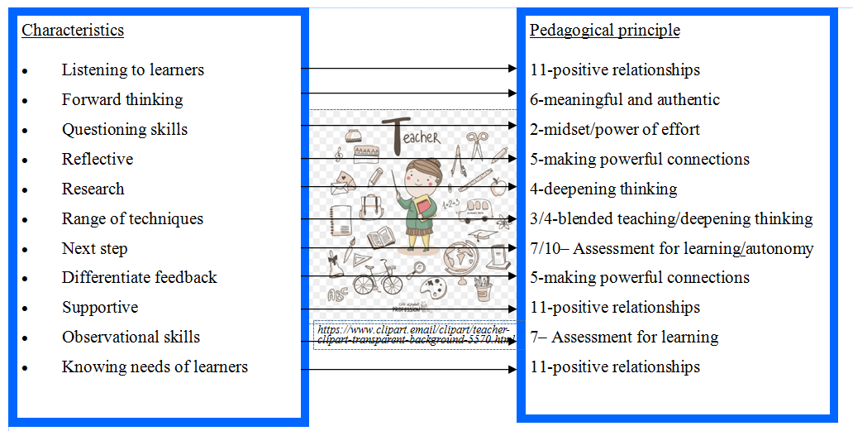
International pedagogy
International assessment data shows that Wales is currently underachieving with some significance in all areas. Programme for International Student Assessment (PISA) data highlights this. PISA is an international assessment for fifteen year old students and takes place every three years. Therefore I feel it is important to view curricula in countries that are at the top of the PISA assessment table in the view that we can adopt some of the pedagogies suitable for the culture and purpose of Wales. For over ten years countries such as Finland and Singapore have been excelling therefore for the purpose of this assignment I have concentrated on these two countries.

Finland
In Finland school age starts at aged seven and there are nine years of compulsory education. Pedagogy differs in comprehensive schools significantly. Heterogeneous groups with experts in pedagogy shows that weaker learners improve and stronger learners stay the same irrespective of the formation of groups (Välijärvi et al 2002 40-41). All schools have student counselling and small teaching groups. Pasi Sahlberg (2011) explains the positives of Finnish education which includes significant differences to education in Wales. Teachers’ training in Finland is rigorous and teachers are highly respected in their communities; modules of training include: language and communication education, pedagogical studies, multi-disciplinary studies and one free choice module. Teachers are free to concentrate on pedagogy as there are no inspections, professional judgement is trusted, no external standardisation is employed to inform the public of the schools performance, teachers have professional autonomy to plan the curriculum, education is publicly financed, there are no fees for schools or universities and a master degree is a basic qualification for teachers. There are six pedagogical principles as defined by Murri (2018)
1. Transversal skills (learning how to learn),
2. Government support,
3. Multi-disciplinary learning theme-pupils participate in planning,
4. Differentiation,
5. Diversity in learner’s assessment,
6. Learners take an active role in setting personal targets.
Teachers.org.uk highlight that The National Union of teachers (NUT) identify that ‘teachers are free to teach and children are liberated to learn’. It is significant to note that twenty seven members out of two hundred of the Finnish parliament are ex- teachers. The NUT are of the opinion that this helps when decisions are made by parliament on education as the shared expertise and experience enhances choices made for improving systems within education.

Singapore
Singapore a country that does equally as well as Finland in the PISA results has a very different approach to education. The Ministry of Education Singapore explains (2018) that there are four pedagogical practices these are:
- understanding students and learning,
- understanding teaching,
- Singapore Curriculum philosophy and
- Understanding of subject matter (there are twenty four corresponding teaching areas).
The philosophy represents a holistic education and it is believed that every child wants and can learn. Learning flourishes in a caring, safe environment where children can construct knowledge and activity through development and thinking deposition. When assessment is used it is to address gaps in learning. In general education in Singapore is highly scripted. It primarily focuses on coverage of the curriculum and is heavily reliant on text book, worksheets and repetition of learning. Children rely on teachers for learning to occur. Singaporean education teaches to the test. The conversation.com states “The essential challenge facing Western jurisdictions is not so much to mimic East Asian instructional regimes but to develop a more balanced pedagogy.”

Comparison between countries
Both International pedagogy styles are very different: children in Finland start school aged seven and Singaporeans aged three. Both countries have similar sized populations and both are successful in PISA assessment. However Singapore’s education has a deep emphasis on testing and examination results which could result in high pressure for students to do well whereas Finland has a more laid back approach with learners only taking one exam at age sixteen. Finland has a greater emphasis on comprehension therefore it is felt that Finland’s pedagogy promotes problem-solving which in turn advances life skills building resilience and overall improvement of well-being.
Wales has twelve pedagogical principles (refer to diagram 1). In my opinion and following discussions within our trust groups I would suggest these twelve principles could easily become four. I suggest that these could be split into constructivism, social constructivism, behaviourist or liberation where some aspects cross over and interlink with each other.

Social constructivism – pedagogy principles: 4. Problem-solving, 8. Making connections, 10. Encourage taking responsibility, 11. Social and emotional and 12. Collaborative learning
Constructivism – pedagogical principles: 2. Sustained effort, 6. Authentic context and 7.Asessment
Behaviourist- pedagogical principles: 3. Blend of approaches, 4. Problem solving and 5. Build on previous knowledge
Liberation- pedagogical principles: 1.Overall purpose, 8. Making connections, 9. Cross curricula and 10. Encourage responsibility

Wales, Finland and Singapore highlight the importance of well-being to enable learning to flow, grow and flourish. Therefore based on the evidence discussed it is my opinion that it is paramount that my setting initially focuses on pupil well-being. Establishing good, consistent well-being strategies will set a positive environment for learners to make progress and enable them to achieve their full potential.
Learning walks
I took part in several learning walks; this supported me to improve my professional practice.

Primary School 1
This is a green rated school which consists of four hundred and fifty pupils 26% of which are free school meals and 20% additional learning needs. During my visit I identified that each class had a humanities area with differentiated tasks set, the four purposes were displayed in the shape of a flower and the pupils we spoke to were able to discuss this in some detail almost in rote fashion. The literacy areas had a sofa and chairs and every class had either an art or cooking area. Classes are fluid and swop areas when needed; children are unsupervised during cooking and construction activities. When asked about health & safety measure teachers explained that the children had received a year’s training before being allowed full autonomy during these activities. Daily timetable consisted of a carousel of activities where the teacher focused on one group. This gives the teacher the opportunity to support and or challenge learners more effectively. After this visit I trialled the use of carousel activities in my own classroom. I found that the children responded well, appreciated the attention and the quality of work improved.
It was explained by senior management that the teacher stays with the same class throughout primary therefore they felt this showed consistency and building of trust and enhancing positive relationships. It was felt that this wouldn’t make transition to secondary more difficult due to children experiencing flowing to one class to another using the different areas. I feel that this links to Finnish curricula.

Primary School 2
26% FSM- this is high for Powys, one hundred and forty eight pupils and every class has a learning support assistant.
This school is the first training school in the United Kingdom for the pedagogical approach of Mantle of the Expert. The head-teacher here feels Mantle of the Expert is the twelve pedagogical principles of Wales. It is the first training school in Wales there are only five in the UK. The head teacher stated that she has turned the school around in recent years. She felt the need to do this due to: school had just come out of monitoring, low staff morale, low standard of pedagogy and poor behaviour. Since the implementation of Mantle of the Expert it is felt that: oracy, perseverance and resilience have grown.
Action research is carried out as a team; staff are given one question each year which is links to the school development plan. The head teacher feels this deepens the engagement from staff. Staff work together in teams; taking their action research in a direction of their own interest. This is then brought back to staff meetings where experiences are shared therefore reducing work load, improving time management which in turn enhancing positive well-being.
The school works on a low stimulation basis i.e. there is little in the way of displays and those in class are always black and white and usually art based. In the Junior department there are not enough seats for everyone, they have adult furniture and children sit where they want (different everyday). Several links can be made to Finnish curricula here. I feel this school is focused on well-being as the evidence around the school to support this is plentiful for example: there has been a big timetable change due to staff stress and children arriving late due to avoidance of maths. The daily timetable is outlined below.
- 9am circle time or philosophy for children-includes teacher discussing their feelings
- 9.30- 10 everyone does PE in different areas of school.
- No playtime due to behaviours
- 10am – 10.10 Newsround/snack/chill time
- Then more trusted work – no lesson length
- MANTLE maybe three or more mornings
- Lunchtime
- 1.30-2.30 Singapore maths
- One problem (not differentiated) children work collaboratively to find one or more method to solve it
- Worship
- Then individual and guided reading
As a result of seeing this practice I have reflected on my own professional practice. I discussed my learning visit and the benefits achieved in the school. I carry out mindfulness and we participate in the daily mile however these took place in the afternoon and are not always consistent. I felt it would be beneficial for my class if I were to adapt my timetable. I discussed this with senior management and it was agreed my class will receive mindfulness first thing in the morning which will be followed the daily mile.
The head teacher explained that Mantle of the Expert has altered everything; the teacher has no voice, this means that the teacher doesn’t stand at the front but rather becomes a part of the learning team. It is not a behaviour management tool but the head teacher stated that it has had a massive impact in this area. They use Building Blocks which is a tool for planning this has reduced workload and helps with tracking and they are currently dipping toes into four purposes, twelve principles and the Literacy and Numeracy Framework (LNF).
The head teacher suggests looking at Alex Beard (2018) Natural Born Learners. The head teacher feels this man should have been employed to write the curriculum due to his vast experience, he has travelled all over the world looking at pedagogies. The head teacher also quoted that ‘Most successful people have been taught via the Montessori way’ she provided the examples of Apple and Beyoncé. To enhance my professional knowledge and practice I did a little research on Beard (2018). He has been teaching for over ten years. He believes we are what we learn and that education has lost touch with human progress he also feels that schools are a relic of the industrial age. Beard (2018) states ‘education is a passport to the future’.
To ensure the correct precedence was given they held one inset where supplies covered classes to allow teachers to work together on the school’s vision.
In the school there is plenty of opportunity for outdoor and hands on learning for example when using tool benches, leaners spend days perhaps weeks on producing a quality prototype than one that has been created in forty minutes and has just been thrown together.
At first the head teacher reported there were doubters, tutting, tears and tantrums from staff and parents however Mantle of the Expert is now bringing money into school. In the beginning staff, were tentative- one member did the training, dabbled and had a go, then another member staff started talking about the activities which made others interested hence the domino effect. Now, even the doubters are on board and advocate the pedagogy. The staff I spoke to were enthusiastic about their curriculum and learners were able to discuss their work in detail.
I think this links with Finland’s curriculum with regards to mixed ability groups and lesson style. The school’s priority is to ensure good well-being to promote learning, in my opinion this links to both Singaporean and Finnish curriculums.

Secondary School 1
This school is a professional learning pioneer school. There are approximately one thousand pupils. 14.7% are entitled to free school meals and 13% have additional learning needs and 1% is English as an additional language.
The school is a formal setting; tables are in roles with the teacher at the front instructing children. It is reliant on whole class teaching, displays are generic and the pedagogy used is direct teaching. Pupils were very good at explaining what they were doing however; the activity meant to advance learning was a cutting and sticking exercise. When looking in books feedback provided is lengthy. When questioned pupils were able to answer but seemed unable to give explanations or expand on the topic which, lead me to believe they are being taught to test. The teachers confirmed that they teach to test which is similar to that of the Singaporean curricula discussed earlier in this assignment. Pupils were dependent on their teacher for learning and no resources were visible. I spoke to one pupil who had thirty five marks out of a possible thirty six and he seemed quite anxious that he dropped one point; I feel this could be detrimental to his emotional well-being. The school had an inspection from Estyn in December 2014 with the outcome being adequate, adequate however in monitoring report in June 2016 the school had shown significant improvement. It seems a more structured, institutionalised pedagogy is working well in this setting. This can be coupled with Singaporean curricula discussed earlier in this assignment.

Secondary School 2
This school has six hundred and forty eight pupils of which 28% are entitled to free school meals, 26% of pupils have additional learning needs. Nearly all pupils are English as a first language. The school had an inspection in October 2016 with the outcome being good, good. The first thing which was apparent is that all class have DRICE displayed- Deep thinking, Role model learning, Impact, Challenged and Engaged all staff have received training and use this pedagogy. Bloom’s Taxonomy was also displayed in each class. Anderson (2201) states using Bloom’s Taxonomy encourages thinking creatively, evaluating, analysing, applying, understanding and remembering which supports pupils to deepen their learning experience independently. Edward Du Bono Thinking hats were on display in some classrooms which is a tool to enhance discussion which also supports deepening of thinking, Bono (1985). The class sizes seemed small, pupils were allowed to sit where they wished lesson last for fifty minutes and the environment seemed calm however, teachers didn’t have time to greet pupils on arrival due to time constraints they issue tasks immediately. The pedagogies in this school seem to link to both that of Finland and Singapore. The pupils were happy, social and informative.

Section 2
The strategic plan will be discussed after the Strengths, Weakness, Opportunities and Threats (SWOT) analysis. A SWOT analysis helps to assess your position, Hill (2019). It supports an organisation to find out what is and what is not working. It helps to reduce the risk of failure. Using my SWOT analysis I’ve identified that as a school we need to begin implementing changes to ease the transition to the new curriculum by 2022.

Swot analysis
Strengths | Weaknesses
Keeping up-to-date with current issues.  Recognising need for changes.  Good senior management team.  Supportive management team.  Staff with a wide range of experiences and knowledge.  Organisation.  Established team.  Established routines.  Data collection. | Current Curriculum is too prescriptive.  Donaldson- 6 areas of learning- we need to adapt.  More opportunities for autonomy needed.  Well-being needs some developments  Reliability of data.  Lack of capabilities.  Time scales.
Opportunities | Threats
Training-development of new skills.  Staff meetings/collaboration.  Update resources.  Utilise staff current skills.  Development of ‘Donaldson’ style activities.  Enhancement of holistic development.  Innovation.  Development of technology.  Utilise current resources including outside areas. | Workload.  Staff resistance.  Time management.  Financial constraints.  Constraints within current curriculum.  Poor organisation.  Environment-suitability.

Advantages of using SWOT include:
It is condensed therefore easier to manage. It examines internal and external factors therefore ensuring a holistic approach. All stakeholders are consulted which in turn allows problem areas to be highlighted so they can be minimised appropriately and swiftly. SWOT focuses on key areas helping to reduce distraction and avoid areas which are not a current priority. It matches strengths with weaknesses therefore highlighting possible issues which could be discussed and solved before they become problems within the proposed change. It can be objective, therefore reducing bias.

Disadvantages of using SWOT include:
It can be over simplified therefore details could be missed or misinterpreted which in turn could have a detrimental effect on the proposed change. It can prevent weaknesses being acknowledged which could cause future problems or disruptions to the proposed change.

Strategic Plan Brief
The purpose of a strategic plan is to establish a direction. Vo (2018) states it provides a place to record your mission and the journey needed to achieve your goals.

Donaldson (2015:28) states that
‘A continuing theme in the evidence was the importance of well-being, and in particular mental health. Schools need to care both for children and young people’s physical and emotional needs and help them to take responsibility for their own lives.’
Due to my new role as well-being lead I particularly wanted to review our current provision in this area. I found that we are adequately meeting physical needs by ensuring children participate in the daily mile, team sports, physical education lessons also we are beginning to utilise the skills of a new staff member who is trained in physical literacy. All staff have received this training and are currently implementing it into the classroom and daily routines.
We have provision for children with known mental health, emotional or behavioural issue however there is no current blanket provision. This is an area that needs to be developed. Exploration and discussion in staff meetings will be needed to make decisions about how we are going to develop this area. Time will be needed to allow staff to go through the storming-forming-norming process to ensure all staff has an input are on-board.
Reviews of other schools good practice would be beneficial with regards to being forewarned of any difficulties and how they have implementing their methods successfully.
Courses and training on pupil well-being will be essential therefore cost implications will need to be considered. This is a large area and will need to be taken in manageable steps. Therefore I decided to complete MIND MAP (see appendix 2). After analysing my mind map I made the decision to focus on 'Mindfulness' because if children have issues that affect their everyday lives they will find it difficult to concentrate or stay focused long enough which could result in lack of progression in learning. Mindfulness will help children to be 'in the moment' and concentrate on the task at hand. Jha et al (2010) explain that relatively short mindfulness interventions have improved visual-spatial memory, working memory and sustained attention.
Lee (2016) discusses how change can affect practice, organisations, individuals and teams. One disadvantage of change is that staff may feel insecure or unsure of their own roles and responsibilities. Prevention of negative reactions could easily be solved by a sequence of meetings and a step by step plan drawn with the participation of all members of the team. This in turn will give staff some ownership of the change and therefore a sense of control and security.
The strategic plan below has been produced in the view of teacher professional development. It will be presented to the senior management team who will review and perhaps adapt it before presenting it to stakeholders in school.
Strategic Plan for White Rose Primary
Four Purposes
1 Ambitious, capable learners
2 Enterprising, creative contributors
3 Ethically informed citizens
4 Healthy confident individuals

Current Trust: healthy confident individuals who are ready to lead fulfilling lives as valued members of society.
Objectives | Actions | Success criteria | Potential Barrier | Evaluation/Impact
Improve knowledge of pedagogical principles. | Two members of staff to join Fern Federation to carry out action research on chosen pedagogical approach. | Research area and select a topic to trust on.  Share experiences within internal and external teams.  Record beginning, middle and end point using IRIS connect.  Use proxy indicators to evaluate beginning, middle and end points.  Make adaptations and put into practice.  Compare recordings.  Evaluate independently.  Share and evaluate as a team. | Time constrictions-sessions need to be timetabled appropriately.  External team members may not be as committed therefore it is essential that good communication is established.  Staff will need to be trained to use IRIS equipment to ensure session can be filmed, shared and evaluated.  Staff may not feel comfortable being recorded therefore it is essential that it is made clear that this is an evaluative tool for teaching techniques. Also it is not essential for the teacher to be physically seen on the video clip. | Session evaluations at beginning/middle/end of action research.  Recommendations to be made at the end of the action research.  Impact- at least two other members of staff in a differing year group to trial the chosen project.
Implement chosen action research in different year group | Two members of staff to follow previous action research and carry out Mindfulness techniques. | Liaise with team leader of action research.  Record sessions using IRIS beginning, middle and end points.  Use proxy indicators as an evaluation tool.  Use a range of Mindfulness techniques and evaluate suitability for the age group it is being used with.  Discuss findings and or issues with Action research lead.  Share experiences/IRIS clips in staff meeting. | Staff may not volunteer to carry out Mindfulness techniques/may lack confidence. To mitigate this, staff members should be given the opportunity to observe sessions and watch previous recordings. Staff will be given the opportunity to engage in Mindfulness sessions/techniques during staff meeting. Staff will be supported in using techniques to provide confidence.  Time constrictions-sessions need to be timetabled appropriately.  Staff may not feel comfortable being recorded therefore it is essential that it is made clear that this is an evaluative tool for teaching techniques. Also it is not essential for the teacher to be physically seen on the video clip. | Session evaluations at beginning/middle/end of action research.  Recommendations to be made at the end of the action research for the different year groups.  Impact more staff and pupils have had access to Mindfulness and begin to feel the benefits of using this technique.  Undesirable behaviour reports reduced.
All stakeholders to have an understanding of the ‘purpose’ healthy confident individuals and the purpose of implementing Mindfulness into the classroom. | All staff to receive Mindfulness training via do-be mindful. | All staff to complete modules.  All staff to carry out the activities set.  Discuss with phase during PPA sessions.  All staff to deliver Mindfulness techniques learned to their classes. | Time management- staff to be given time (6hours) to complete the modules.  Staff may not have computers or access to the internet at home therefore will be allowed to use laptops, Chrome books or PCs to access Do-Be-mindful in school.  Staff may not engage due to lack of interest-therefore it is paramount that the benefits of Mindfulness are explained in advance and discussed as a staff. Staff to share their experiences to help combat this possible barrier. | All staff confident in delivering Mindfulness.  All pupils given the opportunity to participate in Mindfulness.  Reduced use of CWTCH area (area where children go to calm down).  Reduce number of children receiving interventions such as ELSA, THRIVE, Talkabout and Comit.
Staff members to understand the effects of Adverse childhood experiences. | Two members of staff to receive ACEs (adverse childhood experiences) training Units 1 and 2. | Two trained members to deliver the training to other staff.  To provide education on impact of toxic stress on the brain.  To increase school awareness of ACEs.  To increase confidence in identifying ACEs.  Raise awareness of individual’s management of trauma. | Staff may be absent and therefore a mop-up session will need to be planned. | Referrals to the correct interventions will be made.  Teachers will have a better understanding of how to support learners.
Pupils and staff to have knowledge about ‘The Rights of the child’  UNCRC (united nation convention on the | Health & Well-being lead to receive training and then deliver to all staff members.  Inform whole school community that we are working on the Right’s respecting School award.  Be familiar with UNCRC.  Have a pupil led steering group in place.  Measure starting point.  Complete questionnaire summary.  Review school practice against silver descriptors.  Complete action plan for Silver award.  Complete data form.  Contact Right’s Respecting Schools award adviser and apply for Bronze award. | Two learners to become Rights of the Child Ambassadors.  Schools will be invited to a learning walk to view how White Rose has implemented Rights.  Health & Well-being lead to participate in a webinar with the Children’s Commissioner for Wales.  Achieve Bronze award from Rights Respecting Schools. | Staff may be absent and therefore a mop-up session will need to be planned.  Time/date need to be suitable for as many schools as possible therefore communication is paramount. Those schools unable to attend on the agreed date will be invited to visit and a mutually convenient time. | Session 1 UNCRC training: participants will know what the UNCRC (Children’s Rights) are and be introduced to the role of the Children’s Commissioner for Wales.  Session 2 UNCRC training: By the end of this session participants will  Know what a Children’s Rights Approach is.  Know why it’s needed; understand how to develop a Children’s Rights approach in the classroom; whole school approach and a national level.

Section 3 Academic Poster

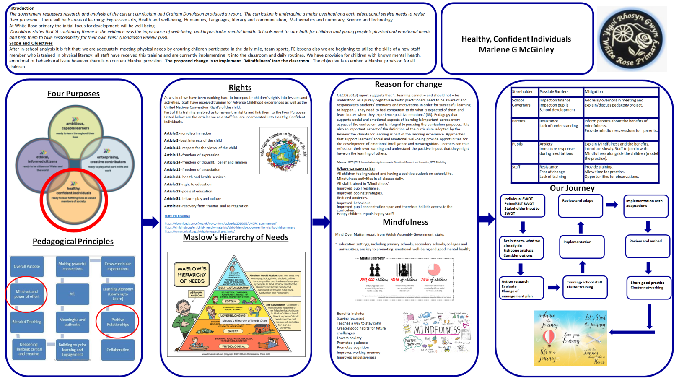

Rationale
I designed this academic poster for staff and governors within my setting. I produced this to support management and to ensure staff and governors are engaging with the new curriculum.

I designed the poster in an organised way with clear headings and sub headings. To engage the reader, research of academic posters has shown that the reader needs to be attracted within the first few seconds of looking at it. Leicester University (www2.le.ac.uk) explain that posters are read from a distance of one meter and therefore they need to be clear. They explain two approaches 1) the one piece method and 2) the panel method. Both are self-explanatory the one piece can be time-consuming and I feel the layout can become complicated if the producer is not careful as well as risking the reader losing concentration. I decided to use the panel method because I felt it was easier to show the flow and allow the reader to follow the sequence with ease and clarity therefore holding their interest.
The design of the poster provides a clear sequence of reading with arrows to show which column to read next to ensure flow. I felt too much writing would discourage the reader therefore I used a combination of the written word and visual images.
I included an introduction to help with the ease of understanding when being read without the delivery and explanation behind it. I chose the colour scheme (mainly blue and white) due to them being out school colours. Our school motto is ‘Believe, Learn and Grow Together’ which establishes the context for this poster. I began with the four purposes due to the nature of them being at the heart of the new curriculum. I emphasised healthy, confident individuals with a red circle to show that this is the purpose I concentrate on due to my professional role as well-being lead and my personal interest in the area. My second and third red circles shown on the pedagogical principles emphasise where the link is being made throughout the whole poster. My next step was to show how the United Nations Convention Rights of the Child (UNCRC unicef.org) are linked to the four purposes. Please see below relevant legislation. I did this as I had recently delivered training to staff; one of the activities was to match the articles in the UNCRC to the four purposes. I collated the data and displayed how many are linked to the healthy, confident individuals. I feel that including the information gathered from an activity stakeholders were involved in would promote engagement.
Alderson (2000) states seeking the opinion of children is stated in the United Nation Convention on the Rights of the Child (1989). The United Kingdom signed up in 1991; it stated three main rights, non- discrimination, best interests and the child’s view, Houghton and McColgan (1995).
A green paper Every Child Matters was issued in 2003. Children chose five key outcomes; being healthy, safe, enjoyment and achieving, making a good contribution and achieving economic well-being HM treasury (2003). The aim is to reduce the gap and disadvantages between children. The focus of this paper is for children aged three to nineteen years the outcomes are at the core of the Children Act (2004), which is the legal document that supports the framework of Every Child Matters (DFES 2003).
I decided to use Maslow’s hierarchy of needs to display the requirements for ensuring a child’s psychological and emotional needs are met. See diagram 3 below.
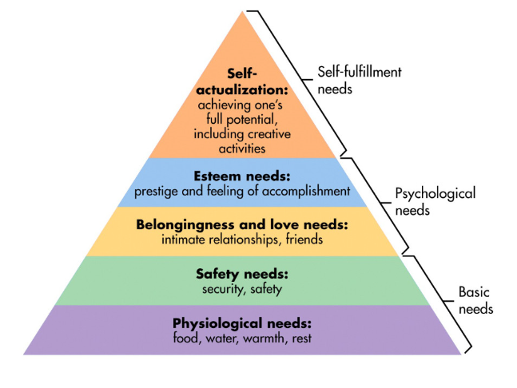
Diagram 3 Maslow’s Hierarchy of Needs

https://www.simplypsychology.org/maslow.html
Needs placed at the bottom need to be met before individuals can attend to the higher up needs. The first four levels are known as deficiency needs whilst the top level is known as growth or being needs. Every individual is capable of succeeding however progress is slowed if lower needs are not met motivation increases as an individual’s needs are met. Leaders within the setting have a responsibility to staff and pupils. Management organise health and safety checks are regularly taken and any issues are dealt with promptly. Senior management ensure the appropriate training is given, recognise and pre-empt needs or issues therefore reducing barriers to achieving self-actualisation. Safe guarding training is mandatory and all staff has a responsibility to report any concerns for pupil’s well-being to the safe guarding officer. As you can see from the diagram physiological needs, safety needs, belongingness and esteem needs to be met to enable a learner to achieve their full potential. It is a legal, professional and morale matter for whoever works or spends time with children to ensure each child has the best possible provision.
Well-being, defined by mentalhealth.org, can be understood as how people feel and how they function, both on a personal and social level’. Foresight Mental Capital and Wellbeing Project (2008) convey that The World Health Organisation describes wellbeing as a “resource for healthy living” and “positive state of health” that is “more than the absence of an illness” and enables us to function well: psychologically, physically, emotionally and socially. It is a broad area which can be group into four areas: physical, mental/emotional, social and spiritual. For the purpose of this assignment I concentrate on mental/emotional well-being. Mental well-being is about feeling confident, valuing yourself and having the ability to express and manage your emotions. It is a normal part of life to suffer disappointments, go through change and loss. However, how we deal with this effects our emotional and mental well-being. Therefore it is paramount to build resilience from a young age. Weare (2014) convey that practising mindfulness has benefits to help combat anxiety and supports a person to deal with their emotions and build up resilience.
Resilience can be defined as “the process of adapting well in the face of adversity, trauma, tragedy, threats or significant sources of stress” American Psychology Association (2019.) Resilience should not be seen as a trait that people have or do not have because it involves behaviours, thoughts and actions that can be learned and developed by anyone and everyone.
Barriers and mitigations are shown on the poster to show understanding of the needs of stakeholders and that their needs are valued as well as providing ways to problems solve therefore reducing said barriers.
The final part of the picture shows our journey as a setting and the image emphasises that our journey is continuous. Our setting shouldn’t become complacent, action research should be continuous, practices need to be reviewed and adapted, in other words plan, reflect and do.
I have shown the poster to staff members and received valuable feedback. On reflection staff reported that they would like more information on further reading therefore if I were to create a similar academic poster I would include QR codes with links to further research, books and websites for staff read in their own time. This would support staff with their continuous professional development. The second thing I would adapt is the ‘Our Journey’ section it was felt that not enough detail was shown. For example I have written one word in some boxes these could be expanded upon. The ‘review and adapt’ box whilst it was discussed when presented it does not state on the poster what is being reviewed or adapted and for ‘implementation’ I haven’t stated what is being implemented, how or when. Therefore next time I would include concise points for example for the ‘implementation’ section I would add mindfulness of breath and the daily mile. Finally to improve the clarity of writing, Denton & Meindl (2015) advocate the use of card and suggests using pastel coloured paper. Therefore I would print on card and provide the option of printing the poster on a colour of individual choice for people who may have dyslexia.

Reference list
Alderson P (2000) Young Children’s Rights Exploring Beliefs, Principles and Practice Jessica Kingsley Publishers London
Alexbeard.org (accessed: 09/01/2020)

American Psychology Association (2019) The Road of Resilience https://www.apa.org/helpcenter/road-resilience (accessed: 17/11/10)
Anderson, L.W & Krathwohl, D.R. (2001) A Taxonomy for Teaching, Learning and Assessing: A Revision of Bloom’s Taxonomy of Educational Objectives New York NY: Longman
Beard (2018) Natural Born Learners Our Incredible Capacity to Learn and how we can Harness it. First published in Great Britain (2018) by Weidenfield & Nicolson an imprint of the Orion Publishing Group LTD London copyright

Bono E (1985) Edward de Bono Six Thinking Hats, Little Brown and Company

Boyd W (1963) The Educational Theory of Jacques Rosseau New York Russell & Russell Inc.

Britton L (1994) Montessori Play & Learn Vermilion London
Bruce T (1996) Childcare & Education Hodder & Arnold London
Children Act (2004) HMSO London
Children’s rights image (no date) available at: http://www.saskadvocate.ca/sites/default/files/images/photos/un_crc.jpg (accessed: 18/11/19)
Davies D (2019) PG cert Tutor Day 2 Trust group Discussion 10/10/19
Denton TF & Meindl JN (2015) The Effect of Coloured Overlays on Reading Fluency in Individuals with Dyslexia. Behaviour analyst practice 2016 Sept 9 (3): 191-198 Publishes online 2015 Aug 12 available at: https://www.ncbi.nlm.gov/pmc/articlles/PMC499357/ (accessed: 10/01/2020)
DFES (2003) Every Child Matters London HMSO as cited by Macleod-Brudenell I (2004) Advanced Early Years Care and Education Heinemann Oxford
Difference between Piaget and Vygotsky posted by admin Oct 21st (2014) cited on https://www.differencebetween.com/difference-between-Piaget (1952)-and-vs-vygotsky/ accessed 12/10/19
Donaldson, G (2015) Successful futures: Independent Review of Curriculum and Assessment Arrangements in Wales. Published: Crown copyright 2015
Shaw J (2018) Coaching and Teaching the Same Thing available at: teachthought.com/pedagogy/4-keycharacteristics-effect-teachers/ (accessed: 01/10/19)
Every Child Matter policy paper (2003) HM Treasury available at: https://www.gov.uk/government/publications/every-child-matters (accessed 18/11/19)
Excellence in Teaching Framework (no date) available at: https://e.excellenceinteaching.co.uk (accessed: 09/01/2020)
Foresight Mental Capital and Well Being Project (2008) Final Project Report. The Government Office for Science, London available at: https://assets.publishing.service.gov.uk/government/uploads/system/uploads/attachment_data/file/292450/mental-capital-wellbeing-report.pdf (accessed: 07/11/19)
Four Purposes image (2018) available at - https://gov.wales/sites/default/files/publications/2018-03/a-report-on-responses-to-the-great-debate.pdf (accessed: 18/11/19)
Freire Education for Critical Consciousness (2015) available at: http://abahlali.org/wp-content/uploads/2012/08/Paulo-Freire-Education-for-Critical-Consciousness-Continuum-Impacts-2005.pdf (accessed: 12/10/19)
Hagerty N (2019) PG cert Tutor Day 2 Trust Group Discussion 10/10/19
Hattie, J (2009) Visible Learning: A Synthesis of over 800 Meta-analyses Relating to Achievement Routledge cited in Donaldson, G (2015) Successful Futures: Independent Review of Curriculum and Assessment Arrangements in Wales. Published: Crown
Hill B (2019) Why Perform a SWOT Analysis? Available at: https://smallbusiness.chron.com (accessed: 09/01/2020)
Houghton D and McColgan M (1995) Working with People Working with Children Collins Educational Ltd. London

The Conversation available at:http://theconversation.com/why-is-singapores-school-system-so-successful-and-is-it-a-model-for-the-west-22917 (accessed: 31/10/19)
Impact Wales (2018) Pedagogical Principles available at: http://www.impact.wales/wp-content/uploads/2018/01/12-Pedagogical-Principles-1.pdf (accessed 07/01/20)

Hurst V (1997) Planning for Early Learning Educating Young Children 2nd edition Paul Chapman Publishing London

Jha A, Stanley E, Kiyonaga A, Wong L and Gelfand L (2010) Examining the Protective Effects of Mindfulness Training on Working Memory Capacity and Affective Experience Emotion 10 (1): 54-64

Journey Image (no date) available at: https://www.dreamstime.com/stock-illustration-inspirational-quote-embrace-journey-life-journey-let-s-start-best-takes-us-home-love-your-image88717793 (accessed: 02/01/20)

Kiel, Joan M (1999) ‘Reshaping Maslow’s Hierarchy of Needs to Reflect Today’s Education and Managerial Philosophies’. Journal of Instructional Psychology vol 26 no 3
Ko and Sammons (2010) available at: https://assets.publishing.service.gov.uk/government/uploads/system/uploads/attachment_data/file/183324/DFE-RR129.pdf (accessed: 09/10/19)

Leicester university (no date) available at: https://www2.le.ac.uk/offices/ld/resources/presentations/designing-poster/poster (accessed: 03/11/19)
Lee D (2016) 15 Factors that Impact how Employees Respond to Change, Talent Management & HR available at: https://www.tlnt.com/15-factors-that-impact-how-your-employees-respond-to-change/ (accessed: 14/01/2020)

Macleod-Brudenell I (2004) Advanced Early Years Care and Education Heinemann Oxford

Murri M (2018) 6 Key Principles that make Finnish Education a Success available at: edsurge.com/news/2018-07-31-6-key-principles-that-make-finnish-education-a-success (accessed: 31/10/19)
Maslow’s Hierarchy of Needs image (no date) available at: http://www.saskadvocate.ca/sites/default/files/images/photos/un_crc.jpg (accessed: 18/11/19)
Mental disorders statistics image (2017) available at: https://educate.worldyo.org/wp-content/uploads/sites/12/2017/01/mental_health_fact.png
Mindfulness: Help or Hype? (2018) available at: https://www.gustoresearch.com/news-and-views/mindfulness-help-or-hype (accessed: 08/11/19)
Ministry of Education (2019) Singapore Teaching Practice available at: moe.gov.sg/about/Singapore-teaching-practice (accessed 31/10/19)
Montessori M (1949) as cited by Macleod-Brudenell I (2004) Advanced Early Years Care and Education Heinemann Oxford
National Assembly for Wales (2018) Mind over Matter available at: https://www.assembly.wales/laid%20documents/cr-ld11522/cr-ld11522-e.pdf (accessed: 12/11/19)
National Union of Teachers (no date) available at teachers.org.uk/6-finnish---education-context%2C---characteristics-end-and-principles.pdf (accessed: 31/10/19)
Nind, M. & Lewthwaithe, S. (2015) Principles for Effective Pedagogy- NCRM quick start guide. Manual. NCRM
OECD (2013) Innovative Learning Environments Educational Research and Innovation, OECD Publishing
Pasi Sahlberg (2011) Finnish Lessons: What can the World Learn from Educational Change in Finland
Pedagogical principles image (2019) available at: http://d6vsczyu1rky0.cloudfront.net/33619_b/wp-content/uploads/2019/01/Teaching-and-Learning.pdf (accessed: 08/11/19)
Piaget (1952), J. (1952). The Origins of Intelligence in Children. New York, NY: W.W. Norton & Co.
Simple Psychology (2018) Maslow's Hierarchy of Needs available at: https://www.simplypsychology.org/maslow.html (accessed: 12/10/19)
Teach Thought (2018) Observable Characteristics of Effective Teaching available at: (https://www.teachthought.com/pedagogy/20-observable-characteristics-of-effective-teaching) accessed 01/10/19
Tes editorial (2018) What is Pedagogy? available at: https://www.tes.com/news/what-is-pedagogy-definition (accessed 12/10/19)
The conversation (2014) Why is Singapore System so Successful available at: theconversation.com.why-is-singapore-system-so-successful-and-is-it-a-model-for-the-west (accessed: 31/10/19)

UNCRC (2010) available at: https://downloads.unicef.org.uk/wp-content/uploads/2010/05/UNCRC_PRESS200910web.pdf?_ga=2.51475242.229792189.1579164328-1635998070.1538062135 (accessed 15/01/20)
Välijärvi J & Malin A (2002) The Effects of Socio-economic Background on the School Level Performances.
Vo E (2019) What is Strategic Planning? Available at: https:sba.thehartford.com (accessed 05/02/20)
Weare K (2014) Evidence for Mindfulness: Impacts on the Wellbeing and Performance of School Staff University of Exeter
Wiliam D (2011) Studies in Educational Evaluation 37: 1 p3-11

