
Data Mining in the Bank Marketing
UWTSD, School of Applied Computing

student name: hai jiang
stdent number:2006613
LETURER, NIK WHITEHEAD PHD
Contents
Abstract 1
Introduction 1
The Concept of Data Mining 1
Data Mining Steps 1
Data Mining Analysis Methods 2
Data Description 2
The Origins of the Data 2
UCI Data Set 3
The Dataset 3
View Data Set Details 3
Attribute Information 4
Why is it Suitability for Analysis 6
Data Pre-processing 6
Convert to DataFrame Format 6
Data transformations performed to convert to ARFF format 7
Initial visualisation of data 8
Build the Best Model 8
Potential Research Questions 15
Data Analysis 15
Question 1 16
Question 2 18
Question 3 20
Question 4 23
Question 5 23
Reflection 28
References 29

Abstract
This course is called data mining and visualization, so this article mainly focuses on data processing, information mining, classification, and prediction. The article first introduces the concept of data mining, understands the meaning of data mining and the process of data mining. Then introduce a data set found from UCI data set suitable for this research. Preliminary analysis and data preprocessing are performed on the obtained data set. Then the data set is converted into ARFF file and imported into weka for preliminary visualization. Then according to the research questions, further mining and analysis of the data in weka, and finally a summary analysis of the results.

Introduction

The Concept of Data Mining
Data mining refers to the process of searching for information hidden in a large amount of data through algorithms. It is also a hot issue in the field of artificial intelligence and database research. The so-called data mining refers to revealing the hidden and previously unknown from the large amount of data in the database. The non-trivial process of information with potential value. Data mining is a decision support process, which is mainly based on artificial intelligence, machine learning, pattern recognition, statistics, databases, visualization technology, etc., highly automated analysis of enterprise data, making inductive reasoning, and digging out potential patterns from it. To help decision-makers adjust market strategies, reduce risks, and make correct decisions. [1]

Data Mining Steps
Data mining technology is an important method of computer data warehouse technology, it can form the large, fuzzy, incomplete, noisy random data and to find and extract hidden in which has not been previously detected information, knowledge and the business model and the related factors of association rules [2]. The knowledge discovery process consists of the following three stages: ①data preparation; ②data mining; ③result expression and interpretation. Data mining can interact with users or knowledge bases. Data preparation, data collection model and mining evaluation constitute the three main stages of data mining, as they were shown in figure 1.
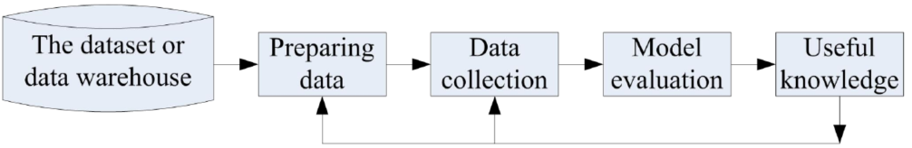
Fig. 1 Data mining process
Data mining is a technique to find the law from a large amount of data by analyzing each data. It mainly includes three steps: data preparation, law search and law expression. Data preparation is to select the required data from related data sources and integrate them into a data set for data mining; rule search is to use a certain method to find out the laws contained in the data set; the rule representation is as far as possible to the user. The way of understanding (such as visualization) expresses the found rules. Data mining tasks include association analysis, cluster analysis, classification analysis, anomaly analysis, specific group analysis and evolution analysis, etc.
Before implementing data mining, it is necessary to formulate what steps to take, what to do at each step, and what goals are necessary to achieve data mining. Only a good plan can ensure the orderly implementation and success of data mining. The data mining process model steps mainly include defining problems, establishing data mining libraries, analyzing data, preparing data, building models, evaluating models and implementing them. [3]

Data Mining Analysis Methods
Data mining is divided into guided data mining and unguided data mining. Guided data mining is the use of available data to build a model, which is a description of a specific attribute. Unguided data mining is to find a certain relationship among all attributes. Specifically, classification, estimation, and prediction belong to guided data mining; association rules and clustering belong to unguided data mining.[4]
1. classification. It first selects the classified training set from the data, uses data mining technology on the training set to establish a classification model, and then uses the model to classify unclassified data.
2. Valuation. The valuation is similar to the classification, but the final output result of the valuation is a continuous value, and the amount of the valuation is not predetermined. Valuation can be used as a preparatory work for classification.
3. prediction. It is carried out through classification or estimation, and a model is obtained through classification or estimation training. If the model has a high accuracy rate for the test sample group, the model can be used for the unknown variables of the new sample Make predictions.
4. Relevance grouping or association rules. The purpose is to discover which things always happen together.
5. Clustering. It is a method of automatically finding and establishing grouping rules. It divides similar samples into a cluster by judging the similarity between samples.

Data Description

The Origins of the Data
The data set for this data mining comes from the UCI data set [5].

UCI Data Set
The UCI (University of California Irvine) data set is an opensource data set suitable for pattern recognition and machine learning proposed by the University of California Irvine. Many scholars choose to use the data set on UCI to verify the correctness of their proposed algorithm. So far, there are nearly 500 data sets, and the data sets are still being expanded. These data sets are mainly divided into binary classification problems, multi-classification problems and regression fitting problems. The UCI data set provides the main attributes of each data set. You can use the various algorithms proposed by yourself to do experimental results on the data set to prove the rationality of your proposed algorithm[5].

The Dataset
The data is related with direct marketing campaigns of a Portuguese banking institution. The marketing campaigns were based on phone calls. Often, more than one contact to the same client was required, in order to access if the product (bank term deposit) would be ('yes') or not ('no') subscribed. The classification goal is to predict if the client will subscribe (yes/no) a term deposit (variable y). Through customer information analysis, customer and bank call information analysis, economic analysis and other related information analysis, to determine the most likely to buy bank deposit products, so as to make intelligent recommendations.[5]
The bank_full.csv with all examples (41188) and 20 inputs, ordered by date (from May 2008 to November 2010.
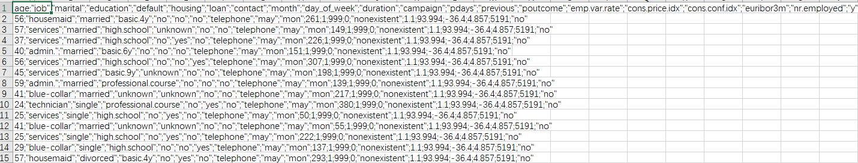

View Data Set Details
Import the processed csv file into RStudio, and use the str() function to view the details of the data set, including the data type of the data set, the number of data, the name and quantity of the attribute, the data type of the attribute value, and so on.
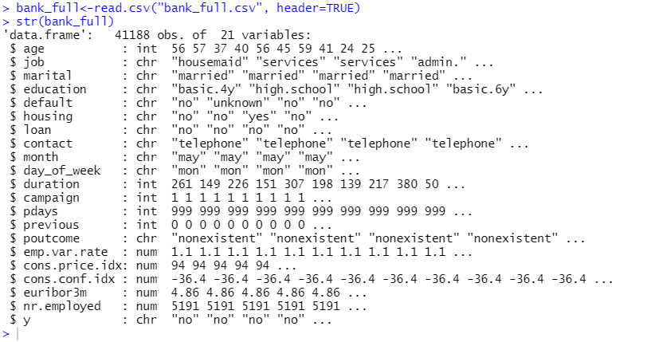

Attribute Information
This data set has 20 input attributes and one output attribute. The input attributes are divided into four categories. As shown in the table below
Attribute Name | Data Type | Description
1 Input variables
- # bank client data
age | Numeric | Client age
job | Textual | Type of job (categorical: ‘admin’, ‘blue-collar’, ‘entrepreneur’,‘housemaid’,‘management’,‘retired’,'self_employed','services','student','technician','unemployed','unknown')
marital | Textual | Marital status (categorical: 'divorced', 'married', 'single', 'unknown'; note: 'divorced' means divorced or widowed)
education | Textual | Education (categorial: 'basic.4y', 'basic.6y', 'basic.9y', 'high.school','illiterate','professional.course','university.degree', 'unknown')
default | Textual | Has credit in default? (categorical: 'no', 'yes', 'unknown')
housing | Textual | Has housing loan? (categorical: 'no', 'yes', 'unknown')
loan | Textual | Has personal loan? (categorical: 'no', 'yes', 'unknown')
- # related with the last contact of the current campaign
contact | Textual | Contact communication type (categorical: 'cellular', 'telephone')
month | Textual | Last contact month of year (categorical: 'jan', 'feb', 'mar', ..., 'nov', 'dec')
day_of_week | Textual | last contact day of the week (categorical: 'mon','tue','wed','thu','fri')
duration | Numeric | last contact duration, in seconds (numeric).
3)# social and economic context attributes
emp.var.rate | Numeric | employment variation rate - quarterly indicator
cons.price.idx | Numeric | consumer price index - monthly indicator
cons.conf.idx | Numeric | consumer confidence index - monthly indicator
euribor3m | Numeric | euribor 3 months rate - daily indicator
nr.employed | Numeric | number of employees - quarterly indicator
4) # other attributes
campaign | Numeric | number of contacts performed during this campaign and for this client
pdays | Numeric | number of days that passed by after the client was last contacted from a previous campaign (numeric; 999 means client was not previously contacted)
previous | Numeric | number of contacts performed before this campaign and for this client
poutcome | Textual | outcome of the previous marketing campaign (categorical: 'failure', 'nonexistent', 'success')
2 Output variable (desired target)
y | Textual | has the client subscribed a term deposit? (binary: 'yes','no')
Table 1. Attribute Information
Important note: this attribute highly affects the output target (e.g., if duration=0 then y='no'). Yet, the duration is not known before a call is performed. Also, after the end of the call y is obviously known. Thus, this input should only be included for benchmark purposes and should be discarded if the intention is to have a realistic predictive model.

Why is it Suitability for Analysis
The size of the dataset means that it is sufficiently large for a wide variety of data mining techniques to be applied to it with a high probability of finding any hidden patterns within it. Some data cleansing will need to be performed in order to ensure that the records used for modelling are complete and are not outliers, but with a dataset this large it is expected that it will still be possible to produce large datasets for both modelling and testing processes. The patterns sought are based upon sound astrophysical principles and can therefore be checked against known existing results.

Data Pre-processing
Because this data set is compiled by others from a data set containing hundreds of attributes, it is a complete and refined data set. It has no missing values, no NA values, and does not require numerical conversion, so it is not necessary Perform data processing on the values of the data set. However, it is necessary to encode the downloaded CSV file and then convert it into an ARFF file.

Convert to DataFrame Format
The bank_full.csv with all examples (41188) and 20 inputs, ordered by date from May 2008 to November 2010. The unprocessed original data set is shown in the figure below. From the picture, it can be seen that the data is very messy.
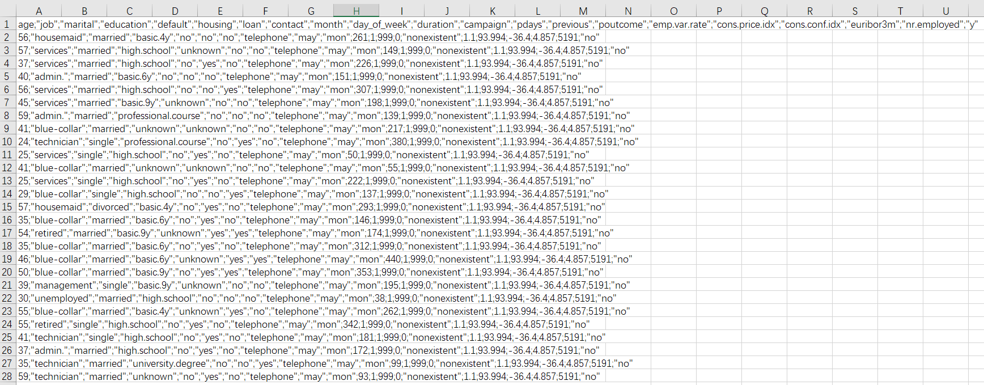
Encode the data set and convert it to DataFrame format. The code and processed data set are as shown in the figure below.
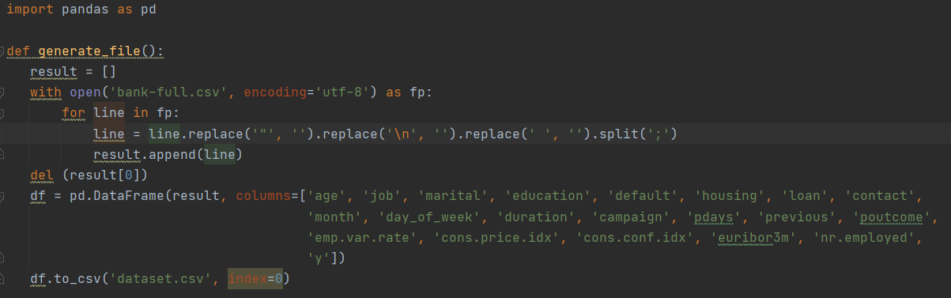
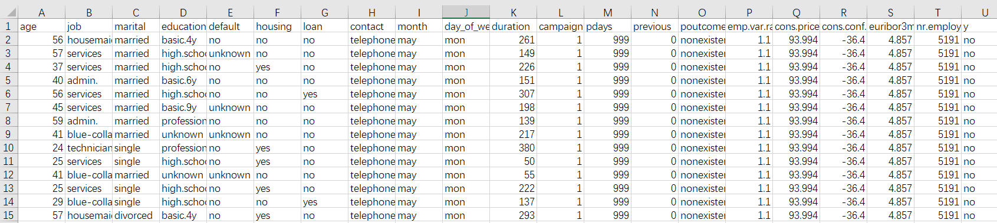

Data transformations performed to convert to ARFF format
Convert the processed CSV file to ARFF file for easy use in weka.

ARFF Header
@relation bank-full

@attribute age numeric
@attribute job {housemaid, zservices, admin., blue_collar, technician, retired, management, unemployed, self-employed, unknown, entrepreneur, student}
@attribute marital {married, single, divorced, unknown}
@attribute education {basic.4y, high.school, basic.6y, basic.9y, professional.course, unknown, university.degree, illiterate}
@attribute default {no, unknown, yes}
@attribute housing {no, yes, unknown}
@attribute loan {no, yes, unknown}
@attribute contact {telephone, cellular}
@attribute month {may, jun, jul, aug, oct, nov, dec, mar, apr, sep}
@attribute day_of_week {mon, tue, wed, thu, fri}
@attribute duration numeric
@attribute campaign numeric
@attribute pdays numeric
@attribute previous numeric
@attribute poutcome {nonexistent, failure, success}
@attribute emp.var.rate numeric
@attribute cons.price.idx numeric
@attribute cons.conf.idx numeric
@attribute euribor3m numeric
@attribute nr.employed numeric
@attribute y {no,yes}

Initial visualisation of data
Import the data set into weka and perform a preliminary visualization of the data. The result is shown in the figure below. From the figure, we can see the distribution of different values of each attribute and the influence on the output result.
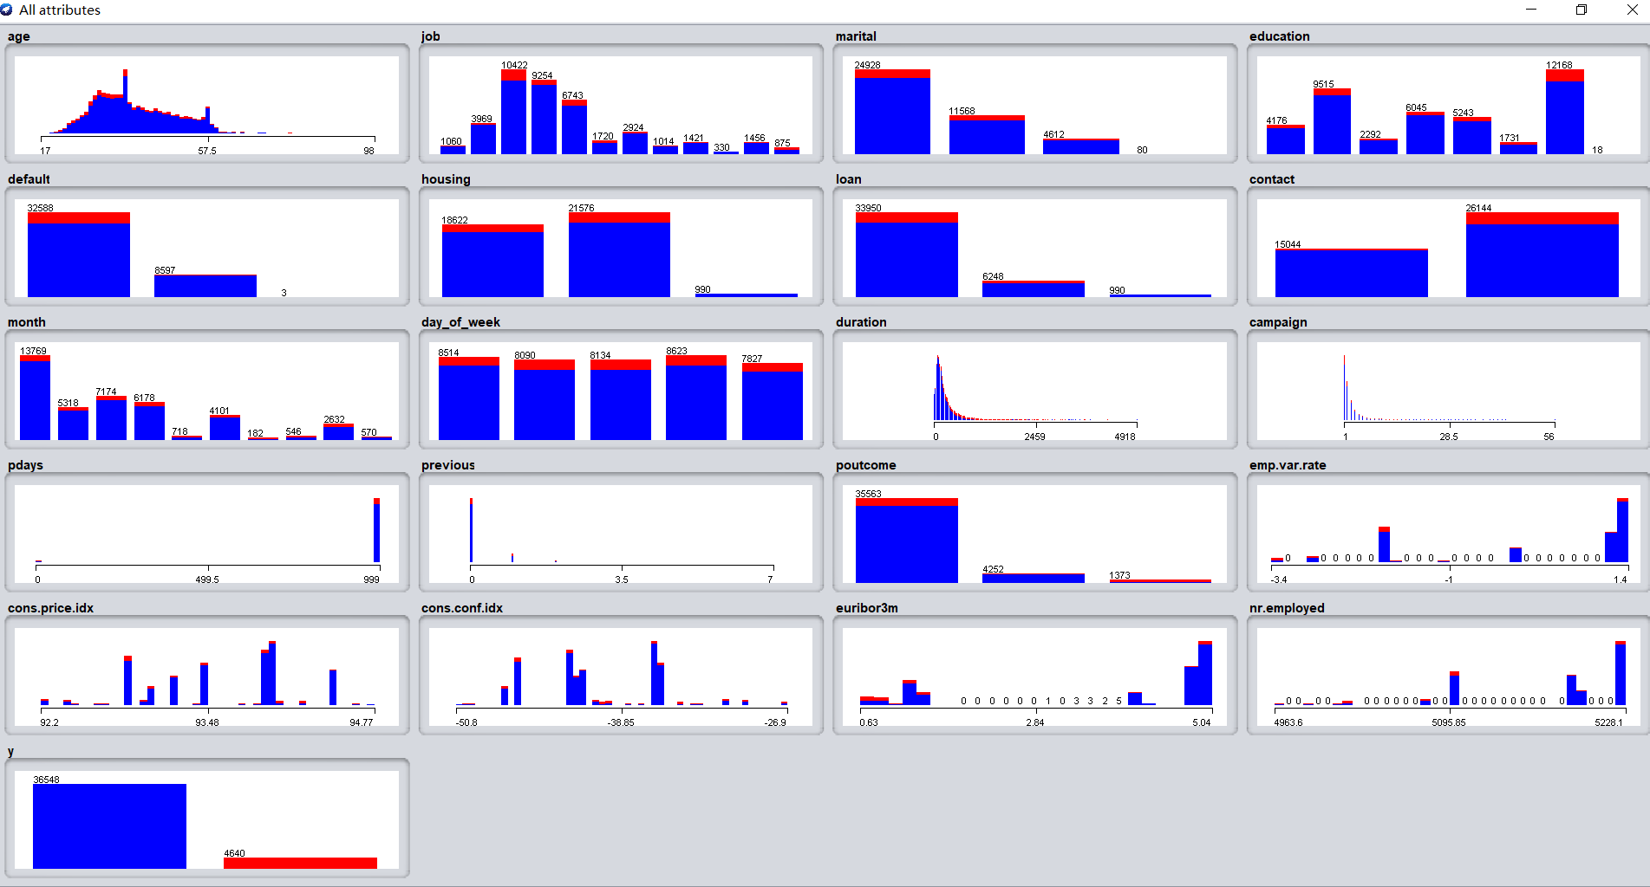
Fig. Initial visualisation of data

Build the Best Model
Because the purpose of this data mining is to predict whether the customer will order bank time deposits, that is, to determine whether the result of the output y is yes or no. Therefore, this is a study of result classification, and a good classification model needs to be established. First, use Cross-validation to classify and predict the data according to different classification methods, compare the classification results of different classification methods, and finally select the classification method with the best classification results. The results are shown in the following figures.
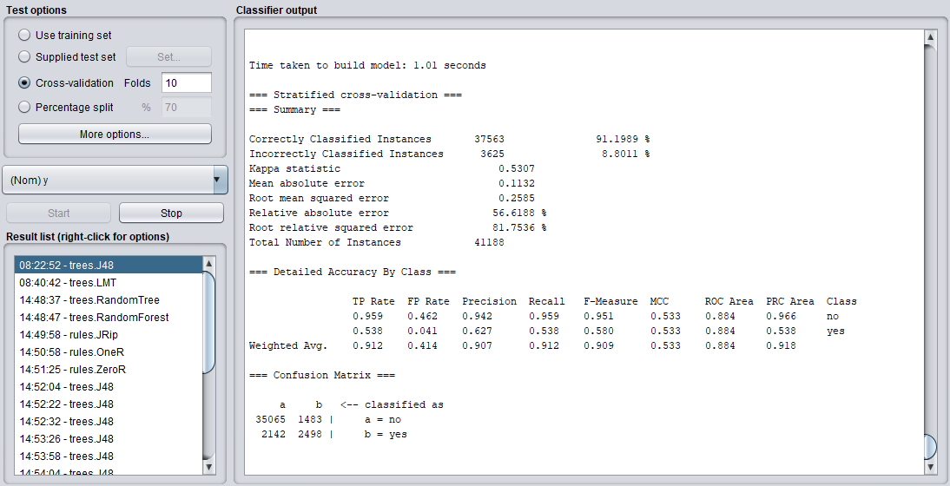
Fig. trees.J48
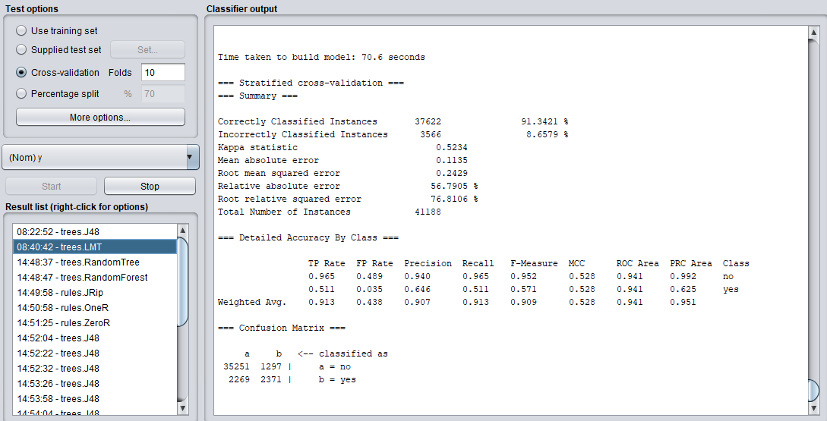
Fig. trees.LMT
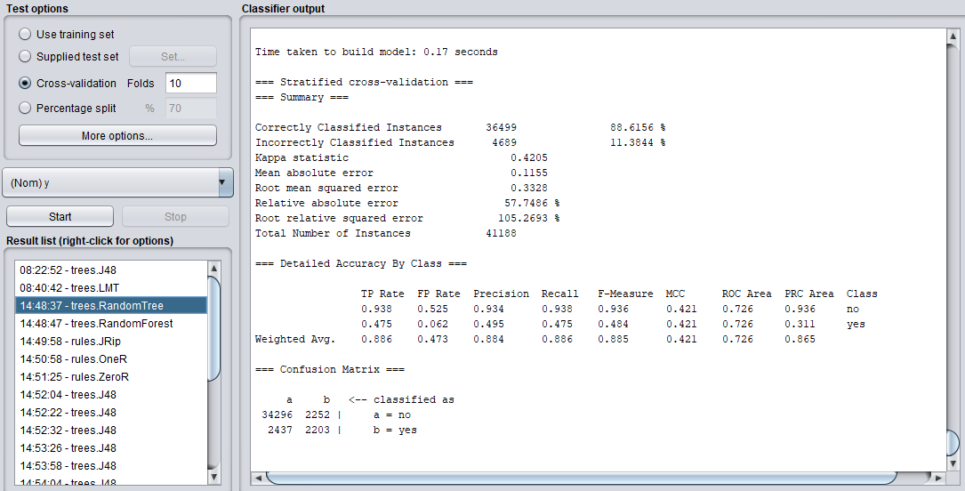
Fig. trees.RandomTree
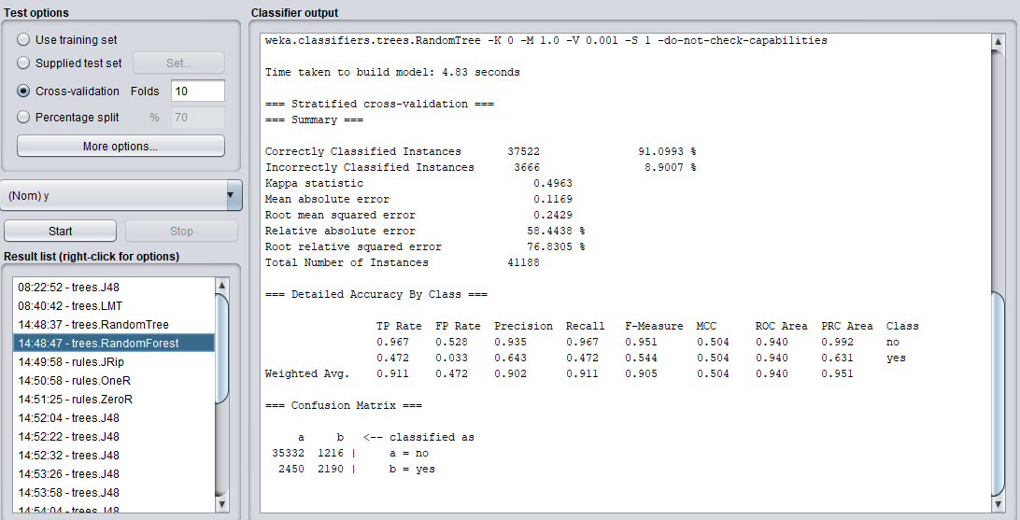
Fig. trees.RandomForest
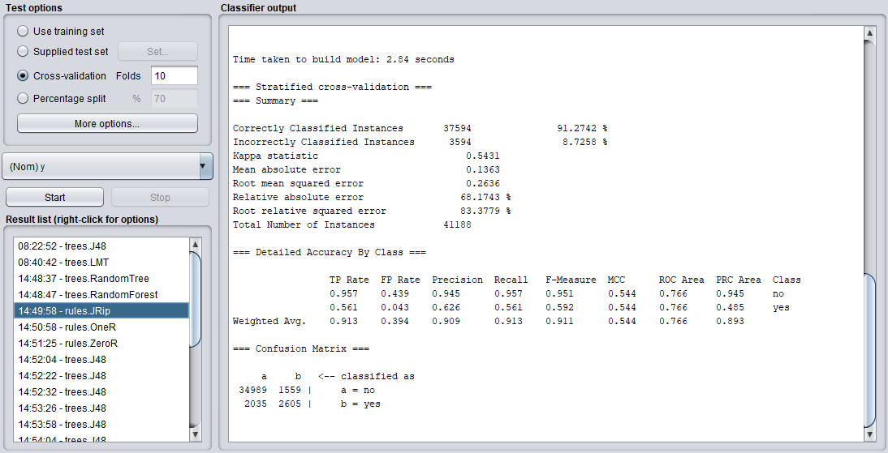
Fig. rules.JRip
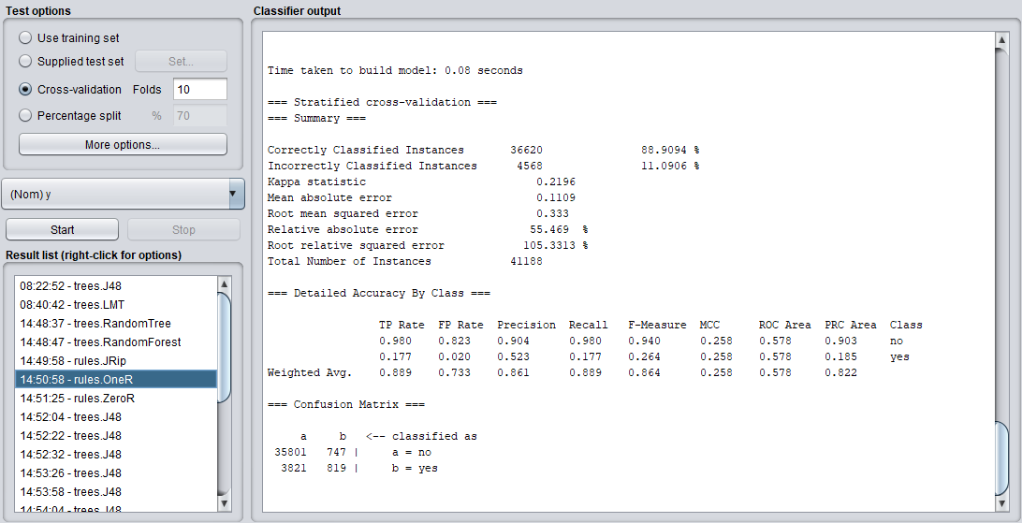
Fig. rules.OneR

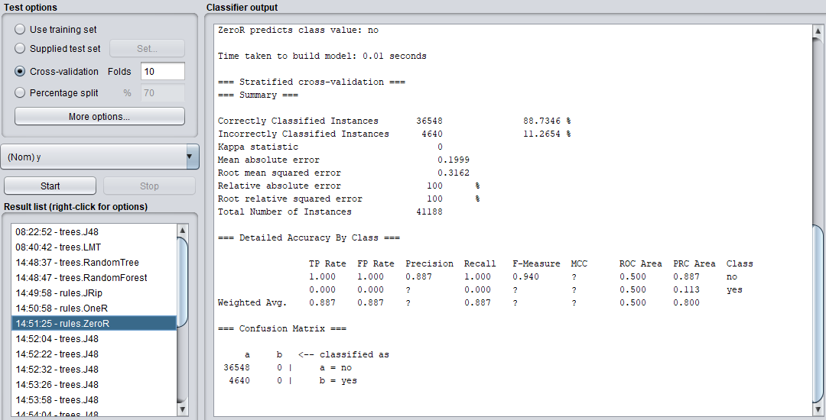
Fig. rules.ZeroR
Classification method | Classification error rate | Classification accuracy
trees.J48 | 8.8011% | 91.1989 %
trees.LMT | 8.6579 % | 91.3421 %
trees.RandomTree | 11.3844 % | 88.6156 %
trees.RandomForest | 8.9007 % | 91.0993 %
rules.JRip | 8.7258 % | 91.2742 %
rules.OneR | 11.0906 % | 88.9094 %
rules.ZeroR | 11.2654 % | 88.7346 %
It can be seen from the table that the best classification method is trees.LMT, and the classification accuracy rate reaches 91.3421%. However, this method takes the longest time in computing.Since the best classification method is selected trees.LMT. Use percentage splits of different percentages for trees.LMT to select the best classification model.
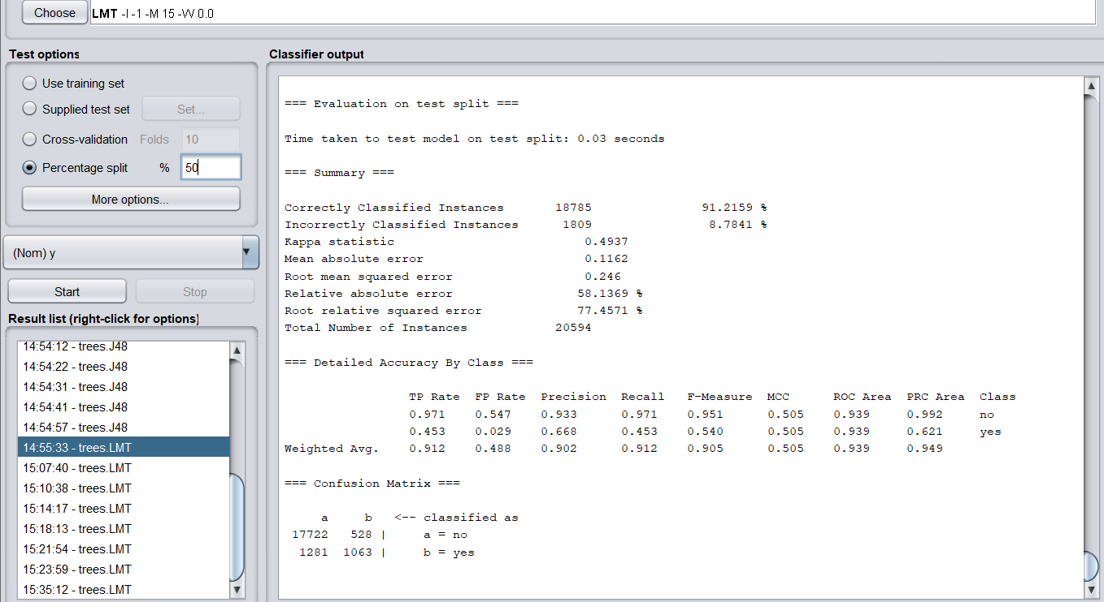
Fig. 50% percentage splits

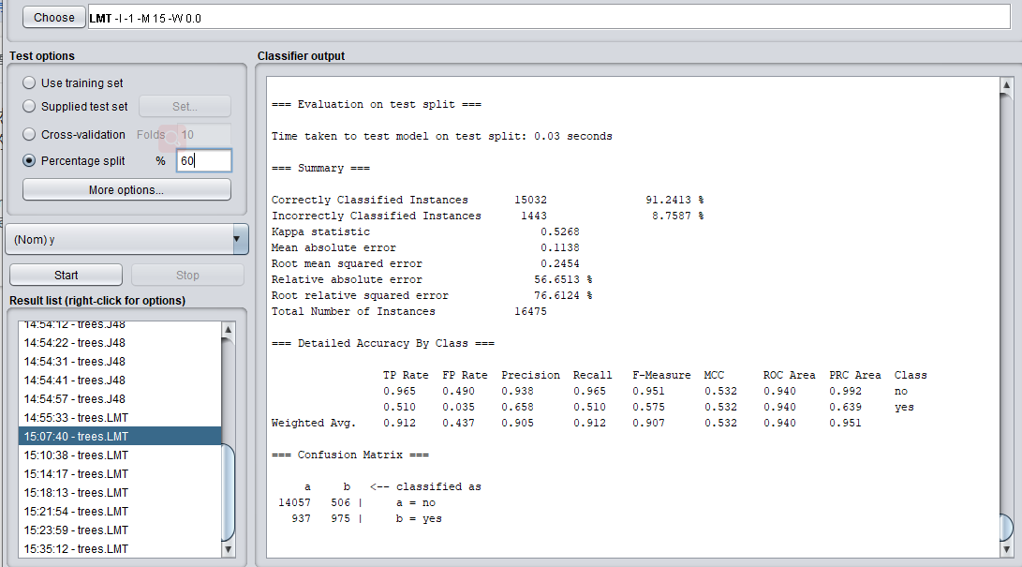
Fig. 60% percentage splits
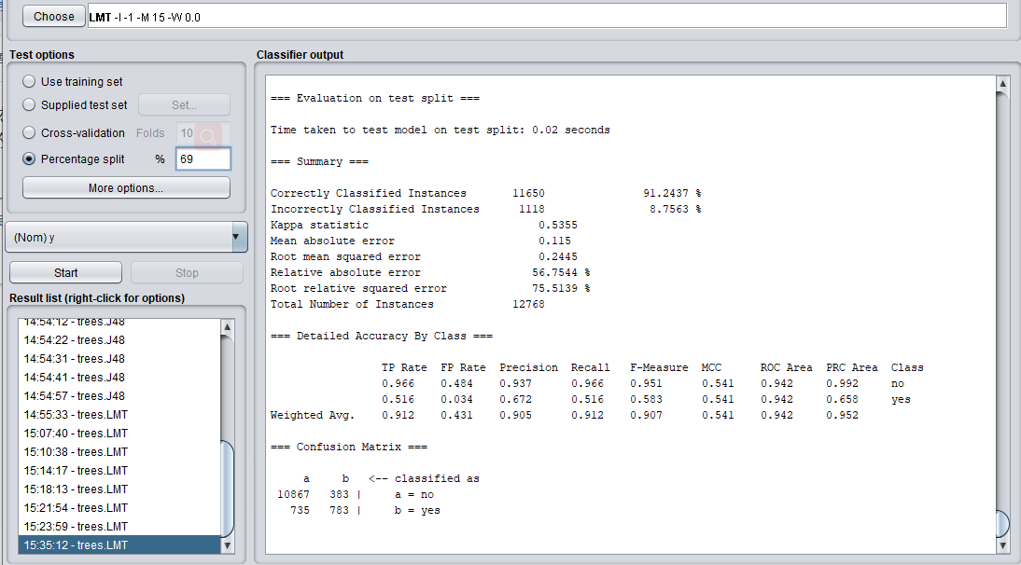
Fig. 69% percentage splits

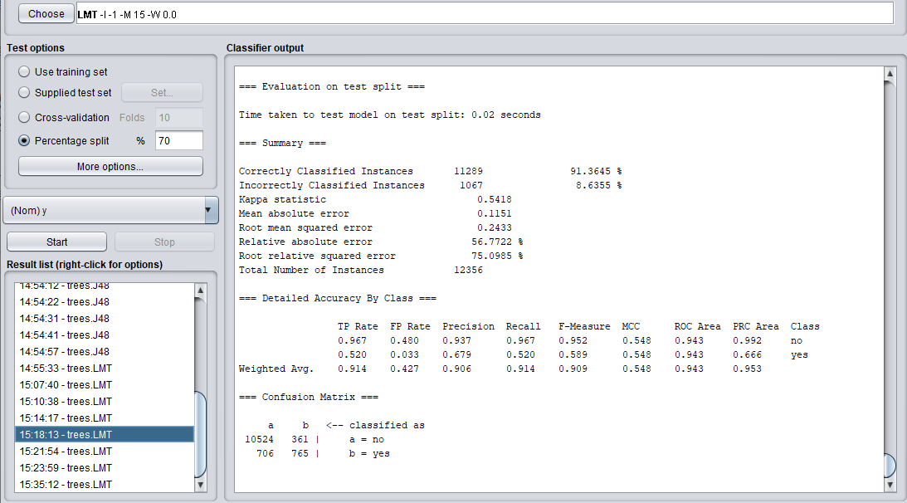
Fig. 70% percentage splits
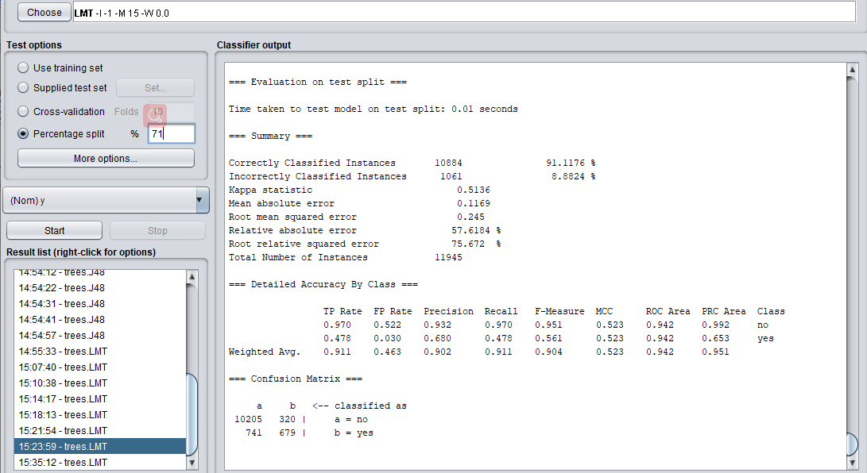
Fig. 71% percentage splits

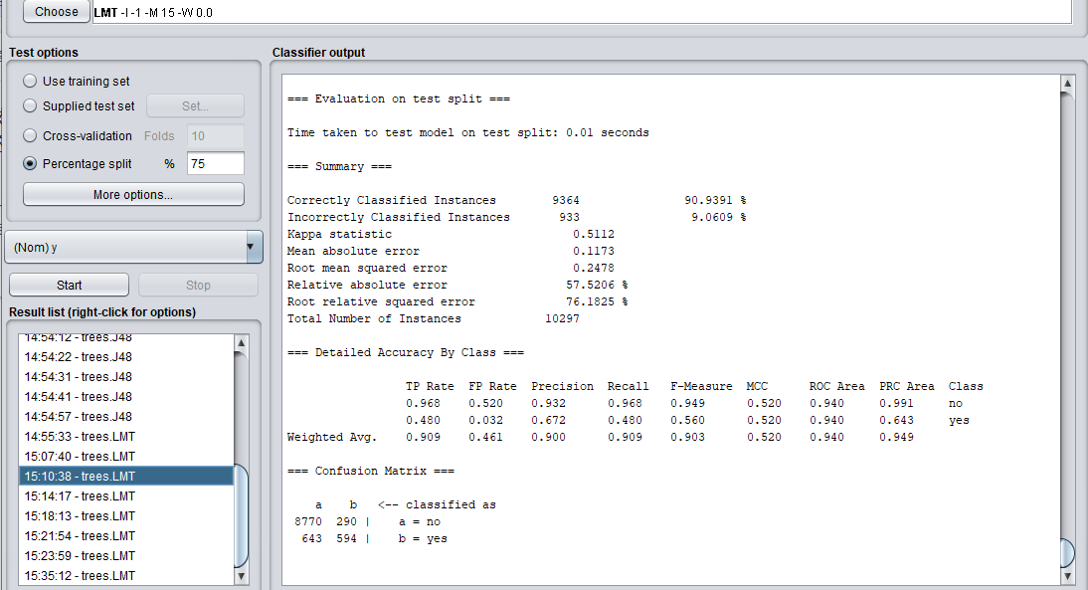
Fig. 75% percentage splits
Percentage splits | Classification error rate | Classification accuracy
50% | 8.7841% | 91.2159%
60% | 8.7587 % | 91.2413%
69% | 8.7563 % | 91.2437%
70% | 8.6355 % | 91.3645%
71% | 8.8824 % | 91.176 %
75% | 9.0609 % | 90.9391%
Table 2 Comparison of the classification results of trees.LMT with different percentages of Percentage splits
It can be seen from the table that the highest classification accuracy is the Percentage splits of 70%. In summary, the best classification model should be trees.LMT with 70% Percentage splits.

Potential Research Questions
The project aims to address the following five questions:
1) Can data mining techniques be used to automatically classify what attributes about bank client are more relevant to whether they subscribe to bank term deposit? And what kinds of attributes have little effect on determining whether a bank client subscribes to a bank term deposit?
2) Can we use data mining techniques to determine if bank staff contacts with clients and advertise to them the bank term deposit whether are effective for customers to subscribe to bank term deposit? If it is effective, how can contact with customers achieve the best results?
Can data mining techniques be used to determine whether bank staff are effective in making customers subscribe to bank term deposit when they contact with clients and advertise bank term deposit to them? If it is effective, how can contact with clients achieve the best results?
3) Is it possible to use data mining technology to distinguish the relationship between the social and economic background information of customers and whether they will subscribe to bank term deposit?
4) Among the 20 input feature attributes, is it possible to reliably distinguish which attributes have the greatest correlation with the output result y using data mining techniques?
5) In the end, can we use data mining technology to predict what kind of client groups the bank staff should target and how to contact them in order to obtain the largest bank term deposit subscriptions?

Data Analysis
Because the 20 input attributes of the selected data set are divided into four categories, namely: 1) bank client data; 2) related with the last contact of the current campaign; 3) social and economic context attributes; 4) other attributes. Therefore, first look at the impact of each category on the prediction results, and then look at the impact of each attribute in each category on the results. Finally, find the type of attribute set that has the greatest impact on the prediction result and the single attribute with the greatest impact.

Question 1
First, only the first type of attributes are retained. The following figure is a visual image of the first type of attributes.
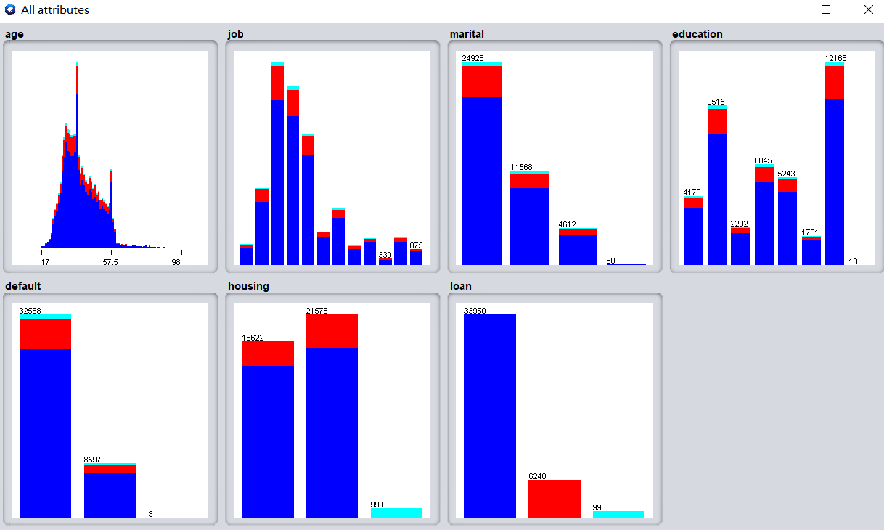
The following figure shows the classification prediction result when there is only the first type of image. The classification accuracy rate is only 84.7523%. The accuracy of the prediction result of only this type of attribute has dropped a lot, indicating that only this type of attribute is not enough.
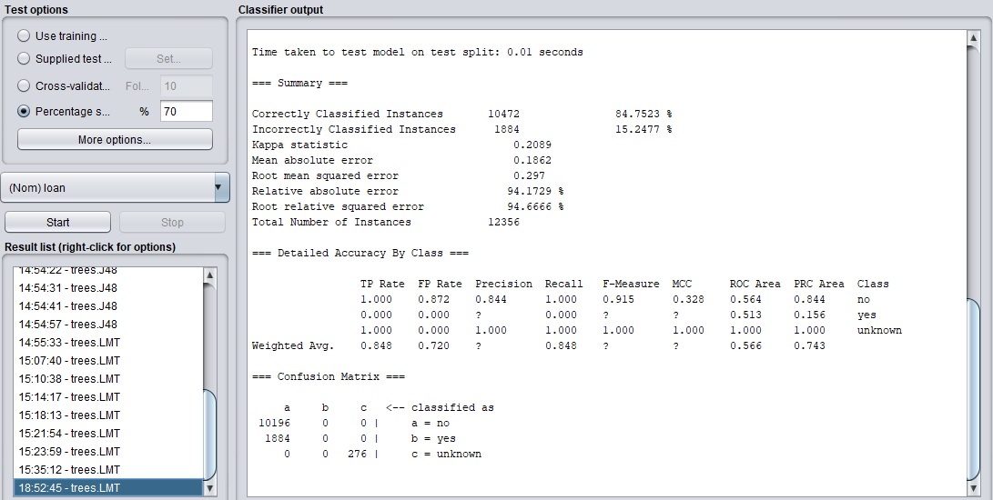
The figure below is a visualization of all the properties left after removing all the properties.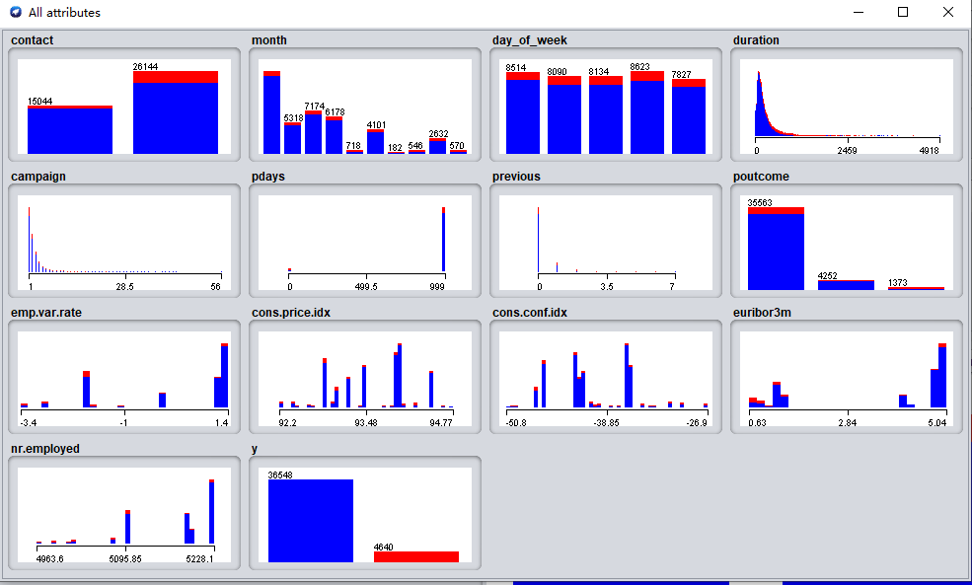
After the first category is removed, the data is classified and predicted, and the result is 91.4616%, which is not much lower than that without removing it. It fully shows that although the first category of attribute information has an impact on the prediction result, it has little effect.
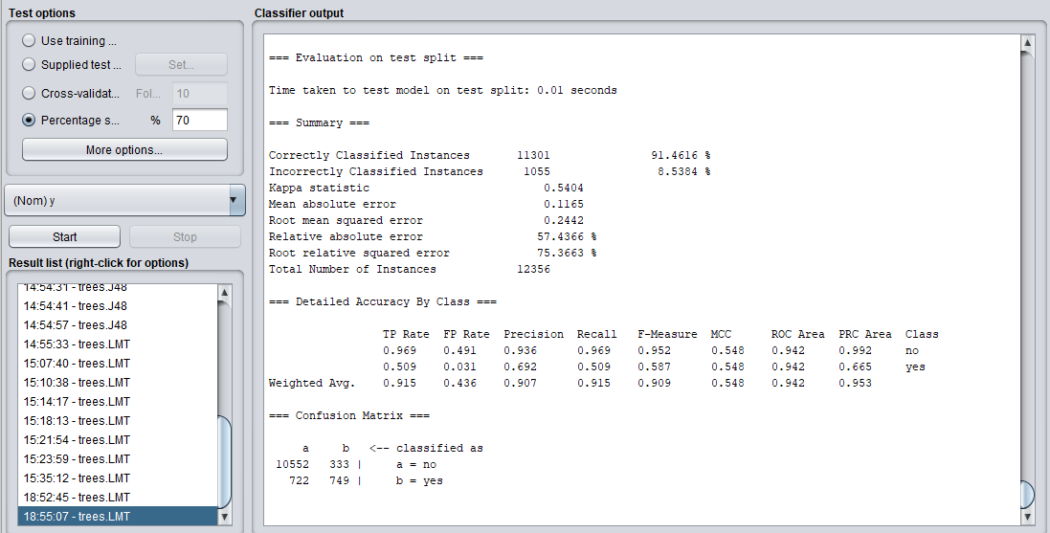
The following table is the prediction result obtained after removing each attribute in the first type of attribute in turn. It can be seen from the table that whether there is age has no effect on the forecast result. However, after removing the job, the forecast result has increased, indicating that the job has a greater influence on whether the customer orders bank products. It can also be seen that education has the same degree of influence as default, and housing and loan have the same degree of influence.

Missing attributes | Classification error rate | Classification accuracy
Age | 8.6355% | 91.3645 %
job | 8.4898 % | 91.5102 %
marital | 8.7083 % | 91.2917 %
education | 8.6112 % | 91.3888 %
default | 8.6112 % | 91.3888 %
housing | 8.6436 % | 91.3564 %
loan | 8.6436 % | 91.3564 %

Question 2
The following figure is the visual image after removing the second type of attributes.
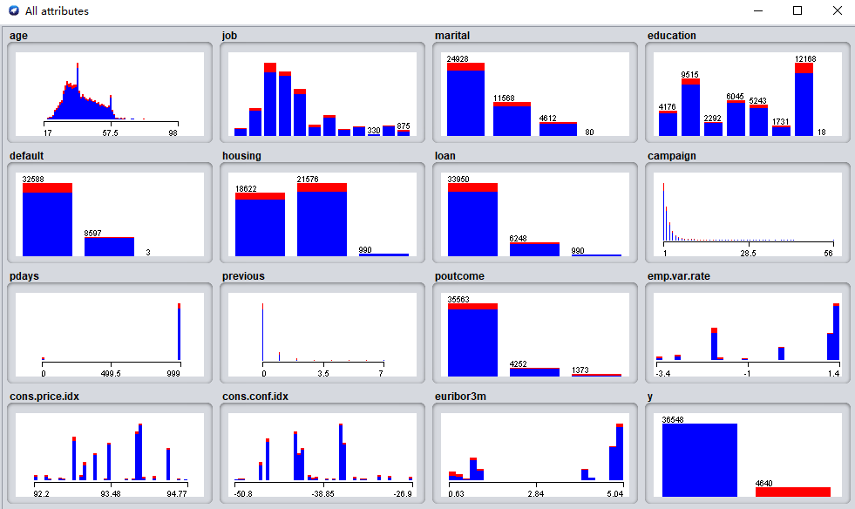
The following figure shows the classification prediction result after removing the second type of attributes. It is found that the classification accuracy rate has dropped significantly, indicating that the second type of attributes are very important to the prediction results.
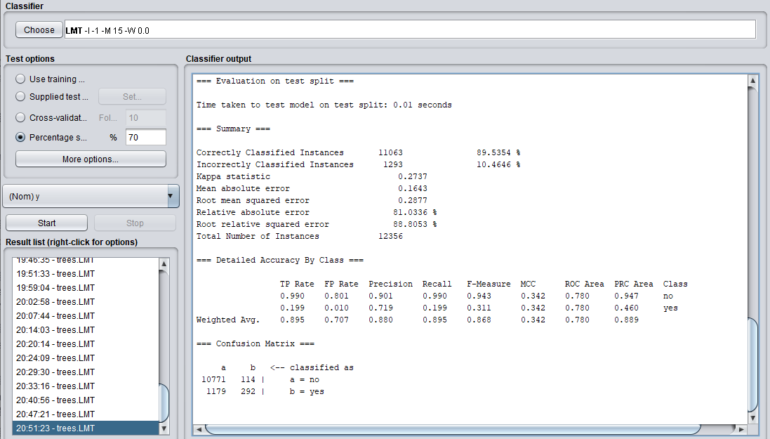
The following figure is a visual image with only the second type of attributes left.
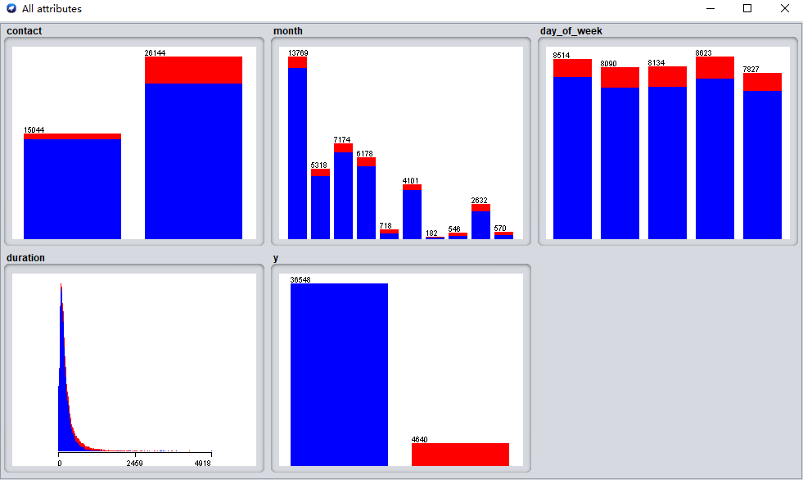
The following figure shows the classification prediction results with only the second type of attributes. It is found that the results have not changed much, so it further illustrates the importance of the second type of attributes to the prediction results. That is, the information of the last time the bank staff contacted the customer has a great influence on whether the customer ordered the bank product.
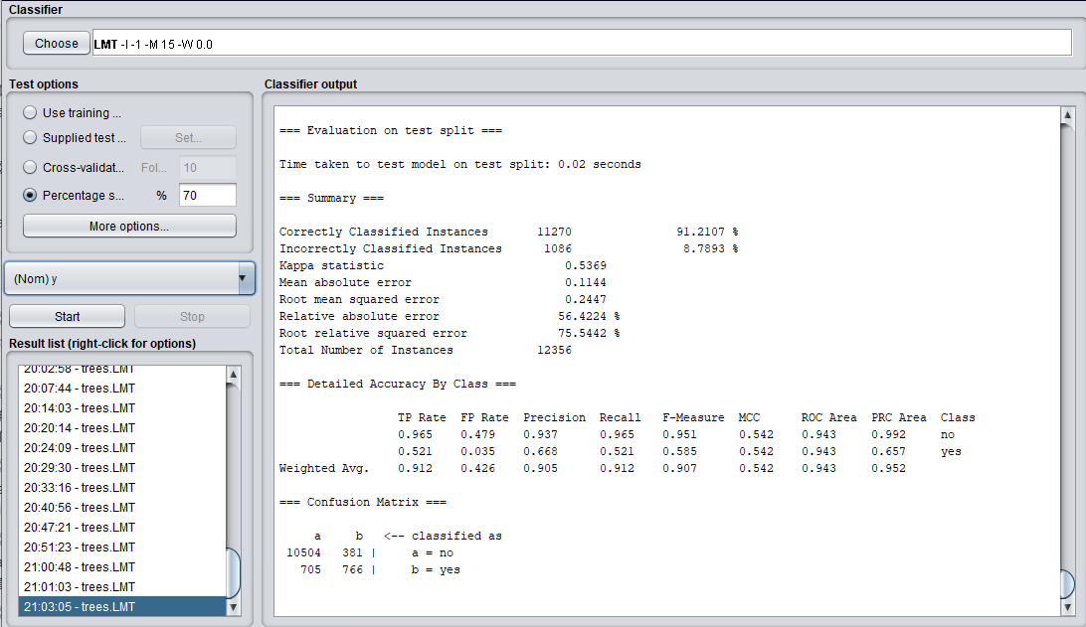
After removing each attribute in the second type of attributes in turn, the prediction results obtained are as shown in the following figure. From the figure, it can be seen that each attribute in the second type of attributes has a certain impact on the prediction results, especially the attribute of duration. The forecast results have a great impact, indicating that the duration of the last contact between the bank staff and the customer is particularly important to whether the customer orders bank products. In summary, it can be seen that bank staff should often contact customers by telephone, and pay particular attention to the quality and duration of the last contact with customers.
Missing attributes | Classification error rate | Classification accuracy
contact | 8.6112 % | 91.3888 %
month | 9.1777 % | 90.8223 % %
day_of_week | 11.3844 % | 91.2107 %
duration | 10.3189 % | 89.6811 %

Question 3
The figure below is the visualized image after removing only the third type of attributes.
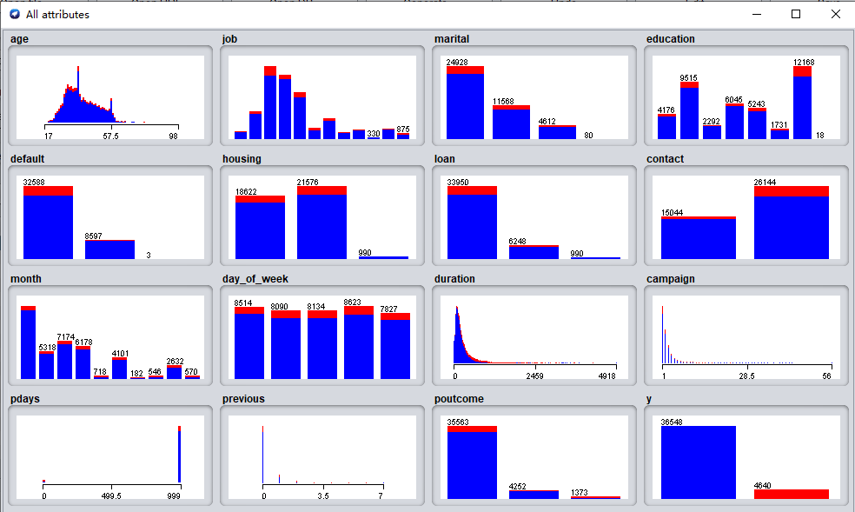
The following figure shows the classification prediction result after removing the third type of attributes. The accuracy rate is 90.6118%, which is still a drop, but the drop is not very large, indicating that although the social and economic context of the customer has an impact on the result, it has little effect.
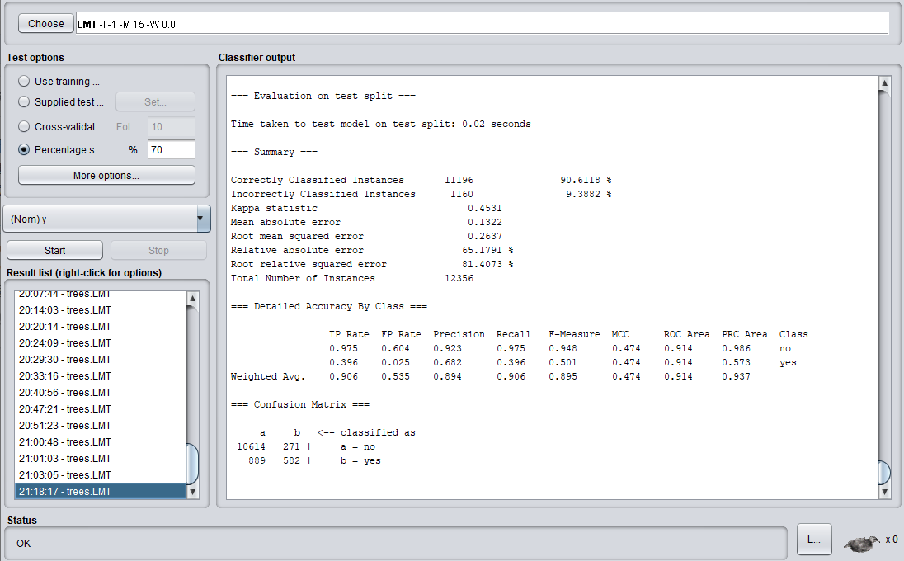
The following figure is the visualization image after only the third type of attributes are left.

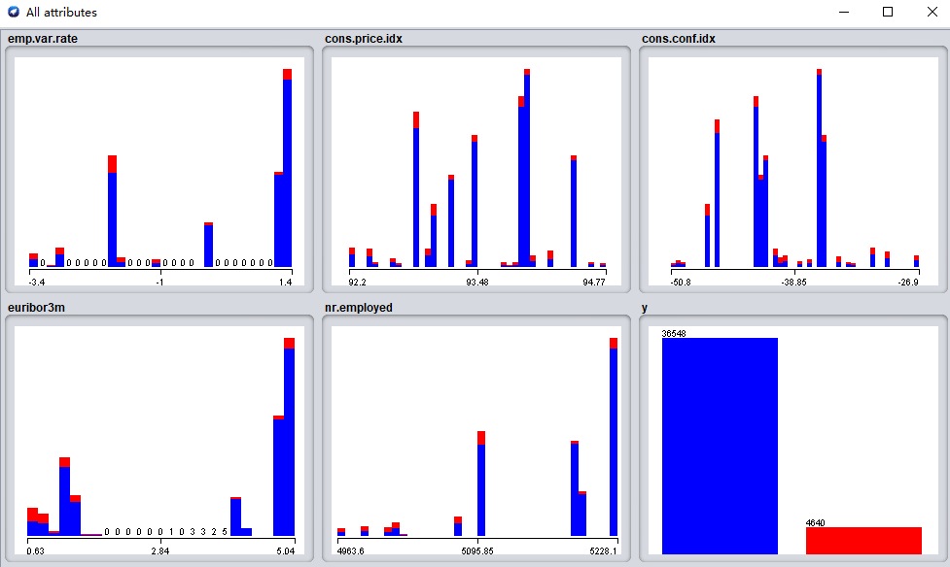
The following figure shows the classification prediction results with only the third type of attributes. The classification results have dropped significantly, indicating that only the third type of attributes can predict the results to a certain extent, but the accuracy rate is not very high.
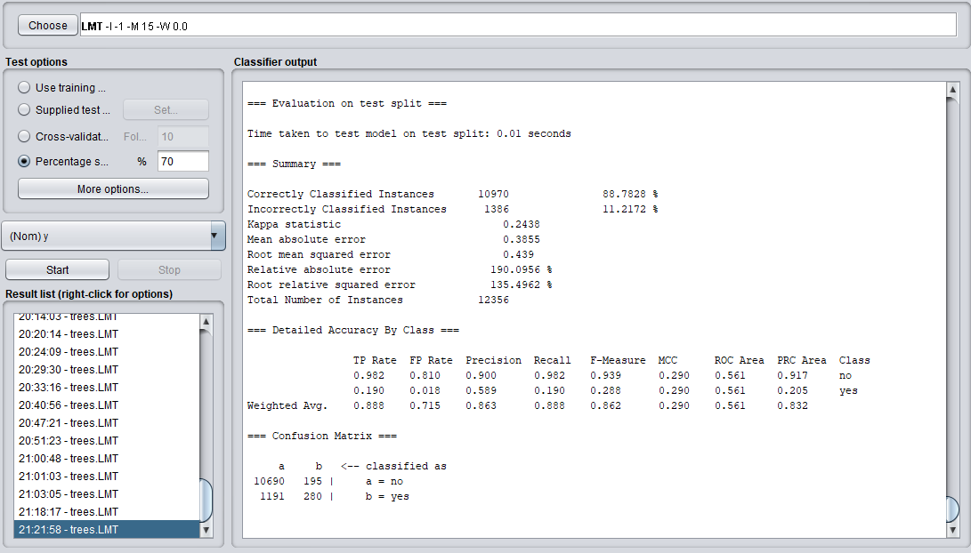
The following table is the classification prediction result after removing one attribute in the third type of attribute.It can be seen from the table that each attribute in the social and economic context attributes has a certain impact on the prediction results, but the impact is not large. Among them, consumer confidence index and number of employees have a greater impact on the results. Therefore, the social and economic context information of customers still has a certain impact on whether they order bank products.

Missing attributes | Classification error rate | Classification accuracy
emp.var.rate | 8.7245 % | 91.2755 %
cons.price.idx | 8.6436 % | 91.3564 %
cons.conf.idx | 8.7731 % | 91.2269 %
euribor3m | 8.6517 % | 91.3483 %
nr.employed | 8.7893 % | 91.2107 %

Question 4
The following table shows the classification prediction results after removing one attribute in the fourth category.
Missing attributes | Classification error rate | Classification accuracy
campaign | 8.6598 % | 91.3402 %
pdays | 8.9997 % | 91.0003 %
previous | 8.6031 % | 91.3969 %
poutcome | 8.6355 % | 91.3645 %
Combining the prediction results obtained by removing one attribute from the 20 input attributes in turn, it can be seen that the result after removing the attribute duration is 89.6811%, which is the lowest among all the prediction results.
The reason is because this attribute highly affects the output target (eg, if duration=0 then y='no'). Yet, the duration is not known before a call is performed. Also, after the end of the call y is obviously known It also shows the need to attach great importance to the contact between bank staff and customers and the duration of the last contact with the customer. Only by contacting more customers can it be possible for customers to order as many bank products as possible.

Question 5
It can be seen from the figure below that people with high school and university degrees are more likely to buy regular bank products.
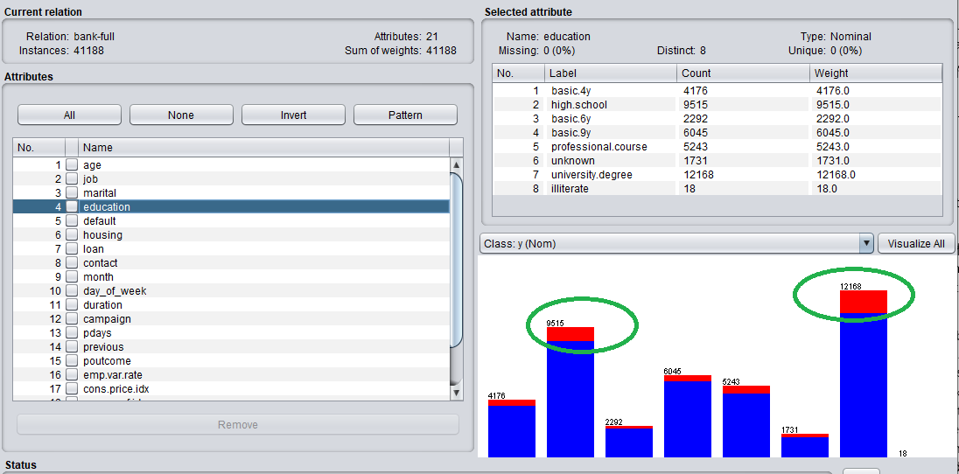
It can be seen from the figure below that people who have no default credit are more likely to buy regular bank products.
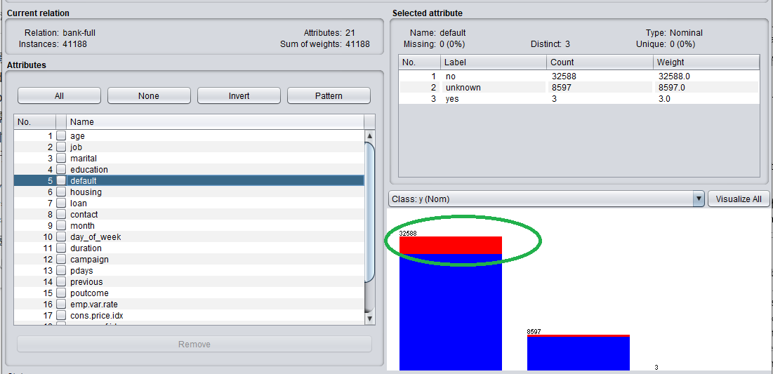
It can be seen from the figure below that contact with customers via cellular is more likely to allow customers to purchase regular bank products.
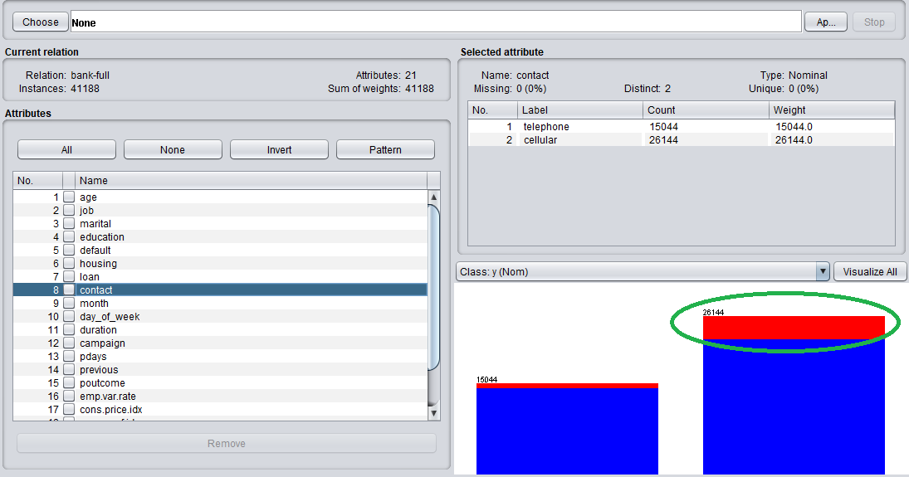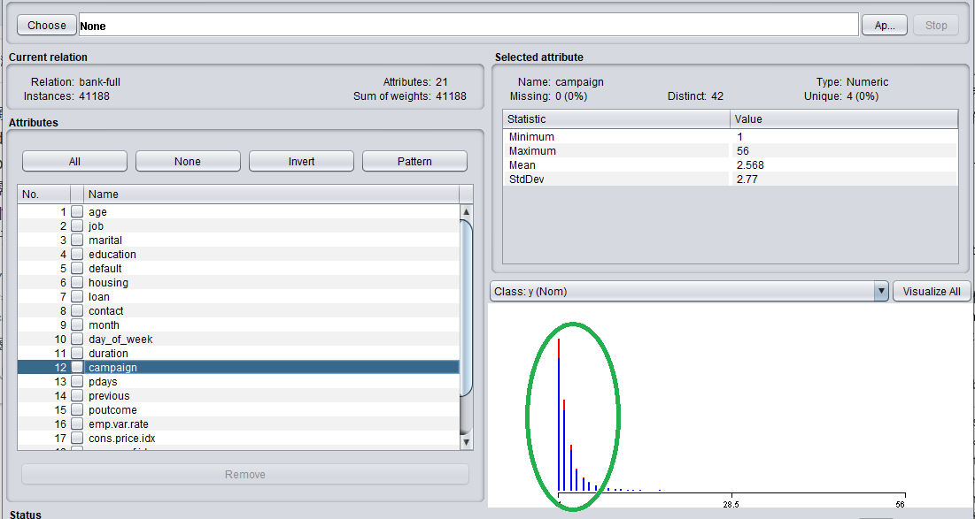
It can be seen from the figure below that customers aged 25-40 are more likely to purchase regular bank products.
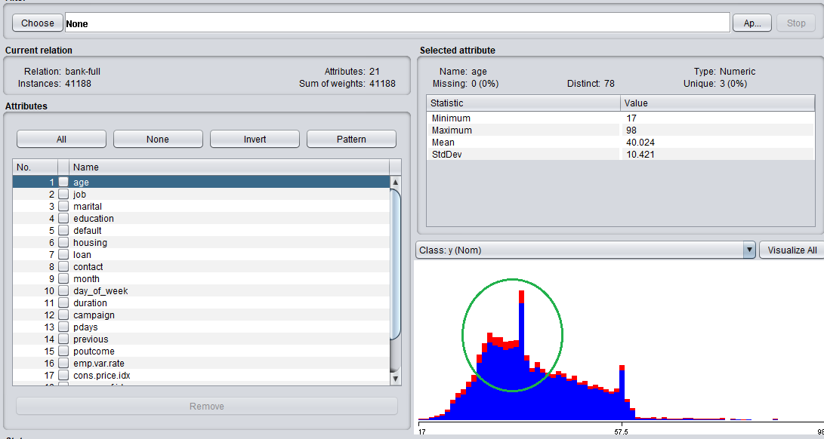
It can be seen from the figure below that contact with customers in May is more likely to allow customers to purchase regular bank products.
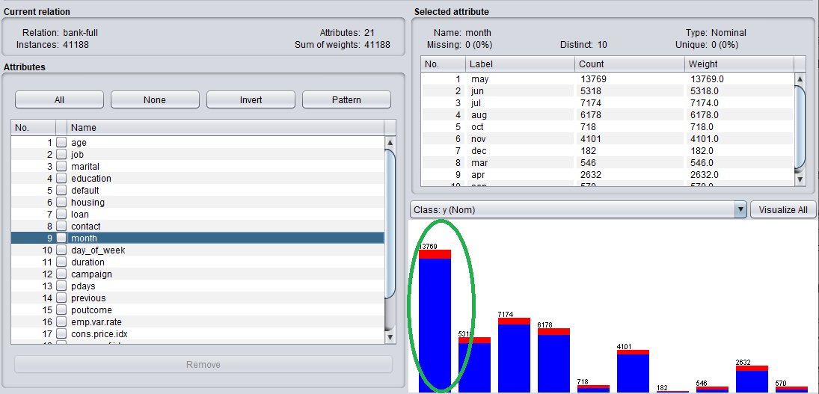
It can be seen from the figure below that married and single customers are more likely to purchase regular bank products.
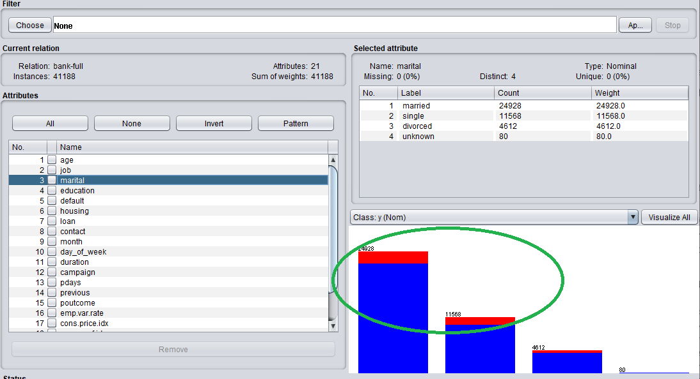
It can be seen from the figure below that people who do not have loans are more likely to purchase bank term products.
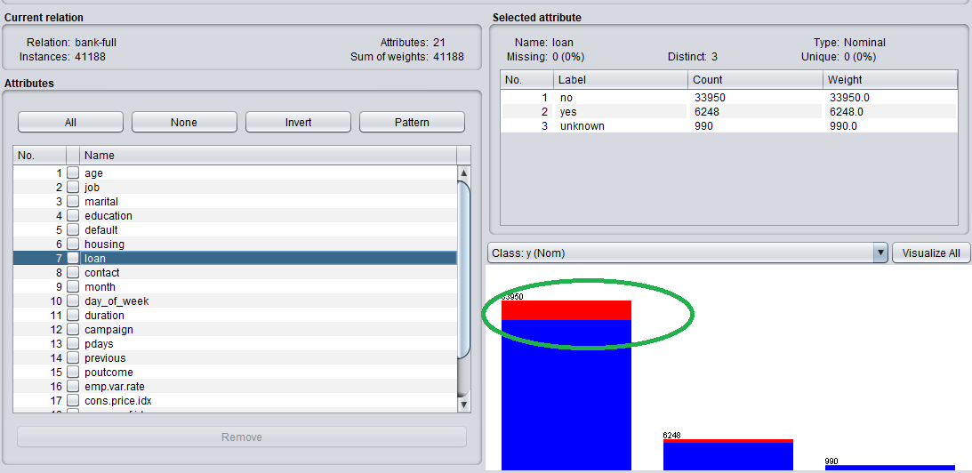

It can be seen from the figure below that managers, blue-collar workers and other workers are more likely to purchase regular bank products.
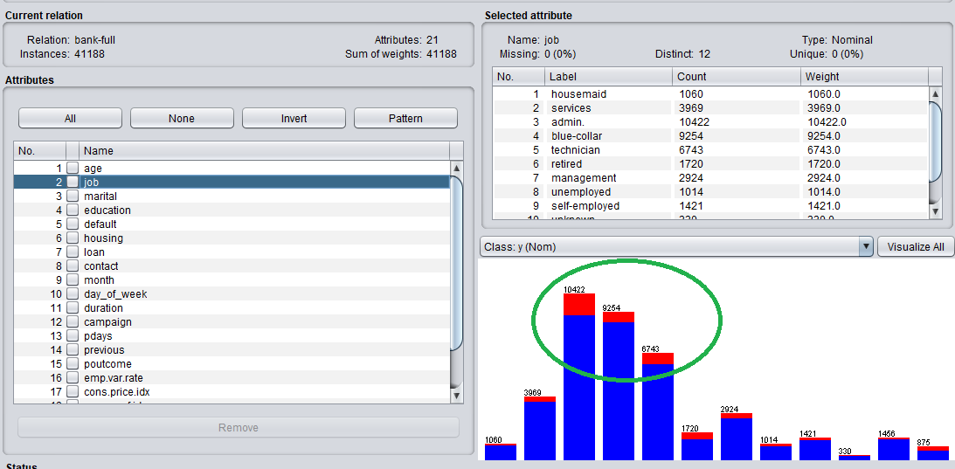
Based on the previous four questions and the above analysis, it can be seen that managers or blue-collar managers who have a high school or university degree, have no credit default, have no loans, are middle-aged, are married or are single, or blue-collar are most likely to purchase bank fixed-term products, so bank staff You should contact them more by cellular means around May, so as to get more regular product orders from the bank.

Reflection
I think the previous part of my task was done smoothly, mainly because my data was too complete. Not only did it have no missing values, but all the attributes were preserved through screening, so this is a complete refinement just right. The data set basically has no attributes that need to be added or deleted. Now I think that if I choose again, I will choose a not-so-good data set, which can increase my workload and learn more in practice.
I think the more difficult task in the process of completing the task is the understanding of each classification method and the familiar use of weka. So far, my use of weka is just a simple selection of classification methods to classify and predict the data set. Increase the degree of prediction after deleting attributes. If you have more time, you must study weka more deeply, and then use more sophisticated and complex methods to mine and analyze the data. Due to the constraints of time and article workload, a lot of my work has not gone deep into it. For example, you can try to delete one or several classification options of certain attributes, so as to gain insight into those values ​​of each attribute that have a greater impact on the results.
The surprise in this task is that the predicted result is still similar to reality, such as high school or college degree, no credit default, no loan, middle-aged, married or single managers, or blue-collar managers are most likely to buy Bank regular products. It shows that using such a method for data mining is useful and consistent with reality. If it is used in real life, it will definitely have guiding significance for people's production and life.
I have benefited a lot from this course. I also learned a lot in this task, which has increased my practical ability. In the future study and research, I know how to process multiple data sets and know what methods to use to analyze and mine. , Visualize data, and more importantly, be familiar with the data mining analysis software weka to a certain extent. Finally, thank you teacher Nik for your patient teaching.

References
[1] Liu Yu, Ni Wenyin. Twenty Years of Chinese Internet Culture Development (1994-2014), Network Technology Edition: Hunan University Press, 2014.11.
[2] Yu, Changhui. Research on emergency logistics decision support system design under data ming &WebGIS technology. Proceedings: 2016 International Conference on Intelligent Transportation, Big Data and Smart City, ICITBS 2016, p 375-378, September 19, 2017.
[3] Yang Liangbin. Information analysis method and practice: Northeast Normal University Press, 2017.01.
[4] Zhang Zenglian. Research on financial analysis, evaluation and management of colleges and universities based on non-profit, data mining and scientific management: Capital University of Economics and Business Press, 2014.05.
[5] https://archive.ics.uci.edu/ml/index.php

