International Financial Management
LCBB6002
Module Lead: Dr Yousuf Kamal
Module Lecturer: Dr Mudassar Hassan

Student Name:Cristian Sirota
Student Id:2130222

Introduction:
Corporate governance consists of mechanisms that regulate a firm from being managed and operated and an essential aspect of managing the relationships as well as the responsibilities between a company and its shareholder and other stakeholders. This report aims to establish the fact that good governance is a key determinant of investor confidence, performance and risk management in Unilever. Apart from these governance standards, organizations and the markets’ performance ratios are the other essential factors to determine the health of the organizations. From the calculation of the various operating profit margin, net margin, asset turnover, liquidity ratio or other ratios it is possible to learn about the efficiency of the company or its profitability.
Importance of corporate governance practices:
Measures of governance relate to the efficiency of a company’s management of its corporate structures, policies, and disclosures. These are important in assessing how efficiently a firm is managed and more so to see whether it is running with shareholders and stakeholders’ interest. The most common factors are discussed below:
Board Composition: Unilever maintains a good combination of Executive and Non Executive directors understandings in order to oversee its operations. It is important for the reasons of impartiality to ensure that an entity is independent (Barr, 2020).
Executive Compensation: Unilever has a good-governance policy in place which associates reward with sustainable shareholder value by avoiding an unnecessary level of risk-taking.
Shareholder Rights: Unilever has a good corporate governance structure where shareholders’ management decisions affect key issues including the election of directors, acquisition, and the remuneration of directors (Bui, 2019).
Audit and Risk Management: Independent auditing and transparent financial reporting practices adopted by Unilever are no more than ‘best practice’, they are major values where credibility and responsibility are paramount.
Transparency and Disclosure: Good governance at Unilever makes it possible for the company to disclose relevant information to users on its performance; financial and non-financial information, including the ESG information (Meghan, 2024).
Corporate Social Responsibility (CSR): CSR is also a factor of good governance and it becomes part of strategy since it factors in the environment. Unilever is a responsible corporate citizen and has proper policies in place including environmental protection mechanisms.
Corporate governance variables identified:
Board Structure: Unilever appreciates the board of directors with a clear focus on diverseness and independency, and with representatives of the executive and non-executive directors. The company also has a diverse board in regard to gender, knowledge, and origin so that good decisions are made (Gordini, 2018).
Sustainability and CSR: For Unilever sustainability is part of its governance structure. It builds a culture of employing ethical procedures acceptable for society and makes long-term investments which will generate more shareholder value looking for environmental and social challenges.
Risk and Audit Management: One way in which Unilever lays emphasis on its sound financial control and risk management is by subjecting its financial statement to external auditors.
Shareholder Engagement: The company continues to have sound shareholders’ protection; it allows shareholders to have a say on important matters such as decision on governance and pay of executives.
Executive Compensation: They have correlated remunerations with performance objectives to support the permanent strategies consistent with operational goals as the company’s executive remuneration policy integrates strategic performance metrics that concern expansion, sustainability and shareholder returns (Annual report 2023).
Relationship between corporate governance practices and financial performance:
Current Ratio:
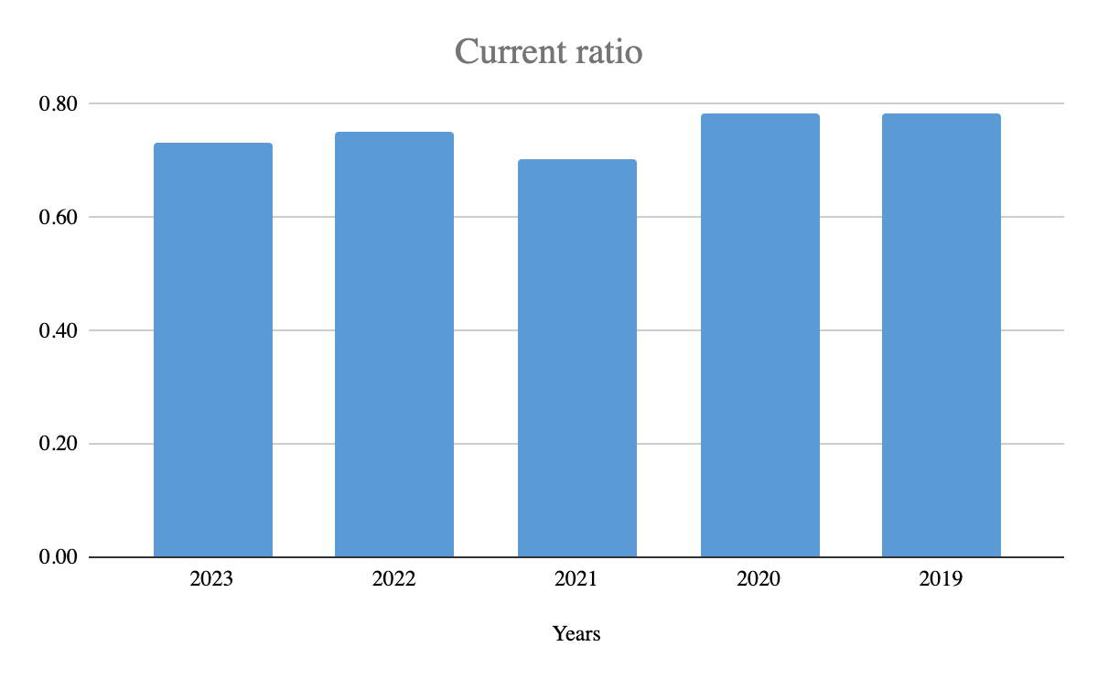
The analysis of the current ratio for years 2019 to 2023 indicates that Unilever had a relatively cyclical current liquidity ratio that ranges from 0.70 to 0.78. These ratios raise questions on the liquidity of the company and are not parallel with the corporate governance of the company.
The current ratio recorded in 2019 and 2020 was 0.78 which presents a somewhat stable liquidity position for Unilever. Nonetheless, there was a steady slippage in 2021, which presented a current ratio of 0.70 indicating a slightly worsened status of Unilever’s liquidity status.
Hence, the marginally even better figure in 2018 to 0.75 in 2022 indicates that Unilever had begun measures to enhance its liquidity, through maybe more efficient working cycles or less use of short-term debts (Girardin, 2022).
Quick ratio:
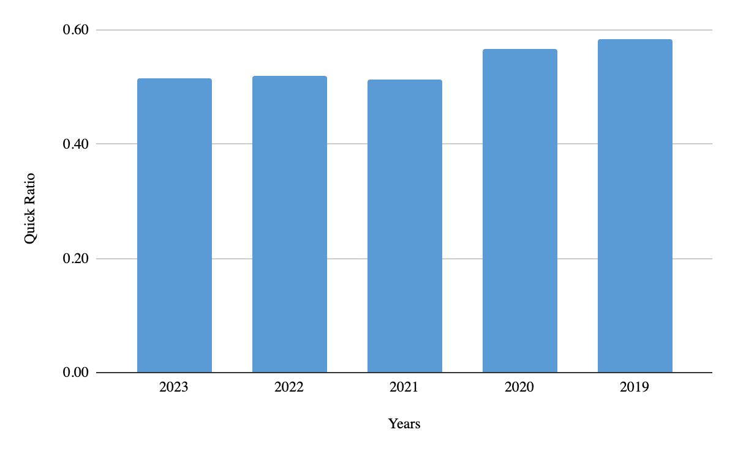
For the Unilever company, the quick ratio has been below 1.0 between 2019 and 2023, being from 0.51 to 0.58, which means that the company has inadequate quick assets to cover its current liabilities.
For 2019 and 2020, Unilever’s quick ratio was 0.58 and 0.57 respectively which indicated a rather stable ability to meet the short term obligations without relying on inventory. It is possible that the company was in a good cash position, and effectively handling its receivables during this period. Nonetheless, a decrease of quick ratio to 0.51 in 2021 means that there is a slight reduction in absolute liquidity of the company. For 2022 and 2023, it remained on the same level by showing a ratio of 0.52 and 0.51 for quick ratio of the company. The above ratio shows lack of performance on the risk management aspect of corporate governance as low ratios pose risk of failure of paying current liabilities (Beaver, 2022).
Debt ratio:
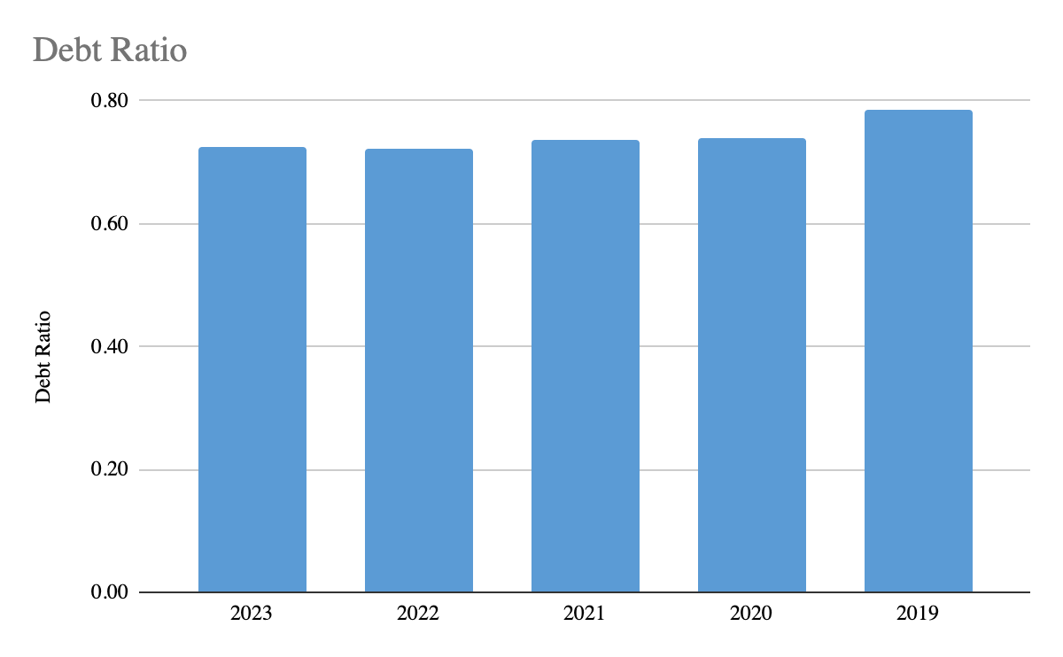
Unilever’s debt ratio, indicates its debt position from 2019 to 2023 and it hovers around 0.72 to 0.79. The debt ratio in the year 2019 was 0.79 which means that about 79% of the company’s assets were financed through liabilities. This comparatively high figure raises doubts about the company’s reliance on credit – combining debt financing in particular, puts the firm in a higher risk of financial risk. Still, over the subsequent years, the debt ratio diminished to 0.74 in 2020 and 2021 and to 0.72 in 2022 and 2023. High debt ratio indicates that there is no proper risk management in the company and needs improvement (‌Forage, 2023).
Interest coverage ratio:
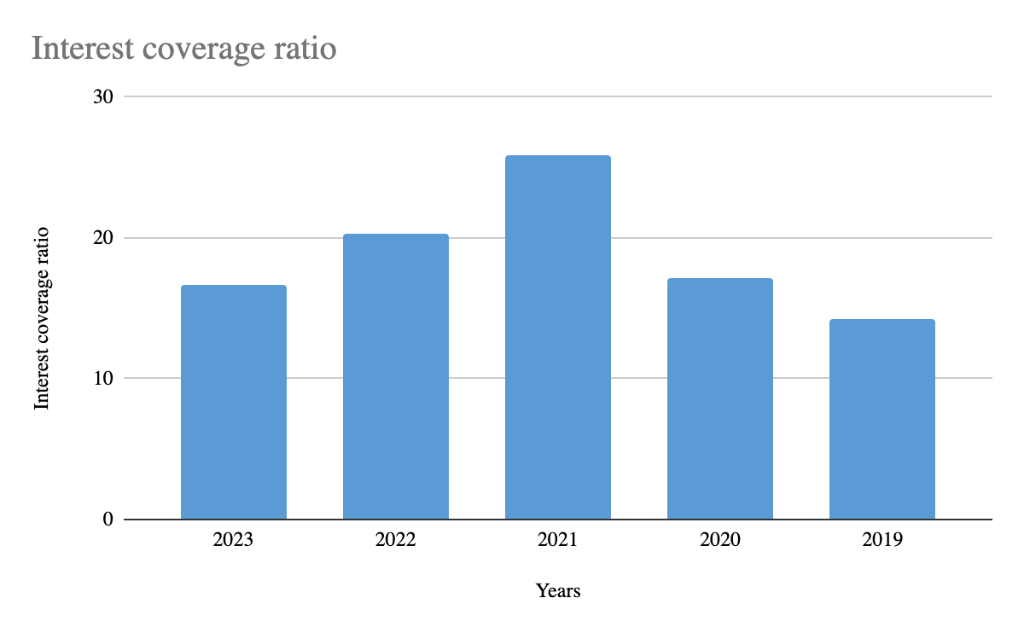
The interest coverage ratio shows Unilever has a strong position in meeting interest expenses based on earnings before interest taxes (EBIT) over the periods 2019 to 2023. For 2019 the rate came to 14 which means that Unilever could make 14 times interest payments using its operating income. This ratio has risen slightly in 2020 to the level of 17 making it easier to meet its interest obligation most probably due to increased profitability or lower interest rates (Finserv, 2023).
It was noted that in 2021, the interest coverage ratio was 26 and the increase in the ratio emphasizes that Unilever can easily pay interest payments and it is a good indicator in favor of good corporate governance practices adopted by the company.
Asset turnover:
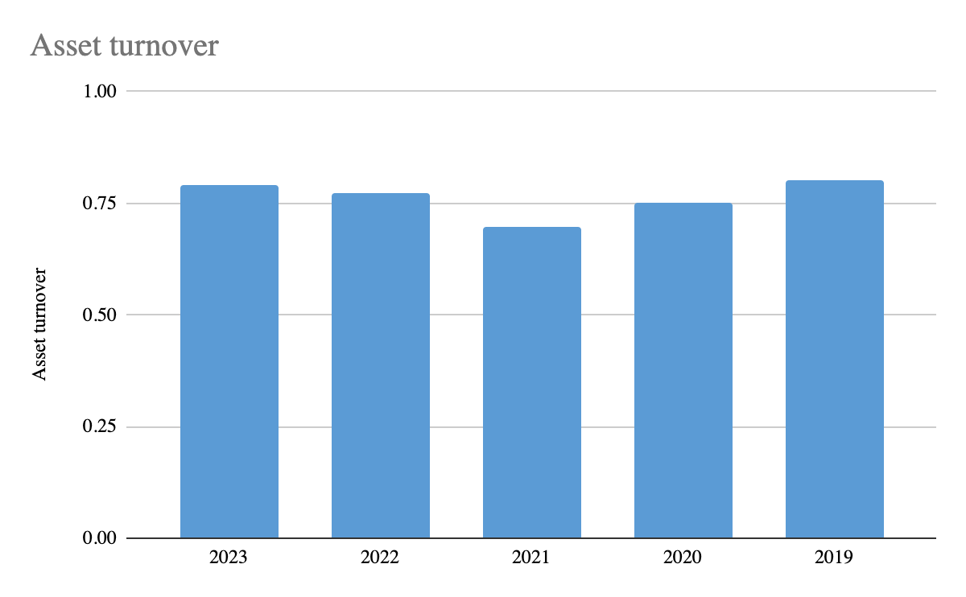
The details derived from Unilever’s accounting records proved that asset turnover ratio increased between 2019 to 2023. For asset turnover in 2019, it stands at 0.80 thereby showing that efficiency in utilizing the assets to generate sales as each dollar of asset was capable of generating $0.80 of sales. The ratio was slightly down in 2020 at 0.75 which shows that the pandemic year affected the overall sales yield/turnover compared to the asset base of the company.
In 2021 the asset turnover ratio decreases to 0.70 indicating further decline meaning that the company is slowing down in its ability to sell its assets. The methods and ratio are as follows: But in the year, 2022 Unilever started improving and shows good corporate governance.
Receivable ratio:
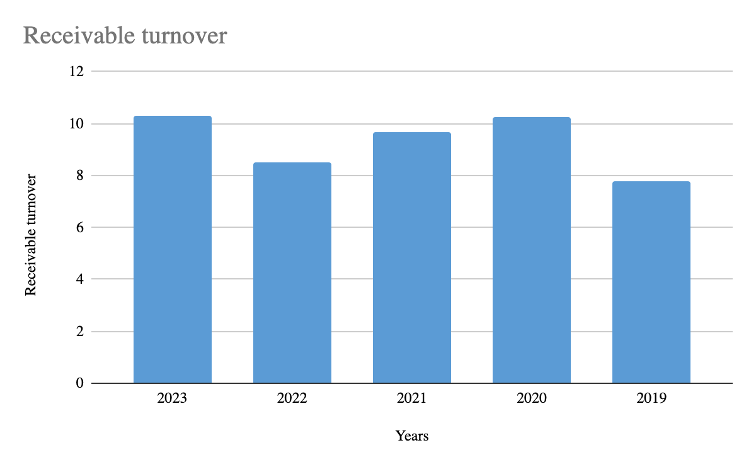
Throughout the 2019-2023 period with the accounts receivable turnover ratio varying between 8 and 10. From the balance sheet we can see that the receivable turnover was 8 in 2019, meaning that Unilever collected its receivables eight times in the year.
In 2020 it rose to 10 showing increased efficiency in recovering our due amounts perhaps due to tight credit standards or good cash flows. This indicates improvement in corporate governance and healthy initiative towards increasing liquidity (Sarah, 2024).
Operating profit ratio:
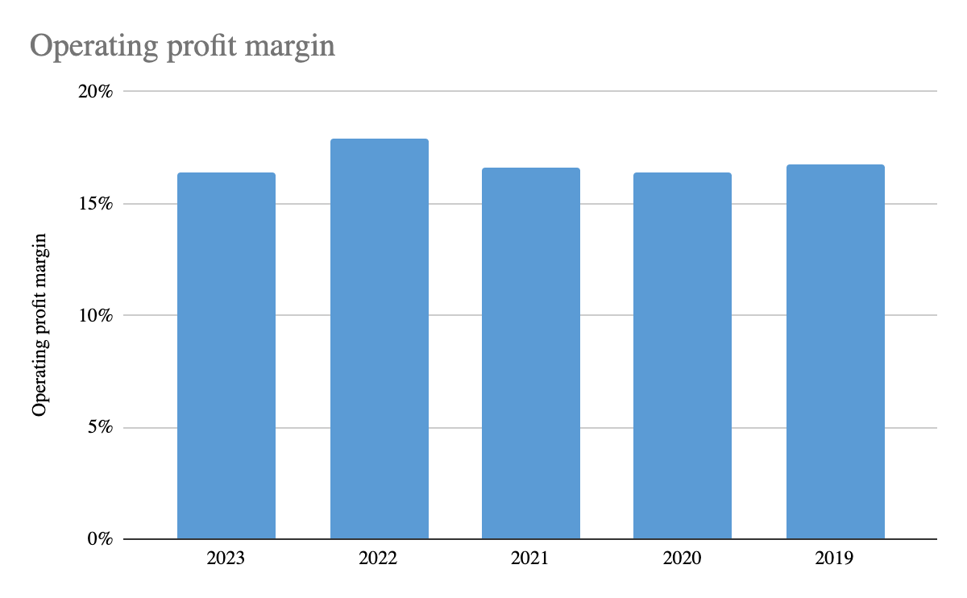
Unilever operating profit margin, presented a consistent rate between the year 2019 and 2023. For operating profit in 2019, Unilever had 17% as a percentage of sales, which is pretty healthy for any organization.
The margin has slightly gone down to 16% in 2020 probably due to the covid 19 effects, this might have cost them more money or sold less products. However, to the company’s credit, it was able to bounce back in 2021 with the margin again rising to 17%. It reduced to 16% by 2023, meaning the operational efficiency may have deteriorated slightly or else costs related to production increased to decrease the profit margin. Overall margins show the effects of good corporate governance indicators (‌Wire, 2024).
Net profit margin:
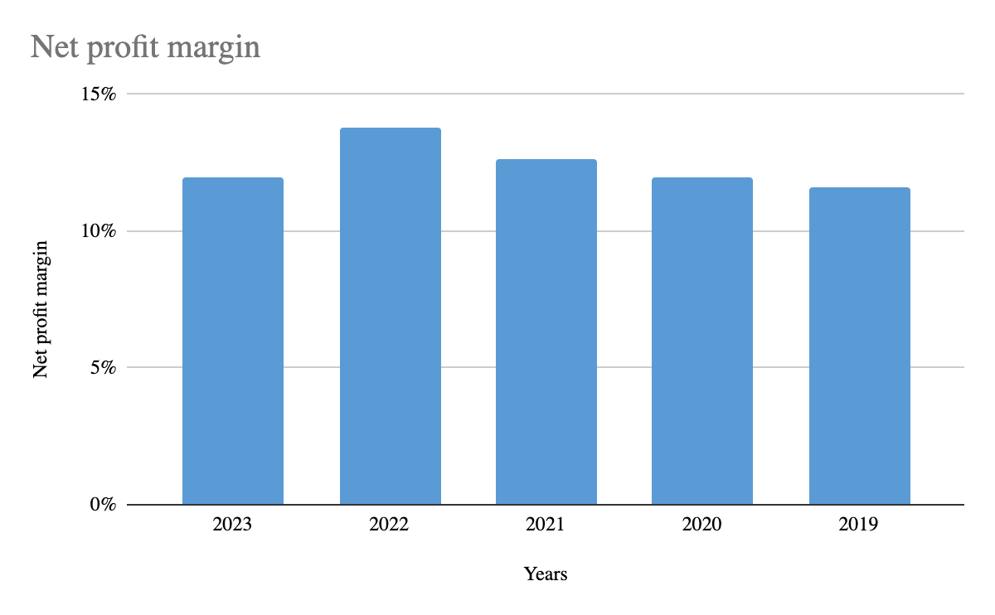
Unilever average net profit margin in 2019 till 2023 shows it as a profitable firm with average percentage variation in the years. In 2019 and 2020, the net profit margin is holding 12% which is really appreciable, which means efficiency of converting its selling into profit is also not decreasing in spite of facing any global issues like pandemic. For the year 2021, this margin increased to 13% indicating better cost control and business operation. Unilever has demonstrated the possibility of improving the margin of profitability, probably due to governance-related decisions. Nonetheless, it narrowed to 12% in 2023, which might be attributed to increasing costs or competitive forces’ influence (Strohkorb, 2024).
Conclusion:
It could be seen from Unilever's corporate governance that the company has internal and external mechanisms to entrench oversight, high transparency standards, and careful attention to sustainability standards. Measures used in the company such as board of directors’ composition and outstanding executive remuneration ensure stakeholder engagement and confidence. Other financial ratio analysis of operation profitability also indicates good corporate governance practices except in maintaining liquidity as the current and quick ratios are not much healthier, company should amend its risk management policies in order to maintain healthy liquidity (Goel, 2018).
References:
Annualreports.com. (2023). Unilever plc. [online] Available at: https://www.annualreports.com/Company/unilever-plc [Accessed 3 Oct. 2024].
Beaver, S. (2022). Quick Ratio: How to Calculate & Examples. [online] Oracle NetSuite. Available at: https://www.netsuite.com/portal/resource/articles/financial-management/quick-ratio.shtml [Accessed 3 Oct. 2024].
Barr, E. (2020). The Importance of Corporate Governance. [online] SpriggHR. Available at: https://sprigghr.com/blog/board-management/the-importance-of-corporate-governance/ [Accessed 3 Oct. 2024].
Bajaj Finserv (2023). Interest Coverage Ratio. [online] www.bajajfinserv.in. Available at: https://www.bajajfinserv.in/investments/interest-coverage-ratio [Accessed 3 Oct. 2024].
Bui, H (2019), The impacts of corporate governance on firms’ performance: from theories and approaches to empirical findings | Emerald Insight. Journal of Financial Regulation and Compliance, [online] 32(1), pp.18–46. doi:https://doi.org/10.1108//JFRC.
‌Forage (2023). Understanding the Debt Ratio: Definition and Formula. [online] Forage. Available at: https://www.theforage.com/blog/skills/debt-ratio [Accessed 3 Oct. 2024].
Gordini, N. (2018). TABLE 3 . CORPORATE GOVERNANCE VARIABLES USED IN THE LITERATURE (IN... [online] Available at: https://www.researchgate.net/figure/CORPORATE-GOVERNANCE-VARIABLES-USED-IN-THE-LITERATURE-IN-ALPHABETIC-ORDER_tbl2_259564014 [Accessed 3 Oct. 2024].
Goel, P. (2018). Implications of corporate governance on financial performance: an analytical review of governance and social reporting reforms in India. Asian Journal of Sustainability and Social Responsibility, [online] 3(1). doi:https://doi.org/10.1186/s41180-018-0020-4.
‌Girardin, M. (2022). What Is the Current Ratio? Formula and Definition. [online] Forage. Available at: https://www.theforage.com/blog/skills/current-ratio [Accessed 3 Oct. 2024].
‌Girardin, M. (2022). What Is the Quick Ratio? Definition and Formula. [online] Forage. Available at: https://www.theforage.com/blog/skills/quick-ratio [Accessed 3 Oct. 2024].
Hargreaves Lansdown. (2024). Unilever plc (ULVR) Ord 3.11p Statements & Reports. [online] Available at: https://www.hl.co.uk/shares/shares-search-results/u/unilever-plc-ordinary-3.11p/financial-statements-and-reports [Accessed 2 Oct. 2024].
Meghan, D (2024). Why is corporate governance so important? [online] Available at: https://www.diligent.com/resources/blog/why-corporate-governance-important-investors [Accessed 3 Oct. 2024].
‌Nguyen, H. (2022). What Is The Current Ratio? Formula and Examples. [online] Irvine Bookkeeping. Available at: https://www.irvinebookkeeping.com/post/current-ratio [Accessed 3 Oct. 2024].
Rossi, M., Nerino, M. and Capasso, A. (2015). CORPORATE GOVERNANCE AND FINANCIAL PERFORMANCE OF ITALIAN LISTED FIRMS. THE RESULTS OF AN EMPIRICAL RESEARCH. Corporate Ownership and Control, 12(2). doi:https://doi.org/10.22495/cocv12i2c6p6.
Sarah, B. (2024). Accounts receivable turnover ratio: Definition, formula & examples. [online] Available at: https://www.plooto.com/blog/accounts-receivable-turnover-ratio?srsltid=AfmBOooJ1J3nwHvmuE619Pc235BbtasN-44oKdMTXoE7Wgp-SFLIeb0l [Accessed 3 Oct. 2024].
Strohkorb, P. (2024). What Is Net Profit Margin, and Why Does It Matter? [online] Salesforce. Available at: https://www.salesforce.com/blog/net-profit-margin/ [Accessed 3 Oct. 2024].
‌Wire, C. (2024). Operating Profit Margin: Definition, Formula and Calculation. [online] Wise. Available at: https://wise.com/gb/blog/operating-profit-margin [Accessed 3 Oct. 2024].
‌Wajdi Affes and Anis Jarboui (2023). The impact of corporate governance on financial performance: a cross-sector study. International Journal of Disclosure and Governance, [online] 20(4), pp.374–394. doi:https://doi.org/10.1057/s41310-023-00182-8.

Appendix:
Liquidity: |  | 2023 | 2022 | 2021 | 2020 | 2019
Current ratio | =Current assets/Current liabilities | 0.73 | 0.75 | 0.70 | 0.78 | 0.78
 | Current assets | 17,211 | 19,129 | 17,401 | 16,157 | 16,430
 | Current liabilities | 23,507 | 25,427 | 24,778 | 20,592 | 20,978
 |  | 2023 | 2022 | 2021 | 2020 | 2019
Quick ratio | =Quick assets/Current liabilities | 0.51 | 0.52 | 0.51 | 0.57 | 0.58
 | Current assets | 17,211 | 19,129 | 17,401 | 16,157 | 16,430
 | Inventory | 5,119 | 5,931 | 4,683 | 4,462 | 4,164
 | Current liabilities | 23,507 | 25,427 | 24,778 | 20,592 | 20,978
Long term solvency:
 |  | 2023 | 2022 | 2021 | 2020 | 2019
Debt ratio | =Total liabilities/Total assets | 0.72 | 0.72 | 0.74 | 0.74 | 0.79
 | Total liabilities | 54,502 | 56,120 | 55,349 | 50,004 | 50,920
 | Total assets | 75,266 | 77,821 | 75,095 | 67,659 | 64,806
 |  | 2023 | 2022 | 2021 | 2020 | 2019
Interest coverage ratio | =Interest expense/EBIT | 17 | 20 | 26 | 17 | 14
 | Interest | 596 | 537 | 344 | 496 | 627
 | EBIT | 9,935 | 10,874 | 8,900 | 8,492 | 8,916
Turnover ratios:
 |  | 2023 | 2022 | 2021 | 2020 | 2019
Asset turnover | =Sales/Total assets | 0.79 | 0.77 | 0.70 | 0.75 | 0.80
 | Sales | 59,604 | 60,073 | 52,444 | 50,724 | 51,980
 | Total assets | 75,266 | 77,821 | 75,095 | 67,659 | 64,806
 |  | 2023 | 2022 | 2021 | 2020 | 2019
Receivable turnover | =Sales/Receivable | 10 | 9 | 10 | 10 | 8
 | Sales | 59,604 | 60,073 | 52,444 | 50,724 | 51,980
 | Receivables | 5,775 | 7,056 | 5,422 | 4,939 | 6,695
Profitability ratios:
 |  | 2023 | 2022 | 2021 | 2020 | 2019
Operating profit | =Operating profit/sales | 16% | 18% | 17% | 16% | 17%
 | Operating profit | 9,758 | 10,755 | 8,702 | 8,303 | 8,708
 | Sales | 59,604 | 60,073 | 52,444 | 50,724 | 51,980
 |  | 2023 | 2022 | 2021 | 2020 | 2019
Net profit margin | =Net profit/sales | 12% | 14% | 13% | 12% | 12%
 | Net profit | 7,140 | 8,269 | 6,621 | 6,073 | 6,026
 | Sales | 59,604 | 60,073 | 52,444 | 50,724 | 51,980

‌

‌

