

Certificate in Higher Education Business Skills for the Workplace
Enterprise and Entrepreneurship
Business Plan
Name: Maksym Dotsyn
Student’s id: 2442213
Lecturer’s name: Charles Obinwa

Table of Contents
Executive Summary 2
Business and Product Description 2
The PropCo: UK Real Estate Investment Trust (REIT) 2
The OpCo: Private Limited Company (LTD) 3
Business Objectives (SMART Objectives) 4
Short-Term Objectives (less than a year) 4
Long-Term Objectives (More than a year) 4
Market Analysis and Marketing Plan 4
STP Analysis 4
PESTEL Analysis 5
SWOT Analysis 7
Marketing Mix (4Ps) 8
Management Team 8
Management Team and Their Background 9
Organisational Chart 10
Key Milestones 10
Financial Plan (One Year) 11
Sources of Finance 11
Cash Flow Forecast 12
Sales Forecast 13
Break Even Analysis 13
Reference List 14

Executive Summary

London Prime Suites REIT aims to acquire undervalued residential flats and houses in London (Zones 1–3), reconfigure them into high-specification apart-hotels, and manage them via a 100% digital self-check-in system. By operating as a REIT, we offer investors a tax-efficient vehicle to gain exposure to the lucrative London short-term rental market

Business and Product Description
To maximize investor returns and safeguard our core assets, the Group utilizes an OpCo-PropCo structural model. This separates the high-value real estate from the day-to-day operational activities of the business. (GOV.UK, 2024).

The PropCo: UK Real Estate Investment Trust (REIT)
The PropCo is established as a Public Limited Company (PLC) and functions as a UK REIT. Its primary mandate is the ownership and preservation of the freehold and long-leasehold property portfolio.
- Listing & Governance: The REIT is listed on a recognized exchange (e.g., The International Stock Exchange - TISE) to meet statutory requirements while maintaining administrative efficiency.
- Tax Efficiency: As a REIT, the entity is exempt from UK Corporation Tax on profits and gains derived from its property rental business.
- Dividend Policy: In compliance with REIT legislation, the PropCo distributes 90% of its tax-exempt property rental profits to shareholders, ensuring a consistent and predictable income stream for investors.

The OpCo: Private Limited Company (LTD)
The OpCo serves as the primary trading entity responsible for the active management and branding of the business operations (e.g., [Insert specific business type, e.g., Hotel Management/Healthcare Services]).
- Lease Agreement: The OpCo enters into a formal lease with the PropCo, paying market-rate rent for the use of the premises.
- Fiscal Strategy: Rental payments to the PropCo are treated as a deductible business expense for the OpCo, optimizing the Group’s overall tax position.
- Risk Isolation: The OpCo holds all operational liabilities, including employment contracts, public liability, and trading risks. This ensures that the underlying real estate in the PropCo remains insulated from any operational volatility or trading losses.

High-tech, low-touch hospitality. We bridge the gap between a sterile hotel and an unmanaged Airbnb.
Modern apartments featuring "invisible service" (keyless entry, 24/7 digital concierge), premium interior design, and prime London locations.

Business Objectives (SMART Objectives)

Short-Term Objectives (less than a year)
Short-Term (Less than 1 year): * Secure £100,000 in seed investment and obtain a commercial mortgage to acquire the first pilot property in London Zone 2 by Q3 2026.
- Complete the high-spec renovation and achieve a 75% occupancy rate within the first 6 months of operation

Long-Term Objectives (More than a year)

Scale to a portfolio of 50+ units within 10 years and achieve official REIT status on the London Stock Exchange (LSE).

Market Analysis and Marketing Plan

STP Analysis

Segmentation
- Geographic: Travelers specifically looking for stays in London Zones 1–3 (Prime locations).
- Demographic: High-income professionals (25–50 years old), corporate employees, and "Digital Nomads."
- Psychographic: People who value privacy, high-tech solutions (digital check-in), and modern interior design over traditional hotel services (like a lobby or bellboy).
- Behavioral: Short-to-medium term stays (3–14 days) for business or "Bleisure" (business + leisure).

Targeting
- Primary Target: The Tech-Savvy Business Traveler. Professionals who need a high-spec apartment with fast Wi-Fi and a seamless, contactless entry system.
- Secondary Target: Affluent Tourists. Couples or small families who want the "living like a local" experience in a luxury London flat but with the reliability of a professional brand.

Positioning
- Positioning Statement: "London Prime Suites REIT positions itself as the premium, tech-forward alternative to traditional hotels. We offer the high standards of a 5-star hotel suite with the autonomy and tax-efficiency of a modern REIT-managed apartment."
- Unique Selling Point (USP): 100% digital journey + prime Zone 1–3 locations + institutional-grade property management.

PESTEL Analysis

- Political:
- Government Housing Policies: Potential changes in UK government regulations regarding short-term rental properties and licensing requirements in London.
- REIT Tax Legislation: Stability of the UK REIT regime which provides tax exemptions for property rental profits.
- Economic:
- Interest Rate Fluctuations: The impact of Bank of England interest rates on mortgage affordability and the cost of debt for property acquisition.
- London Tourism Demand: The resilience of London as a global financial and tourist hub, ensuring a steady stream of high-spending visitors. (Office for National Statistics, 2026).
- Social:
- Shift to "Bleisure" Travel: A growing trend of professionals combining business trips with leisure, increasing demand for high-spec "home-away-from-home" suites.
- Preference for Contactless Services: Consumer shift towards privacy and digital autonomy, favoring self-check-in systems over traditional hotel receptions.
- Technological:
- Smart Home Integration: Use of IoT (Internet of Things) for energy-efficient heating and high-security digital keyless entry systems.
- PropTech Data Analytics: Utilizing AI-driven platforms for dynamic pricing to maximize RevPAR (Revenue Per Available Room).
- Environmental:
- EPC Rating Compliance: The necessity to meet strict UK energy performance standards (minimum Grade C) for all rental properties by 2030.
- Sustainable Urban Living: Growing guest demand for eco-friendly stays, including plastic-free amenities and green energy providers.
- Legal:
- The 90-Day Rule: Compliance with London’s specific legislation that limits short-term rentals of entire homes to 90 nights per calendar year.
- GDPR and Data Privacy: Ensuring strict protection of guest data handled through the 100% digital check-in and booking platform.

SWOT Analysis

Strengths | Weaknesses
- Tax Efficiency: Operating as a UK REIT minimizes corporation tax leakage, providing higher returns for investors.  - Prime Locations: Focus on London Zones 1–3 ensures high asset appreciation and consistent occupancy rates. | - High Capital Requirement: The extreme cost of London real estate requires significant initial funding and high leverage (mortgages).  - Brand Awareness: As a new startup, competing against established hotel chains and high-profile Airbnb "Superhosts."
Opportunities | Threats
- Digital Scalability: The 100% digital model allows for rapid expansion to other UK cities with minimal increase in staff costs.  - Corporate Partnerships: Establishing direct contracts with London-based firms for their employees' medium-term stays. | - Regulatory Crackdown: Stricter local council laws in London that could further restrict short-term digital "apart-hotels."  - Economic Recession: A downturn in the global economy could reduce luxury travel and corporate budgets.

Marketing Mix (4Ps)

- Product: High-end "Apt-Hotels" with workspace and high-speed Wi-Fi.
- Price: Dynamic pricing (AI-driven) to compete with mid-range boutique hotels.
- Place: Strategic London clusters (e.g., Shoreditch, Southwark, Camden).
- Promotion: Direct booking website (to avoid OTA fees), LinkedIn for business travelers, and Instagram for lifestyle branding.

Management Team
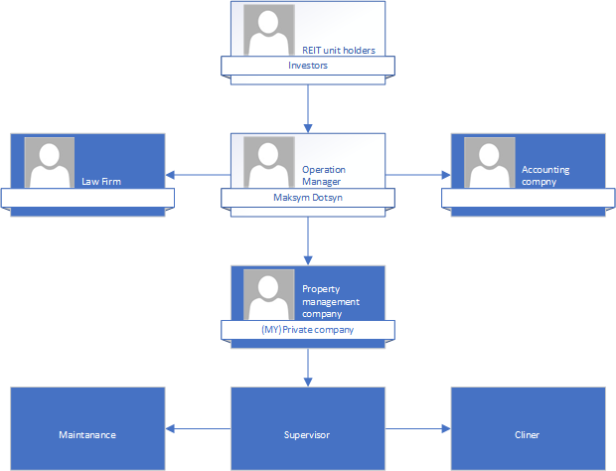

Management Team and Their Background

Maksym Dotsyn – Operations Manager
Professional Background: Maksym brings a unique, multi-disciplinary expertise to London Prime Suites REIT, combining hands-on technical knowledge with high-level hospitality management.
- Construction Expertise: With extensive experience in the UK construction sector and holding industry-standard certifications (CSCS/Building certificates), Maksym possesses a deep understanding of structural reconfigurations and site management. This ensures that the REIT’s strategy of "acquiring and reconfiguring" properties is executed with technical precision, cost-efficiency, and strict adherence to UK building regulations.
- Hospitality Operations: Currently active in the London hotel industry, Maksym has gained an "insider’s view" of modern hospitality systems. This role has provided him with direct insight into guest expectations, operational bottlenecks, and the increasing demand for autonomy in the travel sector.
The Vision (Innovation): By bridging the gap between property development and hospitality service, Maksym is implementing a "Digital-First" philosophy. His strategy replaces traditional, labor-intensive hotel receptions with a 100% digital self-check-in ecosystem. This innovation reduces operational overheads (OpEx) while providing the seamless, tech-driven experience that the modern London traveler demands.

Organisational Chart
Description of the Organisational Structure: London Prime Suites REIT operates on a lean management model, prioritizing scalability and cost-efficiency. At the apex are the REIT Unit Holders (Investors), who provide the capital. The core of the operations is managed by the Operations Manager (Maksym Dotsyn).
Unlike traditional hospitality firms, the business avoids high fixed labor costs by utilizing strategic outsourcing. Professional services, such as legal and accounting, are handled by specialized firms, while day-to-day property operations are managed through a third-party Property Management Company. This company, in turn, oversees the supervisors, maintenance teams, and cleaning staff.

Key Milestones

- Milestone 1: Seed Funding (Month 1-2): * Secure £100,000 in equity from initial REIT unit holders and finalize the mortgage agreement for the first property.
- Milestone 2: Asset Acquisition (Month 3): * Identify and purchase an undervalued residential unit in London Zone 1-3. Complete legal due diligence via the outsourced law firm.
- Milestone 3: Reconfiguration & Tech Setup (Month 4-6): * Renovate the property into a high-spec apart-hotel. Install the 100% digital self-check-in system and smart locks.
- Milestone 4: Market Launch (Month 7): * Go live on major booking platforms (Airbnb, Booking.com) and the company’s direct booking site.
- Milestone 5: Operational Stability & Payouts (Month 12): * Achieve a consistent 75%+ occupancy rate and distribute the first round of dividends to REIT unit holders.

Financial Plan (One Year)

Sources of Finance

Reit cost
property from | £100,000
Registration | 5000
Renovation | 5000
Total | £110,000
The capital structure for the first acquisition follows a Leveraged Equity Model.
- Equity Capital: £100,000 will be raised from REIT Unit Holders (Investors). This initial seed funding will cover the property deposit (approx. 25%), Stamp Duty Land Tax (SDLT), legal fees, and high-spec renovation costs.
- Debt Financing: The remaining 75% of the property value will be secured through a Buy-to-Let Commercial Mortgage.
This approach allows the REIT to control a high-value asset in London Zones 1–3 while maintaining liquidity. By using a mortgage, we improve the Return on Equity (ROE) for our investors through financial gearing.

Cash Flow Forecast

Fixed Costs | per month
Credit Payment | £3,000
Accountant | £100
Total cost | £3,100

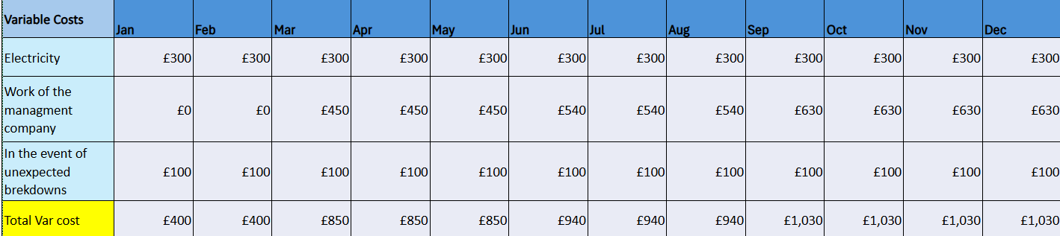
- The REIT’s day-to-day operations are outsourced to a specialized Property Management Company.
- Management Fee: The cost of this service is fixed at 10% of total Gross Revenue.
- Strategic Benefit: This ensures that management costs are strictly scalable. By tying the fee to revenue, the management company is directly incentivized to maximize occupancy rates and premium pricing (RevPAR), aligning their performance with the interests of the REIT unit holders.
- Revenue: (for example) £200 per night x 75% occupancy = £4,500/month.
- Management Fee (10%): £450/month.
- Mortgage Interest: (for example) £1,500/month.
- Net Profit: Revenue minus all costs (including your % as the Operations Manager).

Sales Forecast

Months 1–2 focus on structural reconfiguration and digital system installation, with zero forecasted revenue. From Month 3, a "ramp-up" phase targets 45–55% occupancy. By Month 6, the suite reaches "full speed" with a stabilized 75–85% occupancy, maximizing RevPAR and investor dividends through AI-driven dynamic pricing. (Savills Research, 2025).

Break Even Analysis

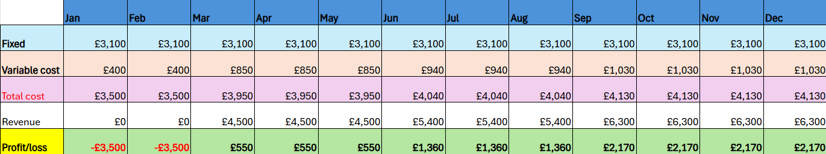

To ensure the financial viability of London Prime Suites REIT, a comprehensive break-even analysis has been conducted. The initial phase requires a total Startup Capital of £117,000, broken down as follows:
- Property Deposit & Acquisition Costs: £110,000
- Renovation & High-Spec Reconfiguration: £3,500
- Digital Systems & Smart Tech Setup: £3,500
- Total Initial Investment: £117,000

Reference List

1 GOV.UK (2024) IFM21000 - Investment Funds Manual: Real Estate Investment Trusts (REITs): Introduction. Available at: https://www.gov.uk/hmrc-internal-manuals/investment-funds-manual/ifm21000 (Accessed: 30 March 2026).

2 Dolan, Robert J. Note on Marketing Strategy. Harvard Business School. (Boston, MA: Harvard Business School Publishing, 1997), pp. 1-17.

3 Office for National Statistics (2026) Average house prices in London: Annual Review 2025. Available at: https://www.ons.gov.uk (Accessed: 30 March 2026).

4 Savills Research (2025) London Residential Market Forecasts 2026-2030. London: Savills.

5 Roger Kerin, Eric Berkowitz, Steven Hartley and William Rudelius. “Marketing”. 7th Ed. (New York, NY: Mc Graw Hill, 2003), Chapter 2.

6 Excel spreadsheet with a built-in calculator for calculating profitabilyti exel calculation for business plan.xlsx

