
Design and Implementation of a Relational Database System
Introduction to Web and Database Concepts (ACCA_4023 BIRM)

Aleksej Vysockij (2512914)
09 July 2026
UNIVERSITY OF WALES TRINITY SAINT DAVID
CertHE Computing Skills for Workplace
LECTURER: DR Sadhana Jha
Contents
Scenario Analysis 2
Entity Relationship Diagram (ERD) 2
1. List of attributes and their descriptions 2
2. List of relationships and their meaning. 3
3. ER diagram 5
Normalization 6
Sample Data Population 9
Query Development 11
Testing and Validation 16
Design Decisions and Future Work 17
1. Design Decisions: 17
2. Future Work: 18
References: 19

Figure 1. Entity Relationship Diagram (ERD) for the AutoPark Management System. 5
Figure 2. Client Table with Sample Data. 9
Figure 3. Vehicle Table with Sample Data. 9
Figure 4. ParkingLocation Table with Sample Data. 10
Figure 5. ParkingSpace Table with Sample Data. 10
Figure 6. Booking Table with Sample Data. 10
Figure 7. Payment Table with Sample Data. 10
Figure 8. Entry/ExitLog Table with Sample Data. 10
Figure 9. Relationships Between Tables in the AutoPark Management System Database. 11
Figure 10. Query Design view - Currently Occupied Parking Spaces. 11
Figure 11. Query Result – Currently Occupied Parking Spaces. 12
Figure 12. Query Design view – Vehicle and Customer Details. 12
Figure 13. Query Result – Vehicle and Customer Information. 12
Figure 14. Query Design view – Booking Details. 13
Figure 15. Query Result – Booking and Parking Space Details. 13
Figure 16. Query Design view – Payment Report. 14
Figure 17. Query Result – Successful Payments. 14
Figure 18. SQL view – Most Popular Parking Location Query. 15
Figure 19. Query Result – Total Bookings by Parking Location. 15
Figure 20. SQL view – Entry and Exit Log Report Query. 15
Figure 21. Query Result – Vehicle Entry and Exit Records. 16

Table 1. Relational Schema in First Normal form (1NF) 6
Table 2. Relational Schema in Third Normal Form (3NF) 8

Scenario Analysis
The company “AutoPark Management System” provides parking services in different areas of the city. At the moment, the company uses manual methods such as paper documents and spreadsheets to record information about vehicles, customers, parking spaces, and payments. This process creates many problems for the business. Staff can make mistakes when entering data, some records may be lost, and parking spaces are not always used efficiently. Because of this, the company wants to create a centralised database system using Microsoft Access.
The purpose of the new database system is to improve the daily operations of the parking company. The system will help employees record vehicle entry and exit information, monitor free and occupied parking spaces, store customer details, and manage payments in real time. In addition, the database will allow managers to create reports about parking usage, income, and business performance.
Several important entities are included in the system design. The Client entity stores customer information such as first name, last name, phone number, email address, and registration date. The Vehicle entity stores records including registration number, make, model, colour, and manufactureе year. The ParkingLocation entity represents each parking site, with attributes such as location city, location name, location street, maximum capacity, and surface type. Within each location, individual ParkingSpace records are defined, each with a unique space number, type (standard, accessible, or EV-charging), current availability status, and section/zone reference. The Booking entity connects vehicles with parking spaces for a specific time period and records the booking status. The Payment entity stores payment information including amount, payment method, and payment status. Finally, the Entry/ExitLog entity records the arrival and departure times of vehicles.
The relationships between these entities help reduce data duplication and improve data accuracy. The database structure also supports normalisation to Third Normal Form (3NF), which improves data integrity and system reliability [1], [2], [3].

Entity Relationship Diagram (ERD)

List of attributes and their descriptions
The ERD contains seven entities. Each entity has a primary key (PK) which is used to identify records uniquely [1], [2].
The Client entity stores information about customers. Its PK is ClientID. FirstName stores the customer’s name. LastName stores the customer’s surname. Phone stores the contact number. Email stores the email address. RegistrationDate records the date when the customer joined the system.
The Vehicle entity stores information about customer vehicles. Its PK is VehicleID. RegistrationNumber stores the vehicle registration number plate. Make shows the manufacturer. Model shows the vehicle model. Colour records the vehicle colour. ManufactureYear stores the year the vehicle was made.
The ParkingLocation entity represents parking sites in the city. Its PK is LocationID. LocationCity stores the name of the city. LocationName stores the name of the site. LocationStreet stores the location street. MaxCapacity shows the total number of parking spaces. SurfaceType describes the parking surface.
The ParkingSpace entity represents individual parking spaces. Its PK is SpaceID. AvailabilityStatus shows if the space is available, occupied, or reserved. SpaceType shows whether the space is standard, accessible, or EV charging. Zone identifies the area of the parking site. SpaceNumber identifies the parking space.
The Booking entity stores reservation information. Its PK is BookingID. BookingStatus shows whether the booking is active, completed, or cancelled. StartDate and StartTime record the booking start date and time. EndDate and EndTime record the booking end date and time.
The Payment entity stores payment details. Its PK is PaymentID. PaymentStatus records whether the payment is pending, successful, or refunded. PaymentDate stores the payment date. PaymentMethod shows how the payment was made. Amount records the payment value.
The Entry/ExitLog entity stores actual vehicle movement information. Its PK is LogID. EntryDate and EntryTime record the arrival date and time. ExitDate and ExitTime record the departure date and time.

List of relationships and their meaning.
There are six relationships between the entities. These relationships help connect the data in the system [1], [2], [4].
Owns (Client to Vehicle): One-to-Many. Participation is mandatory for Vehicle because every vehicle must belong to a client. Participation is optional for Client because a customer may not have a vehicle registered.
Contains (ParkingLocation to ParkingSpace): One -to-Many. Participation is mandatory for ParkingSpace because every parking space must belong to a parking location. Participation is optional for ParkingLocation because a location may exist before parking spaces are assigned to it.
AllocatedTo (ParkingSpace to Booking): One-to-Many. Participation is mandatory for Booking because every booking must have a parking space. Participation is optional for ParkingSpace.
Reserves (Vehicle to Booking): One-to-Many. Participation is optional for Vehicle because a vehicle may not have any bookings. Participation is mandatory for Booking because every booking must be linked to a vehicle.
HasPayment (Booking to Payment): One-to-One. Participation is optional for Booking because a booking may exist before a payment is made. Participation is mandatory for Payment because every payment must be linked to a booking.
Records (Booking to Entry/ExitLog): One-to-One. Participation is mandatory for Entry/ExitLog because every entry/exit record must be linked to one booking. Participation is optional for Booking because some bookings may be cancelled before the vehicle enters the parking area.
Single lines indicate optional participation, while double lines indicate mandatory participation.

ER diagram

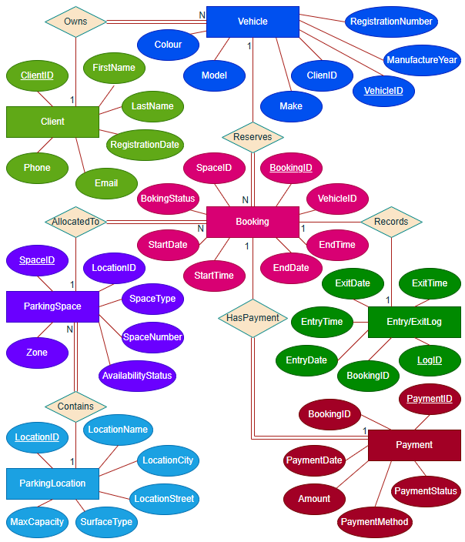
Figure 1. Entity Relationship Diagram (ERD) for the AutoPark Management System.
Figure 1 shows the complete ERD with all entities, attributes, relationships, cardinalities, and participation constraints.
The primary keys (PK) used in the database are:
- Client – ClientID
- Vehicle – VehicleID
- ParkingLocation – LocationID
- ParkingSpace – SpaceID
- Booking – BookingID
- Payment – PaymentID
- Entry/ExitLog – LogID
The following foreign keys (FK) are used to maintain referential integrity:
- Vehicle.ClientID references Client.ClientID
- ParkingSpace.LocationID references ParkingLocation.LocationID
- Booking.SpaceID references ParkingSpace.SpaceID
- Booking.VehicleID references Vehicle.VehicleID
- Payment.BookingID references Booking.BookingID
- Entry/ExitLog.BookingID references Booking.BookingID
These keys help maintain data consistency between related entities and prevent orphan records. They also support efficient queries and improve the reliability of the database system [1], [5].

Normalization
After creating the Entity Relation Diagram (ERD), the entities were converted into a relational schema. The database consists of seven tables: Client, Vehicle, ParkingLocation, ParkingSpace, Booking, Payment, and Entry/ExitLog. Each table contains a primary key to uniquely identify records, while foreign keys are used to create relationships between related tables [1], [2], [6].
First Normal Form (1NF)
Table 1. Relational Schema in First Normal form (1NF)
Client
ClientID (PK) | FirstName | LastName | Phone | Email | RegistrationDate
Table 1. Relational Schema in First Normal Form (1NF) (continued)
Vehicle
VehicleID (PK) | RegistrationNumber | Make | Modеl | Colour | ManufactureYear

ParkingLocation
LocationID (PK) | LocationCity | LocationName | LocationStreet | MaxCapacity | SurfaceType

ParkingSpace
SpaceID (PK) | AvailabilityStatus | SpaceType | Zone | SpaceNumber

Booking
BookingID (PK) | BookingStatus | StartDate | StartTime | EndDate | EndTime

Payment
PaymentID (PK) | PaymentStatus | PaymentDate | PaymentMethod | Amount

Entry/ExitLog
LogID (PK) | EntryDate | EntryTime | ExitDate | ExitTime

A table is in First Normal Form when all attributes contain atomic values and there are no repeating groups. In this database, every attribute stores a single value. For example, FirstName stores one customer name, and LastName stores one customer surname, RegistrationNumber stores one vehicle registration number, and PaymentMethod stores one payment method. None of the provided tables contains multiple values in a single field. Therefore, all tables satisfy the requirements of 1NF [1], [2], [6].
Second Normal Form (2NF)
A table is in Second Normal Form when it is already in 1NF and all non-key attributes depend on the entire primary key. In this database, each table uses a single primary key, such as ClientID, VehicleID, BookingID, and PaymentID. Because there are no composite primary keys, partial dependencies do not exist. All non-key attributes depend directly on the primary key of their table. Therefore, all tables satisfy the requirements and no changes were required to achieve Second Normal Form [1], [2], [6].
Third Normal Form (3NF)
Table 2. Relational Schema in Third Normal Form (3NF)
Client
ClientID (PK) | FirstName | LastName | Phone | Email | RegistrationDate

Vehicle
VehicleID (PK) | ClientID (FK) | Registration  Number | Make | Modеl | Colour | ManufactureYear

ParkingLocation
LocationID (PK) | LocationCity | LocationName | LocationStreet | MaxCapacity | SurfaceType

ParkingSpace
SpaceID (PK) | LocationID (FK) | Availability  Status | Space  Number | SpaceType | Zone

Booking
BookingID (PK) | VehicleID (FK) | SpaceID (FK) | Booking  Status | StartDate | StartTime | EndDate | EndTime

Payment
PaymentID (PK) | BookingID (FK) | PaymentStatus | Payment  Date | Payment  Method | Amount

Entry/ExitLog
LogID (PK) | BookingID (FK) | EntryDate | EntryTime | ExitDate | ExitTime

A table is in Third Normal Form when it is already in 2NF and does not contain transitive dependencies. A transitive dependency occurs when a non-key attribute depends on another non-key attribute instead of the primary key. In the AutoPark database, all non-key attributes depend only on their table’s primary key. For example, in the Vehicle table, RegistrationNumber, Маке, Model, Colour, and ManufactureYear depend only on VehicleID. In the Payment table, Amount, PaymentDate, PaymentMethod, and PaymentStatus depend only on PaymentID. No transitive dependencies were identified.
As a result, the final database design is in Third Normal Form (3NF). This structure reduces data redundancy, improves data consistency, and supports efficient storage and reliable database operations [1], [2], [4], [6].

Sample Data Population
Sample data was entered into all tables to test the functionality of the database and verify that relationships between entities were working correctly. Five records were added to each table. Screenshots of the populated tables are provided below.
The sample data was designed to represent realistic parking operations. Five records were entered into each table to test relationships between entities and database functionality. The dataset includes different customers, vehicles, parking locations, bookings, payments, and entry and exit records. This data was later used during query testing and validation.

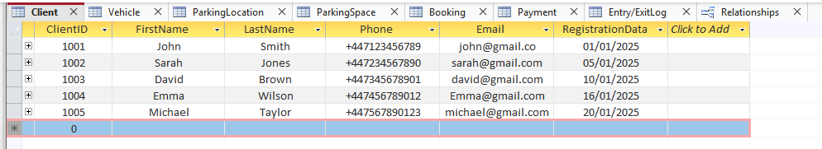
Figure 2. Client Table with Sample Data.
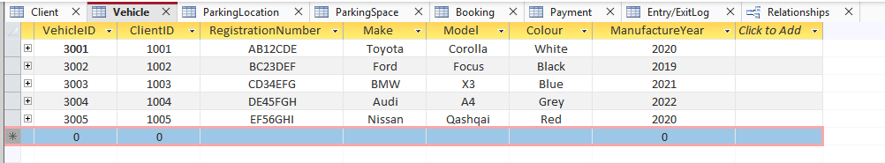
Figure 3. Vehicle Table with Sample Data.
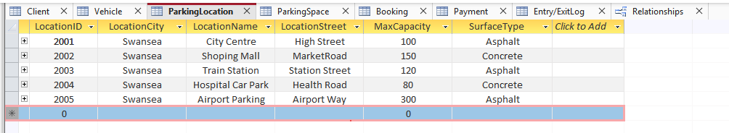
Figure 4. ParkingLocation Table with Sample Data.
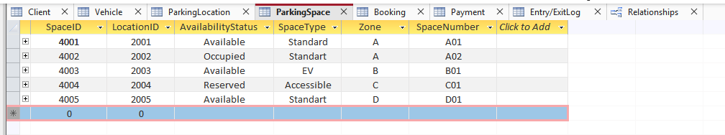
Figure 5. ParkingSpace Table with Sample Data.
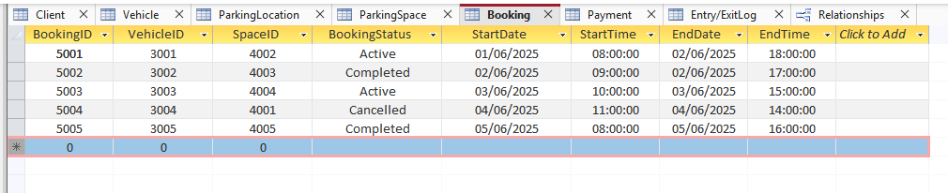
Figure 6. Booking Table with Sample Data.
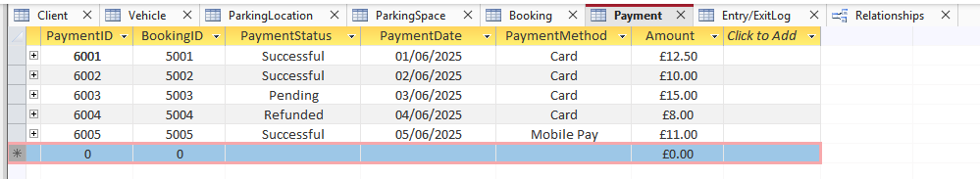
Figure 7. Payment Table with Sample Data.
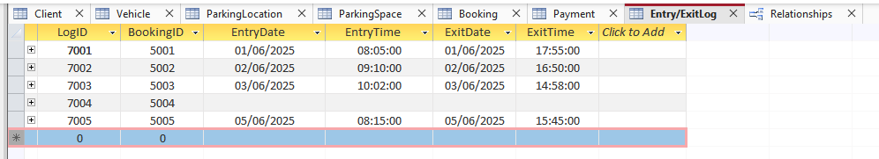
Figure 8. Entry/ExitLog Table with Sample Data.
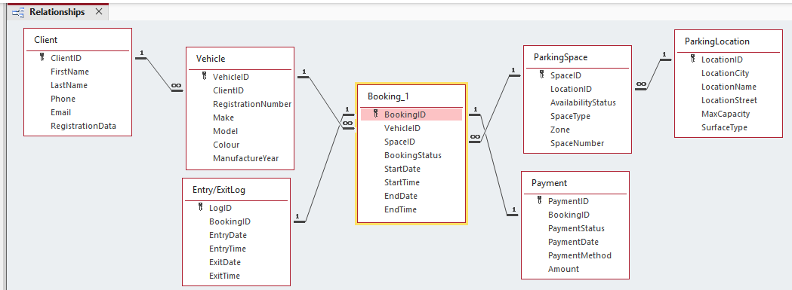
Figure 9. Relationships Between Tables in the AutoPark Management System Database.

Query Development
The queries were created using Microsoft Access query tools and SQL principles [7], [8], [9].
Six queries were created to demonstrate the functionality of the AutoPark Management System database. Four queries were created using Microsoft Access Query Design view, while two queries were created using SQL view. The queries were used to retrieve parking space information, customer and vehicle records, booking details, payment information, parking location statistics, and vehicle entry and entry and exit records.
Query 1: Currently Occupied Parking Spaces
Purpose: Display all parking spaces that are currently occupied.
This query was created using Query Design view.
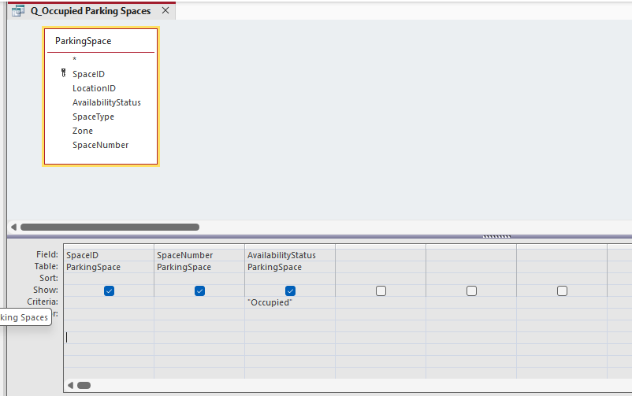
Figure 10. Query Design view - Currently Occupied Parking Spaces.
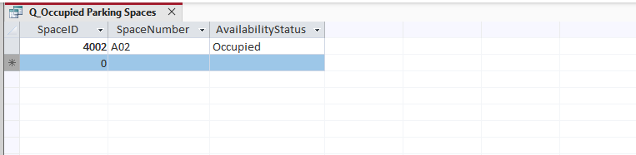
Figure 11. Query Result – Currently Occupied Parking Spaces.

Query 2: Vehicle and Customer Details
Purpose: Display vehicle information together with customer details.
This query was created using Query Design view.

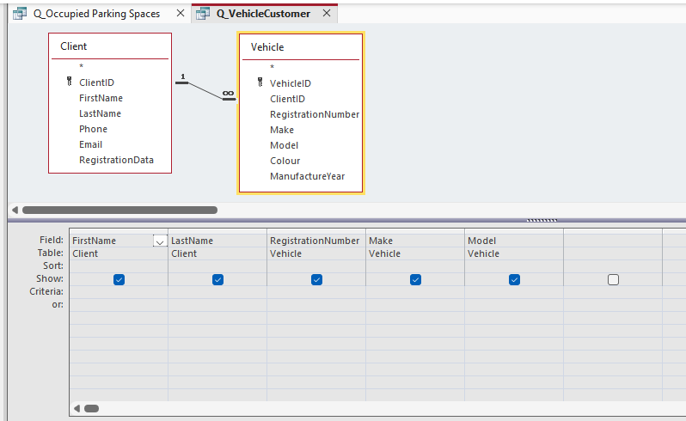
Figure 12. Query Design view – Vehicle and Customer Details.

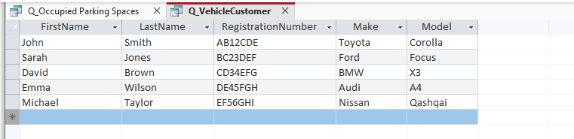
Figure 13. Query Result – Vehicle and Customer Information.
Query 3: Booking Details
Purpose: Display booking information together with the allocated parking space.
This query was created using Query Design view.

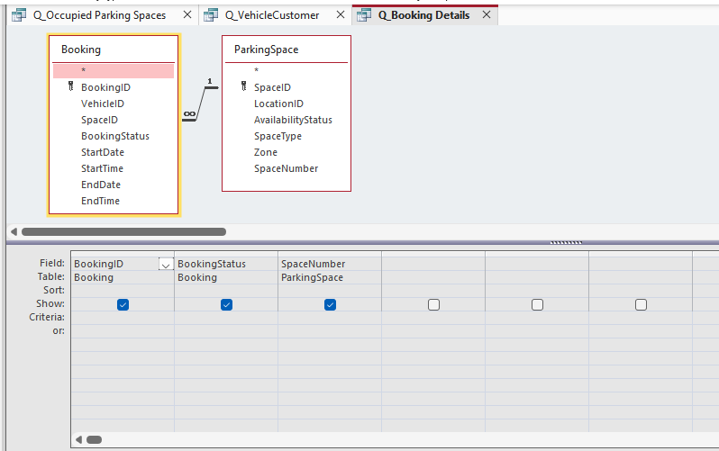
Figure 14. Query Design view – Booking Details.

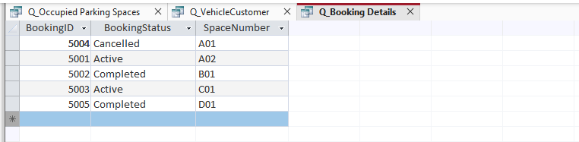
Figure 15. Query Result – Booking and Parking Space Details.

Query 4: Payment Report
Purpose: Display all successful payments.
This query was created using Query Design view.

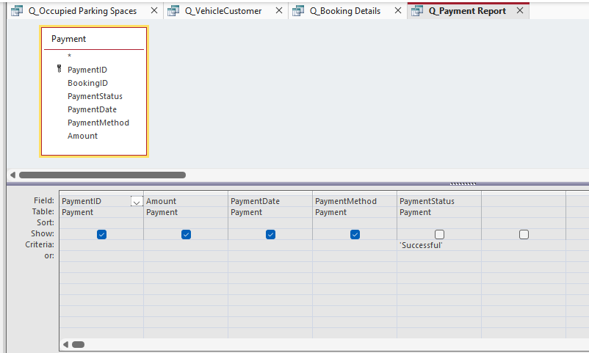
Figure 16. Query Design view – Payment Report.

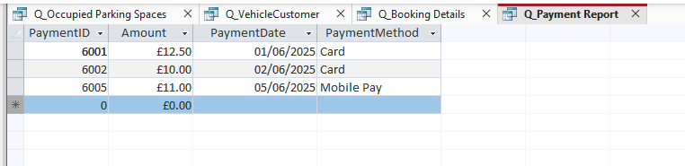
Figure 17. Query Result – Successful Payments.

Query 5: Most popular Parking Location
Purpose: Count bookings for each parking location.
This query created using SQL view.

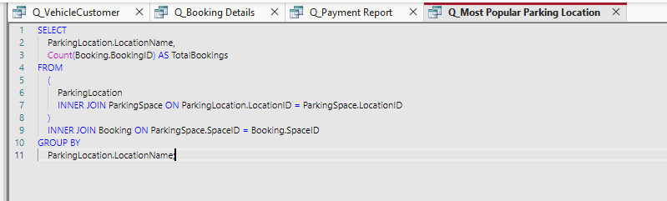
Figure 18. SQL view – Most Popular Parking Location Query.

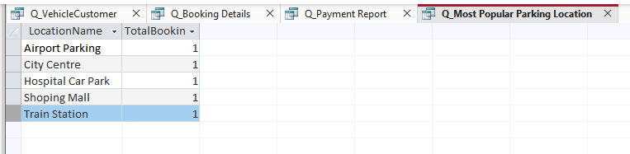
Figure 19. Query Result – Total Bookings by Parking Location.
Query 6: Entry and Exit Log Report
Purpose: Display vehicle entry and exit times.
This query created using SQL view.

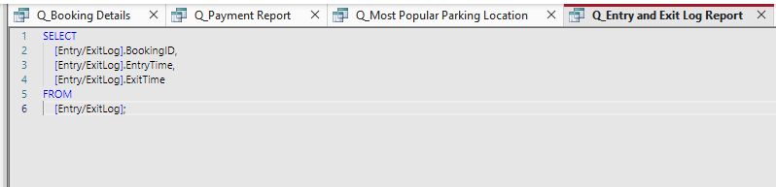
Figure 20. SQL view – Entry and Exit Log Report Query.
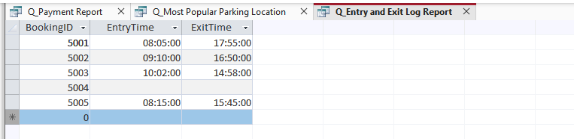
Figure 21. Query Result – Vehicle Entry and Exit Records.

Testing and Validation
To confirm that the Database meets the functional requirements, a series of tests was carried out. The testing process focused on table relationships, data entry, query execution, and referential integrity. The aim was to ensure that the database stores information correctly and produces accurate results.
Several key requirements were tested. First, records were entered into all tables to verify that data could be stored successfully. Client, Vehicle, ParkingLocation, ParkingSpace, Booking, Payment, and Entry/ExitLog records were added without errors.
Second, relationships between tables were tested. The database correctly linked clients to vehicles, parking location to parking spaces, and bookings to vehicles and parking space. Foreign key relationships worked as expected and maintained data consistency.
Third, payment recording was tested. Each payment was linked to an existing booking using the BookingID foreign key. The database prevented records from being linked to non-existent bookings because referential integrity was enabled [1], [5], [10].
Fourth, several queries were executed to test database functionality. Both Query Design view and SQL view were used to create and test the queries. Queries were used to display occupied parking spaces, customer and vehicle information, booking details, payment records, booking totals by parking location, and entry and exit log reports. The results returned by the queries matched the sample data stored in the database and provided accurate information for reporting purposes.
Referential integrity was also validated. When attempting to create records with invalid foreign key values, Microsoft Access prevented the action. This ensured that relationships between tables remained accurate and consistent.
The results of testing showed that the database performs as expected. Data is stored correctly, relationships function properly, and queries return accurate information. Minor formatting adjustments, such as date and time display settings, were completed during testing. Overall, the database is stable and meets the requirements of the AutoPark Management System.

Design Decisions and Future Work

Design Decisions:
The main goal of this project was to create a database that could manage parking operations for the AutoPark Management System. The database was designed using Microsoft Access and includes seven main entities: Client, Vehicle, ParkingLocation, ParkingSpace, Booking, Payment, and Entry/ExitLog.
Several design decisions were made during the development process. Separate tables were created for each entity to reduce data duplication and improve data organisation [1], [6], [3]. Primary keys were used to uniquely identify records, while foreign keys were used to create relationships between tables. Referential integrity was enabled to help maintain data consistency.
Microsoft Access was selected because it provides tools for creating tables, relationships, queries, forms, and reports within a single environment [5], [10]. It is suitable for small and medium-sized database applications and was appropriate for the requirements of this project.
The database was normalised to Third Normal Form. This helped reduce redundancy and ensure that data is stored efficiently. Queries were also created to display useful information, such as occupied parking spaces, booking details, payment records, parking location statistics, and entry and exit logs.
One challenge during development was creating the relationships between tables correctly. It was important to ensure that all foreign keys matched the correct primary keys and that referential integrity was applied properly. Another challenge was understanding the normalisation process and making sure that the database structure met the requirements of 1NF, 2NF, and 3NF. I also experienced some difficulties when entering sample data because records had to be added in the correct order to satisfy the relationships between tables. In addition, creating and testing queries required careful checking to ensure that the correct information was returned. These challenges were resolved through repeated testing and validation of the database structure.

Future Work:
Although the database meets the current requirements, several improvements could be added in the future. One possible improvement would be the development of user-friendly forms for entering and updating data. Another enhancement could be the creation of additional reports and dashboards to support management decision-making.
The system could also be expanded to include automatic parking fee calculations based on the length of stay. Online booking functionality and automatic phone or email notifications for customers could also be added. These improvements would make the system more efficient and provide a better user experience.

References:

[1] T. M. Connolly and C. E. Begg, Database systems : a practical approach to design, implementation, and management, 4th Ed. Harlow, Essex, England ; New York: Addison-Wesley, 2005.
[2] R. Elmasri and S. Navathe, Fundamentals of database systems, 7th Global edition Ed. Boston: Pearson ; Munich, 2017.
[3] C. Coronel and S. Morris, Database systems, 13th edition Ed. Boston, MA, USA: Cengage Learning, 2019.
[4] Edgar F. Codd, "A Relational Model of Data for Large Shared Data Banks," vol. 13, no. 6, pp.377–387, 1970, doi: 10.1145/362384.362685. Available at: https://doi.org/10.1145/362384.362685.
[5] Microsoft Corporation. "Create table relationships in Access." Microsoft Support. Accessed: 01 June 2026. [Online]. Available: https://support.microsoft.com
[6] C. J. Date, An introduction to database systems, 8. ed., internat. ed. Ed. Boston ; Munich [u.a.]: Pearson, Addison-Wesley, 2004. [Online]. Available: https://bvbr.bib-bvb.de:443/F?func=service&doc_library=BVB01&local_base=BVB01&doc_number=010625630&sequence=000001&line_number=0001&func_code=DB_RECORDS&service_type=MEDIA
[7] J. L. Harrington, SQL clearly explained, 3rd ed. Ed. Burlington, Mass: USA: Morgan Kaufmann, 2010. doi: 10.1016/C2009-0-61592-0
[8] J. Viescas, SQL Queries for Mere Mortals, 4th Ed. Hoboken: Pearson Education, Limited, 2018.
[9] P. Wilton and J. W. Colby, Beginning SQL, 1st ed. Ed. Indianapolis, IN, USA: Wiley Publishing, 2005.
[10] Microsoft Corporation. "Introduction to Access database design." Microsoft Support. Accessed: 01 June 2026. [Online]. Available: https://support.microsoft.com

