Title: Financial Performance Evaluation and Capital Budgeting Decision: A Case Study of Tesco PLC and Westward Plc
Name: PATEL MAAN
ID: 2516930

Contents

PART 1 — Financial Analysis Report (Tesco PLC) 4

1. Executive Summary 4

2. Introduction (Financial Statement Analysis) 5

3. Overview of Tesco PLC and Financial Statements 5

4. Ratio Analysis of Tesco PLC 6
4.1 Profitability Ratios 7
4.2 Liquidity Ratios 8
4.3 Efficiency Ratios 9
4.4 Gearing Ratios 10
4.5 Investor Ratios 11

5. Critical Evaluation of Tesco’s Financial Performance 11
Financial Trends 11
Industry Comparison 12
Key Factors Affecting Tesco 13
Limitations of Ratio Analysis 13

6. Recommendations for Tesco Directors 14

7. Conclusion 15

References 16

2. PART 2 — Investment Appraisal Report 18

2. Introduction 18

3. Net Present Value (NPV) Analysis 18
Project A – NPV Calculation 19
Project B – NPV Calculation 20
Project C – NPV Calculation 20
Comparison of Investment Options 21

4. Internal Rate of Return (IRR) 21
IRR Formula 22
Step 1: NPV at 6% 22
Step 2: NPV at 30% 22
Step 3: NPV at 40% 23
Step 4: Approximate IRR 24
Interpretation 24

5. Evaluation of Investment Appraisal Methods 24
Why NPV is the Best Method 24
Why Managers Still Use Non-Discounting Methods 25

6. Capital Rationing Decision 26

7. Sources of Finance 27

8. Final Recommendation and Conclusion 27

References 29

Table 1: Ratio Analysis. 6
Table 2 Industry Comparison 12
Table 3 Net Present Value (NPV) Analysis 19
Table 4 Project A – NPV Calculation 19
Table 5 Project B – NPV Calculation 20
Table 6 Project C – NPV Calculation 20
Table 7 Comparison of Investment Options 21
Table 8 NPV at 30% 22
Table 9 NPV at 40% 23
Table 10 Capital Rationing Investment Allocation 26

Figure 1: Profitability Ratios Chart. 7
Figure 2: Liquidity Ratios Chart. 8
Figure 3: Efficiency Ratios Chart. 9
Figure 4: Solvency Ratios Chart. 10
Figure 5: Grocery market share – 2020 v 2024 v 2025 (Savills India, 2023). 13

PART 1 — Financial Analysis Report (Tesco PLC)

1. Executive Summary
In this report, Tesco PLC financial performance is assessed over the 2023-2025 period using the financial statement analysis and ratio analysis. This report is aimed at evaluating the financial position, business efficiency and profitability trends that Tesco has been experiencing to provide strategic suggestions to the management. The analysis reveals that Tesco has realised some level of improvements in profitability over the period where gross profit margin, net profit margin and return on equity have been improved. Such trends are indicative of improved cost control and better use of resources in the company. Nonetheless, the liquidity analysis has shown that it has comparatively low current and quick ratios, which shows that the company has tight working capital management and this is a characteristic that is usually seen in the grocery retail industry. Despite this, Tesco has stable cash flows and operations. There is also a threat of competition with other big retailers like Aldi, Lidl, and Sainsbury in the company. This is due to the findings that show that Tesco still needs to tighten the reins on inventory management, invest more in digital retailing, and streamline the supply chain operations to increase long-term profitability and shareholder value.

2. Introduction (Financial Statement Analysis)
The financial statement analysis is important in the evaluation of the solvency of a firm and to aid managers in making decisions. It allows managers, investors and other stakeholders to have a complete picture of the organisational performance by allowing them to understand the effectiveness of the deployment of resources and value creation. By conducting a systematic review of financial accounting, companies can measure profitability, liquidity and operational efficiency as well as important factors of sustainable performance over the long term (Olayinka, 2022). Furthermore, financial analysis supports strategic decision-making because it identifies strengths and weaknesses, which can influence the future results (Liu, 2024).
The current report attempts to analyse financial performance of Tesco PLC, which is one of the largest retailing businesses in the London Stock Exchange. Tesco has been chosen due to its high presence in the UK retail industry and the possibility of having a wide range of financial disclosures. The analysis will focus on the fiscal years 2023-2025 and will use ratio analysis to bring to light the relevant trends in the financial situation of the company. Ratio analysis is a logistic structure of comparison over time and helps managers to develop strategic and operational decisions (Tesco PLC, 2025).

3. Overview of Tesco PLC and Financial Statements

Tesco PLC and Retail Sector Context
Tesco PLC is among the largest retailers of super-market in the United Kingdom with a large number of physical stores, online platforms and distribution networks. The company has millions of clients in a weekly basis, and therefore, it holds a consequential position in the UK retail sector. The grocery industry has undergone great change over the last few years due to the digital innovation, changes in consumer behaviour and the adoption of online shopping platforms (Wolniak, Stecula and Aydin, 2024). As a response to elevating operational efficiency and customer experience, retailers, including Tesco, are relying more on digital technologies and data-driven systems (Abbu, Fleischmann and Gopalakrishna, 2021). As a result, the financial performance analysis of Tesco provides useful information on the process of cost, revenue streams and capital investment management in large retail organisations in the environment of competition.

Income Statement – Profitability
The income statement provides details on the profitability of an entity in the sense that it presents revenues, expenditures and net earnings of the entity during a reporting period. In 2023, Tesco increased its total revenue to 65,322 million, which increased to 69,916 million in 2025 which is an indication of growing sales and the demand in the market ( Tesco PLC, 2025). At the same time, net income shifted to a higher level of between £737million to 1,626million which indicates better profitability and better cost management.

Balance Sheet – Financial Position
The balance sheet shows the financial position of the company by listing the assets, liabilities and the shareholders equity. Total assets amounted to £45,868 million by 2023 and then dropped to £38,890 million by 2025 and liabilities are also large and correspond to the scale of its operations.

Cash Flow Statement – Liquidity
The cash flow statement is a statement that shows how cash is generated and used in the enterprise. In 2023, Tesco recorded a modest decrease of operating cash flow to 2,922million as a result of continued capital investment despite registering operation cash flow of 3,722million in 2023. Such financial statements are the foundation of the further ratio analysis and performance analysis.

4. Ratio Analysis of Tesco PLC
Ratio analysis is widely used as a device to estimate the financial and efficiency performance of companies. Ratio analysis can longitudinally help managers and investors to understand profitability, liquidity, financial risk, and operational effectiveness by examining interrelationships among elements of the financial statements. These indicators are particularly useful in the comparison of performance over different financial periods and the making of strategic decisions (Bajus, 2025). The analysis that follows provides an evaluation of the financial ratios of Tesco in 2023-2025, thus, demarcating the trends in the fiscal performance of the company.

Table 1: Ratio Analysis.

4.1 Profitability Ratios
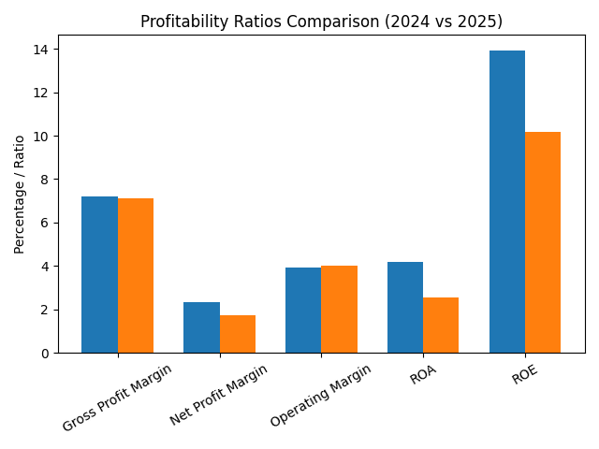
Figure 1: Profitability Ratios Chart.
Profitability ratios are used as a measure of the ability of a firm to make profits through its operation. Within the Tesco case, the gross profit margin improved in 2023 (5.145) to 2025 (7.224), which is an indication of a stronger capacity to control production and supply-chain costs. This expansion of the margins may also have been caused by the rise in food prices, which was accompanied by a modification of the pricing strategies. The retailers continually adjust the price structures in order to maintain the profit margins in the face of inflation and the rising costs of business.
In that manner, the net profit margin of Tesco increased by 0.128 per cent in 2023 to 2.326 per cent in 2025 due to a stronger cost control and efficiency in operation. Increase in the level of profitability is further supported by the change in the return on assets, (ROA) which rose at the end of the period of analysis by 1.607 per cent to 4.181 per cent.
The company return on equity (ROE) also recorded an impressive increase as it stood at 6.023% in 2023 and 13.938 in 2025 hence depicting increased returns to the shareholders. ROE and ROA are vital profitability metrics of organisational performance because these ratios indicate the effectiveness of the firms in using their resources to make profits (Krstic et al., 2023).

4.2 Liquidity Ratios
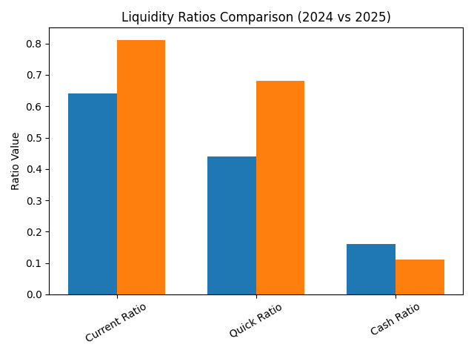
Figure 2: Liquidity Ratios Chart.
Liquidity ratios are used in assessing the ability of the firm to meet its short-term financial commitments. The current ratio of Tesco decreased slightly in 2025 as compared to that of 0.708 in 2023, albeit slightly, to 0.811 in 2024. This trend shows that Tesco has rather close working-capital ratios. However, the low liquidity ratios are observed to be prevalent in the grocery retail industry, which can be explained by the high turnover rates of inventory and the daily cash flow.
The quick ratio also decreased in 2023 to 0.566 to 2025 to 0.441 implying considerable dependence on the sales of inventory to cover short-term obligations. Conversely, the cash ratio went up by 0.113 in 2024 to 0.161 in 2025, which indicates that there is a slight increment in the availability of cash as compared to current liability. All in all, Tesco is on a stable liquidity position despite its existence in a highly competitive retail environment.

4.3 Efficiency Ratios
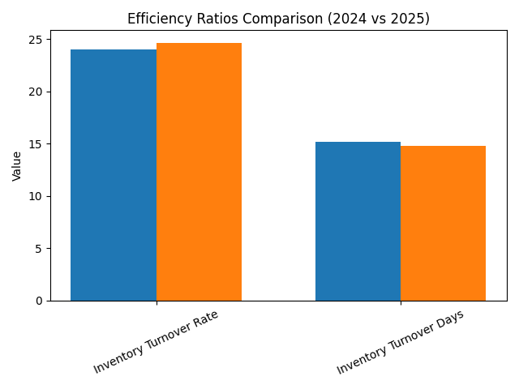
Figure 3: Efficiency Ratios Chart.
The efficiency ratios are used to determine how well a firm makes use of its base of resources so as to generate the revenues. In the background of the retail industry, the inventory management and optimisation of supply-chain activities is key to perpetuating operations. In this case, Tesco inventory valuation increased to about 2.5102.77billionPLN in 2023 to 2025, which is attributed to the increased product coverage and operational coverage of the retail chain.
Comparable efficiency indicators by Tesco give a clue about the efficiency of the company in handling inventory and resources. The ratio of inventory turnover was slightly reduced in 2025 as it was 24.61 times in 2024 and 24.01 times in 2025, which means that it was slightly slower in 2025 than it was in 2024. However, it can be noted based on history that a turnover value of over twenty is still a sign of good performance in the retail sector (Pham et al., 2021); therefore, Tesco is still deemed to be handling its stock efficiently and maintaining a high level of demand on its products. In line with this, the average inventory conversion period was raised slightly by 14.82 days to 15.20 days, which means that the amount of time that the goods spend in inventory before being sold was increased a bit. Nevertheless, the continuity of this amplified cycle fails to reduce Tesco achieving an effective inventory structure in comparison to the normal supermarket business practises where quick-selling products require frequent replenishment and effective inventory management.
The increase in Tesco return on assets (ROA) also highlights the fact that it is exploiting its assets base better. High asset productivity means that Tesco has managed to realise more revenue out of the current resources. Therefore, the establishment of effective logistics systems, streamlined store activities, and logistics supply chain comes out as critical factors that can underpin the overall efficiency of the operations of Tesco and the resultant financial outcomes.

4.4 Gearing Ratios
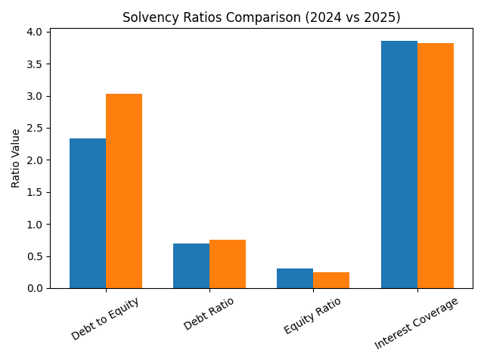
Figure 4: Solvency Ratios Chart.
Gearing ratios are quantitative measures of the capital structure of a firm, which outline the level of debt financing on the operations of a firm. The debt-to-equity ratio decreased by Tesco by 3.031 in 2024 to 2.334 in 2025 indicating that Tesco experienced a visible contraction in its financial leverage. An outcome of such a decrease in leverage is normally a decrease in financial risk and an increase in the general financial stability.
The debt ratio also decreased slightly, 0.752 in 2024 was reduced to 0.700 by 2025 which means that a smaller percentage of assets of Tesco are being funded by liabilities. This change is consistent with the results of Senan et al. (2021) who highlight that maintaining a balanced relationship between debt and equity financing is important to maintain financial flexibility in a way that limits risk.
The interest-coverage ratio of Tesco improved significantly as well, changing to 2.367 in 2023 to 3.854 in 2025. This positive trend is an indicator of an enhanced ability to finance interest payments with operating income, which implies a healthier capital base and is associated with a decrease in financial stress.

4.5 Investor Ratios
Investor ratios are used to evaluate returns that shareholders got and the appeal of a company to investors. The fact that Tesco has increased its return on equity (ROE) significantly by 6.023 per cent in 2023 to 13.938 per cent in 2025 shows a significant increase in the value creation by the shareholder. High profitability generally gives more confidence to the investors since it is the sign of efficiency of the management and long-term financial profitability.
Strong financial performance may have a positive outcome on the market perceptions of Tesco, and this will support its investment attractiveness. The companies, which continuously report efficient utilisation of resources and high profitability, have a greater chance of attracting long-term investors (Bajus, 2025).
Overall, the increase in the profitability and the financial stability of Tesco also means that the company has strengthened its financial performance during the period under consideration. Continued investments in digital retail systems and supply-chain optimisations can also increase the shareholder value in the future.

5. Critical Evaluation of Tesco’s Financial Performance

Financial Trends
The financial performance of Tesco in 2023-2025 indicates inconsistent improvement in the profitability and operational stability. The company announced the rising revenues and an increasing profitability rate, which means that the company had stronger cost control and pricing policies under the existing economic pressure. The level of profitability, including the return on equity and the return on assets, was significantly improved, and it gives an indication that corporate resources were used more efficiently. However, such developments should be viewed with some reservations, considering that the grocery retail industry has also been enjoying increased operation expenses, such as labour, energy, and logistics costs. In Europe, food retailers have been faced by increased price pressure, which can be explained by inflation and supply-chain shocks (Van Dam et al., 2021).
At the same time, Tesco has been able to achieve average sales revenue growth with remains able to maintain a competitive price. The company enjoys the advantage of massive scale operation, big collection of personal-label products and customer retention initiatives like Clubcard that help in customer attraction and retention. However, the issue of cost pressures remains one of the major challenges especially in areas like transportation, supplier cost, and store operations.

Industry Comparison
The grocery retailing industry of the United Kingdom is very competitive with some of the large retailers competing over the market. Tesco is still the biggest chain of supermarkets in the United Kingdom and its market share is around 28-percent, which is way above those of its other competitors (turn0search8; turn0search15). Sainsbury controls about 1516% and discount stores including Aldi and Lidl have gained a fast presence using low-cost measures (Savills India, 2023).
Table 2 Industry Comparison
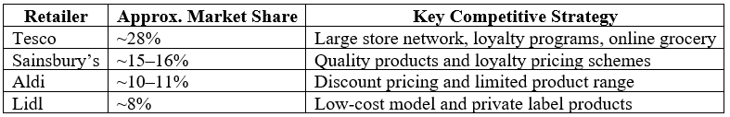
The size and efficiency of Tesco supply-chain make it led the competition with the discount stores and at the same time maintain the product diversity. Nevertheless, Aldi and Lidl still have cost-sensitive buyers through their aggressive pricing plans and rapid store growth. It is this competition that makes the traditional supermarkets like Tesco and Sainsbury keep on tightening their belt in terms of operations and price policies.
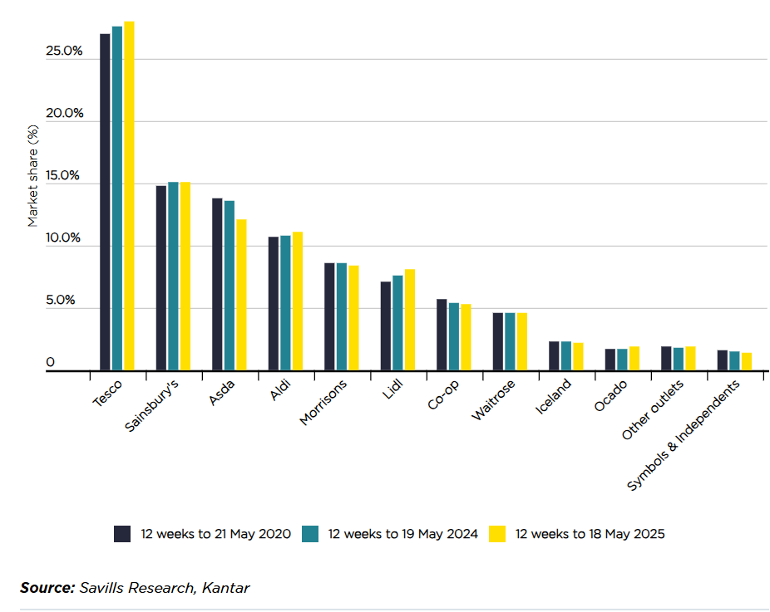
Figure 5: Grocery market share – 2020 v 2024 v 2025 (Savills India, 2023).

Key Factors Affecting Tesco
The financial performance of Tesco is defined by the combination of external and internal determinants. First of these is inflation which has soared the cost of food and operations in the entire retail sector. Soaring grocery costs have changed the consumer buying behaviour where many households are opting to buy cheaper substitutes and promotional bargains. In addition, the supply activities disruption, which is due to economic uncertainty in the world economy has increased transportation and logistics spending by retailers.
Moreover, there is the digital transformation which is a decisive factor. E-grocery shopping and e-commerce platforms have grown at an enormous pace, with retailers investing in fulfilment tools and e-commerce platforms (Ponzoa and Erdmann, 2021). Tesco has been enhancing its online services by increasing online delivery and using data-driven marketing strategies, which might serve as a basis of further development and improved customer engagement.

Limitations of Ratio Analysis
Despite the fact that ratio analysis is an important tool that can assist in understanding financial performance, it has quite a number of limitations. First, financial ratios are historical and this implies that they might not represent present or the future business situations with accuracy. Second, accounting policies among companies could be different and this can lead to differences in comparability of financial ratios; such as methods of determining inventory valuation or a depreciation policy could be used to determine reported profitability. Moreover, ratio analysis fails to capture qualitative variables like brand reputation, customer loyalty and effectiveness of management. Financial outcome can also be influenced by the external factors like inflation and competition in the market but are not clearly given in financial ratios. Ratio analysis is, therefore, a helpful tool to analyse the financial performance but should be supplemented with wider strategic and industry analysis to offer a more in-depth analysis.

6. Recommendations for Tesco Directors
Based on the financial analysis, several strategic suggestions can be made to increase the fiscal performance and competitive positioning of Tesco in the long run. To begin with, the company should strengthen its inventory control systems even more. Effective stock management may also minimise holding costs and waste within the stock and enhance product availability within the retail environment. The implementation of cutting-edge demand-forecasting systems and real-time inventory-tracking solutions would allow optimising the stock level and increasing the level of operational efficiency.
Second, Tesco needs to expand its online retail stores and online shopping. The fast growth of online grocery shopping has been observed within the last few years indicating that it is a strategic move to invest in the digital infrastructure that would enhance customer experience and lead to an increase in sales. Data analytics and personalised marketing approach can also be used to strengthen customer loyalty and increase market share.
Third, another aspect that the company should focus on is the optimisation of operations within its supply-chain. By making logistics networks more efficient, coordinating suppliers, and making them more efficient in the distribution, it is possible to reduce transportation expenses and improve the performance in the delivery. Supply-chain resilience is a strategic area subject to reinforcement especially in the face of uncertainty in the global economy. Lastly, Tesco ought to maintain stringent cost management and financial discipline, and shareholder value enhancement. Profitable cost-management tools and resource prudence are important in maintaining profitability and providing investors with long term payoffs.

7. Conclusion
Tesco PLC financial analysis of the 2023-2025 shows that the profitability and the operating performance is improving gradually. The main profitability ratios, net profit margin, return on assets and return on equity display increased values, which indicate better financial management and increased utilisation of the resources of the company. Despite the fact that liquidity ratios are rather relatively low, these values are characteristic of the grocery-retail industry due to the high inventory turnover and stable sales dynamics. The strategic decisions of Tesco are still influenced by competitive pressures like Aldi, Lidl and Sainsbury retailers. In general, Tesco maintains a sustainable financial situation, and further investment on digital platforms, supply-chain effectiveness, and cost-management can be advised to achieve long-term growth and value of shareholders.

References
Abbu, H., Fleischmann, D. and Gopalakrishna, P., 2021, June. The case of digital transformation in grocery business: A conceptual model of digital grocery ecosystem. In 2021 IEEE International Conference on Engineering, Technology and Innovation (ICE/ITMC) (pp. 1-9). IEEE.
Bajus, R., 2025. Analysis of key determinants affecting the performance of a food company through indicators return on assets and return on equity. Scifood, 19, pp.237-250.
Clark, R., Horstmann, I. and Houde, J.F., 2024. Hub-and-spoke cartels: Theory and evidence from the grocery industry. American Economic Review, 114(3), pp.783-814.
Dakora, E.A.N. and Rambe, P., 2022. The digital transformation of food and grocery retailing under the covid-19 pandemic: a case of major South African retailers. The Retail and Marketing Review, 18(1), pp.59-75.
Krstić, B., Bonić, L., Rađenović, T., Jovanović Vujatović, M. and Ognjanović, J., 2023. Improving profitability measurement: impact of intellectual capital efficiency on return on total employed resources in smart and knowledge-intensive companies. Sustainability, 15(15), p.12076.
Liu, F., 2024. Financial Statement Analysis Based on RNN-RBM Model. Journal of Electrical Systems, 20(1).
Nadales, M.C., The disruption of a digital transformation in the in-store experience of a traditional grocery store. 2020.
Olayinka, A.A., 2022. Financial statement analysis as a tool for investment decisions and assessment of companies’ performance. International Journal of Financial, Accounting, and Management, 4(1), pp.49-66.
Pham, D.C., Do, T.N.A., Doan, T.N., Nguyen, T.X.H. and Pham, T.K.Y., 2021. The impact of sustainability practices on financial performance: empirical evidence from Sweden. Cogent Business & Management, 8(1), p.1912526.
Ponzoa, J.M. and Erdmann, A., 2021. E-commerce customer attraction: Digital marketing techniques, evolution and dynamics across firms. Journal of Promotion Management, 27(5), pp.697-715.
Senan, N.A.M., Ahmad, A., Anagreh, S., Tabash, M.I. and Al-Homaidi, E.A., 2021. An empirical analysis of financial leverage and financial performance: Empirical evidence from Indian listed firms. Investment Management & Financial Innovations, 18(2), p.322.
Tesco PLC (2024) Annual Report and Financial Statements 2024. Available at: Tesco Annual Report 2024
Van Dam, I., Wood, B., Sacks, G., Allais, O. and Vandevijvere, S., 2021. A detailed mapping of the food industry in the European single market: similarities and differences in market structure across countries and sectors. International journal of behavioral nutrition and physical activity, 18(1), p.54.
Whiteoak, P., 2023. Rethinking efficient replenishment in the grocery sector. Logistics and Retail Management Insights into Current Practice and Trends from Leading Experts, pp.110-140.
Wolniak, R., Stecuła, K. and Aydın, B., 2024. Digital transformation of grocery in-store shopping-scanners, artificial intelligence, augmented reality and beyond: A review. Foods, 13(18), p.2948.
Yahoo Finance (2025) Tesco PLC (TSCO.L) balance sheet. Available at:
https://finance.yahoo.com/quote/TSCO.L/balance-sheet/
(Accessed: 8 March 2026).

2. PART 2 — Investment Appraisal Report

2. Introduction
Capital investment decisions form a critical part of organisational strategy as they determine the distribution of financial resources to long term projects that determine future growth patterns and profitability. An intensive investment appraisal process helps managers to evaluate potential projects, measure financial risk and choose those projects that provide the best return to shareholders (Farooq et al., 2022). Inefficient investments can lead to the creation of suboptimal investment decisions and result in resource waste and loss of money; hence, the careful financial analysis is an essential part of the successful strategic planning.
The current report attempts to question the new growth prospects of Westward Plc, an entity that manufactures luxurious curtains and residential furniture. As part of a four-year growth plan, the company is considering three possible investment opportunities: (i) its current retail shop expansion; (ii) the launch of online selling business; and (iii) the launch of new product lines, such as wooden blinds and Roman blinds. Using investment appraisal methods, this report evaluates all the alternatives in order to determine the one that is financially viable. The analysis thus aids the sound decision-making that is evidence-based and helps organisations target financial limitations in making long-term investment choices (Abdeljawad, Abu Alia and Demaidi, 2024).

3. Net Present Value (NPV) Analysis
Net Present Value (NPV) forms part of the most widely used investment appraisal methods in the modern-day financial management. It is a systematic assessment of profitability of investment projects, which compares the value of future cash inflows at present with the initial capital expenditure. The time value of money is explicitly paid in the methodology, thus considering the fact that the cash obtained in the future has a lower economic value compared to the cash obtained today (Sekhar, 2025). According to Sinaga et al. (2023), NPV is a very effective decision-making tool because it computes the estimated increase in shareholder wealth that can be attributed to an investment project.

NPV formula that will be used in the current analysis is:
$$NPV=∑\frac{Cash Flow}{\left(1 + r)^{t}\right.}-Initial Investment$$
Where:
r = discount rate (6%)
t = time period
The discount factors at 6% are:
Table 3 Net Present Value (NPV) Analysis
Year | Discount Factor (6%)
1 | 0.943
2 | 0.890
3 | 0.840
4 | 0.792
Corporation tax is 25 per cent as well as capital allowance is 20 per cent on a straight-line basis within a duration of four years. Tax-adjusted cash flow: cash flow operating is computed with tax deducted and capital allowance tax shield added to it.

Project A – NPV Calculation
Initial Investment = £600,000
Table 4 Project A – NPV Calculation
Year | Cash Flow (£000) | After Tax (75%) | Discount Factor | Present Value
1 | 200 | 150 | 0.943 | 141.45
2 | 400 | 300 | 0.890 | 267.00
3 | 500 | 375 | 0.840 | 315.00
4 | 700 | 525 | 0.792 | 415.80
Total PV of Cash Inflows = £1,139,250
$$NPV_{A}=1,139,250-600,000=£539,250$$

Project B – NPV Calculation
Initial Investment = £1,000,000
Table 5 Project B – NPV Calculation
Year | Cash Flow (£000) | After Tax | Discount Factor | Present Value
1 | 400 | 300 | 0.943 | 282.90
2 | 450 | 337.5 | 0.890 | 300.38
3 | 720 | 540 | 0.840 | 453.60
4 | 980 | 735 | 0.792 | 582.12
Total PV of Cash Inflows = £1,619,000
$$NPV_{B}=1,619,000-1,000,000=£619,000$$

Project C – NPV Calculation
Initial Investment = £1,600,000

Table 6 Project C – NPV Calculation
Year | Cash Flow (£000) | After Tax | Discount Factor | Present Value
1 | 450 | 337.5 | 0.943 | 318.26
2 | 700 | 525 | 0.890 | 467.25
3 | 900 | 675 | 0.840 | 567.00
4 | 1200 | 900 | 0.792 | 712.80
Total PV of Cash Inflows = £2,065,310
$$NPV_{C}=2,065,310-1,600,000=£465,310$$

Comparison of Investment Options
Table 7 Comparison of Investment Options
Project | Initial Investment | NPV (£)
A | 600,000 | 539,250
B | 1,000,000 | 619,000
C | 1,600,000 | 465,310
Through empirical analysis, it can be seen that all the three projects give positive net present values, thus signifying that the firm may potentially have its value increased through implementation. In spite of this fact, Project B achieves the highest NPV (PS619,000), therefore, proposing the most significant increase in shareholder wealth.
Financially, Project B is the most attractive option as a result of its high discounted cash inflows that are compared to the initial investment. The business focus of the programme on building online sales is congruent with the current trends in digital retailing and the growing tendencies to online purchases among the consumers.
In this regard, using the NPV evaluation, the Project B should be recommended to the Westward Plc board of directors. The positive NPV is an indicator of the projected payback exceeding the necessary cost of capital hence confirming the financial feasibility and lack of strategic objections of the project to the company.

4. Internal Rate of Return (IRR)
Internal rate of return (IRR) is an investment-appraisal method that is used to determine the discount rate where the net present value (NPV) of a project is zero. That is, IRR is the projected rate of return which is expected to be earned by a project during the whole life cycle. In the case where the IRR is higher than the cost of capital of the firm, it can be considered a financially acceptable investment as it is likely to give higher returns than the required rate of return (Huang et al., 2022).
Using the analysis of NPV above, Project B, which means building internet sales was found to be the best investment choice as the project would give the highest NPV. As a result, IRR of Project B has been calculated in order to further determine its financial worthiness.

IRR Formula
$$IRR=r_{1}+\frac{NPV_{1}}{NPV_{1}-NPV_{2}}×(r_{2}-r_{1})$$Where:
$r_{1}$= lower discount rate
$r_{2}$= higher discount rate

Step 1: NPV at 6%
From the previous calculation:
NPV at 6% = £1,158,660

Step 2: NPV at 30%
Discount factors at 30%:
Table 8 NPV at 30%
Year | Discount Factor
1 | 0.769
2 | 0.592
3 | 0.455
4 | 0.350

Year | Cash Flow | Discount Factor | Present Value
1 | 400 | 0.769 | 307.60
2 | 450 | 0.592 | 266.40
3 | 720 | 0.455 | 327.60
4 | 980 | 0.350 | 343.00
Total PV = £1,244.60
NPV =
1244.60 − 1000
NPV = £244.60

Step 3: NPV at 40%
Discount factors at 40%:
Table 9 NPV at 40%
Year | Factor
1 | 0.714
2 | 0.510
3 | 0.364
4 | 0.260
Year | Cash Flow | Factor | PV
1 | 400 | 0.714 | 285.60
2 | 450 | 0.510 | 229.50
3 | 720 | 0.364 | 262.08
4 | 980 | 0.260 | 254.80

Total PV = £1,031.98
NPV =
1031.98 − 1000
NPV = £31.98

Step 4: Approximate IRR
Using interpolation:
$$IRR≈40\%$$

Interpretation
The internal rate of return (IRR) was estimated at about 40 percent; this is very high as compared to the cost of capital of the company at 6 percent, thus making Project B economically feasible. In line with the claim of Lin (2023) that any project, which has a high IRR above the required rate of return, should be accepted, in general, because of the anticipated improvement of shareholder wealth, this outcome was the result in this IRR, which supports the previous net present value (NPV) finding that Project B should be preferred. The higher potential returns are in line with the strategic extension of the firm to online retail.

5. Evaluation of Investment Appraisal Methods
The methods of investment appraisal are widely utilised in determining the financial feasibility of long-term projects, and in supporting strategic decision-making. These techniques will help managers to determine whether a given investment is probable to yield adequate returns in terms of its expense. The Net Present Value (NPV) method is considered the most effective, among the existing ones, due to its ability to focus on shareholder wealth and maximise the value of money as time passes (Baum, Crosby and Devaney, 2021).

Why NPV is the Best Method
The major benefit of the NPV method is that it considers the time value of money therefore cash inflows in the future have lower value than cash inflows at the present. NPV provides a more realistic evaluation of economic value that a project creates by discounting future cash flows to the present value. This will enable organisations to rank projects on their ability to create value in the long run as opposed to simple accounting figures.
The other minor advantage of NPV is that it focuses on the wealth maximisation of shareholders. When the NPV is positive, a project enhances the value of the firm since the returns to the project will be more than the required rate of return. In this regard, projects that maximise the positive NPV will be selected to make sure that the corporate resources will be invested in ventures that yield the best financial returns to the shareholders.
Moreover, NPV is deemed to be more precise and holistic compared with most of other methods of investment appraisal. It takes into consideration all the project cash flows over the investment period and includes the cost of capital in the analysis. NPV is therefore more effective in assessing large or long-term investment projects that have financial risk as well as returns timing as a major factor of consideration.

Why Managers Still Use Non-Discounting Methods
Although NPV has its benefits, managers continue to use the less demanding methods like the Payback Period and Accounting Rate of Return (ARR). Payback method is used to estimate the time that an investment will be able to recover its cost thus being of help in determining the liquidity risk and the rate at which the capital is recovered by an organisation.
In the same manner, ARR approach measures performance of the investment using accounting profit and not discounted cash flows. Though the techniques fail to consider the time value of money, they are still popular due to their simplicity and ease of understanding. Managers tend to use such ways when a quick decision is required or when financial information is scarce (Hossain, 2024).
All in all, non-discounting techniques can add effective supplementary information; however, NPV is the most theoretically correct method of the investment decision evaluation due to the focus on the long-term creation of value and financial accuracy.

6. Capital Rationing Decision
Capital rationing is considered to be the procedure through which an enterprise, which has got a limited amount of investable funds, must decide on how best funds can be distributed among the available projects to the enterprise in order to achieve a maximum number of returns with the available budgetary limits. In Westward Plc case at hand, the company has the limit of PS2,500,000 on its investment ceiling. Seeing that the projects under consideration can be broken down, the company has the freedom to spread its resources across a variety of projects as opposed to having only one direction. In line with this, the task is to determine the portfolio of investments with the greatest cumulative Net Present Value (NPV) (Khan, 2024).
The above NPV calculations show that Project B produces the best NPV per unit of investment of capital, then Projects C and A. In order to maximise a return without breaching the PS2,500,000 limit, the company would invest the entire budget in Project B (PS1,000,000) and Project A (PS600,000), which would leave the company with a balance amount of PS900,000. The left-over capital may then be invested in part in Project C. This kind of distribution will help in ensuring that the funds available are utilised optimally hence maximising the total NPV and improving the overall profitability of the project (Purnamasari and Adriza, 2024).

Capital Rationing Investment Allocation
Table 10 Capital Rationing Investment Allocation
Project | Investment Required (£) | NPV (£) | Decision
Project A | 600,000 | 919,000 | Fully Invest
Project B | 1,000,000 | 1,158,660 | Fully Invest
Project C | 1,600,000 | 1,153,750 | Partial Investment (900,000)
Total Investment | 2,500,000 | Maximum Combined NPV | Optimal Allocation
This investment structure allows Westward Plc to gain the greatest financial advantage of the proposed expansion project without violating the required capital budget.

7. Sources of Finance
When considering the funding options of the proposed investment programme, Westward Plc should consider several financing options to fund its expansion programme. One source is internal finance specifically retained earnings, which refer to profits that are held back by the firm to be re-invested into the company instead of being distributed to shareholders. The main benefit of such a strategy is that it does not involve interest payments and other external debt costs. However, the use of only retained earnings can limit the amount of capital that can be used on large ventures.
Another option would be debt finance that includes bank loans and corporate bonds. Debt financing helps a company to raise high amounts of capital but retain control over ownership. The financing cost may be reduced since interest payments are tax-deductible (Berg, Saunders, and Steffen, 2021). However, high borrowings increase the financial risk and the payment of debts (Behera and Sethi, 2024).
Lastly, companies can turn to the market to finance their operations through equity, i.e. issue new shares. This strategy is effective in lessening the financial risk through the elimination of compulsory repayment, but it runs the risk of diluting the ownership and damping the power of its current shareholder (Liu, Wang, and Sun, 2022).

8. Final Recommendation and Conclusion
Following the investment appraisal analysis, project B, which would be the development of internet sales, stands out as the most suitable investment decision that should be made by Westward Plc. The project has produced the greatest Net Present Value (NPV
supplier of raw materials) and a healthy Internal Rate of Return (IRR), which means that the returns anticipated are much higher than the cost of capital of the firm. As a result, the investment is expected to improve on the shareholder value and long-term financial performance.
Taking into consideration the financing factor, the company should take a balanced approach to capitalization combining retained profits and moderate debt instruments (bank loans) to maintain financial flexibility and support the suggested expansion plan.

References
Abdeljawad, I., Abu Alia, M. and Demaidi, M., 2024. Financing constraints and corporate investment decision: evidence from an emerging economy. Competitiveness Review: An International Business Journal, 34(1), pp.208-228.
Baum, A.E., Crosby, N. and Devaney, S., 2021. Property investment appraisal. John Wiley & Sons.
Behera, S.N. and Sethi, M., 2024. Corporate Borrowings: A Conceptual Perspective. European Economic Letters (EEL), 14(1), pp.396-404.
Berg, T., Saunders, A. and Steffen, S., 2021. Trends in corporate borrowing. Annual Review of Financial Economics, 13(1), pp.321-340.
Burkert, M., Calderon, T.G., Hesford, J.W. and Turner, M.J., 2022. Azure Lodging, Inc.: A case study on capital budgeting with capital rationing in a service industry context. Issues in Accounting Education, 37(2), pp.67-89.
Farooq, U., Tabash, M.I., Al-Naimi, A.A. and Drachal, K., 2022. Corporate investment decision: A review of literature. Journal of Risk and Financial Management, 15(12), p.611.
Hossain, T.J., 2024. Methods for screening and evaluation of antimicrobial activity: A review of protocols, advantages, and limitations. European Journal of Microbiology and Immunology, 14(2), pp.97-115.
Huang, J., Tong, J., Wang, P. and Zheng, X., 2022, March. Application and comparison of NPV and IRR methods in the company investment decision. In 2022 7th International Conference on Financial Innovation and Economic Development (ICFIED 2022) (pp. 71-78). Atlantis Press.
Khan, A., 2024. Capital Rationing and Budget Allocation. In Fundamentals of Public Budgeting and Finance (pp. 329-367). Cham: Springer International Publishing.
Lin, J., 2023. A comparative study on the application of NPV and IRR in financial market investment decision. Academic Journal of Business & Management, 5(4), pp.51-54.
Liu, D., Wang, Y. and Sun, C., 2022. Industrial policy, corporate strategic differences, and debt financing cost. Asia-Pacific Journal of Accounting & Economics, 29(1), pp.36-52.
Nugroho, A., Putro, N.H.P.S. and Syamsi, K., 2023. The potentials of ChatGPT for language learning: Unpacking its benefits and limitations. Register Journal, 16(2), pp.224-247.
Purnamasari, P. and Adriza, 2024. Capital budgeting techniques and financial performance: a comparison between SMEs and large listed firms. Cogent Economics & Finance, 12(1), p.2404707.
Sekhar, S.C., 2025. Reassessing The Role Of Net Present Value In Capital Budgeting Decisions. International Journal of Research and Analytical Reviews. Sekhar, S.C., 2025. Reassessing The Role Of Net Present Value In Capital Budgeting Decisions. International Journal of Research and Analytical Reviews.
Sinaga, A.S., Sari, M.M., Hutasuhut, A.A., Zahara, S.T., Amanda, A., Fitri, A. and Caesario, M.A., 2023. Comparison of capital budgeting methods: NPV, IRR, PAYBACK PERIOD. World Journal of Advanced Research and Reviews, 19(2), pp.1078-1081.

D:\MBA\My Excel_maan.xlsx

