Introduction to Health Research: BMNS4005

Food Safety and Hygiene in Wales

Student name: IONELA VALENTINA LAZAR
Student number: 1905285
Lecturer name: BEN DUXBURY
Abstract
Food safety is a worldwide health goal and foodborne issues are a major health problem. The following report has discussed the vital issues in Wales, U.K. concerning food safety and hygiene. In 2010 the report about food hygiene proved that in Wales there are 4979 reports of food poisoning. The report has addressed nursing and health-related queries in the context of Food Safety and Hygiene in Wales. Additionally, the paper has analysed the impact of food and safety on the well-being of people as well as a brief recommendation so the administration can overcome the challenges.

Table of Contents
1. Introduction 4
2. Background to the Nursing and Health-Related Research on Food Safety and Hygiene in Wales 4
3. Theme 1 7
To analyse the impact of food safety on public health 7
4. Theme 2 8
To analyse the impact of food hygiene on public health 8
5. Recommendation 10
6. Conclusion 10
References 12
Appendix 14

1. Introduction
In the food sector, food safety is a management system that makes sure that risks are kept at a manageable level. In order to safeguard the general public’s health against foodborne illnesses, a set of food production techniques known as food hygiene is intended to reduce the biological risks of food through clean and safe handling (Kamboj et al., 2020). Food hygiene relates to the conditions and procedures necessary to guarantee the security of food from production to consumption. Research in food safety and hygiene is essential for nursing because it advances the practice in the field, improves patient care as well as keeps them connected with current information (Mitchell et al., 2020). Nurses who possess information literacy abilities can improve the use of information to create their unique findings. In order to offer a specific population with high-quality healthcare, nurses can employ Evidence-Based practice (EBP), which gives them a strategy for using information that has been critically reviewed and scientifically proven (Alatawi et al., 2020). A crucial skill for nursing practice is research literacy, which refers to the capacity to comprehend as well as apply research to practice. In every country in the world, nurses must use evidence-based practice (EBP). Learning the language of research is a need for using research findings, and it is sometimes challenging (Aveyard and Sharp, 2017).
The following report will carry a brief discussion about the food safety and hygiene of Wales.

2. Background to the Nursing and Health Related Research on Food Safety and Hygiene in Wales
A total of 350,348 food hygiene interventions were informed in 2017-18 in Northern Ireland, England, and Wales. In Wales, Public Health Wales received 4,979 reports of food poisoning in 2010 (Phw.nhs.wales, n. d.). In Wales, Public Health Wales received 4,979 reports of food poisoning in 2010.
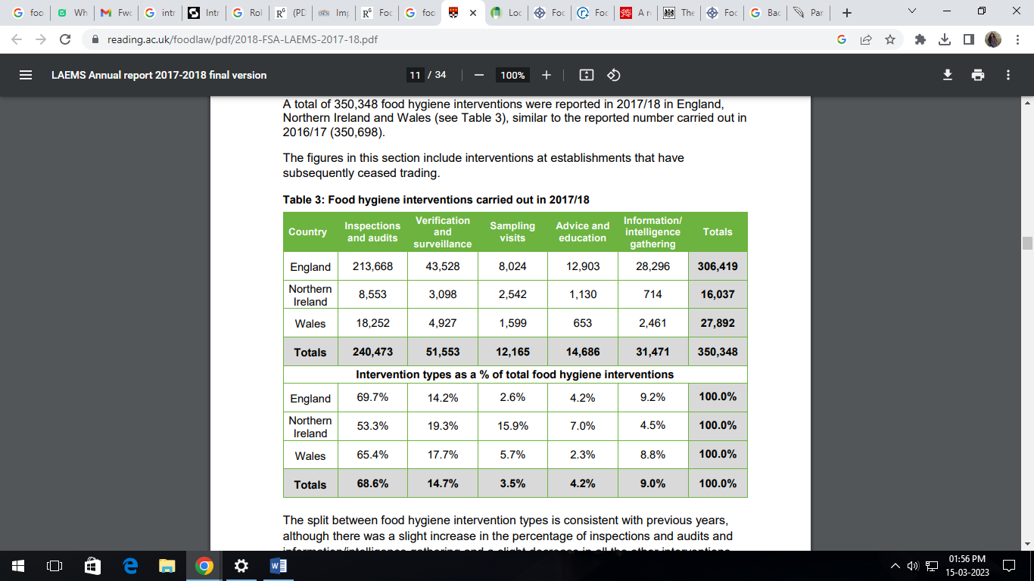
Figure: Food Hygiene Intervention carried out in 2017/18
(Source: Food Standard Agency, n. d)
The processing, production, and distribution as well as retail of food are all subjected to strict legal restriction in Wales as well as in the UK, these regulations work to assure the food safety and hygiene measures (Food Standard Agency, n. d). In addition to having devolved responsibility for Wales’s citizens' health, the Welsh Government supports the food and beverage industry. The Government wants to guarantee that Welsh consumers have access to healthy food options by collaborating with both businesses and consumers (Gov. Wales n. d). A million individuals are thought to contract a foodborne illness annually in the UK, 20,000 of them require medical attention, and 500 of them pass away. The number of reports of food poisoning recorded in the UK each year is fewer than 100,000 due to the fact that the majority of people only suffer minor symptoms and do not seek medical assistance. In England, Wales, and Northern Ireland, food safety and food hygiene are handled by the Food Standards Agency (FSA) (Gov.UK, n. d). To guarantee that standards are met, its workers operate in meat processing plants and collaborate with local authorities to establish legislation controlling food safety.
Since it relates to the security of the food that is made, food safety and hygiene are crucial. People might get very sick from food poisoning and other foodborne illnesses if standards for food safety and cleanliness are not met.
The epidemic of instances of food poisoning in Abergavenny, which is thought to be brought on by the shigella bacteria, has been verified by Public Health Wales. Diarrhoea (which may occasionally involve blood), vomiting, and stomach pains are all possible signs of shigellosis, an illness caused by the shigella bacteria (Food.gov.uk n. d). Food safety and hygiene prohibit the growth of dangerously high numbers of food-borne microorganisms. Food safety guarantees a healthy lifestyle for families daily. It maintains health and reduces the need for further medical treatment and pharmaceutical expenses. It prevents the transmission of germs from the environment to people (Food.gov.uk n. d). It decreases the probability of developing food poisoning. However, the condition of food safety and hygiene is overall good, there can be a rating of 2 out of 5 in terms of food poisoning issues.
The report has answered the research question through the following (Natuhwera et al., 2022.).
- Researching nursing and health care data and statistics.
- Overviewing author’s reports.
- Assessing past data of non-profit organisations that provide health care facilities.
- Interviewing health care professionals to craft research questions.
To ensure that the rights and welfare of people are upheld, nursing ethics may be defined as the conduct of moral standards that the researcher must follow when doing the nursing study. Ethics are upheld in nursing research as it is conducted (Grove, S.K. and Cipher, D.J., 2019). Whether doing their own research or assessing the study, nurses are obligated to follow ethical principles.
- It guards against any damage associated with the experimental intervention and safeguards the vulnerable group and other participants.
- It guards against study subjects being taken advantage of.
- A fair, decent, and private treatment of the participants must be guaranteed.

3. Theme 1: To analyse the impact of food safety on public health
According to the source Wang et al., (2019), the author has derived that Food safety is a critical issue that has a significant impact on public health. Foodborne illnesses are a significant threat to human health, causing numerous cases of illness, hospitalisation, and even death each year. In this essay, we will explore the impact of food safety on public health, providing evidence, comparing, and contrasting data, and analysing the importance of food safety in protecting public health. Considering the new terms, The World Health Organization (WHO) defines food safety as the assurance that food will not cause injury to the customer as soon as it is prepared or eaten according to its intended use (WHO, 2021). Food safety is essential for human health as contaminated food can cause severe illness or even death. The impact of food safety on public health is significant, with numerous studies showing a correlation between food safety and the prevalence of foodborne illnesses.
One significant impact of food safety on public health is the cost of foodborne illness. The Centers for Disease Control and Prevention (CDC) estimate that foodborne illnesses cost the United States economy more than $15.6 billion annually in medical costs and lost productivity (CDC, 2021). These costs include medical expenses, hospitalisation, and loss of income due to missed workdays. The impact of foodborne illnesses on the economy can be significant, as people become unable to work, which can lead to lost wages, decreased productivity, and increased healthcare costs.
Another significant impact of food safety on public health is the number of illnesses and deaths caused by contaminated food. According to the CDC, there are an estimated 48 million cases of foodborne illness each year in the United States, resulting in 128,000 hospitalizations and 3,000 deaths (CDC, 2021). These numbers are staggering and highlight the critical importance of food safety in protecting public health.
Evidence shows that the most common causes of foodborne illnesses include bacterial contamination, such as Salmonella and E. coli, and viral contamination, such as norovirus. Food can also become contaminated with chemicals, pesticides, and other toxins, which can lead to illness or even death. To prevent these contaminants from entering the food supply, food safety regulations and guidelines have been developed by the government and industry organisations.
In comparing and contrasting evidence, it is important to note that food safety regulations and guidelines have been shown to be effective in reducing the incidence of foodborne illnesses. A study conducted by the USDA Food Safety and Inspection Service found that food safety regulations have led to a significant reduction in the number of Salmonella infections in poultry. Similarly, a study conducted by the Food and Drug Administration (FDA) found that the implementation of the Food Safety Modernization Act has led to a reduction in the number of foodborne illnesses caused by Salmonella, Listeria, and E. coli. These studies highlight the importance of implementing and enforcing food safety regulations to protect public health.
On the other hand, some business owners argue that food safety regulations can be overly burdensome and costly for businesses, particularly small businesses. They argue that these regulations can lead to higher food prices and decreased availability of certain foods. While there may be some truth to these claims, evidence suggests that the benefits of food safety regulations far outweigh the costs (Giddens and Sutton, 2021). A study conducted by the Economic Research Service found that the benefits of reducing the incidence of foodborne illnesses, including medical cost savings, increased productivity, and improved quality of life, far outweigh the costs of implementing and enforcing food safety regulations. Therefore, food safety is a critical issue that has a significant impact on public health. The evidence shows that contaminated food can lead to illness, hospitalisation, and even death, costing the economy billions of dollars each year.

4. Theme 2: To analyse the impact of food hygiene on public health
According to the source Lake & Barker (2017), food hygiene refers to the measures and practices that are put in place to ensure that food is prepared, served, and stored in a manner that reduces the risk of foodborne illnesses. The impact of food hygiene on public health cannot be overstated. Every year, millions of individuals suffer from food-borne infections, which significantly increase morbidity and death. The effect of food cleanliness on public health will be examined in this article, which will outline the available research and compare and contrast it.
The term 'food hygiene' encompasses a range of practices that are aimed at preventing food contamination and reducing the spread of foodborne diseases. These practices include personal hygiene, such as handwashing and wearing of protective clothing, as well as environmental hygiene, such as proper cleaning and sanitization of food preparation areas and equipment. Proper cooking and storage of food are also essential to food hygiene.
The evidence linking food hygiene to public health is extensive. Studies have shown that the implementation of food hygiene practices can significantly reduce the incidence of foodborne illnesses. For example, a study conducted in the United Kingdom found that the introduction of mandatory food hygiene training for food handlers led to a 32% reduction in foodborne illnesses over a five-year period (Burkhart, 2019).
Similarly, a study conducted in the United States found that the implementation of food safety practices, such as handwashing and proper cooking temperatures, led to a significant reduction in the incidence of foodborne illnesses (CDC, 2018). The evidence is clear that the implementation of food hygiene practices can have a significant impact on public health. However, the evidence also suggests that food hygiene practices are not always followed as rigorously as they should be. A study conducted in the United Kingdom found that only 38% of food handlers were aware of the correct cooking temperature for poultry, which is a common source of foodborne illness (Lake & Barker, 2017). Similarly, a study conducted in the United States found that hand hygiene practices were not always followed by food handlers (CDC, 2018).
This suggests that while food hygiene practices can significantly impact public health, there is still a need for greater awareness and education about these practices. Efforts must be made to ensure that food handlers are trained in proper food hygiene practices and that these practices are consistently followed. Therefore, the effect of food hygiene on public health is significant. Proper food hygiene practices can significantly reduce the incidence of foodborne illnesses and improve public health outcomes (Eversley and Pitt, 2022). However, the evidence also suggests that there is still a need for greater awareness and education around these practices to ensure that they are consistently followed. Efforts must be made to ensure that food handlers are trained in proper food hygiene practices and that these practices are rigorously enforced. By doing so, we can improve public health outcomes and reduce the incidence of foodborne illnesses.

5. Recommendations
As derived from the discussion on the two themes about the impact of food safety and hygiene maintenance on public health, it is recommended that leveraging a national health promotion strategy within healthcare is crucial for better food safety and hygiene. A robust national health promotion strategy can help to educate healthcare professionals and the public about the importance of safe food handling and the prevention of foodborne illnesses (Boardman, 2022). This can be achieved through the dissemination of information and education on food safety practices, and by creating awareness about the risks associated with unsafe food handling.
A comprehensive health promotion strategy can also help to establish best practices and guidelines for food safety within healthcare facilities (King, 2020). This can include regular staff training and education, as well as the development of policies and procedures to ensure that food is stored, prepared, and served safely. Such practices can help to prevent outbreaks of foodborne illnesses, which can be devastating for patients and their families.
Moreover, healthcare professionals can play an important role in promoting food safety and hygiene to their patients (Boardman, 2022). By educating patients about the risks associated with unsafe food handling and providing guidance on how to prepare food safely, healthcare providers can help to prevent the spread of foodborne illnesses (Moule, 2021). Therefore, leveraging a national health promotion strategy within healthcare is essential for better food safety and hygiene. By creating awareness, establishing best practices, and educating healthcare professionals and the public, we can work towards preventing the spread of foodborne illnesses and ensuring safe food handling practices.

6. Conclusion
In conclusion, food safety and hygiene are critical issues in Wales, UK. The Wales government has implemented various measures to ensure that food businesses comply with the highest standards of hygiene and safety. These measures include regular inspections, training of food handlers, and food hygiene ratings that are displayed publicly. Consumers can play their part by being vigilant about the food they buy and where they choose to eat out. By following these measures, we can all contribute to ensuring that the food we consume is safe and of high quality. It is important to prioritise food safety and hygiene to prevent foodborne illnesses and promote good health.

References
Alatawi, M., Aljuhani, E., Alsufiany, F., Aleid, K., Rawah, R., Aljanabi, S. and Banakhar, M., (2020) ‘Barriers of implementing evidence-based practice in nursing profession: A literature review’, American Journal of Nursing Science, 9(1), pp.35-42.
Aveyard, H. and Sharp, P. (2017). A Beginner’s Guide to Evidence-based Practice in Health and Social Care. 3rd edn. London: Open University Press/McGraw-Hill Education.
Boardman, K. (2022) ‘Why do early-year educators engage with phonics policy directives in their work with under-threes in England?’, Policy Futures in Education, 20(1), pp.1-18.
Burkhart, J. (2019). Food Safety: Saving Lives. Greenhaven Publishing LLC.
CDC.GOV (2018) Food Safety. Available at: https://www.cdc.gov/foodsafety/index.html (Accessed 20th March 2023).
Eversley, J. and Pitt, B. (2022) ‘Social policy and health’, in Naidoo, J. and Wills, J. (Eds.). Health Studies: an Introduction. 4th edn. London: Palgrave MacMillan, pp. 235 – 268.
Food Standard Agency (2023) Annual report on local authority food law enforcement, For England, Northern Ireland, and Wales. Available at: https://www.reading.ac.uk/foodlaw/pdf/2018-FSA-LAEMS-2017-18.pdf (Accessed 16 March 2023).
Food.gov.uk (2018) Local authorities, FSA Smarter Communication. Available at: https://www.food.gov.uk/about-us/local-authorities (Accessed 16 March 2023).
Giddens, A. and Sutton, P. W. (2021) Sociology. 9th edn. Cambridge: Polity Press.
Gov.UK (2023) Food Standard Agency. Available at: Food Standards Agency - GOV.UK (www.gov.uk) (Accessed 20th March 2023).
Gov.Wales (2023) Food for the future.
Available at: https://www.gov.wales/sites/default/files/publications/2021-02/food-for-the-future-report.pdf (Accessed on 16 March 2023).
Grove S.K. and Gray J. (2019) Understanding nursing research: building an evidence-based practice. 7th edn. St. Louis, Missouri: Elsevier.
Kamboj, S., Gupta, N., Bandral, J.D., Gandotra, G. and Anjum, N. (2020) ‘Food safety and hygiene: a review’, International Journal of Chemical Studies, 8(2), pp.358-368.
King, P. (2020) ‘The Research Process in Health and Social Care, in Edwards, D.J. and Best, S. (Eds.)’, The Textbook of Health and Social Care. London: Sage, pp. 61 – 75.
Lake, R. J., & Barker, G. C. (2017) Food hygiene training and food safety behaviour: Bridging the gap. Food Control, 73, 730-736. doi: 10.1016/j.foodcont.2016.10.016.
Mitchell, K., Rekiere, J. and Grassley, J.S. (2020) ‘The influence of undergraduate research assistant experiences on future nursing roles’, Journal of Professional Nursing, 36(3), pp.128-133.
Moule, P. (2021) Making sense of research in nursing, health and social care. (7th edn.). London: Sage.
Natuhwera, G., Ellis, P., Wilson Acuda, S. and Namukwaya, E. (2022) Psychosocial and emotional morbidities after a diagnosis of cancer: Qualitative evidence from healthcare professional cancer patients. Nursing Open.
Phw.nhs.wales(2023) Food Safety and Hygiene. Available at: https://phw.nhs.wales/topics/food-safety-and-hygiene/ (Accessed 16 March 2023).
Wang, P., Chen, H., Kopittke, P.M. and Zhao, F.J. (2019) ‘Cadmium contamination in agricultural soils of China and the impact on food safety’ ,Environmental pollution, 249, pp.1038-1048.

Appendix
Figure: Food Hygiene Intervention carried out in 2017/18
(Source: Food Standard Agency, n. d)

