

BMSW4002
Effective Team Work and Communication
Lecture Joy Botu

Name: Oana Dediu
Student Number: 2027635

Table of Contents
Introduction 3
Models of Communication 4
Shannon and Weaver (1948/49) 4
Schramm (1954) 5
Berlo (1964) 7
Communication skills 8
Refer to Case 9
Examples of poor communication in the workplace 10
Suggestions to improve the communication process in the workplace 10
Conclusion 11
References 12

Introduction
The aim of this report is to address communication and different kinds of communication model as well as communication skills. Speech, writing, and signs may all be used to communicate thoughts, ideas, and information (Covey, 2015). People get more connected as a result of the conversation. In order to be successful in management, communication is a vital part of the whole process. It facilitates the flow of information and understanding between people and organizations. Barriers might distort the message, costing time and/or money by producing confusion and misunderstanding. To communicate effectively, one must overcome these obstacles. Poor communication might lead to poor morale. Employees may feel defeated if inefficient communication leads to misconceptions, missing opportunities, conflict, disinformation, and distrust (Kirk, 2017).

Models of Communication
There are many ways to think about the communication process, and these models enable us to better understand how it works. Models depict the process symbolically and metaphorically (Adam, 2018). They create broad views on communication by reducing communication to its simplest form and keeping its components in order. Shannon and Weaver, Schramm, and Berlo are three of the most well-known communication models in the world today.

Shannon and Weaver (1948/49)
The Shannon and Weaver Model of Communication divides human communication into six essential parts. These concepts are: sender; encoder; channel; noise; decoder and receiver (Carnegie, 2021). It is referred to as the "mother of all models" due to its widespread appeal. Because Claude Shannon was the primary developer of the theory, it is referred to as "information theory" or "Shannon theory." To describe how communications might be misunderstood in the process of transmitting and receiving a message, it's best known.

Figure 1: Components of Shannon and Weaver communication model (Reliable plant, 2021).
Sender
It all starts with a message, the receiver, and the mode of transmission selected by the information source.
Encoder
Shannon Weaver's model continues with the encoder. Converting a concept into a signal for transmission is the encoder's job, a machine or human.

Channel
Sending and receiving information is made possible through a communication channel, which serves as a conduit for information. It is also referred to as the 'medium.'
Noise
Noise disrupts communications in transit from sender to receiver. When we hear the word "noise," we think of it as something that interferes with our comprehension of what we're hearing. Internal and external noise may be found.
Decoder
The opposite of encoding is decoding. For phone-based communication, Shannon and Weaver developed this concept (Weaver, 2013). Messages are encoded in binary numbers or waves, and then decoded by a device that can comprehend them.
Receiver
The receiver is the Shannon and Weaver model's endpoint. Assuming noise has been factored in, here is when the message is ultimately understood.
In the case of Pedro and Maria, the real example of Shannon and Weaver’s model can be seen. Maria called Pedro when he was at the workplace and told him to bring chicken. Due to noise in the workplace and similarities between the words chicken and kitchen, Pedro misheard and wrongly interpreted that he would find Maria in the kitchen.
In such situation, feedback can be applied to avoid. For example, if one remains confuse he should ensure by giving feedback to the sender and clear everything. However, till now, I haven’t faced any such incident in my workplace.

Schramm (1954)
The flow of communication is shown using this model. Communications are two-way streets, with the message traveling back and forth from one person to another (Coleman, 2017).
Sender-to-receiver communication relies on understanding each other's intentions. For example, there's no way an art professor can teach past participle tense to students in second grade. Moreover, Schramm's model states that efficient communication requires both coding and decoding. As a result, he stresses that communication is not complete until the receiver provides input.
Many other communication models consider communication a one-way street where individuals either send or receive messages. In However, in Schramm's model, participants are overlooked in both ends. The instance of Pedro and Maria demonstrates this. Pedro may contact Maria again and inquire whether she said kitchen or chicken in this paradigm. These show the differences between the two models.
The Schramm communication model has four parts: encoder, decoder, interpreter, and message. According to this paradigm, communication is a two-way street, with information flowing both ways.
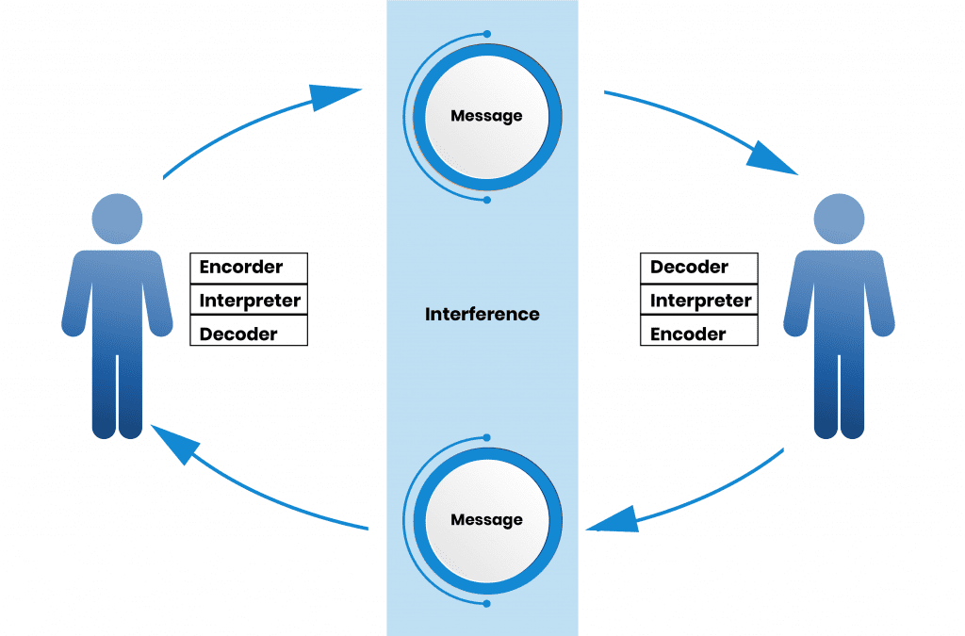
Figure 2: Process and factors of Schramm communication model (Universal class, 2019)
Encoder
Messages are encoded by the encoder, which converts them into codes. To convey the thoughts, people must choose the proper words and arrange them logically for the recipient.
Decoder
The individual receives the encoded message from the encoder and translates it into a language that the receiver can comprehend. Reading, listening, and other abilities are required to decipher a message.
Interpreter
The interpreter strives to comprehend and evaluate the communication. The message is interpreted. They are the same person. The message may be interpreted differently by each individual. In other words, they may have ‘misinterpreted' the text (Dockalikova, 2014).
Message
In language and communication, a message is a data. This information is conveyed via words or letters. Therefore, a message is the content of communication in the Schramm Communication Model.
According to this concept, the transmitter and receiver must encode and decode the message to send a message. This is critical to the message's efficacy and accuracy. Recipients are usually eager to understand what the sender means when they receive information. An unintelligible message from one person to another is pointless since it cannot be deciphered. As a result, decoding and encoding are two of the most critical communication factors. Thus, there is no need to worry about interference in this scenario.

Berlo (1964)
According to Berlo's model, effective communication is only possible when the sender and receiver are on equal ground. A message's intended impact may be thwarted if the recipient and sender are incompatible. The recipient must have excellent listening skills as well. Only the receiver is at the end of a linear communication process. When it comes to good and fluid communication, Berlo thinks the receiver's thinking pattern must mirror the sender's thinking pattern.

Figure 3: Berlo's model application in business (Business jargons, 2021)
In television advertising, the sender, the message, the channel, and the receiver are all involved in a one-way conversation. Sender-message-channel-receiver (SMCR) is the most fundamental method of communication we use today. This also happens to lack of communication gaps. For example, an Asian will frequently face this kind of problem when they go to England. The difficulties of accent which occurs due to listening skills will commit many misunderstandings. Sometimes, this may happen because of people’s attitudes. If a person doesn’t pay any attention to the speaker, miscommunication may arise.
The case of the professor and the village people are a perfect example of the Berlo communication model. In the case, when the professor’s house was burning and he went to village people and sought help using hard English which was beyond understandable for the village and they couldn’t understand him neither he got any help. This is happened because of the knowledge disparity between the professor and village people. People weren’t literate enough and hadn’t been knowledgeable enough to interpret his complex English sentence, which brought a communication gap and the professor didn’t get help.

Communication skills
Communication skills are the talents that people use while offering and receiving various types of information from other people (Gray, 2014). The ability to communicate effectively with others and oneself is critical to understanding the information at hand. Misunderstandings and frustrations are common when communication skills are inadequate.
Verbal communication skills
Using words to communicate with others is known as verbal communication. As a result, it may be used to both spoken and written communications. Many individuals, however, use the phrase to refer exclusively to oral communication. The words you use and the way they are heard and perceived are all part of the verbal component of communication.
Non-Verbal communication skills
Nonverbal communication includes eye contact, facial expressions, gestures, and more (Hulling, 2021). For example, a first smile indicates warmth, welcome, and openness. Whether they realize it or not, everyone employs nonverbal cues.
Nonverbal communication is vital since it talks about a person's mood, taking information, and how to approach them. A talent one may use at any level of your career is understanding nonverbal cues.
Active Listening
Active listening is the capacity to fully concentrate on a speaker, absorb their message, and reply wisely. In contrast to passive listening, in which the speaker's message is heard but not retained, active listening helps you engage and recall specific details without rehearse the material (Gladwell, 2015).
Active listeners utilize verbal and nonverbal cues to focus on the speaker. This helps you concentrate and ensures the speaker sees you interested. An engaged listener thoroughly examines the speaker's words and commits them to memory, rather than mentally rehearsing what you may say afterward.
Empathic listening
To better grasp what is being communicated, both academically and emotionally, empathic listening requires disciplined listening and questioning. It elevates active listening to a new level.
Empathetic listening might help avoid misunderstandings. The more you listen and try to understand people, the less likely one will misinterpret them.

Communication barriers face Barry
Barriers that Barry face in communication are given below:
Language barriers: Verbal communication might be difficult since not all staff are fluent in English (Scott, 2021).
Generational age barriers: "Texting and brief message have made the younger generation's vocabulary and grammar distinct from those of older employees. In terms of intergenerational communication, workplace views and attitudes may have an impact.
Cultural and ethnic barriers: Barry may have difficulty dealing with cultural variances in food safety procedures.
Nonverbal challenges: Barry's body language communicates to others that he is unconcerned with his appearance or cleanliness.
Emotional barriers: Emotional barriers may obstruct communication (Russell, 2013). Barry arrives to work after a rocky start. These unfavorable feelings influence his communication with staff.

Refer to Case
THE PROFESSOR and THE VILLAGE PEOPLE
Questions of this case are answered and referred to below:
Q1 Answer: When the professor asked for help from the village people screamingly saying ‘’A great conflagration is consuming the edifice’’. Village people didn’t help him because they couldn’t understand what he was saying then as he spoke difficult words which aren’t aware of the villagers. So, they didn’t help him out.
Q2 Answer: The professor should use simple and short words that are understandable to village people. For example, he could say just ‘’fire and house’’ people easily understand. But instead of saying fire or house, he used advanced English sentences and words such as edifice and conflagration, which are not familiar words and sentences that people speak.
Q3 Answer: Berlo’s communication model can explain this situation effectively than others.
Q4 Answer: To communicate effectively, the source and receiver must be equal, according to the Berlo model. Here in the case, it can be seen that the villager is not as knowledgeable as the professor. Hence, they could not understand the words of the professor when he was asking for help to stop the fire. Using this model, such situations can be tackled.
MARIA and PEDRO
Q1 Answer: Pedro misunderstood the word Maria because of building site noise which made the confusion between chicken and kitchen.
Q2 Answer: The Shannon and Weaver communication model and Schramm communication model can mainly explain this situation. This model is suitable when miscommunication occurs because of noise and misinterpretation from the receiver (Tools hero, 2021). Here in the case, Pedro misheard the word chicken in the kitchen which confused him. Therefore, these two models can explain the situation most effectively than others.
Q3 Answer: The misunderstanding from the case can be prevented through ‘’feedback’’. If Pedro had called back to Maria and asked whether she said kitchen or something else, the confusion could have been erased.
Q4 Answer: For Pedro and Maria's case, the Shannon communication model will be the best communication model to avoid such a situation. In this model, there are five parts where the receiver can show feedback to the sender in the end. Thus, if there is any confusion there, that can be avoided.

Examples of poor communication in the workplace
Because of poor communication, many problems may arise in the workplace (Lewis, 2020). For example, our manager speaks so fast in English that many workers couldn’t get what he wants in my office. Especially, foreigners face the problem mostly. The direction from the manager makes so confused that they become puzzled. And consequently, they couldn’t deliver the expected outcome in work.

Suggestions to improve the communication process in the workplace
The best way to improve communication is following the Schramm model in the workplace. As this is used in people of the same level, there won’t be any problem.
And following Shannon and Weaver model, the feedback option can be effectively used to improve communication style in the workplace, avoiding any confusion in the workplace (Merkert, 2015).
For foreign employees, an interpreter can be to understand them what managers say to them. Thus, the communication process can be improved.

Conclusion
The report is structured in a way to cover three communication models. And then, communication skills are also covered in the report. This is because communication has a vital role in every phase of life (Communication theory, 2021). After that, the case of Pedro and Maria and the Professor and the village people are addressed in the report. And in the end, a real-life example of my workplace about poor communication is discussed and suggested the communication model to improve the communication process.

References
Adam, T., 2018. Communication models in managing effective communication. The London Journal, 23(3), pp.85–95.
BusinessJargons, 2021. Implementation of Berlo’s communication model in business. [online] Available at: &lt; https://www.businessjargons.com/5386-business-berlo.html&gt; [Accessed 18 December 2021].
Carnegie, D., 2021. Shannon and Weaver communication model and its process. Bulletin of Western Society, 18(6), p.260.
Coleman, J., 2017. Implementation of Schramm communication model in business. Harlow: Pearson. British Journal of Business and Economics, Vol 7, No.5. pp.45-74.
Communication theory, 2021. Impacts of communication in our life. [online] Available at: &lt; https://www. https://www.communicationtheory.org//2/mccall5.asp&gt; [Accessed 18 December 2021].
Covey, S., 2015. Communication Process and Roles. Northampton, MA: Edward Elgar Pub.
Dockalikova, I., 2014. Functions of Schramm communication model in getting good communication style. Academic Conferences International Limited, 43(7), p.68.
Gladwell, D., 2015. A throughout Study on Communicational Skills. London, GA: Robin Collingwood & Brothers Publications.
Gray, L., 2014. Advantages of good communication skills. European Journal of Communication Management News, 43(7), p.68.
Hulling, J., 2021. Efficiency of non-verbal communication skills. Journal of World View, 9(5), p.323-333.
Kirk, C.T., 2017. Approaches for applying good communication model. Communication Research Journal, 28(5), pp.50–59.
Lewis, J. 2020. A study of having good communication in workplace. Harlow: Pearson. The Review of Business Studies, Vol 14, No.08. pp.135-169.
Merkert, R., 2015. Benefits of applying Shannon communication model in a management. Management Business and Accounting, 8, pp.13-22.
Reliable plant, 2021. Factors and components of Shannon and Weaver communication model. [online] Available at: <https://www.reliableplant.com/Read/130/shannon-model-roles> [Accessed 18 December 2021].
Russell, G., 2013. Barriers Towards Good Communication. Hoboken, NJ: John Wiley & Sons Ltd.
Scott, H., 2021. Language barriers in today’s world in communicating with people. Journal of Recent Affairs, 73(5), p.25.
Tools hero, 2021. Impacts of Shannon communication models in business. [online] Available at: &lt; https://www. https://www.toolshero.com//2/mccall5.asp&gt; [Accessed 18 December 2021].
Universal class, 2019. A details study of Schramm communication model. [online] Available at: <https://universalclass.com/schramm-model.html> [Accessed 18 December 2021].
Weaver, J., 2013. A Study on Communication Process. New York: McGraw-Hill Publication.

