

MASTER OF BUSINESS ADMINISTRATION
Strategic Management
LCMB7003

Assessment component: Individual report- Tesla

Lecturer’s name: Zulfiqar Khan
Student name: Noorfatima Mohammad Juned Khan Pathan
Student ID: 2433621
Word count: 5195
Date: 26-11-2025

Executive Summary
This report has been attentive to outline a strategy for Tesla's organisational growth into the Indian market is the aim of this paper. The external environment of the Indian market shows that both economic growth and consumer awareness of environmental issues are improving. Growing urbanisation, the expansion of the Indian EV industry, and consumers' growing concern for the environment all point to Tesla's potential for success in India. Tesla must contend with a fiercely tough rivalry, though. However, according to the internal audit, it can guarantee profitability in the new market because of its patented battery technology, charging infrastructure, brand image, and vertical integration. Its flagship products, such as the Model Y and 3, can also guarantee its success in India.
The company can employ greenfield investment as a market entry option to have ownership control while entering India in accordance with the market development strategy. However, Tesla must successfully execute its procedures, with a strong emphasis on having a good environmental impact. Tesla can use the TBL and BSC frameworks to assess its performance. It is recommended that the company emphasise localisation, invest in infrastructure development, and invest in training and development.

Table of Contents
1. Selection of organisation and target market 4
2. Comprehensive strategic analysis 6
Porter’s five forces 6
PESTLE analysis 8
Porter’s diamond model 12
Critical evaluation of analytical tools 15
3. Strategy development and formulation 16
4. Performance evaluation framework 23
5. Recommendations and conclusion 28
References 30
Appendices 36
Appendix 1: PESTLE analysis 36
Appendix 2: India’s inflation 37
Appendix 3: VRIO 38
Appendix 4: Sales of BEV in the US 39
Appendix 5: Ansoff matrix 40

1. Selection of organisation and target market
Business growth has been seen as a crucial move by companies to strengthen their competitive advantages in today's globalised environment. This is due to the fact that entering new overseas markets enables businesses to diversify risk and guarantee sustained growth in addition to increasing revenue and earnings by gaining access to a new customer base. In light of this, the current report's goal is to propose a strategy for Tesla's organisational growth into the Indian market.
Tesla Inc. is a world-leading company in EVs (Electric Vehicles), renewable energy solutions, and autonomous driving technologies. Founded in 2003 and led by CEO Elon Musk, its mission is “to accelerate the new world’s transition to sustainable energy” (Tesla, 2025). Tesla’s vision emphasises a future powered by clean energy and innovation through electric mobility, solar energy, and storage solutions. The company's mission includes increasing EV adoption, expanding and changing infrastructure, and achieving affordable clean energy products (Tesla, 2025). However, Tesla is a publicly traded company, Tesla is governed by a board of directors, although Elon Musk’s leadership and compensation have been closely examined in recent years.
Revenue | $95.7 Billion (in 2025)
Assets | $125.1Billion (in 2025)
Profits | $125.1 Billion (in 2025)
Market capitalisation | $1.39 Trillion (in 2025)
Table 1: Financial statements of Tesla
(Source: Forbes, 2025; Companies Market Cap, 2025)
Tesla’s organisation is vertically integrated, which allows the company to control its production, distribution, and service processes. Additionally, it manufactures electric cars, battery storage systems, and solar panels, also it updated its software like Autopilot and Full Self-Driving (FSD). Operating across automotive, technology, and renewable energy sectors, Tesla combines hardware, software, and data-driven innovation. Its main products include the Model S, 3, X, and Y vehicles, along with Powerwall and Megapack energy storage systems. Tesla’s competitive side comes from its integrated supply chain, battery technology, and growing changing network (Tesla, 2025).
Globally, Tesla has more than 100,000 people as employees, and its workforce includes engineers, designers, technicians, and manufacturing staff from different countries and backgrounds (Tesla, 2025). The company promotes innovation, high performance, and continuous learning. As a result, Tesla's workplace is renowned for being hectic and demanding, which reflects the company's aspirations, objectives, and hectic production schedules. Tesla's leadership demonstrates and emphasises cooperation, technical innovation, and devotion to being environmentally responsible; they also urge staff to think creatively and solve challenges (Tesla, 2025). Employees at Tesla now contribute to the development of energy storage systems and renewable energy solutions, which promote a future free of carbon emissions, and the company's innovation has expanded beyond automobiles.
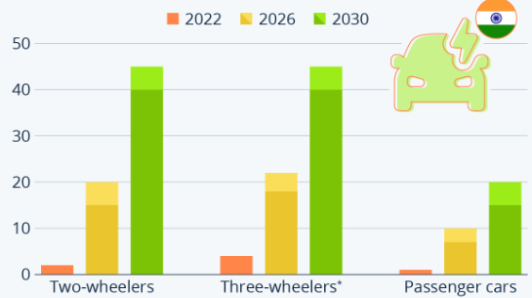
Figure 1: Growth of EV adoption in India
(Source: Buchholz, 2023)
The Indian market is being selected for Tesla's expansion, as India is paving the way for the widespread use of EVs. For evidence, in 2022, the percentage of electrically powered two-wheelers and three-wheelers in the nation exceeded that of electric four-wheeled passenger vehicles (Buchholz, 2023). By 2030, the proportion of BEVs (battery electric vehicles) amongst passenger cars with fewer than two wheels is predicted to rise at the fastest rate in the nation, reaching 40–45% (Buchholz, 2023). Until then, however, just 15–20% of Indian passenger-car sales are anticipated to be BEVs (Buchholz, 2023). According to this forecast, there will be around 30 million electric 2-wheelers, 6 million electric four-wheelers, and 770,000 electric three-wheelers on Indian roads by 2030 (Buchholz, 2023). By 2030, there will be approximately 930,000 small-cab commercial vehicles and around 175,000 buses, with adoption rates of 20–25% for light-duty trucks and 15–20% for buses, respectively (Buchholz, 2023). Heavy-duty vehicles have the slowest rate of EV adoption, similar to other parts of the world.

2. Comprehensive strategic analysis

Porter’s five forces
Forces | Impact | Justification
Threats of new entrants | Low | The barriers to entry are prominently high because there is a significant requirement of capital and investment in manufacturing for automobile businesses (Pavlínek, 2023). Besides, there is a requirement of brand recognition and service network that requires extensive knowledge and well-planned collaboration in terms of regulatory, safety norms, and government incentives can make a new entrant face heavy challenges in the market.
Bargaining power of buyers | High | Indian consumers are known to be very price sensitive, and small changes in fuel cost, price, and the shifting demand can be significantly challenging for businesses (Sinha, 2021). On the other hand, consumers are more aware of the safety, emissions, and EV options that influence their power in the market.
Bargaining powers of suppliers | Moderate | The Indian nation has a wide range of auto components suppliers; however, significant critical parts, such as in terms of advanced electronics, battery semiconductor chips, are prominently imported, which gives the suppliers a moderate power.
Threats of substitutes | High | The threat of substitutes is high because there are significant alternative options for personal vehicle ownership, along with public transport, such as buses, metro, and ridesharing (Ceder, 2021). On the other hand, due to the large availability of massive players in the market, it prominently leads to a rising and growing set of substitutes in the market.
Competitive rivalry | High | The industry is significantly growing at a rate of 61% while having a high competitiveness, as they are significant players, such as Hyundai, Tata Motors, and others (IBEF, 2025). Besides, it is identified that approximately 1,670,736 units have been sold in India between the year 2023 to 2024, which reflects that the current market is rapidly growing and is highly competitive (IBEF, 2025).
Table 2: Porter’s Five Forces
Considering Porter's five forces analysis, it can be stated that EV and new technologies are prominently shifting many of the forces. Besides this, government policy regulations are also playing a critical role. Furthermore, the global supply chain may have a risk of increasing the bargaining power of suppliers, which can prominently reduce the availability of substitutes. In addition to that, the changing consumer behaviour is also focusing on increasing the threat of substitution.

PESTLE analysis
PESTLE analysis refers to the external macro-environmental aspect that analyses external environments while focusing on political, economic, social, technological, and environmental factors (Khan et al. 2023) [Refer to Appendix 1]. In this regard, the external environment of India will be reviewed in the section that will be efficient for Tesla to understand the marketplace of the nation.
Factors | Justification | Impact
Political | - The latest value of the political stability of India is -0.64 points (The Global Economy, 2025)  - India's progressive aspects are profound, while having a stable government that is attracting investments | Medium
Economical | - Indian GDP accounts for $3912.69 billion (Trading Economics, 2025)  - The inflation rate is noted to have decreased from 0.27% to 1.54% in September 2025 (Trading Economics, 2025) | High
Social | - There is an increasing awareness of environmental issues among consumers (Rusyani et al. 2021)  - Growing urbanisation significantly reflects the boosting demand for last-mile mobility | High
Technological | - The Indian EV market is projected to witness a 22.4% growth, reaching $117.78 billion by the next 7 years (Fortune Business Insights, 2025)  - Automation and digitalisation are significantly transforming the supply chain and manufacturing aspects | High
Legal | - Industrial Employment Act, 1946 (CLC, 2025)  - The Patents Act, 1970 (India Filings, 2025) | Medium
Environmental | - There are rules for waste management aspects, along with a keen focus on the circular economy  - India's commitment towards global climate pressure can be undertaken with its target for net zero by 2070 (GOV, 2025) | High
Table 3: PESTLE analysis
Political factor
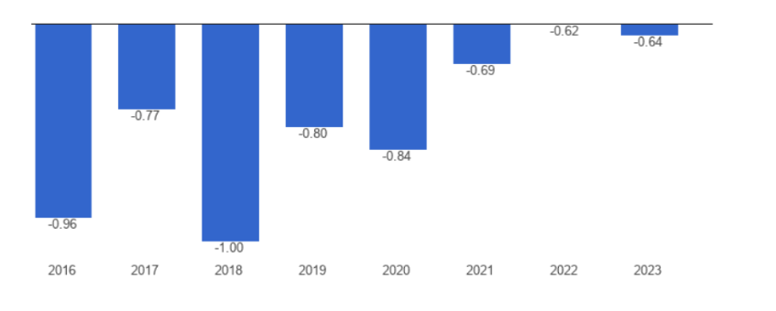
Figure 2: Political stability of India
(Source: The Global Economy, 2025)
The political factor reflects a medium impact on Tesla, as it has been identified that even though there is political instability in the nation; however, there is an aspect of stable government that can allow an organisation to operate successfully (The Global Economy, 2025). Regarding this, it has been noted that the progressive aspects of the nation are that the government is extensively focusing on attracting investments that can lead to a better market position for Tesla.
Economical factor
Economic factors reflect a high influence, as it has been noted that Indian GDP is significantly increasing, and it represents approximately 3.69% of the world economy, with a valuation of $3912.69 billion, as reflected in the figure below (Trading Economics, 2025).
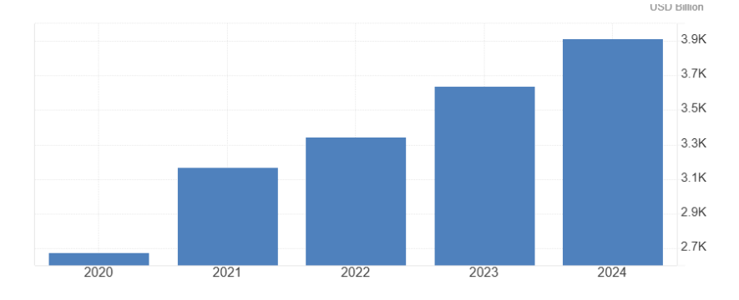
Figure 3: India’s GDP
(Source: Trading Economics, 2025)
Besides this, it has been identified that the inflation is also decreasing, reaching 1.54% which is a positive aspect for Tesla to operate in the Indian marketplace (Trading Economics, 2025) [Refer to Appendix 2].
Social factor
Reflecting on the social aspect, it has been identified that the Indian nation is identified to be rapidly growing in terms of urbanisation, which is reflecting on boosting the demand for mobility. Other than this, it has been noted that consumers are extensively focused on environmental issues, which might impact the consideration of EVs to safeguard the environment (Rusyani et al. 2021).
Technological factor
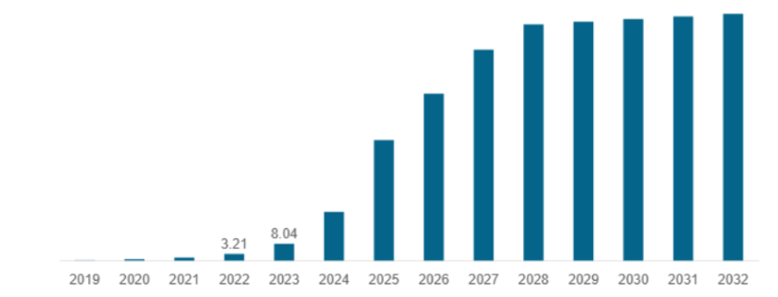
Figure 4: EV market in India
(Source: Fortune Business Insights, 2025)
The technological factor also reflects a positive aspect of Tesla's operation in India. Connecting to this, it is noted that the EV market is significantly growing with a rate of 22.4% as reflected above (Fortune Business Insights, 2025). Furthermore, digitalisation and automation are also prominently transforming the way businesses can manufacture their products and services.
Legal factor
In terms of legal factors, there are significant aspects that need to be considered by Tesla to operate in the marketplaces. For evidence, the Industrial Employment Act, 1946, and the Patents Act, 1970 (CLC, 2025; India Filings, 2025). Considering these legal guidelines, Tesla would be able to operate efficiently without facing any legal lawsuits.
Environmental factor
Environmental factors also reflect a high influence on Tesla, as it is noted that there are significant regulatory considerations towards the waste management aspect and the circular economy. On the other hand, it is also identified that India is extensively committing towards climate pressure and targeting net zero by 2070 (GOV, 2025).

Porter’s diamond model
Determinant | Condition in India (EV/Automotive Sector) | Effectiveness for Tesla
Factor Conditions | - Low-cost labour pool, established conventional auto manufacturing base, and strong R&D  - Deficient charging infrastructure  - Dependence on imports for key EV components, and high energy costs compared to other major EV markets | - Low labour costs are an advantage  - Lack of advanced EV-specific infrastructure and reliance on imported components create significant initial hurdles and raise production and logistics costs
Demand Conditions | - High population and rising middle-class income  - Growing environmental awareness and strong government targets like 30% EV sales by 2030 (GOV, 2025)  - The demand for reasonably priced two- and three-wheelers is currently very high; the luxury EV market is modest but rapidly growing (Buchholz, 2023) | - Large, sophisticated future market for passenger vehicles (Buchholz, 2023)  - Tesla could set the benchmark, but initial volume for premium cars will be low  - The pressure for high-mileage, affordable models may push Tesla toward lower-cost local development
Related and Supporting Industries | - Robust conventional automotive component supplier network.  - Emerging EV ecosystem with local manufacturers for batteries, motors, and power electronics  - Localisation efforts are gaining pace via PLI (Production Linked Incentive) schemes | - A strong traditional auto base provides manufacturing expertise  - Lack of a fully localised, world-class EV component supply chain forces Tesla to rely on imports or build a new supply chain, reducing efficiency
Firm Strategy, Structure, and Rivalry | - Intense domestic rivalry among local players such as Tata Motors, Mahindra, and global entrants like MG, Hyundai, who are rapidly launching models across segments, driving innovation and cost reduction (Fortune Business Insights, 2025)  - Domestic firms dominate the current EV segment | - The intense, rapidly evolving domestic competition will pressure the company to innovate, localise manufacturing, and adapt products to Indian road and climate conditions  - Tesla should enhance its service networks
Table 4: Porter’s diamond model
Due to its enormous demand conditions, including a huge population, rising income, and government EV targets, India presents a high-potential future market. Low-cost labour and a well-established traditional auto base, enabling factor conditions. Nevertheless, there are some obstacles, like the existing demand being biased towards reasonably priced 2-3-wheelers, and the factor conditions are inadequate in vital areas like a developed supply chain for EV components and charging infrastructure. In order to thrive in the face of fierce domestic competition, Tesla must quickly localise manufacturing, innovate for cost and range, and modify its networks of products and services.

Critical evaluation of analytical tools
Analytical Tool | Strengths | Shortcomings
Porter's Five Forces | - It is excellent for assessing industry attractiveness (Sumba-Bustamante et al. 2024)  - Micro-level competitive intensity analysis | - It neglects non-market forces like collaboration, dynamic, technological change and others
Porter's Diamond Model | - Beneficial in explaining the origins of national competitive (Sumba-Bustamante et al. 2024)advantages  - This tool links domestic factors to global success | - It heavily focused on tradeable industries  - It overlooks the impact of MNCs and globalised, fragmented value chains.
PESTLE Analysis | - It provides a comprehensive macro-environmental scan (Sumba-Bustamante et al. 2024)  - It is beneficial for the identification of external threats and opportunities | - Too broad  - Descriptive rather than prescriptive  - Lacks integration with internal firm capabilities
Table 5: Analysis of analytical tools

3. Strategy development and formulation
Using the idea of RBV (Resource-based view), organisational competitiveness is given by their tangible and intangible resources, with the VRIO (Value, Rarity, Imitability, and Organisation) attributes (Kero and Bogale, 2023) [Refer to Appendix 3]. With respect to this, for conducting an internal audit of Tesla, a VRIO analysis is conducted below-
Resources/capabilities | Valuable | Rare | Imitable | Organised | Competitive advantage
Brand reputation and image | ✓ | ✓ |  | ✓ | Short-term competitive advantages
Proprietary battery technology | ✓ | ✓ |  | ✓ | Long-term competitive advantages
Supercharger network and charging infrastructure | ✓ | ✓ |  | ✓ | Sustained competitive advantage
DTC (Direct-to-consumer) sales model | ✓ | ✓ |  | ✓ | Sustained competitive advantage
Vertical integration and manufacturing | ✓ | ✓ |  | ✓ | Sustained competitive advantage
FSD (Full Self-Driving) or autopilot technology |  | ✓ |  | ✓ | Potential sustained competitive advantage
Table 6: VRIO analysis
As noted in the above conducted VRIO analysis, key internal strength of the organisation that can help it to sustain growth in the Indian marketplace includes its brand recognition and reputation, technology, charging infrastructure, DTC model, and vertical integration, as they are positively contributing to its current competitiveness. In particular, with vertical integration and proprietary battery technology, the organisation can control costs as well as innovate rapidly, alongside avoiding disruptions in global supply networks (Persson, 2024). Along with selling cars, Tesla is also known for operating large-scale charging networks, which indicates the possibility for the organisation to successfully operate in India by offering a solution to public charging networks, along with selling vehicles. However, concerning FSD, as a resource, its value is noted to be partial; its autopilot and FSD technology have failed, as noted in the case of 2024 Model Y cars (Ohnsman, 2025).
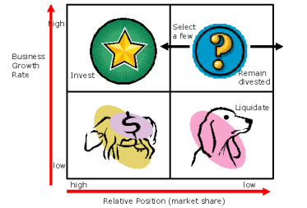
Figure 5: BCG matrix
(Source: Aprilia et al. 2023)
Besides, the BCG Matrix can also be applied to understand the strength of Tesla in terms of its product portfolio, driving competitiveness. The Matrix indicates that products with high growth and high share are of the star category, which should be supported with organisational investments (Aprilia et al. 2023). Regarding this, Model Y and Model 3 of Tesla are noted to have relatively high market share and growth rate, making them star category products. In support of this, combined sales of these models of Tesla are noted to have amounted to over 50% of the entire BEV battery electric vehicles market in the US (Autovista24, 2025). Specifically, the sales of Model Y and Model 3 in the US were around 36000 and 19000, respectively, as of June 2025 [Refer to Appendix 4].
Moreover, Model S and Model X can be regarded as cash cow category products for the company, as despite a low growth rate, they have relatively high market share. However, while this category of products needs reinvestment, Tesla is observed to have a limited focus on this aspect, as it has failed to update the vehicle models with notable changes to satisfy consumer demand and deal with market competition. Consequently, the decline in sales of Model S and Model X, as they limited their production, despite the ability of the company's factory to produce 25,000 cars of these models per quarter (Lewis, 2025). This indicates the failure of Tesla to reinvest in its cash cow category products, indicating a strategic failure.
Besides, its Cybertruck and Semi-Truck are noted to be question mark category products, as, despite having a small market share, these items are used in markets with rapid growth. Regarding this, the leader of Tesla, Musk, predicted its Cybertruck to witness around 250,000 annual sales, whereas the actual sales of this item in 2024 were below 40,000 (Ohnsman, 2025). Thus, for growing their market share and becoming future stars, there is a need to invest in them heavily or discard them. Furthermore, the Original Roadster of Tesla is categorised as a dog category product, as this is not significantly contributing to organisational revenue, having low growth and market share.
Key strategy formulation
The Ansoff matrix refers to evaluating growth initiative organisations to reflect on significant growth opportunities (Peterdy, 2025). These prominent strategies that existed in terms of “market penetration”, “product development”, “market development”, and “diversification” are referred to in the framework [Refer to Appendix 5]. Regarding this, while undertaking the objective of Tesla, “accelerating the world’s transition to sustainable energy” expansion of the organisation requires a “market development” approach that focuses on selling existing products into new markets (Rowland, 2025).
Considering the market development approach, Tesla can significantly introduce its EV models while building sales, service, distribution, and charging infrastructure. Considering greenfield investment, a kind of FDI (foreign direct investment), as a market entrance strategy in India might further promote this. Greenfield investment market entry strategies enable the development of human capital that may advance the company while boosting competition, as well as the creation of jobs while boosting economic growth (Ibarra-Olivo et al. 2024).
All of this can be supported with the opportunities in terms of strong government incentives, rising EV market growth, along EV penetration in the marketplace. However, there are significant limitations, especially in terms of buyer sensitivity and limited charging infrastructure, due to India being a developing nation. Combined with using government subsidies, the strategy of market expansion has significantly enabled Tesla to establish its full advantage in the premium EV category. Additionally, businesses may highlight the importance of having a robust network of charging stations, focusing on affluent urban clients, and successfully integrating localisation.
Regarding this, a proposed market development strategy, greenfield investment-oriented for Tesla in India has been structured in a tabular format.
Phase | Time horizon | Key action | Outcome
Phase 1: Establishing presence | 0-1 year | - Open flagship showrooms  - Set up service hubs  - Building a fast-charging station  - Engaging with government | - Validating market potential  - Addressing service gaps
Phase 2: Localising service and infrastructure | 1-2 years | - Expense service network  - Localised non-critical components  - Expand charging infrastructure | - Improved consumer experience  - Enhanced value proposition
Phase 3: Scaling | 2-4 years | - Set up an assembly facility  - Expanding product lineup  - Leveraging alliances with the government | - Cost efficiency  - Creating network presence
Phase 4: Long-term ecosystem leadership | 4-6 years | - Full-scale manufacturing  - Expanding Tesla energy | - Competitive advantage  - Cost leadership
Table 7: Strategy formulation for Tesla
Strategic objectives
According to Rowe et al. (2025), strategy implementation is the bridge between planning and performance, it creates a linking strategy formulation with measurable outcomes. It requires proper leadership, communication, and a supportive organisational structure. The primary objective which Tesla follows while planning to expand into the Indian market is to achieve long-term sustainable growth by penetrating into the emerging EV market while aligning with the environmental and industrial framework of India. This particular objective would further support Tesla’s mission of transitioning the world to sustainable energy (Tesla, 2025).
Key implementation strategies and implementing the strategies
A few procedures are necessary for a strategy to be implemented successfully. For example, in order for all teams to grasp what success looks like, clear objectives as well as efficiency indicators must first be established. As highlighted by Rowe et al. (2025), these processes help translate strategy into measurable progress and long-term growth. Thus, in relation to extrarenal analysis and internal analysis it can be stated that pursuing a market development strategy and a greenfield investment market entry strategy in India will be more fruitful for Tesla. These implementation steps are essential for the company to strengthen their position in the foreign market. However, the market development strategy focuses on expanding Tesla’s presence by targeting new customer groups and regions within India (Xiao, 2024). In order to lower import taxes and increase cost competitiveness, the greenfield investment approach entails creating a physical presence through manufacturing or assembly facilities (Calya Maheswari and Rasyidah, 2025).
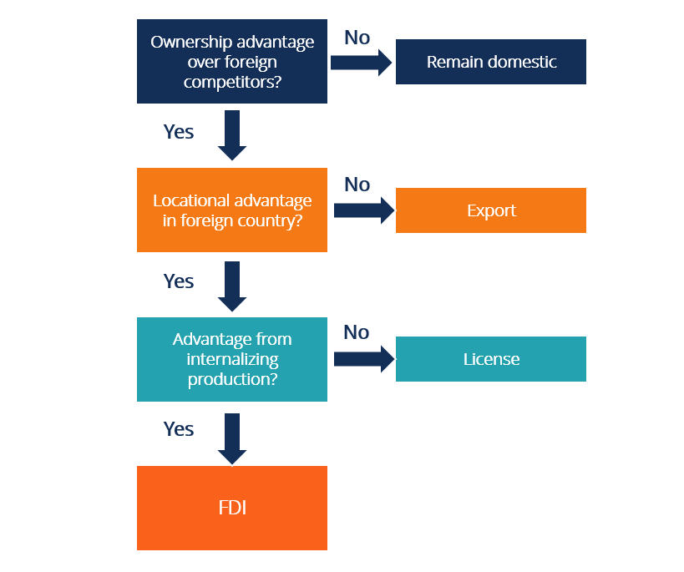
Figure 6: OLI Framework in alignment with FDI
(Source: Ashiru and Oni, 2022)
In order to implement these strategies, Tesla must reveal its market, financial, and internal information into its plans. In alignment with the Dunning’s Eclectic Paradigm (OLI Framework), greenfield investment, as an FDI would help Tesla with ownership advantages in relation to innovation (O), advantage with geographical location for which labour and production cost will be much less and government incentives will be high (L) and internalisation advantages (I) (Ashiru and Oni, 2022).
Based on the market entry strategy the overall entry into the Indian market should be phased in 3 parts
- Phase 1: During 2026-2028, Tesla needs to import and sell their top models like Model 3, Model Y mainly targeting customers from metropolitan cities like Delhi, Mumbai and Bangalore.
- Phase 2: During 2028-2030, Tesla would start establishing plants to manufacture their batteries and assemble products in alliance with localisation policies of India like “Make in India” and “FAME-II” (Faster Adoption and Manufacturing of Hybrid and Electric Vehicles) (IBEF, 2025).
- Phase 3: In this phase, new R&D would be set up by Tesla in order to develop designs and models which would comply with the Indian demands on EV.
These phases would further support the “market development” approach that focuses on selling existing products into new markets making it more practical for Tesla to grow in India (Rowland, 2025). However, to make these strategies work, Tesla is going to need to restructure several areas, like its supply chain and manufacturing structure must be redesigned to increase local sourcing and reduce logistics costs (Ibarra-Olivo et al. 2024). The company’s operational model must adapt to Indian conditions by developing region-specific production and service capabilities. Product designs may require reengineering to suit India’s climate, road conditions, and regulatory requirements. Thus, following these particular strategies the success factor of this expansion plan of Tesla in India will be more practical and achievable.

4. Performance evaluation framework
As Tesla emphasises expansion in the Indian marketplace, there is a requirement for it to pay attention to evaluating its performance. This is because performance evaluation with respect to KPIs (Key Performance Indicators) enables organisations to review their strategic alignment and their outcomes, which are beneficial for making strategic decisions for performance improvement (Al-Hosaini et al. 2023).
Performance measurement systems
Tesla can leverage appropriate systems for performance measurement, including BSC (Balanced Scorecard) and TBL (Triple Bottom Line), which are outlined below-
BSC
A BSC is a framework for strategic management that helps businesses put their goals into practice by evaluating performance from four main perspectives: learning and growth, internal processes, customers, and finances (Al-Hosaini et al. 2023). Based on this idea, a BSC has been designed below for Tesla’s performance measurement in India-
Perspective | Strategic goal | Key performance indicator | Target | Initiative
Financial | To achieve cost-competitive profit | - Profit margin per vehicle | - Increase profit margin per vehicle by around 10%, 12 months | The organisation must take initiative to establish a local gigafactory for leveraging the lower cost of production and get support from government incentives.
Customer | To accelerate the adoption of EVs in India | - Percentage of customers who can get a supercharger within 50 km of their home | - Achieving a 70% coverage in economically significant urban centres or tier-1 cities, 12 months | By leveraging its proprietary supercharging network, Tesla must rapidly build charging networks on major highways and metropolitan corridors in India.
Internal process | To guarantee localisation of the supply chain | - Percentage of vehicle components that are locally sourced | - Achieving at least 60% local sourcing by 12 months | Tesla needs to take the initiative to make partnerships with local suppliers of auto-components in order to localise the supply chain and build resilience.
Learning and growth | To enhance India-specific talent | - Percentage of local rolls within the company field with Indian individuals | - Attaining around 75% of local talent in various segments, including engineering cells and services, within 12 months | The organisation can launch India-specific training programs, which should have a focus on battery management software services and EV technology.
Table 8: Balanced Scorecard
Based on the above table, the BSC offers a comprehensive framework for Tesla's strategic implementation in India from four main angles. The financial objective is to develop a local Gigafactory and increase the profit margin per vehicle by 10% within a year in order to attain cost-competitive profit. Apart from that, reaching 70% supercharger coverage in key cities, the customer emphasis is pushing EV adoption. Besides this, establishing new supplier relationships, the Internal Process aims to achieve 60% locally sourced components in order to guarantee supply chain localisation. In addition, learning and growth seek to develop talent unique to India, with a target of 75% local recruits through specialised training in EV services and technology.
TBL, as an evaluation framework
TBL can be applied by Tesla as an evaluation framework while measuring performance in the new marketplace. “People”, “Planet”, and “Profit” are the three pillars of the TBL framework, which is used to assess a company's sustainability (Hamada et al. 2025). Using this framework, a performance evaluation measurement system has been developed below for the organisation-
TBL Pillars | Performance Area | Measurement | Target
Environmental | - Decarbonisation  - Manufacturing Footprint | Annual vehicle deliveries to displace fossil fuels  Gigafactory energy usage | - 10 million EVs per year  - Net-Zero Energy footprint, by 2030
Social | - Employee Safety  - Workforce Diversity & Inclusion (D&I) | - TRIR (Total Recordable Incident Rate) for manufacturing employees  - Proportion of women and members of under-represented groups in positions of leadership | - 25% reduction year-over-year (YoY) of TRIR until below the industry average  - 45% representation in senior leadership
Economic | - Financial health  - Local contribution | - Revenue growth  - Local procurement and the financial commitment made to new Gigafactory host areas | - An increase of 25% in total company revenue  - $15 billion investment in R&D (Research and Development) in new industrial hubs and the local supply chain
Table 9: Performance evaluation with TBL
As reflected in the above table, the TBL paradigm balances People, Planet, and Profit to evaluate Tesla's sustainable growth over the long run. In particular, the environmental pillar aims to attain a Net-Zero Energy footprint in manufacturing by 2030, track yearly vehicle deliveries that replace fossil fuels, and target 10 million EVs annually. Furthermore, the social pillar places a strong emphasis on diversity and worker well-being, with goals of 45% representation of underrepresented groups in senior leadership for D&I and a 25% year-over-year decrease in the TRIR for safety. Moreover, the economic pillar demands a $15 billion investment in regional R&D and supply chain growth, as well as a 25% rise in revenue.

5. Recommendations and conclusion
Recommendations
Emphasising localisation
Tesla is recommended to emphasise localisation by creating a local supplier base in the Indian marketplace. This is because a localised supplier base allows organisations to increase flexibility and control over their supplies in activities, along with lessening cost (Abdelaziz and Munawaroh, 2024). Localisation is the process of modifying products and services to make them more appropriate for a certain area, nation, or even city. By localising the supplier base, for required raw materials, Tesla can reduce operational costs, along with reducing the risk related to supply chain disruption as well as ensuring faster delivery. By promoting regional production and growth, this program will also help Tesla establish a favourable image in the Indian market. Businesses may modify their brand, goods, and services to appeal to a range of cultures, languages, and tastes by investing in localisation.
Investing in infrastructure development
In India, Tesla is recommended to invest in developing infrastructure, specifically supercharger networks. This is because with the acceleration of the supercharging network in India, the growth of EV adoption can be accelerated positively (Dutta and Padmanaban, 2025). In this regard, the organisation is advised to accelerate the supercharging network development by collaborating with local real estate and power service providing companies, especially in tier-1 areas. Additionally, the organisation is recommended to open the electrical charging network to EVs from other manufacturers in order to improve the whole ecosystem for EVs in India or get government backing for infrastructure expansion. There are several benefits to investing in infrastructure development, including increased economic growth, job creation, increased national productivity and competitiveness, and chances for reliable returns and diversification of portfolios for investors. This will guarantee government backing and favourable perception of Tesla in the Indian market.
Investing in training and development programs
The organisation is highly recommended to invest in employee training and development programmes in the new marketplace. This is because training and development programmes not only allow companies to have a skilled workforce but also ensure employee motivation and commitment toward work (Tumi et al. 2022). Furthermore, investing in training and development will allow the organisation to advance skills as well as transfer knowledge regarding its technology integration and procedures from the home market to this new marketplace. Organisations gain from investing in education and growth initiatives through increased staff productivity and retention, more creativity, and a more robust corporate culture.
In conclusion, Tesla has great potential to enter the Indian market and achieve success. This is because the external environment of the Indian market indicates that there is a positive economic growth along with increasing awareness among customers regarding environmental issues. Along with growing urbanisation, the growth of the Indian EV market, and growing environmental concern among customers also indicate the growth potential for Tesla in India. However, Tesla needs to deal with a highly competitive rivalry. Nonetheless, internal audit reflects that its brand image, proprietary battery technology, charging infrastructure, and vertical integration can allow it to ensure profitability in the new market. Its star products, like Model Y and 3, can ensure its success in India as well. In terms of the market development plan, the company can employ greenfield investment as a way to gain ownership control while entering the Indian market. For Tesla, however, effective process execution is crucial, with a strong emphasis on having favourable environmental effects. Tesla may utilise the BSC and TBL framework to assess its performance. Overall, it is concluded that there is great potential for Tesla to accelerate its financial growth by entering the Indian marketplace.

References
Abdelaziz, S. and Munawaroh, M., (2024). Mitigating supply chain vulnerabilities: a bibliometric analysis of sustainable logistics for resilience and risk management with perspectives on the automotive industry. International Journal of Automotive Science And Technology, 8(4), pp.544-588.
Al-Hosaini, F.F., Ali, B.J., Baadhem, A.M., Jawabreh, O., Atta, A.A.B. and Ali, A., (2023). The impact of the Balanced Scorecard (BSC) non-financial perspectives on the financial performance of private universities. Information Sciences Letters, 12(9), pp.2903-2913.
Aprilia, S., Lionora, C.A. and Aprilistyan, S.F., (2023). Formulating Strategy Through Boston Consulting Group Matrix In The Tourism Industry. Barista: Jurnal Kajian Bahasa dan Pariwisata, 10(02), pp.147-158.
Ashiru, F. and Oni, O., (2022). In support of Dunning's eclectic paradigm: A look at emerging market SME internationalisation to Nigeria. In International Entrepreneurship in Emerging Markets (pp. 316-332). Routledge.
Autovista24, (2025). Which models led the US EV market in the first half of 2025? [Online]. Available at: https://autovista24.autovistagroup.com/news/which-models-led-the-us-ev-market-in-the-first-half-of-2025/ [Accessed on 17 October 2025]
Buchholz, K., (2023). India's EV Growth Expected to Focus on 2W and 3W Markets. [Online]. Available at: https://www.statista.com/chart/29091/india-ev-by-vehicle-type/?srsltid=AfmBOopUjZxaTzDnAthSiq-978CP5umh--c_G34lKwShyCM6FiDn9gtS [Accessed on 25 November 2025]
Calya Maheswari, K. and Rasyidah, R. (2025) ‘Analysis of BYD’s market-seeking FDI strategy in the Thai electric vehicle industry: An eclectic paradigm perspective’, Indonesian Journal of Business Analytics, 2(1), pp. 33–45.
Ceder, A., (2021). Urban mobility and public transport: future perspectives and review. International Journal of Urban Sciences, 25(4), pp.455-479.
CLC, (2025). Chief Labour Commissioner (Central). [Online]. Available at: https://clc.gov.in/clc/labour-law [Accessed on 17 October 2025]
Companies Market Cap, (2025). Market capitalization of Tesla. [Online]. Available at: https://companiesmarketcap.com/inr/tesla/marketcap/ [Accessed on 25 November 2025]
Dutta, A. and Padmanaban, S., (2025). Shaping India’s EV future: a policy framework inspired by global best practices. Academia Green Energy, 2(2), pp. 1-14.
Forbes, (2025). Tesla. [Online]. Available at: https://www.forbes.com/companies/tesla/ [Accessed on 25 November 2025]
Fortune Business Insights, (2025). India Electric Vehicle (EV) Market Size, Share & Industry Analysis, By Platform. [Online]. Available at: https://www.fortunebusinessinsights.com/india-electric-vehicle-market-106623 [Accessed on 25 November 2025]
Fortune Business Insights, (2025). India Electric Vehicle (EV) Market Size, Share & Industry Analysis, By Platform {Two Wheeler, Three Wheeler, Four Wheeler, By Vehicle Type (Passenger cars and Commercial Vehicles) and By Propulsion Type (Battery Electric Vehicle (BEV), and Hybrid Electric Vehicle (HEV))}, and Regional Forecast, 2024-2032. [Online]. Available at: https://www.fortunebusinessinsights.com/india-electric-vehicle-market-106623 [Accessed on 17 October 2025]
GOV, (2025). Electric Vehicles. [Online]. Available at: https://www.psa.gov.in/mission/electric-vehicles/36 [Accessed on 25 November 2025]
GOV, (2025). Ministry of Science & Technology. [Online]. Available at: https://www.pib.gov.in/PressReleaseIframePage.aspx?PRID=1961797 [Accessed on 17 October 2025]
Hamada, M.Q., Kurnia, S.K., Fadhulloh, A.A.N., Nugraha, V.E. and Pandin, M.Y.R., (2025). Integration of Triple Bottom Line (People, Planet, Profit) in Sustainability Accounting and Reporting in Manufacturing Companies. Lead Journal of Economy and Administration, 4(1), pp.12-21.
Ibarra-Olivo, J.E., Neise, T., Breul, M. and Wrana, J., (2024). FDI and human capital development: A tale of two Southeast Asian economies. Journal of International Business Policy, 7(3), pp.314-336.
IBEF, (2025). India opens doors to global electric vehicle (EV) giants with portal launch under scheme to promote manufacturing of electric passenger cars in India (SPMEPCI). Government of India. Available at: https://www.ibef.org/news/india-opens-doors-to-global-electric-vehicle-ev-giants-with-portal-launch-under-scheme-to-promote-manufacturing-of-electric-passenger-cars-in-india-spmepci [Accessed on 15 October 2025].
IBEF, (2025). India's Electric Vehicle Revolution: Trends, Challenges and Opportunities. [Online]. Available at: https://ibef.org/research/case-study/india-s-electric-vehicle-revolution-trends-challenges-and-opportunities [Accessed on 17 October 2025]
India Filings, (2025). Intellectual Property Laws in India. [Online]. Available at: https://www.indiafilings.com/learn/intellectual-property-laws-in-india/ [Accessed on 17 October 2025]
Kero, C.A. and Bogale, A.T., (2023). A Systematic Review of Resource-Based View and Dynamic Capabilities of Firms and Future Research Avenues. International Journal of Sustainable Development & Planning, 18(10), pp.3137-3154.
Khan, U.U., Ali, Y., Petrillo, A. and De Felice, F., (2023). Macro-environmental factors and their impact on startups from the perspective of developing countries. International Journal of Sustainable Engineering, 16(1), pp.166-183.
Lewis, M., (2025). Competitor exec speaks out as EV sales surpass Tesla's Model S: 'Nothing has changed in 12 years'. [Online]. Available at: https://finance.yahoo.com/news/competitor-exec-speaks-ev-sales-233000775.html?guccounter=1&guce_referrer=aHR0cHM6Ly93d3cuZ29vZ2xlLmNvbS8&guce_referrer_sig=AQAAAJMG_5Pqky76Q3P8tr0-Hp6TkGNnCxMS71pvkBnAHzOaO9sT6a6TPX9FeMaUzp4Uqg5NNnY4jOJNN6CT6oO09u38XVgnCmy4y7DV_mNBd887hHlDay9XswupXXE6YTXxEYV5FWDT_Lh_lPTLqFy_ru6vB2Mkg10BS_2KRf_8Sqd7 [Accessed on 17 October 2025]
Ohnsman, A., (2025). Elon Musk’s polygonal pickup is a polarizing sales flop that's missed the billionaire’s volume goal by a staggering 84%. And there’s no sign that things are improving.. [Online]. Available at: https://www.forbes.com/sites/alanohnsman/2025/04/03/elons-edsel-tesla-cybertruck-is-the-auto-industrys-biggest-flop-in-decades/ [Accessed on 17 October 2025]
Pavlínek, P., (2023). Transition of the automotive industry towards electric vehicle production in the east European integrated periphery. Empirica, 50(1), pp.35-73.
Persson, E., (2024). Tesla: Leading the EV Revolution. [Online]. Available at: https://quartr.com/insights/company-research/tesla-leading-the-ev-revolution [Accessed on 17 October 2025]
Peterdy, K., (2025). Ansoff Matrix. [Online]. Available at: https://corporatefinanceinstitute.com/resources/management/ansoff-matrix/ [Accessed on 17 October 2025]
Rowe, W.G. et al., (2025). ‘Creating effective strategy implementation: A systematic review of managerial and organisational levers’, Review of Managerial Science, 19(4), pp. 1223–1251.
Rowland, C., (2025). Tesla’s Mission Statement & Vision Statement (An Analysis). [Online]. Available at: https://panmore.com/tesla-motors-inc-vision-statement-mission-statement-analysis [Accessed on 17 October 2025]
Rusyani, E., Lavuri, R. and Gunardi, A., (2021). Purchasing eco-sustainable products: Interrelationship between environmental knowledge, environmental concern, green attitude, and perceived behavior. Sustainability, 13(9), p.4601.
Sinha, R., (2021). Effect of Price Sensitivity on Consumer Behaviour in the Indian Retail Sector. European Business Review, 34(1), pp.1209-1214.
Sumba-Bustamante, R.Y., Cantos-Figueroa, M.D.L., Santistevan-Villacreses, K.L., Soledispa-Rodríguez, X.E., Nieves-Lizárraga, D.O., Cervantes-Martínez, L., Ultreras-Rodríguez, A., Olguín-Martínez, C.M., Triana-Garcia, R.W., Delgado, D.R. and Valencia-Ortiz, D., (2024). Strategic model for strengthening smes: An empirical study based on porter’s five forces. Journal Of Infrastructure, Policy And Development, 8(10), pp.1-22.
Tesla, (2025). About Tesla. [Online]. Available at: https://www.tesla.com/about [Accessed on 17 October 2025]
The Global Economy, (2025). India: Political stability. [Online]. Available at: https://www.theglobaleconomy.com/India/wb_political_stability/ [Accessed on 17 October 2025]
Trading Economics, (2025). India GDP. [Online]. Available at: https://tradingeconomics.com/india/gdp [Accessed on 17 October 2025]
Trading Economics, (2025). India Inflation Rate. [Online]. Available at: https://tradingeconomics.com/india/inflation-cpi [Accessed on 17 October 2025]
Tumi, N.S., Hasan, A.N. and Khalid, J., (2022). Impact of compensation, job enrichment and enlargement, and training on employee motivation. Business Perspectives and Research, 10(1), pp.121-139.
Xiao, N. (2024). ‘An analysis of Tesla’s disruptive innovation strategy’, Advances in Economics, Management and Political Sciences, 131, pp. 58–66.

Appendices

Appendix 1: PESTLE analysis
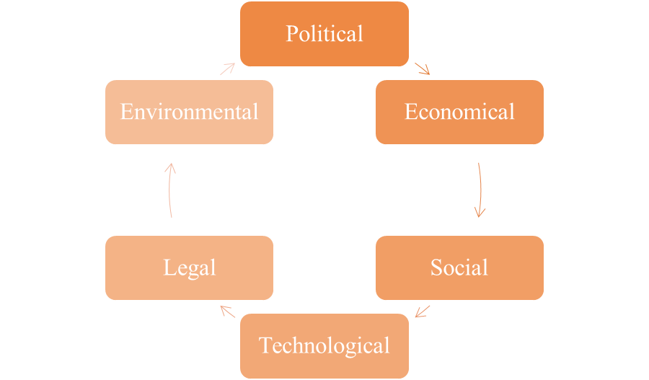
(Source: Self-created)

Appendix 2: India’s inflation
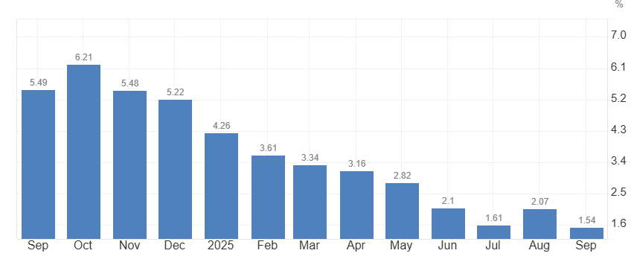
(Source: Trading Economics, 2025)

Appendix 3: VRIO
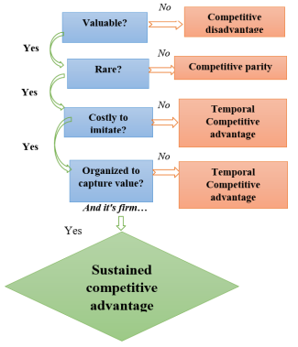
(Source: Kero and Bogale, 2023)

Appendix 4: Sales of BEV in the US
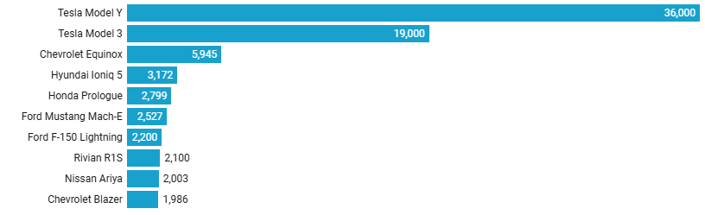
(Source: Autovista24, 2025)

Appendix 5: Ansoff matrix
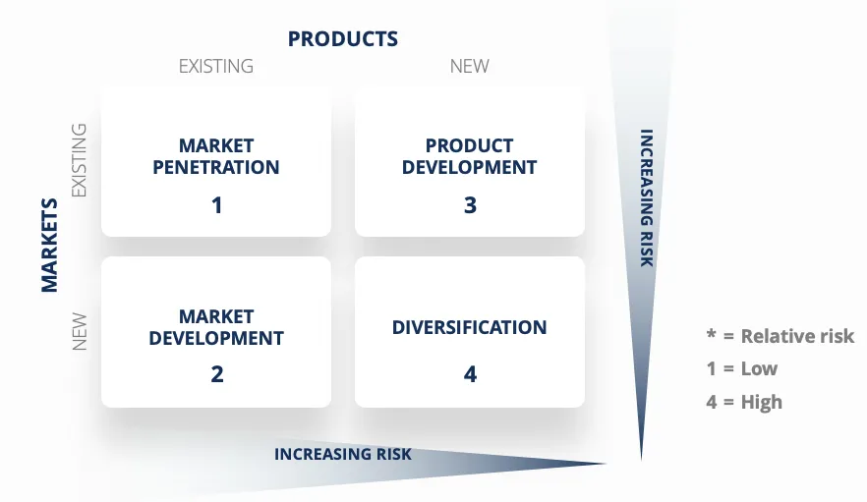
(Source: Peterdy, 2025)

