Module Name – The Global Business Environment
Teacher Name- Gazi Arif
Student name &number – Bres Elisabeta – 1806711

Environmental analysis of an industry

Table of Contents
Introduction 3
A) Assess the environment of the global automobile industry using PESTEL analysis. 4
B) Assess the environment of global automobile industry using Porter’s Five Force Analysis. 7
Conclusion 10
References 11

Introduction
Environmental analysis is a strategic tool or a process used to identify the external or internal environment which may affect the working and growth of an organization. It may also become a hindrance in long-run decision making if properly not introspected. It is done to identify the threats and opportunities in the environment, which may help the industry or organization to plan their working accordingly. These analyses also help in getting in touch with the rapidly changing environment especially in context with government rules, technology up gradation, competitors strategies etc through scanning. In this following assignment, environment analysis and its tools have been taken into consideration in relation to Car production in Eastern Europe. The car manufacturing globally came into existence during the 20th century. But in Europe, it came into existence 130 years ago. They were the first one to bring people from horse cars to four wheels car and bring a revolutionary change in the global market. Currently, this industry has registered 15.5% high performance in the year 2017, and still, it is growing leaps and bounce (Dr Konrad et. al., 2018).

A) Assess the environment of the global automobile industry using PESTEL analysis.
PESTEL analysis is the macro-environmental factor used identifies threats and opportunities in the market. It analyses the political, environmental, social, technological, economical as well as legal factors in the business environment of the industry and hence provide the proper framework which help in the easy and smooth functioning of the industry.
PESTEL Analysis of Eastern Europe car industry:
Political: - In order to execute or operate successfully, there is a need for the industry to get regulated. This factor includes the policies and the processors made by the ruling government, which keeps on changes every now and then whenever the party changes. In the year 1994, there were drastic changes has been seen in the European countries from communism to Democratic Party thou and fro was aggressively taking place which was affect the automobile industry very badly. Due to this industries were not able to arrange funds for there working coz of the less money flow into the system. This situation leads to open doors for outside trade or international trade which introduces the outside country to do trade and by this, they exchange their currency. This brings foreign investment into existence and reduces the issue of funds for the industry. The first exchange was taken place between Latin America and Europe. This factor is very much crucial for any industry because its change whenever the party changes. So, to survive into the system the industry must be in touch with these parties and with the change they bring after a certain time to compete in the long run.
Economic: - This factor includes the money flow into the system and value of the currency in the global market. This factor includes cash inflow and cash outflow into the economy and inflation or deflation or some kind of economic crises the country is facing. This factor creates a huge impact on the industry coz it may increase the trade rates by increasing the imports or exports duties or by increasing the rates of the products into the market. Globally also industry may get affected as some country is facing some kind of issue which has to be resolved by WTO etc. As a continent, the Economy of Europe is currently the largest on earth and it is the richest region as measured in the terms of the asset. In the past year, the euro exchange rate was fall which hampered the car manufactures in Europe in a major way. But, support from neighbouring countries like China and India supported the European market and makes it a global market place. Many strategic alliances and mergers take place in the past year which makes the European market a hub for car production (Green European Journal, 2019).
Social: - This factor includes the change in the taste and preference of the society; their buying patterns and living standard of the society, after the mergers and alliances of the European car market from other countries manufacturers the demand of the society also get changed. In the late 20th century, the fuel-efficient cars were bought into the trend which brings a slowdown in the production of the European car market. But in the year 2009, the GDP of the economy raised which bring high demand for cars in the market.
Technological: - In order to gain or increase the market size one should keep growing with the technology which keeps on changing. This includes up gradation in the engine, design, size etc. In the current century, the country people are demanding electrical cars with high speed and economical in rates wherein the European market is slow and steadily bringing this change into their pattern of manufacturing.
Environmental: - the various environmental factors that to be taken care of by industry is pollution and waste. These two are the major aspects to judge an industry whether they can survive or not. Earlier the cars were not fueled efficiently. But in the year 20087-08 European car market bring the trend of electronic cars and hybrid cars. This was the revolutionary change in the market which again makes them the market leader like Ford, BMW etc.
Legal: - above all the factors this factor also plays an important role in the growth and development of the industry. UK government impose some compulsory fitment of Electronic Stability control and tyre pressure monitoring system in all the cars that will be manufactured in 2010 till now (Jato, 2019).
The above theory states that any new or old industry has to analyse the PESTEL theory very carefully so as to survive in the long run. This factor may help the industry in making the decision wisely. These factors give a picture of the present and future scenario by introspecting the past trends and policies of government as well as the technologies.
This PESTEL done at European market shows that to bring funds and to increase the market size foreign exchange through import and export may bring a variety of cultural, technological and environmental change in the market. It also increases the market size and wide range of product in the market along with the competition (Dr Konrad et. al., 2018).

B) Assess the environment of global automobile industry using Porter’s Five Force Analysis.
Porter’s Five Force Model: It is a model which identifies and analyses the competitive forces that shape any industry or company. It tells the weakness and opportunities an industry can avail from the going on market trends or scenarios. It is a very lucrative model that can be applied easily in any segment of the industry.
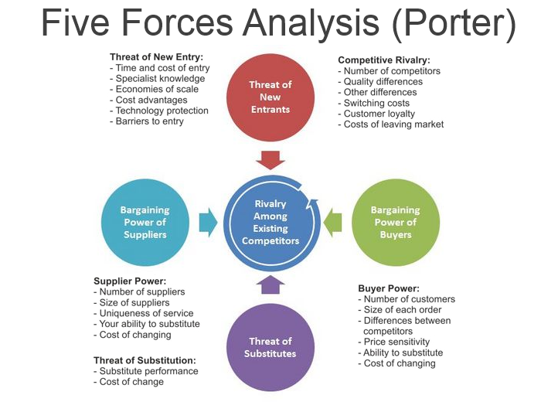
(Source: https://www.visual-paradigm.com/guide/strategic-analysis/what-is-five-forces-analysis/)
- Threats from the new entrance: this industry is capital extensive which demands lots of money to venture or uphold any segments of car manufacturing. In order to sustain in the competition, one should always be in touch with the technology so that they can enforce the entry of new industry in the market.
- Bargaining power of the suppliers: due to the increase in globalization and international trade. The suppliers bargaining power became limited as they cannot demand more because of the availability of other suppliers providing the same product at lucrative rates. So the scope of black marketing reduces.
- Bargaining power of buyers: the buyers got a huge opportunity in the market and a wide variety of product. Customers are also filled with extensive information and numerous brand choices available in the market which makes their bargaining power strong.
- Threats from substitution: they are the alternatives available in the market for the product we make. If the prices are high or the car's technology is not upgraded then people in the UK may prefer to use public transport or they may book rented cars.
- Existing Competitors: as the UK is home and place from where we get our first car. It is a place where 50 car manufacturers are selling 200 models, so as the in house competition is more threating along with this foreign manufacturers are also giving a lot of competition.
- Incorporate discussion of criticism/limitation of the theory :
Mainly two drawbacks this theory faces;
- Blind Spots: this model only works on the past trends and scenarios which helps only in making short-run gaols but in the long run, the company may feel difficulty in surviving. This model doesn’t consider the globalization and rapid technological changes which may lead to poor decision making. It can be used only for small segment company but not to be used for big industries as their trends depend mostly on external factors on a wide range.
- The Bottom Line: this model reduces the difference between the industries and the business.
Porters Diamond model: This theory is an updated model from the above model. This theory gives national advantage and is designed to understand the competitive environment easily. It is a proactive economic theory (Magretta, 2011).
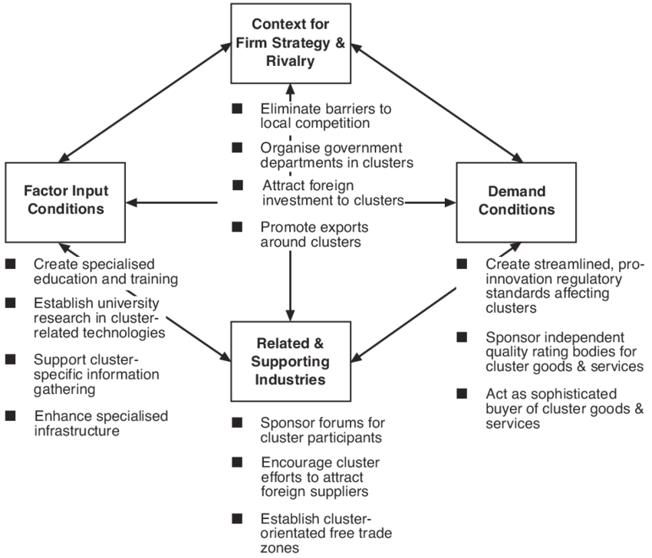
(Source: https://www.researchgate.net/figure/Porters-Diamond-Model-of-Locational-Competitive-Advantage_fig7_237451841)

Conclusion
The above assignment focuses on the environmental analysis of Car manufacturing industries in Europe. The theories used in the above assignment have explained how the European car industry changes and became the world largest manufacturer. It also explains what factors may affect the working of the industry by using PESTEL theory and Porters 5 Force Model theory. Both models have used to explain the competitive market of Europe car manufacturing along with their limitations

References
- Dr Konrad, K., Stagl, S., Dr. Kurne, E., Michelmann, J., Dr. Muuller, B., Muller, M., Dr. Wangler, L., & Zinke, G., 2018. European automotive manufacturing industry. Institute for Innovation and Technology.
- Green European Journal, 2019. 2049: Open Future. [Online] Green European Journal. Available at: https://www.greeneuropeanjournal.eu
- Jato, 2019. Our Story. [Online] Jato. Available at: https://www.jato.com
- Magretta, J., 2011. Understanding Michael Porter: The Essential Guide to Competition and Strategy. Harvard Business Review Press.

